# include<stdio.h>

int main()

{

int num;

num=0;

printf("enter the number...:");

scanf("%d",&num);

if(num%2==0)

printf("this is an even number");

else

printf("this is an odd number");

}

Output01:

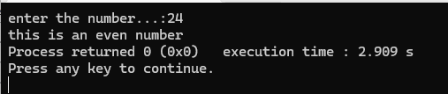

Output02:

