TASK12 – ONLINE CAR BOOKING SYSTEM
Aim:
To make an open project-based online cab booking management system.
Abstract:
The online cab booking system is a database-driven project designed to manage cab services efficiently. It allows customers to book rides, drivers to accept bookings, and administrators to monitor trips and payments.
🎯 Objectives
- Design and implement a relational database for a cab booking platform.
- Efficiently store and manage customer, driver, cab, booking, and payment data.
- Maintain data integrity and avoid redundancy through normalization.
- Implement CRUD operations using SQL.
- Provide reports such as daily rides, revenue, and driver performance.
📘 Entity-Relationship (ER) Model
Entities:
- Customer
- Driver
- Cab
- Booking
- Payment
- Route
Relationships:
- One customer can make many bookings.
- One driver can handle many bookings.
- Each booking is linked to one cab and one payment.
One booking follows one route

Customer Table

CREATE TABLE Customer (
customer_id INT PRIMARY KEY AUTO_INCREMENT,
name VARCHAR(100),
email VARCHAR(100) UNIQUE,
phone VARCHAR(15),
address TEXT
);
Customer Table
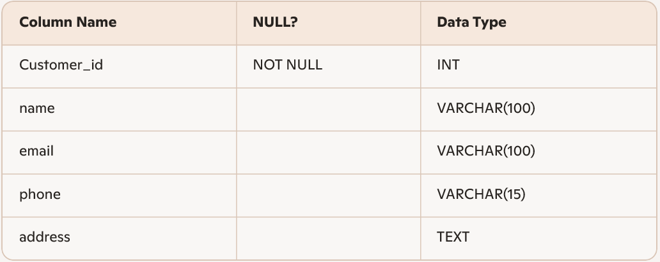

Driver Table
CREATE TABLE Driver (
driver_id INT PRIMARY KEY AUTO_INCREMENT,
name VARCHAR(100),
phone VARCHAR(15),
license_number VARCHAR(50),
rating DECIMAL(2,1)
);

Driver Table
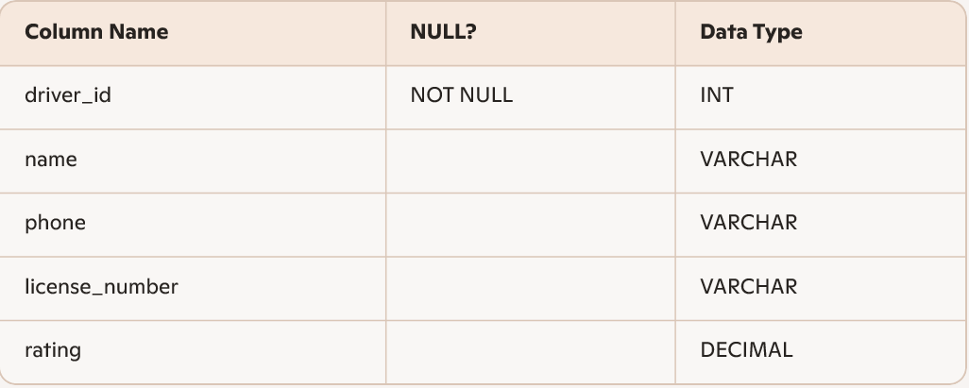

CREATE TABLE Cab (
cab_id INT PRIMARY KEY AUTO_INCREMENT,
driver_id INT,
cab_number VARCHAR(20),
cab_model VARCHAR(50),
cab_type VARCHAR(30),
FOREIGN KEY (driver_id) REFERENCES Driver(driver_id) };

Cab Table
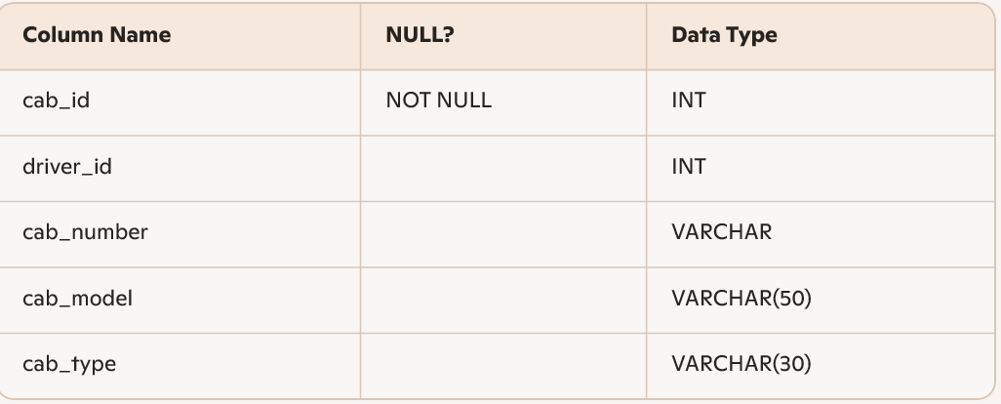

CREATE TABLE Route (
route_id INT PRIMARY KEY AUTO_INCREMENT,
pickup_location VARCHAR(100),
drop_location VARCHAR(100),
distance_km DECIMAL(5,2)
);

Route Table
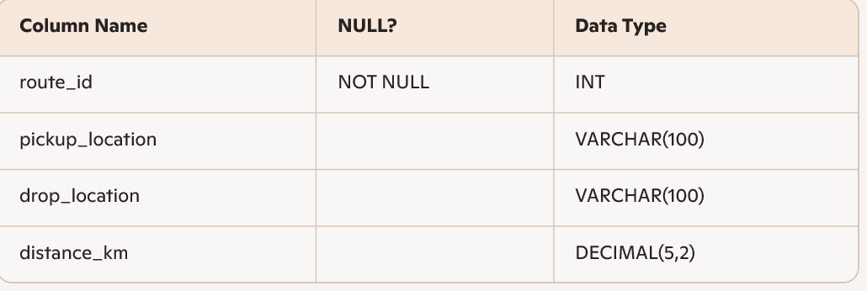

Sample Data Insertion
INSERT INTO Customer (name, email, phone, address)
VALUES ("Rahul Artham", "rahulartham@gmail.com", "939191235", "Mumbai");

INSERT INTO Driver (name, phone, license_number, rating)
VALUES ("Amit", "9798764321", "MH-1234-AB1", 4.7);

INSERT INTO Cab (driver_id, cab_number, cab_model, cab_type)
VALUES (1, "MH10AB1234", "Toyota Etios", "Sedan");

INSERT INTO Route (pickup_location, drop_location, distance_km)
VALUES ("Andheri", "Bandra", 12.5);

Sample Queries
- Display all customers
SELECT * FROM Customer;
- List all completed bookings with customer and driver details
SELECT c.name AS Customer, d.name AS Driver, b.fare, b.booking_date FROM Booking data
JOIN Customer c ON b.customer_id = c.customer_id
JOIN Driver d ON b.driver_id = d.driver_id
WHERE b.status = 'completed';
- Total revenue generated
SELECT SUM(amount) AS Total_Revenue FROM Payment;
2 Top-rated drivers
SELECT name, rating FROM Driver WHERE rating >= 4.5;
3 Find rides longer than 10 km
SELECT pickup_location, drop_location, distance_km FROM Route WHERE distance_km > 10;
🧠 Normalization
- 1NF: All attributes contain atomic values.
- 2NF: Every non-key attribute is fully functionally dependent on the primary key.
- 3NF: No transitive dependencies.

✅ result
The online cab booking system efficiently manages ride bookings, drivers, payments, and routes using a relational database model. It ensures data consistency, integrity, and reliability through proper normalization and foreign key relationships.
If you'd like help turning this into a working project, visual ER diagram, or interactive SQL demo, I’d be happy to assist!

