Name : V.lohitha

Reg no : 11702932

Section: k17jp

Roll no : 53 G2

Github link :

1. Multi Level Queue

Sample Input :-

3

1. 0 3 3
2. 1 3 2
3. 2 4 1

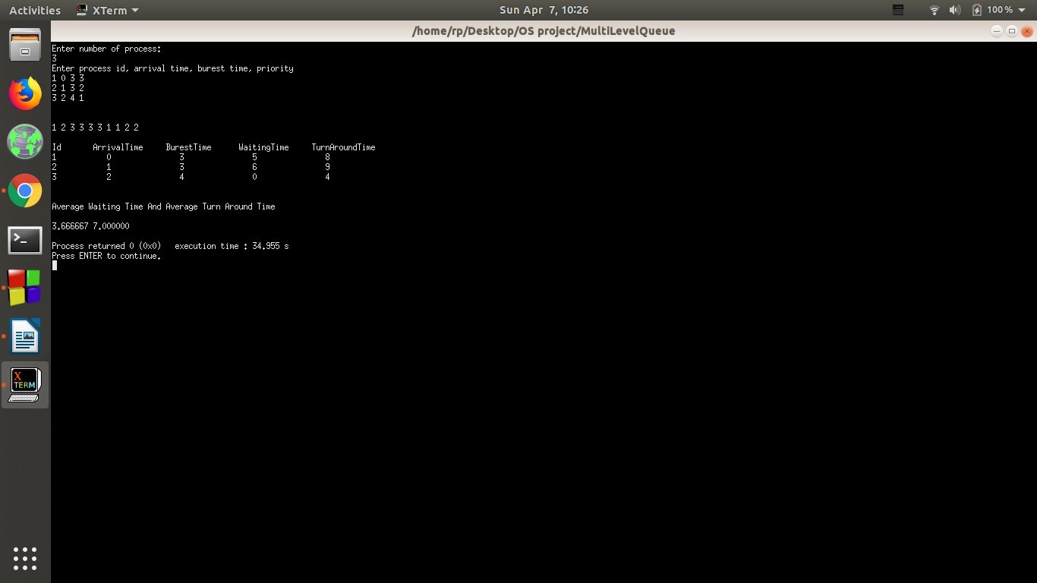

Sample Input 2 :-

5

1. 0 5 3
2. 1 3 4
3. 2 4 1
4. 3 3 2
5. 4 2 5

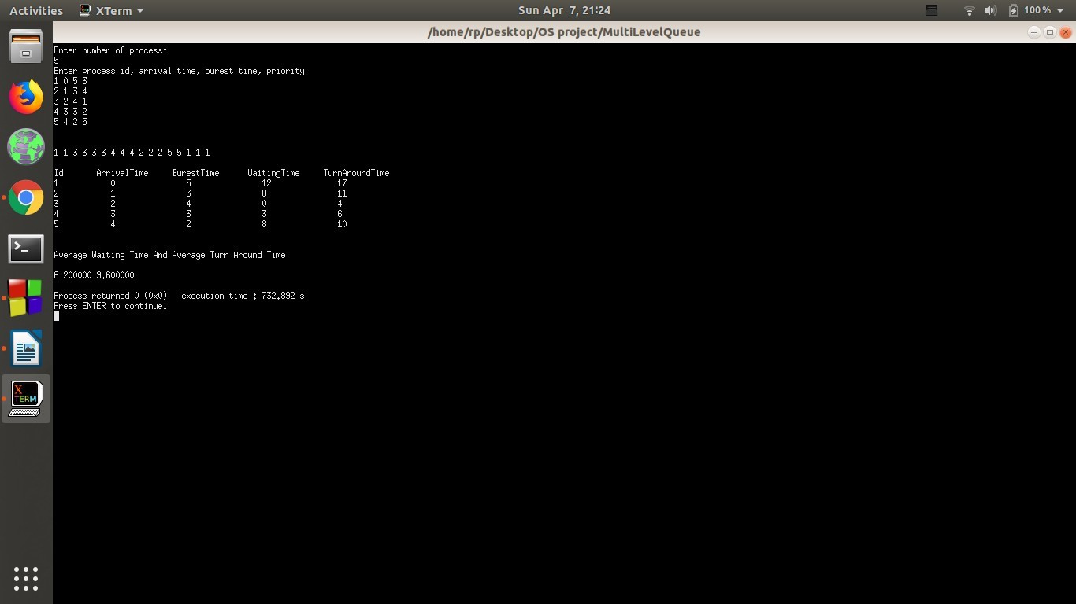

Sample Input 3 :-

5

1. 0 5 3
2. 1 3 4
3. 2 4 5
4. 3 3 2
5. 4 2 5

