PROGRAMMIMG IN JAVA

“Smart city”

Bachelor in Technology

(Computer science and engineering)



SCHOOL OF CSE (LPU)

PHAGWARA

GROUP MEMBER

|  |  |  |
| --- | --- | --- |
| 1. Y. Lohitha | Regno:  12100706 | Roll no:  62 |
| 2.CN Gayathri | Regno:  12105037 | Roll no:  11 |

**Section: K21BG Course code: CSE310 Faculty: Shruthi mam**

**Table of contents:**

1.Introduction

2.Objectives

3.Features

4.Algorithm

5.Result

**INTRODUCTION**

Smart City is a application based software developed in Java programming language to store the details of a city. The main purpose of this project to help the tourists and other visitors to the city by providing information about hotels, city attractions, etc.

Everyday a large number of people are coming to all the cities seeking job, higher studies, tourism, etc. Initially all the system of the city are unknown to the new comers of the city. They don’t know much about booking hotel, transportation, shopping, etc. But implementation of Smart City Java Project provides the complete solution package for new comers. One can see all the necessary information about city through this application.

**OBJECTIVES:**

Using this project, the details of city can be accessed from anywhere at any time. With the help of this application software, students can look for the academic institutes located in the city.

To provide GUI interface for the above objectives.

**FEATURES:**

* Admin:- It is class which deal with Function like update city, add city, remove city.
* Login:- It has attributes userid and password of string datatypes. It has method of student login, Tourists login.
* Person:- It is base class of student and Tourists and having attributes first name, last name, address, and mobile number and method get data and set data.
* Student:- It is a class which will use login class and have method of view college and view library
* Tourist:- It is a class which will use login class and have method of view hotels and view city guide.
* Hotel:- It is class which has attributes name, description, and method display data and update data.
* College:- It is class which has attributes name, description, and method display data and update data
* Tourist attractions:- It is class which has attributes name, description, and method display data and update data
* Library:- It is class which has attributes name, description, and method display data and update data.

***ALGORITHM OF THE CODE:***

1. Start

2. Create the MainMenu frame which contains Sign Up and Login buttons

3. If Sign Up button is clicked, create SignUp frame which allows user to create an account

4. If Login button is clicked, create Login frame which allows user to enter their username, password, and user type

5. Read in the usernames.txt file and check if the entered username and password match an existing user

6. If the user type is Student, create the StudentMenu frame

7. If the user type is Tourist, create the TouristMenu frame

8. End

**RESULT:**

Main menu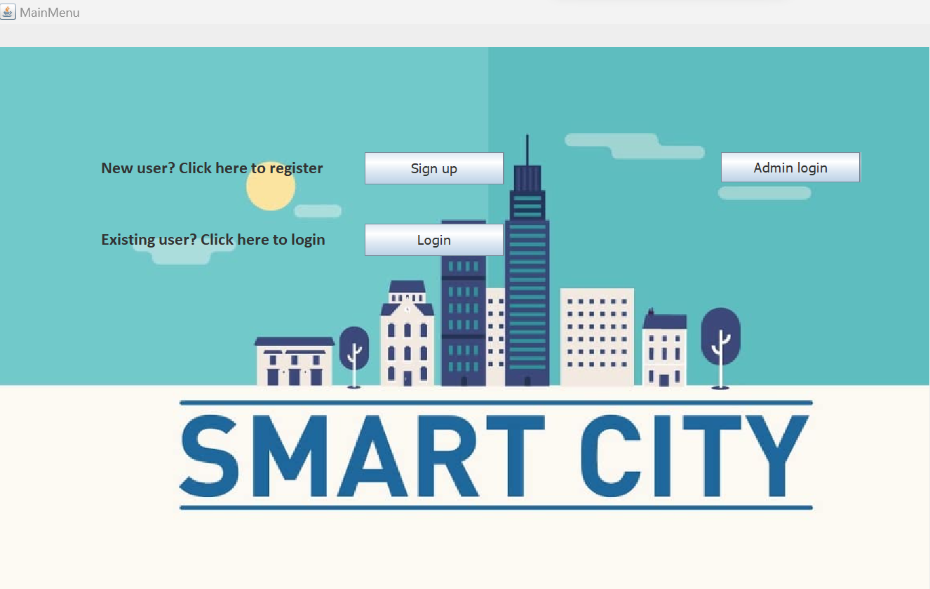

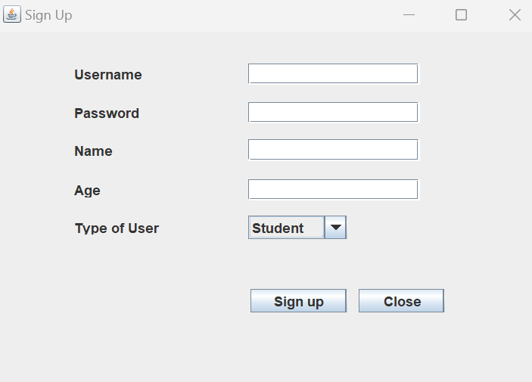

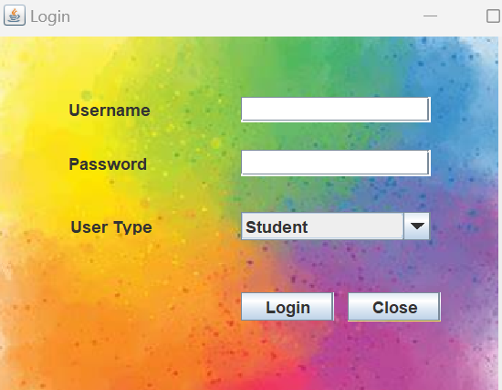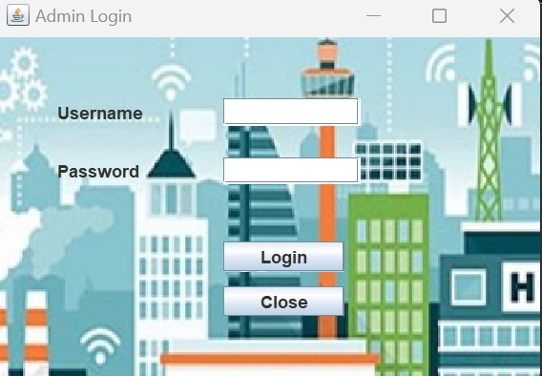

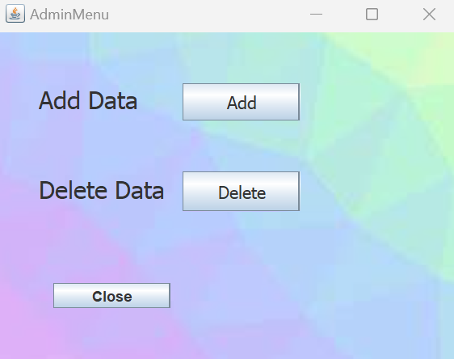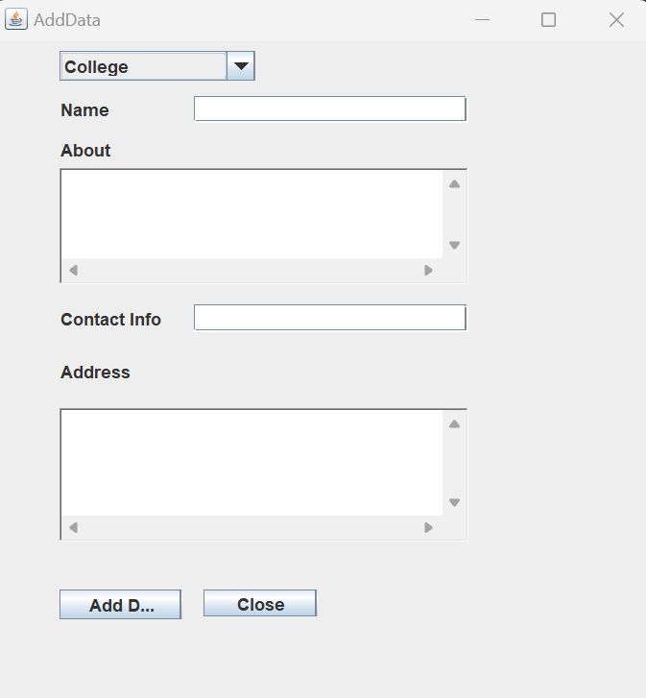

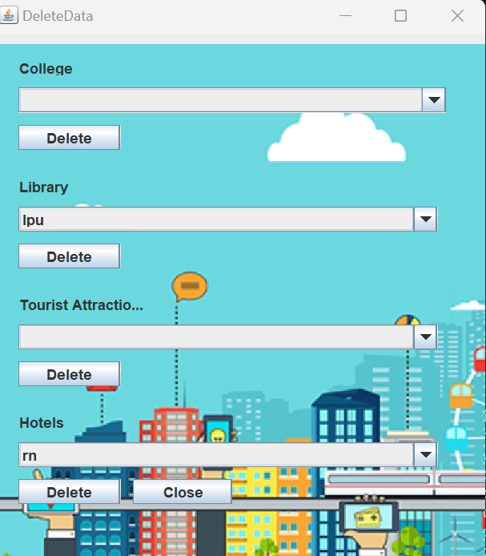

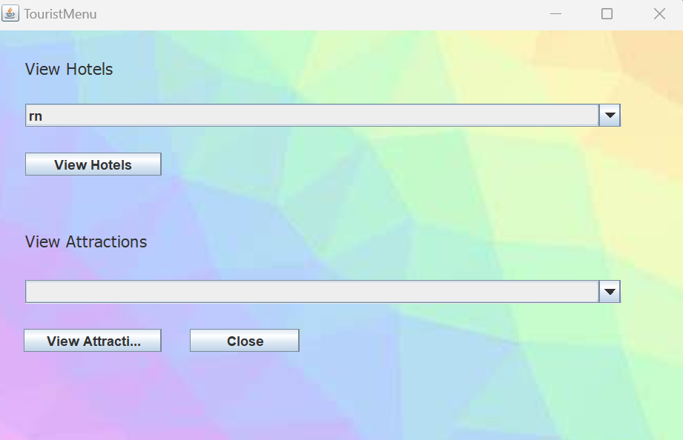

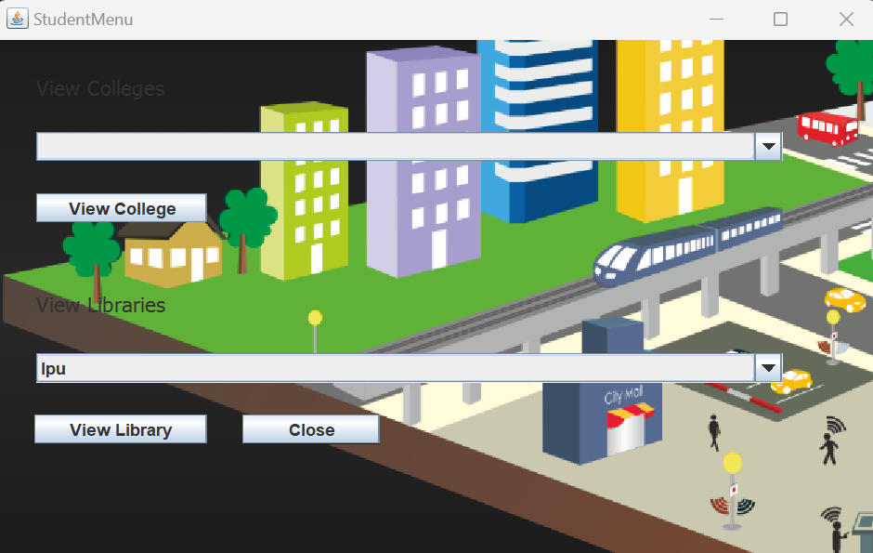GITHUB LINK:

* https://github.com/lohitha6/Smart-city-project-