**<TABLEAU> PROJECT REPORT**

(6th Semester January-April 2024)

***ONLINE SHOPPING TRENDS***

Submitted by

Y. LOHITHA

Registration No:12100706

Program

DATA SCIENCE

Section

KMO54

Course code: INTB233

Under the Guidance of

**BALJINDER KAUR (27952)**

**Discipline of CSE/IT**

**Lovely School of computer sciences**

**Lovely Professional University, Phagwara**



**CERTIFICATE**

This is to certify that Y LOHITHA bearing Registration no. 12100706 has completed the INTB233 project titled, **“ONLINE SHOPPING TRENDS”** under my guidance and supervision. To the best of my knowledge, the present work is the result of his/her original development, effort, and study.

**Signature and Name of the Supervisor**

**Designation of the Supervisor**

**School of Computer Sciences**

Lovely Professional University

Phagwara, Punjab.

Date: 18-04-2024

**DECLARATION**

I, Y LOHITHA student of DATA SCIENCE (Program name) under CSE/IT Discipline at, Lovely Professional University, Punjab, hereby declare that all the information furnished in this project report is based on my own intensive work and is genuine.

Date: 18-04-2024 Signature

Registration No. 12100706 Name of the student: Y LOHITHA

**Table of Contents**

1. Introduction
2. Objectives/Scope of the Analysis
3. Source of dataset
4. ETL process
5. Analysis on dataset (for each analysis)
6. Introduction
7. General Description
8. Specific Requirements, functions and formulas
9. Analysis results
10. Visualization
11. List of Analysis with results
12. References

8. Bibliography

**INTRODUCTION:**

Understanding consumer behavior and trends in sales is crucial for businesses to adapt their strategies and cater to evolving consumer preferences effectively. In this Tableau project, we delve into the realm of supermarket sales using a comprehensive dataset sourced from Kaggle.com.

In today's dynamic retail landscape, understanding customer behavior and market trends is paramount for the success of any supermarket chain. With the advent of big data analytics and advanced visualization tools like Tableau, supermarkets can delve deeper into their sales data to extract actionable insights and make informed decisions. This report aims to provide a comprehensive analysis of supermarket sales, focusing on various aspects such as customer preferences, product categories, payment methods, branch performance, geographical trends, and gender demographics.

Through the utilization of Tableau's powerful data visualization tools, we will conduct a thorough examination of the dataset, employing descriptive analytics techniques to reveal patterns, trends, and correlations within the data. By visualizing key metrics and relationships, we aim to provide actionable insights that enable stakeholders to make informed decisions and drive business growth in the competitive landscape of online retail.

**Objectives/Scope of the Analysis**

1. Analysis on items purchased by customer

2. Examining discounts applied on items purchased

3. Studying items purchased by different genders

4. Analyzing items purchased in different seasons

5. Investigating items purchased by different payment methods

**Source of Dataset:**

The source of the dataset is kaagle.com which is a website where we can find thousands of datasets and download them for free.

Link of the dataset:

<https://www.kaggle.com/datasets/jacksondivakarr/online-shopping-dataset>

**ETL PROCESS:**

**Extract:**

Retrieve the Dataset:

Download the dataset from Kaggle.com, ensuring it includes relevant information such as online shopping transactions, including items purchased, locations, genders, payment methods, discounts, and timestamps.

**Transform**:

Data Cleaning: Identify and handle missing values, duplicates, and inconsistencies in the dataset.

Data Formatting: Standardize data formats and units to ensure consistency across variables.

Feature Engineering: Create new variables or features as needed, such as deriving seasonal indicators from timestamps or aggregating data for analysis.

**Load**:

Prepare Data for Tableau:

Export the cleaned and transformed dataset into a format compatible with Tableau, such as CSV, Excel, or a Tableau Data Extract (TDE) file. Connect Data to Tableau: Import the prepared dataset into Tableau Desktop or connect it directly to the original data source. Optimize Performance: If working with large datasets, consider optimizing data extracts or applying filters to improve Tableau performance during visualization.

**Analysis of the dataset (for each analysis**)

**1. Introduction:**

The analysis of items purchased in different locations

**2. General Description:**

It aims to understand the geographical distribution of purchases and identify any regional trends or preferences in online shopping behavior.

**3. Specific Requirements, functions, and formulas:**

**Aggregation**: Use aggregation functions (COUNT of items purchased) to calculate total purchases or sales volumes by location

We choose the top 10 cities for the analysis using filter.

**4. Analysis results**

Highest number of items purchased (city): Montana

Lowest number of items purchased (city): Delaware

**5. Visualization:**

We use a horizontal bar graph to show the visualization

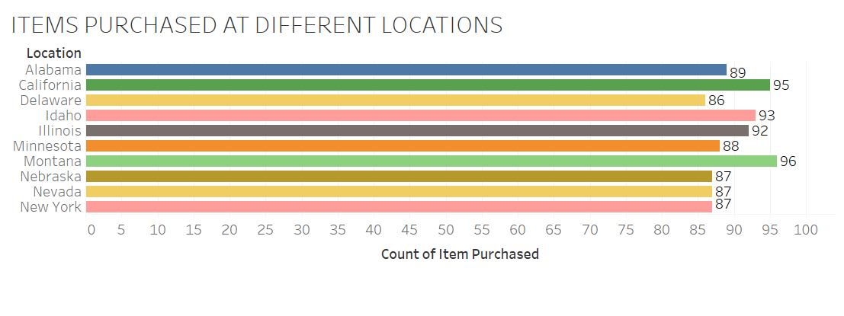

**1. Introduction:**

Examining discount applied on items purchased

**2. General Description:**

Impact of discounts across different product categories, customer segments, and promotional campaigns. Through rigorous analysis and visualization, we endeavor to shed light on the nuanced interplay between discounts and consumer behavior, offering valuable insights that pave the way for strategic decision-making and sustained business growth in the competitive landscape of online retail.

**3. Specific Requirements, functions, and formulas:**

**Aggregation**: Use aggregation functions (COUNT of items purchased) to know if discount is applied on that item or not.

**4. Analysis results**

Discount applied on 1677 items

Discount not applied on 2223 items

**5. Visualization:**

We used a packed bubble chart to show the visualization

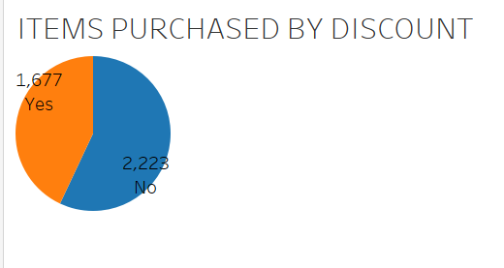

**1. Introduction:**

Studying items purchased by different genders

**2. General Description:**

The examination of items purchased by different genders encompasses a multifaceted analysis that seeks to uncover patterns, trends, and preferences within distinct demographic cohorts. By dissecting purchasing behavior through the lens of gender, businesses can gain actionable insights into the types of products, brands, and categories that resonate most strongly with male and female consumers alike

**3. Specific Requirements, functions, and formulas:**

**Aggregation**: Use aggregation functions (COUNT of items purchased) to know which gender is buying which type of clothes

**4. Analysis results**

Females buy 1248 items

Males buy 2652 items

**5. Visualization:**

We used pie chart to show the visualization

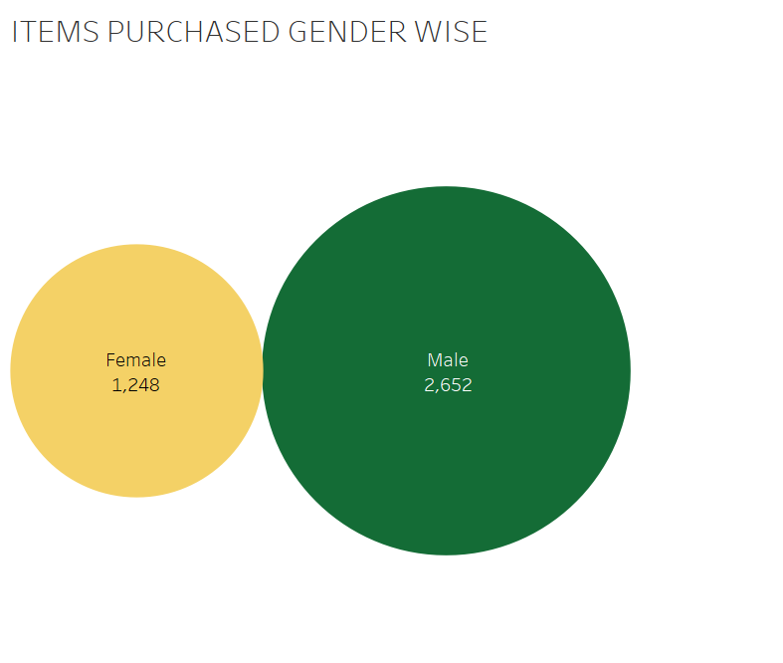

**1. Introduction:**

Analysing items purchased in different seasons

**2. General Description:**

Seasonal variations have a profound impact on consumer behavior, influencing purchasing patterns, product preferences, and overall market demand. In the realm of online shopping, the transition between seasons often heralds shifts in consumer needs, preferences, and spending habits, as individuals adapt their purchases to align with changing weather conditions, holidays, and cultural events. Analyzing items purchased in different seasons offers valuable insights into the dynamics of seasonal shopping trends, enabling businesses to anticipate and respond to shifting consumer preferences with agility and precision

**3. Specific Requirements, functions, and formulas:**

**Aggregation**: Use aggregation functions (COUNT of items purchased) to know in which season items are sold highest.

**4. Analysis results**

Spring has highest purchases(999)

Summer has least purchases(955)

**5. Visualization:**

We used treemap to show visualization

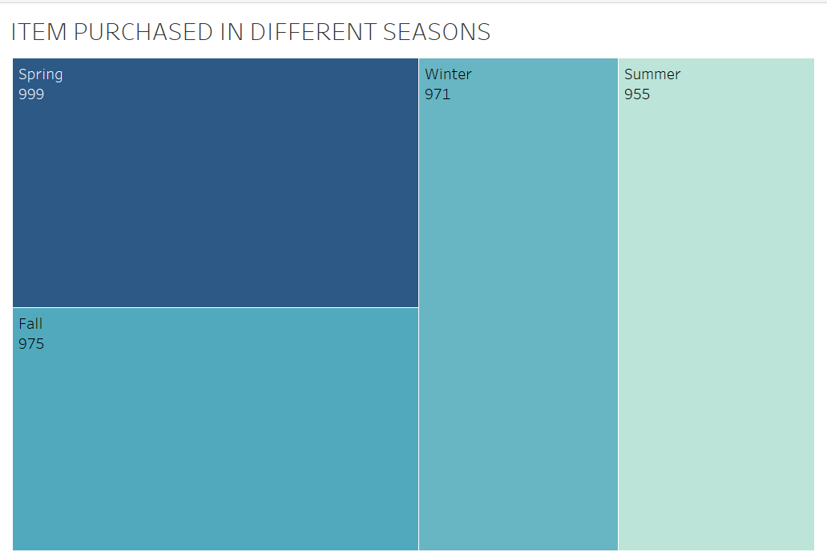

**1. Introduction:**

Investigating items purchased by various payment methods

**2. General Description:**

In the ever-evolving landscape of online retail, the proliferation of payment methods offers consumers unprecedented flexibility and convenience in completing their transactions. From credit and debit cards to digital wallets and alternative payment solutions, the diverse array of payment options available to consumers reflects the shifting preferences and expectations of modern shoppers. Analyzing items purchased by different payment methods provides valuable insights into consumer payment behaviors, preferences, and trends, enabling businesses to optimize their checkout experiences, streamline payment processes, and enhance overall customer satisfaction.

**3. Specific Requirements, functions, and formulas:**

**Aggregation**: Use aggregation functions (COUNT of items purchased) to know which payment method is easier to customers for buying products

**4. Analysis results**

Paypal is used more for purchasing

Bank transactions are less used

**5. Visualization:**

We used bar graph to show visualization

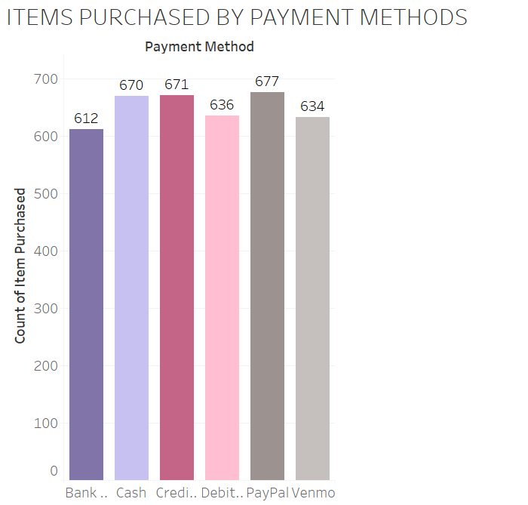

**List of Analysis With results:**

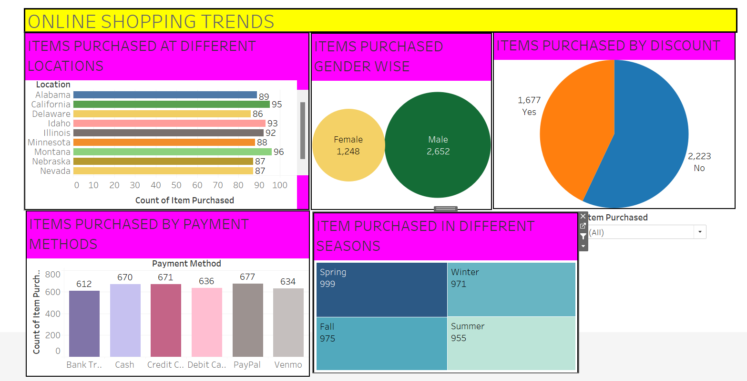

**Montana** City has higher number of sales

**Males** buy more products than females

**Spring** season has the highest number of purchases

People mostly use **PayPa**l for easier transactions while purchasing

Discounts are applied on **fewer** items**.**

**REFERENCES:**

**COURSERA MOOC**

[**https://www.coursera.org/learn/introduction-to-tableau**](https://www.coursera.org/learn/introduction-to-tableau)

**BIBLIOGRAPHY:**

**1. Kaggle. com, Online dataset available at**

[**https://www.kaggle.com/datasets/jacksondivakarr/online-shopping-dataset**](https://www.kaggle.com/datasets/jacksondivakarr/online-shopping-dataset)