Crime Rate Prediction & Analysis using K-Means Clustering Algorithm
In this project we are using clustering and regression algorithms to predict crime rate. Clustering algorithm is used to predict HIGH or LOW crime area and regression algorithms are used to forecast future crime rate.
This application consists of two users
- Admin: admin can login to application using username and password as ‘admin’ and ‘admin’ and after login admin can upload dataset and then train that dataset using machine learning algorithms
- User: users can enter area name and then enter crime details and then system will predict future crime rate.
SCREEN SHOTS
Double click on run.bat file to start python server and get below screen
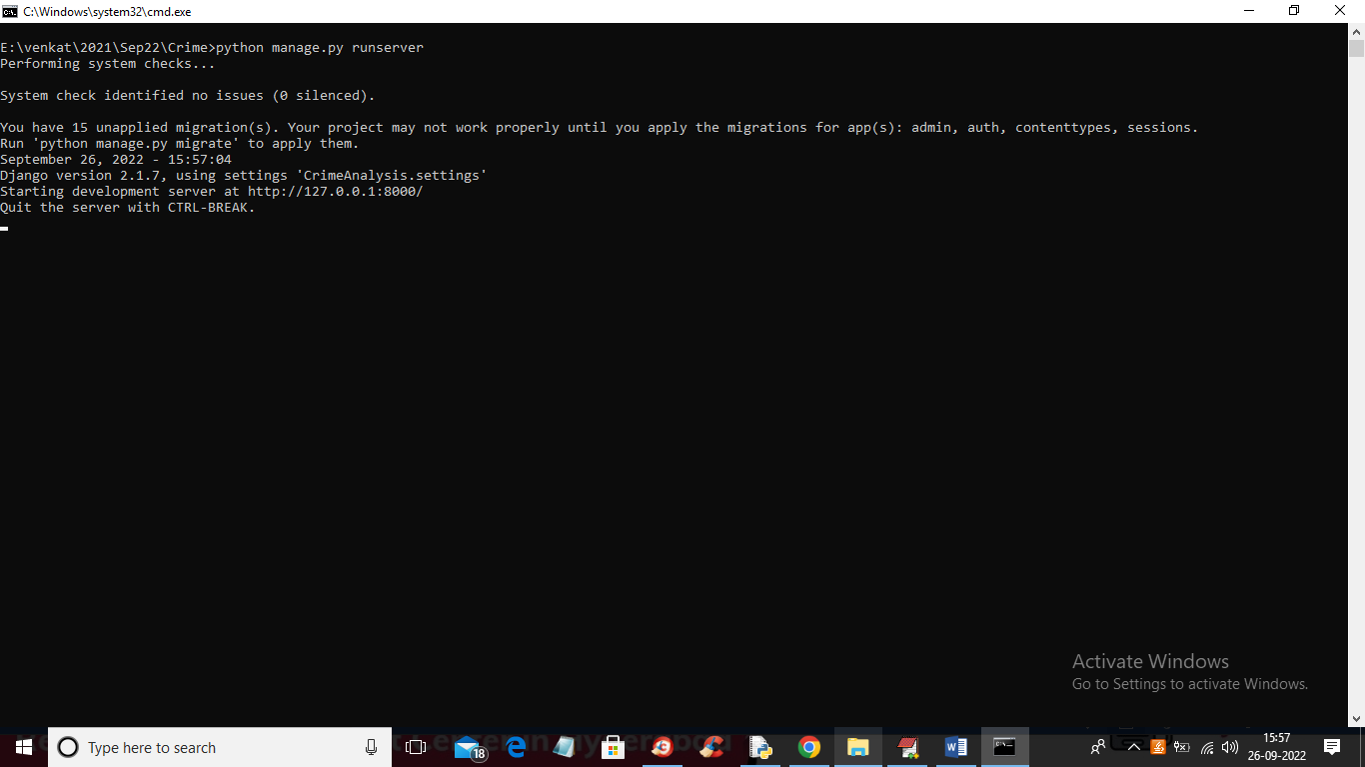
In above screen python server started and now open browser and enter URL as ‘http://127.0.0.1:8000/index.html’ and press enter key to get below page

In above screen click on ‘Admin Login’ link to get below login page
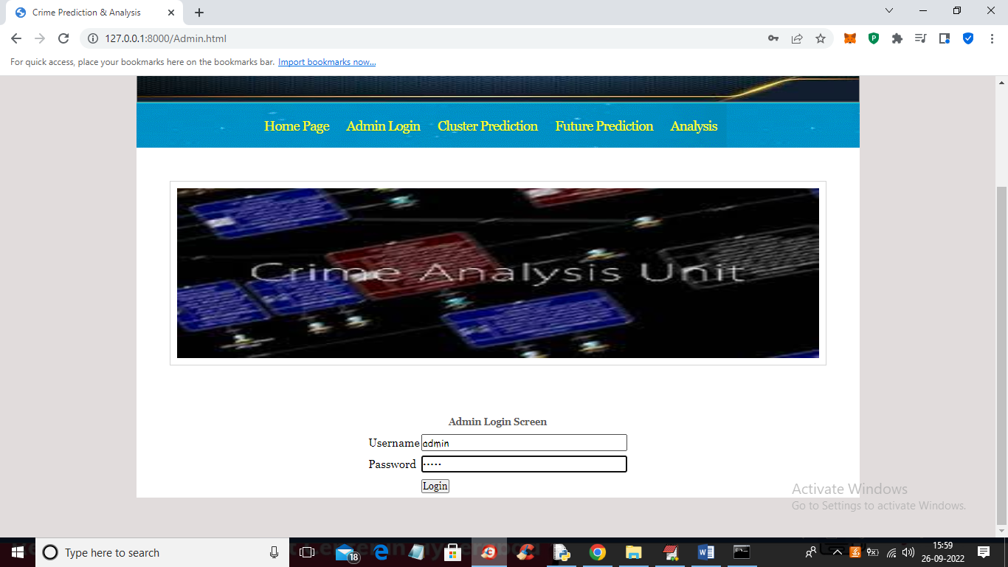
In above screen admin is login and after login will get below screen
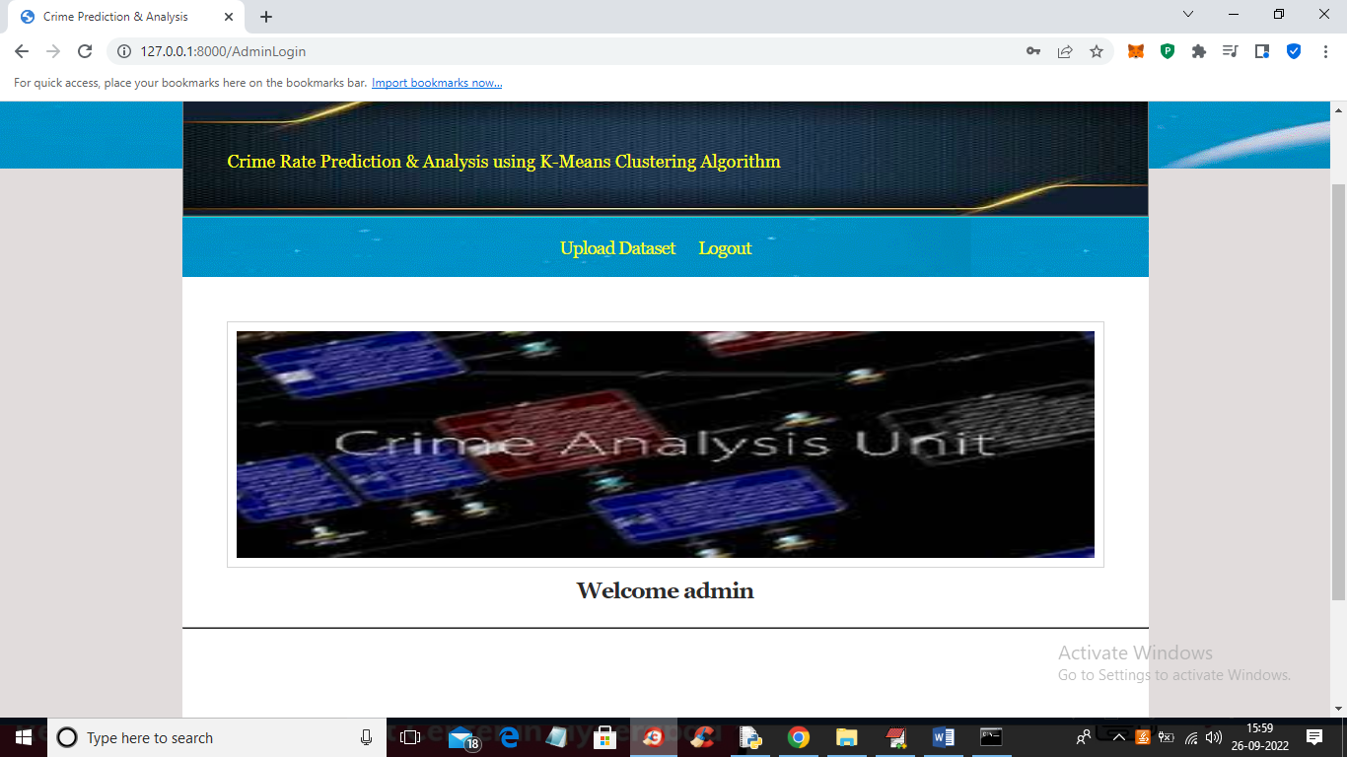
In above screen admin can click on ‘Upload Dataset’ link to upload dataset and then click submit button to load dataset and then train it with machine learning algorithms
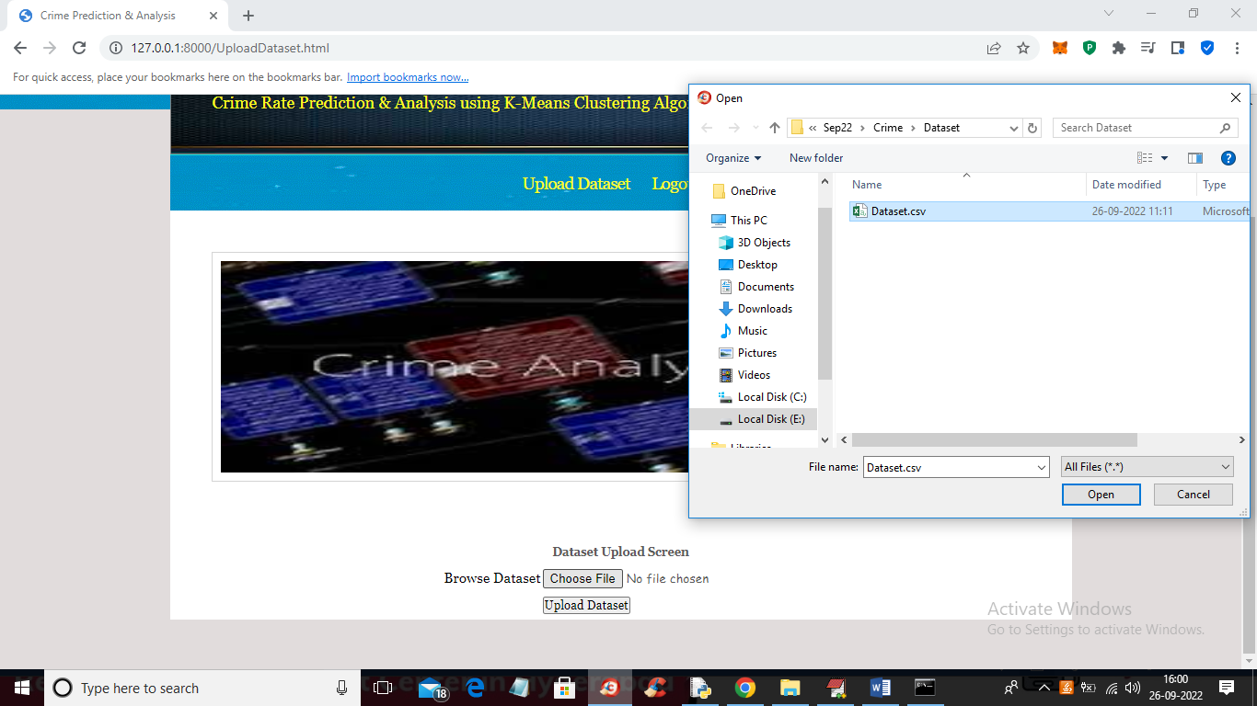
In above screen selecting and upload dataset and then click on ‘Open’ and ‘Upload Dataset’ button to load and complete training process and get below output
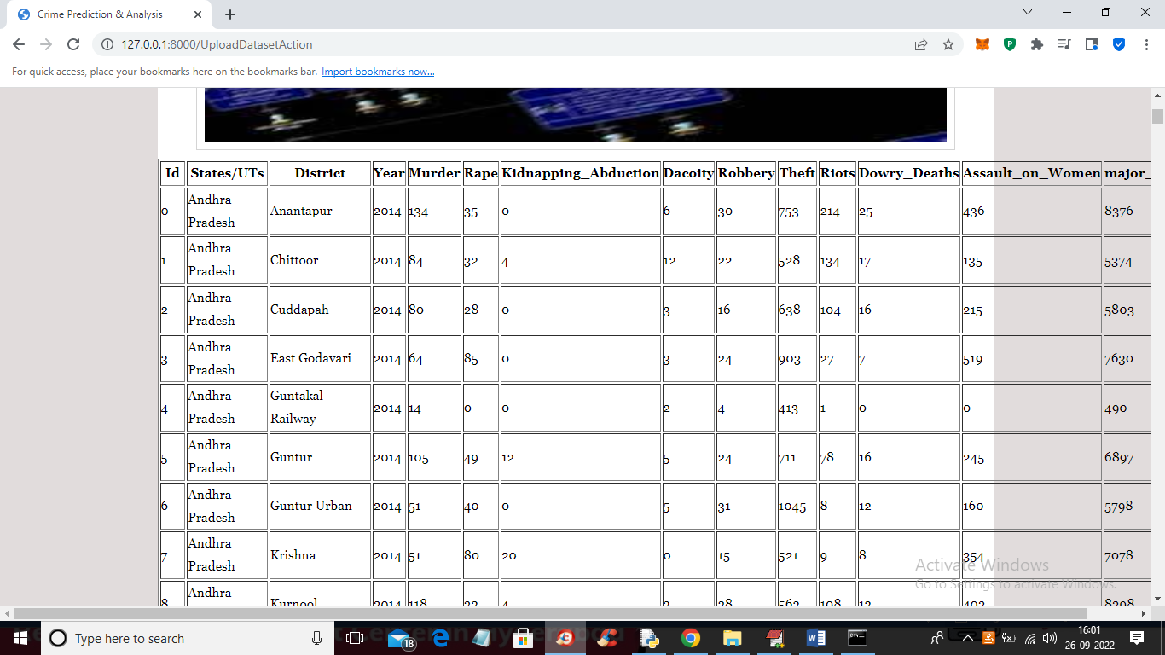
In above screen training is completed and then we got all dataset details and now click on ‘Logout’ link to get below screen

In above screen click on ‘Cluster Prediction’ link to get below screen
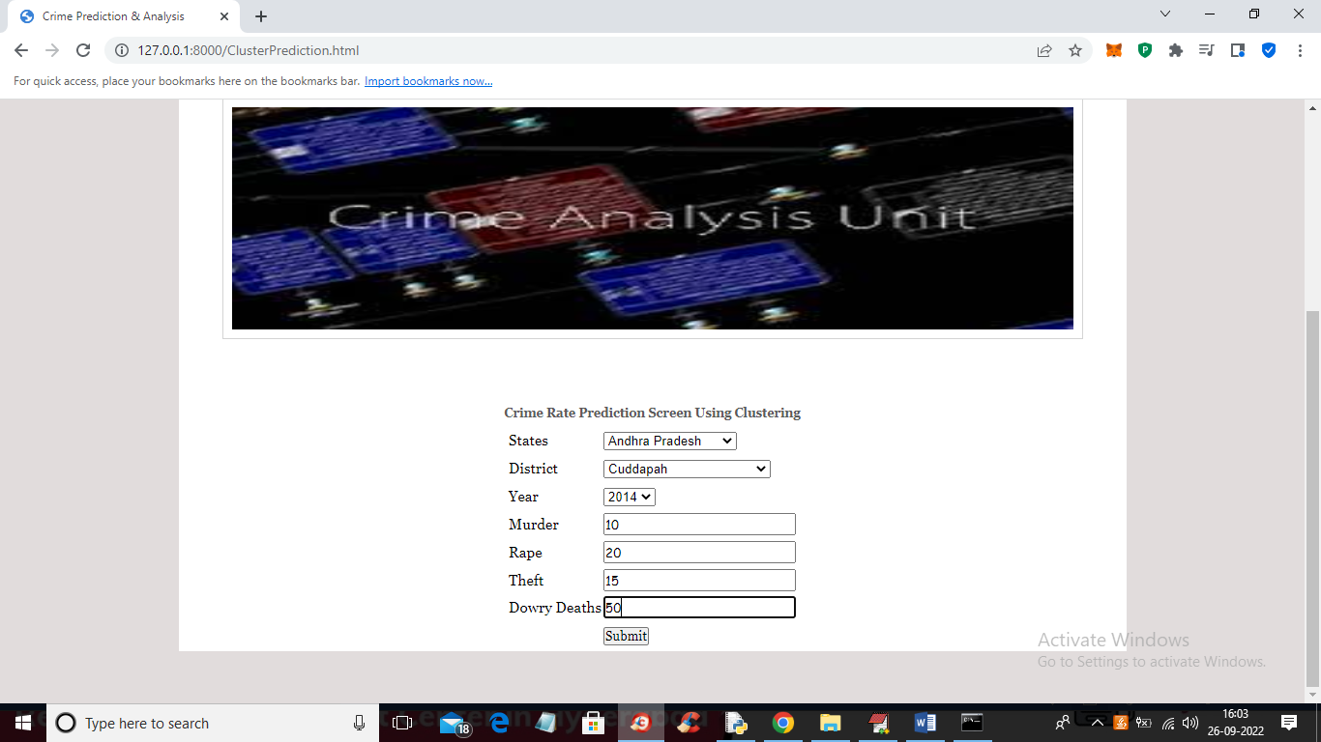
In above screen select state and district name and then enter details of crime and then press ‘Submit’ button to get below output
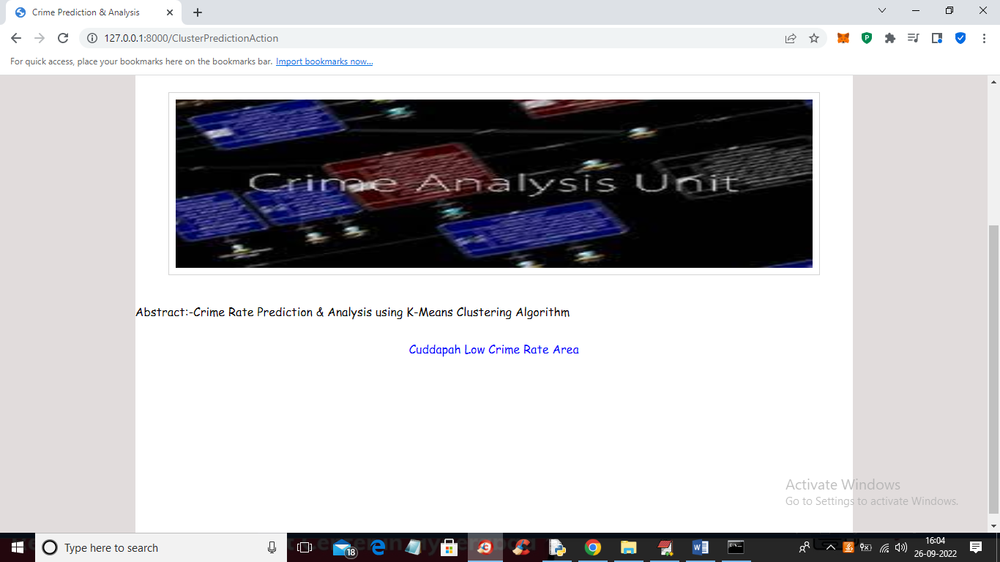
In above screen in blue colour we got output as ‘Cuddapah is the Low Crime Area’ and similarly we can test any other state
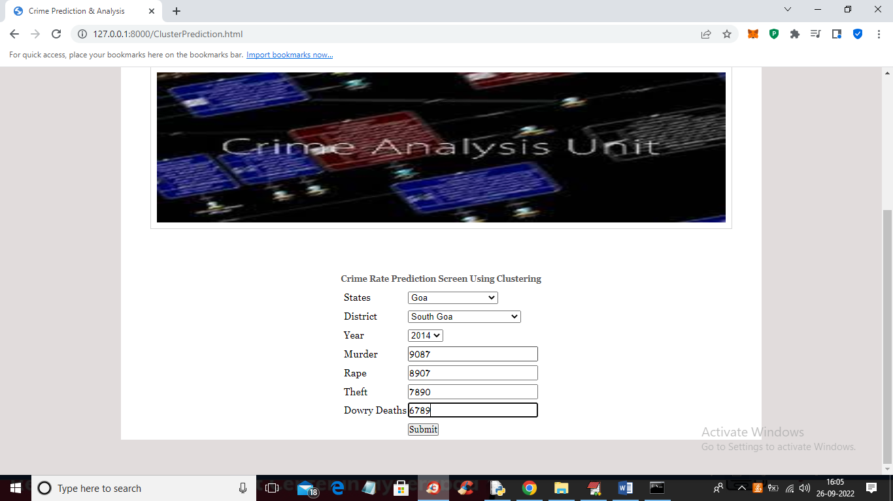
In above screen I entered some other state and crime rate and press button to get below output
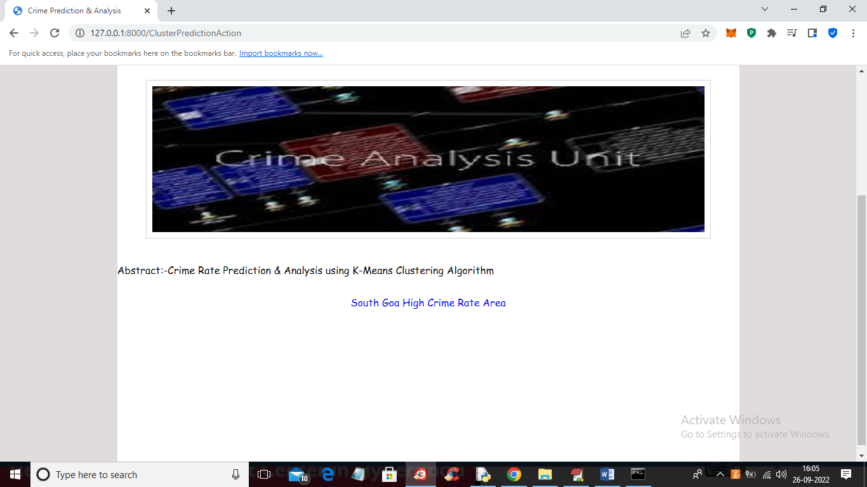
In above screen in blue colour text we got output as ‘Goa is High Crime area’ and now click on ‘Future Prediction’ link to get below screen
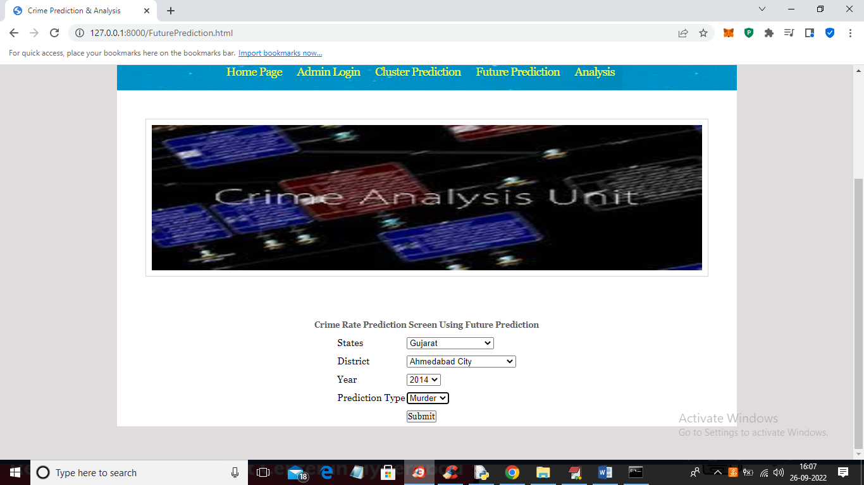
In above screen I selected state, district and then select crime as ‘Murder’ and then press ‘Submit’ button to get below output
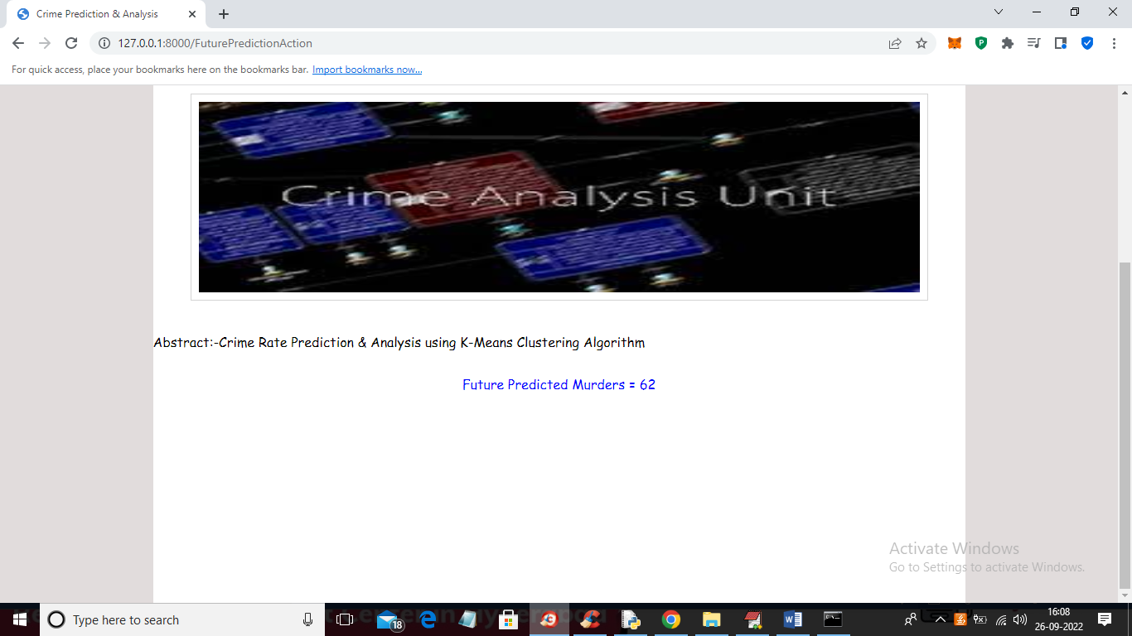
In above screen future predicted Murders for Gujarat state and Ahmadabad district is 62 and similarly you can select option and get future prediction and now click on ‘Analysis’ link to get below screen
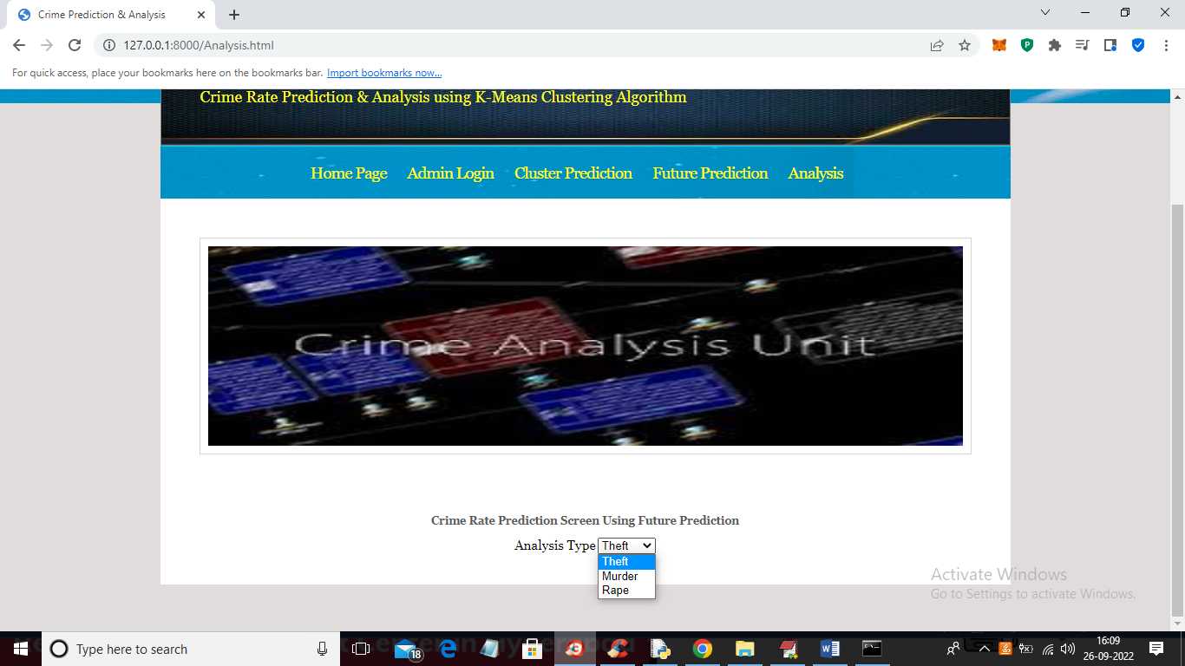
In above screen select the type of analysis and press button to get below graphs
