Experiment-5

**(Note:** All Blue Words is a command, just copy and paste**)**

**Aim:**Build War file in Devops

**Require Software & Tools:** Jenkins, Jdk-17 or jdk-21, Git bash.

**Procedure:**

**Step-1:** First open any browser and Search download Jenkins -> click on first link -> scroll down and click on windows logo -> download will be started.

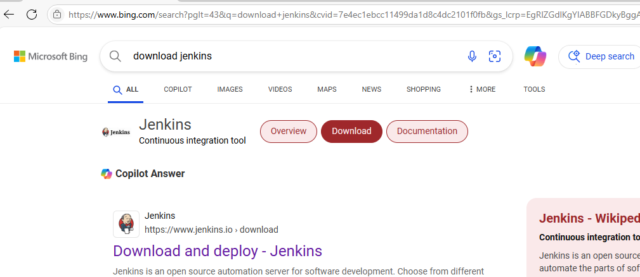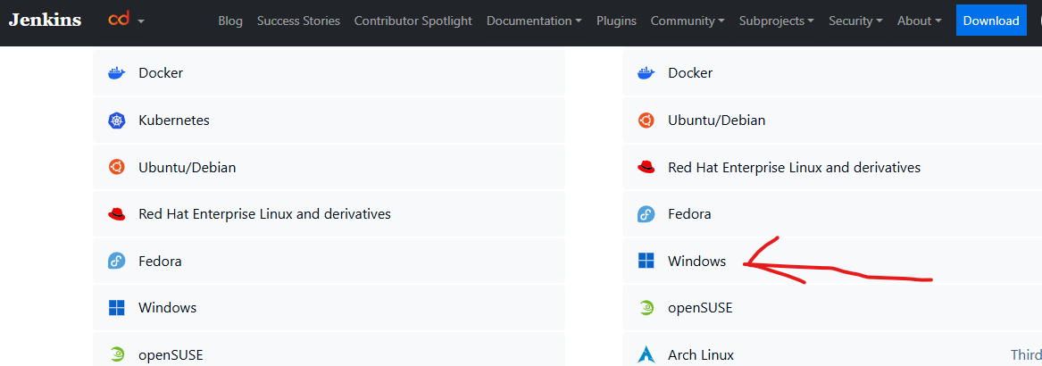

**Step2:** First check java jdk in your system, if java is available check the java version using cmd. otherwise download and install jdk-17.

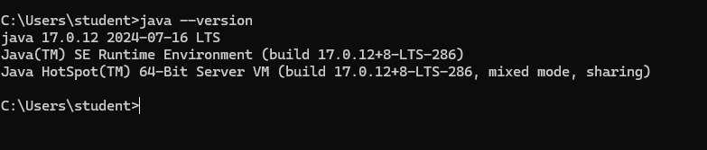

#### Step-3: Download Git Bash 64-bit Standalone Installer, and install git bash in your system. After installation set the git.exe path in your runtime environment.

#### 54.png

#### Step-4: Now install Jenkins in your system -> click on next and again next -> select run service as a local system -> click on next and click on Test port -> click on next and click on change and set the java jdk path -> click on next and again next and click on install.

#### 56.png57.png

#### Step-5: After that install Git Bash in your system (no need to change anything just click on next next and next till last).

#### Step-6: Now open a browser -> search localhost:8080

#### Step-7: It will open your Jenkins server -> Copy red line location and search it to in your File manager.

#### Step-7: It will show open with option just select notepad -> after that copy the password and paste in Jenkins server -> click on continue -> click on suggested plugin -> it will take some time for installation -> create admin user using given details and click on save and continue -> after that click on save and finish -> Click on start using jenkins It will show Jenkins Dashboard.

#### 58.png59.png60.png

#### 61.png

#### Step-8: After that click on manage Jenkins -> click on plugin -> click on available plugin -> search maven -> select maven integration -> click on install -> scroll down and check maven integration and and loading plugin is green and success or not -> After success click on go back to the top page

#### 62.png

#### 63.png64.png

#### Step-9: Now again click on Manage Jenkins -> click on tools -> scroll down and check Git path -> after that scroll down and in a Maven installation section -> click on add maven -> write maven name and click on apply -> click on save.

#### 65.png67.png

#### 66.png

#### Step-10: now click on dashboard -> click on create a job -> type your buildwar name (i.e. myWar) -> select Maven Project -> click on OK

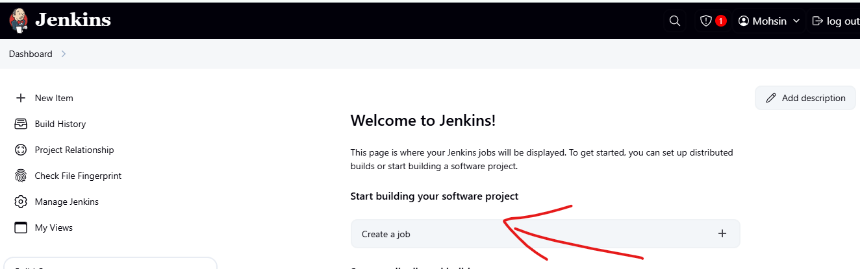

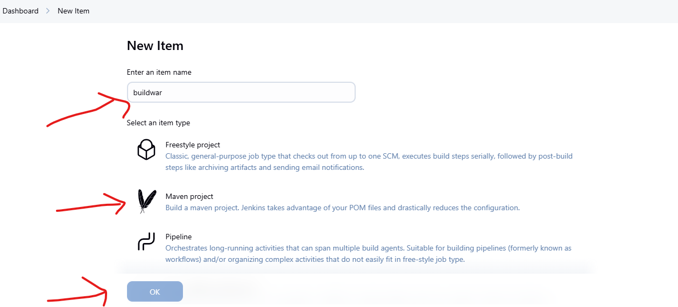

#### Step-10: Now take a new page -> login your GitHub -> check second experiment repository like Devops_pipeline -> copy the git link of second experiment.

#### 70.png

#### Step-11: scroll down and go to Source code management section -> select git -> paste git link -> scroll down go to build option and type clean install package in goals option -> click on apply -> click on save.

#### 71.png

#### 72.png

#### Step-12: After save the file -> it will show an option in left side build now -> click on build now -> It will take two to five minute for creating build file.

#### 73.png

#### Step-12: After building it will show success with green mark -> click on that section -> it will open new section -> click on console output -> scroll down and check status, build success or not.

#### 74.png

#### 75.png

#### OUTPUT

#### 76.png