Name:Lohit Hadapad

Usn: 2JR20EC012

1]

def oddword(words):

max_length = 0

max_length_word = ""

for word in words:

if len(word) % 2 == 1:

if len(word) > max_length:

max_length = len(word)

max_length_word = word

if max_length_word:

return max_length_word

else:

return "Try Again"

def main():

num_words = int(input("Enter the number of words: "))

sentence = input("Enter the sentence composed from the words: ").split()

max_odd_word = oddword(sentence)

print("Word with maximum odd number length:", max_odd_word)

if __name__ == "__main__":

main()

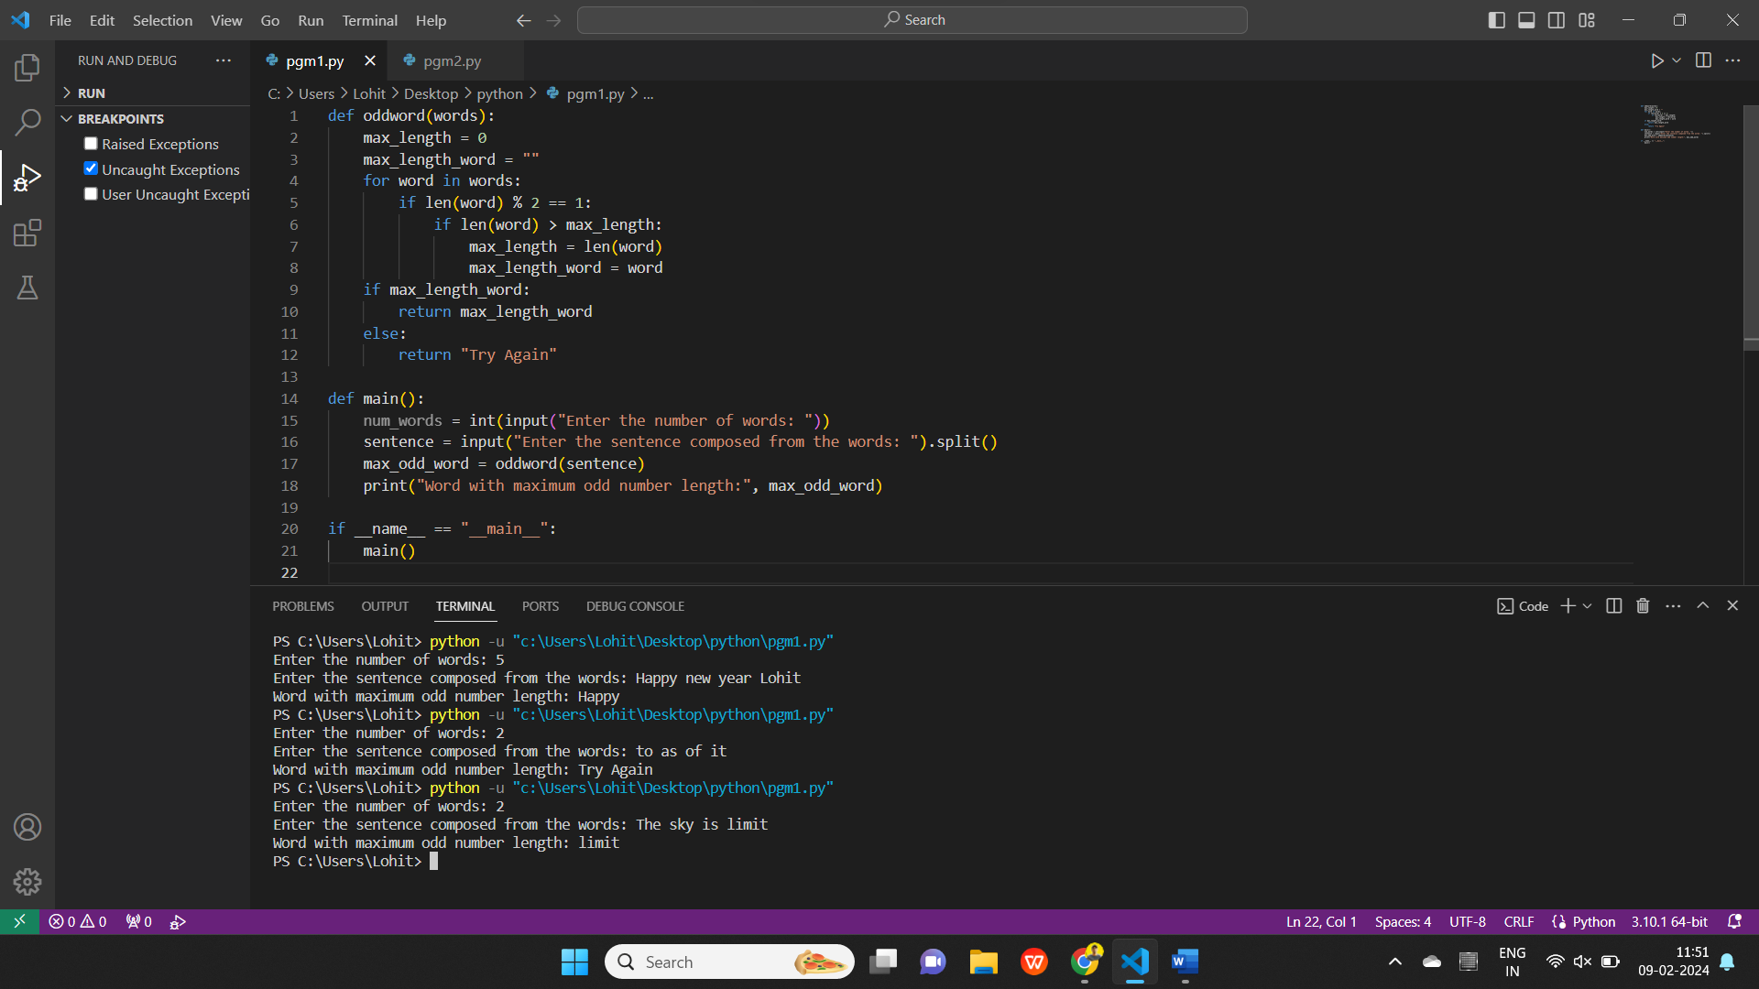

2]

def add(x, R):

    if R not in x:

        return x

    N = len(x)

    result = x[:]

    seq_num = 1

    index = x.index(R)

    for i in range(1, N + 1):

        for j in range(i):

            if 0 <= index + j < N:

                result[index + j] += seq_num

            if 0 <= index - j < N:

                result[index - j] += seq_num

        seq_num += 1

    return result

x = [1,2,3,4,5,6,7,8]

R = 4

output = add(x, R)

print(output)

