OS & SP
Name : S LOHITHA Roll No : 2520030109
Practical – 05
Producer-Consumer using Anonymous Pipe :

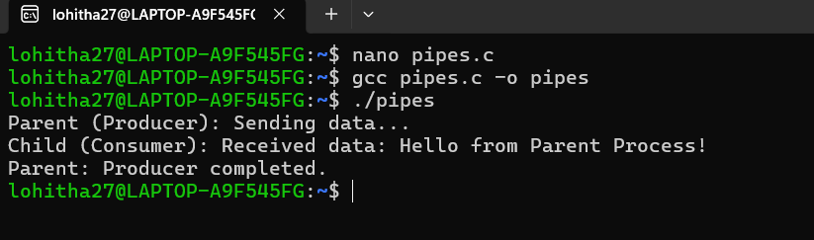
Ls_grep :
