IT Service Desk and
Incident Management System
Report
L1 Support | ServiceNow | Active Directory

Report By: |  | MH Lohith
Date: |  | 01 June 2026
Version: |  | 1.0

1. Introduction

This project simulates real-world IT Service Desk operations using ServiceNow and Active Directory. The objective is to demonstrate incident handling, SLA compliance, user administration, and escalation procedures performed by L1 Support Engineers.
Key areas covered in this project:
- Incident creation and management using the ServiceNow portal
- SLA (Service Level Agreement) definition, attachment, and tracking
- Ticket escalation workflows from L1 to L2 and L3 teams
- User account management and administration via Active Directory
- Password reset and account unlock operations
- VPN troubleshooting and resolution procedures
- Complete ticket lifecycle tracking: New → In Progress → Resolved → Closed

This report includes screenshots, workflow diagrams, and documentation of every major operation performed, making it a practical reference for L1 Support, Service Desk, and IT Help Desk roles.

2. Architecture Diagram

The following architecture illustrates the end-to-end IT Service Desk workflow, from user request to final resolution or escalation.

End User
↓
ServiceNow Portal
↓
L1 Service Desk
↓
Troubleshooting
↓
Resolved? ── Yes → Close Ticket
│
No
↓
L2 Support
↓
L3 Support
↓
Resolution
Figure 1: IT Service Desk Architecture — L1 Support to Escalation Flow

3. ServiceNow — Incident Management Screenshots

The following screenshots document the complete incident management workflow in ServiceNow, from initial creation through assignment, work notes, and resolution.

3.1 Incident Creation
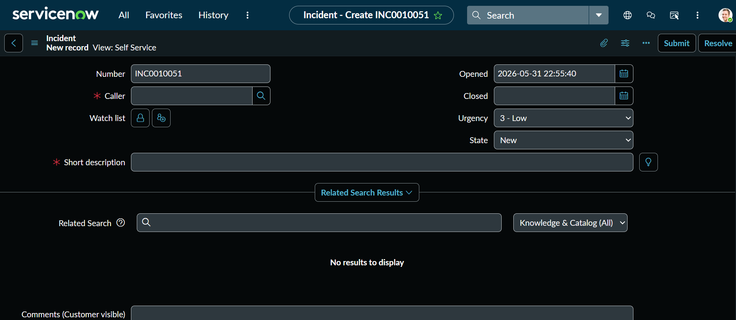
Figure 2: Incident Creation Form — New Ticket Submitted via Portal

3.2 Incident Form Details
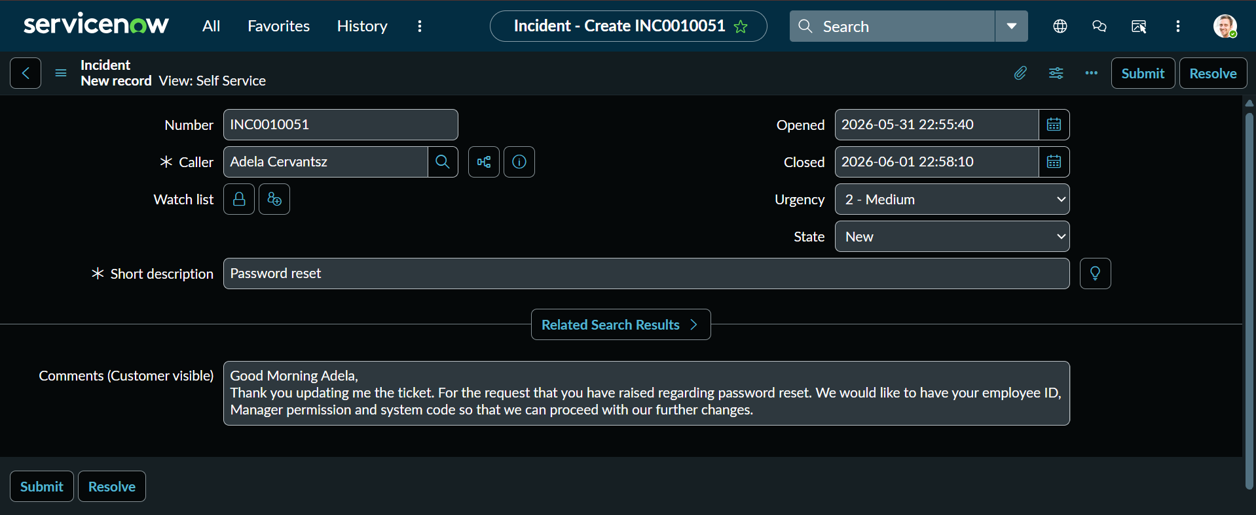
Figure 3: Incident Form — Caller, Category, Priority, Description Filled

3.3 Incident List / Dashboard
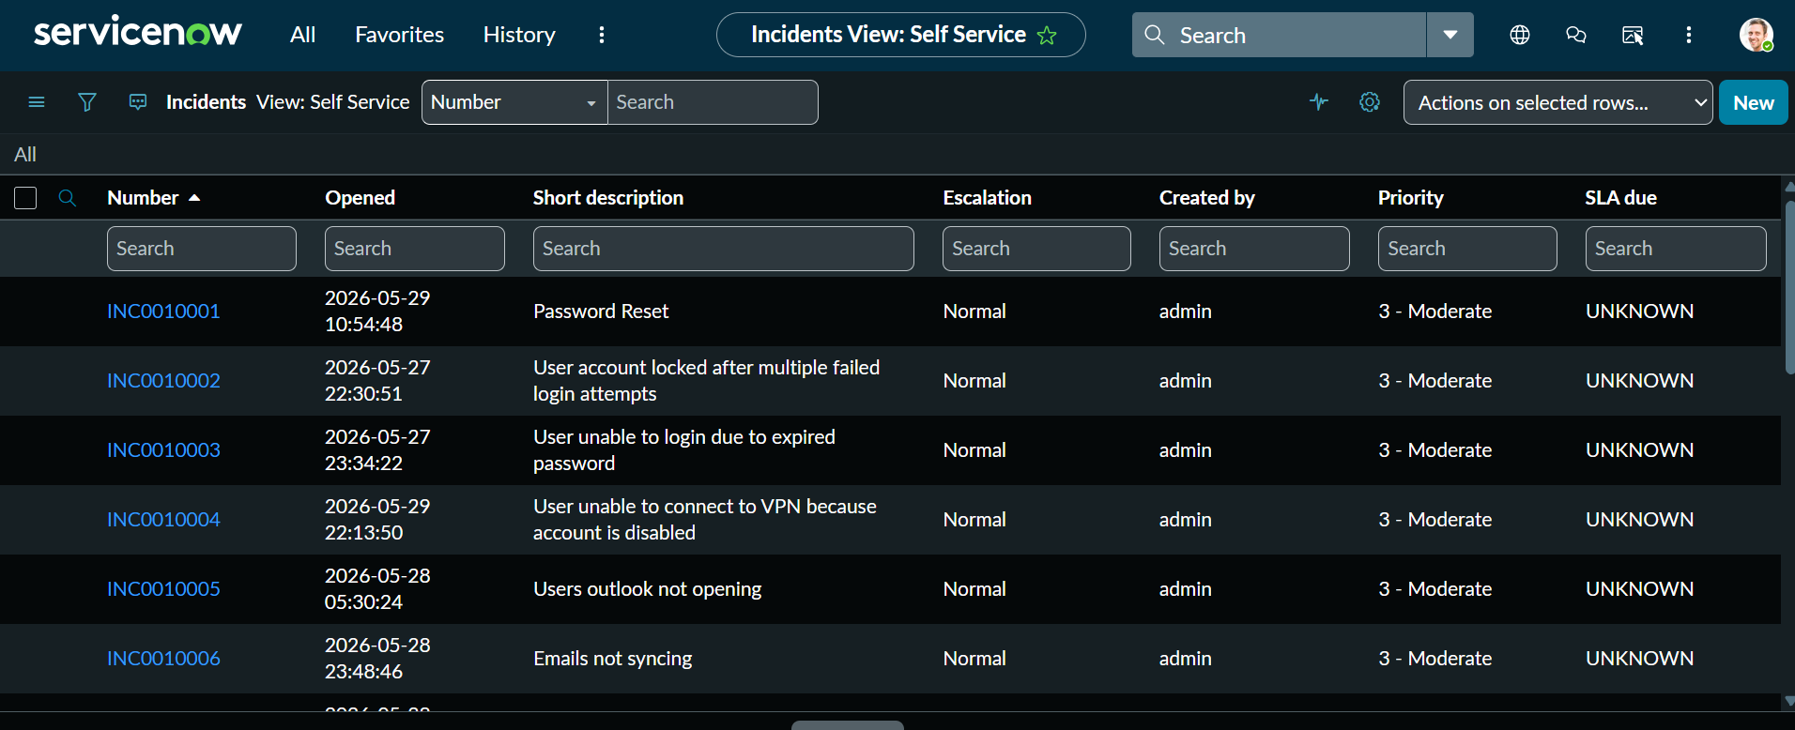
Figure 4: Incident Management Dashboard — All Active Incidents

3.4 Assignment Group
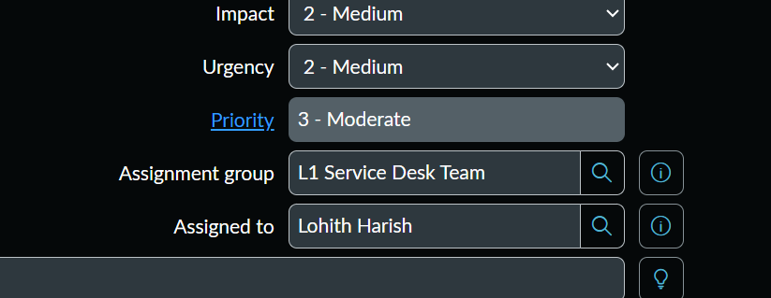
Figure 5: Assignment Group — Ticket Assigned to L1 Service Desk Team

3.5 Work Notes
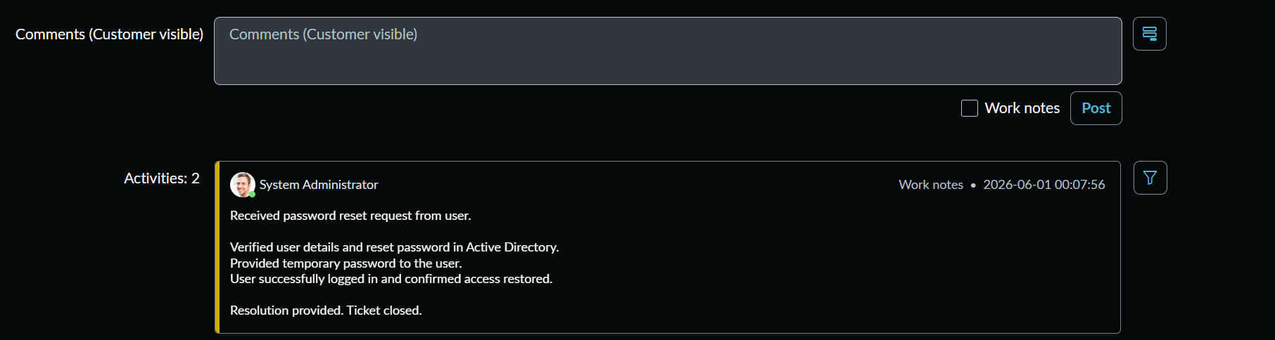
Figure 6: Work Notes — L1 Troubleshooting Steps Documented

3.6 Resolved Ticket
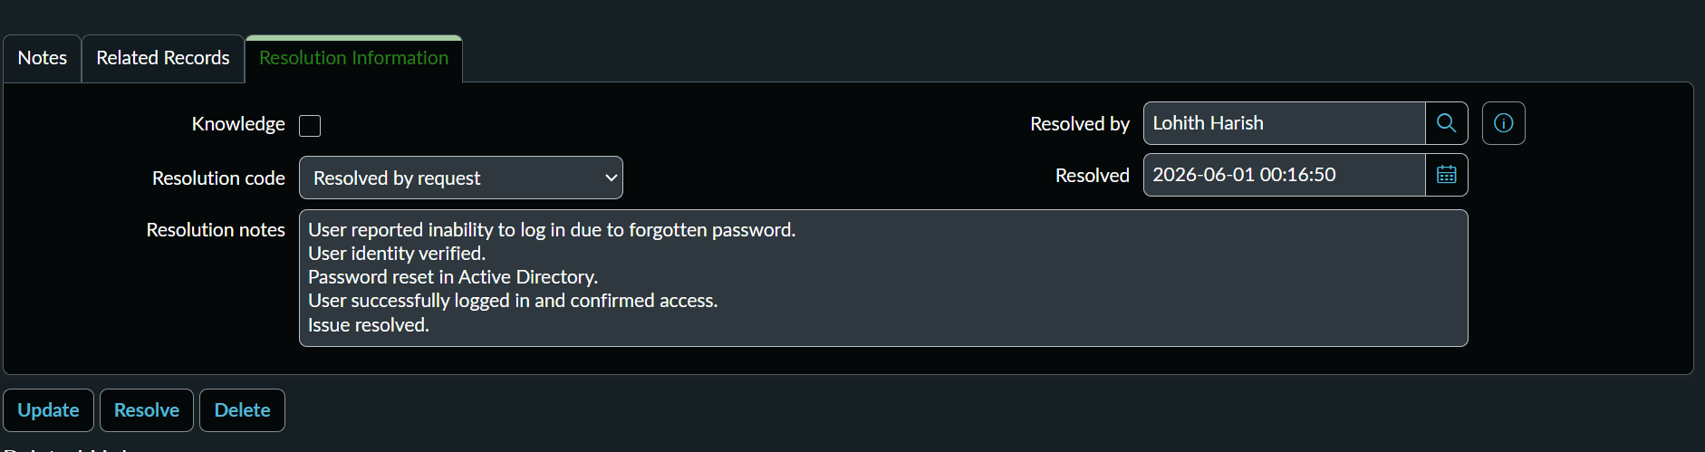
Figure 7: Resolved Incident — Resolution Code and Notes Added

4. Ticket Lifecycle Screenshots

Tickets in ServiceNow follow a defined ITSM lifecycle. The following screenshots capture each status transition from creation to final closure.

1. New
↓
2. In Progress
↓
3. On Hold (if applicable)
↓
4. Resolved
↓
5. Closed
Figure 8: Ticket Lifecycle — Status Progression in ServiceNow

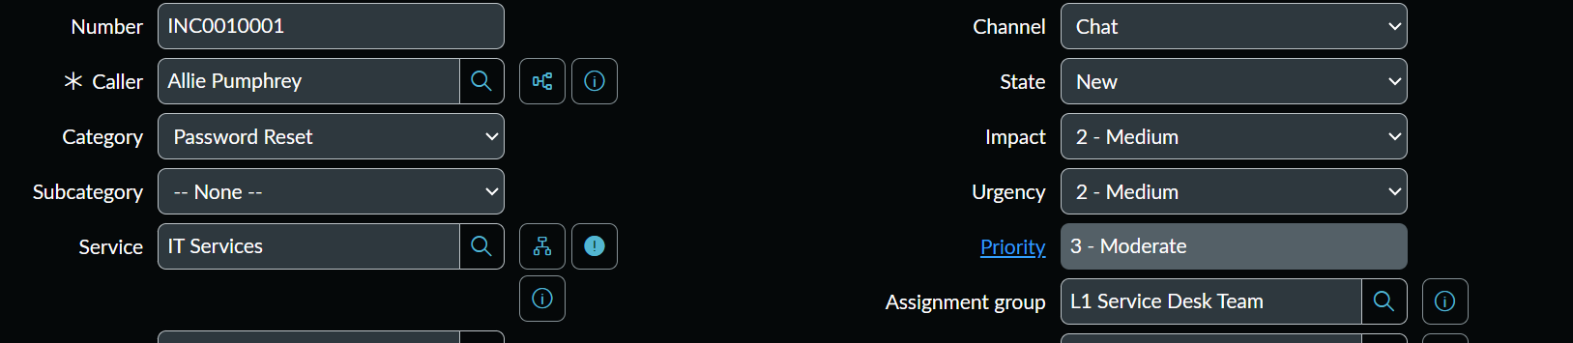
Figure 9: Ticket Status: New — Incident Opened
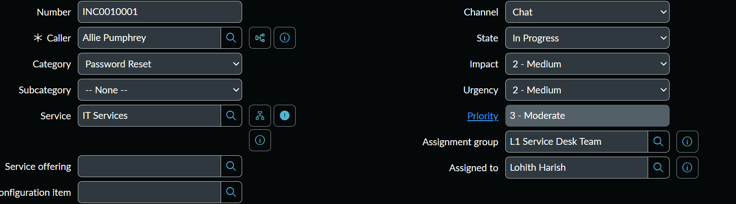
Figure 10: Ticket Status: In Progress — L1 Working the Issue
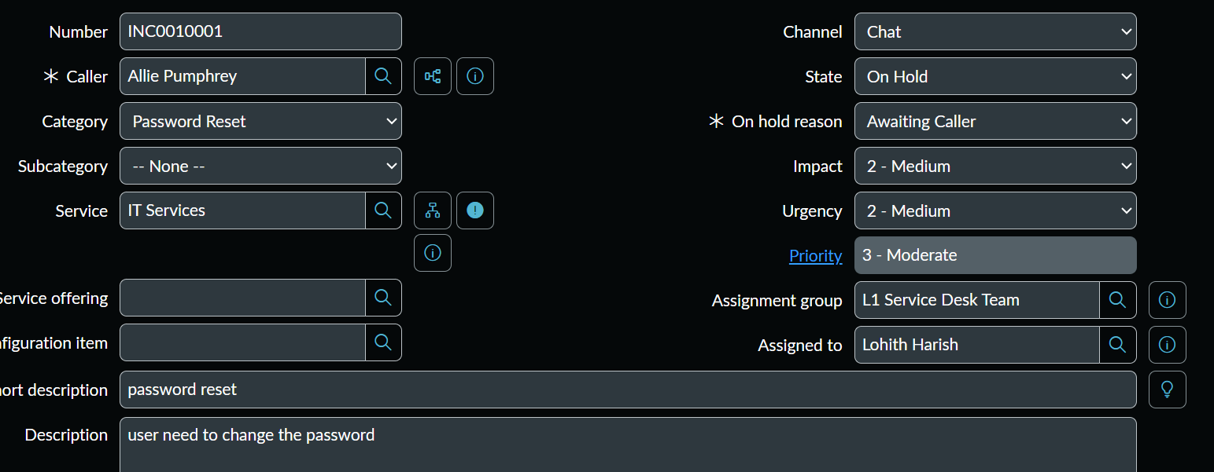

Figure 11: Ticket Status: On Hold — Awaiting User Response / Info
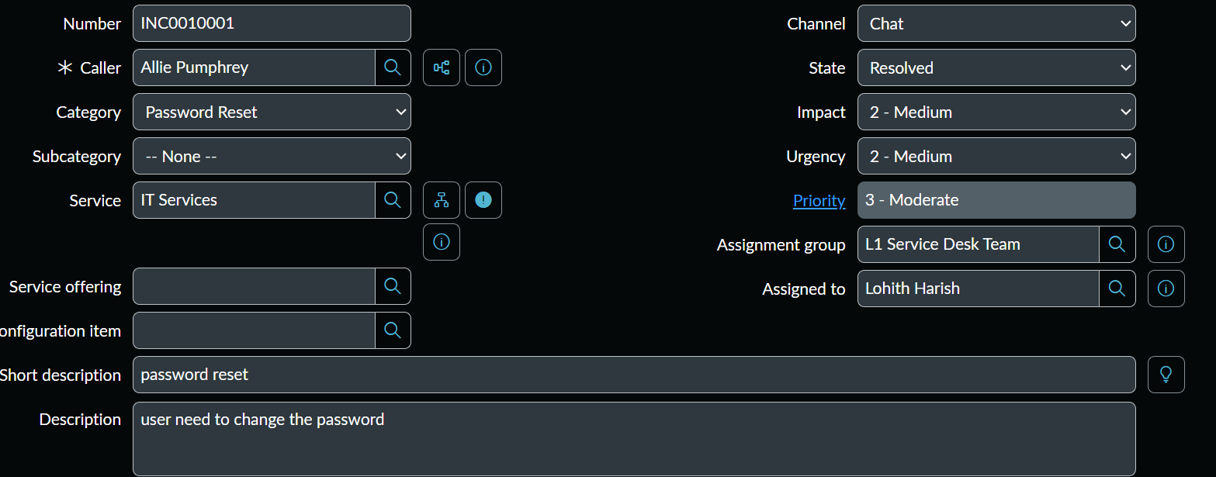
Figure 12: Ticket Status: Resolved — Issue Fixed, Resolution Added
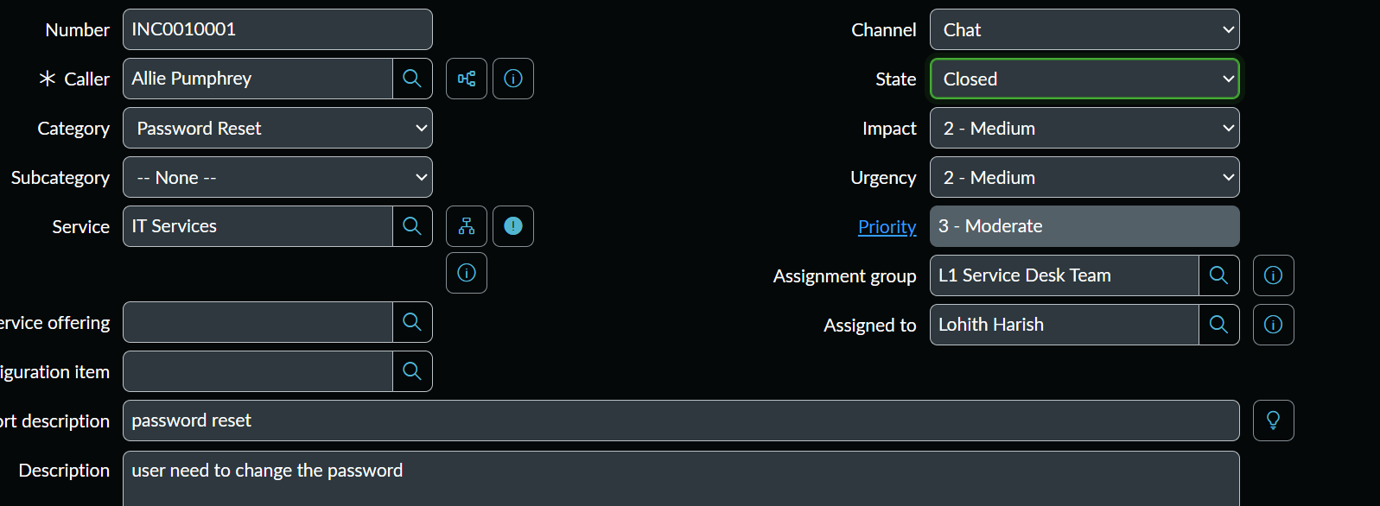
Figure 13: Ticket Status: Closed — Confirmed and Closed by Service Desk

5. SLA Screenshots

Service Level Agreements (SLAs) define the target response and resolution times for incidents. The screenshots below show SLA configuration, attachment to incidents, and tracking.

SLA Type | Target Time
P1 — Critical Incident Response | 15 Minutes
P1 — Critical Incident Resolution | 4 Hours
P2 — High Priority Response | 30 Minutes
P2 — High Priority Resolution | 8 Hours
P3 — Medium Priority Response | 2 Hours
P4 — Low Priority Response | 4 Hours
Password Reset SLA | 1 Hour
VPN Issue Resolution SLA | 2 Hours

Table 1: SLA Definitions — Priority-based Response and Resolution Targets

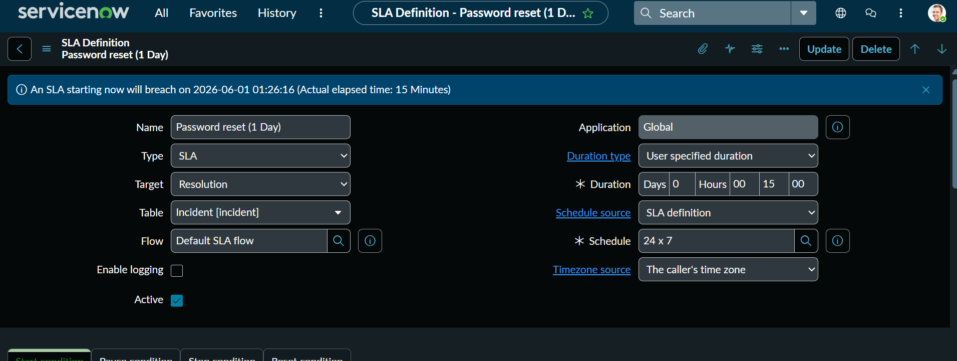
Figure 14: SLA Definition — Password Reset SLA Configured
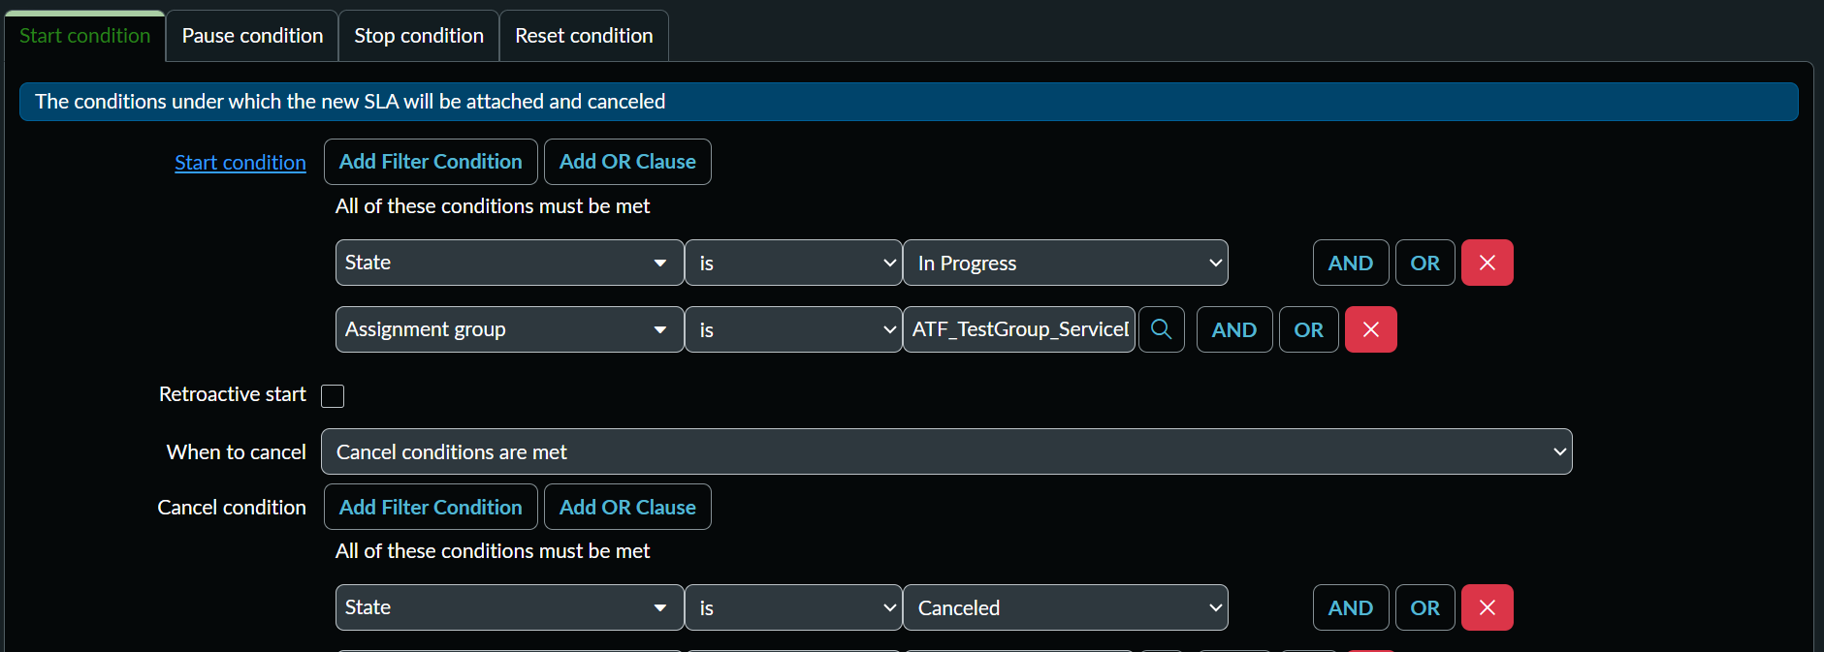
Figure 15: SLA Attached to Incident — SLA Timer Started
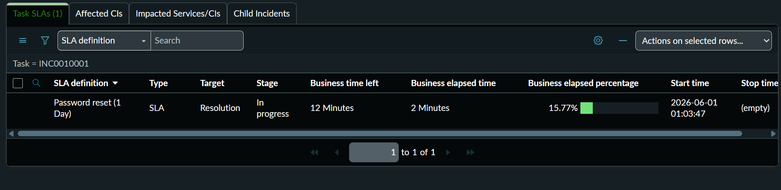
Figure 16: SLA Running — Countdown Active on Incident
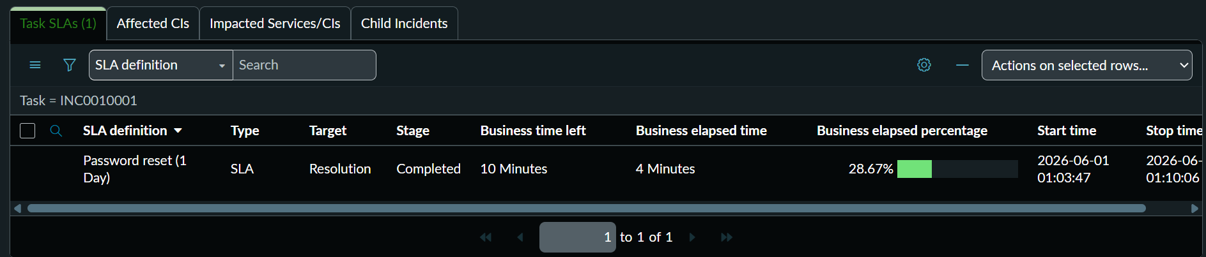
Figure 17: SLA Completed — Resolved Within SLA Timeframe
6. Escalation Screenshots

The following scenario demonstrates a full escalation workflow triggered by a VPN account disable issue that could not be resolved at L1 level.

6.1 Escalation Scenario — VPN Account Disabled
Field | Value | Notes
Incident Type | VPN Access — Account Disabled | Reported by remote worker
Initial Assignee | L1 Support Engineer | First response
Category | Network / VPN | ITSM classification
Priority | P2 — High | Business impact: remote work halted
Escalation To | L2 Network Team | After L1 troubleshooting failed
Final Resolver | L2 / L3 Network Engineer | VPN account re-enabled in AD

Table 2: VPN Escalation Scenario Details

6.2 Escalation Workflow Screenshots
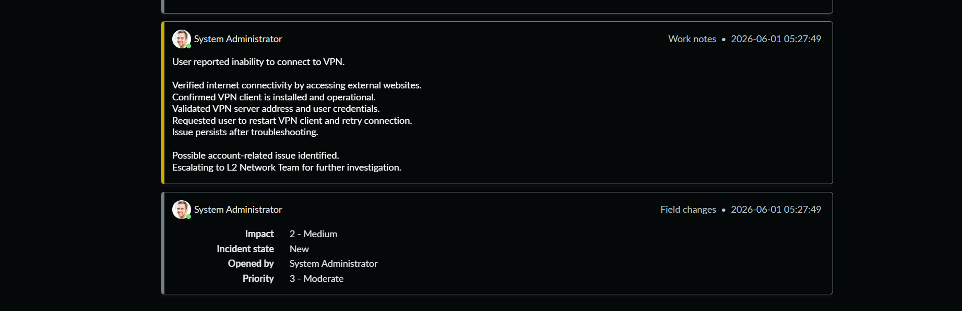
Figure 18: L1 Troubleshooting — Initial VPN Diagnostics
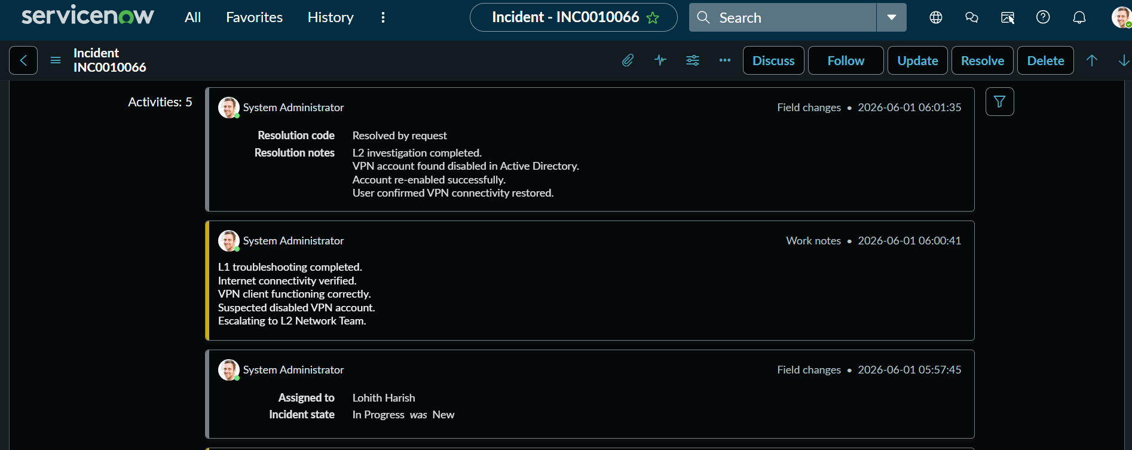
Figure 19: L1 Unable to Resolve — Escalation Decision Documented
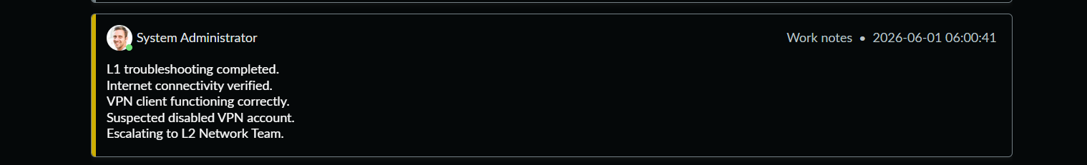
Figure 20: Escalation Work Notes — Reason and Steps Noted
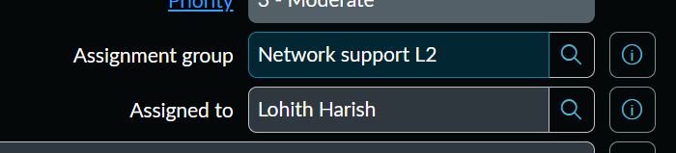
Figure 21: Assignment Group Changed — Ticket Assigned to L2 Network Team
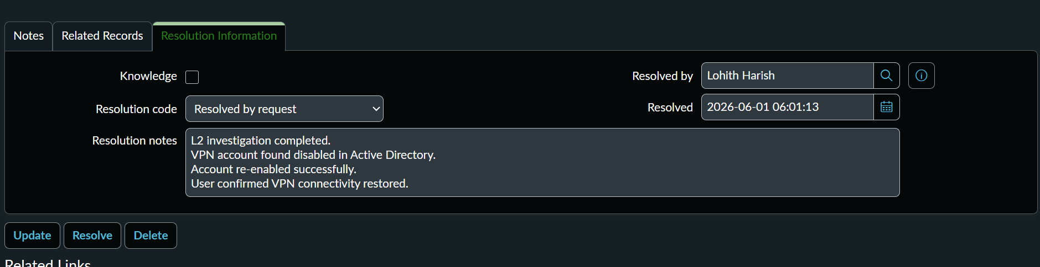
Figure 22: L2 Resolution — VPN Account Re-enabled, Issue Fixed

7. Active Directory Screenshots

Active Directory (AD) is used for centralized user management in enterprise environments. The following operations were performed as part of the L1 Support workflow to resolve user account-related incidents.

AD Operation | Action Performed
User Account Creation | Created new AD user, set UPN, assigned OU, set initial password
Password Reset | Reset user password via ADUC, enforced 'Must change at next logon'
Account Unlock | Unlocked locked-out user account after failed login attempts
Group Membership | Added/removed user from security and distribution groups
User Properties Review | Reviewed account properties — department, manager, logon hours

Table 3: Active Directory Operations Performed

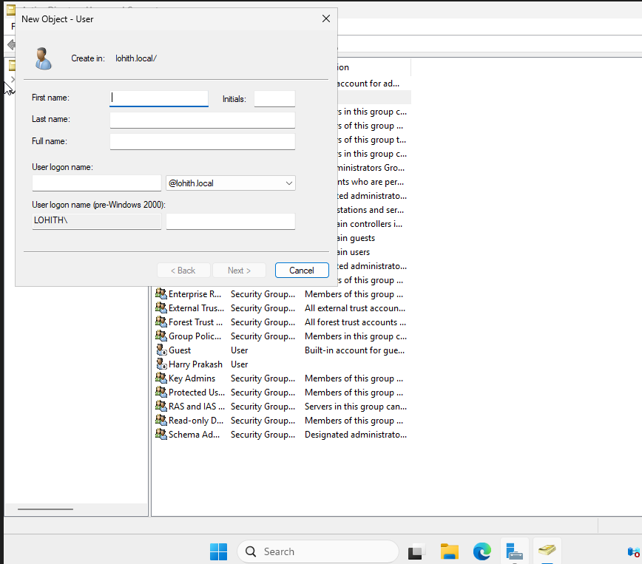
Figure 23: Active Directory — New User Account Creation (ADUC)
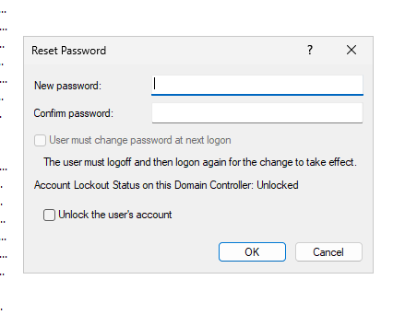
Figure 24: Password Reset — Force Change on Next Login Enabled
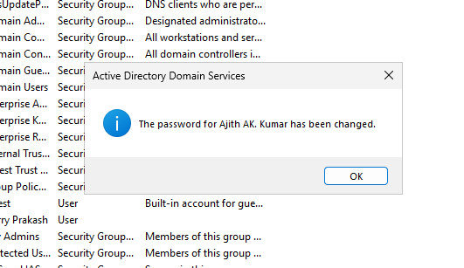
Figure 25: Account Unlock — User Account Unlocked via ADUC
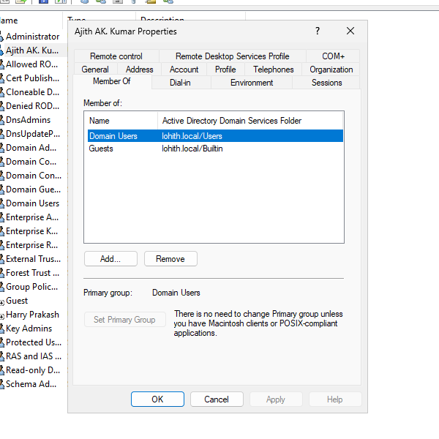
Figure 26: Group Membership — User Added to Required Security Group
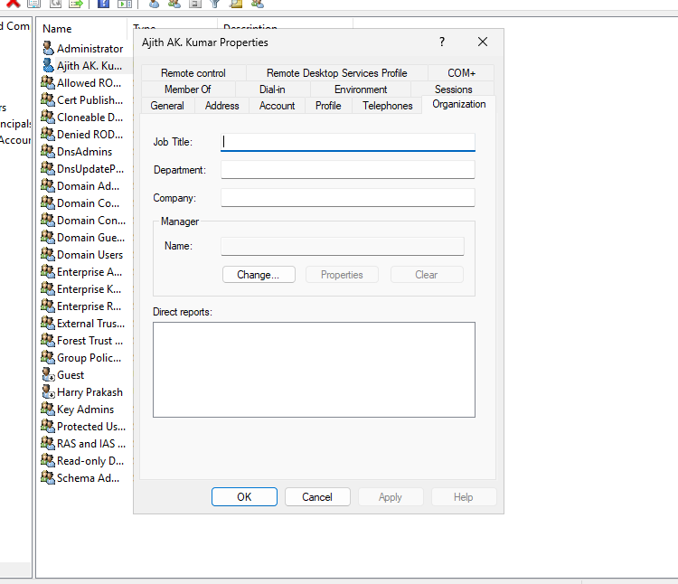
Figure 27: User Properties — Account Details, Department, Manager

8. GitHub Repository Structure

All project assets are organized and uploaded to a public GitHub repository for portfolio visibility and recruiter review.

IT-ServiceDesk-Project/
│
├── README.md
├── Project_Report.pdf
├── screenshots/
│ ├── servicenow/
│ │ ├── incident_creation.png
│ │ └── resolved_ticket.png
│ ├── escalation/
│ │ └── escalation_to_l2.png
│ └── active_directory/
└── password_reset.png

Figure 28: Recommended GitHub Repository Structure

9. Conclusion

This project successfully demonstrates hands-on IT Service Desk operations using industry-standard tools — ServiceNow and Active Directory — aligned with ITIL best practices followed in enterprise environments.

Key accomplishments across this project:
- Successfully created, managed, and resolved incidents using the ServiceNow ITSM platform
- Demonstrated SLA definition, attachment, and monitoring across multiple priority levels
- Executed complete ticket lifecycle management from New to Closed status
- Performed L1 troubleshooting and documented escalation procedures for VPN and account issues
- Administered user accounts in Active Directory — including creation, password reset, and unlocking
- Managed group memberships and reviewed user properties for L1 service desk tasks
- Organized all project assets in a GitHub repository for portfolio presentation

This project validates practical readiness for L1 Support, Service Desk, and IT Help Desk roles, demonstrating proficiency in incident management, SLA compliance, escalation procedures, and Active Directory administration — all documented with real screenshots and organized for portfolio review.

