# 4.Git-HOL Steps

## 1. Verify if master is in a clean state

Command: git checkout master

git status

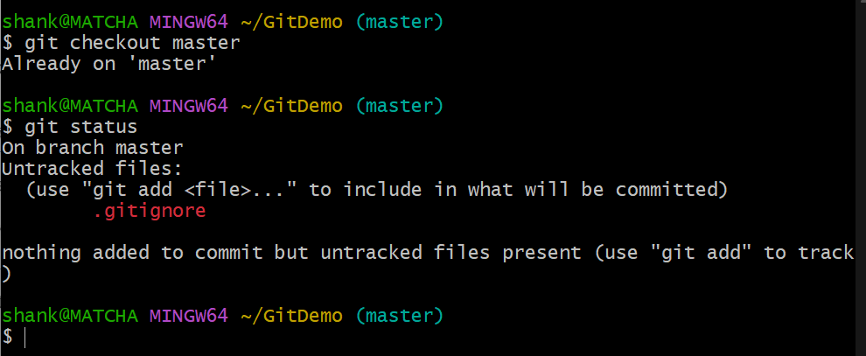

## 2. Create a branch 'GitWork' and add a file 'hello.xml'

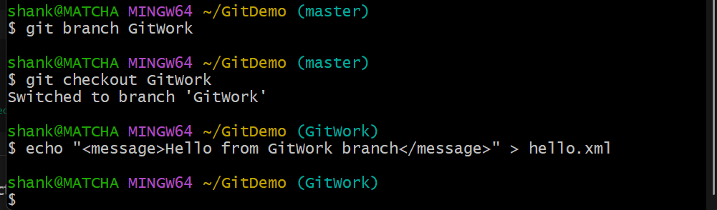

## 3. Update the content of 'hello.xml' and observe the status

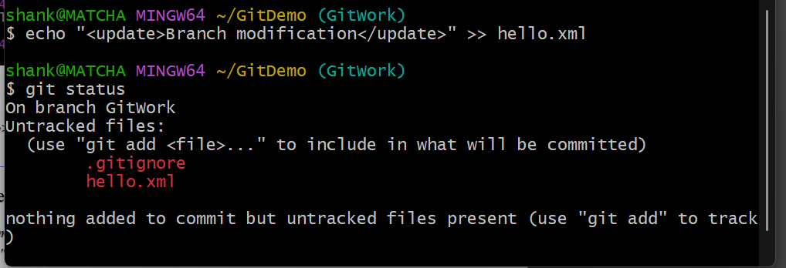

## 4. Commit the changes to reflect in the branch

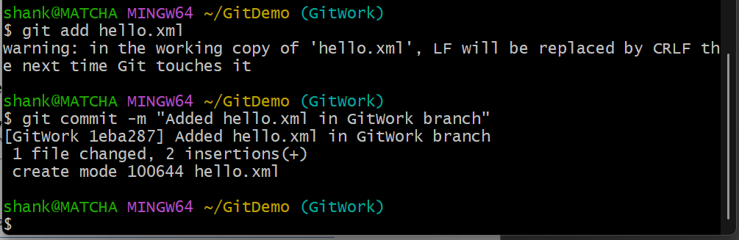

## 5. Switch to master

*git checkout master*

## 6. Add a file 'hello.xml' to master with different content

*echo "<message>Hello from master branch</message>" > hello.xml*

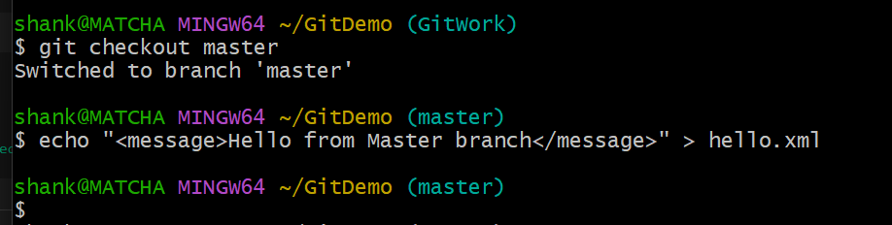

## 7. Commit the changes to master

*git add hello.xml  
git commit -m "Added hello.xml in master branch with different content"*

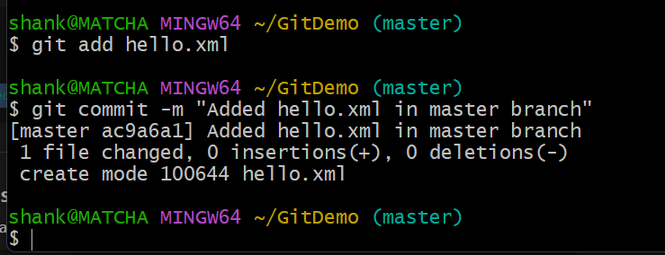

## 8. Observe the log

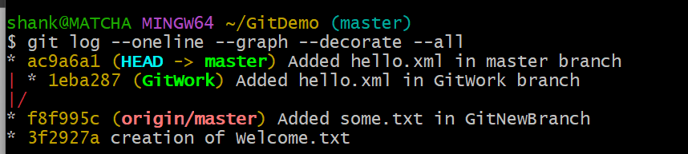

## 9. Check the differences with Git diff tool(CLI)

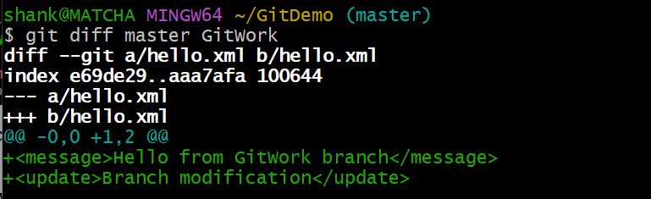

## 10. Use P4Merge for visual comparison

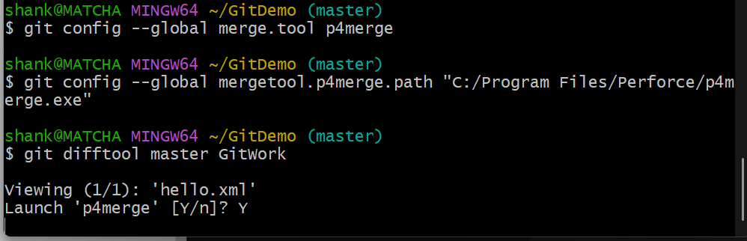

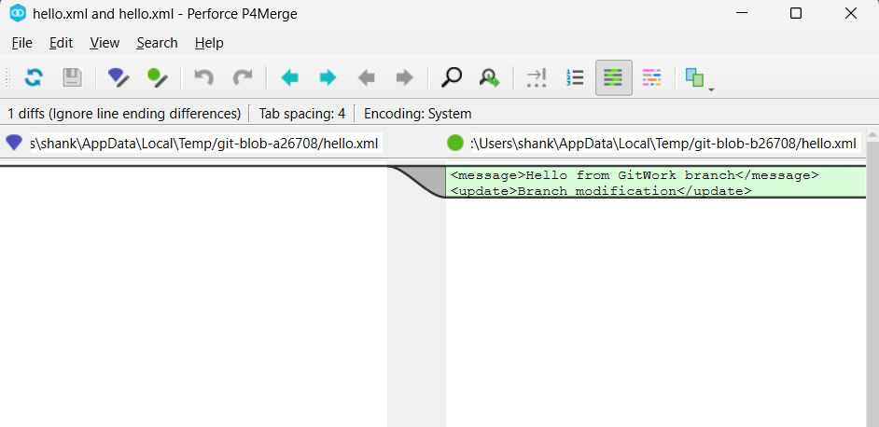

## 11. Merge the branch into master

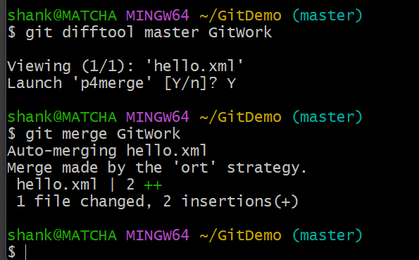

## 12. Commit the resolved file

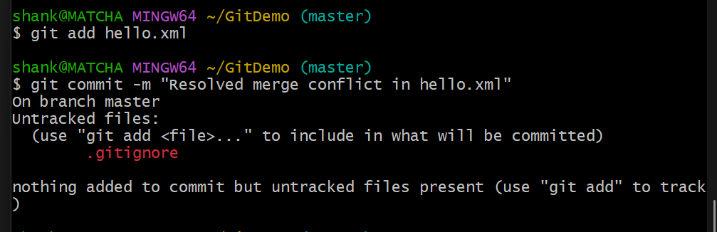

## 13. Check status and ignore backup files

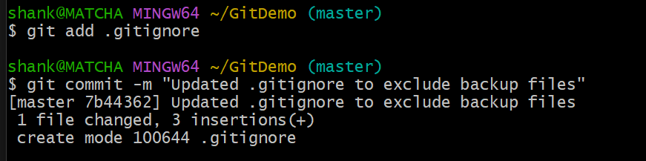

## 14. Clean Up & View Log &Delete merged branch &View final log

