

**CUSTOMER RETENTION PROJECT**

**Submitted by:**

**NARA LOHITH**

**ACKNOWLEDGMENT**

References:

1. Google.com

2. Data source provided by the client.

3. Wikipedia

**INTRODUCTION**

“We do not need many customers to buy once, we need one customer to buy many times”. That is a very familiar slogan of companies providing products and services. Attracting new customers is important to businesses, but they are not necessarily the best customers. Because if they only buy once and do not come back, the business will not be able to make much profit. That’s why businesses need to keep finding a way to hold them back, make them trust the brand and keep buying. That’s why customer retention arises.

The customer retention definition in marketing is the process of engaging existing customers to continue buying products or services from your business. The best customer retention tactics enable you to form lasting relationships with consumers who will become loyal to your brand. They might even spread the word within their own circles of influence, which can turn them into brand ambassadors.

Successful e-commerce brands are often the ones that focus on their customer retention rate and keep working to improve it. Take the example of a newly launched online store that sells women’s shoes. They launch a social media campaign to get sign-ups from 20,000 women customers. The store then shoots emails and SMS to their list with exclusive discount offers for ‘VIP Members’.2,500 Women sign-up for the VIP membership to avail of exclusive discounts on the latest shoes. This new ‘VIP Members List’ now becomes valuable retained customers for the store.

**PROBLEM STATEMENT:**

Customer satisfaction has emerged as one of the most important factors that guarantee the success of online store; it has been posited as a key stimulant of purchase, repurchase intentions and customer loyalty. A comprehensive review of the literature, theories and models have been carried out to propose the models for customer activation and customer retention. Five major factors that contributed to the success of an e-commerce store have been identified as: service quality, system quality, information quality, trust and net benefit. The research furthermore investigated the factors that influence the online customers repeat purchase intention. The combination of both utilitarian value and hedonistic values are needed to affect the repeat purchase intention (loyalty) positively.

**Analytical Problem Framing**

* The sample data is provided to us in Microsoft excel format(.xlsx). The sample data for the reference is as shown below:

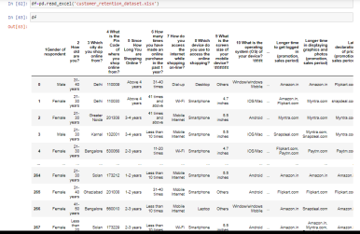

* Then we further checked more about data using info, shapes using .shape, columns using .columns(), datatypes using .dtypes(),null values using .isnull. .sum().sum(), and further visualize it through heatmap as follows:

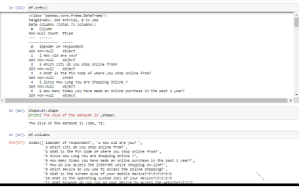

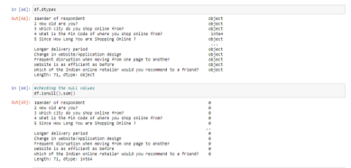

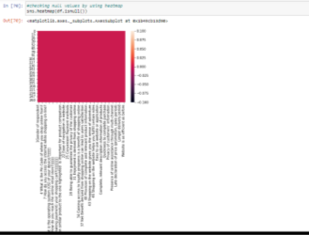

* Then we check unique values for categorical columns and their value_counts and also the count of nan values if present in that column

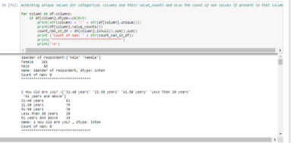

* We then create two lists to split the data according numerical and categorical features and further check the length of each of the list.

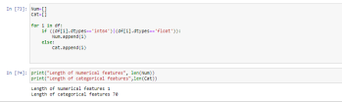

* The data is then deeply analyzed by finding a relationship between each attribute and the Customer according to given details. We made following observations:
* Females(age group 21-30) do more shopping than male

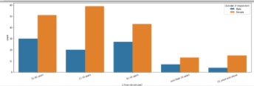

* People in age group of 31-40 years do maximum and least is done by 51 years and above
* People in metropolitan cities do more online shopping such as Delhi, Greater Noida, Bangalore and Noida

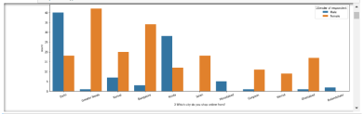

* Most people prefer Card payment option followed by COD

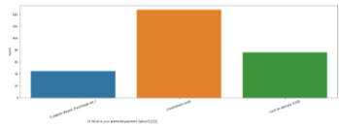

* Most of the time people abandon the item in shopping cart because they find better alternative.

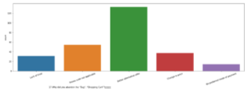

* Most of the people strongly agree that content on the website must be easy to read and understand, must have all the information on listed seller and product.

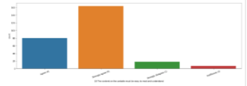

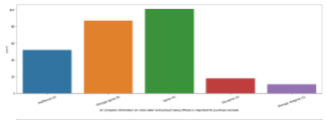

* There must be ease of navigation in website, must have convenient payment method, must have empathy towards the customers

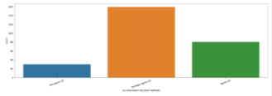

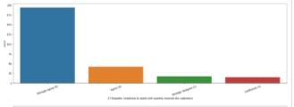

* Most people strongly agree that online shopping gives monetary benefit and discounts

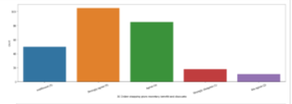

* There must be return and replacement policy of the e-tailer for purchasing.

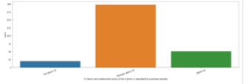

* Customers strongly agree that that are getting value for money spent

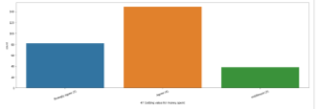

* Most people strongly agree that Amazon.in, Paytm.com and Myntra.com are easy to use and maximum shopping has been done from these websites. Also it has complete and relevant information of products

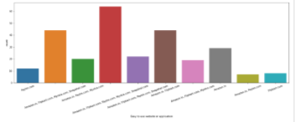

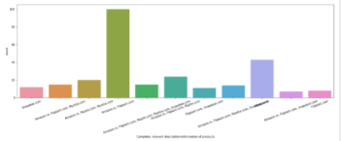

* Amazon and flipcart offer wide variety of products

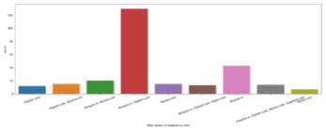

* Amazon has fastest delivery followed by flipcart and myntra. Also it’s good for keeping privacy of customer's information. Moreover amazon website is best since it’s as efficient as before

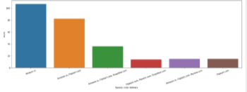

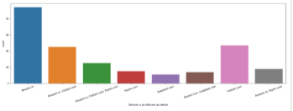

* Snapdeal provides limited mode of payment and has frequent disruption on moving from one page to other.

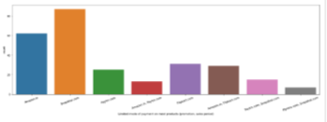

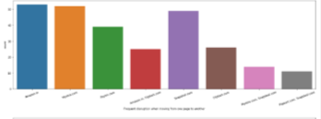

* Maximum females find amazon reliable whereas males find amazon, flipcart and paytm

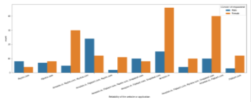

* Most of the People opt for cash on delivery who shop frequently

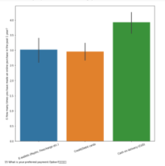

* Most of the people would refer Amazon to others.

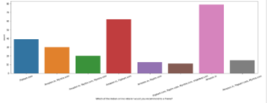

**CONCLUSION**

Customer retention doesn’t improve overnight. First, know your customers. Figure out what they want and need and where their pain points lie. Few ways to improve customer retention can be as follows:

* Customer retention is a byproduct of customer service and experience. If you create a good experience, that is consistent and predictable, such as – improve customer satisfaction, convert first time customers to loyal customers and improve customer advocacy, then you have a right shot at improving and setting good customer retention examples.
* Businesses that empower their customer support team with live customer engagement such as co-browsing and video chat can deliver faster solutions.
* Respond to customer issues instantly
* Loyalty programs help your customers feel valued and appreciated. By delighting your customers with special offers and rewards, you make them feel good about purchasing and motivate them to keep coming back.
* The easy way to know your customers are happy or unhappy with your products and services is by having regular customer feedback. Customer complaints or feedback provide you the customer’s perceptions about your overall business. They also give a clearer view of how you are performing. Collecting feedback requires asking customers to share their feedback about the product, service, or about their overall experience.
* The best time to ask feedback from customers is right after a customer service conversation. Collecting feedback becomes effective when you analyze and act upon it.
* Identify the most preferred channels like phone, social channels, website by customers to connect with your business. It provides customers as many ways to reach out to your business.
* Customers should be given multiple payment methods. Most importantly COD(cash on delivery) should be provided since new customers don’t trust easily. Also, fast Delivery should be provided.
* Never miss out on any opportunity to surprise your customers. Try to deliver better service at a lower cost, do more than they were expecting. Treat them as special people and you will for sure improve customer retention programs.
* Thoroughly listening to customers helps you to develop empathic abilities. An empathetic statement has a good impact on customers and the feeling that you are able to understand their problem.
* Emails newsletters are one of the best ways to stay connected with customers and build lasting relationships with them.