**CS585: Assignment – 2 (Summer 2016)**

**USC ID: 8299-5642-86 | Email: paripati@usc.edu**

**Name: Lohith Paripati**

CREATE EXTENSION postgis;

CREATE TABLE FavSpots (

name varchar(255),

locations geometry

);

INSERT INTO FavSpots values

('Home - 1444 W 28',ST_MakePoint(-118.29510259921852, 34.02938025139842)),

('SVA / WJ',ST_MakePoint(-118.29136818643024, 34.025318343513258)), ('WJ / SF',ST_MakePoint(-118.28014577386638, 34.02186360023527)), ('SF / WEB',ST_MakePoint(-118.28235354363242, 34.01840421348877)), ('WEB / SVA',ST_MakePoint(-118.291400773224665, 34.018467976432216)), ('Leavey Library',ST_MakePoint(-118.28288794982601, 34.02179234228872)), ('Doheny Library',ST_MakePoint(-118.28390663298927, 34.02023098891323)), ('Panda Express',ST_MakePoint(-118.28623782769767, 34.02033642174687)), ('No Tomatoes',ST_MakePoint(-118.28977229789768, 34.02015143254322));

SELECT ST_AsText(ST_ConvexHull(ST_Collect(locations))) as PolygonCords FROM FavSpots;

SELECT ST_AsText(locations) FROM FavSpots

where name <> 'Home - 1444 W 28'

ORDER BY locations <-> (SELECT locations from FavSpots where name = 'Home - 1444 W 28')

LIMIT 3;

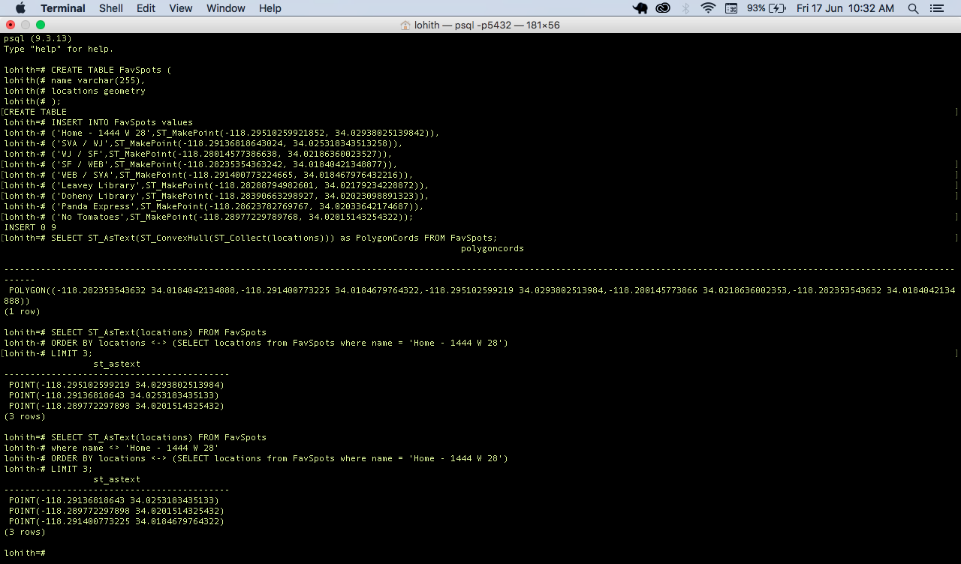

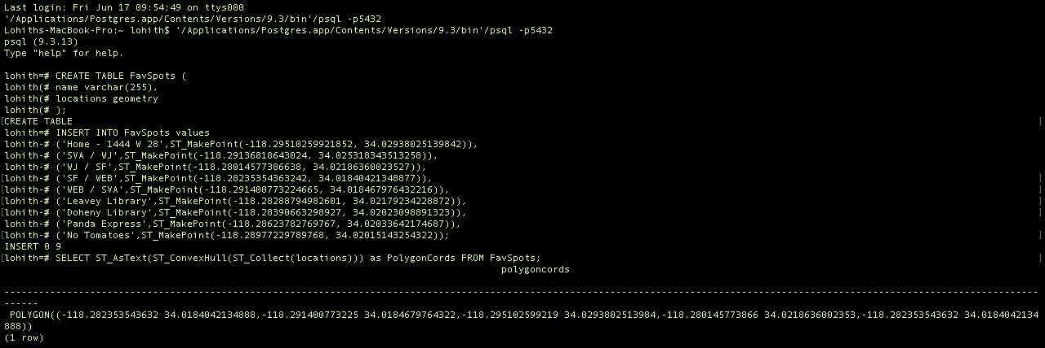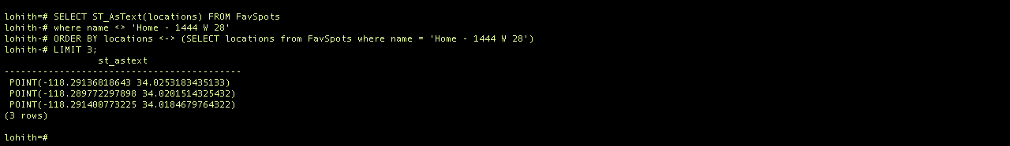

**GoogleEarth Screenshots**

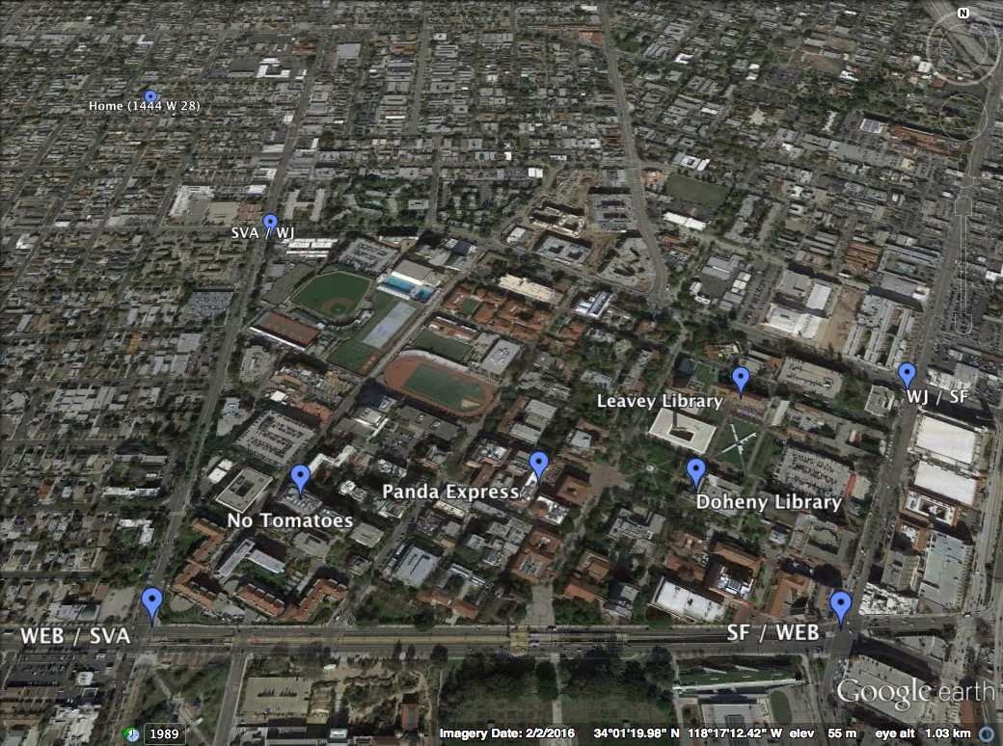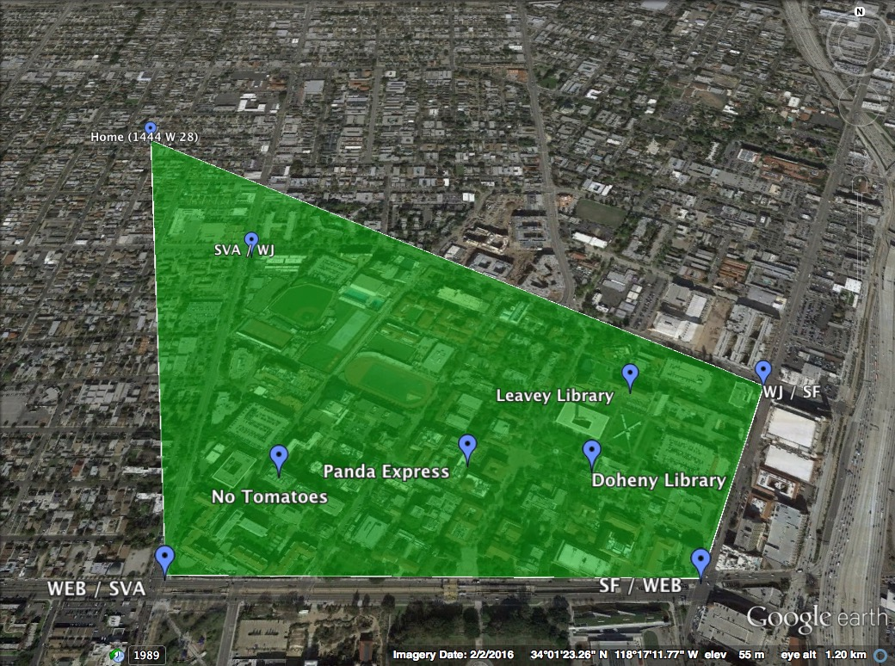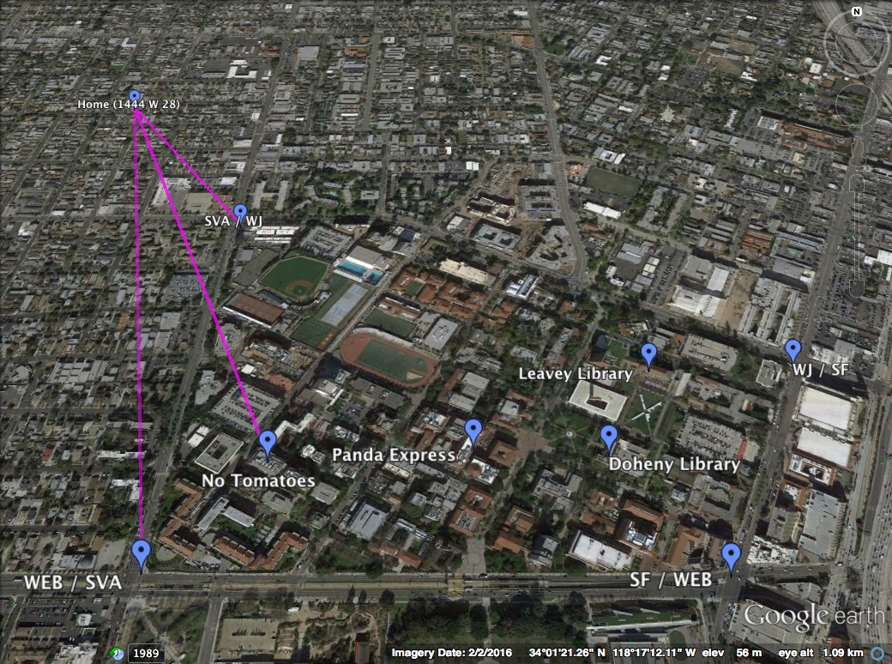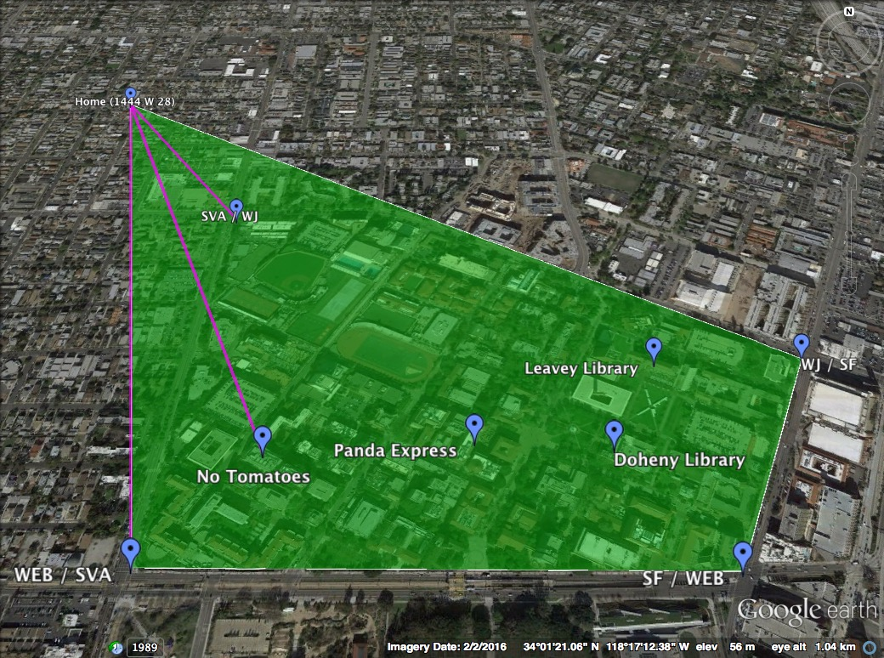

**Source Code for above screengrabs - Keyhole Markup Language (KML file)**

<?xml version="1.0" encoding="UTF-8"?>

<kml xmlns="http://earth.google.com/kml/2.0">

<Document>

<Style id="z1">

<IconStyle><Icon><href>http://www.google.com/intl/en_us/mapfiles/ms/micons/blue-dot.png</href></Icon></IconStyle>

</Style>st)

<Placemark><name>Home (1444 W 28)</name>

<styleUrl>#z1</styleUrl><Point><coordinates>-118.29510259921852, 34.02938025139842</coordinates></Point>

</Placemark>

<Placemark><name>SVA / WJ</name>

<styleUrl>#z1</styleUrl><Point><coordinates>-118.29136818643024, 34.025318343513258</coordinates></Point>

</Placemark>

<Placemark><name>WJ / SF</name>

<styleUrl>#z1</styleUrl><Point><coordinates>-118.28014577386638, 34.02186360023527</coordinates></Point>

</Placemark>

<Placemark><name>SF / WEB</name>

<styleUrl>#z1</styleUrl><Point><coordinates>-118.28235354363242, 34.01840421348877</coordinates></Point>

</Placemark>

<Placemark><name>WEB / SVA</name>

<styleUrl>#z1</styleUrl><Point><coordinates>-118.29140077322466, 34.018467976432216</coordinates></Point>

</Placemark>

<Placemark><name>Leavey Library</name>

<styleUrl>#z1</styleUrl><Point><coordinates>-118.28288794982601, 34.02179234228872</coordinates></Point>

</Placemark>

<Placemark><name>Doheny Library</name>

<styleUrl>#z1</styleUrl><Point><coordinates>-118.28390663298927, 34.02023098891323</coordinates></Point>

</Placemark>

<Placemark><name>Panda Express</name>

<styleUrl>#z1</styleUrl><Point><coordinates>-118.28623782769767, 34.02033642174687</coordinates></Point>

</Placemark>

<Placemark><name>No Tomatoes</name>

<styleUrl>#z1</styleUrl><Point><coordinates>-118.28977229789768, 34.02015143254322</coordinates></Point>

</Placemark>

<Style id="transGreenPoly">

<LineStyle>

<width>1.5</width>

</LineStyle>

<PolyStyle>

<color>7d00ff00</color>

</PolyStyle>

</Style>

<Placemark>

<styleUrl>#transGreenPoly</styleUrl>

<Polygon>

<extrude>1</extrude>

<outerBoundaryIs>

<LinearRing>

<coordinates>

-118.282353543632,34.0184042134888

-118.291400773225,34.0184679764322

-118.295102599219,34.0293802513984

-118.280145773866,34.0218636002353

-118.282353543632,34.0184042134888

</coordinates>

</LinearRing>

</outerBoundaryIs>

</Polygon>

</Placemark>

<Style id="transPurpleLineGreenPoly">

<LineStyle>

<color>7fff00ff</color>

<width>4</width>

</LineStyle>

<PolyStyle>

<color>7f00ff00</color>

</PolyStyle>

</Style>

<Placemark>

<name>Absolute</name>

<styleUrl>#transPurpleLineGreenPoly</styleUrl>

<LineString>

<extrude>1</extrude>

<tessellate>1</tessellate>

<coordinates>

-118.29510259921852,34.02938025139842 -118.29136818643,34.0253183435133

-118.29510259921852,34.02938025139842 -118.289772297898,34.0201514325432

-118.29510259921852,34.02938025139842 -118.291400773225,34.0184679764322

</coordinates>

</LineString>

</Placemark>

</Document>

</kml>