# Install windows subsystem for linux(wsl): ***wsl –install***

Install docker. Pre requisites

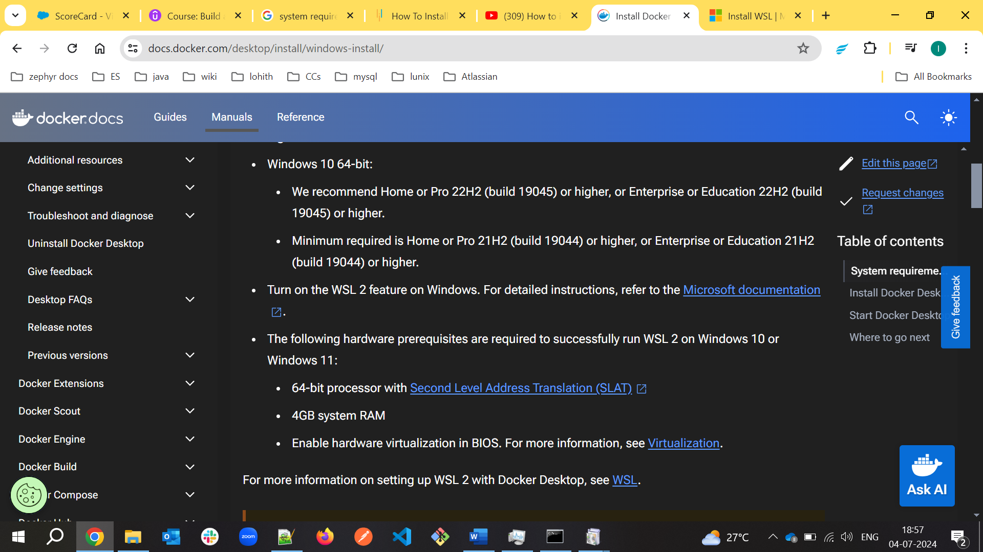

Check WSL2 in turn windows features on or off feature

# Django docker project

Run docker command ***docker-compose run -rm app sh -c “py manage.py collectstatic”***

Run **“*docker build .”*** to build the docker image

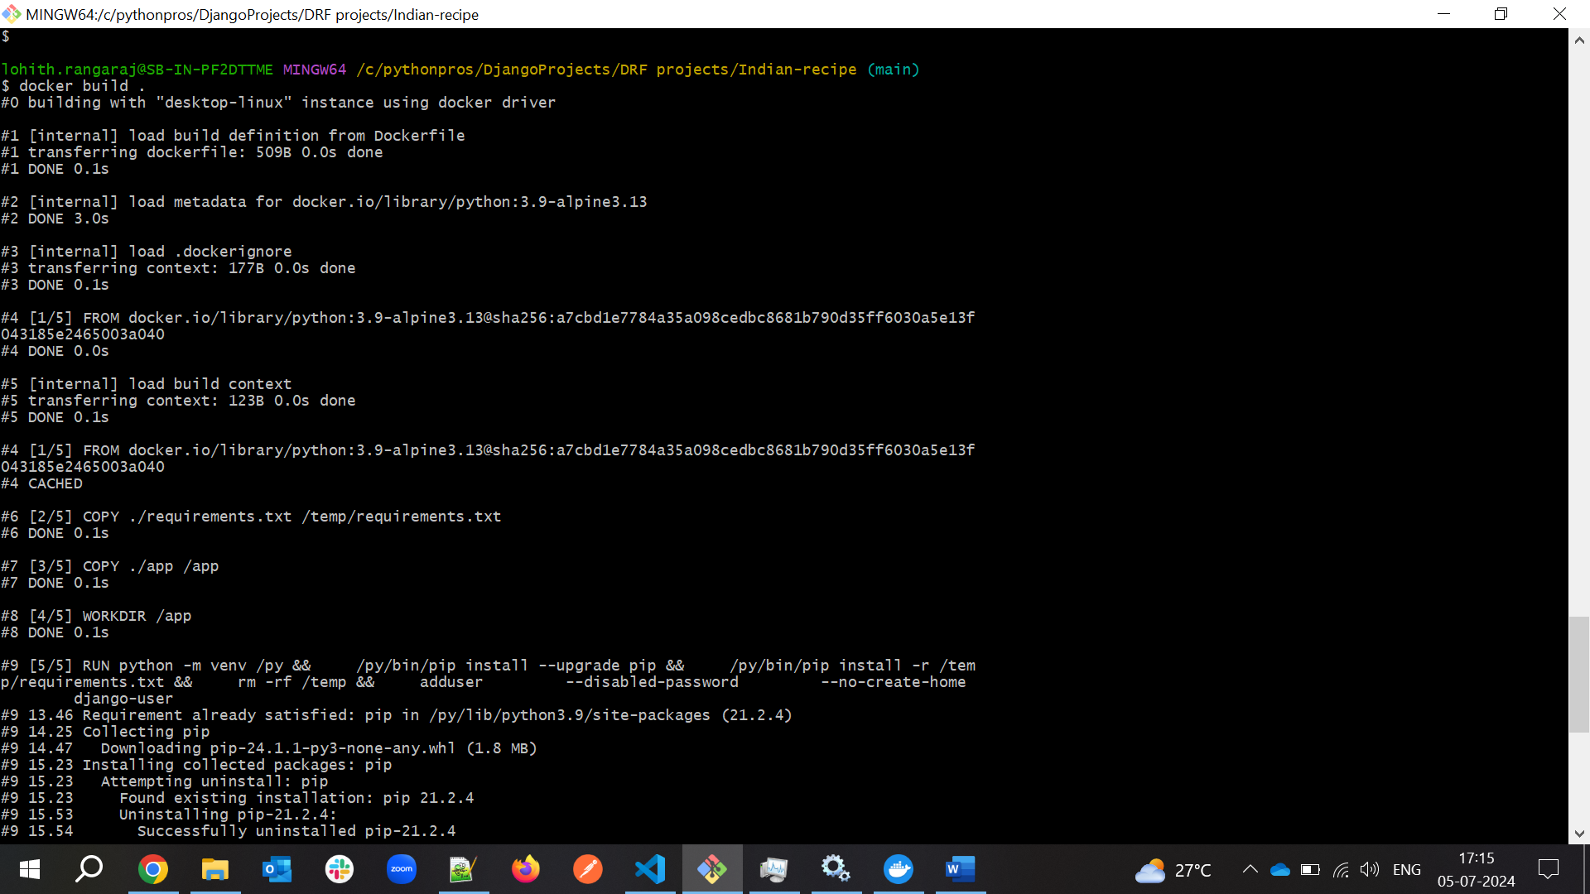

Build the docker image using  ***“docker-compose build”***

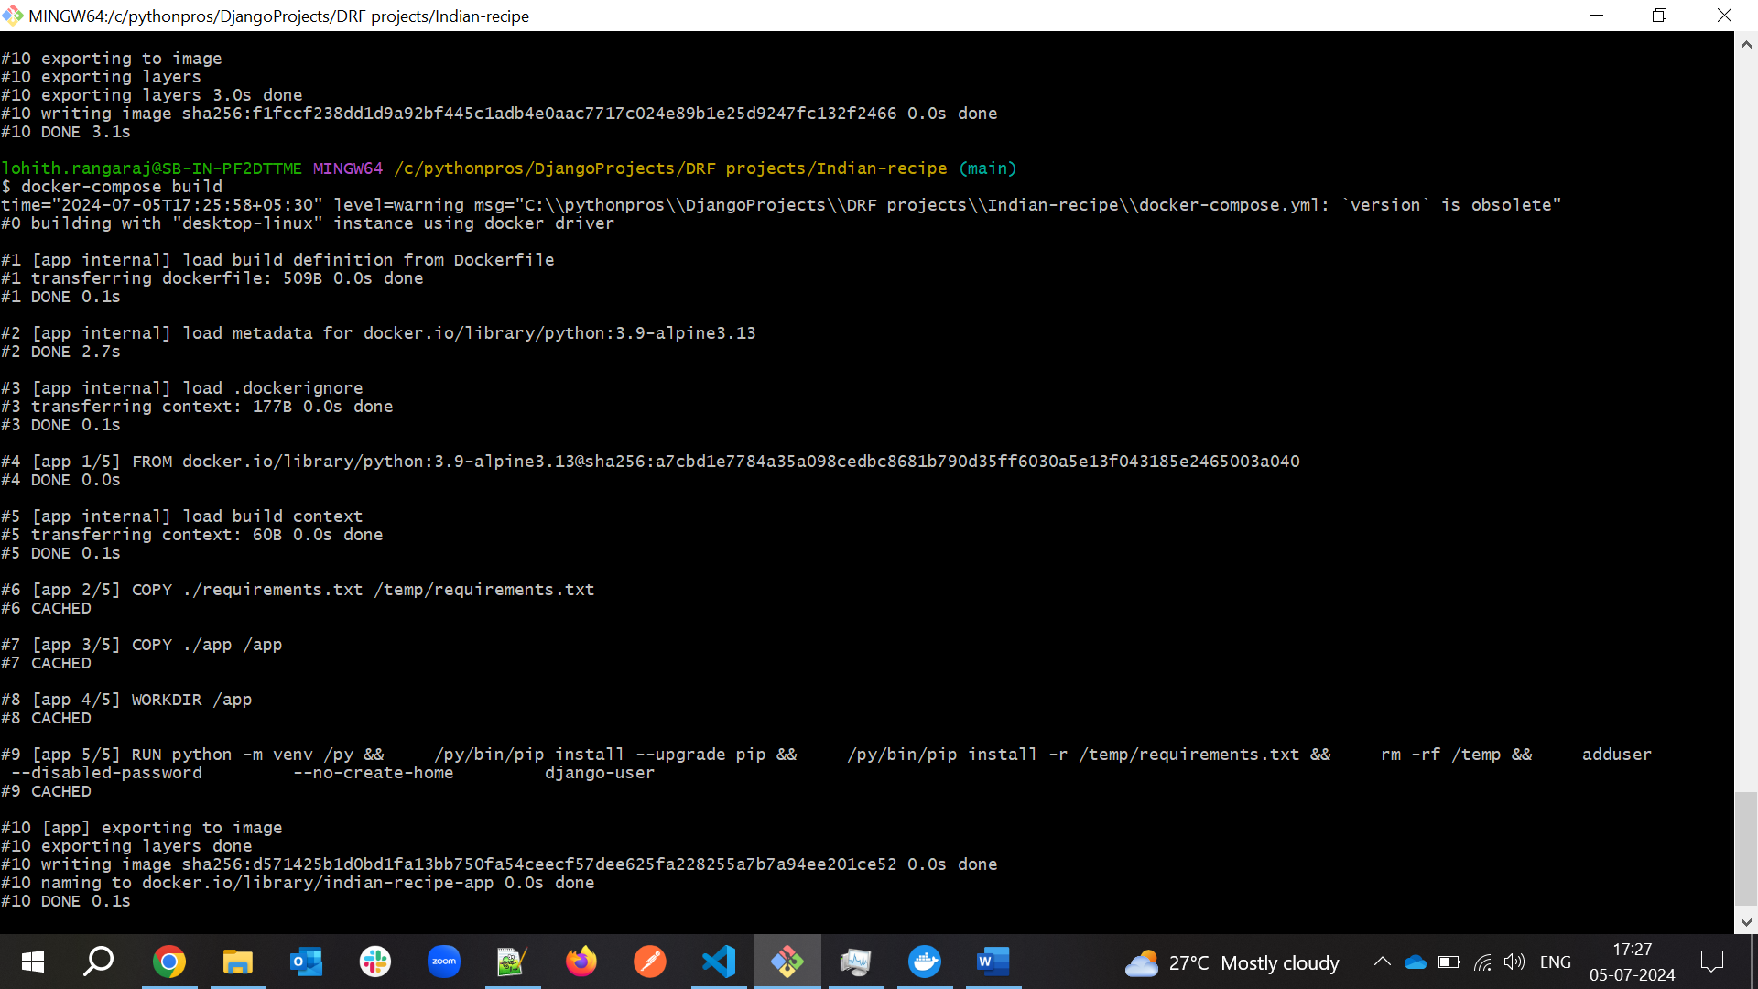

Install linting using command ***docker-compose run –-rm app sh -c “flake2”***

Tets the app “***docker-compose run –rm app sh -c “py manage.py test”***

***docker-compose run --rm app sh -c "flake8"***

if it return below error then build the project and run again



Create Django project using docker-compose

***docker-compose run --rm app sh -c "django-admin startproject app ."***

here dot(.) denotes create project in current dir

run the docker service’

***“docker-compose up”***

Authorize docker hub with github

