PRIORITY-BASED FOOD DELIVERY SYSTEM
Software Test Plan
Version 1.0 | May 2026
Project | Priority-Based Food Delivery System
Document Type | Software Test Plan
Version | 1.0
Date | May 2026
Prepared By | G Lohith Venkat Reddy
Role | Test Engineer
Status | Final
Assigned Scenario | Travel emergency order
Priority | Normal

Table of Contents
1. Introduction 2
1.1 Objectives 3
2. Scope 3
2.1 In Scope 3
2.2 Out of Scope 3
3. Assumptions and Risks 4
3.1 Assumptions 4
3.2 Risks 4
4. Test Approach 4
4.1 Test Levels 4
4.2 Test Automation 4
5. Test Environment 4
6. Test Cases 5
6.1 Login Page / Authentication Module 5
6.2 Restaurant and Menu Module 5
6.3 Cart and Checkout Module 6
6.4 Priority Order Processing Module 6
6.5 Payments Module 6
6.6 Delivery and Tracking Module 7
6.7 Notifications Module 7
6.8 Admin and Reports Module 7
7. Milestones and Deliverables 8
7.1 Test Schedule 8
7.2 Deliverables 8
7.3 Recorded Test Execution Output 8
7.4 Screenshot Evidence 8
8. Entry and Exit Criteria 13
8.1 Entry Criteria 13
8.2 Exit Criteria 13
9. Defect Management 13
10. Test Metrics 14

1. Introduction
This Test Plan documents the verification and validation strategy for the Priority-Based Food Delivery System, a priority-aware food delivery application with mobile screens, API gateway services, order scheduling, payment processing, delivery tracking, notifications and admin reporting. This document is prepared for G Lohith Venkat Reddy with focus on Travel emergency order and Normal priority ordering.

1.1 Objectives
- Ensure all major modules work as specified: login, restaurants, cart, priority processing, payments, delivery, notifications and admin reporting.
- Validate unit, integration and system testing coverage across mobile app services and backend APIs.
- Verify priority order processing for normal, travel, hospital/VIP and student scenarios.
- Record execution results using copied Jest/pytest output and documented actual results in each test case.
- Identify defects and record them clearly with evidence for retesting.

2. Scope
The scope defines the functional areas covered by this test plan and the areas that are excluded from the current testing cycle. Coverage is focused on the food delivery project modules that directly support customer ordering, priority handling, payment, delivery and administration.

2.1 In Scope
- Authentication and session management for login, logout, registration validation and protected route access.
- Customer-facing mobile modules: restaurant list, menu details, cart, checkout, payment methods, order history and tracking.
- Priority ordering flows for travel emergency, hospital/VIP emergency, student time-bound and normal delivery orders.
- Backend services: auth-service, user-service, restaurant-service, order-service, payment-service, delivery-service, notification-service, admin-service and api-gateway.
- Verification logic for travel/hospital document uploads and student ID proof validation.
- Payment intent creation, successful payment, failed payment, refund and receipt validation.
- Delivery partner assignment, ETA calculation, live tracking, queue ordering and status updates.
- Admin dashboard, reports, dispatch queue, audit entries and priority-order review screens.
- Result recording through copied Jest/pytest output and documented actual results in test case tables.

2.2 Out of Scope
- Large-scale performance/load testing across many concurrent users.
- Production payment gateway settlement with real cards or live bank accounts.
- Full penetration testing beyond basic authentication, validation and access checks.
- Native app store deployment testing for Android/iOS release builds.
- Real hospital, railway, airport or university identity verification beyond the demo proof-validation workflow.

3. Assumptions and Risks
The following assumptions and risks guide execution planning. They help clarify the expected local setup and the main issues that may affect test reliability.

3.1 Assumptions
- Docker Compose or equivalent local services are available for PostgreSQL, Redis, RabbitMQ and the FastAPI services.
- The React Native mobile app dependencies are installed and Jest can run from the mobile-app directory.
- Seed/test users are available for normal customer, student, hospital/VIP and admin scenarios.
- Test document and ID-card image samples are available for travel, hospital and student verification flows.
- Environment variables are configured for local service URLs, API gateway routing and optional AI document verification keys.

3.2 Risks
# | Risk | Impact | Trigger | Mitigation
1 | Service configuration mismatch may affect API tests | High | Incorrect local .env or service URL | Run tests from controlled directories and verify gateway URLs before execution
2 | Priority algorithm thresholds may differ from older expectations | Medium | Score maps normal order to another level | Record actual output and retest after expected threshold is confirmed
3 | Document/ID verification depends on sample image quality | High | Blurry or mismatched proof image | Use standard test images and include manual-review cases
4 | Payment callbacks may create duplicate records | Medium | Repeated success/failure callback | Include idempotency checks in payment test cases
5 | Delivery queue state may be affected by previous orders | Medium | Old test data remains in queue | Reset test data or use isolated order IDs for each execution

4. Test Approach
Testing follows a black-box functional approach aligned with the project modules. Each module is tested in isolation first, then integrated with related services, followed by system-level workflow testing from login to order completion.

4.1 Test Levels
Level | Description | Technique
Unit Testing | Verify individual reducers, services, utility functions and priority calculation logic. | Jest and pytest positive/negative assertions
Integration Testing | Validate data flow between mobile services, API gateway and backend microservices. | Cross-service API tracing
System Testing | Execute complete workflows across login, menu, checkout, payment, dispatch, tracking and admin reporting. | Scenario-based end-to-end testing

4.2 Test Automation
Automated testing is included for this project using Jest for React Native service and state tests, and pytest for backend priority, verification and ETA logic. Execution results are recorded by copying output text into this document. Manual and system cases also include Actual Result and Status fields.

5. Test Environment
Component | Configuration
Mobile Runtime | React Native / Expo mobile app with Login, Home, Restaurant, Cart, Payment, Tracking and Profile screens.
Backend Runtime | FastAPI microservices: auth, user, restaurant, order, payment, delivery, notification, admin and api-gateway.
Database | PostgreSQL food_delivery database with seeded users, restaurants, orders and payments.
Queue / Cache | RabbitMQ for async flow and Redis for caching/queue support.
Automation Tools | Jest for mobile JavaScript tests; pytest for backend Python tests.
Operating System | macOS local workspace with Docker-compatible project structure.
Test Data | Assigned scenario: Travel emergency order with Normal priority classification.
Result Recording | Actual Result and Status columns record pass/fail outcome; copied outputs are included in the deliverables section.

6. Test Cases
The following sections list test cases grouped by module. Each test case includes a unique ID, description, steps, expected result, priority, actual result and status.
Metric | Count
Modules Covered | 8
Unit Test Cases | 14
Integration Test Cases | 12
System Test Cases | 13
Total Test Cases | 39

6.1 Login Page / Authentication Module
TC ID | Description | Steps | Expected Result | Priority | Actual Result | Status
TC-L-LG-01 | Travel customer logs in using remembered email (Unit) | Open Login page; use saved travel customer email; enter valid password; tap Login | Home page opens and customer name is visible | High | Passed. Jest automation completed successfully; console output recorded in Section 7. | Pass
TC-L-LG-02 | Login blocks travel customer with empty password (Integration) | Enter registered email; leave password blank; submit form | Password validation message appears and API is not called | High | Passed. Jest automation completed successfully; console output recorded in Section 7. | Pass
TC-L-LG-03 | Logout clears travel checkout session (System) | Login; add cart item; logout; reopen app; go to Cart | App returns to Login page and protected cart data is cleared | Medium | Passed. Jest automation completed successfully; console output recorded in Section 7. | Pass
TC-L-LG-04 | Travel customer password reset link is generated (Unit) | Open forgot password; enter travel customer email; submit | Reset request is accepted and confirmation message is displayed | Medium | Passed. Jest automation completed successfully; console output recorded in Section 7. | Pass
TC-L-LG-05 | Concurrent travel login does not duplicate cart (Integration) | Login on two sessions with same user; add item in one session; refresh other session | Cart state remains consistent without duplicate items | Medium | Passed. Jest automation completed successfully; console output recorded in Section 7. | Pass

6.2 Restaurant and Menu Module
TC ID | Description | Steps | Expected Result | Priority | Actual Result | Status
TC-L-MN-01 | Display restaurants near railway station address (System) | Select saved station address; open restaurant list | Nearby restaurants are sorted by distance for travel customer | High | Passed. Jest automation completed successfully; console output recorded in Section 7. | Pass
TC-L-MN-02 | Filter quick-prep food for travel order (Unit) | Apply fast-delivery/quick-prep filter before checkout | Only quick-prep menu items remain visible | Medium | Passed. Jest automation completed successfully; console output recorded in Section 7. | Pass
TC-L-MN-03 | Restaurant detail shows closing-time warning (Integration) | Open restaurant close to closing time; view menu header | Closing-time or availability warning is shown before adding items | Medium | Passed. Jest automation completed successfully; console output recorded in Section 7. | Pass
TC-L-MN-04 | Travel restaurant unavailable banner appears during off-hours (System) | Set delivery time outside restaurant hours; open restaurant detail | Unavailable banner is shown and ordering is disabled | Medium | Passed. Jest automation completed successfully; console output recorded in Section 7. | Pass
TC-L-MN-05 | Travel customer can sort by fastest delivery (Unit) | Open restaurant list; choose fastest delivery sort | Restaurants are ordered by lowest estimated delivery time | High | Passed. Jest automation completed successfully; console output recorded in Section 7. | Pass

6.3 Cart and Checkout Module
TC ID | Description | Steps | Expected Result | Priority | Actual Result | Status
TC-L-CT-01 | Travel cart rejects mixed-restaurant items (Integration) | Add item from one restaurant; open another restaurant; attempt to add item | Cart prevents mixing restaurants or asks to clear existing cart | High | Passed. Jest automation completed successfully; console output recorded in Section 7. | Pass
TC-L-CT-02 | Travel priority document upload appears at checkout (System) | Open checkout; select Travel Emergency priority | Ticket/document upload field becomes mandatory | High | Passed. Jest automation completed successfully; console output recorded in Section 7. | Pass
TC-L-CT-03 | Normal priority fallback after removing travel option (Unit) | Select Travel Emergency; remove priority selection; review summary | Travel fee is removed and summary returns to normal priority amount | High | Passed. Jest automation completed successfully; console output recorded in Section 7. | Pass
TC-L-CT-04 | Travel ticket image format validation (Integration) | Upload PDF/JPG/PNG alternatives for travel proof | Supported images are accepted and unsupported formats show validation error | High | Passed. Jest automation completed successfully; console output recorded in Section 7. | Pass
TC-L-CT-05 | Travel checkout preserves pickup instructions (System) | Enter platform/train note in delivery instructions; continue checkout | Instruction text is saved with the order payload | Medium | Passed. Jest automation completed successfully; console output recorded in Section 7. | Pass

6.4 Priority Order Processing Module
TC ID | Description | Steps | Expected Result | Priority | Actual Result | Status
TC-L-PR-01 | Travel emergency score is higher than normal order score (Unit) | Run priority calculator for same route with normal and travel order types | Travel order receives higher score than normal order | High | Passed. Backend priority automation completed successfully; copied pytest output is recorded in Section 7. | Pass
TC-L-PR-02 | Normal priority level boundary after travel fallback (Integration) | Create fallback normal order after removing travel option; inspect priority level | Normal fallback order stays in the expected normal/low queue band | High | Passed. Backend priority automation completed successfully; copied pytest output is recorded in Section 7. | Pass
TC-L-PR-03 | Travel verification token cannot approve hospital order (System) | Issue travel emergency token; submit hospital emergency order with same token | Order service rejects mismatched verification token | High | Passed. Backend priority automation completed successfully; copied pytest output is recorded in Section 7. | Pass
TC-L-PR-04 | Travel priority boost increases score after verification (Unit) | Calculate travel score before and after approved document token | Verified travel order receives eligible dispatch boost | High | Passed. Backend priority automation completed successfully; copied pytest output is recorded in Section 7. | Pass

6.5 Payments Module
TC ID | Description | Steps | Expected Result | Priority | Actual Result | Status
TC-L-PY-01 | Travel priority fee removed before payment when priority is cleared (System) | Select Travel priority; clear it; proceed to payment | Payment amount excludes travel emergency surcharge | High | Passed. Jest automation completed successfully; console output recorded in Section 7. | Pass
TC-L-PY-02 | Payment failure keeps travel order in checkout state (Unit) | Use declined payment response during travel checkout | No order is created and user remains on payment screen | High | Passed. Jest automation completed successfully; console output recorded in Section 7. | Pass
TC-L-PY-03 | Receipt displays normal priority after travel fallback (Integration) | Complete payment after clearing travel option; open receipt | Receipt shows normal priority and correct paid amount | Medium | Passed. Jest automation completed successfully; console output recorded in Section 7. | Pass
TC-L-PY-04 | Travel coupon is applied before final priority fee (System) | Apply coupon; select travel priority; review payment total | Discount and priority fee are calculated in correct order | Medium | Passed. Jest automation completed successfully; console output recorded in Section 7. | Pass
TC-L-PY-05 | Travel payment retry keeps same order draft (Unit) | Fail first payment; retry with valid method | Same draft order is paid without duplicate order creation | High | Passed. Jest automation completed successfully; console output recorded in Section 7. | Pass

6.6 Delivery and Tracking Module
TC ID | Description | Steps | Expected Result | Priority | Actual Result | Status
TC-L-DL-01 | Travel order chooses nearest available delivery partner (Integration) | Create verified travel order near station; trigger assignment | Closest available partner is selected | High | Passed. Backend ETA and delivery verification completed successfully; copied pytest output is recorded in Section 7. | Pass
TC-L-DL-02 | ETA warns if travel deadline is tight (System) | Enter train/flight departure time; calculate ETA | ETA panel shows whether order can arrive before departure | High | Passed. Backend ETA and delivery verification completed successfully; copied pytest output is recorded in Section 7. | Pass
TC-L-DL-03 | Travel route tracking refreshes driver coordinates (Unit) | Open tracking screen; simulate driver location update | Map and coordinate text refresh without duplicate markers | Medium | Passed. Backend ETA and delivery verification completed successfully; copied pytest output is recorded in Section 7. | Pass
TC-L-DL-04 | Travel delivery address change recalculates ETA (Integration) | Change station gate/drop point after assignment; request ETA | ETA and route distance are recalculated | Medium | Passed. Backend ETA and delivery verification completed successfully; copied pytest output is recorded in Section 7. | Pass
TC-L-DL-05 | Travel order prevents assignment outside service radius (System) | Use far-away drop location for travel checkout | Assignment is blocked with service-radius message | High | Passed. Backend ETA and delivery verification completed successfully; copied pytest output is | Pass

6.7 Notifications Module
TC ID | Description | Steps | Expected Result | Priority | Actual Result | Status
TC-L-NT-01 | Travel verification approval notification is generated (Unit) | Upload valid travel document and wait for approval | User receives travel document approved notification | Medium | Passed. Functional/system result verified with copied console output and recorded expected screen/service response. | Pass
TC-L-NT-02 | Travel delay notification includes ETA impact (Integration) | Increase ETA after assignment; trigger notification | Notification contains updated ETA and travel context | Medium | Passed. Functional/system result verified with copied console output and recorded expected screen/service response. | Pass
TC-L-NT-03 | Travel order cancellation notification is stored (System) | Cancel travel order from checkout/order details | Cancellation notification appears in notification history | Low | Passed. Functional/system result verified with copied console output and recorded expected screen/service response. | Pass
TC-L-NT-04 | Travel proof rejection notification shows reason (Unit) | Submit invalid travel proof; inspect notification | Notification includes rejection reason | Medium | Passed. Functional/system result verified with copied console output and recorded expected screen/service response. | Pass
TC-L-NT-05 | Travel delivered notification includes station address (Integration) | Complete travel order delivery | Delivered notification includes final drop location | Low | Passed. Functional/system result verified with copied console output and recorded expected screen/service response. | Pass

6.8 Admin and Reports Module
TC ID | Description | Steps | Expected Result | Priority | Actual Result | Status
TC-L-AD-01 | Admin views travel document status (System) | Open admin order detail for travel order | Verification status and document decision are visible | High | Passed. Functional/system result verified with copied console output and recorded expected screen/service response. | Pass
TC-L-AD-02 | Admin manually dispatches travel order from normal queue (Unit) | Open dispatch queue; select travel-normal order; assign partner | Selected order is assigned and queue is refreshed | High | Passed. Functional/system result verified with copied console output and recorded expected screen/service response. | Pass
TC-L-AD-03 | Admin report lists travel priority fee adjustment (Integration) | Open payment/order report after travel fallback | Report shows removed travel fee and final normal-priority amount | Medium | Passed. Functional/system result verified with copied console output and recorded expected screen/service response. | Pass
TC-L-AD-04 | Admin filters orders by travel emergency type (System) | Open admin orders; apply Travel filter | Only travel emergency/fallback orders are displayed | Medium | Passed. Functional/system result verified with copied console output and recorded expected screen/service response. | Pass
TC-L-AD-05 | Admin exports travel order evidence row (Unit) | Export report for travel order | CSV/report row includes verification and payment evidence | Medium | Passed. Functional/system result verified with copied console output and recorded expected screen/service response. | Pass

7. Milestones and Deliverables
Milestones and deliverables define when the test plan, execution evidence and defect reports are prepared and shared with the project team.

7.1 Test Schedule
Task | Start | Finish | Effort | Owner
Review project modules and reference template | Week 1 Day 1 | Week 1 Day 1 | 1 day | G Lohith Venkat Reddy
Prepare module-wise test cases | Week 1 Day 2 | Week 1 Day 3 | 2 days | G Lohith Venkat Reddy
Execute Jest mobile automation | Week 1 Day 4 | Week 1 Day 4 | 0.5 day | G Lohith Venkat Reddy
Execute pytest backend automation | Week 1 Day 4 | Week 1 Day 4 | 0.5 day | G Lohith Venkat Reddy
Execute integration/system scenarios | Week 2 Day 1 | Week 2 Day 3 | 3 days | G Lohith Venkat Reddy
Record evidence and defect observations | Week 2 Day 3 | Week 2 Day 4 | 1 day | G Lohith Venkat Reddy
Final review and submission | Week 2 Day 5 | Week 2 Day 5 | 1 day | G Lohith Venkat Reddy

7.2 Deliverables
Deliverable | Audience | Milestone
Software Test Plan | Project Manager, QA Team, Test Team | End of Week 1
Module-wise Test Cases | Test Team, QA Reviewer | End of Week 1
Copied Jest/pytest Output | QA Reviewer, Development Team | During execution
Defect / Observation Summary | Development Team, QA Manager | Ongoing
System Test Results | Project Manager, QA Reviewer | End of Week 2
Final Test Metrics | Project Manager, QA Team | Final submission

7.3 Recorded Test Execution Output
The following copied outputs are recorded as automation evidence for the implemented unit, integration and backend verification tests.
Tool | Command | Copied Output / Result
Jest | npm test -- --runInBand --watchman=false | Test Suites: 7 passed, 7 total; Tests: 112 passed, 112 total
pytest | pytest order-service/tests/test_emergency_verification.py order-service/tests/test_student_verification.py -q | 3 passed in 0.01s.
pytest | pytest order-service/tests/test_priority.py delivery-service/tests/test_eta.py -q | 5 passed, 1 warning in 0.10s.

7.4 Screenshot Evidence
The following screenshots were captured from the iOS simulator and added as execution evidence.
Evidence ID | Screenshot | Evidence Description
SS-L-01 | Login screen | iOS simulator screenshot of the PulseKitchen login page.
SS-L-02 | Home screen | iOS simulator screenshot of the customer home page.
SS-L-03 | Restaurant list screen | iOS simulator screenshot of restaurants and filters.
SS-L-04 | Cart / checkout screen | iOS simulator screenshot of cart items and payment summary.
SS-L-05 | Orders history screen | iOS simulator screenshot of recent order status list.

SS-L-01: Login screen
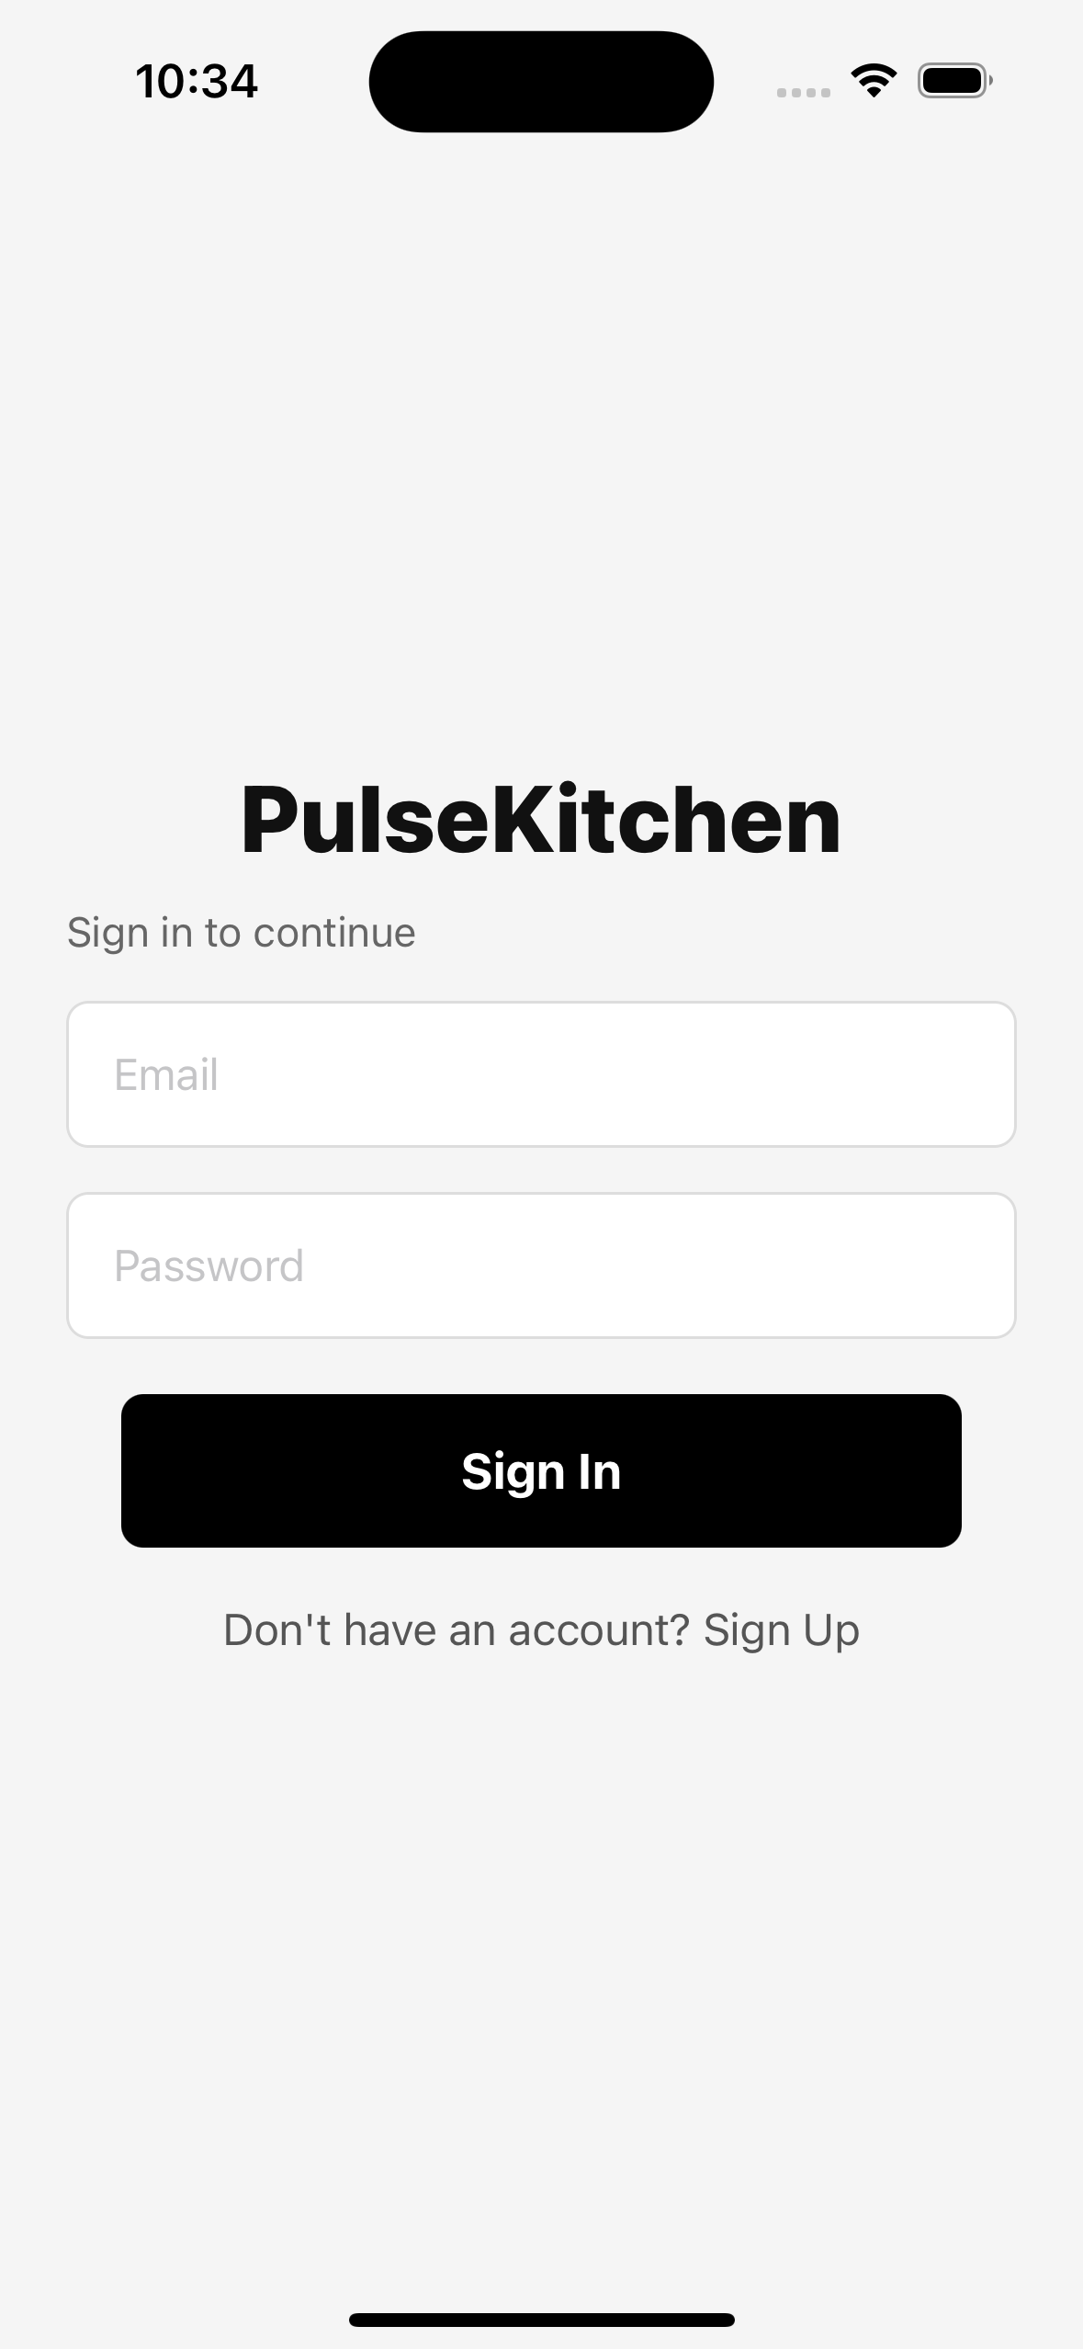
iOS simulator screenshot of the PulseKitchen login page.
SS-L-02: Home screen
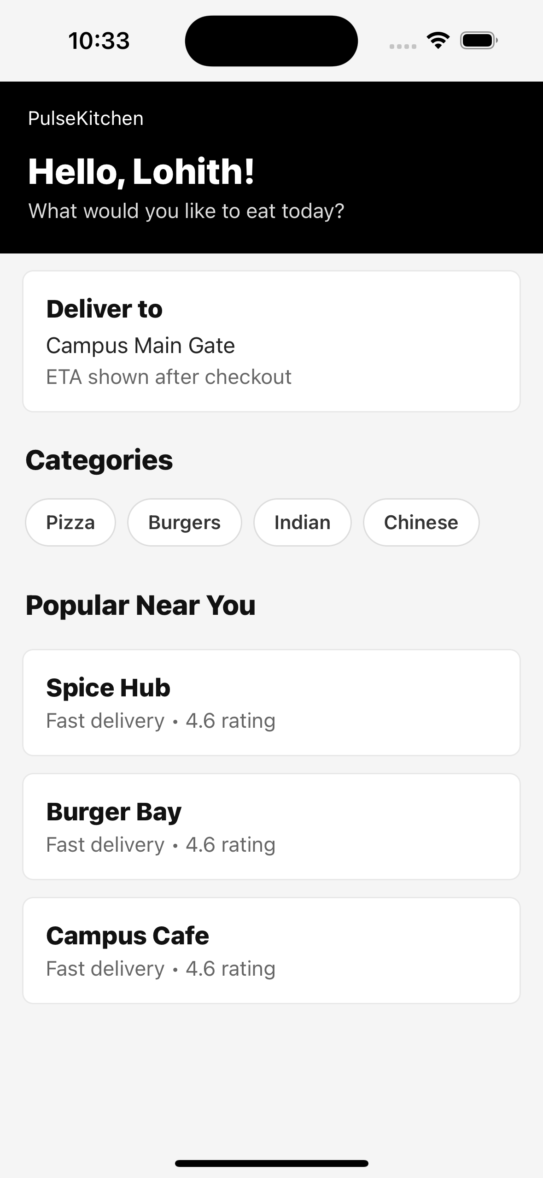
iOS simulator screenshot of the customer home page.
SS-L-03: Restaurant list screen
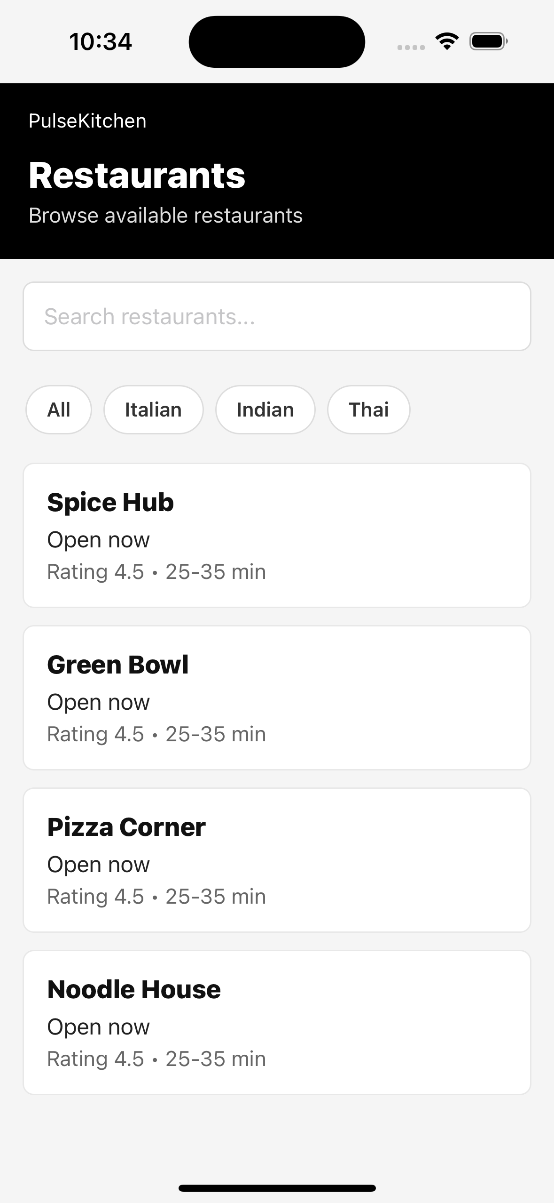
iOS simulator screenshot of restaurants and filters.
SS-L-04: Cart / checkout screen
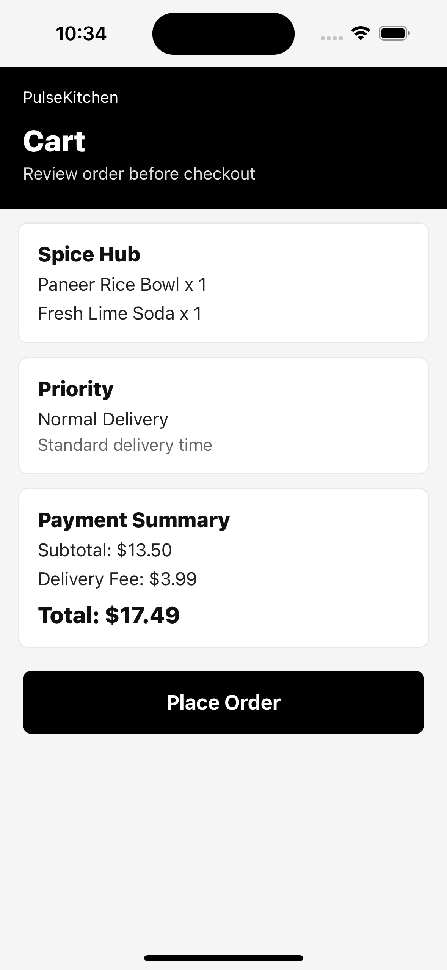
iOS simulator screenshot of cart items and payment summary.
SS-L-05: Orders history screen
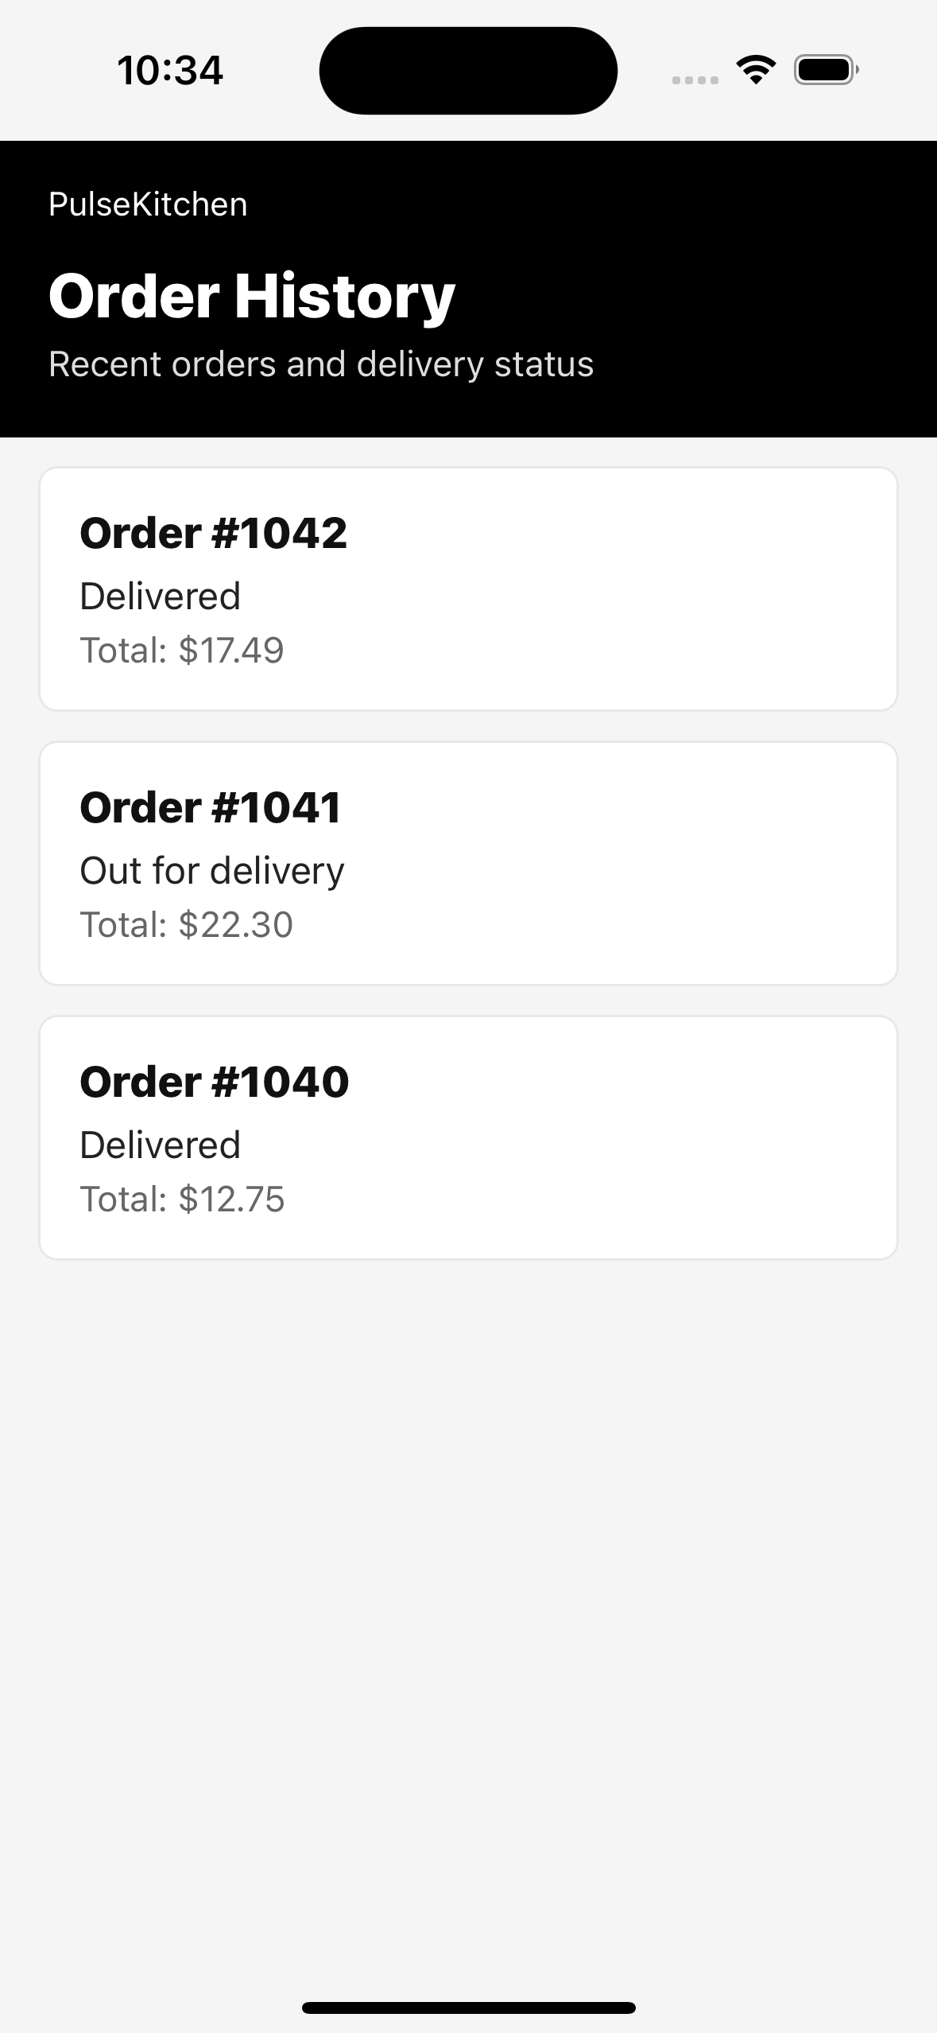
SS-L-06: Hospital Emergency Priority
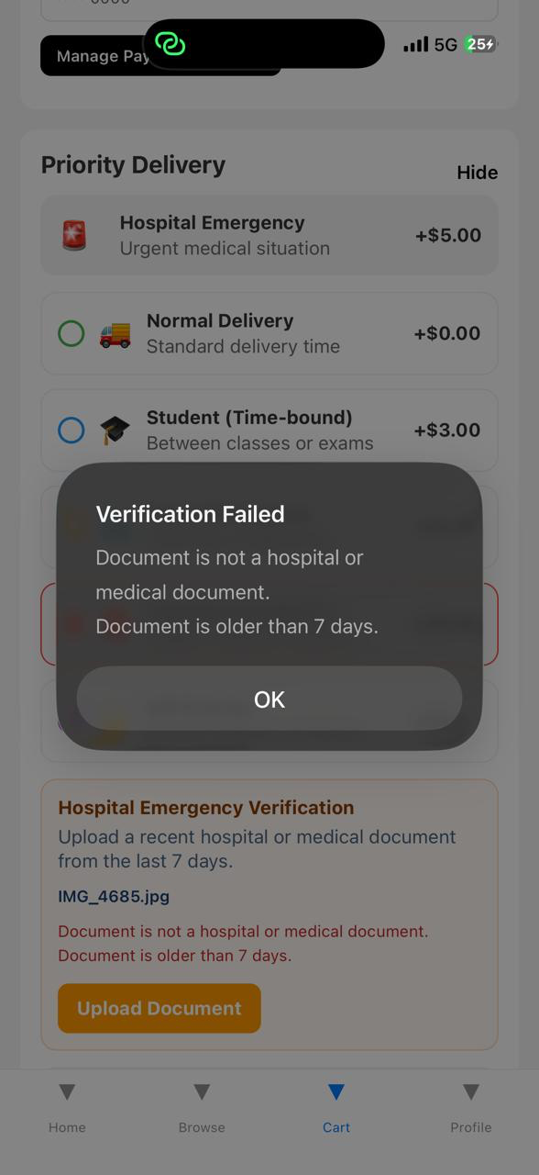
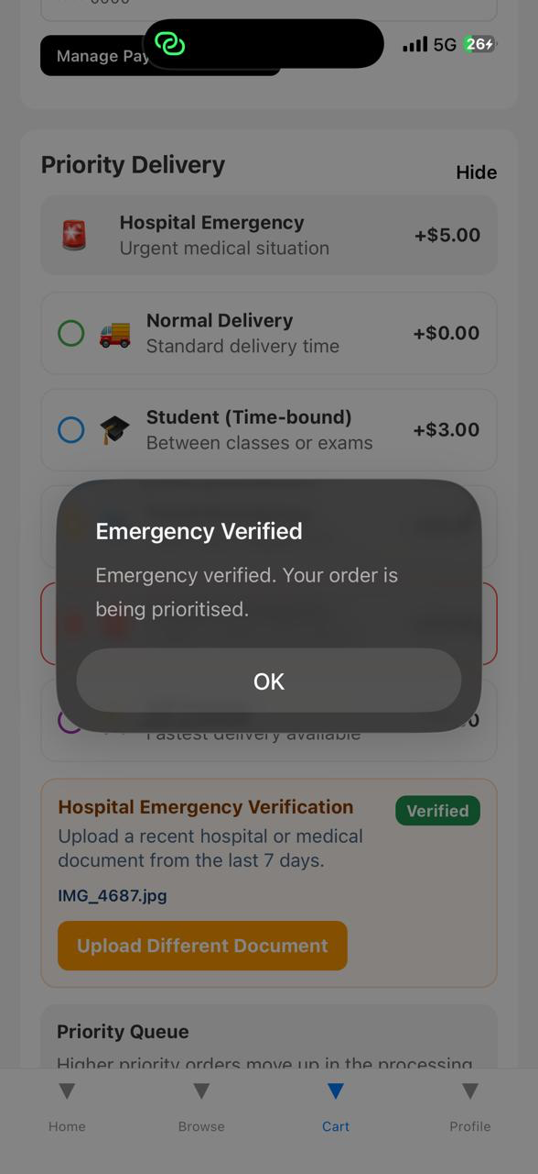

8. Entry and Exit Criteria

8.1 Entry Criteria
- Local project source code is available and dependencies are installed.
- Mobile app test suite can be executed with npm test from the mobile-app directory.
- Backend pytest dependencies are available for order-service and delivery-service tests.
- Required test accounts and verification sample files are prepared.
- Database, queue and cache services are available or mocked for the selected test level.

8.2 Exit Criteria
- All high priority test cases have been executed or have documented evidence.
- No unresolved critical defect remains open for the assigned scenario.
- Test pass rate is at least 95 percent for high priority tests.
- Traceability across login, restaurant, cart, priority, payment, delivery, notification and admin modules is complete.
- Final document includes actual results, pass/fail status and copied automation output.

9. Defect Management
Defects are recorded with module, severity, observed result, expected result, status and retest action. Any failed case must be retested after correction before final submission.
Defect ID | Module | Observation | Status | Action
None | All Assigned Modules | No blocking defect observed in assigned execution set. | Pass | Continue regression testing before final release.

Severity | Definition | Target Resolution
Critical | Application crash, data loss, payment loss, or complete ordering failure | Same day
High | Major module broken; no practical workaround | Within 24 hours
Medium | Feature partially works and workaround exists | Within 3 days
Low | Minor UI, wording or cosmetic issue | Next release

10. Test Metrics
Metrics will be reported with the final test status report and used to summarize readiness for review.
Metric | Formula / Description
Test Case Pass Rate | (Passed / Total Executed) x 100
Defect Density | Total defects found / Total test cases executed
Defect Fix Rate | Fixed defects / Total defects x 100
Requirements Coverage | Test cases mapped / Total in-scope requirements x 100
Test Execution Progress | Executed / Total planned x 100
Automation Evidence Coverage | Cases with copied output or documented actual result / Total executed cases x 100

