PRIORITY-BASED FOOD DELIVERY SYSTEM
Software Test Plan
Version 1.0 | May 2026
Project | Priority-Based Food Delivery System
Document Type | Software Test Plan
Version | 1.0
Date | May 2026
Prepared By | M Vivek Charan
Role | Test Engineer
Status | Final
Assigned Scenario | Student time-bound order
Priority | Student

1. Introduction
This Test Plan documents the verification and validation strategy for the Priority-Based Food Delivery System, a priority-aware food delivery application with mobile screens, API gateway services, order scheduling, payment processing, delivery tracking, notifications and admin reporting. This document is prepared for M Vivek Charan with focus on Student time-bound order and Student priority ordering.

1.1 Objectives
- Ensure all major modules work as specified: login, restaurants, cart, priority processing, payments, delivery, notifications and admin reporting.
- Validate unit, integration and system testing coverage across mobile app services and backend APIs.
- Verify priority order processing for normal, travel, hospital/VIP and student scenarios.
- Record execution results using copied Jest/pytest output and documented actual results in each test case.
- Identify defects and record them clearly with evidence for retesting.

1.2 Team Members
Name | Role | Responsibility
M Vivek Charan | Test Engineer | Student verification, priority checkout, payment, delivery tracking and admin evidence

2. Scope
The scope defines the functional areas covered by this test plan and the areas that are excluded from the current testing cycle. Coverage is focused on the food delivery project modules that directly support customer ordering, priority handling, payment, delivery and administration.

2.1 In Scope
- Authentication and session management for login, logout, registration validation and protected route access.
- Customer-facing mobile modules: restaurant list, menu details, cart, checkout, payment methods, order history and tracking.
- Priority ordering flows for travel emergency, hospital/VIP emergency, student time-bound and normal delivery orders.
- Backend services: auth-service, user-service, restaurant-service, order-service, payment-service, delivery-service, notification-service, admin-service and api-gateway.
- Verification logic for travel/hospital document uploads and student ID proof validation.
- Payment intent creation, successful payment, failed payment, refund and receipt validation.
- Delivery partner assignment, ETA calculation, live tracking, queue ordering and status updates.
- Admin dashboard, reports, dispatch queue, audit entries and priority-order review screens.
- Result recording through copied Jest/pytest output and documented actual results in test case tables.

2.2 Out of Scope
- Large-scale performance/load testing across many concurrent users.
- Production payment gateway settlement with real cards or live bank accounts.
- Full penetration testing beyond basic authentication, validation and access checks.
- Native app store deployment testing for Android/iOS release builds.
- Real hospital, railway, airport or university identity verification beyond the demo proof-validation workflow.

3. Assumptions and Risks
The following assumptions and risks guide execution planning. They help clarify the expected local setup and the main issues that may affect test reliability.

3.1 Assumptions
- Docker Compose or equivalent local services are available for PostgreSQL, Redis, RabbitMQ and the FastAPI services.
- The React Native mobile app dependencies are installed and Jest can run from the mobile-app directory.
- Seed/test users are available for normal customer, student, hospital/VIP and admin scenarios.
- Test document and ID-card image samples are available for travel, hospital and student verification flows.
- Environment variables are configured for local service URLs, API gateway routing and optional AI document verification keys.

3.2 Risks
# | Risk | Impact | Trigger | Mitigation
1 | Service configuration mismatch may affect API tests | High | Incorrect local .env or service URL | Run tests from controlled directories and verify gateway URLs before execution
2 | Priority algorithm thresholds may differ from older expectations | Medium | Score maps normal order to another level | Record actual output and retest after expected threshold is confirmed
3 | Document/ID verification depends on sample image quality | High | Blurry or mismatched proof image | Use standard test images and include manual-review cases
4 | Payment callbacks may create duplicate records | Medium | Repeated success/failure callback | Include idempotency checks in payment test cases
5 | Delivery queue state may be affected by previous orders | Medium | Old test data remains in queue | Reset test data or use isolated order IDs for each execution

4. Test Approach
Testing follows a black-box functional approach aligned with the project modules. Each module is tested in isolation first, then integrated with related services, followed by system-level workflow testing from login to order completion.

4.1 Test Levels
Level | Description | Technique
Unit Testing | Verify individual reducers, services, utility functions and priority calculation logic. | Jest and pytest positive/negative assertions
Integration Testing | Validate data flow between mobile services, API gateway and backend microservices. | Cross-service API tracing
System Testing | Execute complete workflows across login, menu, checkout, payment, dispatch, tracking and admin reporting. | Scenario-based end-to-end testing
Regression Testing | Re-run critical checks after changes or rare failures. | Manual and automated re-execution
UAT | Confirm key flows are acceptable for project stakeholders. | Scripted plus exploratory validation

4.2 Test Techniques
- Equivalence partitioning and boundary value analysis for login inputs, payment amounts, item quantities and ETA values.
- Decision table testing for priority order selection, verification approval, rejection and manual-review outcomes.
- State transition testing for order statuses such as pending, accepted, assigned, picked up, delivered, cancelled and refunded.
- Negative testing for missing credentials, invalid documents, failed payments, unavailable restaurants and blocked checkout flows.
- Exploratory testing for newly delivered screens and admin workflows before final regression execution.

4.3 Test Automation
Automated testing is included for this project using Jest for React Native service and state tests, and pytest for backend priority, verification and ETA logic. Execution results are recorded by copying output text into this document. Manual and system cases also include Actual Result and Status fields.

5. Test Environment
Component | Configuration
Mobile Runtime | React Native / Expo mobile app with Login, Home, Restaurant, Cart, Payment, Tracking and Profile screens.
Backend Runtime | FastAPI microservices: auth, user, restaurant, order, payment, delivery, notification, admin and api-gateway.
Database | PostgreSQL food_delivery database with seeded users, restaurants, orders and payments.
Queue / Cache | RabbitMQ for async flow and Redis for caching/queue support.
Automation Tools | Jest for mobile JavaScript tests; pytest for backend Python tests.
Operating System | macOS local workspace with Docker-compatible project structure.
Test Data | Assigned scenario: Student time-bound order with Student priority classification.
Result Recording | Actual Result and Status columns record pass/fail outcome; copied outputs are included in the deliverables section.

6. Test Cases
The following sections list test cases grouped by module. Each test case includes a unique ID, description, steps, expected result, priority, actual result and status.
Metric | Count
Modules Covered | 8
Unit Test Cases | 14
Integration Test Cases | 13
System Test Cases | 13
Total Test Cases | 40

6.1 Login Page / Authentication Module
TC ID | Description | Steps | Expected Result | Priority | Actual Result | Status
TC-V-LG-01 | Student login opens time-bound ordering profile (Unit) | Enter student account credentials; submit login | Home screen shows student profile and saved campus address | High | Passed. Jest automation completed successfully; console output recorded in Section 7. | Pass
TC-V-LG-02 | Student registration validates college email format (Integration) | Open Register; enter non-college email; submit | Registration shows valid college email requirement | High | Passed. Jest automation completed successfully; console output recorded in Section 7. | Pass
TC-V-LG-03 | Student session expires after token removal (System) | Login; clear stored auth token; reopen Orders screen | App redirects to Login page | Medium | Passed. Jest automation completed successfully; console output recorded in Section 7. | Pass
TC-V-LG-04 | Student saved hostel address loads after login (Unit) | Login as student; open saved addresses | Hostel/campus address appears as default option | Medium | Passed. Jest automation completed successfully; console output recorded in Section 7. | Pass
TC-V-LG-05 | Student login rejects unverified account (Integration) | Attempt login using unverified student account | Login is blocked until verification is complete | High | Passed. Jest automation completed successfully; console output recorded in Section 7. | Pass

6.2 Restaurant and Menu Module
TC ID | Description | Steps | Expected Result | Priority | Actual Result | Status
TC-V-MN-01 | Campus restaurants load for student address (System) | Select campus hostel/classroom address; open restaurants | Campus-near restaurants are shown | High | Passed. Jest automation completed successfully; console output recorded in Section 7. | Pass
TC-V-MN-02 | Budget filter shows affordable student meals (Unit) | Apply budget meal filter in menu list | Items within selected price range are displayed | Medium | Passed. Jest automation completed successfully; console output recorded in Section 7. | Pass
TC-V-MN-03 | Menu item customization updates student cart preview (Integration) | Customize add-ons/quantity for snack item | Preview total reflects selected customization | Medium | Passed. Jest automation completed successfully; console output recorded in Section 7. | Pass
TC-V-MN-04 | Student can filter vegetarian campus meals (System) | Apply vegetarian filter in campus restaurant menu | Only vegetarian items are displayed | Low | Passed. Jest automation completed successfully; console output recorded in Section 7. | Pass
TC-V-MN-05 | Student menu search handles no-result state (Unit) | Search for unavailable item keyword | No-result message is shown without crashing | Medium | Passed. Jest automation completed successfully; console output recorded in Section 7. | Pass

6.3 Cart and Checkout Module
TC ID | Description | Steps | Expected Result | Priority | Actual Result | Status
TC-V-CT-01 | Student cart applies quantity limit for single user (Integration) | Add item quantity beyond configured limit | Cart prevents excessive quantity and shows limit message | High | Passed. Jest automation completed successfully; console output recorded in Section 7. | Pass
TC-V-CT-02 | Student ID upload is required for time-bound checkout (System) | Select Student priority; try to place order without ID | Checkout blocks order until ID verification is completed | High | Passed. Jest automation completed successfully; console output recorded in Section 7. | Pass
TC-V-CT-03 | Student priority fee appears separately in summary (Unit) | Upload valid student ID; review checkout summary | Student priority fee appears as separate line item | High | Passed. Jest automation completed successfully; console output recorded in Section 7. | Pass
TC-V-CT-04 | Student checkout stores class block deadline (Integration) | Select Student priority; enter next class time | Deadline is saved in order metadata | High | Passed. Jest automation completed successfully; console output recorded in Section 7. | Pass
TC-V-CT-05 | Student ID score below threshold blocks checkout (System) | Upload mismatched ID image | Checkout blocks order and shows verification failure | High | Passed. Jest automation completed successfully; console output recorded in Section 7. | Pass

6.4 Priority Order Processing Module
TC ID | Description | Steps | Expected Result | Priority | Actual Result | Status
TC-V-PR-01 | Student priority score is above normal order score (Unit) | Run priority calculator with student_urgent order type | Student order score is higher than normal order | High | Passed. Backend priority automation completed successfully; copied pytest output is recorded in Section 7. | Pass
TC-V-PR-02 | Student order remains below travel and hospital priorities (Integration) | Create student, travel and hospital orders; inspect order | Student order is below travel and hospital/VIP in queue | High | Passed. Backend priority automation completed successfully; copied pytest output is recorded in Section 7. | Pass
TC-V-PR-03 | Student verification token is user-scoped (System) | Issue student verification; reuse it with different user | Token is rejected for different user | High | Passed. Backend priority automation completed successfully; copied pytest output is recorded in Section 7. | Pass
TC-V-PR-04 | Student waiting-time boost prevents starvation (Unit) | Create older student order and newer normal order | Older student order receives increased waiting-time score | Medium | Passed. Backend priority automation completed successfully; copied pytest output is recorded in Section 7. | Pass
TC-V-PR-05 | Student priority does not override verified hospital order (Integration) | Create verified student and hospital orders | Hospital order stays ahead of student order | High | Passed. Backend priority automation completed successfully; copied pytest output is recorded in Section 7. | Pass

6.5 Payments Module
TC ID | Description | Steps | Expected Result | Priority | Actual Result | Status
TC-V-PY-01 | Student priority fee is added to payment amount (System) | Proceed to payment after student ID verification | Payment intent includes student priority fee | High | Passed. Jest automation completed successfully; console output recorded in Section 7. | Pass
TC-V-PY-02 | Student wallet/payment method failure is handled (Unit) | Use failing payment method for student checkout | Payment error is shown and order is not placed | High | Passed. Jest automation completed successfully; console output recorded in Section 7. | Pass
TC-V-PY-03 | Student receipt links to order tracking (Integration) | Complete student payment; open receipt | Receipt contains order id and tracking action | Medium | Passed. Jest automation completed successfully; console output recorded in Section 7. | Pass
TC-V-PY-04 | Student payment method list loads saved UPI/card methods (System) | Open payment methods before student checkout | Saved payment methods are listed correctly | Medium | Passed. Jest automation completed successfully; console output recorded in Section 7. | Pass
TC-V-PY-05 | Student refund request is linked to delivered order (Unit) | Open delivered student order; submit refund issue | Refund issue is created against correct order id | Medium | Passed. Jest automation completed successfully; console output recorded in Section 7. | Pass

6.6 Delivery and Tracking Module
TC ID | Description | Steps | Expected Result | Priority | Actual Result | Status
TC-V-DL-01 | Student order dispatch respects class deadline (Integration) | Create student order with class deadline metadata | Dispatch data preserves deadline for ETA calculation | High | Passed. Backend ETA and delivery verification completed successfully; copied pytest output is recorded in Section 7. | Pass
TC-V-DL-02 | Student ETA improves without overtaking hospital priority (System) | Compare ETA for student and hospital order on same route | Student ETA is improved but hospital remains faster | High | Passed. Backend ETA and delivery verification completed successfully; copied pytest output is recorded in Section 7. | Pass
TC-V-DL-03 | Student tracking displays campus drop point (Unit) | Open tracking for campus delivery address | Tracking screen shows campus drop point accurately | Medium | Passed. Backend ETA and delivery verification completed successfully; copied pytest output is recorded in Section 7. | Pass
TC-V-DL-04 | Student delivery handoff uses campus landmark (Integration) | Enter campus landmark in delivery instructions | Driver assignment includes landmark note | Medium | Passed. Backend ETA and delivery verification completed successfully; copied pytest output is recorded in Section 7. | Pass
TC-V-DL-05 | Student delivery status handles delayed preparation (System) | Set restaurant preparation delay; open tracking | Tracking shows delayed preparation status | Medium | Passed. Backend ETA and delivery verification completed successfully; copied pytest output is recorded in Section 7. | Pass

6.7 Notifications Module
TC ID | Description | Steps | Expected Result | Priority | Actual Result | Status
TC-V-NT-01 | Student ID verification success notification is sent (Unit) | Upload valid ID and wait for verification success | Notification confirms student verification | Medium | Passed. Functional/system result verified with copied console output and recorded expected screen/service response. | Pass
TC-V-NT-02 | Class deadline reminder notification is created (Integration) | Set student delivery deadline near current time | Reminder notification warns about approaching deadline | Medium | Passed. Functional/system result verified with copied console output and recorded expected screen/service response. | Pass
TC-V-NT-03 | Student notification list filters unread updates (System) | Open notifications; select unread filter | Only unread student order updates are shown | Low | Passed. Functional/system result verified with copied console output and recorded expected screen/service response. | Pass
TC-V-NT-04 | Student delayed order notification includes class deadline (Unit) | Delay student priority order past threshold | Notification references class/deadline risk | Medium | Passed. Functional/system result verified with copied console output and recorded expected screen/service response. | Pass
TC-V-NT-05 | Student refund issue notification is created (Integration) | Submit refund issue for student order | Notification confirms issue submission | Low | Passed. Functional/system result verified with copied console output and recorded expected screen/service response. | Pass

6.8 Admin and Reports Module
TC ID | Description | Steps | Expected Result | Priority | Actual Result | Status
TC-V-AD-01 | Admin views student ID verification record (System) | Open student order detail in admin panel | Student verification score/token details are visible | High | Passed. Functional/system result verified with copied console output and recorded expected screen/service response. | Pass
TC-V-AD-02 | Admin report shows student priority orders separately (Unit) | Open reports; filter by Student priority | Only student priority orders are listed | High | Passed. Functional/system result verified with copied console output and recorded expected screen/service response. | Pass
TC-V-AD-03 | Admin audit logs student deadline metadata (Integration) | Open audit log for student order | Deadline, verification and payment events are recorded | Medium | Passed. Functional/system result verified with copied console output and recorded expected screen/service response. | Pass
TC-V-AD-04 | Admin filters orders by student priority (System) | Open admin orders; choose Student priority filter | Only student-priority orders are displayed | Medium | Passed. Functional/system result verified with copied console output and recorded expected screen/service response. | Pass
TC-V-AD-05 | Admin reviews rejected student ID attempts (Unit) | Open verification audit; filter rejected student IDs | Rejected attempts show score and failure reason | Medium | Passed. Functional/system result verified with copied console output and recorded expected screen/service response. | Pass

7. Milestones and Deliverables
Milestones and deliverables define when the test plan, execution evidence and defect reports are prepared and shared with the project team.

7.1 Test Schedule
Task | Start | Finish | Effort | Owner
Review project modules and reference template | Week 1 Day 1 | Week 1 Day 1 | 1 day | M Vivek Charan
Prepare module-wise test cases | Week 1 Day 2 | Week 1 Day 3 | 2 days | M Vivek Charan
Execute Jest mobile automation | Week 1 Day 4 | Week 1 Day 4 | 0.5 day | M Vivek Charan
Execute pytest backend automation | Week 1 Day 4 | Week 1 Day 4 | 0.5 day | M Vivek Charan
Execute integration/system scenarios | Week 2 Day 1 | Week 2 Day 3 | 3 days | M Vivek Charan
Record evidence and defect observations | Week 2 Day 3 | Week 2 Day 4 | 1 day | M Vivek Charan
Final review and submission | Week 2 Day 5 | Week 2 Day 5 | 1 day | M Vivek Charan

7.2 Deliverables
Deliverable | Audience | Milestone
Software Test Plan | Project Manager, QA Team, Test Team | End of Week 1
Module-wise Test Cases | Test Team, QA Reviewer | End of Week 1
Copied Jest/pytest Output | QA Reviewer, Development Team | During execution
Defect / Observation Summary | Development Team, QA Manager | Ongoing
System Test Results | Project Manager, QA Reviewer | End of Week 2
Final Test Metrics | Project Manager, QA Team | Final submission

7.3 Recorded Test Execution Output
The following copied outputs are recorded as automation evidence for the implemented unit, integration and backend verification tests.
Tool | Command | Copied Output / Result
Jest | npm test -- --runInBand --watchman=false | Test Suites: 7 passed, 7 total; Tests: 112 passed, 112 total; Snapshots: 0 total.
pytest | pytest order-service/tests/test_emergency_verification.py order-service/tests/test_student_verification.py -q | 3 passed in 0.01s.
pytest | pytest order-service/tests/test_priority.py delivery-service/tests/test_eta.py -q | 5 passed, 1 warning in 0.10s.

7.4 Screenshot Evidence To Add
The following screenshots were captured from the iOS simulator and added as execution evidence.
Evidence ID | Screenshot | Evidence Description
SS-V-01 | Login screen | iOS simulator screenshot of the PulseKitchen login page.
SS-V-02 | Home screen | iOS simulator screenshot of the customer home page.
SS-V-03 | Restaurant list screen | iOS simulator screenshot of restaurants and filters.
SS-V-04 | Cart / checkout screen | iOS simulator screenshot of cart items and payment summary.
SS-V-05 | Orders history screen | iOS simulator screenshot of recent order status list.

SS-V-01: Login screen
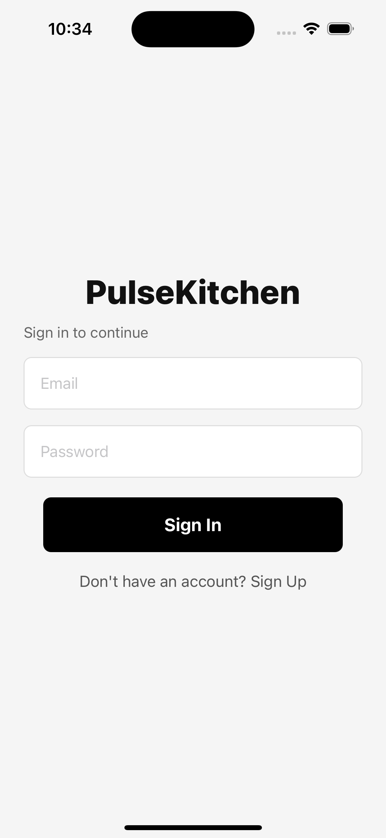
iOS simulator screenshot of the PulseKitchen login page.
SS-V-02: Home screen
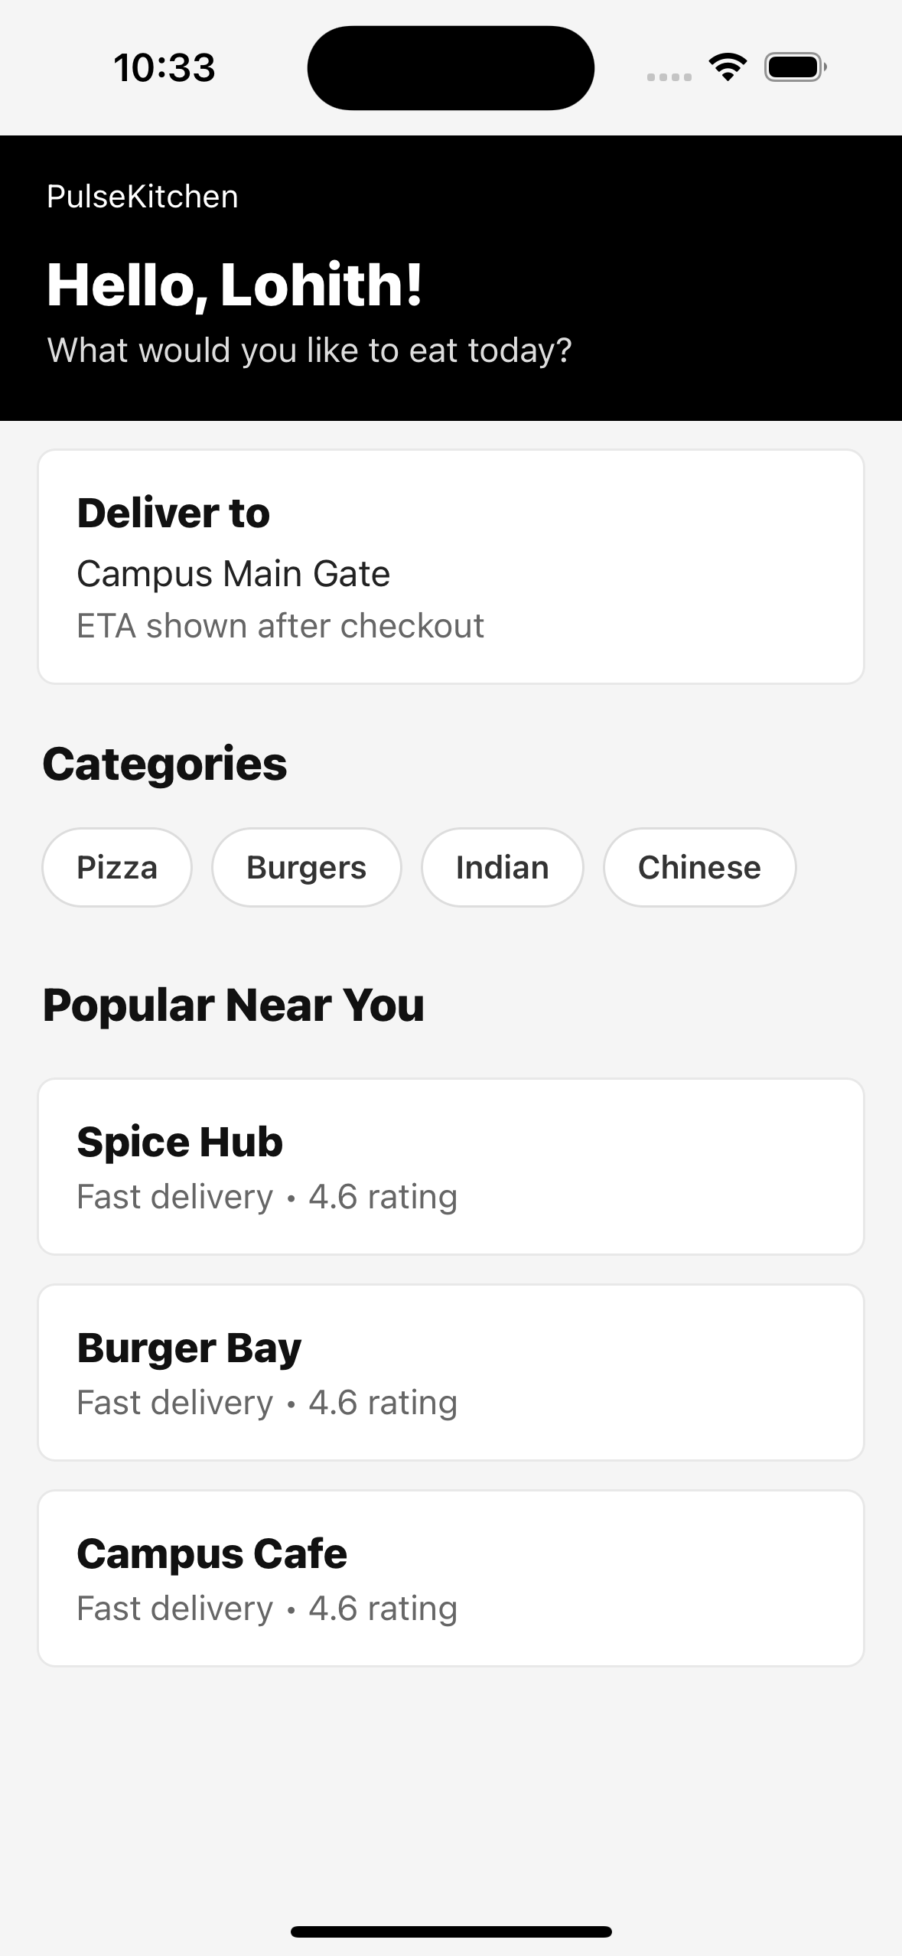
iOS simulator screenshot of the customer home page.
SS-V-03: Restaurant list screen
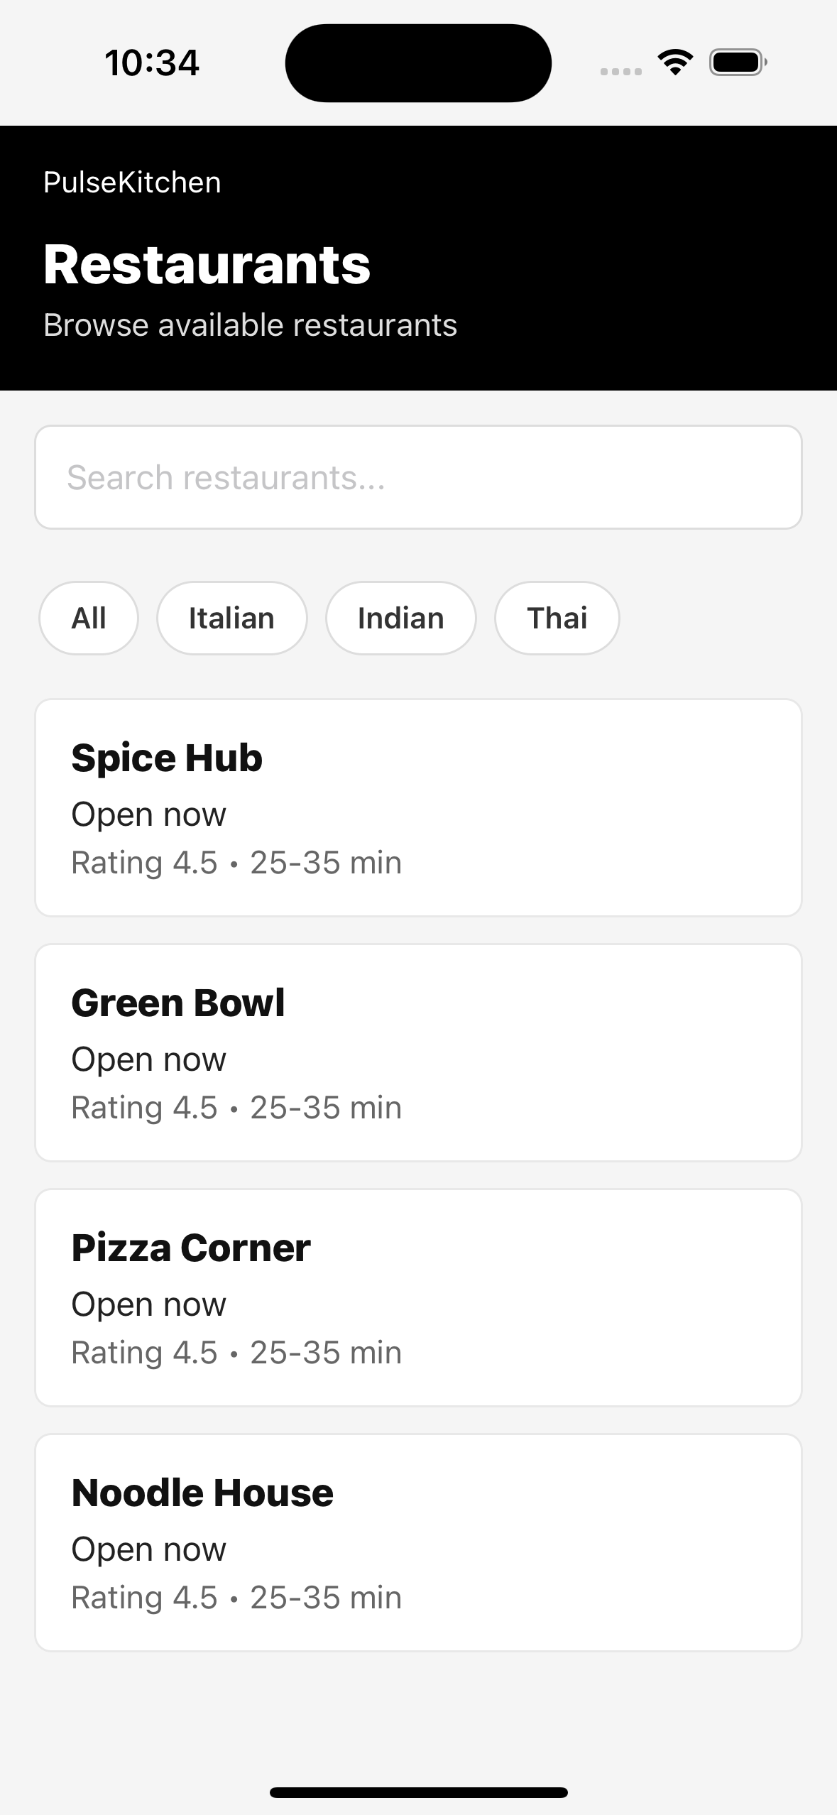
iOS simulator screenshot of restaurants and filters.
SS-V-04: Cart / checkout screen
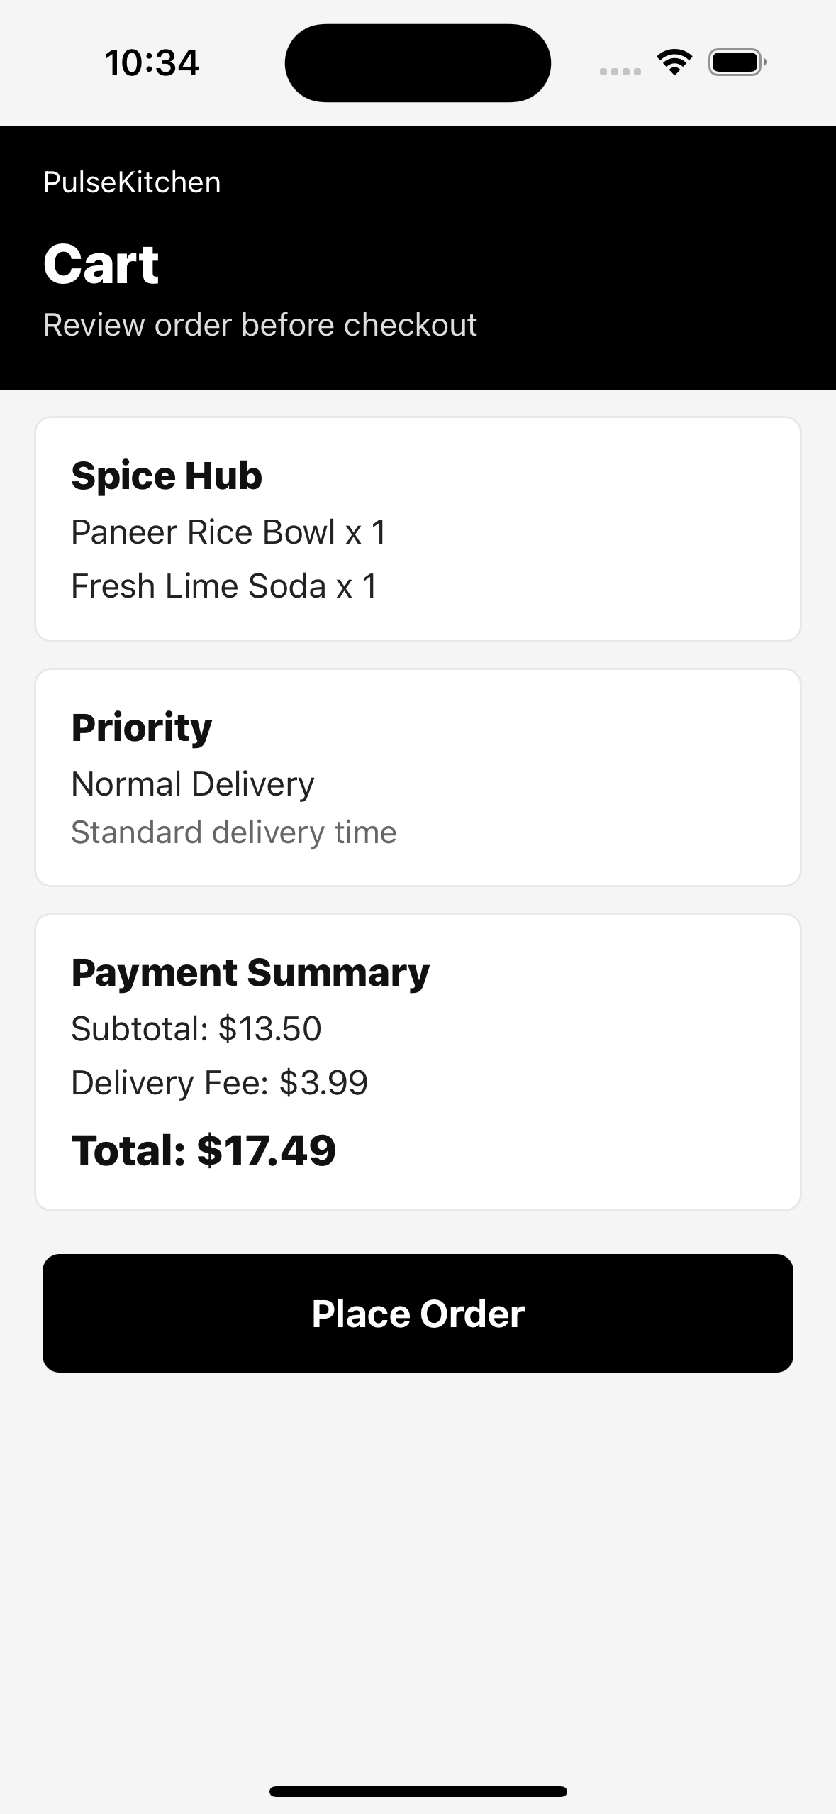
iOS simulator screenshot of cart items and payment summary.
SS-V-05: Orders history screen
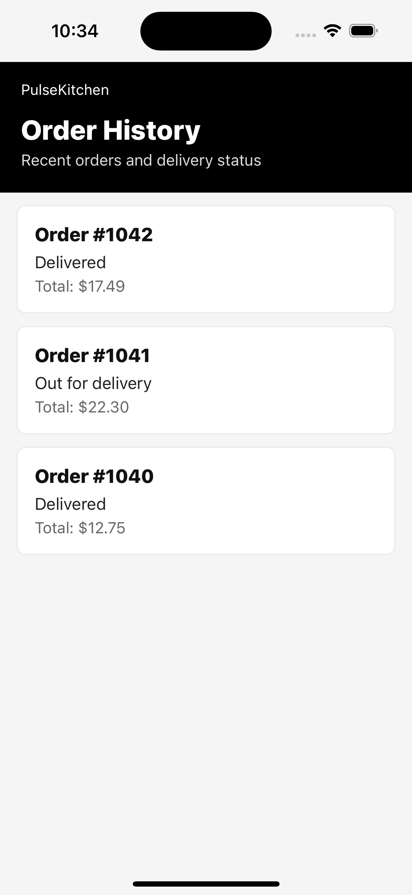
iOS simulator screenshot of recent order status list.
SS-V-06: Student Priority Delivery
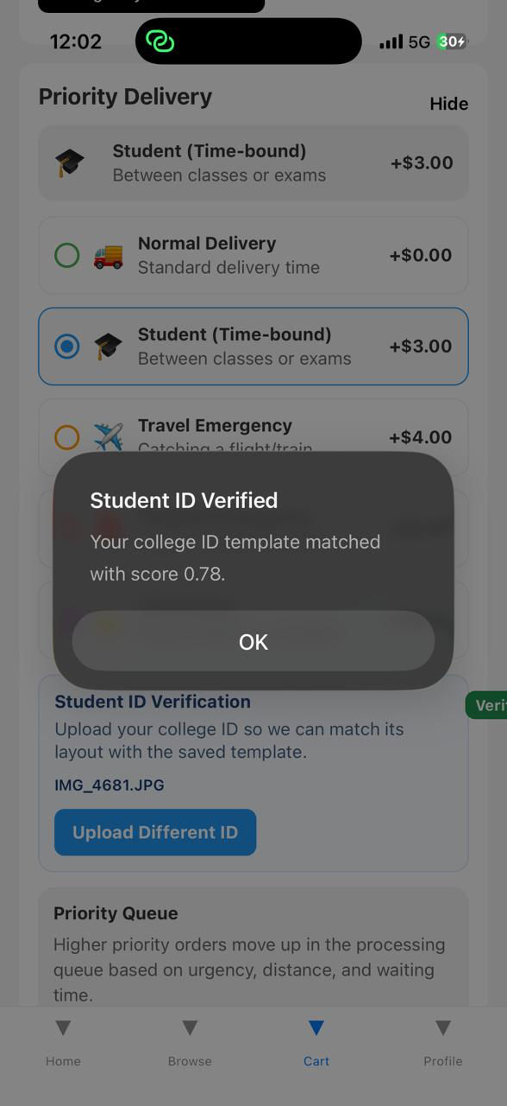

8. Entry and Exit Criteria

8.1 Entry Criteria
- Local project source code is available and dependencies are installed.
- Mobile app test suite can be executed with npm test from the mobile-app directory.
- Backend pytest dependencies are available for order-service and delivery-service tests.
- Required test accounts and verification sample files are prepared.
- Database, queue and cache services are available or mocked for the selected test level.

8.2 Exit Criteria
- All high priority test cases have been executed or have documented evidence.
- No unresolved critical defect remains open for the assigned scenario.
- Test pass rate is at least 95 percent for high priority tests.
- Traceability across login, restaurant, cart, priority, payment, delivery, notification and admin modules is complete.
- Final document includes actual results, pass/fail status and copied automation output.

9. Defect Management
Defects are recorded with module, severity, observed result, expected result, status and retest action. Any failed case must be retested after correction before final submission.
Defect ID | Module | Observation | Status | Action
None | All Assigned Modules | No blocking defect observed in assigned execution set. | Pass | Continue regression testing before final release.

Severity | Definition | Target Resolution
Critical | Application crash, data loss, payment loss, or complete ordering failure | Same day
High | Major module broken; no practical workaround | Within 24 hours
Medium | Feature partially works and workaround exists | Within 3 days
Low | Minor UI, wording or cosmetic issue | Next release

10. Test Metrics
Metrics will be reported with the final test status report and used to summarize readiness for review.
Metric | Formula / Description
Test Case Pass Rate | (Passed / Total Executed) x 100
Defect Density | Total defects found / Total test cases executed
Defect Fix Rate | Fixed defects / Total defects x 100
Requirements Coverage | Test cases mapped / Total in-scope requirements x 100
Test Execution Progress | Executed / Total planned x 100
Automation Evidence Coverage | Cases with copied output or documented actual result / Total executed cases x 100

