PRIORITY-BASED FOOD DELIVERY SYSTEM
Software Test Plan
Version 1.0 | May 2026
Project | Priority-Based Food Delivery System
Document Type | Software Test Plan
Version | 1.0
Date | May 2026
Prepared By | P Sai Sankeerthan Reddy
Role | Test Engineer
Status | Final
Assigned Scenario | Hospital emergency order
Priority | VIP

1. Introduction
This Test Plan documents the verification and validation strategy for the Priority-Based Food Delivery System, a priority-aware food delivery application with mobile screens, API gateway services, order scheduling, payment processing, delivery tracking, notifications and admin reporting. This document is prepared for P Sai Sankeerthan Reddy with focus on Hospital emergency order and VIP priority ordering.

1.1 Objectives
- Ensure all major modules work as specified: login, restaurants, cart, priority processing, payments, delivery, notifications and admin reporting.
- Validate unit, integration and system testing coverage across mobile app services and backend APIs.
- Verify priority order processing for normal, travel, hospital/VIP and student scenarios.
- Record execution results using copied Jest/pytest output and documented actual results in each test case.
- Identify defects and record them clearly with evidence for retesting.

1.2 Team Members
Name | Role | Responsibility
P Sai Sankeerthan Reddy | Test Engineer | VIP/hospital priority processing, payment confirmation, dispatch and notification evidence

2. Scope
The scope defines the functional areas covered by this test plan and the areas that are excluded from the current testing cycle. Coverage is focused on the food delivery project modules that directly support customer ordering, priority handling, payment, delivery and administration.

2.1 In Scope
- Authentication and session management for login, logout, registration validation and protected route access.
- Customer-facing mobile modules: restaurant list, menu details, cart, checkout, payment methods, order history and tracking.
- Priority ordering flows for travel emergency, hospital/VIP emergency, student time-bound and normal delivery orders.
- Backend services: auth-service, user-service, restaurant-service, order-service, payment-service, delivery-service, notification-service, admin-service and api-gateway.
- Verification logic for travel/hospital document uploads and student ID proof validation.
- Payment intent creation, successful payment, failed payment, refund and receipt validation.
- Delivery partner assignment, ETA calculation, live tracking, queue ordering and status updates.
- Admin dashboard, reports, dispatch queue, audit entries and priority-order review screens.
- Result recording through copied Jest/pytest output and documented actual results in test case tables.

2.2 Out of Scope
- Large-scale performance/load testing across many concurrent users.
- Production payment gateway settlement with real cards or live bank accounts.
- Full penetration testing beyond basic authentication, validation and access checks.
- Native app store deployment testing for Android/iOS release builds.
- Real hospital, railway, airport or university identity verification beyond the demo proof-validation workflow.

3. Assumptions and Risks
The following assumptions and risks guide execution planning. They help clarify the expected local setup and the main issues that may affect test reliability.

3.1 Assumptions
- Docker Compose or equivalent local services are available for PostgreSQL, Redis, RabbitMQ and the FastAPI services.
- The React Native mobile app dependencies are installed and Jest can run from the mobile-app directory.
- Seed/test users are available for normal customer, student, hospital/VIP and admin scenarios.
- Test document and ID-card image samples are available for travel, hospital and student verification flows.
- Environment variables are configured for local service URLs, API gateway routing and optional AI document verification keys.

3.2 Risks
# | Risk | Impact | Trigger | Mitigation
1 | Service configuration mismatch may affect API tests | High | Incorrect local .env or service URL | Run tests from controlled directories and verify gateway URLs before execution
2 | Priority algorithm thresholds may differ from older expectations | Medium | Score maps normal order to another level | Record actual output and retest after expected threshold is confirmed
3 | Document/ID verification depends on sample image quality | High | Blurry or mismatched proof image | Use standard test images and include manual-review cases
4 | Payment callbacks may create duplicate records | Medium | Repeated success/failure callback | Include idempotency checks in payment test cases
5 | Delivery queue state may be affected by previous orders | Medium | Old test data remains in queue | Reset test data or use isolated order IDs for each execution

4. Test Approach
Testing follows a black-box functional approach aligned with the project modules. Each module is tested in isolation first, then integrated with related services, followed by system-level workflow testing from login to order completion.

4.1 Test Levels
Level | Description | Technique
Unit Testing | Verify individual reducers, services, utility functions and priority calculation logic. | Jest and pytest positive/negative assertions
Integration Testing | Validate data flow between mobile services, API gateway and backend microservices. | Cross-service API tracing
System Testing | Execute complete workflows across login, menu, checkout, payment, dispatch, tracking and admin reporting. | Scenario-based end-to-end testing
Regression Testing | Re-run critical checks after changes or rare failures. | Manual and automated re-execution
UAT | Confirm key flows are acceptable for project stakeholders. | Scripted plus exploratory validation

4.2 Test Techniques
- Equivalence partitioning and boundary value analysis for login inputs, payment amounts, item quantities and ETA values.
- Decision table testing for priority order selection, verification approval, rejection and manual-review outcomes.
- State transition testing for order statuses such as pending, accepted, assigned, picked up, delivered, cancelled and refunded.
- Negative testing for missing credentials, invalid documents, failed payments, unavailable restaurants and blocked checkout flows.
- Exploratory testing for newly delivered screens and admin workflows before final regression execution.

4.3 Test Automation
Automated testing is included for this project using Jest for React Native service and state tests, and pytest for backend priority, verification and ETA logic. Execution results are recorded by copying output text into this document. Manual and system cases also include Actual Result and Status fields.

5. Test Environment
Component | Configuration
Mobile Runtime | React Native / Expo mobile app with Login, Home, Restaurant, Cart, Payment, Tracking and Profile screens.
Backend Runtime | FastAPI microservices: auth, user, restaurant, order, payment, delivery, notification, admin and api-gateway.
Database | PostgreSQL food_delivery database with seeded users, restaurants, orders and payments.
Queue / Cache | RabbitMQ for async flow and Redis for caching/queue support.
Automation Tools | Jest for mobile JavaScript tests; pytest for backend Python tests.
Operating System | macOS local workspace with Docker-compatible project structure.
Test Data | Assigned scenario: Hospital emergency order with VIP priority classification.
Result Recording | Actual Result and Status columns record pass/fail outcome; copied outputs are included in the deliverables section.

6. Test Cases
The following sections list test cases grouped by module. Each test case includes a unique ID, description, steps, expected result, priority, actual result and status.
Metric | Count
Modules Covered | 8
Unit Test Cases | 14
Integration Test Cases | 13
System Test Cases | 13
Total Test Cases | 40

6.1 Login Page / Authentication Module
TC ID | Description | Steps | Expected Result | Priority | Actual Result | Status
TC-S-LG-01 | Hospital staff login redirects to urgent ordering dashboard (Unit) | Enter hospital/VIP account credentials; submit login | Home screen highlights hospital emergency ordering option | High | Passed. Jest automation completed successfully; console output recorded in Section 7. | Pass
TC-S-LG-02 | VIP account rejects disabled-user login (Integration) | Attempt login using disabled VIP account test data | Login is denied with account status error | High | Passed. Jest automation completed successfully; console output recorded in Section 7. | Pass
TC-S-LG-03 | Admin switch from hospital user requires fresh authentication (System) | Login as hospital user; attempt admin route directly | App/API blocks admin access without admin credentials | Medium | Passed. Jest automation completed successfully; console output recorded in Section 7. | Pass
TC-S-LG-04 | Hospital account MFA prompt appears for sensitive login (Unit) | Login using hospital account from new device | Extra verification prompt is displayed before checkout | Medium | Passed. Jest automation completed successfully; console output recorded in Section 7. | Pass
TC-S-LG-05 | VIP user profile flag is loaded after login (Integration) | Login as VIP user; inspect profile response | Profile contains VIP flag used by priority checkout | High | Passed. Jest automation completed successfully; console output recorded in Section 7. | Pass

6.2 Restaurant and Menu Module
TC ID | Description | Steps | Expected Result | Priority | Actual Result | Status
TC-S-MN-01 | Hospital user sees emergency-friendly restaurants first (System) | Login as hospital/VIP user; open restaurants | Restaurants supporting fastest preparation appear at top | High | Passed. Jest automation completed successfully; console output recorded in Section 7. | Pass
TC-S-MN-02 | Hospital diet filter returns safe menu items (Unit) | Apply hospital-friendly/diet filter in restaurant menu | Only matching diet-safe items are displayed | Medium | Passed. Jest automation completed successfully; console output recorded in Section 7. | Pass
TC-S-MN-03 | Unavailable emergency item cannot be added (Integration) | Open menu item marked unavailable; tap Add | Add action is disabled and unavailable message appears | Medium | Passed. Jest automation completed successfully; console output recorded in Section 7. | Pass
TC-S-MN-04 | Hospital order hides restaurants with long prep time (System) | Apply emergency-only filter | Restaurants above prep-time threshold are hidden | High | Passed. Jest automation completed successfully; console output recorded in Section 7. | Pass
TC-S-MN-05 | Hospital notes field accepts dietary restrictions (Unit) | Open item detail; enter patient dietary note | Dietary note is saved with cart item | Medium | Passed. Jest automation completed successfully; console output recorded in Section 7. | Pass

6.3 Cart and Checkout Module
TC ID | Description | Steps | Expected Result | Priority | Actual Result | Status
TC-S-CT-01 | VIP cart keeps priority badge beside subtotal (Integration) | Add items; select VIP/Hospital priority | Cart summary shows VIP badge and emergency surcharge | High | Passed. Jest automation completed successfully; console output recorded in Section 7. | Pass
TC-S-CT-02 | Hospital checkout requires medical document (System) | Select Hospital Emergency; proceed without document | Checkout blocks submission and requests hospital proof | High | Passed. Jest automation completed successfully; console output recorded in Section 7. | Pass
TC-S-CT-03 | Large hospital order keeps item-level totals accurate (Unit) | Add multiple quantities; apply VIP priority | Line totals, subtotal and VIP fee remain correct | High | Passed. Jest automation completed successfully; console output recorded in Section 7. | Pass
TC-S-CT-04 | VIP checkout shows critical confirmation warning (Integration) | Select VIP/Hospital priority and continue | Checkout displays critical-priority confirmation message | High | Passed. Jest automation completed successfully; console output recorded in Section 7. | Pass
TC-S-CT-05 | Hospital checkout blocks expired medical proof (System) | Upload expired/old medical proof image | Document is rejected or sent to manual review | High | Passed. Jest automation completed successfully; console output recorded in Section 7. | Pass

6.4 Priority Order Processing Module
TC ID | Description | Steps | Expected Result | Priority | Actual Result | Status
TC-S-PR-01 | Hospital VIP score maps to critical priority (Unit) | Run priority calculator with hospital user and VIP flag | Priority level returns critical or highest dispatch band | High | Passed. Backend priority automation completed successfully; copied pytest output is recorded in Section 7. | Pass
TC-S-PR-02 | Hospital order outranks travel and student orders (Integration) | Create hospital, travel and student orders; inspect queue | Hospital/VIP order appears before travel and student orders | High | Passed. Backend priority automation completed successfully; copied pytest output is recorded in Section 7. | Pass
TC-S-PR-03 | Low-confidence hospital document enters manual review (System) | Submit blurry hospital document to verification normalizer | Decision is manual review with failure reasons preserved | High | Passed. Backend priority automation completed successfully; copied pytest output is recorded in Section 7. | Pass
TC-S-PR-04 | VIP flag alone increases urgency score (Unit) | Calculate score for VIP regular user and non-VIP regular user | VIP score is higher for same route and wait time | High | Passed. Backend priority automation completed successfully; copied pytest output is recorded in Section 7. | Pass
TC-S-PR-05 | Hospital priority remains critical after waiting-time update (Integration) | Recalculate hospital order after wait-time aging | Order remains in critical priority band | High | Passed. Backend priority automation completed successfully; copied pytest output is recorded in Section 7. | Pass

6.5 Payments Module
TC ID | Description | Steps | Expected Result | Priority | Actual Result | Status
TC-S-PY-01 | VIP surcharge is included in payment intent (System) | Proceed to payment with hospital/VIP priority selected | Payment intent includes VIP surcharge exactly once | High | Passed. Jest automation completed successfully; console output recorded in Section 7. | Pass
TC-S-PY-02 | Refund is created when hospital order is rejected (Unit) | Reject hospital verification after payment authorization | Refund/void flow is triggered for the payment | High | Passed. Jest automation completed successfully; console output recorded in Section 7. | Pass
TC-S-PY-03 | Saved card can be selected for VIP order (Integration) | Open payment methods; select saved card; confirm | Saved method is used and tokenized payment succeeds | Medium | Passed. Jest automation completed successfully; console output recorded in Section 7. | Pass
TC-S-PY-04 | Hospital invoice records emergency surcharge (System) | Complete hospital/VIP payment; open invoice record | Invoice lists emergency/VIP surcharge separately | Medium | Passed. Jest automation completed successfully; console output recorded in Section 7. | Pass
TC-S-PY-05 | Duplicate hospital payment callback is idempotent (Unit) | Send same payment success callback twice | Only one payment record is marked successful | High | Passed. Jest automation completed successfully; console output recorded in Section 7. | Pass

6.6 Delivery and Tracking Module
TC ID | Description | Steps | Expected Result | Priority | Actual Result | Status
TC-S-DL-01 | Critical hospital order auto-assigns fastest partner (Integration) | Create paid hospital/VIP order; trigger assignment | Fastest eligible partner receives assignment first | High | Passed. Backend ETA and delivery verification completed successfully; copied pytest output is recorded in Section 7. | Pass
TC-S-DL-02 | Hospital ETA receives strongest reduction (System) | Calculate ETA for same route using hospital/VIP metadata | Hospital/VIP ETA is lower than student/travel/normal ETA | High | Passed. Backend ETA and delivery verification completed successfully; copied pytest output is recorded in Section 7. | Pass
TC-S-DL-03 | Driver status update escalates hospital tracking banner (Unit) | Move hospital order to picked-up status | Tracking screen shows critical delivery banner | Medium | Passed. Backend ETA and delivery verification completed successfully; copied pytest output is recorded in Section 7. | Pass
TC-S-DL-04 | Hospital order reassigns if partner declines (Integration) | Assign hospital order; simulate partner decline | System reassigns to next eligible partner | High | Passed. Backend ETA and delivery verification completed successfully; copied pytest output is recorded in Section 7. | Pass
TC-S-DL-05 | Critical delivery route keeps live tracking enabled (System) | Open tracking while hospital order is active | Live tracking remains enabled until delivery | Medium | Passed. Backend ETA and delivery verification completed successfully; copied pytest output is recorded in Section 7. | Pass

6.7 Notifications Module
TC ID | Description | Steps | Expected Result | Priority | Actual Result | Status
TC-S-NT-01 | Hospital order confirmation is sent as urgent alert (Unit) | Place hospital/VIP order successfully | Urgent confirmation notification is created | Medium | Passed. Functional/system result verified with copied console output and recorded expected screen/service response. | Pass
TC-S-NT-02 | Admin receives critical dispatch notification (Integration) | Hospital order enters dispatch queue | Admin notification highlights critical priority | Medium | Passed. Functional/system result verified with copied console output and recorded expected screen/service response. | Pass
TC-S-NT-03 | VIP delivered notification includes priority completion (System) | Mark hospital/VIP order delivered | Delivered notification includes priority completion message | Low | Passed. Functional/system result verified with copied console output and recorded expected screen/service response. | Pass
TC-S-NT-04 | Hospital manual review approval notifies customer (Unit) | Approve manual review in admin panel | Customer receives approval and checkout continuation alert | Medium | Passed. Functional/system result verified with copied console output and recorded expected screen/service response. | Pass
TC-S-NT-05 | VIP refund notification is sent after cancellation (Integration) | Cancel paid hospital/VIP order | Refund/cancellation notification is delivered | Medium | Passed. Functional/system result verified with copied console output and recorded expected screen/service response. | Pass

6.8 Admin and Reports Module
TC ID | Description | Steps | Expected Result | Priority | Actual Result | Status
TC-S-AD-01 | Admin dashboard shows hospital order at top (System) | Open admin orders while hospital order is pending | Hospital/VIP order is displayed above lower-priority orders | High | Passed. Functional/system result verified with copied console output and recorded expected screen/service response. | Pass
TC-S-AD-02 | Admin manual review records hospital document decision (Unit) | Open manual review; approve hospital proof | Order becomes eligible for critical dispatch | High | Passed. Functional/system result verified with copied console output and recorded expected screen/service response. | Pass
TC-S-AD-03 | Critical order audit contains reviewer and timestamp (Integration) | Open audit log for reviewed hospital order | Reviewer, timestamp and decision are stored | Medium | Passed. Functional/system result verified with copied console output and recorded expected screen/service response. | Pass
TC-S-AD-04 | Admin escalates hospital order from manual review (System) | Open manual review queue; approve and escalate | Order moves into critical dispatch queue | High | Passed. Functional/system result verified with copied console output and recorded expected screen/service response. | Pass
TC-S-AD-05 | Admin report highlights VIP service time (Unit) | Open VIP/hospital performance report | Report shows order acceptance-to-delivery duration | Medium | Passed. Functional/system result verified with copied console output and recorded expected screen/service response. | Pass

7. Milestones and Deliverables
Milestones and deliverables define when the test plan, execution evidence and defect reports are prepared and shared with the project team.

7.1 Test Schedule
Task | Start | Finish | Effort | Owner
Review project modules and reference template | Week 1 Day 1 | Week 1 Day 1 | 1 day | P Sai Sankeerthan Reddy
Prepare module-wise test cases | Week 1 Day 2 | Week 1 Day 3 | 2 days | P Sai Sankeerthan Reddy
Execute Jest mobile automation | Week 1 Day 4 | Week 1 Day 4 | 0.5 day | P Sai Sankeerthan Reddy
Execute pytest backend automation | Week 1 Day 4 | Week 1 Day 4 | 0.5 day | P Sai Sankeerthan Reddy
Execute integration/system scenarios | Week 2 Day 1 | Week 2 Day 3 | 3 days | P Sai Sankeerthan Reddy
Record evidence and defect observations | Week 2 Day 3 | Week 2 Day 4 | 1 day | P Sai Sankeerthan Reddy
Final review and submission | Week 2 Day 5 | Week 2 Day 5 | 1 day | P Sai Sankeerthan Reddy

7.2 Deliverables
Deliverable | Audience | Milestone
Software Test Plan | Project Manager, QA Team, Test Team | End of Week 1
Module-wise Test Cases | Test Team, QA Reviewer | End of Week 1
Copied Jest/pytest Output | QA Reviewer, Development Team | During execution
Defect / Observation Summary | Development Team, QA Manager | Ongoing
System Test Results | Project Manager, QA Reviewer | End of Week 2
Final Test Metrics | Project Manager, QA Team | Final submission

7.3 Recorded Test Execution Output
The following copied outputs are recorded as automation evidence for the implemented unit, integration and backend verification tests.
Tool | Command | Copied Output / Result
Jest | npm test -- --runInBand --watchman=false | Test Suites: 7 passed, 7 total; Tests: 112 passed, 112 total; Snapshots: 0 total.
pytest | pytest order-service/tests/test_emergency_verification.py order-service/tests/test_student_verification.py -q | 3 passed in 0.01s.
pytest | pytest order-service/tests/test_priority.py delivery-service/tests/test_eta.py -q | 5 passed, 1 warning in 0.10s.

7.4 Screenshot Evidence To Add
The following screenshots were captured from the iOS simulator and added as execution evidence.
Evidence ID | Screenshot | Evidence Description
SS-S-01 | Login screen | iOS simulator screenshot of the PulseKitchen login page.
SS-S-02 | Home screen | iOS simulator screenshot of the customer home page.
SS-S-03 | Restaurant list screen | iOS simulator screenshot of restaurants and filters.
SS-S-04 | Cart / checkout screen | iOS simulator screenshot of cart items and payment summary.
SS-S-05 | Orders history screen | iOS simulator screenshot of recent order status list.

SS-S-01: Login screen
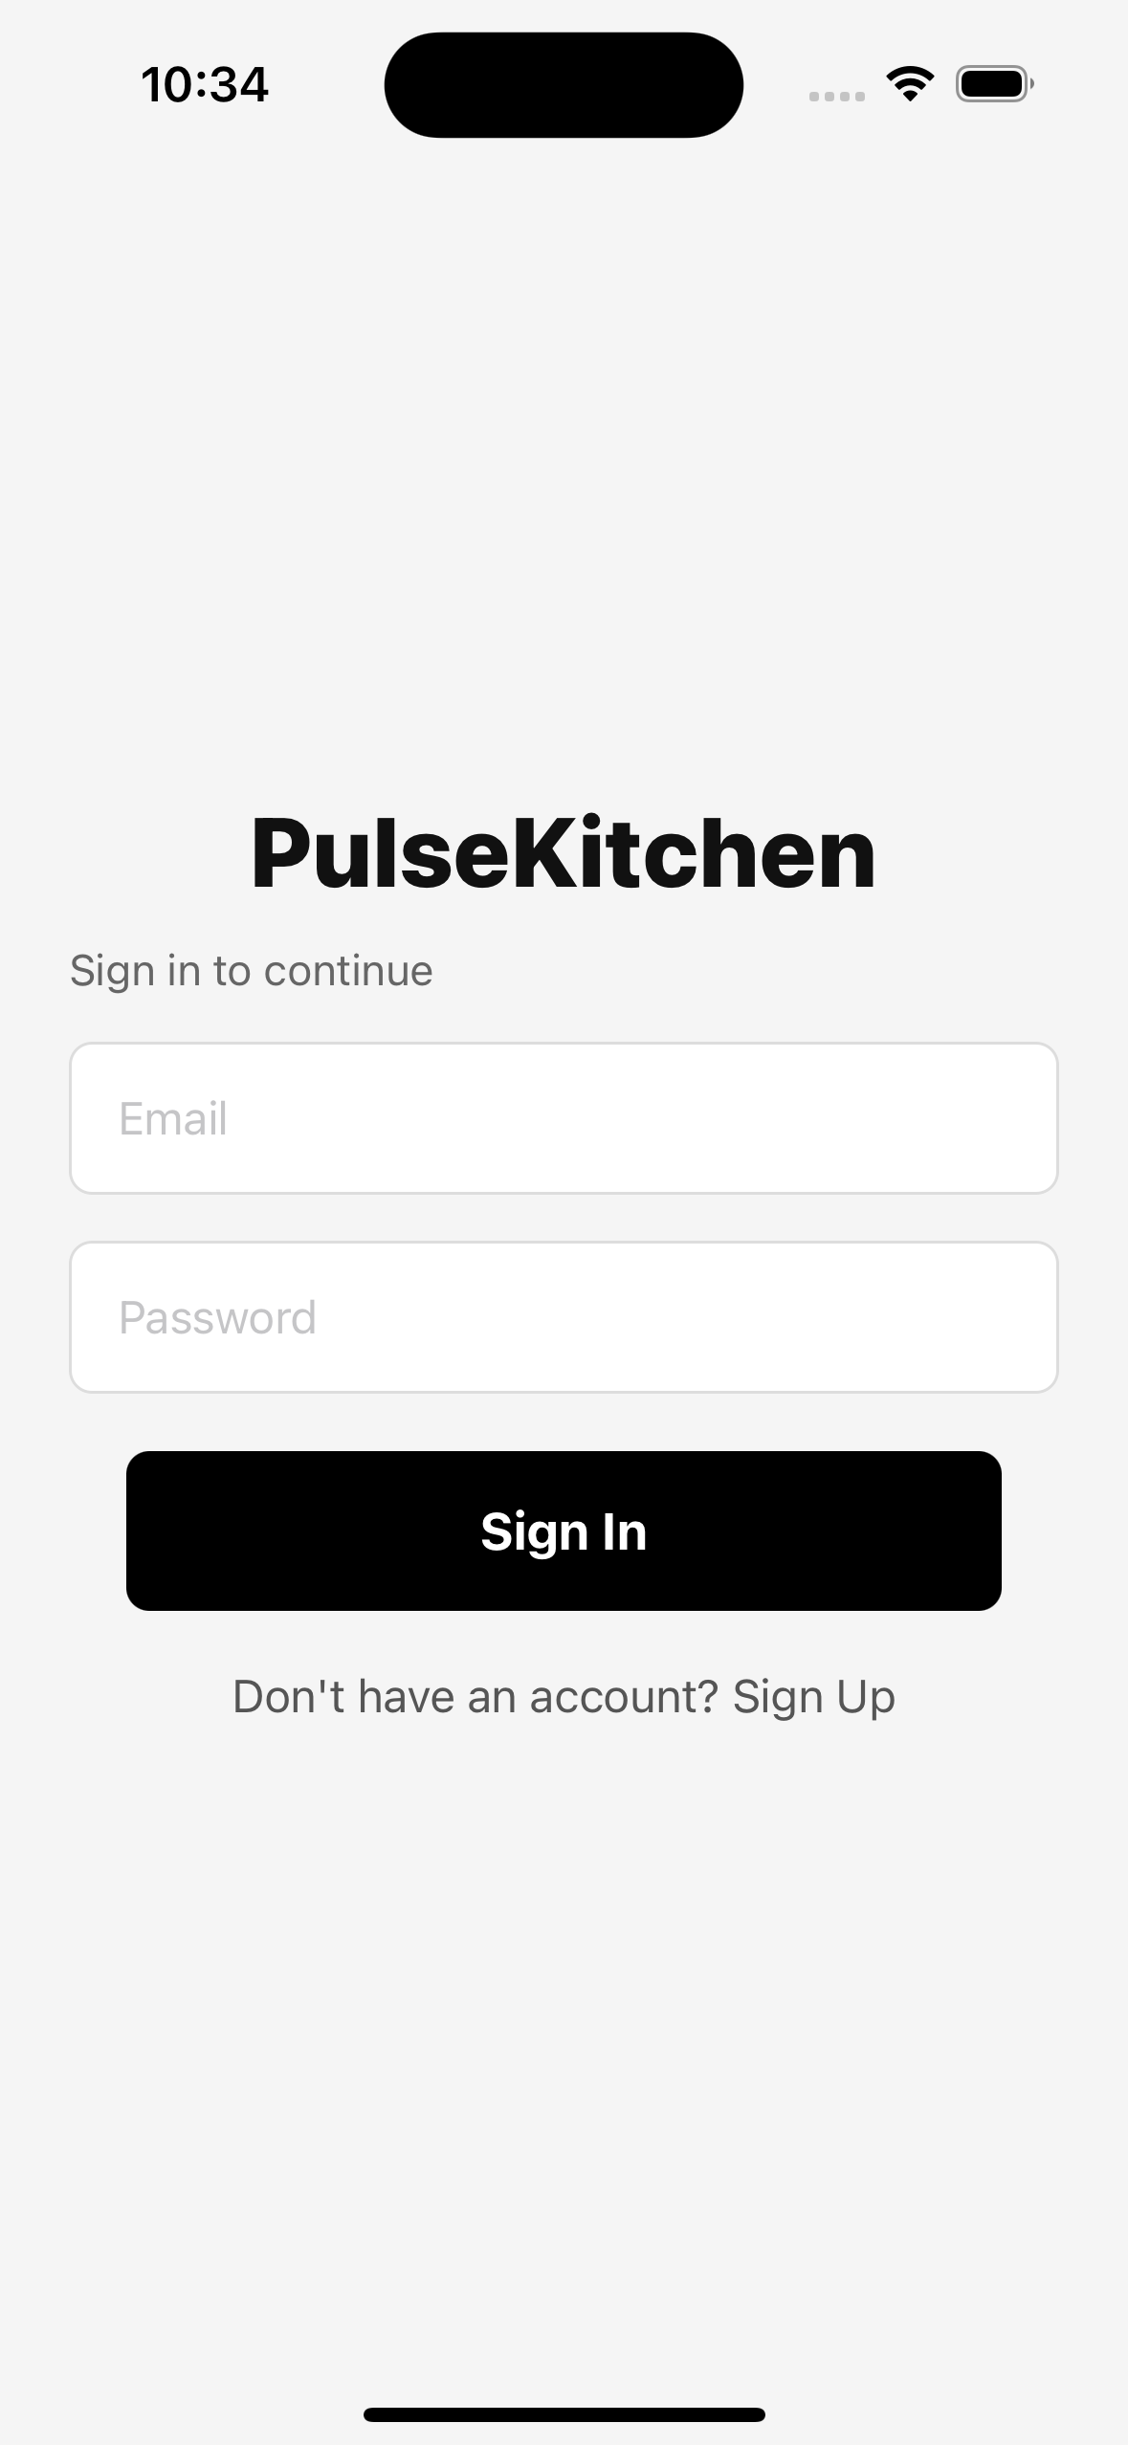
iOS simulator screenshot of the PulseKitchen login page.
SS-S-02: Home screen
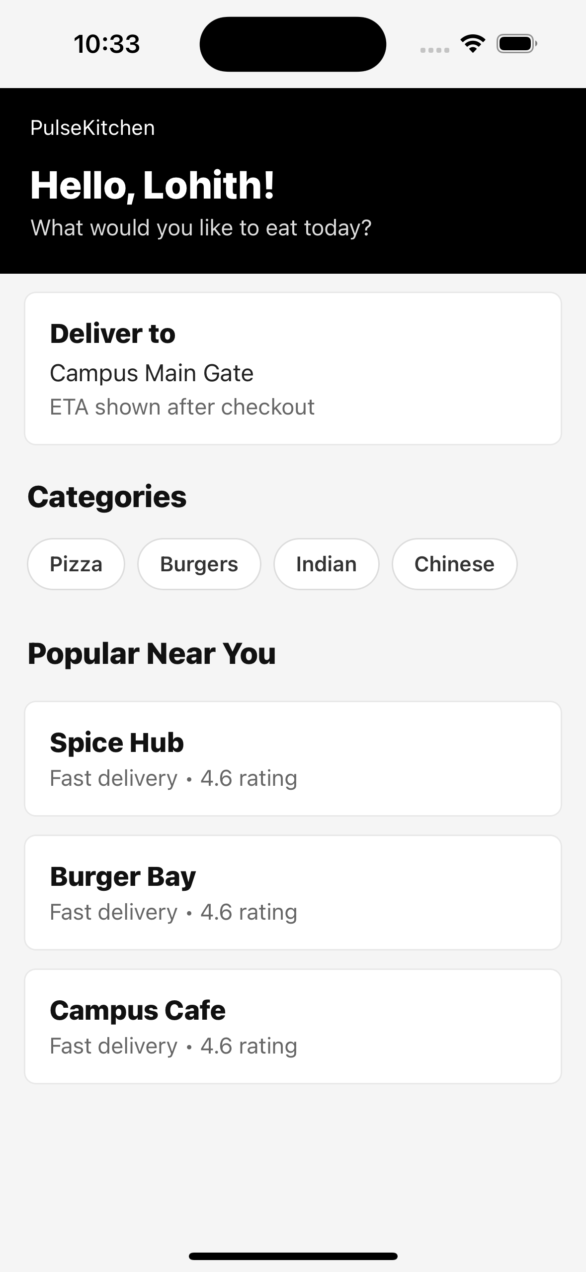
iOS simulator screenshot of the customer home page.
SS-S-03: Restaurant list screen
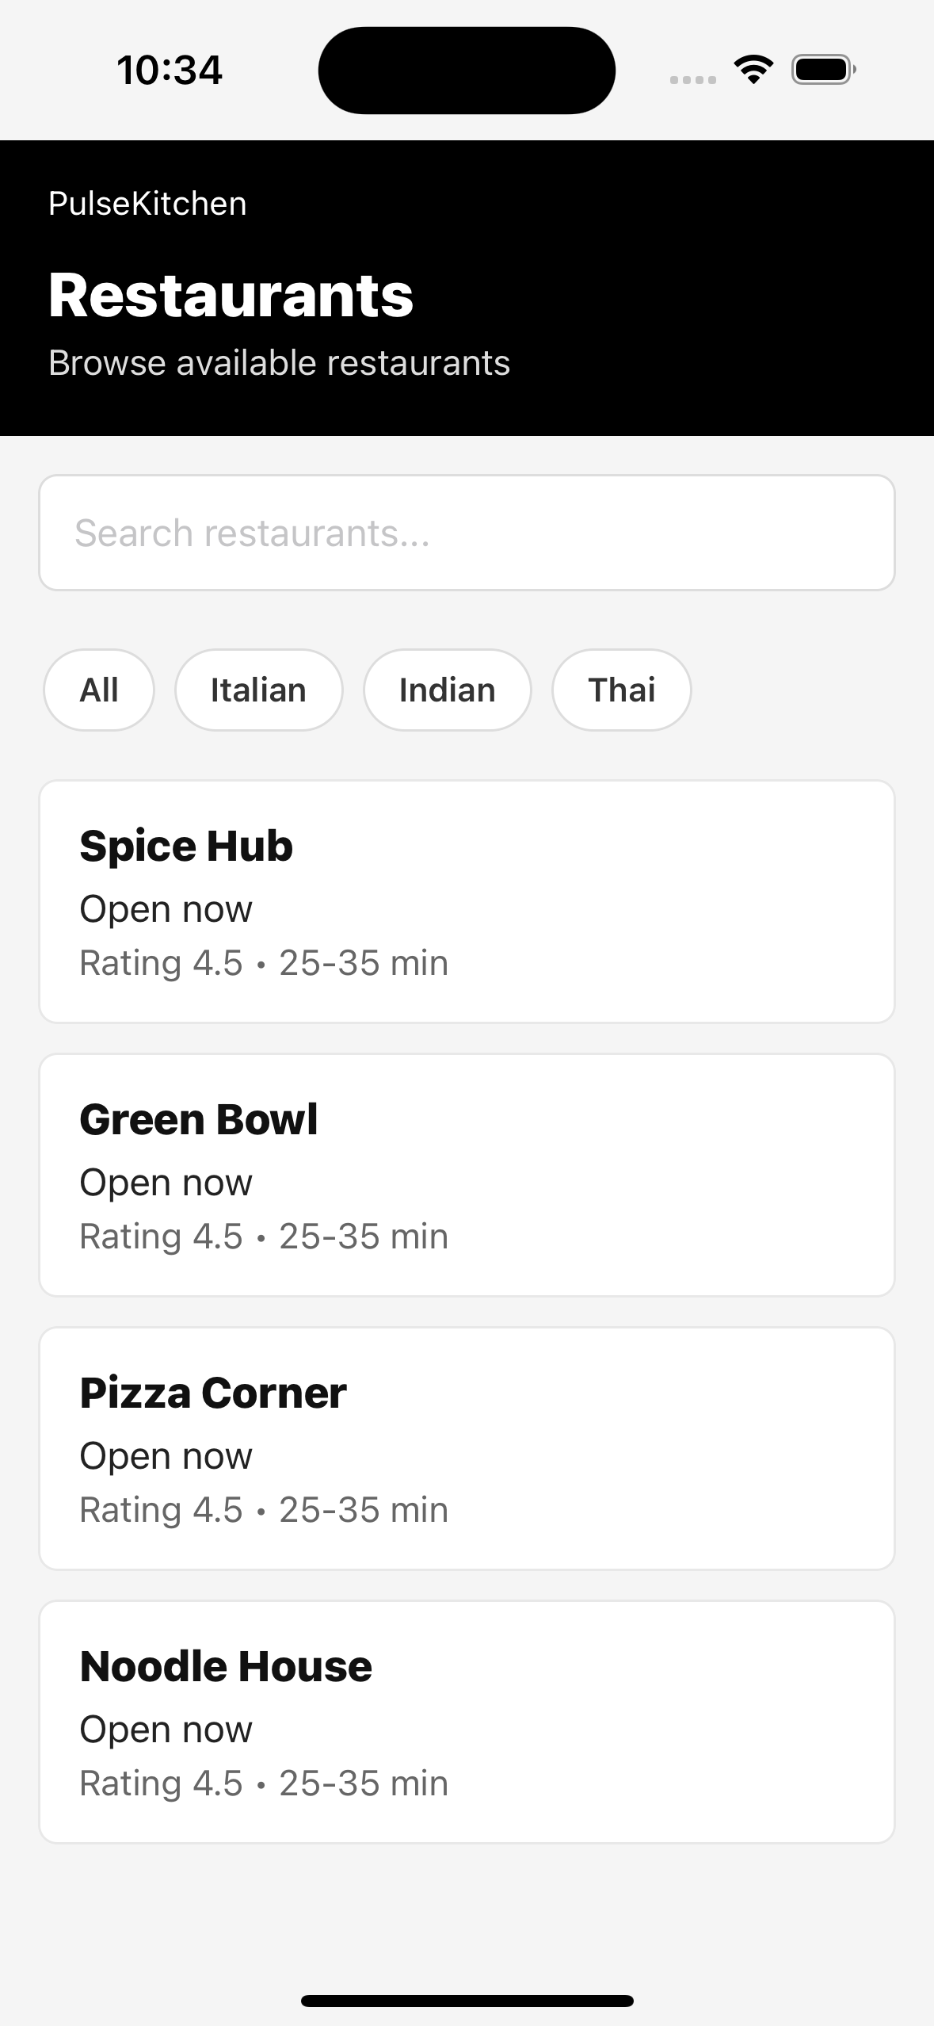
iOS simulator screenshot of restaurants and filters.
SS-S-04: Cart / checkout screen
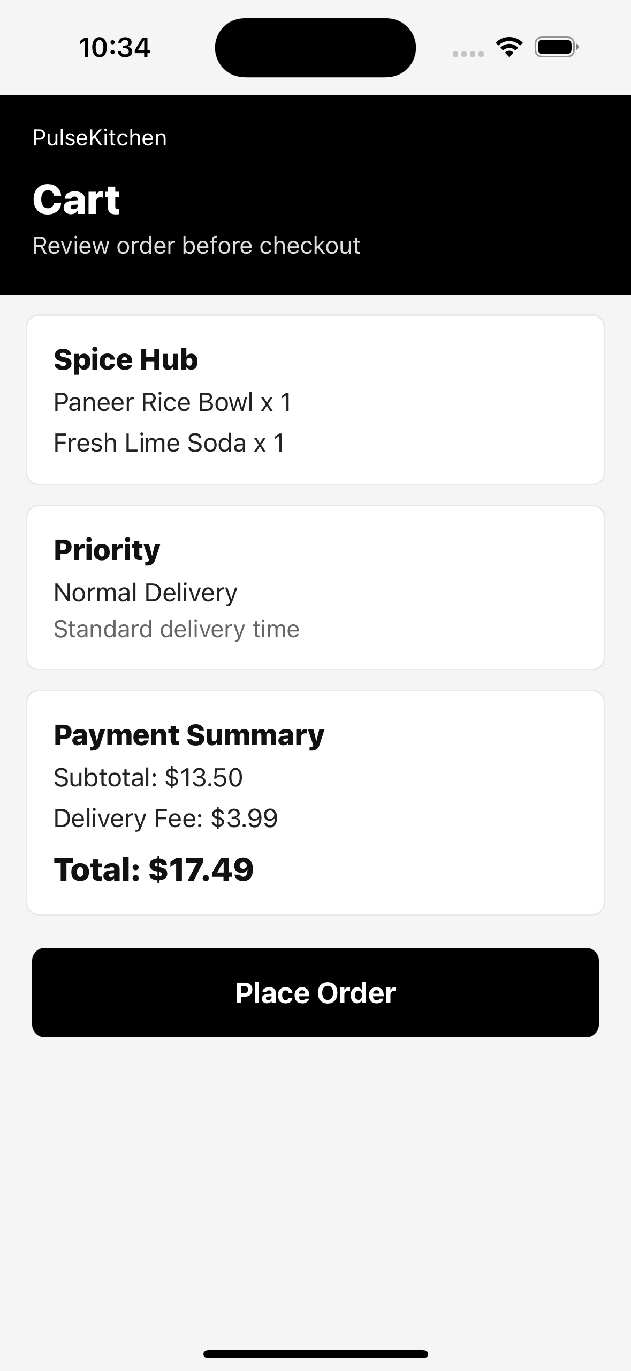
iOS simulator screenshot of cart items and payment summary.
SS-S-05: Orders history screen
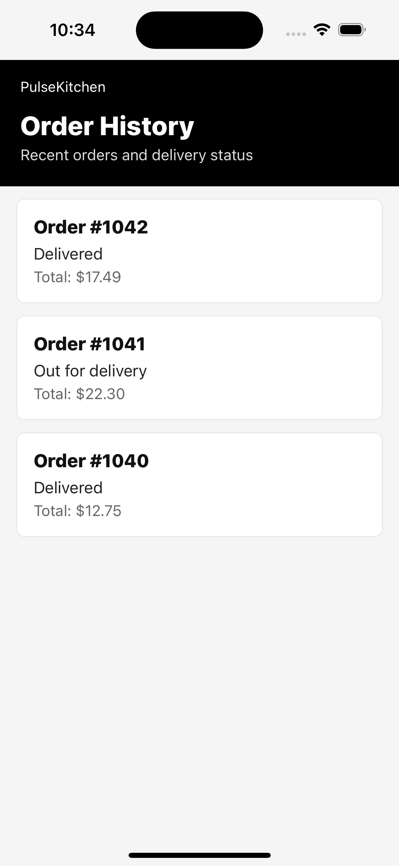
iOS simulator screenshot of recent order status list.

SS-S-05: Travel Emergency
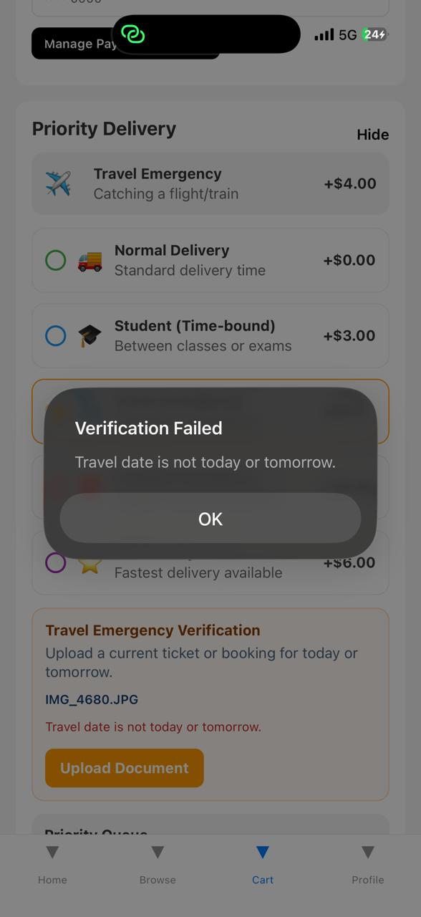
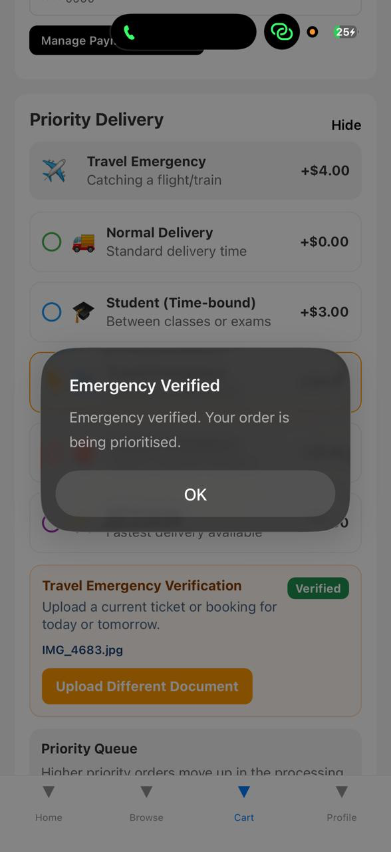

8. Entry and Exit Criteria

8.1 Entry Criteria
- Local project source code is available and dependencies are installed.
- Mobile app test suite can be executed with npm test from the mobile-app directory.
- Backend pytest dependencies are available for order-service and delivery-service tests.
- Required test accounts and verification sample files are prepared.
- Database, queue and cache services are available or mocked for the selected test level.

8.2 Exit Criteria
- All high priority test cases have been executed or have documented evidence.
- No unresolved critical defect remains open for the assigned scenario.
- Test pass rate is at least 95 percent for high priority tests.
- Traceability across login, restaurant, cart, priority, payment, delivery, notification and admin modules is complete.
- Final document includes actual results, pass/fail status and copied automation output.

9. Defect Management
Defects are recorded with module, severity, observed result, expected result, status and retest action. Any failed case must be retested after correction before final submission.
Defect ID | Module | Observation | Status | Action
None | All Assigned Modules | No blocking defect observed in assigned execution set. | Pass | Continue regression testing before final release.

Severity | Definition | Target Resolution
Critical | Application crash, data loss, payment loss, or complete ordering failure | Same day
High | Major module broken; no practical workaround | Within 24 hours
Medium | Feature partially works and workaround exists | Within 3 days
Low | Minor UI, wording or cosmetic issue | Next release

10. Test Metrics
Metrics will be reported with the final test status report and used to summarize readiness for review.
Metric | Formula / Description
Test Case Pass Rate | (Passed / Total Executed) x 100
Defect Density | Total defects found / Total test cases executed
Defect Fix Rate | Fixed defects / Total defects x 100
Requirements Coverage | Test cases mapped / Total in-scope requirements x 100
Test Execution Progress | Executed / Total planned x 100
Automation Evidence Coverage | Cases with copied output or documented actual result / Total executed cases x 100

