

Engineering Science Design Project
“CO2 Adsorption in Packed-Bed Column using Polymer-based Sorbent: Parametric Study and Model Prediction”
Interim Report

Student Names: Loh John Ray (S10267908K)
Saraswati Eloise Gunawan (S10267534J)

NP Supervisor: Dr. Pham The Hanh

Institution Supervisor: Prof. Erik Birgersson
Dr. Prapatsorn Borisut
Project Group ID: 3
Project Period: April 2026 – August 2026
Report Date: 18 May 2026

Declaration by students:
- By submitting this report online, I confirm that the report has been submitted to and vetted by my institution supervisor and thereby confirm that the report contains no confidential material from the company.
- I declare that the report is written by me and not plagiarised from other sources.

____________________
Students Signature / Date

Abstract
The growing demand for scalable carbon capture technologies has intensified research into adsorption processes, particularly using amine-impregnated capture sorbent. In this paper, a comprehensive review on breakthrough models, discussing the process parameters and assumptions is provided. Models are validated against breakthrough data at three inlet CO₂ concentrations (5, 10 and 15% by volume) at three flow rates (50, 100 and 150 ml/min), across a 3×3 design of experiment. Existing problems in breakthrough adsorption including data reliability, complete and partial breakthrough curves are discussed, and a standard operating procedure (SOP) is proposed to solve these issues. Breakthrough data are further employed to evaluate existing adsorption breakthrough models and support predictive modelling in Python, with the aim of identifying operating conditions that enhance CO₂ capture efficiency.

Table of Contents
Abstract 2
Table of Contents 3
List of Figures 5
1 Introduction 6
1.1 Scope of Project 8
2 Project Outline and Objectives 8
2.1 Project Outline 8
2.2 Project Objectives 9
2.2 Project Schedule 10
3 Literature review 16
3.1 Overview 16
3.2 Adsorption process 17
3.3 Packed-bed adsorption and breakthrough behaviour 18
3.3 Adsorption Isotherms 21
3.3.1 Langmuir Isotherm 21
3.3.2 Toth Isotherm 22
3.4 Adsorption breakthrough models 22
3.4.1 Bohart-Adams Model 23
3.4.2 Thomas Model 23
3.4.3 Yoon-Nelson Model 24
3.4.4 Mathematical equivalence of traditional breakthrough models 24
3.4.5 Clark Model 25
3.4.6 Gudermannian and Error functions 26
3.4.7 Weibull and Avrami Models 26
3.5 Review of Prior Solutions 26
3.5.1 Classical Symmetric Models 27
3.5.2 Models for Asymmetric Breakthrough Curves 27
3.5.3 Implication for Packed-Bed CO₂ Capture 27
3.6 Design or Research Procedure 28
4. Standard Operating Procedure for CO₂ Adsorption Experiment 28
4.1 Apparatus and Instrumentation 30
4.1.1 Gas Feeding Section 30
4.1.2 Adsorption Column 31
4.1.3 Gas Analysis and Monitoring 31
4.1.4 Pre-Run Preparation 31
4.2 Experimental Procedure 32
4.2.1 Sensor Setup and Calibration 32
4.2.3 Feed Gas Preparation 32
4.2.2 Column Loading and Purge 33
4.2.4 CO₂ Adsorption (Breakthrough Experiment) Run 34
4.3 After the Run 35
4.3.1 Acceptance Criteria and Validity 35
4.4 Data to Record 35
4.5 Safety Notes 36
5 Experimental Results 36
6 Experimental Analysis 38
7 Conclusions 40
7.1 Next Steps 41
8 References 42

List of Figures
Fig. 1) Greenhouse gas emissions by sector in Singapore, 2023. Adapted from CO₂ and Greenhouse Gas Emissions, by H. Ritchie and P. Rosado, 2025, Our World in Data (https://ourworldindata.org/profile/co2/singapore).
Fig. 2) Research methodology design of design for CO2 breakthrough adsorption.
Fig. 3) Packed-bed configuration. Influent gas flows axially towards the outlet along the $x$-axis. A cylindrical packed-bed column of length $L$ and internal radius $R$, filled with spherical or near-spherical PEI@SiO2 granules of mean diameter $d_{p}$. A gas mixture of CO2 (mole fraction $y_{in}$) in N2 enters at superficial velocity $u_{s}$ and temperature $T_{in}$.
Table 1) Weekly Gantt chart schedule for Design Project; timeline is split into phases and tasks within each phase ensure that deliverables are clearly defined and progress is on track; one week is represented as ‘W’; (a) Weeks 0 to 5; (b) Weeks 8 to 13
Fig. 5 & 6) Sourced from SUTD via Dr. Prapatsorn in Project_introduction.pptx. Shows lab setup for granule-based adsorption experiments using packed-bed columns via polymer-based sorbents; where $C_{0}$ is the sorbate initial concentration, $C_{t}$ the sorbate concentration at time $t$, $t_{0}$ the breakthrough time, $t_{E}$: equilibrium time (saturation time), $V_{0}$: superficial velocity, $v$: interstitial velocity, $Q_{o}$: initial gas volumetric flow rate, $A_{c}$: column cross-sectional area.
Fig. 7) shows an image of the adsorption setup, including the gas supply lines, MFCs, adsorption column, and associated sensors. The valves are labelled 1 to 5, and will be referenced as such in the rest of the SOP.
Fig. 8) Labelled process flow diagram of CO₂ adsorption in fixed-bed column
Fig. 9) Predicted vs. observed values in breakthrough models fit using scipy.optimise_curve.fit()
Fig. 10) Breakthrough curve fitting with linear adsorption isotherm using scipy.optimise_curve.fit()

1 Introduction
Anthropogenic carbon dioxide (CO₂) emissions are a primary driver of climate change (Shariff et al., 2012). Atmospheric CO2 concentrations rose from 280 ppm to over 440 ppm above pre-industrial levels today and is expected to rise to 900 ppm should current CO2 emissions level persist (Xu et al., 2024). As a result, global temperatures are rising with more frequent extreme weather events, and a rising sea-level. While nations aim to limit global warming, conventional emissions reduction strategies are insufficient to meet the 2$℃$ target set during the Paris Agreement. More pressingly, carbon dioxide accumulation also has immediate consequences for human health, comfort, and wellbeing (IPCC, 2023; WMO, 2023) across two distinct operational scales.
At the atmospheric level, anthropogenic CO2 emissions drive climate-induced heatwaves and severe environmental disruptions. These systemic shifts placed unprecedented strain on public health, particularly among vulnerable demographics such as the elderly, children, and outdoor workers, while simultaneously threatening infrastructure resilience and global food security (IPCC, 2023; WMO, 2023).
Secondly, modern populations spend most of their time indoors. Localised CO2 accumulation can show poor ventilation and degraded air quality. Ambient indoor concentrations exceeding 800 ppm are explicitly linked to acute physiological symptoms, including headaches, chronic fatigue, dizziness, and upper respiratory tract irritation (Norbäck & Nordström, 2008; Tsai et al., 2012). In high-density environments like offices and schools, these elevated levels aggravate chronic conditions such as asthma and severely impair cognitive performance and workplace productivity (Simoni et al., 2010; Carreiro-Martins et al., 2014).

Fig. 1) Greenhouse gas emissions by section in Singapore (2023)
This issue of increased CO₂ levels is especially relevant in Singapore, where land is limited and the economy is closely tied to hard-to-abate sectors (Ritchie & Rosado, 2025) such as shipping, aviation, and petrochemicals as shown in Fig. 1). Thus, Singapore cannot rely on land-intensive carbon sinks such as large-scale afforestation to reduce the CO₂ in the atmosphere and will need solutions to curb excessive increase in indoor settings. As a result, there is growing interest in compact and scalable carbon capture technologies that can reduce CO₂ emissions more effectively.
Fixed-bed column adsorption presents a promising separation method for CO₂ capture due to its simple setup and fast adsorption-desorption cycles. Recent developments in CO2 capture by adsorption demonstrate the attractiveness of this technique for post-combustion treatment of flue gas. Various adsorption technologies such as pressure swing adsorption (PSA), vacuum swing adsorption (VSA), temperature swing adsorption (TSA) and moisture swing adsorption (MSA) are thus viewed as scalable CO2 separation and purification techniques. Prior to the design of an adsorption process, many studies concerning the selection of an appropriate adsorbent material for CO2 capture have resulted in a wide variety of adsorbent materials investigated. Sorbent materials for low-pressure CO2 capture, such as amine-functionalised materials, zeolites, metal oxides, metal-based materials, silicas, activated carbon and carbon molecular sieves (Chuah et al., 2025; Xu et al., 2005), have varying process dependent parameters (i.e. selectivity, working capacity, desorption capacity, etc). Solid sorbent-based carbon capture offers advantages over amine scrubbing: lower regeneration energy, reduced corrosion, and tolerance to moisture (Qi et al., 2011). Amine-functionalised silica sorbents, particularly polyethyleneimine (PEI) impregnated SiO₂ exhibit high CO₂ selectivity, fast kinetics and good cyclic stability (Qi et al., 2011; Jung et al., 2017).

1.1 Scope of Project
Development of a mathematical model is essential to describe the complex dynamics of adsorption. However, existing phenomenological models often fail to capture all process-dependent parameters. Furthermore, constructing predictive models solely through extensive experimentation is both time-consuming and costly (Siahpoosh et al., 2009). In principle, models that utilise established parameters, such as adsorption rate constants and equilibrium data, can estimate column capacity without extensive experimental work. However, prediction of column dynamics requires the solution of a set of simultaneous partial differential equations (PDEs) representing mass, energy and momentum balances over a fixed bed with appropriate boundary conditions (Hwang et al., 1995). Thus, the use of simpler and more tractable models (Hu et al., 2024) that can satisfactorily predict fixed-bed behaviour is desirable. The literature survey reveals how these simplified assumptions can be made to represent transport phenomena within adsorbent particles as an alternative way to investigate fixed-bed adsorption calculations.

2 Project Outline and Objectives

2.1 Project Outline
This project addresses the need for effective CO₂ capture technologies that can be applied in compact, modular systems. The experimental work is centered on a packed-bed adsorption setup designed to capture CO₂ using Carbon Capture Composite (C³) granules (Wong et al., 2021). The system was selected because adsorption is well suited to diluting gas streams and can be operated with relatively low energy demand compared with liquid-based capture systems (Karimi et al., 2023; Stampi-Bombelli et al., 2024).
The project began with laboratory familiarisation, followed by the procurement of components and assembly of the experimental setup. After this, we developed a standard operating procedure (SOP) and planned the design of experiments (DOE) for the adsorption runs. The technical understanding gained so far indicates that breakthrough behaviour is strongly influenced by inlet concentration, flow rate, and the interaction between the gas stream and the sorbent surface (Jin et al., n.d.; Karimi et al., 2023). These factors hence form the basis for the experimental and modelling work in the project.
The aim of this project was to review and understand existing breakthrough models (Myers et al., 2023; Hu et al., 2024) and apply practical templates (Lin, 2017; Juela, 2021) against collected breakthrough data. These models were experimentally verified at three inlet CO₂ concentrations (5, 10 and 15% by volume) at three flow rates (50, 100 and 150 ml/min). The system’s adsorption performance across a 3×3 parameter sweep will be compared to support model development and validation. The overall aim is to determine how operating conditions affect the adsorption behaviour of the packed-bed column and to assess the suitability of the sorbent system for future carbon capture studies.
Problem Statement: To design and analyse a packed-bed column for CO₂ capture using PEI@SiO₂ granules, evaluating breakthrough dynamics and validating predictive models.

2.2 Project Objectives
The project aims to:
- Assemble and operate the packed-bed adsorption experimental setup.
- Carry out breakthrough experiments using C³ granules.
- Study the effects of CO₂ concentration and flow rate on adsorption capacity.
- Fit and validate breakthrough models using Python.
- Identify operating conditions that improve adsorption performance.

2.2 Project Schedule
Table 1. Design Project Schedule (a) Timeline for Weeks 0 to 6; (b) Timeline for Weeks 8 to 13;
Phase (a) | Task | W0 (20/04) | W1 (27/04) | W2 (04/05) | W3 (11/05) | W4 (18/05) | W5 (25/05)
Deliverables | First Meetings w/ Supervisors
 | Literature Review
 | Bi-weekly Journal #1
 | Defining our Problem Statement
 | Refining our Problem Statement
 | Bi-weekly Journal #2
 | Submit First Draft of Interim Report
 | Interim Report
 | Interim Review & Presentation
 | Bi-weekly Journal #3
 | Bi-weekly Journal #4
 | Final Report
 | Final Presentation
Literature  Review | Review on CO2 capture (material and technology)
 | Review on packed bed adsorption and models
 | Review on breakthrough model
 | Review data analysis methods
 | Review mathematical models (Toth, DK)
 | Finalise Models to Use
Mathematical Modelling | R-H shock + travelling wave (Myers & Font 2020)
 | Method of lines+stiff ODE theory
 | Upwind schemas, CFL, numerical diffusion (LeVeque, Ch. 6-7)
 | Constant pattern analysis (Ruthven, Ch. 8)
 | Sensitivity equations; forward sensitivity analysis
 | Breakthrough metrics (Ruthven, Ch. 5)
 | Dimensionless analysis (Pe, NTU, α)
 | Response surface design (Montgomery, Ch. 1)
Experimentation  Preparation | Prepare Bill of Materials (BOM)
 | Rig Familiarisation
 | Standard of Procedure (SOP)
 | Equipment Setup
 | Data acquisition & curve-fit workflow setup
 | Pre-Session Checks (recurring)
Experimentation  Execution | OAT - vary flow rate & concentration
 | Model Fitting & Error Minimisation
 | Validation runs - baseline (4 exp; PFO/DK model)
 | Addition/Repeat (if required)

Phase (b) | Task | W8 (15/06) | W9 (22/06) | W10 (29/06) | W11 (06/07) | W12 (13/07) | W13 (20/07)
Deliverables | First Meetings w/ Supervisors
 | Literature Review
 | Bi-weekly Journal #1
 | Defining our Problem Statement
 | Refining our Problem Statement
 | Bi-weekly Journal #2
 | Submit First Draft of Interim Report
 | Interim Report
 | Interim Review & Presentation
 | Bi-weekly Journal #3
 | Bi-weekly Journal #4
 | Final Report
 | Final Presentation
Literature  Review | Review on CO2 capture (material and technology)
 | Review on packed bed adsorption and models
 | Review on breakthrough model
 | Review data analysis methods
 | Review mathematical models (Toth, DK)
 | Finalise Models to Use
Mathematical Modelling | R-H shock + travelling wave (Myers & Font 2020)
 | Method of lines+stiff ODE theory
 | Upwind schemas, CFL, numerical diffusion (LeVeque, Ch. 6-7)
 | Constant pattern analysis (Ruthven, Ch. 8)
 | Sensitivity equations; forward sensitivity analysis
 | Breakthrough metrics (Ruthven, Ch. 5)
 | Dimensionless analysis (Pe, NTU, α)
 | Response surface design (Montgomery, Ch. 1)
 | Modelling in Python
Experimentation  Preparation | Prepare Bill of Materials (BOM)
 | Rig Familiarisation
 | Standard of Procedure (SOP)
 | Equipment Setup
 | Data acquisition & curve-fit workflow setup
 | Pre-Session Checks (recurring)
Experimentation  Execution | OAT - vary flow rate & concentration
 | Model Fitting & Error Minimisation
 | Validation runs - baseline (4 exp; PFO/DK model)
 | Addition/Repeat (if required)

Legend
Done | Recurring
Not Started
In Progress
Submission

3 Literature review

3.1 Overview
Experimental data
Breakthrough curve
$c/c_{0}$ vs. $t$

Breakthrough model types
Application scope
Adsorption principles
Breakthrough models
Linear fitting
Nonlinear fitting
Data fitting (parameter estimation)
Error functions
Plot of residuals
Optimal model
Prediction
Mathematical modelling

Legend:
Decision nodes
Input nodes

Fig. 2) Research methodology design for CO₂ breakthrough adsorption

3.2 Adsorption process
Adsorption is a surface phenomenon in which molecules from a gas or liquid phase accumulate on the surface of a solid material rather than penetrating its bulk structure. The term originates from the Latin adsorptio or adsorbere, meaning “to draw towards” or “to suck in”, which reflects the tendency of molecules to be retained at a surface through intermolecular interactions (Etymonline, 2024; Wiktionary, 2021). Physisorption, where gas molecules attach to the surface through weak van der Waals forces, is quickly reversible via regeneration but results in poor selectivity at low partial pressures as most physical sorbents lose most of their CO₂ capacity in the presence of humidity because water competes for the same sites (Xu et al., 2024). Chemisorption forms covalent or ionic bonds with CO₂ and is highly selective; amine-functionalised sorbents leverage this by impregnating amine groups that react with CO₂ via two distinct mechanisms: (i) carbamate-ammonium ion pairs are formed under dry conditions and can hydrolyse to bicarbonate in the presence of water and; (ii) polymer plasticisation induced chain mobility can enable CO2 to access the amine-sites that were previously inaccessible.
Amine-functionalised silica composites represent a major class of solid sorbents for CO₂ capture. These materials combine the high CO₂ affinity of amines with the large surface area and pore volume of porous silica supports. Chen et al. (2020) classified amine-silica composites into three categories based on preparation method: (i) physical impregnation of polymeric amines such as polyethylenimine (PEI) or tetraethylenepentamine (TEPA) into porous supports; (ii) chemical grafting of aminosilanes via covalent bonding to surface silanol groups; and (iii) in-situ polymerisation of amine-containing monomers to create hyperbranched aminosilicas (Chen et al., 2020). The review by Chen et al. (2020) emphasised that mesoporous silica supports such as MCM-41, SBA-15, and KIT-6 have been widely studied, with textural properties (particularly pore diameter and pore volume) playing a critical role in determining CO₂ capture performance at a given amine loading.
In particular, PEI-fumed structured sorbents exhibits two distinct classes of amine sites: (i) accessible surface amine sites at the PEI-gas interface, and (ii) bulk amine-layer sites buried within the PEI polymer matrix, which require diffusion through the viscous polymer before CO₂ can react (Bollini et al., 2012; Kalyanaraman et al., 2015; Stampi-Bombelli et al., 2024). This heterogeneity produces the characteristic sharp initial breakthrough followed by a prolonged tail observed experimentally in amine-functionalised sorbents, which a simple pseudo-first-order (PFO) model cannot capture. This resulted in extensive research into adsorption modelling, particularly in packed-bed columns, which is one of the simplest configurations for studying breakthrough adsorption behaviour.

3.3 Packed-bed adsorption and breakthrough behaviour
$$c_{in}$$
$$u_{in}$$
$$x$$
Fig. 3) Packed-bed configuration. Influent gas flows axially towards the outlet along the $x$-axis.
$d_{p}$

Fig. 4) Diagram of spherical PEI@SiO₂ granule of mean diameter $d_{p}$
Packed beds filled with pellets have long been the preferred design for adsorption processes due to their ease of processing, costs, flow distributions and ease to handle (Born et al., 2024). However, packed bed pressure drop primarily depends on the gas velocity and pellet size. Moreover, the increase in pressure drop generally leads to excessive power consumption (de Joannis, 2025). The system under consideration as shown in Fig. 3) is a cylindrical packed-bed column of length $L$ and internal radius $R$, the bed is filled with spherical or near-spherical PEI@SiO₂ granules of mean diameter $d_{p}$ as shown in Fig. 4). In Fig. 3), a gas mixture of CO₂ (mole fraction $c_{in}$) in N₂ enters the column at superficial velocity $u_{in}$.
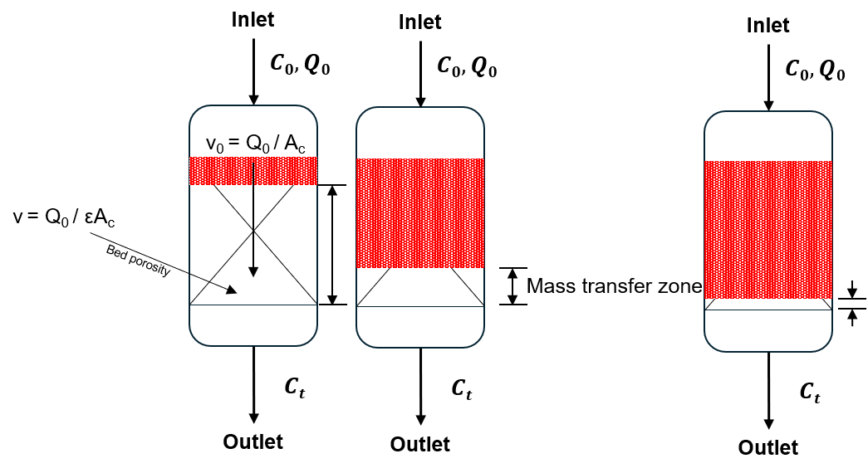
Fig. 5) Schematic diagram of MTZ traveling through a fixed-bed column
In a fixed-bed column, fresh gas enters one end and pushes a sharp adsorption front, called the mass transfer zone (MTZ) progressively towards the outlet. In Fig. 4) the inlet CO₂ concentration (mole fraction $C_{0}$) flows through the packed bed at a volumetric flow rate of $v_{0}$. As the CO₂ gas gets adsorbed by the adsorbent material, the adsorption zone is indicated by the red-shaded region travelling axially through the columns at a speed much slower than the influent gas velocity.
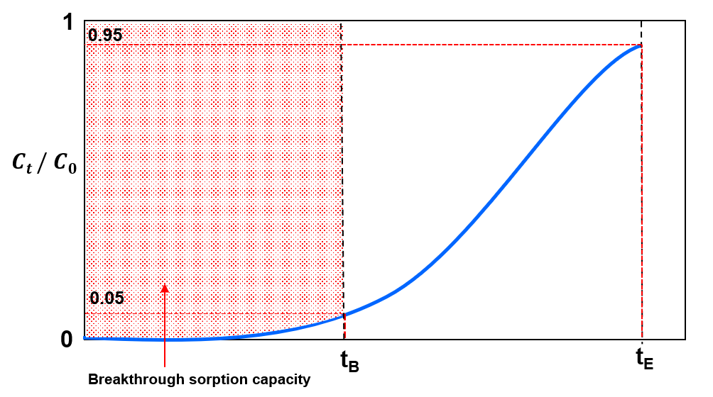
Fig. 6) Breakthrough curve diagram through a fixed-bed column
Hence, in Fig. 5) the bed divides into three zones during adsorption: saturation zone, mass-transfer zone, and adsorption zone. In the saturation zone, the adsorbent contaminant reaches dynamic equilibrium, where the amount absorbed, $q_{0}$, is in equilibrium to the influent concentration, $c_{0}$. Thus, the loading capacity of the adsorbent is exhausted, and no mass transfer takes place. Adsorption only occurs in the MTZ, in which the adsorbent accumulates molecules continuously from the feed, and the amount adsorbed in the bed increases from zero to $q_{0}$. The shape and length of the MTZ largely depends on the rate of adsorption, $κ$, and the shape of the isotherm curve. Breakthrough is registered when the MTZ first reaches the outlet, and the resulting S-shaped breakthrough curve is a mirror of the MTZ whose sharpness is set jointly by the rate of adsorption and the curvature of the equilibrium isotherm (Hu et al., 2024). With the assumptions: (i) plug flow in the axial direction; (ii) negligible radial dispersion; (ii) a linear driving force for solid adsorption; (iii) uniformly spherical adsorbent particles and; (iv) constant geometric dimensions, interstitial velocity, and void fraction (Hu et al., 2024). This behaviour can be described by the following mass-balance equation:
$$\frac{δc}{δt}+u\frac{δc}{δz}+\frac{1-ε}{ε}\frac{δq_{t}}{δt}=D_{L}\frac{δ^{2}c}{δz^{2}}$$
where $c$ represents the adsorbate concentration in fluid phase, $z$ is the distance along the bed length, $u$ is the fluid velocity, $t$ denotes time, $ε$ is the void bed fraction, $q_{t}$ is the concentration in an adsorbent particle component and the effect of axial dispersion is lumped into a single effective axial dispersion coefficient $D_{L}$.
The advection term $u\frac{δc}{δz}$ and the axial dispersion term $D_{L}\frac{δ^{2}c}{δz^{2}}$ transport CO₂ along the column while the sink term $\frac{1-ε}{ε}\frac{δq_{t}}{δt}$ represents gas to solid phase transition via intraparticle resistances lumped as linear driving force (LDF). The axial dispersion coefficient can be estimated as $D_{L}=ud_{p}\left(\frac{20}{ε}\frac{D_{m}}{ud_{p}}+\frac{1}{2}\right)$ where $D_{m}$ is the molecular diffusivity. The linear driving force can be represented as the linear approach of the instantaneous loading $q_{t}$ to its equilibrium value $q_{e}$ expressed as:
$$\frac{δq_{t}}{δt}=k_{s}\left(q_{e}-q_{t}\right)$$
The initial and boundary conditions can be given via Danckwert’s boundary conditions for a dispersed plug flow, expressed as:
$$D_{L}\frac{δc}{δt}{\left.​\right|}_{z=0}=-u{\left.​\right|}_{z=0}\left(c_{i}{\left.​\right|}_{z=0^{-}}-c_{i}{\left.​\right|}_{z=0}\right), \frac{δc}{δz}{\left.​\right|}_{z=L}=0$$
where $c_{i}{\left.​\right|}_{z=0}$ is the feed composition for component $i$ and $L$ is the bed length.

3.3 Adsorption Isotherms
Adsorption depends on the concentration of the target molecule in the fluid and gas pressure in the bulk phase. Adsorption site heterogeneity combines the properties of the adsorbent at various amounts adsorbed, including surface area, pore volume, concentration of functional groups and pore-size distribution. The ‘heterogeneity’ of the adsorbent can be estimated by modelling the number of adsorption sites of the solid and their types (Kumar et al., 2021). Adsorption isotherms are graphs that indicate loading-pressure relationships in the $x$- and $y$-axis respectively. In the case of CO₂ adsorption, the x-axis represents pressure of CO₂ in gas phase (or the concentration of the species or partial pressure) while the y-axis represents CO₂ loading on the sorbent (or the number of adsorbed species by the adsorbent) at equilibrium (the state where the rate of molecules attaching to the sorbent surface equals to the rate of molecules being released from the sorbent). A wide variety of models have been formulated to describe the adsorption isotherms observed experimentally. Some of the more common adsorption isotherms are described in the following sections. In practice, CO2 capacity of PEI-impregnated sorbents will not be able to reach its maximum theoretical limit due to the mass transfer resistances involved.

3.3.1 Langmuir Isotherm
Assuming that: (i) adsorption of molecules occur at a fixed number of well-defined localised sites; (ii) each site only accommodates one adsorbent molecule (monolayer adsorption); (iii) the surface of the adsorbent is homogeneous i.e. all sites are energetically equivalent and; (iv) there are no interactions between the neighboring sites and molecules already adsorbed (Ruthven, 1985).
The Langmuir isotherm relates the surface coverage, $θ$, to pressure, $P$, and temperature, $T$:
$$θ=\frac{KP}{1+KP}$$
, where $K=\frac{1}{p^{0}}e^{-ϵ/kT}$ is the rate constant of equilibrium. We observe that for $KP≪1$, the model increases linearly. But as $KP$ increases (i.e pressure increases), the model converges to 1. Higher temperatures lead to slower asymptotic convergence. In the case where the amount adsorbed, $q$, is much smaller than the maximum adsorption capacity, $q_{s},$ a linear equation following Henry’s is derived: $θ=KP$.
Langmuir isotherm assumes a homogeneous (i.e. uniform) binding site distribution. Discrete models attempt to preserve model heterogeneity by assuming a discrete number of different adsorption sites (K. Vasanth, n.d.). However, different adsorbents have different numbers of adsorption sites with varying binding energy. Continuous distribution functions are considered an improvement to discrete models—considering the affinity spectrum which is a plot of the binding affinity against the number of adsorption sites. A Toth isotherm is hence used to model both a homogeneous and heterogeneous distribution of adsorption site affinities. The values of parameters of the Toth model can be found by nonlinear curve fitting method using sigma plot software (Benzaoui et al. 2017).

3.3.2 Toth Isotherm
In this work, as a case study, we used only the three-parameter Toth isotherms to describe adsorption on both homogeneous and heterogeneous surfaces. Mathematically, the Toth isotherm can predict the monolayer adsorption capacity of a homogeneous surface that will match with the surface area predicted by Langmuir isotherm. The Toth isotherm (1971) is given by:
$$q=q_{s}{\left[\frac{k_{T}p}{1+{\left(k_{T}p\right)}^{t}}\right]}^{\frac{1}{t}}$$
, where $k_{T}$ and $t$ are the Toth isotherm constants. $k_{T}$ is related to the binding energy, $q_{s}$ is the monolayer adsorption capacity.

3.4 Adsorption breakthrough models
Traditional breakthrough models i.e. Bohart-Adams, Thomas, Yoon-Nelson are dissected and expressed as a single logistic function in three notations: $k_{YN}=k_{BA}c_{0}=k_{T}c_{0}; τ=\frac{a_{0}x}{uc_{0}}=\frac{q_{0}m}{vc_{0}}$. For the more general Clark model, when $n≠2$, the dominant mass-transfer mechanism results in an asymmetric breakthrough curve. Thus, empirical breakthrough models like the Gudermannian and error functions (Hu et al., 2021) with the involvement of fractal-like kinetics i.e. $k\left(t\right)=k_{0}t^{-h}$, where $h$ is the heterogeneity parameter—is needed to fit asymmetric breakthrough curves.

3.4.1 Bohart-Adams Model
Bohart-Adams and other models discussed below remain popular because it can be linearized, allowing unknown parameters to be determined via linear regression analysis. The Bohart-Adams model predicts a linear relationship between bed depth and breakthrough time. Interestingly, the form—also known as an incorrect “Adams-Bohart” model originates from a 1995 paper by Guibal et al. which provided no derivation—is expressed as (Hu et al., 2025):
$$\frac{c}{c_{0}}=\frac{1}{1+\exp\left[K_{BA}c_{0}\left(\frac{a_{0}x}{uc_{0}}-t\right)\right]}$$
However, the appropriate analytical solution for the adsorbate concentration at the column as a function of time is given as (Khim, 2019; Hu et al., 2024):
$$\frac{c}{c_{0}}=\frac{\exp\left(k_{BA}c_{0}t\right)}{\exp\left(\frac{k_{BA}a_{0}x}{u}\right)+\exp\left(k_{BA}c_{0}t\right)-1}$$
Rewriting this into its linear form gives us (Khim, 2019):
$$\ln\left(\frac{c_{0}}{c}-1\right)=\ln\left[\exp\left(\frac{k_{BA}N_{0}L}{u}\right)-1 \right]-k_{BA}c_{0}t$$
As the rate of adsorption ($k_{BA})$ becomes very large,
$$\ln\left(\frac{c_{0}}{c}-1\right)=\frac{k_{BA}N_{0}L}{u}-k_{BA}c_{0}t$$
Thus, $k_{BA}$ can be evaluated by finding the slope of $\ln\left(\frac{c_{0}}{c}-1\right)$ against $t$, $N_{0}$ from the y-intercept.

3.4.2 Thomas Model
The simplified solution is given as
$$\ln\left(\frac{c_{0}}{c}-1\right)=k_{T}c_{0}\left(\frac{q_{0}m}{vc_{0}}-t\right)$$
, where it assumes Langmuir equilibrium (Hu et al., 2024). However, $q_{0}$ and $k_{T}$ are purely empirical parameters which can be estimated by fitting. Eq. () can be written as:
$$\frac{c}{c_{0}}=\frac{1}{1+exp⁡(a-bt)}$$
, where $a=\frac{k_{T}q_{0}M}{Q}$ and $b=k_{T}c_{0}$. Since this is a logistic equation, Eqs. () and () will exhibit the same shape and error statistics as they are mathematically equivalent. The same applies to the Yoon-Nelson model as described below.

3.4.3 Yoon-Nelson Model
This model is derived from probability arguments about the column inlet. It assumes that the probability of adsorption rate increase is proportional to the probabilities of adsorption and breakthrough respectively. This can be written as:
$$\frac{c}{c_{0}}=\frac{1}{1+exp⁡(a+bt)}$$
, where $a=k_{YN}τ, b=k_{YN}$.

3.4.4 Mathematical equivalence of traditional breakthrough models
We show that these are notational variances of a single logistic sigmoid.
Theorem (BA-Thomas-YN equivalence). Define the logistic breakthrough curve
$$\frac{c}{c_{0}}=σ\left(k_{YN}\left(t-τ\right)\right)≔\frac{1}{1+exp⁡(k_{YN}(t-τ))}$$
Thus, $k_{YN}=k_{BA}c_{0}=k_{T}c_{0}; τ=\frac{a_{0}x}{uc_{0}}=\frac{q_{0}m}{vc_{0}}$ , where $a_{0}$ is the Bohart-Adams volumetric capacity, $q_{0}$ the Thomas equilibrium loading, $m$ the sorbent mass, $v$ the volumetric flow rate, and $x$ the bed length.
Proof Bohart-Adams model is $\frac{c}{c_{0}}={\left[1+\exp\left(k_{BA}\left(a_{0}x/u-c_{0}t\right)\right)\right]}^{-1}$. Factoring $c_{0}$ from the exponent gives $\frac{c}{c_{0}}=σ\left(k_{BA}c_{0}\left(t-\frac{a_{0}x}{uc_{0}}\right)\right)$. The Thomas model is $\frac{c}{c_{0}}={\left[1+\exp\left(k_{T}\left(q_{0}m/v-c_{0}t\right)\right)\right]}^{-1}$, and the same factoring gives $c/c_{0}=σ\left(k_{T}c_{0}(t-q_{0}m/(vc_{0})\right))$. The YN model is $σ\left(k_{YN}\left(t-τ\right)\right)$ by definition.
Remark. Three sigmoidal functions appear in the breakthrough literature (Hu et al., 2024): the logistic $σ\left(x\right)={\left(1+e^{-x}\right)}^{-1},$ the error function: $\operatorname{erf}\left(x\right)$ and the Gudermannian function $\operatorname{gd}{(x)}=2\arctan\left(\tanh{(x/2)}\right).$ Before normalization, these have ranges $\left(0,1\right)$, $\left(-1,1\right)$ and $\left(-\frac{π}{2},\frac{π}{2}\right)$ respectively. After affine scaling,
$$\tilde{σ}=σ\left(x\right), \tilde{erf}{(x)}=\frac{1}{2}(\operatorname{erf}\left(x\right)+1), \tilde{gd}{(x)}=\frac{1}{π}\operatorname{gd}\left(x\right)+\frac{1}{2}$$
all three map $R→\left(0,1\right)$ with $f\left(0\right)=0.5$, and they are visually indistinguishable in the central transient region $\left|X\right|≤2$. Anchoring an experimental breakthrough curve $\frac{c\left(t\right)}{c_{0}}$ fixes both the location $τ$ and (after slope fitting) the rate constant; the residual sup-norm distance between any two of $σ_{*},E_{*},G_{*}$ i.e.:
$$\max_{f,g∈\left\{σ_{*},E_{*},G_{*}\right\}}\left|f\left(X\right)-g\left(X\right)\right|<0.04$$on the central region $\left|X\right|≤0.5$. Consequently, if observational noise has standard deviation $ε≥0.04$—typical of NDIR sensors on packed-bed rigs—then no statistically meaningful distinction between the three kernels is possible on the experimentally accessible breakthrough region (ChatGPT, n.d.; $§8.2$).

3.4.5 Clark Model
The Clark (1987) model introduces asymmetry through an additional exponent $n≥1$:
$$\frac{c}{c_{0}}={\left[\frac{1}{1+Ae^{-rt}}\right]}^{1/(n-1)}$$
At $n=2$, this reduces to the logistic Eq. (??). For $n>2$, the curve is left-asymmetric i.e. sharper rise, longer tail; for $1<n<2$ it is right-asymmetric. The Clark model is therefore a minimal one-parameter extension of the unified Bohart-Adams, Thomas, Yoon-Nelson family that can encode mass transfer asymmetry.

3.4.6 Gudermannian and Error functions
In Hu et al. (2024), the normalized Gudermannian and error functions—when the range of the Gudermannian and error function is [0,1]—can define asymmetric breakthrough curves by employing two lumped parameters: $κ$ and $τ$ as majorly empirical fitting parameters, where $κ$ denotes the shape of the breakthrough and $τ$ denotes its location. The models are expressed as (Hu et al., 2024):
$$\frac{c}{c_{0}}=\frac{1}{2}\left\{1+\frac{2}{π}\arctan{(\sinh{[k\left(t-τ\right)])}}\right\}$$
$$\frac{c}{c_{0}}=\frac{1}{2}\left(1+\operatorname{erf}{[k(t-τ)]}\right)$$

3.4.7 Weibull and Avrami Models
Weibull and Avrami models are probability distribution functions with floating inflection points. Kimani (2023) demonstrated that the Weibull function
$$\frac{c}{c_{0}}=1-\exp\left[-{\left(\frac{t}{a_{5}}\right)}^{b_{5}} \right]$$
outperformed normal and Gompertz functions (Adj R² > 0.97) due to its flexible inflexion point that shifts towards the origin for asymmetric data. Hu et al., (2021) shows that the Weibull and Avrami models are nearly mathematically equivalent when describing breakthrough curves, explaining their near-identical performance.

3.5 Review of Prior Solutions
A range of CO₂ capture technologies has been developed, including liquid solvent absorption, adsorption over solid sorbents, membrane separation, cryogenic separation, direct air capture (DAC), and hybrid systems. However, this experiment looks at specifically adsorption in a packed-bed setting.
Adsorption-based capture is especially relevant to this project because it uses solid sorbents in packed-bed systems and is compatible with dilute CO₂ streams (Schindler, n.d.; Stampi-Bombelli et al., 2024). Prior work has shown that PEI-based silica C³ sorbents perform well for CO₂ capture, particularly in applications where adsorption capacity, regenerability, and process stability are important (Jin et al., n.d.; Karimi et al., 2023). These findings support the use of PEI@SiO₂ C³ granules as the sorbent material in our project.

3.5.1 Classical Symmetric Models
The Bohart-Adams, Thomas, and Yoon-Nelson models are mathematically equivalent forms of the logistic function, representing a centrosymmetric S-shaped curve with an inflection point fixed at $c/c_{0}$ = 0.5 (Hu et al., 2019). These models perform well when the breakthrough curve is symmetric but fail for asymmetric (tailed) data characteristic of diffusion-limited adsorption on heterogeneous surfaces (Hu et al., 2019). Hu et al., 2019 demonstrated that for norfloxacin adsorption on granular activated carbon, the logistic model yielded Adj. R² = 0.9879, significantly lower than fractal-modified versions.

3.5.2 Models for Asymmetric Breakthrough Curves
Fractal-like models introduce a time-dependent rate coefficient ($k = k₀·t⁻ʰ$) derived from fractal kinetics, which accounts for the heterogeneous, diffusion-limited nature of adsorption on real surfaces (Hu et al., 2019). The fractal-like Bohart-Adams (or equivalently, fractal-like Thomas and fractal-like Yoon-Nelson) model includes an additional parameter $h$ (fractal exponent). When $h$ = 0, the model reduces to the classical logistic function; as $h$deviates from zero, the breakthrough curve becomes increasingly asymmetric (Hu et al., 2019). Kimani (2023) showed that the fractal-like Bohart-Adams model outperformed all others in fitting tailed breakthrough data from bisphenol-A adsorption on polyaniline (Adj. R² > 0.99, lowest BIC values). The model accurately estimated breakthrough times (13, 26, and 90 min for 6, 9, and 12 mm bed depths) and a critical bed depth of 5.65 mm (Kimani, 2023).

3.5.3 Implication for Packed-Bed CO₂ Capture
For the packed-bed adsorption of CO2 using C3 granules, the selection of an appropriate breakthrough model is crucial for accurate process design. The fractal-like models, particularly, fractal-Gudermannian and fractal-ERF are expected to provide superior fits when the breakthrough data exhibit asymmetry due to: (i) heterogeneous sorbent surface chemistry (amine-functionalised sites varying reactivity); (ii) diffusion limitations within the composite granule structure and; (ii) non-linear adsorption isotherms typical of CO2 chemisorption. The high Adj. R2 values (>0.998) reported for these models (Kimani, 2023; Hu et al., 2021; Hu et al., 2019) suggest they are well-suited to the diffusion-limited heterogeneous-surface systems characteristic of practical CO2 capture adsorbents.

3.6 Design or Research Procedure
The research procedure begins with a review of CO₂ capture technologies and adsorption principles, followed by the assembly and calibration of the experimental rig. Once the setup is complete, the SOP is used to standardise the operation of the system and ensure consistent testing conditions. A 3 × 3 DOE is then used to study the combined effects of CO₂ concentration and flow rate on adsorption breakthrough behaviour.
The experimental data will be processed using Python to fit breakthrough curves to industry-standard models. These results will be used to assess the influence of operating conditions on adsorption performance and to validate the suitability of the PEI@SiO₂ sorbent under the tested conditions. The project requires knowledge of adsorption theory, laboratory operation, data analysis, and numerical modelling, and these skills are being developed through literature study, supervision, and trial runs of the experimental setup.

4. Standard Operating Procedure for CO₂ Adsorption Experiment
This SOP describes the step-by-step method for operating the SUTD fixed-bed experimental setup to conduct CO₂ adsorption breakthrough experiments using C3 (PEI@SiO₂) granules as the solid sorbent. The aim is to observe the behaviour of the system under initial and boundary conditions across repeated experimental runs and obtain breakthrough data for subsequent breakthrough parameters estimation and modelling. Fig. 7. shows the labelled valves (1, 2, 3, 4, and 5). Fig. 8. shows the process flow diagram of the CO₂ adsorption experiment in packed-bed column.
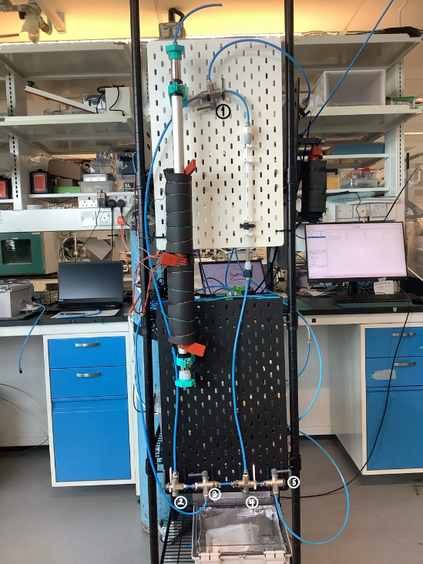
Fig. 7) labelled valves and apparatus for SUTD CO2 Adsorption experiments
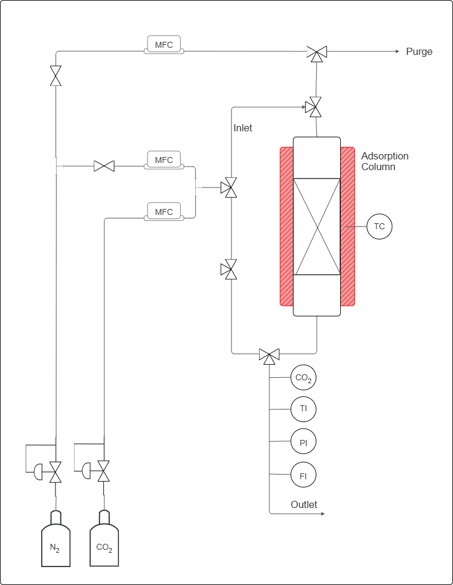
X%
CO2 (v/v)
CO₂ concentration
Gas stream temperature
Gas stream pressure
Gas stream flow rate
PEI@SiO2 granules bed
Heat for regeneration
To purge column before start adsorption
Fig. 8) labelled process flow diagram of CO₂ adsorption in fixed-bed column

4.1 Apparatus and Instrumentation
The apparatus comprises a gas-feeding section, an adsorption column and a gas analysis section at the outlet, as described below.

4.1.1 Gas Feeding Section
Two compressed gas cylinders with pure CO₂ and pure N₂ is fitted with a dedicated pressure regulator and a manual needle valve. Three mass flow controllers (MFCs) regulate the volumetric flow rates throughout the experiment:
- MFC-A (top position): controls the N₂ flow used exclusively for the pre-adsorption column purge and for the regeneration purge sweep.
- MFC-B (middle position): controls the N₂ flow during the adsorption step, contributing to the binary N₂/CO₂ feed mixture.
- MFC-C (lower position): controls the CO₂ flow during the adsorption step; blended with the N₂ stream from MFC-B to produce a feed gas of composition X% CO₂ (v/v), where X is a pre-specified experimental variable.
The mixed gas stream is produced by combining the outputs of MFC-B and MFC-C at a T-junction downstream of both controllers, prior to entry into the column inlet.

4.1.2 Adsorption Column
The fixed-bed column is oriented vertically with gas entering at the bottom inlet and exiting at the top outlet. The column, with an inside diameter of 8.2mm and length of 32cm is packed with PEI@SiO₂ granules.

4.1.3 Gas Analysis and Monitoring
The outlet stream passes through four in-line instruments arranged in series: (i) CO₂ analyser (CO2), thermocouple (TI), pressure indicator (PI) and flow meter (FI). A dedicated purge outlet line at the top of the rig vents the N₂ stream used during column purge; this line is isolated from the analysis train during adsorption.
The following lists the equipment needed for the experiment:
- Compressed CO₂ gas cylinder with 100% CO₂,
- Compressed N₂ gas cylinder with 100% N₂,
- Mass flow controllers (MFCs), connected to the Sensirion software on the laptop,
- Three-way valves (Labelled 1, 2, 3, 4 and 5) and gas lines with tube inside diameter of 6mm,
- Adsorption column, inside diameter of 0.85cm and length 38.6 $±$ 0.1cm, packed with PEI@SiO₂ based C³ granules,
- CO₂ concentration sensor, connected to the Gaslab software on the laptop,
- Flow rate sensor, connected to the Sensirion software on the laptop,
- Laptop interfaces for sensor monitoring and data acquisition.

4.1.4 Pre-Run Preparation
Before beginning the experiment, inspect all gas lines, valves, and fittings to ensure that the system is secure. Ensure that the MFCs, sensors, and data acquisition software are functioning correctly. Weigh approximately 8g of granules was used for the pre-run experiment. Ensure that the bed is packed consistently by tapping the column until no changed in packed height. Note down the sorbent mass and bed length.

4.2 Experimental Procedure

4.2.1 Sensor Setup and Calibration
- Connect all sensors to their respective laptop applications.
- Verify that the CO₂ concentration sensor is connected to the Gaslab interface.
- Remember to adjust Auto-Logging to 5 Seconds for 6 Hours.
- Verify that the flow sensor is connected to the Sensirion software.
- Flow 1 bar of N₂ using the MFC and tube connected to valve 3 through the mixed-gas secondary line by turning valve 2 upward, and valve 3 to the left. to establish a baseline before calibration.
- This is done by using the N₂ MFC and line connected to valve 3, and by turning valve 2 upward and valve 3 to the left. Valve 1 would be turned to the left, to allow the gas to flow from the mixed-gas secondary line into the sensors. Meanwhile, valves 4 and 5 is turned to the right to prevent pressure buildup in the tubes connected to the column.
- Allow the CO₂ sensor to stabilise at 0 ppm, or at a stable linear baseline, before continuing.
- Maintain this calibration period for approximately 15 minutes, or until the readings are stable to ensure that the line contain only N₂ gas.
- If the CO2 sensor does not calibrate to zero, but maintains a stable reading, can ‘configure to zero’ on the Gaslab application.

4.2.3 Feed Gas Preparation
- Set the desired CO₂ and N₂ flow rates using the MFCs corresponding to desired inlet CO2 concentration.This is done by calculating the required MFC setpoints for MFC-B (N₂) and MFC-C (CO₂) such that their combined volumetric flow rates give the desired composition at the target total flow rate $Q_{total}$. The inlet CO₂ mole fraction $y_{CO_{2}}$ satisfies:
$$y_{CO_{2}}=\frac{Q_{CO_{2}}}{Q_{CO_{2}}+Q_{N_{2}}}=\frac{X}{100}$$
, where $Q_{CO_{2}}$ and $Q_{N_{2}}$ are the volumetric flow rates set on MFC-C and MFC-B, respectively.
- Direct the mixed gas stream through the secondary bypass line.
- This is done by turning valve 2 upward and valve 3 to the left. Valve 1 would be turned to the left, to allow the gas to flow from the mixed-gas secondary line into the sensors.
- Use the CO₂ concentration sensor to confirm that the influent concentration, and the flow rate sensor to ensure the amount of gas flowing through are correct before introducing the gas into the packed bed.
- Adjust the flow setting if necessary, until the target or desired inlet concentration is obtained and stable.

4.2.2 Column Loading and Purge
- After calibration, disconnect the temporary tube arrangement.
- Load the pre-weighed PEI@SiO₂ granules into the adsorption column (if not already done before the start of the calibration).
- Pack the sorbent uniformly by tapping the column to ensure consistent and distribute flow through the bed.
- Perform an N₂ purge through the column to remove residual atmospheric gases and establish an initial condition without CO₂ accumulation.
- This is done by using the purge line connected to valve 5. Turn valves 1 and 4 to the right, and valve 5 to the left, to allow the gas to flow through the column and into the sensors.
- As during calibration, position the other valves to prevent pressure build-up within the experimental setup.
- Continue purging until the system is stable, there is no more/very little CO2 in the column and now, the setup ready for the adsorption experiment.

4.2.4 CO₂ Adsorption (Breakthrough Experiment) Run
- Once the inlet conditions have been verified, divert the mixed-gas stream from the bypass line into the adsorption column.
- To do this, turn valve 5 to the right, valve 4 to the left, and valve 3 to the right in that order to prevent pressure buildup. Valve 1 needs to be to the right to ensure the gas through the column goes to the sensors. By this time, the N2 purge line can be switched off (by setting the gas flow to 0 lpm) or disconnected.
- Indicate the time when the valves are turned (specifically valve 3) as the experiment start time (t = 0 s).
- Monitor the outlet CO₂ concentration continuously throughout the run with 5 s interval.
- Continue the experiment until the outlet CO₂ concentration rises close and/or equal to the inlet concentration, indicating that breakthrough and equilibrium adsorption has occurred.
- When CO₂ concentration rise to 5% of an inlet concentration, indicate the time as breakthrough time
- When CO₂ concentration rises close and/or equal to the inlet concentration, indicate the time as equilibrium time.
- Stop the run once the bed approaches saturation and the data trend has stabilised.
- Record time as end time, before turning valve 3 to the left, valve 2 turn down, turning off the MFCs, and finally disconnecting all gas from the main gas tube.
- Save all data files with a filename that encodes the experimental date, run number, and key parameters (e.g., YYYYMMDD_Run##_Cin_Qtotal.csv).

4.3 After the Run
At the end of the experiment, stop the gas flow and close all valves in a controlled manner. Save all collected data and verify that the system is left in a safe condition for the next run.

4.3.1 Acceptance Criteria and Validity
A completed run is considered valid and suitable for quantitative analysis only if all of the following are satisfied:
- The CO₂ analyser baseline prior to adsorption was ≤ 10 ppm (confirming complete purge).
- The inlet composition, as back-calculated from MFC-B and MFC-C setpoints and confirmed by the steady-state outlet concentration at saturation, matches the target C_{in} within ±2%.
- The outlet flow rate (FI) remained within ±5% of the inlet total flow rate throughout the adsorption step, confirming no significant pressure build-up or line blockage.
Any run that fails one or more criteria shall be marked as invalid in the data log and the cause investigated before repeating.

4.4 Data to Record
During the experiment, record the following variables:
- Weight of adsorbent and corresponding packed height
- CO₂ inlet concentration,
- CO₂ outlet concentration,
- Gas outlet flow rate, to confirm consistency with inlet setpoint,
- Time taken to reach breakthrough, from the breakthrough time,
- Time taken to reach equilibrium, from the equilibrium time; when outlet concentration reaches $≥$ 95% of $C_{in}$ and has been stable for $≥$ 5 minutes.
- 50% breakthrough, when outlet concentration reaches 0.5 $C_{in}$
- Outlet gas temperature (to detect thermal wave front passing through the bed)
- Outlet pressure, P₁, to confirm no unintended pressure build up
These data will be used to construct the breakthrough curve and assess the adsorption performance of the sorbent under the selected operating conditions.

4.5 Safety Notes
- Handle gas cylinders carefully and ensure that the system is operated in a well-ventilated laboratory.
- Check for leaks before each run and make sure all fittings are tightened properly.
- Follow laboratory safety procedures at all times when working with pressurised gases, sensors, and electrical instrumentation.

5 Experimental Results
The equilibrium adsorption data was carried out in an experimental batch adsorber. Experiments were conducted in the adsorber packed with C³ granules of different initial concentrations at ambient room temperature. For the fixed-bed experiments, an acrylic column with an inside diameter of 8.5 mm and a length of 38.6 $±$ 0.1 cm was used as an adsorber. The influent concentration of the CO2 gas was varied at three inlet concentrations (5, 10 and 15%). The gas flow rate varied at 50, 100 and 150 ml per minute respectively. The operating conditions and the corresponding parameters are given in Table 2). The result of the equilibrium adsorption test is shown in Table 3).
Higher concentration and flow rate was used with the experimental setup, resulting in drastic changes in breakthrough and saturation on different operating conditions. This work simulates post-combustion carbon capture scenarios like flue gas, rather than ambient CO2 found indoors. Nonetheless, a trend of accelerated breakthrough time with increased concentration and inlet flow rate was observed, but for equilibrium time, there seemed to be a good in-between value that showed it at peak optimisation. Experimental errors, like sudden sensor jumps, as well as the experiment never reaching its initial concentration was encountered. Next steps are to maximise data reliability, giving the precise foundation for optimization of the packed bed's performance.
Table 2) The basic parameters for packed-bed adsorption.
Parameter | Value | Units

Length of column | 38.6 $±$ 0.1 | cm
Inlet diameter | 0.85 | cm
Height of packed-bed | 21.0 – 21.5 (per run) | cm
Volume of packing | 11.92 | cm³
Inlet velocity | 1.47 – 4.41 | cm$∙$s⁻¹
Volume flow rate | 3.0 – 9.0 | cm³$∙$h⁻¹
Angle of bed | 90 | deg

Table 3) Experimental Parameters of PEI@SiO2 Fixed-Bed Adsorbers
No. | Interstitial Velocity, m/s | Hgt. of Carbon Bed, m

3 | 0.147 | 0.210
4 | 0.049 | 0.213
5 | 0.098 | 0.212
6 | 0.147 | 0.215
8 | 0.098 | 0.215

Table 4) Breakthrough adsorption of CO₂ onto PEI@SiO₂ granules
No. | CO₂ concentration (%) | Flow Rate (lpm) | Breakthrough Time (min) | Equilibrium Time (min)

1 | 5 |  | 0.05 | 14 |  | 108
2 | 5 |  | 0.10 | 4 |  | 125
3 | 5 |  | 0.15 | 2 |  | 110
4 | 10 |  | 0.05 | 11 |  | 146
5 | 10 |  | 0.10 | 3 |  | 64
6 | 10 |  | 0.15 | 3 |  | 58
7 | 15 |  | 0.05 | 4 |  | 151
8 | 15 | 0.10 |  |  | 2 | 81
9 | 15 | 0.15 |  |  | 1 | 78

6 Experimental Analysis
The experimental results show that both CO₂ concentration and gas flow rate influenced the adsorption behaviour of the PEI@SiO₂ packed-bed system. At 5% CO₂, the breakthrough time decreased from 14 min at 0.05 l/min to 4 min at 0.1 l/min and 2 min at 0.15 l/min, indicating that higher flow rates shortened the contact time between the gas stream and the sorbent. A similar trend was observed at 10% CO₂, where breakthrough time reduced from 11 min at 0.05 l/min to 3 min at both 0.1 l/min and 0.15 l/min. At 15% CO₂, breakthrough times were again short, decreasing from 4 min to 2 min and finally 1 min as flow rate increased. Overall, the data suggest that increasing flow rate accelerates breakthrough, while higher CO₂ concentration also leads to faster saturation of the column.
The equilibrium times showed greater variability and did not follow a perfectly monotonic trend. At 5% CO₂, equilibrium time ranged from 108 min to 125 min and then 110 min, while at 10% CO₂ it varied from 146 min to 64 min and 58 min. At 15% CO₂, equilibrium time decreased from 151 min at 0.05 l/min to 81 min and 78 min at the higher flow rates. This suggests that equilibrium behaviour is influenced by additional factors beyond concentration and flow rate alone, such as packing uniformity, pressure drop, sensor response, and gas–solid mass transfer effects.

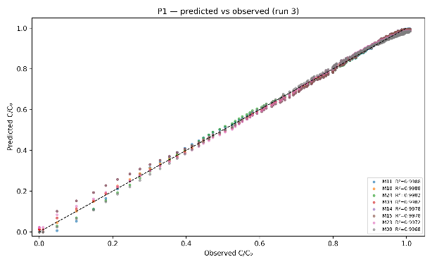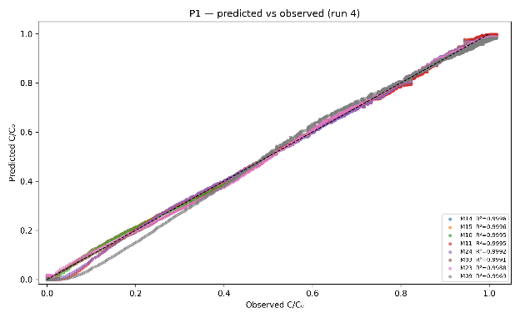
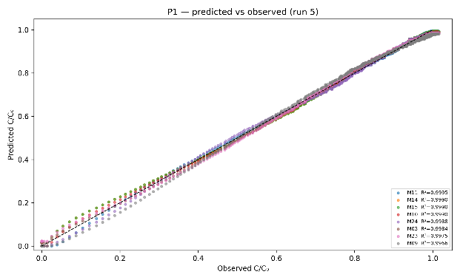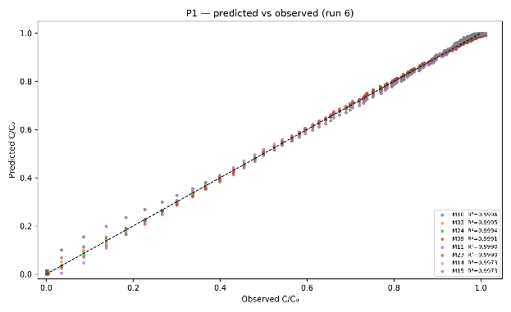
Fig. 9) Predicted vs. observed values in breakthrough models fit
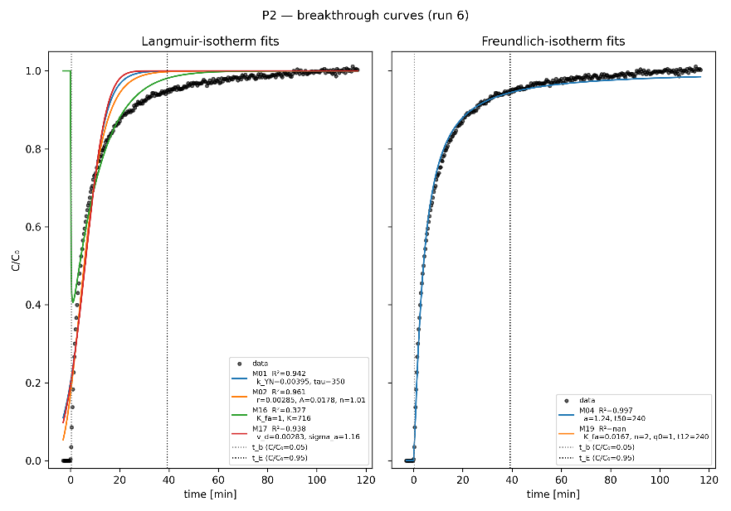
Fig. 10) Breakthrough curve fitting with linear adsorption isotherm
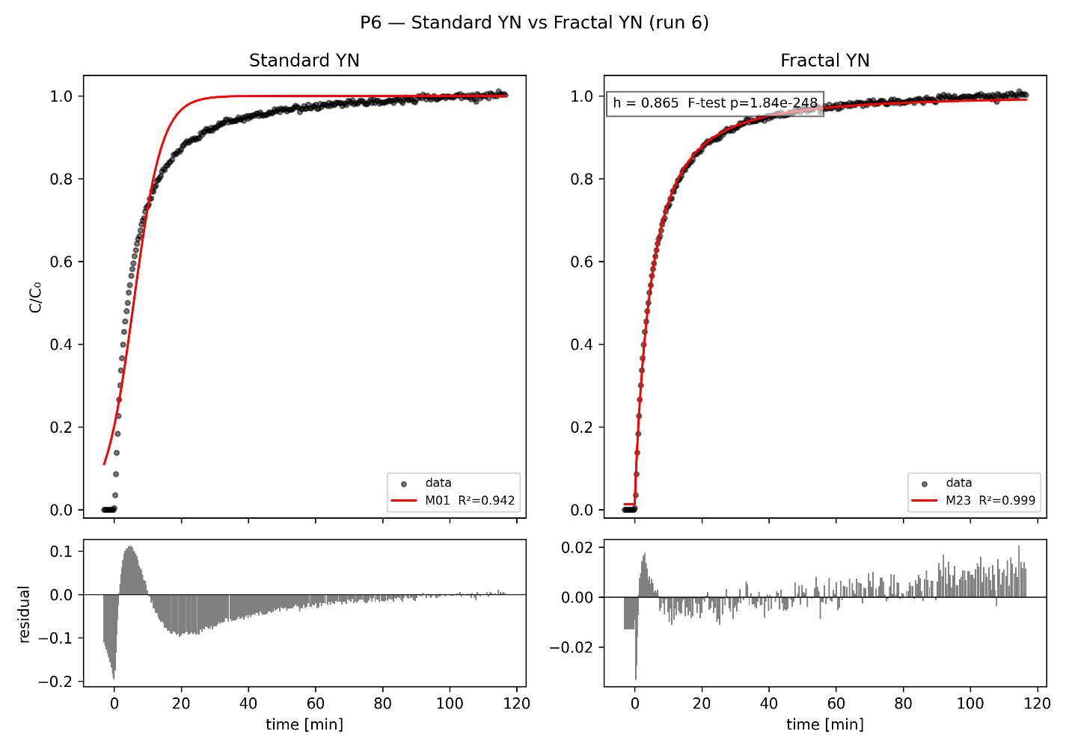
Fig. 11) Validation of fractal-like kinetics on logistic breakthrough model curve

7 Conclusions
This interim report provides a comparative analysis of breakthrough models for CO2 adsorption in a packed-bed column using PEI@SiO₂ (C3) granules. It also develops a new standard operating procedure (SOP) and initial experiment data. For systems exhibiting asymmetric breakthrough behaviour, which is common when adsorbent surfaces are increasingly heterogeneous, fractal-like coefficients have shown to provide superior fits. Similarly, the introduction of a shape parameter $n$ into logistic and hyperbolic tangent models further improves asymmetric breakthrough curve fit. The project is ongoing, with Python-based model fitting and a 3×3 design-of-experiments sweep planned to systematically resolve the interplay between flow rate, feed concentration, and adsorbent loading effects on breakthrough dynamics and equilibrium capacity.

7.1 Next Steps
1) To plot and optimise breakthrough adsorption curves using Python 3.11; 2) employ methods in error statistics to evaluate fitting quality of various breakthrough models; 3) estimate hidden parameters by linear regression to implement a full non-isothermal solver to predict and model breakthrough curves from elementary adsorption principles.

8 References
- Azuma, K., Kagi, N., Yanagi, U., & Osawa, H. (2018). Effects of low-level inhalation exposure to carbon dioxide in indoor environments: A short review on human health and psychomotor performance. Environment International, 121, 51–56. https://doi.org/10.1016/j.envint.2018.08.059
- Bos, M. J., Kroeze, V., Sutanto, S., & Brilman, D. W. F. (2018). Evaluating Regeneration Options of Solid Amine Sorbent for CO2 Removal. Industrial & Engineering Chemistry Research, 57(32), 11141–11153. https://doi.org/10.1021/acs.iecr.8b00768
- Cabrera-Codony, A., Calvo-Schwarzwalder, M., Lopez, L. R., Valverde, A., Puig, S., & Myers, T. G. (2026). An analytical breakthrough model for CO2 adsorption on PEI-impregnated silica: Separating stoichiometric and structural effects of humidity. Carbon Capture Science & Technology, 19, 100618. https://doi.org/10.1016/j.ccst.2026.100618
- Carreiro-Martins, P., Viegas, J., Papoila, A. L., Aelenei, D., Caires, I., Araújo-Martins, J., Gaspar-Marques, J., Cano, M. M., Mendes, A. S., Virella, D., Rosado-Pinto, J., Leiria-Pinto, P., Annesi-Maesano, I., & Neuparth, N. (2014). CO2 concentration in day care centres is related to wheezing in attending children. European Journal of Pediatrics, 173(8), 1041–1049. https://doi.org/10.1007/s00431-014-2283-0
- Chu, K. H. (2020). Breakthrough curve analysis by simplistic models of fixed bed adsorption: In defense of the century-old Bohart-Adams model. Chemical Engineering Journal, 380, 122513. https://doi.org/10.1016/j.cej.2019.122513
- Chuah, C. Y., Ho, Y. L., Syed, A. M. H., Thivyalakshmi, K. G. K., Yang, E., Johari, K., Yang, Y., & Poon, W. C. (2025). Applicability of Adsorbents in Direct Air Capture (DAC): Recent Progress and Future Perspectives. Industrial & Engineering Chemistry Research, 64(8), 4117–4147. https://doi.org/10.1021/acs.iecr.4c03265
- de Joannis, P., Castel, C., Kanniche, M., Favre, E., & Authier, O. (2025). Techno-economic analysis of packed bed and structured adsorbent for direct air capture. Carbon Capture Science & Technology, 17, 100518. https://doi.org/10.1016/j.ccst.2025.100518
- Elfving, J., Kauppinen, J., Jegoroff, M., Ruuskanen, V., Järvinen, L., & Sainio, T. (2021). Experimental comparison of regeneration methods for CO2 concentration from air using amine-based adsorbent. Chemical Engineering Journal, 404, 126337. https://doi.org/10.1016/j.cej.2020.126337
- Hu, Q., Huang, Q., Yang, D., & Liu, H. (2021). Prediction of breakthrough curves in a fixed-bed column based on normalized Gudermannian and error functions. Journal of Molecular Liquids, 323, 115061. https://doi.org/10.1016/j.molliq.2020.115061
- Hu, Q., Lan, R., He, L., Liu, H., & Pei, X. (2023). A critical review of adsorption isotherm models for aqueous contaminants: Curve characteristics, site energy distribution and common controversies. Journal of Environmental Management, 329, 117104. https://doi.org/10.1016/j.jenvman.2022.117104
- Hu, Q., Wang, D., Pang, S., & Xu, L. (2022). Prediction of breakthrough curves for multicomponent adsorption in a fixed-bed column using logistic and Gompertz functions. Arabian Journal of Chemistry, 15. https://doi.org/10.1016/j.arabjc.2022.104034
- Hu, Q., Xie, Y., & Zhang, Z. (2020). Modification of breakthrough models in a continuous-flow fixed-bed column: Mathematical characteristics of breakthrough curves and rate profiles. Separation and Purification Technology, 238, 116399. https://doi.org/10.1016/j.seppur.2019.116399
- International Adsorption Society. (n.d.). What is adsorption? https://www.int-ads-soc.org/what-is-adsorption/
- International Energy Agency. (2022). Direct air capture 2022. https://www.iea.org/reports/direct-air-capture-2022
- Ji, Y., Liu, W., Yong, J. Y., Zhang, X. J., & Jiang, L. (2024). Techno-economic analysis on temperature vacuum swing adsorption system integrated with pre-dehumidification for direct air capture. Carbon Capture Science & Technology, 12, 100199. https://doi.org/10.1016/j.ccst.2024.100199
- Juela, D., Vera, M., Cruzat, C., Alvarez, X., & Vanegas, E. (2021). Mathematical modeling and numerical simulation of sulfamethoxazole adsorption onto sugarcane bagasse in a fixed-bed column. Chemosphere, 280, 130687. https://doi.org/10.1016/j.chemosphere.2021.130687
- Langlo, P., & Espedal, M. S. (1994). Macrodispersion for two-phase, immiscible flow in porous media. Advances in Water Resources, 17(5), 297–316. https://doi.org/10.1016/0309-1708(94)90033-7
- Myers, T. G., Cabrera-Codony, A., & Valverde, A. (2023). On the development of a consistent mathematical model for adsorption in a packed column (and why standard models fail). International Journal of Heat and Mass Transfer, 202, 123660. https://doi.org/10.1016/j.ijheatmasstransfer.2022.123660
- Norbäck, D., & Nordström, K. (2008). Sick building syndrome in relation to air exchange rate, CO2, room temperature and relative air humidity in university computer classrooms: An experimental study. International Archives of Occupational and Environmental Health, 82(1), 21–30. https://doi.org/10.1007/s00420-008-0301-x
- Online Etymology Dictionary. (n.d.). Adsorb. https://www.etymonline.com/word/adsorb
- Pedrozo, H. A., Gonzalez-Ramirez, M. G., Lin, T. Y., Moore, T., Roy, T., Nguyen, D. T., Roy, P., Baker, S., Biegler, L. T., & Panagakos, G. (2026). Optimization of direct air capture processes using reactive transport models of adsorption-desorption cycles. Computers & Chemical Engineering, 204, 109379. https://doi.org/10.1016/j.compchemeng.2025.109379
- Schindler, M. (2012). Untersuchungen zur selektiven Adsorption von Kohlendioxid aus Gasgemischen an metallorganischen Koordinationspolymeren (in German) [Doctoral dissertation, Technische Universität Kaiserslautern]. https://kluedo.ub.rptu.de/frontdoor/deliver/index/docId/3359/file/Dissertation_Schindler.pdf
- Shafeeyan, M. S., Wan Daud, W. M. A., & Shamiri, A. (2014). A review of mathematical modeling of fixed-bed columns for carbon dioxide adsorption. Chemical Engineering Research and Design, 92(5), 961–988. https://doi.org/10.1016/j.cherd.2013.08.018
- Simoni, M., Annesi-Maesano, I., Sigsgaard, T., Norback, D., Wieslander, G., Nystad, W., Canciani, M., Sestini, P., & Viegi, G. (2010). School air quality related to dry cough, rhinitis and nasal patency in children. European Respiratory Journal, 35(4), 742–749. https://doi.org/10.1183/09031936.00016209
- Stampi-Bombelli, V., Storione, A., Grossmann, Q., & Mazzotti, M. (2024). On Comparing Packed Beds and Monoliths for CO2 Capture from Air Through Experiments, Theory, and Modeling. Industrial & Engineering Chemistry Research, 63(26), 11637–11653. https://doi.org/10.1021/acs.iecr.4c01392
- Tsai, D. H., Lin, J. S., & Chan, C. C. (2012). Office workers' sick building syndrome and indoor carbon dioxide concentrations. Journal of Occupational and Environmental Hygiene, 9(6), 345–351. https://doi.org/10.1080/15459624.2012.675291
- Wong, H. C., Low, H. Y., & Tan, M. C. (2021). Textured carbon capture composite (C3) films for distributed direct air capture in urban spaces. Cleaner Engineering and Technology, 4, 100145. https://doi.org/10.1016/j.clet.2021.100145
- Xu, H., Yu, L., Chong, C., & Wang, F. (2024). A comprehensive review on direct air carbon capture (DAC) technology by adsorption: From fundamentals to applications. Energy Conversion and Management, 322, 119119. https://doi.org/10.1016/j.enconman.2024.119119

