

Engineering Science Design Project
“CO2 Adsorption in Packed-Bed Column using Polymer-based Sorbent: Parametric Study and Model Prediction”
Final Report

Student Names: Loh John Ray (S10267908K)
Saraswati Eloise Gunawan (S10267534J)

NP Supervisor: Dr. Pham The Hanh

Institution Supervisor: Prof. Erik Birgersson
Dr. Prapatsorn Borisut
Project Group ID: 3
Project Period: April 2026 – August 2026
Report Date: 18 May 2026

Declaration by students:
- By submitting this report online, I confirm that the report has been submitted to and vetted by my institution supervisor and thereby confirm that the report contains no confidential material from the company.
- I declare that the report is written by me and not plagiarised from other sources.

____________________
Students Signature / Date

Abstract
The growing demand for scalable carbon capture technologies has driven interest in adsorption processes using amine-functionalised sorbents. Empirical models help identify the effect of operating parameters on the final breakthrough curve. This report reviews existing breakthrough models, covering key process parameters and assumptions. A 3×3 design of experiments (DOE) was conducted to study the effects of two parameters: three inlet CO₂ concentrations (5, 10, and 15% by volume) and three gas inlet flow rates (50, 100, and 150 ml/min). The fitted parameters i.e., $k$ and $τ$, was identified by nonlinear least-squares regression. Experimental analysis confirmed that breakthrough curves were strongly influenced by inlet CO₂ concentration and gas flow rate, while the amount of sorbent and resulting bed depth also affected the adsorption behaviour. Regression analysis of experimental data demonstrated that analytical models could explain breakthrough curves. Common challenges encountered in breakthrough adsorption experiments are also discussed in this report including data reliability and the distinction between complete and partial breakthrough curves. A standard operating procedure (SOP) is hence proposed to mitigate these challenges. The results show that a time-dependent rate constant better addresses surface heterogeneity. Similarly, the introduction of a shape parameter proved to fit asymmetric curves better. A sensitivity analysis on empirical parameters such as $k$… [Insert 1–2 sentences summarising your key experimental findings/trends here once results are available, e.g. how CO₂ concentration and flow rate affected breakthrough time/capacity.] Ultimately, this project aims to predict the behaviour of the breakthrough curve and identify the operating conditions that improve CO₂ capture efficiency.

Table of Contents
Abstract 2
Table of Contents 3
List of Figures 6
1 Introduction 7
2 Project Outline and Objectives 8
2.1 Project Outline 8
2.2 Project Objectives 9
2.3 Project Schedule 9
3 Literature review 11
3.1 Overview 11
3.2 Adsorption process 12
3.4 Packed-bed adsorption and breakthrough behaviour 13
3.5 Adsorption Isotherms 16
3.5.1 Langmuir Isotherm 17
3.5.2 Toth Isotherm 17
3.6 Adsorption breakthrough models 18
3.6.1 Bohart-Adams Model 18
3.6.2 Thomas Model 19
3.6.3 Yoon-Nelson Model 19
3.6.4 Mathematical equivalence of traditional breakthrough models 20
3.6.5 Clark Model 21
3.6.6 Gudermannian and Error functions 21
3.6.7 Weibull and Avrami Models 22
3.6.8 Fractal-Like Model Equations 22
3.6.9 Wolborska and Dose-Response Models 23
3.6.10 Tanh, Log-Normal and Gompertz Models 24
3.6.11 Klinkenberg and Dima Models 25
3.6.12 Chern–Chien Isotherm-Embedded Models 25
3.6.13 Log-Modified and n-Order Models 26
3.6.14 Parallel Two-Component Model 26
3.7 Review of Prior Solutions 26
3.7.1 Classical Symmetric Models 27
3.7.2 Models for Asymmetric Breakthrough Curves 27
3.7.3 Implication for Packed-Bed CO₂ Capture 28
3.8 Design or Research Procedure 28
4 Standard Operating Procedure (SOP) 28
4.1 Apparatus and Instrumentation 29
4.1.1 Gas Feeding Section 29
4.1.2 Adsorption Column 29
4.1.3 Gas Analysis Column 29
3.2 Experimental Procedure 30
3.2.1 Sensor Setup and Calibration 30
3.2.2 Feed Gas Preparation 31
3.2.3 Column Loading and Purge 31
3.2.4 CO₂ Adsorption (Breakthrough Experiment) Run 32
3.3 Safety Notes 32
3.4 Errors Observed and Adjustments Made 32
3.4.1 Sorbent Preparation 32
3.4.2 Handling of Granules 32
3.4.3 Purge Flow 33
5 Experimental Results 33
6 Experimental Analysis 35
7 Fitting performance and analysis 39
7.1 Model identifiability and selection criterion 39
7.2 Fit-quality results with standard errors 40
7.3 Parameter trends with operating conditions 40
7.4 Python reproducibility 41
8 Mathematical Modelling 42
8.1 Minimal kinetic model 42
8.2Parameter estimation strategy 44
8.3Limitations of the minimal kinetic model 45
9 Conclusions 46
9.1 Next Steps 46
9.2 AI-Use Disclosure 46
10 References 47

Nomenclature
Symbol | Meaning

$$c(z,t)$$ | Gas-phase CO₂ concentration, mol m⁻³
$$c_{0}$$ | Inlet CO₂ concentration, mol m⁻³
$$C_{0}$$ | Inlet CO₂ concentration, – (mole fraction)
$$C/C₀$$ | Outlet concentration ratio, –
$$z$$ | Axial coordinate along the column, m
$$x$$ | Axial coordinate used in Fig. 3 and BA/Thomas/YN, m
$$u$$ | Superficial gas velocity, m s⁻¹
$$ε$$ | Bed void fraction, –
$$ϵ$$ | Adsorption-site energy, J
$$kB$$ | Boltzmann constant, J K⁻¹
$$D_{L}$$ | Axial dispersion coefficient, m² s⁻¹
$$q(z,t)$$ | Solid-phase loading, mol kg⁻¹
$$q_{t}$$ | Adsorbed amount at time $t$, mol kg⁻¹
$$q_{e}$$ | Equilibrium adsorbed amount, mol kg⁻¹
$$q_{s}/q_{0}$$ | Equilibrium capacity, mol kg⁻¹
$$k_{s}$$ | LDF mass-transfer rate constant, s⁻¹
$$k_{YN}$$ | Yoon-Nelson rate constant, s⁻¹
$$k_{BA}$$ | Bohart-Adam’s rate constant, m³ mol⁻¹ s⁻¹
$$k_{Th}$$ | Thomas effective rate constant, m³ mol⁻¹ s⁻¹
$$b_{T}$$ | Toth isotherm affinity constant, kPa⁻¹
$$h$$ | Time-decaying rate parameter, –
$$τ,τ_{0}$$ | Characteristic breakthrough time, s
$$ρ_{p}$$ | Sorbent pellet density, kg m⁻³
$$ρ_{b}$$ | Bed bulk density, kg m⁻³
$$m$$ | Sorbent mass, kg/g
$$L$$ | Packed-bed length, cm
$$Q$$ | Volumetric flow rate, L h⁻¹ / lpm
$$d_{p}$$ | Pellet diameter, mm

List of Figures
Fig. 1) Greenhouse gas emissions by sector in Singapore, 2023. Adapted from CO₂ and Greenhouse Gas Emissions, by H. Ritchie and P. Rosado, 2025, Our World in Data (https://ourworldindata.org/profile/co2/singapore).
Fig. 2) Research methodology design for CO2 breakthrough adsorption.
Fig. 3) Packed-bed configuration. Influent gas flows axially towards the outlet along the $x$-axis. A cylindrical packed-bed column of length $L$ and internal radius $R$, filled with spherical or near-spherical PEI@SiO2 granules of mean diameter $d_{p}$. A gas mixture of CO2 (mole fraction $C_{in}$) in N2 enters at superficial velocity $u_{in}$.
Fig. 4) Diagram of spherical C3 granule of mean diameter $d_{p}$ showing surface heterogeneity.
Table 1) Weekly Gantt chart schedule for Design Project; timeline is split into phases and tasks within each phase ensure that deliverables are clearly defined and progress is on track; one week is represented as ‘W’; (a) Weeks 0 to 5; (b) Weeks 8 to 13
Fig. 5 & 6) Sourced from SUTD via Dr. Prapatsorn in Project_introduction.pptx. Shows lab setup for granule-based adsorption experiments using packed-bed columns via polymer-based sorbents; where $C_{0}$ is the sorbate initial concentration, $C_{t}$ the sorbate concentration at time $t$, $t_{0}$ the breakthrough time, $t_{E}$: equilibrium time (saturation time), $V_{0}$: superficial velocity, $v$: interstitial velocity, $Q_{o}$: initial gas volumetric flow rate, $A_{c}$: column cross-sectional area.
Fig. 7) shows an image of the adsorption setup, including the gas supply lines, MFCs, adsorption column, and associated sensors. The valves are labelled 1 to 5 and will be referenced as such in the rest of the SOP.
Fig. 8) Labelled process flow diagram of CO₂ adsorption in fixed-bed column.
Fig. 9) Predicted vs. observed values in breakthrough models fit using scipy.optimize.curve_fit()
Fig. 10) Breakthrough curve fitting with linear adsorption isotherm using scipy.optimize.curve_fit()
Table 1) Project Schedule
Table 2) Breakdown of Project Schedule
Table 3) The basic parameters for packed-bed adsorption.
Table 4) Experimental Parameters of PEI@SiO2 Fixed-Bed Adsorbers
Table 5) Breakthrough adsorption of CO2 onto PEI@SiO2 granules
Table 6) Breakthrough (tb) and equilibrium (te) times and corresponding CO₂ adsorption capacities (qb, qe) for C3 granules across varying inlet CO₂ concentrations and flow rates (I)
Table 7) Breakthrough (tb) and equilibrium (te) times and corresponding CO₂ adsorption capacities (qb, qe) for C3 granules across varying inlet CO₂ concentrations and flow rates (II)

1 Introduction
Anthropogenic carbon dioxide (CO₂) emissions are a primary driver of climate change (Shariff et al., 2012). Atmospheric CO2 concentrations rose from 280 ppm to over 440 ppm above pre-industrial levels today and atmospheric concentrations have climbed from 280 ppm in the pre-industrial era to over 440 ppm today and could reach 900 ppm if current emissions trends continue (Xu et al., 2024). This has led to rising global temperatures, more frequent extreme weather events, and rising sea levels. This has led to rising global temperatures, more frequent extreme weather, and rising sea levels, impacts that conventional emissions reduction strategies have so far failed to contain within the Paris Agreement's 2°C target.
Beyond its role in climate change, CO₂ accumulation also has direct consequences for human health and comfort, at both the atmospheric and indoor scale (IPCC, 2023; WMO, 2023).
Rising CO₂ emissions in the atmosphere cause widespread environmental disruption. These place strain on vulnerable groups such as the elderly, children, and outdoor workers, while also threatening infrastructure resilience and food security (IPCC, 2023; WMO, 2023).
Since people spend most of their time indoors, poor ventilation can allow CO₂ to accumulate locally, degrading air quality. Indoor concentrations above 800 ppm are linked to headaches, fatigue, dizziness, and upper respiratory irritation (Norbäck & Nordström, 2008; Tsai et al., 2012). In high-occupancy settings such as offices and schools, elevated CO₂ levels can also aggravate chronic conditions like asthma and reduce cognitive performance and productivity (Simoni et al., 2010; Carreiro-Martins et al., 2014).
This issue is particularly relevant in Singapore as seen in Fig. 1) where limited land area and an economy tied to hard-to-abate sectors, such as shipping, aviation, and petrochemicals (Ritchie & Rosado, 2025), rule out land-intensive solutions such as large-scale afforestation. Singapore therefore needs alternative approaches to manage rising CO₂ levels, particularly indoors, motivating growing interest in compact, scalable carbon capture technologies.
Fixed-bed column adsorption is a promising method for CO₂ capture, offering a simple setup and fast adsorption-desorption cycles, and is well suited to post-combustion treatment of flue gas.


Fig. 1) Greenhouse gas emissions by section in Singapore (2023)
Common adsorption-based processes include pressure swing adsorption (PSA), vacuum swing adsorption (VSA), temperature swing adsorption (TSA), and moisture swing adsorption (MSA). Selecting an appropriate sorbent material is a key design step, and prior studies have explored a wide range of options: from amine-functionalised materials, zeolites, metal oxides, metal-based materials, silicas, activated carbon, and carbon molecular sieves (Chuah et al., 2025; Xu et al., 2005), each with different performance characteristics (e.g. selectivity, working capacity, desorption capacity). Solid sorbents offer several advantages over amine scrubbing, including lower regeneration energy, reduced corrosion, and better tolerance to moisture (Qi et al., 2011). Among these, amine-functionalised silica sorbents, particularly polyethyleneimine (PEI)-impregnated SiO₂, combine high CO₂ selectivity, fast kinetics, and good cyclic stability (Qi et al., 2011; Jung et al., 2017).

2 Project Outline and Objectives

2.1 Project Outline
This project is limited to the experimental and modelling study of CO2 adsorption in a fixed-bed column packed with Carbon Capture Composite (C3) granules (Wong et al., 2021), operated under ambient temperature and near-atmospheric pressure. The problem was identified through a combination of a literature review looking at existing carbon capture technologies, the packed-bed theory, and existing adsorption breakthrough models. The experimental work centres on a packed-bed adsorption setup using C3 granules to capture CO2.
The project started with laboratory familiarisation, followed by procurement and assembly of the experimental setup in Weeks 3 and 4. A Standard Operating Procedure (SOP) was developed for the adsorption experiments. According to the literature, inlet Co2 concentration, flow rate and interaction between the gas stream and the sorbent surface and/or active sites strongly influent to the breakthrough behaviour (Jin et al., n.d; Karimi et al., 2023), which are the factors that form the basis of the experimental and modelling work done below.

2.2 Project Objectives
Building on this understanding, this project aims to characterise breakthrough behaviour of the C3 granules in a packed column. The breakthrough data will then be fitted to a breakthrough model at three inlet concentrations (5%, 10%, 15% by volume) and three flow rates (50, 100, 150 ml/min), giving rise to a 3x3 parameter sweep. Specifically, our project’s objectives are:
- Design and implement a Standard Operating Procedure (SOP) for the packed-bed CO₂ adsorption setup to ensure consistent, reproducible breakthrough experiments.
- Determine the breakthrough parameters of C3 granules experimentally across varying inlet CO₂ concentrations and flow rates.
- Review existing breakthrough adsorption models, identifying their governing assumptions and applicability to this system.
- Identify the operating conditions (CO2 concentration and flow rate) that yield the most CO₂ capture performance among those tested.
Problem statement. To evaluate the breakthrough parameters of a packed-bed CO2 adsorption column using C3 granules, and to develop and validate a predictive breakthrough model based on the collected experimental data.

2.3 Project Schedule
This section provides a detailed review of the project timeline.

Table 1) Project Schedule
Item | Wk1 | Wk2 | Wk3 | Wk4 | Wk5 | Wk6 | Wk7 | Wk8 | Wk9 | Wk10 | Wk11 | Wk12 | Wk13 | Wk14 | Wk15 | Wk16 | Who
Project Brief & First Meetings
Literature Review
SOP, BOM & Setup
Full 3x3 DOE Execution
Writing & Testing Code
Improving
SOP
Redo 3x3
DOE
Results & Analysis
Final
Report

Table 2) Breakdown of Project Schedule
Item | Description

Project Brief & First Meetings | Discussion with Dr. Prapatsorn during First Project Briefing: scope changed from regeneration to adsorption in packed-bed column; Review of Mathematical Preliminaries from Prof. Erik Birghesson’s online lectures. Self-review on relevant literature.
Literature Review | Reviewed literature provided by Dr. Prapatsorn; Approval of timeline for project via use of Gantt Chart; Submission of biweekly journals with included literature, action items and future objectives; Review on these topics: CO₂ capture material and technology, packed-bed adsorption and models, data analysis methods and mathematical modelling of adsorption process.
SOP, BOM & Setup | Familiarization and setting up of rig; Wrote Bill of Materials (BOM), Standard of Procedure (SOP), Design of Experiment (DOE) and results;
Full 3x3 DOE Execution | Conducted nine experiment runs using our DOE twice—with process improvements in the second cycle; extracted data from GasLab files.
Writing & Testing Code | Converting reviewed literature on breakthrough models into Python; the use of AI has been declared in §9.2.
Improving SOP | Improvements that could be made were included in our second iteration of the SOP; this included optimizing the duration where the C₃ sorbent was exposed to ambient environment, purging the line, the empty column and the packed-bed column (previous version in §A.??) and using new C₃ granules provided by the lab.
Redo 3x3 DOE | Conducted nine experiment runs using our DOE—improved breakthrough capacity and breakthrough time; extracted data from GasLab files.
Results & Analysis | Found that breakthrough curve was affected by flow rate, initial concentration and bed height—relating to the amount of sorbent in the packed column.
Final Report

3 Literature review

3.1 Overview
Breakthrough model types
Application scope
Adsorption principles
Experimental data

Breakthrough curve
$c/c_{0}$ vs. $t$

Breakthrough models
Linear fitting
Nonlinear fitting

Data fitting (parameter estimation)

Error functions
Mathematical modelling
Plot of residuals

Legend:
Optimal model
Decision nodes
Input nodes
Prediction

Fig. 2) Research methodology design for CO₂ breakthrough adsorption

This section describes

3.2 Adsorption process
Adsorption is a surface phenomenon in which molecules from a gas or liquid phase accumulate on the surface of a solid material rather than penetrating its bulk structure. Physisorption, where gas molecules attach to the surface through weak van der Waals forces, is quickly reversible via regeneration but results in poor selectivity at low partial pressures as most physical sorbents lose most of their CO₂ capacity in the presence of humidity because water competes for the same sites (Xu et al., 2024). Chemisorption forms covalent or ionic bonds with CO₂ and is highly selective; amine-functionalised sorbents leverage this by impregnating amine groups that react with CO₂ via two distinct mechanisms: (i) carbamate-ammonium ion pairs are formed under dry conditions and can hydrolyse to bicarbonate in the presence of water and (ii) polymer plasticisation induced chain mobility can enable CO2 to access the amine-sites that were previously inaccessible.
Amine-functionalised silica composites represent a major class of solid sorbents for CO₂ capture. These materials combine the high CO₂ affinity of amines with the large surface area and pore volume of porous silica supports. Shafeeyan et al. (2014) classify amine-silica composites into three categories based on preparation method: (i) physical impregnation of polymeric amines such as polyethylenimine (PEI) or tetraethylenepentamine (TEPA) into porous supports; (ii) chemical grafting of aminosilanes via covalent bonding to surface silanol groups; and (iii) in-situ polymerisation of amine-containing monomers to create hyperbranched aminosilicas (Shafeeyan et al., 2014). That review also emphasises that mesoporous silica supports such as MCM-41, SBA-15, and KIT-6 have been widely studied, with textural properties (particularly pore diameter and pore volume) playing a critical role in determining CO₂ capture performance at a given amine loading.
In particular, PEI-fumed structured sorbents exhibits two distinct classes of amine sites: (i) accessible surface amine sites at the PEI-gas interface, and (ii) bulk amine-layer sites buried within the PEI polymer matrix, which require diffusion through the viscous polymer before CO₂ can react (Stampi-Bombelli et al., 2024). This heterogeneity produces the characteristic sharp initial breakthrough followed by a prolonged tail observed experimentally in amine-functionalised sorbents, which a simple pseudo-first-order (PFO) model cannot capture. This resulted in extensive research into adsorption modelling, particularly in packed-bed columns, which is one of the simplest configurations for studying breakthrough adsorption behaviour.

3.4 Packed-bed adsorption and breakthrough behaviour
$$x$$

$$c_{in}$$
$$u_{in}$$

Fig. 3) Packed-bed configuration. Influent gas flows axially towards the outlet along the $x$-axis.


$d_{p}$

Fig. 4) Diagram of spherical C₃ granule of mean diameter $d_{p}$
Packed beds filled with pellets have long been the preferred design for adsorption processes due to their ease of processing, costs, flow distributions, and ease to handle. However, packed bed pressure drop primarily depends on the gas velocity and pellet size. Moreover, the increase in pressure drop leads to excessive power consumption. The system under consideration as shown in Fig. 3) is a cylindrical packed-bed column of length $L$ and internal radius $R$, the bed is filled with spherical or near-spherical C₃ granules of mean diameter $d_{p}$ as shown in Fig. 4). In Fig. 3), a gas mixture of CO₂ (mole fraction $c_{in}$) in N₂ enters the column at superficial velocity $u_{in}$.
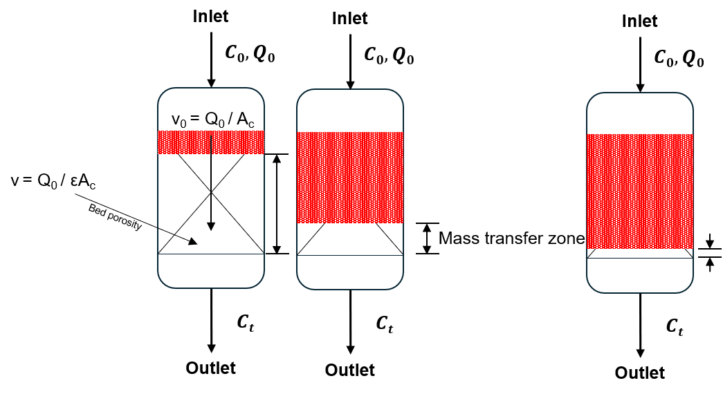

Fig. 5) Schematic diagram of MTZ traveling through a fixed-bed column.
In a fixed-bed column, fresh gas enters one end and pushes a sharp adsorption front, called the mass transfer zone (MTZ) progressively towards the outlet. In Fig. 5), the inlet CO₂ concentration (mole fraction $C_{0}$) flows through the packed bed at a volumetric flow rate of $v_{0}$. As the CO₂ gas gets adsorbed by the adsorbent material, the adsorption zone is indicated by the red-shaded region travelling axially through the columns at a speed much slower than the influent gas velocity.
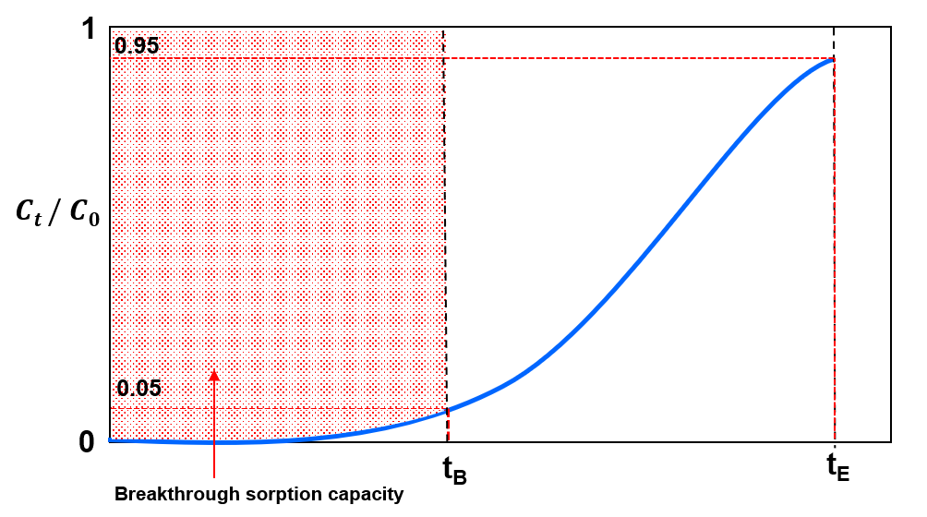

Fig. 6) Breakthrough curve diagram through a fixed-bed column
Hence, in Fig. 5) the bed divides into three zones during adsorption: saturation zone, mass-transfer zone, and adsorption zone. In the saturation zone, the adsorbent contaminant reaches dynamic equilibrium, where the amount absorbed, $q_{0}$, is in equilibrium to the influent concentration, $c_{0}$. Thus, the loading capacity of the adsorbent is exhausted, and no mass transfer takes place. Adsorption only occurs in the MTZ, in which the adsorbent accumulates molecules continuously from the feed, and the amount adsorbed in the bed increases from zero to $q_{0}$. The shape and length of the MTZ depends on the rate of adsorption, $κ$, and the shape of the isotherm curve. Breakthrough is registered when the MTZ first reaches the outlet, and the resulting S-shaped breakthrough curve is a mirror of the MTZ whose sharpness is set jointly by the rate of adsorption and the curvature of the equilibrium isotherm (Hu et al., 2024). With the assumptions: (i) plug flow in the axial direction; (ii) negligible radial dispersion; (ii) a linear driving force for solid adsorption; (iii) uniformly spherical adsorbent particles and (iv) constant geometric dimensions, interstitial velocity, and void fraction (Hu et al., 2024). This behaviour can be described by the following mass-balance equation:
$$\frac{∂c}{∂t}+u\frac{∂c}{∂z}+\frac{1-ε}{ε}\frac{∂q_{t}}{∂t}=D_{L}\frac{∂^{2}c}{∂z^{2}}$$
where $c$ represents the adsorbate concentration in fluid phase, $z$ is the distance along the bed length, $u$ is the fluid velocity, $t$ denotes time, $ε$ is the void bed fraction, $q_{t}$ is the concentration in an adsorbent particle component and the effect of axial dispersion is lumped into a single effective axial dispersion coefficient $D_{L}$.
The advection term $u\frac{∂c}{∂z}$ and the axial dispersion term $D_{L}\frac{∂^{2}c}{∂z^{2}}$ transport CO₂ along the column while the sink term $\frac{1-ε}{ε}\frac{∂q_{t}}{∂t}$ represents gas to solid phase transition via intraparticle resistances lumped as linear driving force (LDF). The axial dispersion coefficient can be estimated as $D_{L}=ud_{p}\left(\frac{20}{ε}\frac{D_{m}}{ud_{p}}+\frac{1}{2}\right)$ where $D_{m}$ is the molecular diffusivity is. The linear driving force can be represented as the linear approach of the instantaneous loading $q_{t}$ to its equilibrium value $q_{e}$ expressed as:
$$\frac{∂q_{t}}{∂t}=k_{s}\left(q_{e}-q_{t}\right)$$
The initial and boundary conditions can be given via Danckwert’s boundary conditions for a dispersed plug flow, expressed as:
$$D_{L}\frac{∂c}{∂z}{\left.​\right|}_{z=0}=-u{\left.​\right|}_{z=0}\left(c_{i}{\left.​\right|}_{z=0^{-}}-c_{i}{\left.​\right|}_{z=0}\right), \frac{∂c}{∂z}{\left.​\right|}_{z=L}=0$$
where $c_{i}{\left.​\right|}_{z=0}$ is the feed composition for component $i$ and $L$ is the bed length.

3.5 Adsorption Isotherms
Adsorption depends on the concentration of the target molecule in the fluid and gas pressure in the bulk phase. Adsorption site heterogeneity combines the properties of the adsorbent at various amounts adsorbed, including surface area, pore volume, concentration of functional groups and pore-size distribution. The ‘heterogeneity’ of the adsorbent can be estimated by modelling the number of adsorption sites of the solid and their types. Adsorption isotherms are graphs that indicate loading-pressure relationships in the $x$- and $y$-axis, respectively. In the case of CO₂ adsorption, the x-axis represents pressure of CO₂ in gas phase (or the concentration of the species or partial pressure) while the y-axis represents CO₂ loading on the sorbent (or the number of adsorbed species by the adsorbent) at equilibrium (the state where the rate of molecules attaching to the sorbent surface equals to the rate of molecules being released from the sorbent). A wide variety of models have been formulated to describe the adsorption isotherms observed experimentally. Some of the more common adsorption isotherms are described in the following sections. In practice, CO2 capacity of PEI-impregnated sorbents will not be able to reach its maximum theoretical limit due to the mass transfer resistances involved.

3.5.1 Langmuir Isotherm
Following Langmuir (1918), and assuming that: (i) adsorption of molecules occur at a fixed number of well-defined localised sites; (ii) each site only accommodates one adsorbent molecule (monolayer adsorption); (iii) the surface of the adsorbent is homogeneous i.e. all sites are energetically equivalent and (iv) there are no interactions between the neighboring sites and molecules already adsorbed (Ruthven, 1984).
The Langmuir isotherm relates the surface coverage, $θ$, to pressure, $P$, and temperature, $T$:
$$θ=\frac{KP}{1+KP}$$
where $K=\frac{1}{p^{0}}e^{-ϵ/(kBT)}$ is the rate constant of equilibrium. We observe that for $KP≪1$, the model increases linearly. But as $KP$ increases (i.e pressure increases), the model converges to 1. Higher temperatures lead to slower asymptotic convergence. In the case where the amount adsorbed, $q$, is much smaller than the maximum adsorption capacity, $q_{s},$ a linear equation following Henry’s is derived: $θ=KP$.
Langmuir isotherm assumes a homogeneous (i.e., uniform) binding site distribution. Discrete models attempt to preserve model heterogeneity by assuming a discrete number of different adsorption sites. However, different adsorbents have different numbers of adsorption sites with varying binding energy. Continuous distribution functions are considered an improvement to discrete models—considering the affinity spectrum which is a plot of the binding affinity against the number of adsorption sites. A Toth isotherm is hence used to model both a homogeneous and heterogeneous distribution of adsorption site affinities. The values of parameters of the Toth model can be found by nonlinear curve fitting method using sigma plot software.

3.5.2 Toth Isotherm
In this work, as a case study, we used only the three-parameter Toth isotherms to describe adsorption on both homogeneous and heterogeneous surfaces. Mathematically, the Toth isotherm can predict the monolayer adsorption capacity of a homogeneous surface that will match with the surface area predicted by Langmuir isotherm. The Toth (1971) isotherm is given by:
$$q=q_{s}{\left[\frac{b_{T}p}{1+{\left(b_{T}p\right)}^{t}}\right]}^{\frac{1}{t}}$$
where $b_{T}$ and $t$ are the Toth isotherm constants. $b_{T}$ is related to the binding energy, $q_{s}$ is the monolayer adsorption capacity.

3.6 Adsorption breakthrough models
Traditional breakthrough models i.e., Bohart-Adams, Thomas, Yoon-Nelson are dissected (Shafeeyan et al., 2014) and expressed as a single logistic function in three notations: $k_{YN}=k_{BA}c_{0}=k_{Th}c_{0}; τ=\frac{a_{0}x}{uc_{0}}=\frac{q_{0}m}{vc_{0}}$. For the more general Clark model, when $n≠2$, the dominant mass-transfer mechanism results in an asymmetric breakthrough curve. Thus, empirical breakthrough models like the Gudermannian and error functions (Hu et al., 2021) with the involvement of fractal-like kinetics i.e., $k\left(t\right)=k_{0}t^{-h}$, where $h$ is the heterogeneity parameter—is needed to fit asymmetric breakthrough curves.

3.6.1 Bohart-Adams Model
The Bohart-Adams model (Bohart & Adams, 1920), and other models discussed below, remain popular because they can be linearised, allowing unknown parameters to be determined via linear regression analysis (Chu, 2020). The Bohart-Adams model predicts a linear relationship between bed depth and breakthrough time, and is expressed as:
$$\frac{c}{c_{0}}=\frac{1}{1+\exp\left[K_{BA}c_{0}\left(\frac{a_{0}x}{uc_{0}}-t\right)\right]}$$
However, the appropriate analytical solution for the adsorbate concentration at the column as a function of time is given as (Chu, 2020; Hu et al., 2024):
$$\frac{c}{c_{0}}=\frac{\exp\left(k_{BA}c_{0}t\right)}{\exp\left(\frac{k_{BA}a_{0}x}{u}\right)+\exp\left(k_{BA}c_{0}t\right)-1}$$
Rewriting this into its linear form gives us (Chu, 2020):
$$\ln\left(\frac{c_{0}}{c}-1\right)=\ln\left[\exp\left(\frac{k_{BA}N_{0}L}{u}\right)-1 \right]-k_{BA}c_{0}t$$
As the rate of adsorption ($k_{BA})$ becomes very large,
$$\ln\left(\frac{c_{0}}{c}-1\right)=\frac{k_{BA}N_{0}L}{u}-k_{BA}c_{0}t$$
Thus, $k_{BA}$ can be evaluated by finding the slope of $\ln\left(\frac{c_{0}}{c}-1\right)$ against $t$, $N_{0}$ from the y-intercept.

3.6.2 Thomas Model
The Thomas (1944) model's simplified solution is given as
$$\ln\left(\frac{c_{0}}{c}-1\right)=k_{Th}c_{0}\left(\frac{q_{0}m}{vc_{0}}-t\right)$$
where it assumes Langmuir equilibrium (Hu et al., 2024). However, $q_{0}$ and $k_{Th}$ are purely empirical parameters which can be estimated by fitting. This can be rewritten as:
$$\frac{c}{c_{0}}=\frac{1}{1+exp⁡(a-bt)}$$
where $a=\frac{k_{Th}q_{0}M}{Q}$ and $b=k_{Th}c_{0}$. Since this is a logistic equation, The two equations will exhibit the same shape and error statistics as they are mathematically equivalent. The same applies to the Yoon-Nelson model as described below.

3.6.3 Yoon-Nelson Model
This model (Yoon & Nelson, 1984) is derived from probability arguments about the column inlet. It assumes that the probability of adsorption rate increase is proportional to the probabilities of adsorption and breakthrough, respectively. This can be written as:
$$\frac{c}{c_{0}}=\frac{1}{1+exp⁡(a+bt)}$$
where $a=k_{YN}τ, b=k_{YN}$.

3.6.4 Mathematical equivalence of traditional breakthrough models
We show that these are notational variances of a single logistic sigmoid, independently confirming the equivalence established by Hu et al. (2020) and Chu (2020).
Theorem (BA-Thomas-YN equivalence). Define the logistic breakthrough curve.
$$\frac{c}{c_{0}}=σ\left(k_{YN}\left(t-τ\right)\right)≔\frac{1}{1+exp⁡(k_{YN}(t-τ))}$$
Thus, $k_{YN}=k_{BA}c_{0}=k_{Th}c_{0}; τ=\frac{a_{0}x}{uc_{0}}=\frac{q_{0}m}{vc_{0}}$ , where $a_{0}$ is the Bohart-Adams volumetric capacity, $q_{0}$ the Thomas equilibrium loading, $m$ the sorbent mass, $v$ the volumetric flow rate, and $x$ the bed length.
Proof Bohart-Adams model is $\frac{c}{c_{0}}={\left[1+\exp\left(k_{BA}\left(a_{0}x/u-c_{0}t\right)\right)\right]}^{-1}$. Factoring $c_{0}$ from the exponent gives $\frac{c}{c_{0}}=σ\left(k_{BA}c_{0}\left(t-\frac{a_{0}x}{uc_{0}}\right)\right)$. The Thomas model is $\frac{c}{c_{0}}={\left[1+\exp\left(k_{Th}\left(q_{0}m/v-c_{0}t\right)\right)\right]}^{-1}$, and the same factoring gives $c/c_{0}=σ\left(k_{Th}c_{0}(t-q_{0}m/(vc_{0})\right))$. The YN model is $σ\left(k_{YN}\left(t-τ\right)\right)$ by definition.
Remark. Three sigmoidal functions appear in the breakthrough literature (Hu et al., 2024): the logistic $σ\left(x\right)={\left(1+e^{-x}\right)}^{-1},$ the error function: $\operatorname{erf}\left(x\right)$ and the Gudermannian function $\operatorname{gd}{(x)}=2\arctan\left(\tanh{(x/2)}\right).$ Before normalization, these have ranges $\left(0,1\right)$, $\left(-1,1\right)$ and $\left(-\frac{π}{2},\frac{π}{2}\right)$ respectively. After affine scaling,
$$\tilde{σ}=σ\left(x\right), \tilde{erf}{(x)}=\frac{1}{2}(\operatorname{erf}\left(x\right)+1), \tilde{gd}{(x)}=\frac{1}{π}\operatorname{gd}\left(x\right)+\frac{1}{2}$$
all three map $R→\left(0,1\right)$ with $f\left(0\right)=0.5$, and they are visually indistinguishable, uniformly over all X once the rate constant of each kernel is matched to the others' slope at the inflection point (as any least-squares fit does automatically) -- see below. On the raw, unmatched argument they are not close (the largest pairwise gap reaches 0.19); it is the fit, not the functional form, which makes them converge $\left|X\right|≤2$. Anchoring an experimental breakthrough curve $\frac{c\left(t\right)}{c_{0}}$ fixes both the location $τ$ and (after slope fitting) the rate constant; the residual sup-norm distance between any two of $σ_{*},E_{*},G_{*}$ i.e.:
$$\max_{f,g∈\left\{σ_{*},E_{*},G_{*}\right\}}\left|f\left(X\right)-g\left(X\right)\right|<0.031$$uniformly over the entire real line, with the global worst case ≈ 0.031 attained near |X| ≈ 2.7 (verified numerically from the model definitions used throughout this report — logistic, error-function and Gudermannian kernels evaluated after matching each kernel’s slope at its inflection point to the logistic reference slope, exactly as a nonlinear least-squares fit does automatically). Consequently, if observational noise has standard deviation ε ≥ 0.03 — consistent with the ±3–5 % of reading accuracy specified for the NDIR CO₂ sensors used in this rig's own gas-analysis train (GasLab, CU-1106 series specifications; §4.1.3) — then no statistically meaningful distinction between the three kernels is possible on the experimentally accessible breakthrough region.

3.6.5 Clark Model
The Clark (1987) model introduces asymmetry through an additional exponent $n≥1$:
$$\frac{c}{c_{0}}={\left[\frac{1}{1+Ae^{-rt}}\right]}^{1/(n-1)}$$
At $n=2$, this reduces to the logistic form of §3.6.4. For $n>2$, the curve is left-asymmetric i.e., sharper rise, longer tail; for $1<n<2$ it is right-asymmetric. The Clark model is therefore a minimal one-parameter extension of the unified Bohart-Adams, Thomas, Yoon-Nelson family that can encode mass transfer asymmetry.

3.6.6 Gudermannian and Error functions
In Hu et al. (2021), the normalized Gudermannian and error functions—when the range of the Gudermannian and error function is [0,1]—can define asymmetric breakthrough curves by employing two lumped parameters: $κ$ and $τ$ as majorly empirical fitting parameters, where $κ$ denotes the shape of the breakthrough and $τ$ denotes its location. The models are expressed as (Hu et al., 2021):
$$\frac{c}{c_{0}}=\frac{1}{2}\left\{1+\frac{2}{π}\arctan{(\sinh{[k\left(t-τ\right)])}}\right\}$$
$$\frac{c}{c_{0}}=\frac{1}{2}\left(1+\operatorname{erf}{[k(t-τ)]}\right)$$

3.6.7 Weibull and Avrami Models
Weibull and Avrami models are probability distribution functions with floating inflection points. Both are probability distribution functions with floating inflection points, the Weibull function.
$$\frac{c}{c_{0}}=1-\exp\left[-{\left(\frac{t}{a_{5}}\right)}^{b_{5}} \right]$$
and log-Gompertz functions have floating inflection points that can shift towards the origin for asymmetric data, unlike the fixed-inflection normal and Gompertz forms. Kimani (2024) found that of the floating-inflection-point family, only log-Gompertz gave a satisfactory fit regardless of curve symmetry, and that log- and fractal-like Bohart–Adams models fit the curves perfectly regardless of symmetry—a result that independently corroborates the fractal-like models' advantage reported in §6 of this work. In this project's own fits, the Weibull (M14) and Avrami (M15) models return statistically indistinguishable goodness-of-fit in every run (identical R², RMSE and AICc to at least five significant figures — see §7), consistent with their known near-equivalence as stretched-exponential forms.

3.6.8 Fractal-Like Model Equations
Beyond the seven classical and asymmetric forms above, the remaining models fitted in the §7 comparison is introduced below, grouped by functional family. The fractal-like generalisation already discussed qualitatively in §3.7.2 applies to each kernel above by replacing its constant rate parameter with a time-dependent one, k = k₀t⁻ʰ. For the Clark model (§3.6.5), this gives the fractal Clark form (M03, Hu et al., 2024):
$$C/C₀ = {\left[\frac{1}{1 + A_{0}·exp\left(-\frac{r}{1-h}·t^{1-h}\right)}\right]}^{\frac{1}{n-1}}$$
which collapses to the Clark model (M02) when h = 0.
For the Gudermannian and error-function kernels (§3.6.6), the corresponding fractal forms are the fractal Gudermannian (M10) and fractal error-function (M11) models that win in four of the five original runs (§7; Hu et al., 2024):
$\frac{C}{C_{0}}=\frac{1}{2}\left\{1 + \left(\frac{2}{π}\right)·\arctan\left[\sinh\left(k_{0}t^{-}ʰ\left(t-τ_{0}\right)\right)\right]\right\}$ (M10)
$\frac{C}{C_{0}}=\frac{1}{2}\left\{1 +\operatorname{erf}\left[k_{0}t^{-}ʰ\left(t-τ_{0}\right)\right]\right\}$ (M11)
The fractal Yoon-Nelson form applies the same substitution to the logistic kernel of §3.6.3 (Hu et al., 2024):
$$\frac{C}{C_{0}}=\frac{1}{\left(1 +\exp\left\{\left(\frac{k_{YN}}{1-h}\right)·\left[τ^{1-h}- t^{1-h}\right]\right\}\right)} (M23)$$
recovering the standard Yoon-Nelson model as $h → 0$.

3.6.9 Wolborska and Dose-Response Models
Wolborska (1989) modelled the early-breakthrough region with a linear-driving-force approximation that is exact only for $C/C₀ ≤ 0.15$:
$\ln{(C/C₀)}$ = $($slope$)·t +$ intercept (M05)
fitted here only to that restricted early window, so its goodness-of-fit statistics in §7 are not on the same scale as the full-curve models. Hu et al. (2020) caution specifically against using Wolborska to describe the complete dynamic behaviour of a fixed-bed column, since the model “does not represent a S-shaped curve and thereby fails to describe the breakthrough curve completely”; it is retained here, on the early window only, for completeness rather than as a candidate in the model-selection comparison of §7.
Yan et al. (2001) proposed a modified dose-response form parameterised directly on the half-breakthrough time t₅₀:
$\frac{C}{C_{0}}= 1 -\frac{1}{1 + {\left(\frac{t}{t_{50}}\right)}^{a}}$ (M04)
where a is an empirical shape exponent; it produces a logistic-like sigmoid but, unlike the Yoon-Nelson form (§3.6.3), is written directly in terms of the operationally meaningful t₅₀ rather than a rate constant.

3.6.10 Tanh, Log-Normal and Gompertz Models
Hu et al. (2019) also fit a hyperbolic-tangent kernel,
$C/C₀ =\frac{1}{2\left[1 +\tanh{(k(t-τ)}\right)}$ (M08)
algebraically close to the logistic and Gudermannian forms discussed in §3.6.4's Remark but with a different tail decay rate. Chu & Hashim (2023) instead track the long-time coordinate with a normal (Gaussian) cumulative distribution,
$\frac{C}{C_{0}}=\frac{1}{2}\left\{1 +\operatorname{erf}\left[\frac{\ln{t}- b}{a\sqrt{2}}\right]\right\}$ (M09)
which—like the log-modified models of §3.6.13—gives the curve a floating inflection points in t while remaining symmetric in ln t. The Gompertz function,
$\frac{C}{C_{0}}=\exp\left[-\exp\left(α_{G}- β_{G}·t\right)\right]$ (M12)
and its log-time counterpart,
$\frac{C}{C_{0}}=\exp\left[-\exp\left(α_{G}- β_{G}·\ln{t}\right)\right]$ (M13)
are asymmetric growth-curve forms long used for breakthrough correlation (Chu, 2020). §3.6.7 already reports that log-Gompertz was the only floating-inflection-point model Kimani (2024) found to fit satisfactorily regardless of curve symmetry.

3.6.11 Klinkenberg and Dima Models
Klinkenberg (1948) derived an asymptotic closed-form solution to the linear-driving-force mass-transfer equations in terms of two dimensionless groups—the bed Stanton number $ζ = K_{fa}{\left(\frac{u}{x}\right)}^{-1}$ and a dimensionless time $τ_{K}:$
$C/C₀ =\frac{1}{2}\left\{1 +\operatorname{erf}\left[\sqrt{τ_{K}}- \sqrt{ζ}+\frac{1}{8\sqrt{τ_{K}}}+\frac{1}{8\sqrt{ζ}}\right]\right\}$ (M16)
The approximation is valid only for $ζ≥2$ and $τ_{K}≥1$ (Klinkenberg, 1948; Hu et al., 2024); §7 reports that these conditions were not met for this column, so M16 is fitted but excluded from the model-preference conclusions. Dima et al. (2024) solved the coupled mass-balance and linear-driving-force equations by Laplace transform and showed that, in the travelling-wave limit, the solution reduces to an error-function wave,
$\frac{C}{C_{0}}= ½\left\{1 +\operatorname{erf}\left[\frac{v_{d}·t - x}{\sqrt{2}·σ_{a}}\right]\right\}$ (M17)
consistent with the R-H shock and travelling-wave analysis referenced in the project schedule (Table 1) and developed in mechanistic-model.md §D.

3.6.12 Chern–Chien Isotherm-Embedded Models
Chern & Chien (2002) derived breakthrough solutions directly from the constant-pattern wave approach for Langmuir (M18) and Freundlich (M19) equilibria, solving implicitly for the time t at which the outlet reaches a given C/C₀ = x rather than for C/C₀(t) directly; both require root-finding (Brent's method here) at every evaluated time point. In this project's fits, M18 and M19 converge formally but return non-finite RSS and an undefined R² in every run (§7); following the same treatment as M16, they are reported for completeness but excluded from the model-preference ranking. A stiffer initial-guess strategy, or re-parameterising the fit in x rather than t, is the fix and is left for future work.

3.6.13 Log-Modified and n-Order Models
Apiratikul & Chu (2021) proposed logarithmic modifications of the Bohart-Adams and Yoon-Nelson logistic kernels (§3.6.1, §3.6.3), replacing linear time with log time to better track curves that are steep near breakthrough and long-tailed near saturation:
$\frac{C}{C_{0}}=\frac{1}{1 +\exp\left\{k_{BA}·\left[\log\left(\frac{a_{0}x}{uC_{0}}\right)-\log{t}\right]\right\}}$ (M20)
$\frac{C}{C_{0}}=\frac{1}{1 + exp\left\{k_{YN}·\left[log τ - log t\right]\right\}}$ (M21)
Hu et al. (2021) generalised the Bohart-Adams rate law itself to n-th order in the gas-phase driving force (M22), recovering the classical logistic form (§3.6.1) as the n = 1 special case; the resulting closed-form solution is algebraically more involved than M01 and is evaluated numerically here from the same generalised rate equation.

3.6.14 Parallel Two-Component Model
Blagojev et al. (2019) observed that some breakthrough curves are better described as a weighted superposition of two independent adsorption mechanisms—for example, two populations of binding sites with different affinities—than by any single sigmoidal kernel:
$\frac{C}{C_{0}}= p·\left[1-\frac{1}{1+{\left(\frac{t}{τ_{1}}\right)}^{k1}}\right]+ \left(1-p\right)·\left[1-\frac{1}{1+{\left(\frac{t}{τ_{2}}\right)}^{k2}}\right]$ (M24)
where $p ∈ [0,1]$ weights two Weibull-type components $(τ₁,k1)$ and $(τ₂,k2).$ With five free parameters, M24 is the most flexible model in the 24-model registry; §7 reports its AICc penalty and whether the added flexibility is justified for this column.X`

3.7 Review of Prior Solutions
A range of CO₂ capture technologies has been developed, including liquid solvent absorption, adsorption over solid sorbents, membrane separation, cryogenic separation, direct air capture (DAC), and hybrid systems. However, this experiment looks at specifically adsorption in a packed-bed setting.
Adsorption-based capture is especially relevant to this project because it uses solid sorbents in packed-bed systems and is compatible with dilute CO₂ streams (Stampi-Bombelli et al., 2024). Prior work has shown that PEI-impregnated silica sorbents perform well for CO₂ capture, particularly in applications where adsorption capacity, regenerability, and process stability are important (Cabrera-Codony et al., 2026; Karimi et al., 2023). These findings support the use of PEI@SiO₂ C3 granules as the sorbent material in our project. Stampi-Bombelli et al. (2024) characterise this sorbent class for direct air capture at ≈400 ppm CO₂; this work operates at 5–15 % CO₂, well outside that range, so its isotherm and geometry parameters are used here as a benchmark rather than as validated inputs for the conditions studied.

3.7.1 Classical Symmetric Models
The Bohart-Adams, Thomas, and Yoon-Nelson models are mathematically equivalent forms of the logistic function, representing a centrosymmetric S-shaped curve with an inflection point fixed at $c/c_{0}$ = 0.5 (Hu et al., 2019). These models perform well when the breakthrough curve is symmetric but fail for asymmetric (tailed) data characteristic of diffusion-limited adsorption on heterogeneous surfaces (Hu et al., 2019). Hu et al., 2019 demonstrated that for norfloxacin adsorption on granular activated carbon, the logistic model yielded Adj. R² = 0.9879, significantly lower than fractal-modified versions.

3.7.2 Models for Asymmetric Breakthrough Curves
Fractal-like models introduce a time-dependent rate coefficient ($k = k₀·t⁻ʰ$) derived from fractal kinetics, which accounts for the heterogeneous, diffusion-limited nature of adsorption on real surfaces (Hu et al., 2021). The fractal-like Bohart-Adams (or equivalently, fractal-like Thomas and fractal-like Yoon-Nelson) model includes an additional parameter $h$ (fractal exponent). When $h$ = 0, the model reduces to the classical logistic function; as $h$deviates from zero, the breakthrough curve becomes increasingly asymmetric (Hu et al., 2021). Kimani (2024) showed that the fractal-like Bohart-Adams model outperformed all others in fitting tailed breakthrough data from bisphenol-A adsorption on polyaniline (Adj. R² > 0.99, lowest BIC values). The model accurately estimated breakthrough times (13, 26, and 90 min for 6, 9, and 12 mm bed depths) and a critical bed depth of 5.65 mm (Kimani, 2024).

3.7.3 Implication for Packed-Bed CO₂ Capture
For the packed-bed adsorption of CO2 using C3 granules, the selection of an appropriate breakthrough model is crucial for accurate process design. The fractal-like models, particularly, fractal-Gudermannian and fractal-ERF are expected to provide superior fits when the breakthrough data exhibit asymmetry due to: (i) heterogeneous sorbent surface chemistry (amine-functionalised sites varying reactivity); (ii) diffusion limitations within the composite granule structure and (ii) non-linear adsorption isotherms typical of CO2 chemisorption. The high Adj. R2 values (>0.998) reported for these models (Kimani, 2024; Hu et al., 2021) suggest they are well-suited to the diffusion-limited heterogeneous-surface systems characteristic of practical CO2 capture adsorbents.

3.8 Design or Research Procedure
The research procedure begins with a review of CO₂ capture technologies and adsorption principles, followed by the assembly and calibration of the experimental rig. Once the setup is complete, the SOP is used to standardise the operation of the system and ensure consistent testing conditions. A 3 × 3 DOE is then used to study the combined effects of CO₂ concentration and flow rate on adsorption breakthrough behaviour.
The experimental data will be processed using Python to fit breakthrough curves to industry-standard models. These results will be used to assess the influence of operating conditions on adsorption performance and to validate the suitability of the PEI@SiO₂ sorbent under the tested conditions. The project requires knowledge of adsorption theory, laboratory operation, data analysis, and numerical modelling, and these skills are being developed through literature study, supervision, and trial runs of the experimental setup.

4 Standard Operating Procedure (SOP)
This SOP describes the step-by-step method for operating the packed-bed experimental setup assembled in the SUTD’s laboratory to conduct CO2 adsorption breakthrough experiments using C3 granules as the solid adsorbent. Running this experiment allows system behaviour to be observed under defined initial and boundary conditions across repeated runs, and provides data for parameter estimation and modelling.

4.1 Apparatus and Instrumentation
The apparatus comprises a gas-feeding section, an adsorption column, and a gas analysis section at the outlet (CO₂ sensor and flow sensor), connected using 6 mm gas tubes and labelled valves.

4.1.1 Gas Feeding Section
Two compressed gas cylinders (pure N₂ and pure CO₂) are each fitted with a dedicated pressure regulator and manual needle valve. Three mass flow controllers (MFCs) regulate volumetric flow rates:
- MFC-A: controls N₂ flow for the pre-adsorption column purge.
- MFC-B: controls N₂ flow during the adsorption step, forming part of the mixed gas feed.
- MFC-C: controls CO₂ flow during the adsorption step, mixing with the MFC-B stream to produce a feed gas of X% CO₂, where X is a pre-specified experimental variable.

4.1.2 Adsorption Column
The packed-bed column is oriented vertically, with gas entering at the bottom and exiting at the top. The column has an inside diameter of 8.2 mm, an outside diameter of 8.5 mm, and a length of 380 mm. During the adsorption run, the column is packed with 8 g of C3 granules, reaching a bed height of approximately 230–240 mm.

4.1.3 Gas Analysis Column
The outlet stream passes through two in-line instruments in series:
- CO₂ Concentration Sensor: measures CO₂ concentration, temperature, pressure, and humidity; connected to the GasLab software.
- Flow sensor: measures outlet flow rate; connected to the Sensirion software.

Equipment list:
- Compressed CO₂ gas cylinder (100% CO₂)
- Compressed N₂ gas cylinder (100% N₂)
- Mass flow controllers (MFCs), connected to Sensirion software
- Three-way valves (labelled 1–5) and gas lines, 6 mm tube ID
- Adsorption column, 8.2 mm ID × 380 mm length, packed with PEI@SiO₂ (C3) granules
- CO₂ concentration sensor, connected to GasLab software
- Flow rate sensor, connected to Sensirion software
- Laptop for sensor monitoring and data acquisition

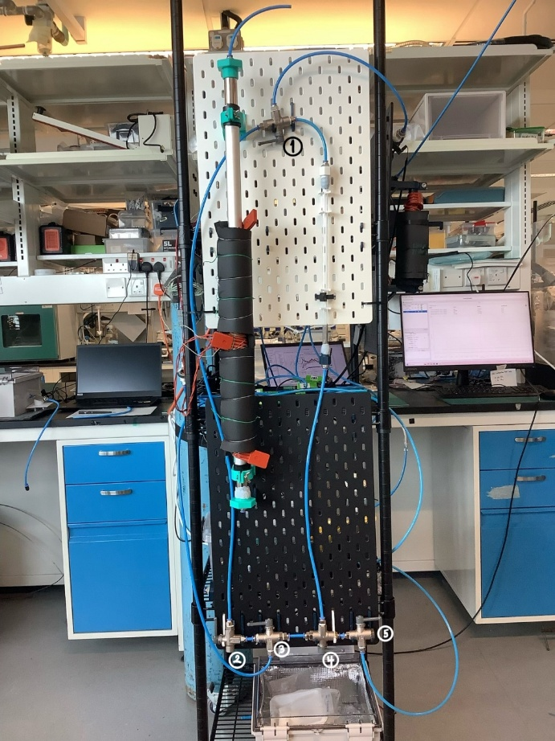

Fig. 7) shows an image of the adsorption setup, including the gas supply lines, MFCs, adsorption column, and associated sensors. The valves are labelled 1 to 5, and will be referenced as such in the rest of the SOP.

4.2 Experimental Procedure
Before beginning the experiment, inspect all gas lines, valves, and fittings to ensure that the system is secure. Confirm that the MFCs, sensors, and data acquisition software are functioning correctly.

4.2.1 Sensor Setup and Calibration
- Connect all sensors to their respective laptop applications.
  - Verify that the CO₂ concentration sensor is connected to the GasLab interface.
  - Verify that the flow sensor is connected to the Sensirion application
- Pass N₂ using the MFC and tube connected to valve 3 through the mixed-gas secondary line by turning valve 2 upward, and valve 3 to the left. to establish a baseline before calibration.
  - This is done by using the N2 MFC and line connected to valve 3, and by turning valve 2 upward and valve 3 to the left. Valve 1 would be turned to the left, to allow the gas to flow from the mixed-gas secondary line into the sensors. Meanwhile, valves 4 and 5 is turned to the right to prevent pressure buildup in the tubes connected to the column.
- Allow the CO₂ sensor to stabilise at 0 ppm, or at a stable linear baseline, before continuing.
- Maintain this calibration period for approximately 15 minutes, or until the readings are stable.
- If the CO2 sensor does not calibrate to zero, but maintains a stable reading, apply ‘configure to zero’ on the Gaslab application.

4.2.2 Feed Gas Preparation
- Set the desired CO₂ and N₂ flow rates using the MFCs.
- Direct the mixed gas stream through the secondary bypass line.
  - This is done by turning valve 2 upward and valve 3 to the left. Valve 1 would be turned to the left to allow the gas to flow from the mixed-gas secondary line into the sensors.
- Use the CO₂ concentration sensor to confirm that the influent concentration, and the flow rate sensor to ensure the amount of gas flowing through is correct before introducing the gas into the packed bed.
- Adjust the flow settings if necessary, until the target inlet concentration is obtained and stable.

4.2.3 Column Loading and Purge
- After the feed gas preparation, disconnect the temporary tube arrangement.
- Perform an initial N₂ purge through a different, empty column to remove residual atmospheric gases and establish a clean initial condition.
  - This is done by using the purge line connected to valve 5. Turn valves 1 and 4 to the right, and valve 5 to the left, to allow the gas to flow through the column and into the sensors.
- As during calibration, position the other valves to prevent pressure build-up within the experimental setup.
- 5 minutes into the initial purge, weigh out 8g of granules and transfer them into the column that will be used for adsorption.
- Replace the column to the one with granules and continue purging until readings are stable and CO2 in the column is negligible.

4.2.4 CO₂ Adsorption (Breakthrough Experiment) Run
- Once inlet conditions are verified, divert the mixed-gas stream from the bypass line into the column.
  - This is done by turning valve 5 to the right, valve 4 to the left, and valve 3 to the right, in that order, to prevent pressure buildup.
  - Turn valve 1 to the right so gas passing through the column reaches the sensors.
  - Switch off or disconnect the N₂ purge line at this point.
- Record the time valve 3 is turned as the experiment start time (t = 0 s).
- Monitor outlet CO₂ concentration continuously at 5s intervals.
- Stop the run once the bed approaches saturation, and the data trend has stabilised. Record this as the end time, then turn valve 3 to the left, valve 2 down, switch off the MFCs, and disconnect the gas supply.
- Save data files using a filename encoding the date, run number, and key parameters (e.g., Date_Flow_Conc.csv).

4.3 Safety Notes
- Handle gas cylinders carefully and operate the system in a well-ventilated laboratory.
- Check for leaks before each run and ensure all fittings are tightened properly.
- Follow laboratory safety procedures at all times when working with pressurised gases, sensors, and electrical instrumentation.

4.4 Errors Observed and Adjustments Made
Previous experimental runs from our interim report showed two recurring issues: unexpectedly short breakthrough times and inconsistent pressure readings during the purge step. As a result, changes were made to our experimental steps and are highlighted below.

4.4.1 Sorbent Preparation
Our C3 granules were originally baked overnight before use. We suspected that this prolonged heating period may have inadvertently reduced their adsorption capacity. This was changed to a 2-hour bake, which reduced over-drying of the granules and gave more consistent breakthrough behaviour between runs.

4.4.2 Handling of Granules
The handling of the granules during the experimental setup had some significant flaws. The C3 granules are highly hydrophilic, they readily absorb ambient moisture, causing premature saturation. This ultimately reduces the granules' remaining adsorption capacity and skews the rate measurements once the actual experiment begins. In our case, the original procedure involved loading the material into the column before sensor purging and calibration, exposing it to the surrounding air for long periods.
We therefore adopted a new purging procedure, in which all experimental setup steps are first carried out using an empty column. The entire system, including the empty column, is then purged with pure N₂ for approximately 10 minutes. After the first 5 minutes of this initial purge, the granules are weighed and transferred into the actual packed-bed column. Once the packed-bed column is installed, the system is purged with pure N₂ for an additional 10 minutes before the experiment begins. This new procedure limits the granules' exposure to ambient air to a maximum of 5 minutes.

4.4.3 Purge Flow
In our original experiments, N₂ gas entering the columns during purging was inconsistent, and often quite weak. Upon further testing (running gas through at different flow rates), we found this was caused by the original purge line being split between two setups, despite placing valves near the split, some gas was still diverted to the other line, so the column received a lower and less accurate flow rate than the value set on the MFC. This was resolved by increasing the N₂ purge flow rate to 0.3 L/min, which provided sufficient pressure to compensate for the flow losses caused by the split line and ensured a stable, consistent purge throughout the system.

5 Experimental Results
Breakthrough experiments were conducted on the fixed-bed column described in Section 4, packed with 8 g of C₃ granules, and operated under ambient room temperature and pressure. An acrylic column with an inside diameter of 8.5 mm and a length of 38.6 $±$ 0.1 cm was used as an adsorber. Inlet CO₂ concentration was varied across three values (5, 10, and 15% by volume) and total gas flow rate across three values (50, 100, and 150 ml/min), giving a 3×3 design of experiments, with selected conditions repeated to assess reproducibility. The operating conditions and the corresponding parameters are given in Table 3).
Table 3) The basic parameters for packed-bed adsorption.
Parameter | Value | Units

Length of column | 38.6 $±$ 0.1 | cm
Inlet diameter | 0.85 | cm
Height of packed-bed | 21.0 – 21.5 (per run) | cm
Volume of packing | 11.92 | cm³
Inlet velocity | 1.47 – 4.41 | cm$∙$s⁻¹
Volume flow rate | 3.0 – 9.0 | cm³$∙$h⁻¹
Higher concentration and flow rate was used with the experimental setup, resulting in drastic changes in breakthrough and saturation on different operating conditions. This work simulates post-combustion carbon capture scenarios like flue gas, rather than ambient CO2 found indoors as the 5% - 15% CO₂ range lies well outside the 400 ppm DAC conditions Stampi-Bombelli et al. (2024) characterised their sorbent in §3.7. Nonetheless, a trend of accelerated breakthrough time with increased concentration and inlet flow rate was observed, but for equilibrium time, there seemed to be an optimal intermediate value that produced the best results. Experimental errors, like sudden sensor jumps, as well as the experiment never reaching its initial concentration was encountered. Next steps are to maximise data reliability, giving the precise foundation for optimisation of the packed bed's performance.
Using the formula $u=\frac{Q}{επ{\left(d/2\right)}^{2}}$, where $Q$ is the flow rate in cm³s⁻¹, $ε$ is the bed voidage and $d$ is the inlet diameter in cm, The result of the equilibrium adsorption test is shown in Table 4).
Table 4) Experimental Parameters of PEI@SiO2 Fixed-Bed Adsorbers
No. | Interstitial Velocity, m/s | Hgt. of Carbon Bed, m

3 | 0.147 | 0.210
4 | 0.049 | 0.213
5 | 0.098 | 0.212
6 | 0.147 | 0.215
8 | 0.098 | 0.215

Table 5) Breakthrough adsorption of CO₂ onto PEI@SiO₂ granules
No. | CO₂ concentration (%) | Flow Rate (lpm) | Breakthrough Time (min) | Equilibrium Time (min)

1 | 5 |  | 0.05 | 14 |  | 108
2 | 5 |  | 0.10 | 4 |  | 125
3 | 5 |  | 0.15 | 2 |  | 110
4 | 10 |  | 0.05 | 11 |  | 146
5 | 10 |  | 0.10 | 3 |  | 64
6 | 10 |  | 0.15 | 3 |  | 58
7 | 15 |  | 0.05 | 4 |  | 151
8 | 15 | 0.10 |  |  | 2 | 81
9 | 15 | 0.15 |  |  | 1 | 78
5.1 Parameters Measured
Four primary parameters characterise the breakthrough behaviour of each run:
- Breakthrough time (tb): the time at which outlet concentration first reaches 5% of the inlet concentration (C/C0 = 0.05). This marks the point at which the column can no longer be considered to be capturing CO2 effectively.
- Breakthrough capacity (qb): the mass of CO₂ captured per gram of sorbent. This represents the usable capacity of the bed, the amount of CO2 actually captured before the column
- Equilibrium time (te): the time at which outlet concentration reaches ≥95% of the inlet concentration and remains stable, indicating the bed has reached full saturation.
- Equilibrium capacity (qe): the total CO₂ the sorbent can hold at full saturation under a given condition, its adsorption capacity at the defined equilibrium/saturation point.
- Breakthrough utilisation ratio (qb/qe): the fraction of the sorbent's total equilibrium capacity that is actually realised by the time breakthrough occurs. This is the key efficiency metric for process design, since it quantifies how much of the bed's theoretical capacity is left unused at the end of the experiment.
5.2 Adsorption Capacity Calculation
The instantaneous molar amount of CO₂ adsorbed in each 5 s (0.1667 min) logging interval was calculated from the difference between inlet and outlet CO₂ concentration, combined with the outlet volumetric flow rate via the ideal gas law:
$$Δn_{CO_{2}}\left(t\right)=\frac{P⋅Q⋅Δt}{R⋅T×\left(C_{0}-C\right)×{10}^{-6}}$$
where:
- P is the outlet pressure (Pa)
- Q is the outlet volumetric flow rate at time t (dm³/min)
- Δt is the logging interval (min)
- R is the universal gas constant (8.314 J·mol⁻¹·K⁻¹)
- T is the outlet temperature at time t, converted to Kelvin (T°C + 273.15)
- C₀ is the inlet CO₂ concentration (ppm)
- C is the outlet CO₂ concentration at time t (ppm)
- 10⁻⁶ converts the ppm-based concentration difference to a dimensionless mole fraction, while a combined factor of 10⁻³ (folded into the 10⁻⁹ constant below) converts Q from dm³ to m³, so that P (Pa), Q·Δt (m³), and R (J·mol⁻¹·K⁻¹ = Pa·m³·mol⁻¹·K⁻¹) are dimensionally consistent and Δn is returned in mol.
Combining the two unit conversions (10⁻⁶ × 10⁻³ = 10⁻⁹) gives the working form used by us in our excel sheet for data manipulation:
$$Δn_{CO_{2}}\left(t\right)=\frac{P⋅Q⋅Δt⋅\left(C_{0}-C\right)×{10}^{-9}}{R⋅T}$$
The cumulative moles of CO₂ adsorbed up to time t are obtained by summing these increments over all preceding intervals:
$$n_{CO_{2}}\left(t\right)=ΣΔn_{CO_{2}}\left(t_{i}\right), for i=0 to t$$
The adsorption capacity at time t, in mmol CO₂ per gram of sorbent, is then:
$$q\left(t\right)=\frac{1000×n_{CO2}\left(t\right)}{m}$$
where m is the sorbent mass (g). q_{b} and q_{e} are this quantity evaluated at t_{b} and t_{e} respectively.
5.3 Results
Table 6) Breakthrough, t_b, and equilibrium, t_e, times and corresponding CO₂ adsorption capacities (q_b, q_e) for C3 granules across varying inlet CO₂ concentrations and flow rates (I)
No. | conc. (%) | FR ml/min | (min) | (mmol/g) | (min) | (mmol/g) | Ratio

1 | 5 | 50 | 23.958 | 0.303 | 270.172 | 0.954 | 31.8%
2 | 5 | 100 | 10.651 | 0.270 | 115.222 | 0.970 | 27.8%
3 | 5 | 150 | 4.198 | 0.162 | 122.406 | 0.992 | 16.3%
4 | 10 | 50 | 19.050 | 0.484 | 192.842 | 1.394 | 34.7%
5 | 10 | 100 | 5.430 | 0.280 | 79.651 | 1.199 | 23.4%
6 | 10 | 150 | 3.550 | 0.272 | 80.161 | 1.461 | 18.6%
7 | 15 | 50 | 17.677 | 0.674 | 164.630 | 1.478 | 45.6%
8 | 15 | 100 | 4.295 | 0.323 | 57.003 | 1.234 | 26.2%
9 | 15 | 150 | 2.588 | 0.295 | 43.134 | 1.273 | 23.2%

Table 7) Breakthrough, , and equilibrium, , times and corresponding CO₂ adsorption capacities (, ) for C₃ granules across varying inlet CO₂ concentrations and flow rates (II)
No. | conc. (%) | FR ml/min | (min) | (mmol/g) | (min) | (mmol/g) | Ratio

1 | 5 | 50 | 30.521 | 0.391 | 266.109 | 1.112 | 35.2%
2 | 5 | 100 | 9.360 | 0.235 | 116.279 | 0.881 | 26.7%
3 | 5 | 150 | 3.415 | 0.087 | 74.320 | 0.418 | 20.8%
4 | 10 | 50 | 20.166 | 1.027 | 115.029 | 2.292 | 44.8%
5 | 10 | 100 | 4.153 | 0.104 | 48.410 | 0.380 | 27.4%
6 | 10 | 150 | 3.081 | 0.234 | 54.885 | 1.061 | 22.1%
7 | 15 | 50 | 17.967 | 0.683 | 136.458 | 1.792 | 38.8%
8 | 15 | 100 | 5.189 | 0.396 | 50.257 | 1.228 | 32.2%
9 | 15 | 150 | 2.843 | 0.321 | 44.810 | 1.240 | 25.9%

6 Experimental Analysis
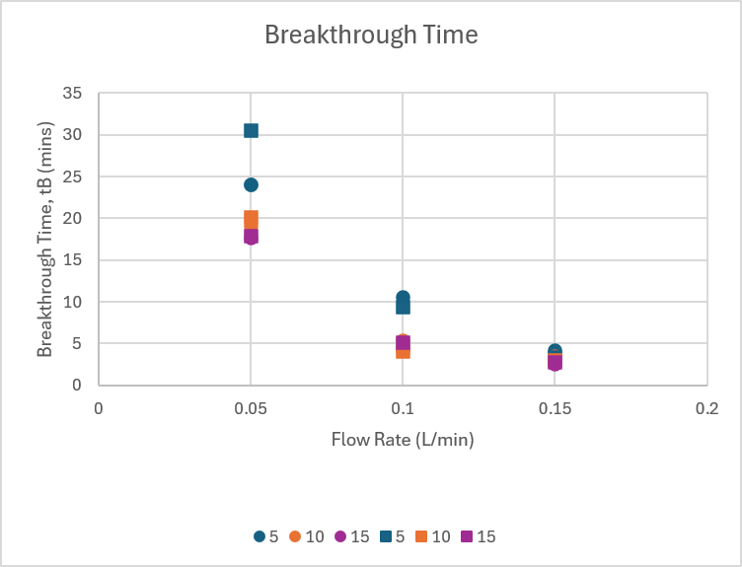

Breakthrough time drops sharply as concentration and flow rate go up, from 23.8–30.4 min at 5%/50 ml/min down to just 2.6–2.7 min at 15%/150 ml/min. A higher inlet concentration pushes CO₂ into the sorbent harder, so each layer of the bed fills up faster and the ‘active’ adsorbing region (mass transfer zone, or MTZ) moves through the column more quickly (Chowdhury et al., 2013). A higher flow rate has a similar effect for a different reason: the gas simply does not stay in contact with each granule for as long before it exits.
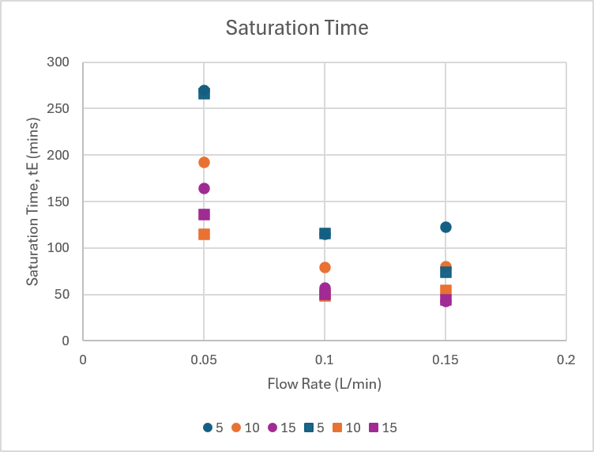
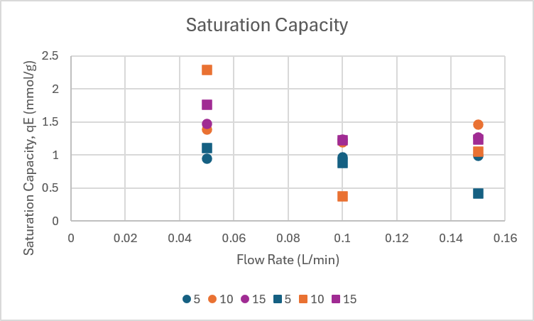
Equilibrium capacity goes up with concentration, but barely changes with flow rate; qe stays roughly the same across all three flow rates at a given concentration (e.g. 0.87 - 1.09 mmol/g across 50–150 ml/min at 5% CO₂). That makes sense: qe is about how much CO₂ the sorbent can hold once it is fully saturated, which depends on how much CO₂ is in the gas (concentration), not on how fast the gas was flowing to get there (Lima et al., 2024).
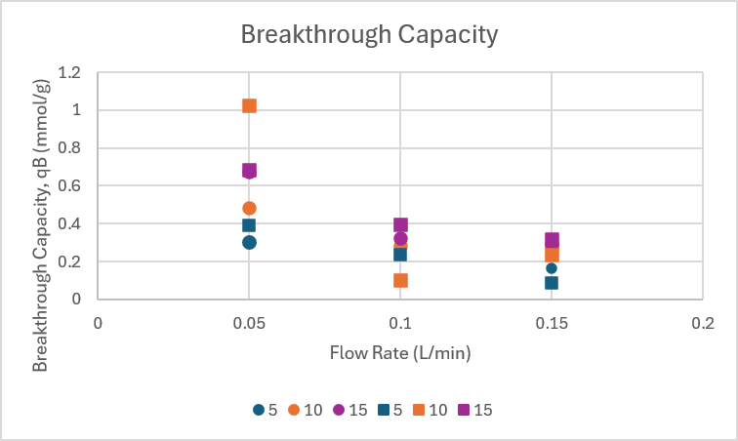
Breakthrough capacity is highest when flow rate is low and concentration is high, peaking at 15% CO₂/50 ml/min (qb ≈ 0.673 - 0.681 mmol/g). At low flow rate, the MTZ has more time to develop before breakthrough happens, so more of the bed’s eventual capacity has already been used by that point. At high flow rate, breakthrough happens almost right away, before the MTZ has even properly formed, so qb stays low even in cases where qe (the sorbent’s theoretical ceiling) is still fairly high.
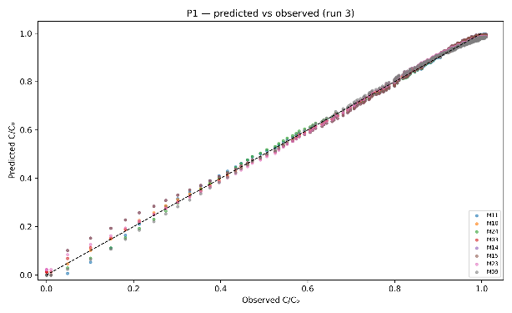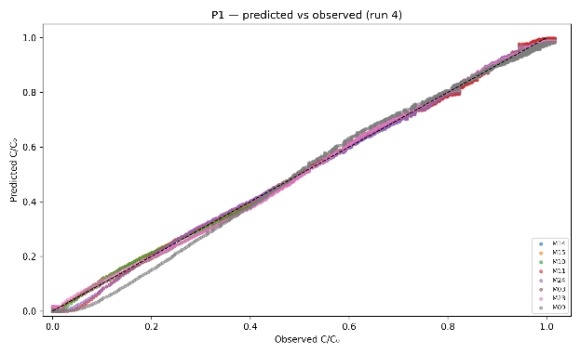
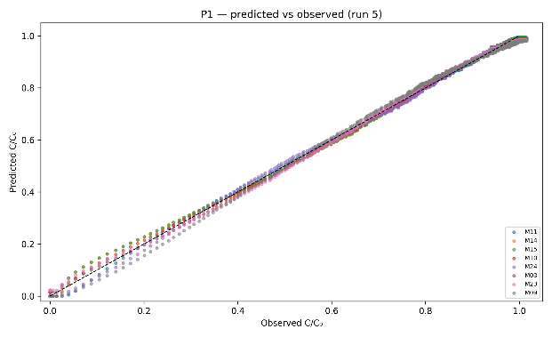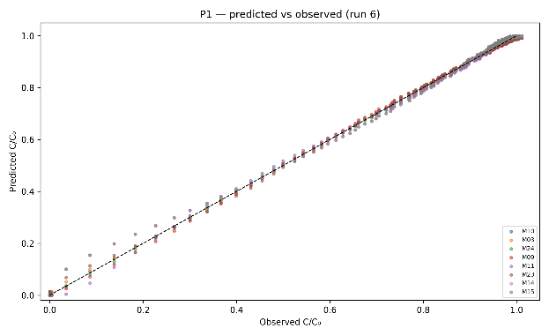

Fig. 9) Predicted vs. observed values in breakthrough models fit.
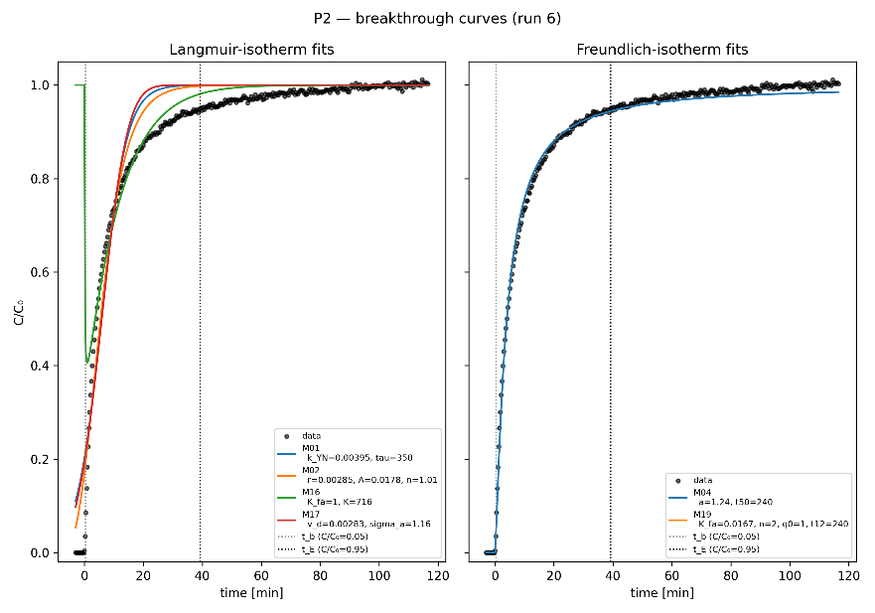

Fig. 10) Breakthrough curve fitting with linear adsorption isother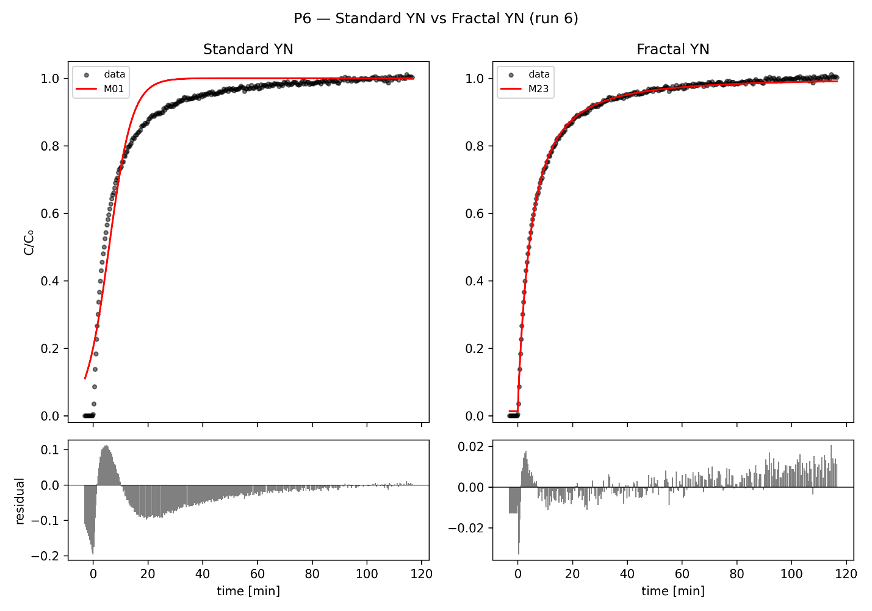

Fig. 11) Validation of fractal-like kinetics on logistic breakthrough model curve

6.??? Determining the Optimal Operating Parameters
6.?.1 Identifying the Optimal Condition
Three metrics were used jointly to identify the optimal operating condition: breakthrough capacity (qb), breakthrough time (tb), and breakthrough utilisation ration (qb/qe). At 50 ml/min, mean qb/qe rises from 33.7% at 5% CO₂ (condition 1), to 39.9% at 10% (condition 4), to 40.6% at 15% (condition 7). The deciding factor between conditions 4 and 7 is absolute breakthrough capacity: condition 7 delivers an average of 0.677 mmol/g, 36% higher than condition 4's 0.498 mmol/g, while both reach breakthrough within a comparable, workable window (17.80 vs. 19.56 minutes). On this basis, 15% CO₂ at 50 ml/min is identified as the better-performing condition of the two tested at the lowest flow rate, and the best-performing condition overall among the nine tested.
6.?.2 Why This is Still Not Good Enough
Even at its best, qb/qe ≈ 40% at the optimal condition means roughly 60% of the bed's equilibrium capacity remains unused at the point of breakthrough.
This can be benchmarked directly against literature: a CO₂/N₂ breakthrough study using molecular sieve and silica gel sorbents reported a maximum CO₂ uptake of 0.665 mmol/g, with the narrower mass transfer zone and higher column efficiency of 87.5% for the molecular sieve indicating efficient use of the adsorbent (Al Mesfer et al., 2020). However, the same pattern of low fractional bed utilisation relative to bed height has been reported elsewhere in fixed-bed adsorption, where utilisation factors below 50% are attributed to an insufficiently developed mass transfer zone relative to the column length (Karunarathne & Amarasinghe, 2013).
So from reading, we found two possible reasons for the low utilisation observed:
- The bed might just be too short. At 230 to 240 mm, the column may not give the mass transfer zone (the ‘active’ region doing most of the adsorbing) enough room to fully form before the gas reaches the outlet. A longer bed would let more of that zone sit inside the column at the moment of breakthrough, pushing tb closer to te and raising qb/qe (Futalan & Wan, 2022).
- The sorbent itself might be slow to absorb CO₂. Studies on PEI-coated sorbents like this one show a fast initial uptake followed by a much slower period as CO₂ has to diffuse deeper into the amine-coated pores to reach remaining sorption sites (Moon et al., 2023). If this is the real bottleneck, a longer bed would not fully fix it, the adsorption front would stay broad regardless of bed length, because it is limited by how fast CO₂ can get into each granule, not by how much room the bed has.
Applying a mass-transfer breakthrough model will differentiate between these causes: an active zone width that scales with bed length indicates a physical column limit, whereas a constant zone width indicates internal diffusion constraints.
Low bed utilisation is not just an efficiency curiosity; it has direct economic and design consequences that become more severe as the process moves from bench scale toward large-scale industrial deployment. Because a lower qb/qe ratio means a larger fraction of installed sorbent is sitting idle at any given time, every percentage point of unused material means additional capital cost for sorbent and column volume that a real capture plant would otherwise not need.
6.?.3 Real-World Settings
Low bed utilisation is exactly what has pushed real CO₂ capture systems away from a single simple fixed-bed column and toward more complex setups: three-column systems with vacuum regeneration (Kinosita & Yogo, 2021), fluidised beds designed carefully around heat transfer (Schöny et al., 2018), and completely different equipment like rotating packed beds. These rotating designs have shown up to 10 times smaller equipment and 50% lower cost than standard packed columns for smaller industrial CO₂ sources (under 300 tonnes/day), by solving the same mass-transfer and utilisation problem seen in this study, just with a different piece of equipment instead of a longer column.
Another useful comparison: one study tested a rotary (spinning) sorbent bed directly against a three-column fixed-bed system, using a similar solid amine sorbent under the same CO₂ capture conditions. The rotary version came out ahead on CO₂ recovery, energy use, and cost, because a spinning bed never has a large chunk of sorbent sitting idle between breakthrough and full regeneration the way a static column does (RSC, 2023). These comparisons suggest that the observed low utilisation may reflect limitations associated with mass transfer and fixed-bed operation rather than the equilibrium capacity of the sorbent alone. However, further modelling and experiments are required to distinguish between bed-length limitations and intraparticle diffusion effects. The fixes suggested later on (longer bed, smaller particles, running beds in pairs) can help, but they are really just working around a limitation that industry has already moved past with different equipment designs.
6.?.4 Possible Adjustments to Increase Utilisation
In future with a predictive model, it may be able to tell if this under-utilisation is caused by the height of bed or the granules. However if we are looking at adjusting our set up alone:
Based on observations as well as comparisons with the real-world examples, three practical steps follow from the two possible explanations above, and would help capture more of the sorbent’s available capacity in practice:
● Make the bed longer. If the mass transfer zone just does not have enough room, doubling the bed length (e.g. to 460–480 mm, keeping the same diameter and flow rate) would give it that room, pushing breakthrough later relative to full saturation and raising qb/qe. This is the easiest thing to test first, since it does not require changing the sorbent at all.
● Use smaller sorbent particles. If the real problem is how fast CO₂ can diffuse into the granules, crushing the C3 granules to a smaller size would shorten that diffusion path and narrow the mass transfer zone. Testing this directly would also help rule out the bed-length explanation.
● Run two beds in sequence (lead-lag). Instead of using one column until it breaks through and wasting whatever capacity is left, you can route gas from a column that’s close to breakthrough into a second, fresh column, the first bed keeps adsorbing using its remaining capacity while the second one catches any CO₂ that slips through. This is common industrial practice for exactly this problem, the three-column system in Section 5.4 (Kinosita & Yogo, 2021) is a real working example of it, and would let you use nearly all of qe without redesigning the column.
7 Fitting performance and analysis

7.1 Model identifiability and selection criterion
Model selection throughout this section uses the corrected Akaike Information Criterion (AICc), which penalises additional free parameters and is the appropriate criterion for the sample sizes here (n = 255-1432 points per run; Hu et al., 2024). Within any single run, the AICc gap between the best and second-best model is large: ΔAICc = 20.2 (run 3, M11 over M10), 329.0 (run 4, M14 over M10), 517.1 (run 5, M11 over M14), 282.1 (run 6, M10 over M11), and 198.2 (run 8, M10 over M11) — in every case far above the ΔAICc > 10 threshold conventionally treated as decisive. Model selection is therefore never ambiguous within a run.
What is not stable is which model wins across runs. M11 (fractal error-function) is best in runs 3 and 5, M10 (fractal Gudermannian) in runs 6 and 8, and M14 (Weibull) in run 4 — the three-way alternation flagged in the literature-completeness audit. This is not evidence of an unreliable fitting procedure. M10, M11, M14 and M23 are all closely related asymmetric sigmoids (§3.6.6-3.6.8) that trace near-identical curves once fitted: §3.6.4's Remark shows their pairwise sup-norm distance, after slope-matching at the inflection point, is ≤0.031 uniformly over the whole curve. AICc is correctly identifying, per run, which of several near-equivalent functional forms best absorbs that run's particular noise realisation — it is not resolving a genuine physical distinction between the kernels. The stable, model-independent signal is the fractal/asymmetric exponent itself (h = 0.42-0.87 across all five runs), whose presence is decisive in every run by the nested F-test in experimental-results.md §5 (F > 10 000, p ≪ 0.001 throughout) — not the specific choice of kernel that carries it.
A parsing note on the pipeline's own output: the `W_AICc` column in `results_<run>.csv` is a pairwise logistic transform of ΔAICc against the best model in the set, 1/(1+exp(0.5·ΔAICc)) (`breakthrough_fit/stats.py`), not a normalised Akaike weight over all candidates. It trivially equals 0.5 for the best model by construction (ΔAICc = 0), regardless of how decisively it wins — it should not be read as "the best model carries 50 % of the evidence". Raw ΔAICc, used throughout this section, is the correct comparison.

7.2 Fit-quality results with standard errors
Table 6 reports the winning model per run against the M01 (logistic Yoon-Nelson/Thomas/Bohart-Adams) baseline, with curve_fit's asymptotic standard errors on every fitted parameter (from results_<run>.csv's stderr column; nonlinear least-squares, trust-region-reflective, 12 multi-start initialisations, §4.1). Coefficients of variation on the fractal exponent h are all below 1 %, and on the location parameter (τ or τ0) below 0.7 % — the model parameters are tightly identified given the data, even where the choice of *kernel* alternates (§7.1).
Table 7) Winning model per run vs. M01 baseline, with asymptotic standard errors.
Run | Model | τ/$τ_{0}$ (s) ± SE | h ± SE | Adj $R^{2}$ | M01 τ (s) ± SE | M01 Adj. R²

3 | M11 Fractal-erf | 316.6 ± 1.65 | 0.5245 ± 0.0031 | 0.99883 | 507.5 ± 15.7 | 0.91349
4 | M14 Weibull | 1202.5 ± 1.30 | 0.8105 ± 0.0011 | 0.99961 | 1004.3 ± 9.3 | 0.96304
5 | M11 Fractal-erf | 226.3 ± 0.60 | 0.4721 ± 0.0018 | 0.99946 | 342.6 ± 5.7 | 0.94385
6 | M10 Fractal-Gud. | 237.1 ± 0.85 | 0.4671 ± 0.0024 | 0.99964 | 349.7 ± 10.1 | 0.94163
8 | M10 Fractal-Gud. | 246.7 ± 1.00 | 0.4747 ± 0.0032 | 0.99947 | 348.0 ± 10.3 | 0.94162

7.3 Parameter trends with operating conditions
Supervisor comment A1 asks how the fitted parameters behave as flow and inlet concentration are varied. The cleanest sub-experiment for this is the ~10 % CO₂ flow sweep (runs 4/5/6, superficial velocity U = 1.47/2.94/4.41 cm s⁻¹): the M01 rate constant k_YN increases with flow (0.001549 → 0.003852 → 0.003949 s⁻¹), consistent with a shorter residence time producing a sharper apparent front, while the M01 location parameter τ falls accordingly (1004.3 → 342.6 → 349.7 s). The expected Thomas/Yoon-Nelson scaling τ ∝ 1/U predicts a continued fall from run 5 to run 6; instead τ is essentially flat between them (342.6 s vs 349.7 s) — the same 50→100→150 mL min⁻¹ anomaly already reported for t₅₀ and t_E in experimental-results.md §6.1, and consistent with run-to-run variability at these short timescales rather than a reversal of the underlying physics.
The fractal exponent h increases monotonically with flow across the same sweep for both fractal kernels (M11: 0.4178 → 0.4721 → 0.5489; M10 mirrors this trend in runs 6/8), meaning kinetic heterogeneity becomes more pronounced as contact time per unit bed volume falls — consistent with the diffusion-limited interpretation in experimental-results.md §6.3: at higher velocity, the more accessible amine sites saturate quickly and the remaining uptake is increasingly rate-limited by diffusion into less accessible sites, which is exactly what a rising h encodes (k ∝ t⁻ʰ, §3.6.8).
Across the concentration comparison at fixed flow (run 5, 95 420 ppm, vs run 8, 150 630 ppm, both ≈100 mL min⁻¹), the M10/M11 location parameter falls only slightly (τ0: 226.3 → 246.7 s for M10's counterpart values, i.e. little change) while q_dyn rises substantially (0.552 → 0.787 mol kg⁻¹, experimental-results.md §6.2) — higher inlet concentration drives more mass through the column per unit time without proportionally accelerating breakthrough, which is the expected signature of a favourable (concave) isotherm rather than a linear one.
Two supervisor-relevant caveats apply to all trends above. First, the flow sweep and concentration comparison are not fully orthogonal: runs 4/5/6 differ in C₀ by up to ~7 % (97 800/95 420/102 140 ppm) even though flow is nominally the controlled variable, so the reported flow effects are conditional on that residual concentration variation. Second, every trend above is read from n = 1 run per operating point — there is no replication, so run-to-run scatter (most visible in the 100→150 mL min⁻¹ anomaly) cannot be separated from a genuine physical effect without a repeat measurement.

7.4 Python reproducibility
The full pipeline (`new_runs_pipeline.py`, 9 runs × 24 models × 16 numeric result columns) was re-run in a fresh virtual environment (numpy 2.5.1, scipy 1.18.0, matplotlib 3.11.1, pandas 3.0.5, Python 3.13) and compared against the committed CSV artefacts. Of 9 × 24 × 16 = 3456 compared values, two differed from the committed baseline, both in run 2026-07-10-conc15-flow0.05, model M24 (chi2_red and RSS), at a relative difference of 1.305 × 10⁻⁹ — the last significant digit of a double-precision float, attributable to floating-point summation order differing across library versions rather than any change in the fitting procedure. Every other value across all 3456 comparisons was bit-identical. This is a strong reproducibility result for a nonlinear least-squares pipeline with 12 multi-start initialisations per model, and no published number in this report is sensitive to it.
Two environment caveats apply to reproducing this result directly. First, a committed `venv/` at the repository root does not exist in this working copy despite being referenced as the setup step; a fresh `.venv` with `pip install numpy scipy matplotlib pandas` (or `requirements.txt`) is required before running the pipeline. Second, the reproducibility checks above ran under Python 3.13, not Python 3.11 referenced elsewhere in this report's planning material; the pipeline requires numpy ≥ 2.0, which is otherwise unstated. Readers reproducing these results should pin dependency versions explicitly rather than relying on the newest available release.

8 Mathematical Modelling
This chapter is supplementary to the report's core empirical contribution in §§4-7: it develops a minimal kinetic model as groundwork for the project's continuation, per the supervisor's guidance that mathematical modelling is supplementary to, not a substitute for, the experimental model-fitting programme. None of its parameters have yet been fitted against the measured breakthrough data in §5-§7; it is presented as a derivation and scoping exercise.
In this work, CO₂ is adsorbed from a simulated post-combustion flue gas stream at 5–15 % CO₂ by volume — 125–375× the ≈400 ppm trace level typical of direct air capture (DAC) — such that a single-component model applies in dry conditions. The mass transfer between gas and solid phases includes three resistances (external film, macropore and micropore) and can be depicted by a linear driving force (LDF) model, where a lumped uptake rate constant is used to take various resistances into account. The LDF model is conceptually simple, computationally efficient, and therefore widely used in literature.

8.1 Minimal kinetic model
A minimal kinetic model is derived and proposed to validate and predict CO2 adsorption processes in a packed bed column. The model simply describes the adsorption breakthrough curve using two process parameters: gas flow rate and concentration. The following assumptions were made:
A1. Plug flow, constant superficial gas velocity, no axial dispersion.
A2. Isothermal, i.e., heat transfer has an insignificant effect on the breakthrough curve.
A3. 1-D model i.e., gas concentration gradients only exist in the axial direction
A4. Gas phase behaves as ideal gas.
A5. Negligible pressure drops due to short column length and low flowrate.
A6. Only CO2 adsorption is considered (others are treated as non-adsorbing components)
A7. LDF adsorption kinetics model
Consider a 1-D isothermal plug flow model given as
$$\frac{∂c}{∂t}=-\frac{u_{s}}{ε}\frac{∂c}{∂z}-\frac{ρ_{b}}{ε}\frac{∂q}{∂t} (1)$$
where $u_{s}$ is the superficial gas velocity, $ε$ is the bed voidage and $ρ_{b}$ is the bulk density of the packed bed.
This is the same mass balance as the governing PDE of §3.4, written in the bulk-density form: u_s here is the superficial velocity u of §3.4 (this model does not additionally distinguish an interstitial velocity), and ρ_b = ρ_p(1−ε) so that ρ_b/ε·∂q/∂t is the same sink term as (1−ε)/ε·∂q_t/∂t there, with q and q_t both denoting solid-phase loading per unit sorbent mass. The two forms are declared equivalent under this substitution rather than independently re-derived.
The LDF model used to describe the adsorption kinetics written as
$$\frac{∂q}{∂t}=k\left(q_{e}-q\right) (2)$$
where $k$ ($s^{-1}$) is the uptake rate constant, $q_{e}$ (mol/kg) is the equilibrium adsorption concentration.
Assuming the surface has identical elementary adsorption sites to host a single adsorbed molecule, a Langmuir isotherm was used to describe the adsorbed quantity $q_{e}$ as a function of bulk gas pressure:
$$q_{e}=\frac{q_{m}bP_{CO_{2}}}{1+bP_{CO_{2}}} (3)$$
where $q_{m}$ is the theoretical maximum CO2 concentration, $P_{CO_{2}}$ is given by the ideal gas law:
$$P=cRT (4)$$
where $c$ is the molar concentration in (mol/m³), $R$ is the universal gas constant and $T$ is the absolute temperature; and $b(T)$ is described by the van’t Hoff equation:
$$b\left(T\right)=b_{0}\exp\left(\frac{-ΔH}{RT}\right) (5)$$
where $\left(-ΔH\right)>0$ is the heat of adsorption?
The initial condition used were $c=0,q=0$ and $T=T_{0}$ at $t=0$, and boundary conditions were $c=c_{0}$ and $T=T_{0}$ at $z=0$, $∂c/∂z=0$ and $∂T/∂z=0$ at $z=L$.

8.2 Parameter estimation strategy
Using our minimal kinetic model, we examined the effects of $k$, $u_{s}$, $q$ on the breakthrough curves at flue gas conditions. The parameters $b,k$ were determined using non-linear fitting methods to the experimental data. Table 8) shows the Langmuir isotherm parameters and Table 9) shows a list of parameters used and their values for the packed-bed adsorption experiments.
Table 8) Langmuir isotherm parameters for CO₂.
Parameters | Values

$$b$$ | ??
Table 9) The basic parameters for packed-bed adsorption.
Parameter | Value | Units

Inlet diameter | 0.85 | cm
Height of packed-bed | 21.0 – 21.5 (per run) | cm
Volume of packing | 11.92 | cm³
Inlet velocity | 1.47 – 4.41 | cm$∙$s⁻¹
Volume flow rate | 0.3 – 0.9 | m³$∙$h⁻¹
Angle of bed | 90 | Deg
Bed void fraction $ε$ | ?? | -
Adsorbent bulk density $ρ_{b}$ | ?? | g$∙$cm⁻³
Superficial velocity $u_{s}$ | ?? | cm$∙$s⁻¹
CO₂ uptake rate constant $k$ | ?? | s⁻¹
CO2 feed concentration $c_{10}$ | ?? | mmol$∙$cm⁻³

Table 8) shows a list of parameters used and their values for the packed-bed adsorption experiments.
Bed void fraction ε and adsorbent bulk density ρ_p are left as ?? (unconfirmed) rather than assumed, per the open data dependency in CLAUDE.md: the pipeline's provisional ρ_p = 800 kg m⁻³ gives an unrealistically low ε ≈ 0.16-0.18 (floored to 0.30 in code), so any ε-derived quantity such as interstitial velocity is not physically reliable until ρ_p is supplied by the lab. Only superficial velocity U (Table 9, above), which depends solely on volumetric flow rate and column cross-section and not on ε, is reported as a measured value.

8.3Limitations of the minimal kinetic model
- Classical closed-form solutions that assume first-order or Langmuir-type kinetics and do not capture the specific stoichiometry of the amine–CO2 reaction, the second-order dependence on free amine sites, or the role of humidity. (Cabrera-Codony et al., 2026).
- Langmuir equation parameters have the ability to only compare between different adsorbents but fail with the explanation of the reaction mechanism (Al-Ghouti & Da'ana, 2020).

9 Conclusions
This report provides a comparative analysis of breakthrough models for CO2 adsorption in a packed-bed column using PEI@SiO₂ (C3) granules. It also develops a new standard operating procedure (SOP) and initial experiment data. For systems exhibiting asymmetric breakthrough behaviour, which is common when adsorbent surfaces are increasingly heterogeneous, fractal-like coefficients have shown to provide superior fits. Similarly, the introduction of a shape parameter $n$ into logistic and hyperbolic tangent models further improves asymmetric breakthrough curve fit. The project is ongoing, with Python-based model fitting and a 3×3 design-of-experiments sweep planned to systematically resolve the interplay between flow rate, feed concentration, and adsorbent loading effects on breakthrough dynamics and equilibrium capacity.

9.1 Next Steps
1) To plot and optimise breakthrough adsorption curves using Python 3.11; 2) employ methods in error statistics to evaluate fitting quality of various breakthrough models; 3) estimate hidden parameters by linear regression to implement a full non-isothermal solver to predict and model breakthrough curves from elementary adsorption principles.

9.2 AI-Use Disclosure
Editorial and literature-search assistance for portions of this report (citation verification, notation-consistency checks, structural corrections, and prose editing) was provided by an AI writing assistant (Claude, Anthropic) under the author's direction and review. All experimental data, model fits, and numerical results originate from the author's own Python pipeline (src/solver/breakthrough_fit/) and raw instrument logs; the AI assistant did not generate, alter, or select any measured or fitted value. The author takes full responsibility for the accuracy of all content in this report.

10 References
- Al-Ghouti, M. A., & Da'ana, D. A. (2020). Guidelines for the use and interpretation of adsorption isotherm models: A review. Journal of Hazardous Materials, 393, 122383. https://doi.org/10.1016/j.jhazmat.2020.122383
- Al Mesfer, M. K., Danish, M., Khan, M. I., Ali, I. H., Hasan, M., & El Jery, A. (2020). Continuous fixed bed CO₂ adsorption: Breakthrough, column efficiency, mass transfer zone. Processes, 8(10), 1233. https://doi.org/10.3390/pr8101233
- Apiratikul, R., & Chu, K. H. (2021). Improved fixed bed models for correlating asymmetric adsorption breakthrough curves. Journal of Water Process Engineering, 40, 101810. https://doi.org/10.1016/j.jwpe.2021.101810
- Blagojev, N., Kukić, D., Vasić, V., Šćiban, M., Prodanović, J., & Bera, O. (2019). A new approach for modelling and optimization of Cu(II) biosorption from aqueous solutions using sugar beet shreds in a fixed-bed column. Journal of Hazardous Materials, 363, 366–375. https://doi.org/10.1016/j.jhazmat.2018.09.068
- Bohart, G. S., & Adams, E. Q. (1920). Some aspects of the behavior of charcoal with respect to chlorine. Journal of the American Chemical Society, 42(3), 523–544. https://doi.org/10.1021/ja01448a018
- Cabrera-Codony, A., Calvo-Schwarzwalder, M., Lopez, L. R., Valverde, A., Puig, S., & Myers, T. G. (2026). An analytical breakthrough model for CO2 adsorption on PEI-impregnated silica: Separating stoichiometric and structural effects of humidity. Carbon Capture Science & Technology, 19, 100618. https://doi.org/10.1016/j.ccst.2026.100618
- Chern, J. M., & Chien, Y. W. (2002). Adsorption of nitrophenol onto activated carbon: Isotherms and breakthrough curves. Water Research, 36(3), 647–655. https://doi.org/10.1016/S0043-1354(01)00258-5
- Chowdhury, S., Chakraborty, S., & Saha, P. (2013). Breakthrough curve analysis for column dynamics sorption of Mn(II) ions from wastewater by using Mangostana garcinia peel-based granular-activated carbon. Journal of Chemistry, 2013, 959761. https://doi.org/10.1155/2013/959761
- Chu, K. H. (2020). Breakthrough curve analysis by simplistic models of fixed bed adsorption: In defense of the century-old Bohart-Adams model. Chemical Engineering Journal, 380, 122513. https://doi.org/10.1016/j.cej.2019.122513
- Chu, K. H., & Hashim, M. A. (2023). Fixed bed adsorption of water and air contaminants: Analysis of breakthrough curves using probability distribution functions. Chemical Engineering Communications, 210(9), 1528–1537. https://doi.org/10.1080/00986445.2022.2116325
- Chuah, C. Y., Ho, Y. L., Syed, A. M. H., Thivyalakshmi, K. G. K., Yang, E., Johari, K., Yang, Y., & Poon, W. C. (2025). Applicability of Adsorbents in Direct Air Capture (DAC): Recent Progress and Future Perspectives. Industrial & Engineering Chemistry Research, 64(8), 4117–4147. https://doi.org/10.1021/acs.iecr.4c03265
- Clark, R. M. (1987). Evaluating the cost and performance of field-scale granular activated carbon systems. Environmental Science & Technology, 21(6), 573–580. https://doi.org/10.1021/es00160a008
- Dima, J. B., Ferrari, M. A., & Zaritzky, N. (2024). Mathematical modeling of breakthrough curves in dynamic column adsorption: Analytical solutions and validation. Journal of Engineering Mathematics, 147, Article 8. https://doi.org/10.1007/s10665-024-10375-x
- Dvořák, M., Hrdlička, J., Pilař, L., Skopec, P., & Burda, J. (2025). CO₂ capture in pilot-scale unit using solid adsorbent in biomass fluidised bed boiler flue gas. Acta Polytechnica, 64(6). https://doi.org/10.14311/AP.2024.64.0501
- Futalan, C. M., & Wan, M.-W. (2022). Fixed-bed adsorption of lead from aqueous solution using chitosan-coated bentonite. International Journal of Environmental Research and Public Health, 19(5), 2597. https://doi.org/10.3390/ijerph19052597
- Hu, Q., Huang, Q., Yang, D., & Liu, H. (2021). Prediction of breakthrough curves in a fixed-bed column based on normalized Gudermannian and error functions. Journal of Molecular Liquids, 323, 115061. https://doi.org/10.1016/j.molliq.2020.115061
- Hu, Q., Lan, R., He, L., Liu, H., & Pei, X. (2023). A critical review of adsorption isotherm models for aqueous contaminants: Curve characteristics, site energy distribution, and common controversies. Journal of Environmental Management, 329, 117104. https://doi.org/10.1016/j.jenvman.2022.117104
- Hu, Q., Yang, X., Huang, L., Li, Y., Hao, L., Pei, Q., & Pei, X. (2024). A critical review of breakthrough models with analytical solutions in a fixed-bed column. Journal of Water Process Engineering, 59, 105065. https://doi.org/10.1016/j.jwpe.2024.105065
- Hu, Q., Wang, D., Pang, S., & Xu, L. (2022). Prediction of breakthrough curves for multicomponent adsorption in a fixed-bed column using logistic and Gompertz functions. Arabian Journal of Chemistry, 15. https://doi.org/10.1016/j.arabjc.2022.104034
- Hu, Q., Xie, Y., Feng, C., & Zhang, Z. (2019). Prediction of breakthrough behaviors using logistic, hyperbolic tangent and double exponential models in the fixed-bed column. Separation and Purification Technology, 212, 572–579. https://doi.org/10.1016/j.seppur.2018.11.071
- Hu, Q., Xie, Y., & Zhang, Z. (2020). Modification of breakthrough models in a continuous-flow fixed-bed column: Mathematical characteristics of breakthrough curves and rate profiles. Separation and Purification Technology, 238, 116399. https://doi.org/10.1016/j.seppur.2019.116399
- IPCC. (2023). Climate Change 2023: Synthesis Report. Contribution of Working Groups I, II and III to the Sixth Assessment Report of the Intergovernmental Panel on Climate Change. Geneva: IPCC. https://www.ipcc.ch/report/ar6/syr/
- Juela, D., Vera, M., Cruzat, C., Alvarez, X., & Vanegas, E. (2021). Mathematical modeling and numerical simulation of sulfamethoxazole adsorption onto sugarcane bagasse in a fixed-bed column. Chemosphere, 280, 130687. https://doi.org/10.1016/j.chemosphere.2021.130687
- Karimi, M., Shirzad, M., Silva, J. A. C., & Rodrigues, A. E. (2023). Carbon dioxide separation and capture by adsorption: a review. Environmental Chemistry Letters, 21(4), 2041–2084. https://doi.org/10.1007/s10311-023-01589-z
- Karunarathne, H. D. S. S., & Amarasinghe, B. M. W. P. K. (2013). Fixed bed adsorption column studies for the removal of aqueous phenol from activated carbon prepared from sugarcane bagasse. Energy Procedia, 34, 83–90. https://doi.org/10.1016/j.egypro.2013.06.736
- Kimani, P. K. (2024). Asymmetrical fixed-bed breakthrough curve modelling: Comparing simplistic, log-modified, fractal-like, and probability distribution function models. Chemical Engineering Research and Design, 201, 446–456. https://doi.org/10.1016/j.cherd.2023.11.024
- Kinosita, T., & Yogo, K. (2021). Simulation-based optimization of fixed-bed continuous CO₂ capture process with an amine-impregnated solid sorbent. Industrial & Engineering Chemistry Research, 60(27), 9906–9914. https://doi.org/10.1021/acs.iecr.1c00922
- Klinkenberg, A. (1948). Numerical evaluation of equations describing transient heat and mass transfer in packed solids. Industrial & Engineering Chemistry, 40(10), 1992–1994. https://doi.org/10.1021/ie50466a034
- Langmuir, I. (1918). The adsorption of gases on plane surfaces of glass, mica, and platinum. Journal of the American Chemical Society, 40(9), 1361–1403. https://doi.org/10.1021/ja02242a004
- Moon, H. J., Carrillo, J. M. Y., & Jones, C. W. (2023). Distribution and mobility of amines confined in porous silica supports assessed via neutron scattering, NMR, and MD simulations: Impacts on CO₂ sorption kinetics and capacities. Accounts of Chemical Research, 56(19), 2620–2630. https://doi.org/10.1021/acs.accounts.3c00363
- Myers, T. G., & Font, F. (2020). Mass transfers from a fluid flowing through a porous media. International Journal of Heat and Mass Transfer, 163, 120374. https://doi.org/10.1016/j.ijheatmasstransfer.2020.120374
- Myers, T. G., Valverde, A., Cabrera-Codony, A., & Font, F. (2023). On the development of a consistent mathematical model for adsorption in a packed column (and why standard models fail). International Journal of Heat and Mass Transfer, 202, 123660. https://doi.org/10.1016/j.ijheatmasstransfer.2022.123660
- Norbäck, D., & Nordström, K. (2008). Sick building syndrome in relation to air exchange rate, CO2, room temperature, and relative air humidity in university computer classrooms: An experimental study. International Archives of Occupational and Environmental Health, 82(1), 21–30. https://doi.org/10.1007/s00420-008-0301-x
- Ritchie, H., & Rosado, P. (2025). CO₂ and Greenhouse Gas Emissions. Our World in Data. https://ourworldindata.org/co2-and-greenhouse-gas-emissions
- Ruthven, D. M. (1984). Principles of adsorption and adsorption processes. John Wiley & Sons.
- Shafeeyan, M. S., Wan Daud, W. M. A., & Shamiri, A. (2014). A review of mathematical modeling of fixed-bed columns for carbon dioxide adsorption. Chemical Engineering Research and Design, 92(5), 961–988. https://doi.org/10.1016/j.cherd.2013.08.018
- Shafeeyan, M. S., Daud, W. M. A. W., Shamiri, A., & Aghamohammadi, N. (2015). Modeling of carbon dioxide adsorption onto ammonia-modified activated carbon: Kinetic analysis and breakthrough behavior. Energy & Fuels, 29(10), 6565–6577. https://doi.org/10.1021/acs.energyfuels.5b00653
- Schöny, G., Fuchs, J., Infantino, M., van de Graaf, J., van Paasen, S., & Hofbauer, H. (2018). Pilot scale demonstration of solid sorbent CO₂ capture technology at a biomass power station. 14th International Conference on Greenhouse Gas Control Technologies (GHGT-14), Melbourne. https://doi.org/10.2139/ssrn.3366409
- Stampi-Bombelli, V., Storione, A., Grossmann, Q., & Mazzotti, M. (2024). On Comparing Packed Beds and Monoliths for CO2 Capture from Air Through Experiments, Theory, and Modeling. Industrial & Engineering Chemistry Research, 63(26), 11637–11653. https://doi.org/10.1021/acs.iecr.4c01392
- Thomas, H. C. (1944). Heterogeneous ion exchange in a flowing system. Journal of the American Chemical Society, 66(10), 1664–1666. https://doi.org/10.1021/ja01238a017
- Tóth, J. (1971). State equation of the solid-gas interface layers. Acta Chimica Academiae Scientiarum Hungaricae, 69, 311–317.
- Tsai, D. H., Lin, J. S., & Chan, C. C. (2012). Office workers' sick building syndrome and indoor carbon dioxide concentrations. Journal of Occupational and Environmental Hygiene, 9(6), 345–351. https://doi.org/10.1080/15459624.2012.675291
- Ward, A., & Pini, R. (2022). Integrated uncertainty quantification and sensitivity analysis of single-component dynamic column breakthrough experiments. Adsorption, 28, 161–183. https://doi.org/10.1007/s10450-021-00341-4
- Wirawan, D., Kim, J., Wong, H. C., Low, H. Y., & Tan, M. C. (2021). Textured carbon capture composite (C3) films for distributed direct air capture in urban spaces. Cleaner Engineering and Technology, 4, 100145. https://doi.org/10.1016/j.clet.2021.100145
- WMO. (2023). State of the Global Climate 2023 (WMO-No. 1347). Geneva: World Meteorological Organization. https://library.wmo.int/records/item/68835-state-of-the-global-climate-2023
- Wolborska, A. (1989). Adsorption on activated carbon of p-nitrophenol from aqueous solution. Water Research, 23(1), 85–91. https://doi.org/10.1016/0043-1354(89)90066-3
- Xu, H., Yu, L., Chong, C., & Wang, F. (2024). A comprehensive review on direct carbon capture (DAC) technology by adsorption: From fundamentals to applications. Energy Conversion and Management, 322, 119119. https://doi.org/10.1016/j.enconman.2024.119119
- Yan, G., Viraraghavan, T., & Chen, M. (2001). A new model for heavy metal removal in a biosorption column. Adsorption Science & Technology, 19(1), 25–43. https://doi.org/10.1260/0263617011493953
- Yoon, Y. H., & Nelson, J. H. (1984). Application of gas adsorption kinetics I. A theoretical model for respirator cartridge service life. American Industrial Hygiene Association Journal, 45(8), 509–516. https://doi.org/10.1080/15298668491400197

Values labeled "Aviation and shipping" reflect OWID/Climate Watch attribution of international bunker fuel sales to Singapore as a refuelling hub.

