

Engineering Science Design Project
“CO2 Adsorption in Packed-Bed Column using Polymer-based Sorbent: Parametric Study and Model Prediction”
Interim Report

Student Names: Loh John Ray (S10267908K)
Saraswati Eloise Gunawan (S10267534J)

NP Supervisor: Dr. Pham The Hanh

Institution Supervisor: Prof. Erik Birgersson
Dr. Prapatsorn Borisut
Project Group ID: 3
Project Period: April 2026 – August 2026
Report Date: 18 May 2026

Declaration by students:
- By submitting this report online, I confirm that the report has been submitted to and vetted by my institution supervisor and thereby confirm that the report contains no confidential material from the company.
- I declare that the report is written by me and not plagiarised from other sources.

____________________
Students Signature / Date

Abstract
The growing demand for scalable carbon capture technologies has intensified research into adsorption processes, particularly using amine-impregnated capture sorbent. We provide a comprehensive review on breakthrough models, discussing the process parameters, alongside our assumptions and initial conditions to improve understanding of packed-bed CO₂ adsorption performance and identify conditions that could enhance capture efficiency. We validate the model against breakthrough data at three inlet CO₂ concentrations (5, 10 and 15% by volume) at various flow rates (50, 100 and 150 ml/min), using a 3 × 3 design. We discuss existing problems in breakthrough adsorption—ensuring data reliability, complete and partial breakthrough curves—and proposed a standard operating procedure (SOP). Breakthrough data are further employed to evaluate existing adsorption breakthrough models and support predictive modelling in Python, with the aim of identifying operating conditions that enhance CO₂ capture efficiency.

Table of Contents
Abstract 2
Table of Contents 3
Nomenclature 5
List of Figures 6
Preamble 7
1 Introduction 9
1.1 Scope of Project 10
2 Project Outline and Objectives 11
2.1 Project Outline 11
2.2 Project Objectives 11
2.1 Project Outline 11
2.2 Project Budget 13
2.3 Project Schedule 14
3 Literature research 16
3.1 Overview 16
3.2 Adsorption Process 16
3.2.1 CO2 Capture from Air Through Experiments, Theory and Modelling 19
3.2.2 Materials used for adsorption experiments 20
3.3 Adsorption Isotherms 21
3.3.1 Langmuir Isotherm 21
3.3.2 Toth Isotherm 22
3.4 Breakthrough Adsorption 22
3.4.1 Bohart-Adams 23
3.4.2 Thomas Model 24
3.4.3 Yoon-Nelson 24
3.4.4 Equivalence of classical breakthrough models 25
3.4.5 Gudermannian and Error functions 26
3.4.5 Clark 26
3.4.1 Hu et al. (2024) A critical review of breakthrough models 26
3.4.2 Formulation of CO2 adsorption model in fixed-bed column 27
3.4.3 Review of Prior Solutions 28
3.4.4 Design or Research Procedure 29
4. Standard Operating Procedure for CO₂ Adsorption Experiment 30
4.1 Apparatus and Instrumentation 31
4.1.1 Gas Feeding Section 31
4.1.2 Adsorption Column 31
4.1.3 Gas Analysis and Monitoring 31
4.1.4 Pre-Run Preparation 33
4.2 Experimental Procedure 33
4.2.1 Sensor Setup and Calibration 33
4.2.3 Feed Gas Preparation 33
4.2.2 Column Loading and Purge 34
4.2.4 CO₂ Adsorption (Breakthrough Experiment) Run 34
4.3 After the Run 35
4.3.1 Acceptance Criteria and Validity 35
4.4 Data to Record 36
4.5 Safety Notes 36
5 Experimental Results 37
6 Experimental Analysis 37
8 Appendix 39
8.1 Transport Phenomena 39
8.1.1 Continuity Equation 39
8.1.2 The Stress Tensor 40
9 References 41

Nomenclature

List of Figures
Fig. 1. Greenhouse gas emissions by sector in Singapore, 2023. Adapted from CO₂ and Greenhouse Gas Emissions, by H. Ritchie and P. Rosado, 2025, Our World in Data (https://ourworldindata.org/profile/co2/singapore). .............. 7
Figure X & Y. Sourced from SUTD via Dr. Prapatsorn in Project_introduction.pptx. Shows lab setup for granule-based adsorption experiments using packed-bed columns via polymer-based sorbents; where $C_{0}$ is the sorbate initial concentration, $C_{t}$ the sorbate concentration at time $t$, $t_{0}$ the breakthrough time, $t_{E}$: equilibrium time (saturation time), $V_{0}$: superficial velocity, $v$: interstitial velocity, $Q_{o}$: initial gas volumetric flow rate, $A_{c}$: column cross-sectional area. ………………………………………………………………………………………………………………............ XX
Figure Z: A schematic representation of steps involved in adsorption-based processes, https://doi.org/10.1002/macp.202200032, A schematic representation of the steps involved in adsorption-based separations. a) A feed solution containing multiple analytes is passed through the sorbent. (i) Ideally, the sorbent is selective towards one analyte and competing analytes pass through the membrane unhindered. (ii) A saturation front of bound solute moves through the sorbent until the available active sites are occupied. (iii) For an ideal sorbent, the feed fraction of analyte (i.e., the solute concentration in the effluent relative to the feed) will resemble a step function. However, due to phenomena including mass transfer and kinetic limitations as well as dispersion, this is unrealistic and experimental breakthrough curves are sigmoidal in nature. Innovative polymer processing methods provide opportunities for controlling sorbent structure to minimize these limiting phenomena. b) The sorbent is regenerated by subjecting it to an external stimulus that releases the adsorbate molecules from the selective sites so that the target solute can be eluted. Environmental stimuli (green) are introduced by changing the temperature or composition of the solution around the sorbent. Other stimuli (orange) effect the sorbent nanostructure directly to disrupt the energetically favorable sorbent-analyte interactions and promote the desorption of the analyte. c) Ideally, all sorbent sites within the sorbent are regenerated and the cycle can begin again. …………………………………………………………. XX
Figure W. 18-week (in-progress) Gantt chart detailing project scope, preparation phases and deliverable timelines.
Fig. X. shows an image of the adsorption setup, including the gas supply lines, MFCs, adsorption column, and associated sensors. The valves are labelled 1 to 5, and will be referenced as such in the rest of the SOP. (will replace with image of the actual tubing. …………………………………………………………………………………….. XX

1 Introduction
Carbon dioxide accumulation is the primary driver of anthropogenic climate change, resulting in severe global consequences, such as rising global temperatures, more frequent extreme weather events, and sea-level rise. Atmospheric CO2 concentrations rose from 280 ppm to over 440 ppm above pre-industrial levels today and is expected to rise to 900 ppm should current CO2 emissions level persist (Xu et al., 2024). While nations aim to limit global warming, conventional emissions reduction strategies are insufficient to meet the 2$℃$ target set during the Paris Agreement [??].
Beyond this, CO₂ accumulation also compromises human health and well-being across macro- and micro-scales. On a macroscale, climate-induced environmental disruptions, such as extreme heatwaves, can place severe strain on public health, especially amongst vulnerable demographic groups, as well as threaten livelihoods through reduced food security and poorer living conditions. On a microscale, elevated CO₂ concentrations indoors have been associated with poor health symptoms which we can see when taking a closer look at two high-density settings: (i) office workers exposed to CO₂ concentrations above 800ppm (8%) reported more eye irritation and upper respiratory symptoms, as well as reduced cognitive productivity [??] and ; (ii) other studies [??] have linked higher indoor CO₂ levels with asthma-related ailments, tiredness, and dizziness in schools and childcare settings.

Fig. 1) Greenhouse gas emissions by section in Singapore (2023)
This issue of increased CO₂ levels is especially relevant in Singapore, where land is limited and the economy is closely tied to hard-to-abate sectors such as shipping, aviation, and petrochemicals as shown in Fig. 1). Thus, Singapore cannot rely on land-intensive carbon sinks such as large-scale afforestation to reduce the CO₂ in the atmosphere and will need solutions to curb excessive increase in indoor settings. As a result, there is growing interest in compact and scalable carbon capture technologies that can reduce CO₂ emissions more effectively.
Fixed-bed column adsorption presents a promising separation method for CO2 capture due to its simple setup. Recent developments in CO2 capture by adsorption demonstrate the attractiveness of this technique for post-combustion treatment of flue gas. Various adsorption technologies such as pressure swing adsorption (PSA), vacuum swing adsorption (VSA), temperature swing adsorption (TSA) and moisture swing adsorption (MSA) are thus viewed as scalable CO2 separation and purification techniques. Prior to the design of an adsorption process, many studies concerning the selection of an appropriate adsorbent material for CO2 capture have resulted in a wide variety of adsorbent materials investigated. Sorbent materials for low-pressure CO2 capture, such as amine-functionalised materials, zeolites, metal oxides, metal-based materials, silicas, activated carbon and carbon molecular sieves (Chuah et al., 2025; Xu et al., 2005), have varying process dependent parameters (i.e. selectivity, working capacity, desorption capacity, etc).

1.1 Scope of Project
Development of a mathematical model is required to describe the complex dynamics of adsorption. However, in many cases, existing phenomenological models cannot completely describe all its process dependent parameters. Moreover, the design of a predictive mathematical model described purely by extensive experimentation and process development tends to be time-consuming and expensive (Siahpoosh et al., 2009). A model that uses prior established process parameters like adsorption rate constant and equilibrium data can, in theory, provide a method of estimating the column capacity without extensive experiments. However, prediction of column dynamics requires the solution of a set of simultaneous partial differential equations (PDEs) representing mass, energy and momentum balances over a fixed bed with appropriate boundary conditions (Hwang et al., 1995). Thus, the use of simpler and more tractable models (Hu et al., 2024) that can satisfactorily predict fixed-bed behaviour is desirable. The literature survey reveals how these simplified assumptions can be made to represent transport phenomena within adsorbent particles as an alternative way to investigate fixed-bed adsorption calculations.

2 Project Outline and Objectives

2.1 Project Outline
This project addresses the need for effective CO₂ capture technologies that can be applied in compact, modular systems. The experimental work is centered on a packed-bed adsorption rig designed to capture CO₂ using PEI-SiO₂ granules. The system was selected because adsorption is well suited to diluting gas streams and can be operated with relatively low energy demand compared with liquid-based capture systems (Karimi et al., 2023; Stampi-Bombelli et al., 2024).
The project began with laboratory familiarisation, procurement of components, and assembly of the experimental setup. After this, the team developed a standard operating procedure (SOP) and planned the design of experiments (DOE) for the adsorption experiments. The technical understanding gained so far indicates that breakthrough behaviour is strongly influenced by inlet concentration, flow rate, and the interaction between the gas stream and the sorbent surface (Jin et al., n.d.; Karimi et al., 2023). These factors form the basis for the experimental and modelling work in the project.
The aim of this project was to review and understand existing breakthrough models (Myers et al., 2023; Hu et al., 2024) and apply practical templates (Lin, 2017; Juela, 2021) against collected breakthrough data. These models were experimentally verified at three inlet CO₂ concentrations (5, 10 and 15% by volume) at various flow rates (50, 100 and 150 ml/min), in a 3 × 3 design. The system’s adsorption performance across a 3 × 3 parameter sweep will be compared to support model development and validation. The overall aim is to determine how operating conditions affect the adsorption behaviour of the packed-bed column and to assess the suitability of the sorbent system for future carbon capture studies.
Problem Statement. How might we validate the CO2 concentration and mass flow rate in the SUTD wet-rig experiment setup using existing breakthrough models, by finding out the hidden adsorption parameters that can only be determined experimentally using fixed-bed data, enabling the modelling and prediction of breakthrough experiments at SUTD without the need to conduct experiments repeatedly?

2.2 Project Objectives
The project aims to:
- Assemble and operate the packed-bed adsorption experimental setup.
- Carry out breakthrough experiments using PEI-SiO₂ granules.
- Study the effects of CO₂ concentration and flow rate on adsorption capacity.
- Fit and validate breakthrough models using Python.
- Identify operating conditions that improve adsorption performance.

2.2 Project Schedule
Phase | Task | W0 (20/04) | W1 (27/04) | W2 (04/05) | W3 (11/05) | W4 (18/05) | W5 (25/05)
Deliverables | First Meetings w/ Supervisors
 | Literature Review
 | Bi-weekly Journal #1
 | Defining our Problem Statement
 | Refining our Problem Statement
 | Bi-weekly Journal #2
 | Submit First Draft of Interim Report
 | Interim Report
 | Interim Review & Presentation
Literature  Review | Review on CO2 capture (material and technology)
 | Review on packed bed adsorption and models
 | Review on breakthrough model
 | How to analyse data
 | Finalise Models to Use
Experimentation  Preparation | Prepare Bill of Materials (BOM)
 | Rig Familiarisation
 | Standard of Procedure (SOP)
 | Equipment Setup
 | Data acquisition & curve-fit workflow setup
 | Pre-Session Checks (recurring)
Experimentation  Execution | OAT - vary flow rate & concentration
 | Model Fitting & Error Minimisation
 | Validation runs - baseline (4 exp; PFO/DK model)
 | Addition/Repeat (if required)

Phase | Task | W6 (01/06) | W7 (08/06) | W8 (15/06) | W9 (22/06) | W10 (29/06) | W11 (06/07)
Deliverables | Bi-weekly Journal #3
 | Bi-weekly Journal #4
 | Report Writing (Wk 5–7 Interim; Wk 15–17 Final)
 | Final Report
 | Final Presentation
Literature  Review | Literature Review
 | PDE Derivation & Non-dimensionalisation
 | Solver Development & Validation
Experimentation  Preparation | Parametric Sensitivity Sweeps (computational)
 | Data Analysis & Dimensionless Recast (Wk 12–14)
 | Standard of Procedure (SOP)
 | Equipment Setup
 | Data acquisition & curve-fit workflow setup
 | Pre-Session Checks (recurring)
Experimentation  Execution | OAT - vary flow rate & concentration
 | Model Fitting & Error Minimisation
 | Validation runs - baseline (4 exp; PFO/DK model)
 | Addition/Repeat (if required)

3 Literature review

3.1 Overview
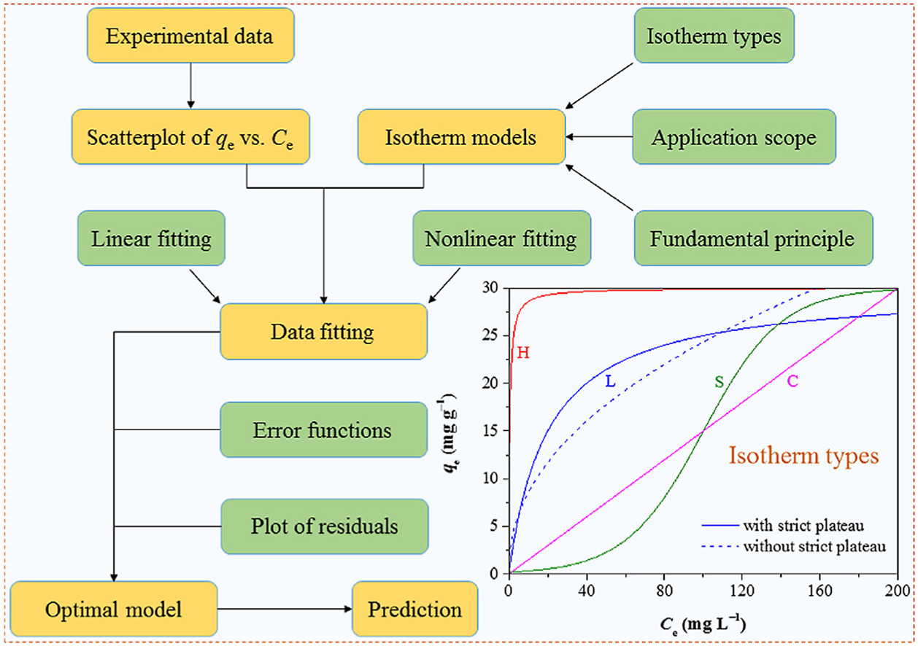
Fig. ??. Research methodology design for CO₂ breakthrough adsorption

3.2 Adsorption process
Adsorption is a surface phenomenon in which molecules from a gas or liquid phase accumulate on the surface of a solid material rather than penetrating its bulk structure. The term originates from the Latin adsorptio or adsorbere, meaning “to draw towards” or “to suck in”, which reflects the tendency of molecules to be retained at a surface through intermolecular interactions (Etymonline, 2024; Wiktionary, 2021). Physisorption, by van der Waals forces, is quickly reversible via regeneration but results in poor selectivity at low partial pressures as most physical sorbents lose most of their CO2 capacity in the presence of humidity because water competes for the same sites (Xu et al., 2024). Chemisorption forms covalent or ionic bonds with CO2 and is highly selective; amine-functionalised sorbents leverage this by impregnating amine groups that react with CO2 via two distinct mechanisms: (i) carbamate-ammonium ion pairs are formed under dry conditions and can hydrolyse to bicarbonate in the presence of water and; (ii) polymer plasticization induced chain mobility can enable CO2 to access the amine-sites that were previously inaccessible.
Mesoporous silica (SBA-15 or fumed silica, pore diameter ~6–13 nm) is impregnated with branched polyethyleneimine (PEI, molecular weight ~600–25000). The PEI fills the mesopore network and provides a high density of amine groups (primary, secondary, tertiary) that react chemically with CO₂ via carbamate and bicarbonate formation. The sorbent exhibits two structurally distinct classes of amine sites: (i) easily accessible surface amine sites at the PEI-gas interface, and (ii) bulk amine-layer sites buried within the PEI polymer matrix, which require diffusion through the viscous polymer before CO₂ can react (Bollini et al., 2012; Kalyanaraman et al., 2015; Stampi-Bombelli et al., 2024). This heterogeneity produces the characteristic sharp initial breakthrough followed by a prolonged tail observed experimentally in amine-functionalized sorbents, which a simple pseudo-first-order (PFO) model cannot capture.

3.3 Packed-bed adsorption and breakthrough behaviour
Packed beds filled with pellets have long been the preferred design for adsorption processes due to their ease of processing, costs, flow distributions and ease to handle (Born et al., 2024). However, packed bed pressure drop primarily depends on the gas velocity and pellet size. Moreover, the increase in pressure drop generally leads to excessive power consumption (de Joannis, 2025). The system under consideration is a cylindrical packed-bed column of length $L$ and internal radius $R$, filled with spherical or near-spherical PEI@SiO₂ granules of mean diameter $d_{p}$. A gas mixture of CO₂ (mole fraction $y_{in}$) in N₂ enters the column at superficial velocity $u_{s}$ and temperature $T_{in}$.
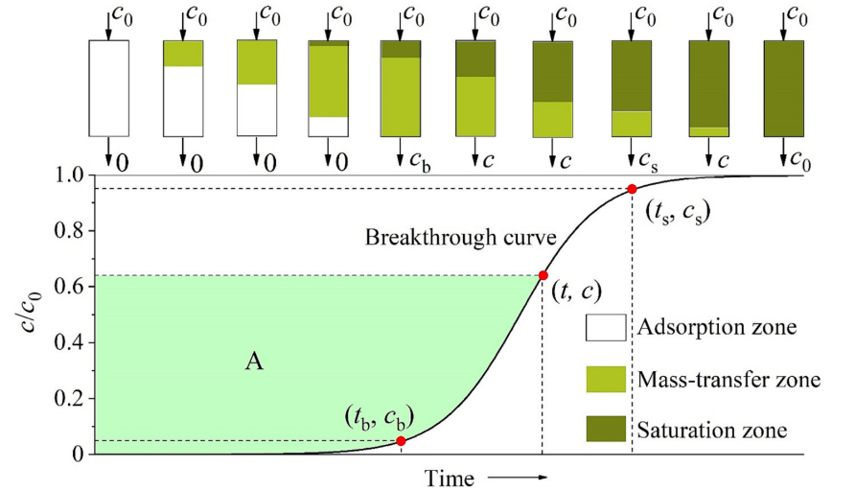
Fig. 4) Schematic diagram of MTZ traveling through a fixed-bed column and the breakthrough curve.
In a fixed-bed column, fresh gas enters one end and pushes a sharp adsorption front, called the mass transfer zone (MTZ) progressively towards the outlet. The MTZ travels axially through the columns at a speed much slower than the influent velocity (Hu et al., 2024). Thus, the bed divides into three zones during adsorption: saturation zone, mass-transfer zone, and adsorption zone. In the saturation zone, the adsorbent contaminant reaches dynamic equilibrium, where the amount absorbed, $q_{0}$, is in equilibrium to the influent concentration, $c_{0}$. Thus, the loading capacity of the adsorbent is exhausted, and no mass transfer takes place. Adsorption only occurs in the MTZ, in which the adsorbent accumulates molecules continuously from the feed, and the amount adsorbed in the bed increases from zero to $q_{0}$. The shape and length of the MTZ largely depends on the rate of adsorption, $κ$, and the shape of the isotherm curve. Breakthrough is registered when the MTZ first reaches the outlet, and the resulting S-shaped breakthrough curve is a mirror of the MTZ whose sharpness is set jointly by the rate of adsorption and the curvature of the equilibrium isotherm (Hu et al., 2024). With the assumptions: (i) plug flow in the axial direction; (ii) negligible radial dispersion; (ii) a linear driving force for solid adsorption; (iii) uniformly spherical adsorbent particles and; (iv) constant geometric dimensions, interstitial velocity, and void fraction (Hu et al., 2024). This behaviour can be described by the following mass-balance equation:
$$\frac{δc}{δt}+u\frac{δc}{δz}+\frac{1-ε}{ε}\frac{δq_{t}}{δt}=D_{L}\frac{δ^{2}c}{δz^{2}}$$
where $c$ represents the adsorbate concentration in fluid phase, $z$ is the distance along the bed length, $u$ is the fluid velocity, $t$ denotes time, $ε$ is the void bed fraction, $q_{t}$ is the concentration in an adsorbent particle component and the effects of axial dispersion is lumped into a single effective axial dispersion coefficient $D_{L}$.
The advection term $u\frac{δc}{δz}$ and the axial dispersion term $D_{L}\frac{δ^{2}c}{δz^{2}}$ transport CO₂ along the column while the sink term $\frac{1-ε}{ε}\frac{δq_{t}}{δt}$ represents gas to solid phase transition via intraparticle resistances lumped as linear driving force (LDF). The axial dispersion coefficient can be estimated as $D_{L}=ud_{p}\left(\frac{20}{ε}\frac{D_{m}}{ud_{p}}+\frac{1}{2}\right)$ where $D_{m}$ is the molecular diffusivity. The linear driving force can be represented as the linear approach of the instantaneous loading $q_{t}$ to its equilibrium value $q_{e}$ expressed as:
$$\frac{δq_{t}}{δt}=k_{s}\left(q_{e}-q_{t}\right)$$
The initial and boundary conditions can be given via Danckwert’s boundary conditions for a dispersed plug flow, expressed as:
$$D_{L}\frac{δc}{δt}{\left.​\right|}_{z=0}=-u{\left.​\right|}_{z=0}\left(c_{i}{\left.​\right|}_{z=0^{-}}-c_{i}{\left.​\right|}_{z=0}\right), \frac{δc}{δz}{\left.​\right|}_{z=L}=0$$
where $c_{i}{\left.​\right|}_{z=0}$ is the feed composition for component $i$ and $L$ is the bed length.

3.3 Adsorption Isotherms
Adsorption depends on the concentration of the target molecule in the fluid and gas pressure in the bulk phase. Adsorption site heterogeneity combines the properties of the adsorbent at various amounts adsorbed, including surface area, pore volume, concentration of functional groups and pore-size distribution. The ‘heterogeneity’ of the adsorbent can be estimated by modelling the number of adsorption sites of the solid and their types (Kumar et al., 2021). Adsorption isotherms are graphs that indicate loading-pressure relationships in the $x$- and $y$-axis respectively. In the case of CO₂ adsorption, the x-axis represents pressure of CO₂ in gas phase (or the concentration of the species or partial pressure) while the y-axis represents CO₂ loading on the sorbent (or the number of adsorbed species by the adsorbent) at equilibrium (the state where the rate of molecules attaching to the sorbent surface equals to the rate of molecules being released from the sorbent). A wide variety of models have been formulated to describe the adsorption isotherms observed experimentally. Some of the more common adsorption isotherms are described in the following sections. In practice, CO2 capacity of PEI-impregnated sorbents will not be able to reach its maximum theoretical limit due to the mass transfer resistances involved.

3.3.1 Langmuir Isotherm
Assuming that: (i) adsorption of molecules occur at a fixed number of well-defined localised sites; (ii) each site only accommodates one adsorbent molecule (monolayer adsorption); (iii) the surface of the adsorbent is homogeneous i.e. all sites are energetically equivalent and; (iv) there are no interactions between the neighboring sites and molecules already adsorbed (Ruthven, 1985).
The Langmuir isotherm relates the surface coverage, $θ$, to pressure, $P$, and temperature, $T$:
$$θ=\frac{KP}{1+KP}$$
, where $K=\frac{1}{p^{0}}e^{-ϵ/kT}$ is the rate constant of equilibrium. We observe that for $KP≪1$, the model increases linearly. But as $KP$ increases (i.e pressure increases), the model converges to 1. Higher temperatures lead to slower asymptotic convergence. In the case where the amount adsorbed, $q$, is much smaller than the maximum adsorption capacity, $q_{s},$ a linear equation following Henry’s is derived: $θ=KP$.
Langmuir isotherm assumes a homogeneous (i.e. uniform) binding site distribution. Discrete models attempt to preserve model heterogeneity by assuming a discrete number of different adsorption sites (K. Vasanth, n.d.). However, different adsorbents have different numbers of adsorption sites with varying binding energy. Continuous distribution functions are considered an improvement to discrete models—considering the affinity spectrum which is a plot of the binding affinity against the number of adsorption sites. A Toth isotherm is hence used to model both a homogeneous and heterogeneous distribution of adsorption site affinities. The values of parameters of the Toth model can be found by nonlinear curve fitting method using sigma plot software (Benzaoui et al. 2017).

3.3.2 Toth Isotherm
In this work, as a case study, we used only the three-parameter Toth isotherms to describe adsorption on both homogeneous and heterogeneous surfaces. Mathematically, the Toth isotherm can predict the monolayer adsorption capacity of a homogeneous surface that will match with the surface area predicted by Langmuir isotherm. The Toth isotherm (1971) is given by:
$$q=q_{s}{\left[\frac{k_{T}p}{1+{\left(k_{T}p\right)}^{t}}\right]}^{\frac{1}{t}}$$
, where $k_{T}$ and $t$ are the Toth isotherm constants. $k_{T}$ is related to the binding energy, $q_{s}$ is the monolayer adsorption capacity.

3.4 Adsorption breakthrough models
Traditional breakthrough models i.e. Bohart-Adams, Thomas, Yoon-Nelson are dissected and expressed as a single logistic function in three notations: $k_{YN}=k_{BA}c_{0}=k_{T}c_{0}; τ=\frac{a_{0}x}{uc_{0}}=\frac{q_{0}m}{vc_{0}}$. For the more general Clark model, when $n≠2$, the dominant mass-transfer mechanism results in an asymmetric breakthrough curve. Thus, empirical breakthrough models like the Gudermannian and error functions (Hu et al., 2021) with the involvement of fractal-like kinetics i.e. $k\left(t\right)=k_{0}t^{-h}$, where $h$ is the heterogeneity parameter--is needed to fit asymmetric breakthrough curves.

3.4.1 Bohart-Adams Model
Bohart-Adams and other models discussed below remain popular because it can be linearized, allowing unknown parameters to be determined via linear regression analysis. The Bohart-Adams model predicts a linear relationship between bed depth and breakthrough time. Interestingly, the form—also known as an incorrect “Adams-Bohart” model originates from a 1995 paper by Guibal et al. which provided no derivation—is expressed as (Hu et al., 2025):
$$\frac{c}{c_{0}}=\frac{1}{1+\exp\left[K_{BA}c_{0}\left(\frac{a_{0}x}{uc_{0}}-t\right)\right]}$$
However, the appropriate analytical solution for the adsorbate concentration at the column as a function of time is given as (Khim, 2019; Hu et al., 2024):
$$\frac{c}{c_{0}}=\frac{\exp\left(k_{BA}c_{0}t\right)}{\exp\left(\frac{k_{BA}a_{0}x}{u}\right)+\exp\left(k_{BA}c_{0}t\right)-1}$$
Rewriting this into its linear form gives us (Khim, 2019):
$$\ln\left(\frac{c_{0}}{c}-1\right)=\ln\left[\exp\left(\frac{k_{BA}N_{0}L}{u}\right)-1 \right]-k_{BA}c_{0}t$$
As the rate of adsorption ($k_{BA})$ becomes very large,
$$\ln\left(\frac{c_{0}}{c}-1\right)=\frac{k_{BA}N_{0}L}{u}-k_{BA}c_{0}t$$
Thus, $k_{BA}$ can be evaluated by finding the slope of $\ln\left(\frac{c_{0}}{c}-1\right)$ against $t$, $N_{0}$ from the y-intercept.

3.4.2 Thomas Model
The simplified solution is given as
$$\ln\left(\frac{c_{0}}{c}-1\right)=k_{T}c_{0}\left(\frac{q_{0}m}{vc_{0}}-t\right)$$
, where it assumes Langmuir equilibrium (Hu et al., 2024). However, $q_{0}$ and $k_{T}$ are purely empirical parameters which can be estimated by fitting. Eq. () can be written as:
$$\frac{c}{c_{0}}=\frac{1}{1+exp⁡(a-bt)}$$
, where $a=\frac{k_{T}q_{0}M}{Q}$ and $b=k_{T}c_{0}$. Since this is a logistic equation, Eqs. () and () will exhibit the same shape and error statistics as they are mathematically equivalent. The same applies to the Yoon-Nelson model as described below.

3.4.3 Yoon-Nelson Model
This model is derived from probability arguments about the column inlet. It assumes that the probability of adsorption rate increase is proportional to the probabilities of adsorption and breakthrough respectively. This can be written as:
$$\frac{c}{c_{0}}=\frac{1}{1+exp⁡(a+bt)}$$
, where $a=k_{YN}τ, b=k_{YN}$.

3.4.4 Mathematical equivalence of traditional breakthrough models
We show that these are notational variances of a single logistic sigmoid.
Theorem (BA-Thomas-YN equivalence). Define the logistic breakthrough curve
$$\frac{c}{c_{0}}=σ\left(k_{YN}\left(t-τ\right)\right)≔\frac{1}{1+exp⁡(k_{YN}(t-τ))}$$
Thus, $k_{YN}=k_{BA}c_{0}=k_{T}c_{0}; τ=\frac{a_{0}x}{uc_{0}}=\frac{q_{0}m}{vc_{0}}$ , where $a_{0}$ is the Bohart-Adams volumetric capacity, $q_{0}$ the Thomas equilibrium loading, $m$ the sorbent mass, $v$ the volumetric flow rate, and $x$ the bed length.
Proof Bohart-Adams model is $\frac{c}{c_{0}}={\left[1+\exp\left(k_{BA}\left(a_{0}x/u-c_{0}t\right)\right)\right]}^{-1}$. Factoring $c_{0}$ from the exponent gives $\frac{c}{c_{0}}=σ\left(k_{BA}c_{0}\left(t-\frac{a_{0}x}{uc_{0}}\right)\right)$. The Thomas model is $\frac{c}{c_{0}}={\left[1+\exp\left(k_{T}\left(q_{0}m/v-c_{0}t\right)\right)\right]}^{-1}$, and the same factoring gives $c/c_{0}=σ\left(k_{T}c_{0}(t-q_{0}m/(vc_{0})\right))$. The YN model is $σ\left(k_{YN}\left(t-τ\right)\right)$ by definition.
Remark. Three sigmoidal functions appear in the breakthrough literature (Hu et al., 2024): the logistic $σ\left(x\right)={\left(1+e^{-x}\right)}^{-1},$ the error function: $\operatorname{erf}\left(x\right)$ and the Gudermannian function $\operatorname{gd}{(x)}=2\arctan\left(\tanh{(x/2)}\right).$ Before normalization, these have ranges $\left(0,1\right)$, $\left(-1,1\right)$ and $\left(-\frac{π}{2},\frac{π}{2}\right)$ respectively. After affine scaling,
$$\tilde{σ}=σ\left(x\right), \tilde{erf}{(x)}=\frac{1}{2}(\operatorname{erf}\left(x\right)+1), \tilde{gd}{(x)}=\frac{1}{π}\operatorname{gd}\left(x\right)+\frac{1}{2}$$
all three map $R→\left(0,1\right)$ with $f\left(0\right)=0.5$, and they are visually indistinguishable in the central transient region $\left|X\right|≤2$. Anchoring an experimental breakthrough curve $\frac{c\left(t\right)}{c_{0}}$ fixes both the location $τ$ and (after slope fitting) the rate constant; the residual sup-norm distance between any two of $σ_{*},E_{*},G_{*}$ i.e.:
$$\max_{f,g∈\left\{σ_{*},E_{*},G_{*}\right\}}\left|f\left(X\right)-g\left(X\right)\right|<0.04$$on the central region $\left|X\right|≤0.5$. Consequently, if observational noise has standard deviation $ε≥0.04$—typical of NDIR sensors on packed-bed rigs—then no statistically meaningful distinction between the three kernels is possible on the experimentally accessible breakthrough region (ChatGPT, n.d.; $§8.2$).

3.4.5 Clark Model
The Clark (1987) model introduces asymmetry through an additional exponent $n≥1$:
$$\frac{c}{c_{0}}={\left[\frac{1}{1+Ae^{-rt}}\right]}^{1/(n-1)}$$
At $n=2$, this reduces to the logistic Eq. (??). For $n>2$, the curve is left-asymmetric i.e. sharper rise, longer tail; for $1<n<2$ it is right-asymmetric. The Clark model is therefore a minimal one-parameter extension of the unified Bohart-Adams, Thomas, Yoon-Nelson family that can encode mass transfer asymmetry.

3.4.6 Gudermannian and Error functions
In Hu et al. (2024), the normalized Gudermannian and error functions—when the range of the Gudermannian and error function is [0,1]—can define asymmetric breakthrough curves by employing two lumped parameters: $κ$ and $τ$ as majorly empirical fitting parameters, where $κ$ denotes the shape of the breakthrough and $τ$ denotes its location. The models are expressed as (Hu et al., 2024):
$$\frac{c}{c_{0}}=\frac{1}{2}\left\{1+\frac{2}{π}\arctan{(\sinh{[k\left(t-τ\right)])}}\right\}$$
$$\frac{c}{c_{0}}=\frac{1}{2}\left(1+\operatorname{erf}{[k(t-τ)]}\right)$$

3.5 Review of Prior Solutions
A range of CO₂ capture technologies has been developed, including liquid solvent absorption, adsorption over solid sorbents, membrane separation, cryogenic separation, direct air capture (DAC), and hybrid systems.
Adsorption-based capture is especially relevant to this project because it uses solid sorbents in packed-bed systems and is compatible with dilute CO₂ streams (Schindler, n.d.; Stampi-Bombelli et al., 2024). Prior work has shown that PEI-based silica sorbents perform well for CO₂ capture, particularly in applications where adsorption capacity, regenerability, and process stability are important (Jin et al., n.d.; Karimi et al., 2023). These findings support the use of PEI-SiO₂ granules as the sorbent material in the present study.
Direct air capture (DAC) is a carbon removal technology that extracts CO₂ directly from the atmosphere. DAC can be used to counter emissions from industries that may find it more difficult to fully decarbonise. It is also useful in a net-zero future because some residual emissions will remain even after major decarbonisation efforts (IEA, 2022).
DAC is attractive because it can be deployed in various locations, does not require large areas of land, and can be integrated with existing and new technologies. This, for one, makes it less disruptive to current systems and a very adaptable solution. It is also very useful in a net-zero future because some residual emissions will definitely remain in the environment even after major decarbonation efforts (IEA, 2022).
However, DAC remains challenging to implement at a large-scale, because the atmoshpere contains only a very small concentration of CO2. This means that very large volumes of air must be processed to capture meaningful amounts of carbon, making current technologies energy-intensive and expensive, and therefore not viable for large-scale adoption (IEA, 2022; Belfer Center for Science and International Affairs, 2023). Hence, it is very important to test and experiment with the absorption parameters, mimicking different environmental conditions and setups. These parameters are particularly important because they directly influence how effectively CO₂ can be absorbed in real-world applications; understanding and optimising them will be essential if such systems are to be scaled up and deployed in practical carbon capture setups.
Take for example the leading DAC company, Climeworks. Their Orca and Mammoth plants in Iceland show that DAC can be deployed commercially with modular designs, minimal land use, and the safe and permanent storage of extracted CO2However, real-world performance has been limited: Mammoth captured 105 tons of CO₂ in 2024 against a 36,000-ton design capacity, highlighting the energy intensity and high costs that currently limit scalability (IEA, 2022; Keith et al., 2018). This underscores why optimising packed bed parameters like flow conditions and mass transfer is critical for making DAC economically viable.

3.6 Design or Research Procedure
The research procedure begins with a review of CO₂ capture technologies and adsorption principles, followed by the assembly and calibration of the experimental rig. Once the setup is complete, the SOP is used to standardise the operation of the system and ensure consistent testing conditions. A 3 × 3 DOE is then used to study the combined effects of CO₂ concentration and flow rate on adsorption breakthrough behaviour.
The experimental data will be processed using Python to fit breakthrough curves to industry-standard models. These results will be used to assess the influence of operating conditions on adsorption performance and to validate the suitability of the PEI-SiO₂ sorbent under the tested conditions. The project requires knowledge of adsorption theory, laboratory operation, data analysis, and numerical modelling, and these skills are being developed through literature study, supervision, and trial runs of the experimental setup.

4. Standard Operating Procedure for CO₂ Adsorption Experiment
This SOP describes the step-by-step method for operating the SUTD fixed-bed experimental rig to conduct CO₂ adsorption breakthrough experiments using PEI-SiO₂ granules as the solid sorbent. The aim is to observe the behaviour of the system under initial and boundary conditions across repeated experimental runs and obtain breakthrough data for subsequent breakthrough parameters estimation and modelling. Fig. X. shows the labelled valves (1, 2, 3, 4, and 5). Fig. Y. shows the process flow diagram of the CO₂ adsorption experiment in packed-bed column.
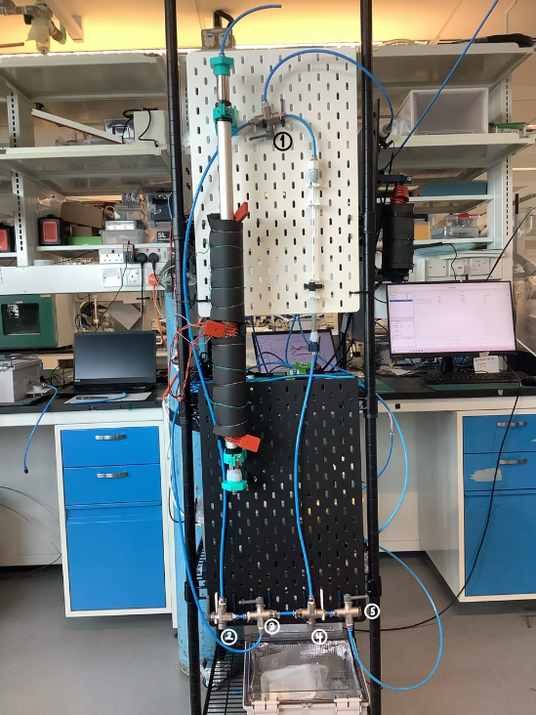
Fig. X. labelled valves and apparatus for SUTD CO2 Adsorption experiments
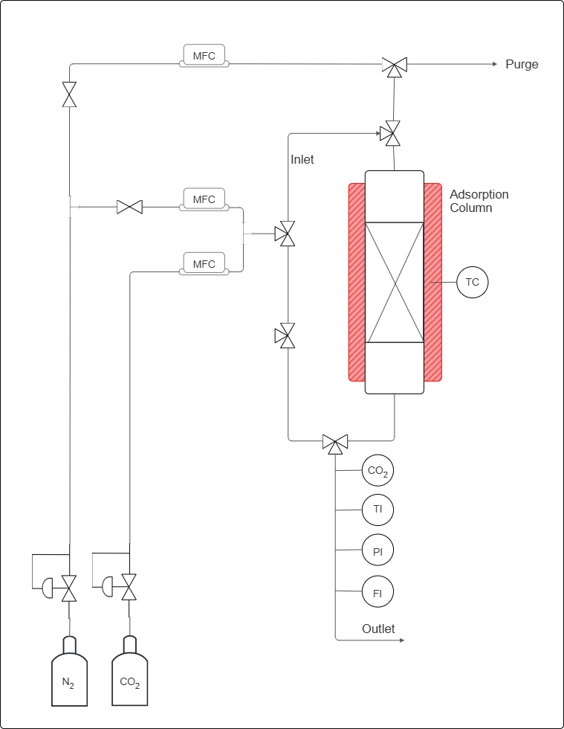
X%
CO2 (v/v)
CO₂ concentration
Gas stream temperature
Gas stream pressure
Gas stream flow rate
PEI@SiO2 granules bed
Heat for regeneration
To purge column before start adsorption
Fig. Y. labelled process flow diagram of CO₂ adsorption in fixed-bed column

4.1 Apparatus and Instrumentation
The apparatus comprises a gas-feeding section, an adsorption column and a gas analysis section at the outlet, as described below.

4.1.1 Gas Feeding Section
Two compressed gas cylinders with pure CO2 and pure N2 is fitted with a dedicated pressure regulator and a manual needle valve. Three mass flow controllers (MFCs) regulate the volumetric flow rates throughout the experiment:
- MFC-A (top position): controls the N₂ flow used exclusively for the pre-adsorption column purge and for the regeneration purge sweep.
- MFC-B (middle position): controls the N₂ flow during the adsorption step, contributing to the binary N₂/CO₂ feed mixture.
- MFC-C (lower position): controls the CO₂ flow during the adsorption step; blended with the N₂ stream from MFC-B to produce a feed gas of composition X% CO₂ (v/v), where X is a pre-specified experimental variable.
The mixed gas stream is produced by combining the outputs of MFC-B and MFC-C at a T-junction downstream of both controllers, prior to entry into the column inlet.

4.1.2 Adsorption Column
The fixed-bed column is oriented vertically with gas entering at the bottom inlet and exiting at the top outlet. The column, with an inside diameter of 8.2mm and length of 32cm is packed with PEI@SiO₂ granules.

4.1.3 Gas Analysis and Monitoring
The outlet stream passes through four in-line instruments arranged in series: (i) CO₂ analyser (CO2), thermocouple (TI), pressure indicator (PI) and flow meter (FI). A dedicated purge outlet line at the top of the rig vents the N₂ stream used during column purge; this line is isolated from the analysis train during adsorption.
The following lists the equipment needed for the experiment:
- Compressed CO₂ gas cylinder with 100% CO2,
- Compressed N₂ gas cylinder with 100% N2,
- Mass flow controllers (MFCs), connected to the Sensirion software on the laptop,
- Three-way valves (Labelled 1, 2, 3, 4 and 5) and gas lines with tube inside diameter of 6mm,
- Adsorption column, inside diameter of ….mm and length od mm., packed with PEI-SiO₂ granules,
- CO₂ concentration sensor, connected to the Gaslab software on the laptop,
- Flow rate sensor, connected to the Sensirion software on the laptop,
- Laptop interfaces for sensor monitoring and data acquisition.

4.1.4 Pre-Run Preparation
Before beginning the experiment, inspect all gas lines, valves, and fittings to ensure that the system is secure. Ensure that the MFCs, sensors, and data acquisition software are functioning correctly. Weigh approximately 10 g of PEI-SiO₂ granules was used for the pre-run experiment. Ensure that the bed is packed consistently by tapping the column until no changed in packed height. Note down the sorbent mass and bed length.

4.2 Experimental Procedure

4.2.1 Sensor Setup and Calibration
- Connect all sensors to their respective laptop applications.
- Verify that the CO₂ concentration sensor is connected to the GasLab interface.
- Remember to adjust Auto-Logging to 5 Seconds for 6 Hours.
- Verify that the flow sensor is connected to the Sensirion software.
- Flow 1 bar of N₂ using the MFC and tube connected to valve 3 through the mixed-gas secondary line by turning valve 2 upward, and valve 3 to the left. to establish a baseline before calibration.
- This is done by using the N2 MFC and line connected to valve 3, and by turning valve 2 upward and valve 3 to the left. Valve 1 would be turned to the left, to allow the gas to flow from the mixed-gas secondary line into the sensors. Meanwhile, valves 4 and 5 is turned to the right to prevent pressure buildup in the tubes connected to the column.
- Allow the CO₂ sensor to stabilise at 0 ppm, or at a stable linear baseline, before continuing.
- Maintain this calibration period for approximately 15 minutes, or until the readings are stable to ensure that the line contain only N2 gas.
- If the CO2 sensor does not calibrate to zero, but maintains a stable reading, can ‘configure to zero’ on the Gaslab application.

4.2.3 Feed Gas Preparation
- Set the desired CO₂ and N₂ flow rates using the MFCs corresponding to desired inlet CO2 concentration.This is done by calculating the required MFC setpoints for MFC-B (N₂) and MFC-C (CO₂) such that their combined volumetric flow rates give the desired composition at the target total flow rate $Q_{total}$. The inlet CO₂ mole fraction $y_{CO_{2}}$ satisfies:
$$y_{CO_{2}}=\frac{Q_{CO_{2}}}{Q_{CO_{2}}+Q_{N_{2}}}=\frac{X}{100}$$
, where $Q_{CO_{2}}$ and $Q_{N_{2}}$ are the volumetric flow rates set on MFC-C and MFC-B, respectively.
- Direct the mixed gas stream through the secondary bypass line.
- This is done by turning valve 2 upward and valve 3 to the left. Valve 1 would be turned to the left, to allow the gas to flow from the mixed-gas secondary line into the sensors.
- Use the CO₂ concentration sensor to confirm that the influent concentration, and the flow rate sensor to ensure the amount of gas flowing through are correct before introducing the gas into the packed bed.
- Adjust the flow setting if necessary, until the target or desired inlet concentration is obtained and stable.

4.2.2 Column Loading and Purge
- After calibration, disconnect the temporary tube arrangement.
- Load the pre-weighed PEI-SiO₂ granules into the adsorption column (if not already done before the start of the calibration).
- Pack the sorbent uniformly by tapping the column to ensure consistent and distribute flow through the bed.
- Perform an N₂ purge through the column to remove residual atmospheric gases and establish an initial condition without CO2 accumulation.
- This is done by using the purge line connected to valve 5. Turn valves 1 and 4 to the right, and valve 5 to the left, to allow the gas to flow through the column and into the sensors.
- As during calibration, position the other valves to prevent pressure build-up within the experimental setup.
- Continue purging until the system is stable, there is no more/very little CO2 in the column and now, the setup ready for the adsorption experiment.

4.2.4 CO₂ Adsorption (Breakthrough Experiment) Run
- Once the inlet conditions have been verified, divert the mixed-gas stream from the bypass line into the adsorption column.
- To do this, turn valve 5 to the right, valve 4 to the left, and valve 3 to the right in that order to prevent pressure buildup. Valve 1 needs to be to the right to ensure the gas through the column goes to the sensors. By this time, the N2 purge line can be switched off (by setting the gas flow to 0 lpm) or disconnected.
- Indicate the time when the valves are turned (specifically valve 3) as the experiment start time (t = 0 s).
- Monitor the outlet CO₂ concentration continuously throughout the run with 5 s interval.
- Continue the experiment until the outlet CO₂ concentration rises close and/or equal to the inlet concentration, indicating that breakthrough and equilibrium adsorption has occurred.
- When CO2 concentration rise to 5% of an inlet concentration, indicate the time as breakthrough time
- When CO2 concentration rises close and/or equal to the inlet concentration, indicate the time as equilibrium time.
- Stop the run once the bed approaches saturation and the data trend has stabilised.
- Record time as end time, before turning valve 3 to the left, valve 2 turn down, turning off the MFCs, and finally disconnecting all gas from the main gas tube.
- Save all data files with a filename that encodes the experimental date, run number, and key parameters (e.g., YYYYMMDD_Run##_Cin_Qtotal.csv).

4.3 After the Run
At the end of the experiment, stop the gas flow and close all valves in a controlled manner. Save all collected data and verify that the system is left in a safe condition for the next run.

4.3.1 Acceptance Criteria and Validity
A completed run is considered valid and suitable for quantitative analysis only if all of the following are satisfied:
- The CO₂ analyser baseline prior to adsorption was ≤ 10 ppm (confirming complete purge).
- The inlet composition, as back-calculated from MFC-B and MFC-C setpoints and confirmed by the steady-state outlet concentration at saturation, matches the target C_in within ±2%.
- The outlet flow rate (FI) remained within ±5% of the inlet total flow rate throughout the adsorption step, confirming no significant pressure build-up or line blockage.
Any run that fails one or more criteria shall be marked as invalid in the data log and the cause investigated before repeating.

4.4 Data to Record
During the experiment, record the following variables:
- Weight of adsorbent and corresponding packed height
- CO₂ inlet concentration,
- CO₂ outlet concentration,
- Gas outlet flow rate, to confirm consistency with inlet setpoint,
- Time taken to reach breakthrough, from the breakthrough time,
- Time taken to reach equilibrium, from the equilibrium time; when outlet concentration reaches $≥$ 95% of $C_{in}$ and has been stable for $≥$ 5 minutes.
- 50% breakthrough, when outlet concentration reaches 0.5 $C_{in}$
- Outlet gas temperature (to detect thermal wave front passing through the bed)
- Outlet pressure, P1, to confirm no unintended pressure build up
These data will be used to construct the breakthrough curve and assess the adsorption performance of the sorbent under the selected operating conditions.

4.5 Safety Notes
- Handle gas cylinders carefully and ensure that the system is operated in a well-ventilated laboratory.
- Check for leaks before each run and make sure all fittings are tightened properly.
- Follow laboratory safety procedures at all times when working with pressurised gases, sensors, and electrical instrumentation.

5 Experimental Results
Present your experimental findings.

6 Experimental Analysis
This section shall provide analysis of the results: If your results do not come out as expected, consider how you can enhance or modify your project to reach the original goals. When you do obtain favourable results, do not throw out the unsuccessful data sets. Include your troubleshooting process, the difficulties encountered and how the problem was solved. Highlight how your results prove your original theories or achieve the project objectives.
7 Conclusions
Conclude the report with a short summary and an outline of your next steps.
We end this interim report with further actions: (i) plot and optimize breakthrough adsorption curves using Python 3.11; (ii) employ methods in error statistics to evaluate fitting quality of various breakthrough models; (iii) estimate hidden parameters by linear regression to implement a full non-isothermal solver to predict and model breakthrough curves from elementary adsorption principles.

8 Appendix

8.1 Transport Phenomena

8.1.1 Continuity Equation
Consider the fixed volume element $ΔxΔyΔz$, the density $ρ$ is such that for some velocity $\vec{v}=\left(u,v,w\right)$, the rate of mass transfer in is given by:
$$ΔyΔz\left(ρu\right){\left.​\right|}_{x}+ΔzΔx\left(ρv\right){\left.​\right|}_{y}$$
Thus, the continuity equation is given by:
$$\frac{δρ}{dt}+∇\left(ρ\vec{v}\right)=0 \left(1\right)$$
We can also understand it as a density function $u\left(x,t\right)$ such that for all $R⊂Q,$ the amount of $u$ in $R$ is given by: $\int_{R}{udx}$ is locally constant, lost through domain boundaries and sinks. Hence, suppose $u$ is associated with some flux $\vec{J}\left(x,t\right)$ such that $\vec{J}⋅\hat{n}d=\int_{R}{udx}$. Suppose a source producing $u$ at some rate $Q\left(x,t\right), Q>0$. By conservation of $u$ on $R⊂Q$,
$$\frac{d}{dt}\int_{R}{udx}=\int_{R}{\frac{δu}{δt}dx=-\int_{δR}{\vec{J}⋅\hat{n}dx}+\int_{R}{Q(x,t)dx}}$$
where we understand it as the change in $u$ is due to the flow and source terms in $R$.
By divergence theorem,
$$\int_{δR}{\vec{J}⋅\hat{n}dx}=\int_{R}{∇\vec{J}⋅dx}$$
Hence,
$$\int_{R}{\frac{δu}{δt}dx+\int_{δR}{\vec{J}⋅\hat{n}dx}=\int_{R}{Q(x,t)dx}}⇒\frac{δu}{δt}+∇\vec{J}=Q$$
If $u$ is constant, and there is no source term, $∇\vec{J}=0$ (or $∇\vec{v}$ in Eq. 1) means there is no compressing or expanding of the fluid due to constant density. Thus, a volume element with a constant density will have incompressible flow.

8.1.2 The Stress Tensor
Given an area element $δA$, not parallel with any cartesian components (i.e. $\hat{i},\hat{j})$,
$$δA_{1}=\vec{a}∙\hat{n}δA$$
The force across this element is $δF=∑\left(\hat{n},\vec{x},t\right)δA$ where $n$ is the unit normal, the stress by the fluid on the side of the surface element $n$ points to. As $δV→0$, the (body force proportional to $δV$) $<δA$ approaches zero. Hence the equation, $\sum_{i}{\left(\hat{n}\right)=\left\{a_{j}\sum_{i}{\left(\hat{a}\right)}+b_{j}\sum_{i}{\left(\hat{b}\right)}+c_{j}\sum_{i}{\left(\hat{c}\right)}\right\}n_{j}}$. Thus, the component of stress in a given direction represented by the suffix $i$across a plane surface element with an arbitrary orientation specified by the unit normal $n$ is related to the same component of stress across any three orthogonal plane surface elements at the same position in the fluid

9 References
Use IEEE or APA citation style.

References are compulsory as a form of basic respect for intellectual property. Any and all referenced works must be cited, no matter how minute their contribution. Even
pictures should be properly sourced and cited in an appropriate format

- Bos, M. J., Kroeze, V., Sutanto, S., & Brilman, D. W. F. (2018). Evaluating Regeneration Options of Solid Amine Sorbent for CO2 Removal. Industrial & Engineering Chemistry Research, 57(32), 11141–11153. https://doi.org/10.1021/acs.iecr.8b00768
- Cabrera-Codony, A., Calvo-Schwarzwalder, M., Lopez, L. R., Valverde, A., Puig, S., & Myers, T. G. (2026). An analytical breakthrough model for CO2 adsorption on PEI-impregnated silica: Separating stoichiometric and structural effects of humidity. Carbon Capture Science & Technology, 19, 100618. https://doi.org/10.1016/j.ccst.2026.100618
- Chu, K. H. (2020). Breakthrough curve analysis by simplistic models of fixed bed adsorption: In defense of the century-old Bohart-Adams model. Chemical Engineering Journal, 380, 122513. https://doi.org/10.1016/j.cej.2019.122513
- Chuah, C. Y., Ho, Y. L., Syed, A. M. H., Thivyalakshmi, K. G. K., Yang, E., Johari, K., Yang, Y., & Poon, W. C. (2025). Applicability of Adsorbents in Direct Air Capture (DAC): Recent Progress and Future Perspectives. Industrial & Engineering Chemistry Research, 64(8), 4117–4147. https://doi.org/10.1021/acs.iecr.4c03265
- de Joannis, P., Castel, C., Kanniche, M., Favre, E., & Authier, O. (2025). Techno-economic analysis of packed bed and structured adsorbent for direct air capture. Carbon Capture Science & Technology, 17, 100518. https://doi.org/10.1016/j.ccst.2025.100518
- Elfving, J., Kauppinen, J., Jegoroff, M., Ruuskanen, V., Järvinen, L., & Sainio, T. (2021). Experimental comparison of regeneration methods for CO2 concentration from air using amine-based adsorbent. Chemical Engineering Journal, 404, 126337. https://doi.org/10.1016/j.cej.2020.126337
- Hu, Q., Huang, Q., Yang, D., & Liu, H. (2021). Prediction of breakthrough curves in a fixed-bed column based on normalized Gudermannian and error functions. Journal of Molecular Liquids, 323, 115061. https://doi.org/10.1016/j.molliq.2020.115061
- Hu, Q., Lan, R., He, L., Liu, H., & Pei, X. (2023). A critical review of adsorption isotherm models for aqueous contaminants: Curve characteristics, site energy distribution and common controversies. Journal of Environmental Management, 329, 117104. https://doi.org/10.1016/j.jenvman.2022.117104
- Hu, Q., Wang, D., Pang, S., & Xu, L. (2022). Prediction of breakthrough curves for multicomponent adsorption in a fixed-bed column using logistic and Gompertz functions. Arabian Journal of Chemistry, 15. https://doi.org/10.1016/j.arabjc.2022.104034
- Hu, Q., Xie, Y., & Zhang, Z. (2020). Modification of breakthrough models in a continuous-flow fixed-bed column: Mathematical characteristics of breakthrough curves and rate profiles. Separation and Purification Technology, 238, 116399. https://doi.org/10.1016/j.seppur.2019.116399
- Ji, Y., Liu, W., Yong, J. Y., Zhang, X. J., & Jiang, L. (2024). Techno-economic analysis on temperature vacuum swing adsorption system integrated with pre-dehumidification for direct air capture. Carbon Capture Science & Technology, 12, 100199. https://doi.org/10.1016/j.ccst.2024.100199
- Juela, D., Vera, M., Cruzat, C., Alvarez, X., & Vanegas, E. (2021). Mathematical modeling and numerical simulation of sulfamethoxazole adsorption onto sugarcane bagasse in a fixed-bed column. Chemosphere, 280, 130687. https://doi.org/10.1016/j.chemosphere.2021.130687
- Langlo, P., & Espedal, M. S. (1994). Macrodispersion for two-phase, immiscible flow in porous media. Advances in Water Resources, 17(5), 297–316. https://doi.org/10.1016/0309-1708(94)90033-7
- Myers, T. G., Cabrera-Codony, A., & Valverde, A. (2023). On the development of a consistent mathematical model for adsorption in a packed column (and why standard models fail). International Journal of Heat and Mass Transfer, 202, 123660. https://doi.org/10.1016/j.ijheatmasstransfer.2022.123660
- Pedrozo, H. A., Gonzalez-Ramirez, M. G., Lin, T. Y., Moore, T., Roy, T., Nguyen, D. T., Roy, P., Baker, S., Biegler, L. T., & Panagakos, G. (2026). Optimization of direct air capture processes using reactive transport models of adsorption-desorption cycles. Computers & Chemical Engineering, 204, 109379. https://doi.org/10.1016/j.compchemeng.2025.109379
- Shafeeyan, M. S., Wan Daud, W. M. A., & Shamiri, A. (2014). A review of mathematical modeling of fixed-bed columns for carbon dioxide adsorption. Chemical Engineering Research and Design, 92(5), 961–988. https://doi.org/10.1016/j.cherd.2013.08.018
- Stampi-Bombelli, V., Storione, A., Grossmann, Q., & Mazzotti, M. (2024). On Comparing Packed Beds and Monoliths for CO2 Capture from Air Through Experiments, Theory, and Modeling. Industrial & Engineering Chemistry Research, 63(26), 11637–11653. https://doi.org/10.1021/acs.iecr.4c01392
- Xu, H., Yu, L., Chong, C., & Wang, F. (2024). A comprehensive review on direct air carbon capture (DAC) technology by adsorption: From fundamentals to applications. Energy Conversion and Management, 322, 119119. https://doi.org/10.1016/j.enconman.2024.119119

