

Engineering Science Design Project
“CO2 Adsorption in Packed-Bed Column using Polymer-based Sorbent: Parametric Study and Model Prediction”
Final Report

Student Names: Loh John Ray (S10267908K)
Saraswati Eloise Gunawan (S10267534J)

NP Supervisor: Dr. Pham The Hanh

Institution Supervisor: Prof. Erik Birgersson
Dr. Prapatsorn Borisut
Project Group ID: 3
Project Period: April 2026 – August 2026
Report Date: 18 May 2026

Declaration by students:
- By submitting this report online, I confirm that the report has been submitted to and vetted by my institution supervisor and thereby confirm that the report contains no confidential material from the company.
- I declare that the report is written by me and not plagiarised from other sources.

____________________
Students Signature / Date

Abstract
The growing demand for scalable carbon capture technologies has intensified research into adsorption processes, particularly using amine-impregnated capture sorbent. In this paper, a comprehensive review on breakthrough models, discussing the process parameters and assumptions is provided. Models are validated against breakthrough data at three inlet CO₂ concentrations (5, 10 and 15% by volume) at three flow rates (50, 100 and 150 ml/min), across a 3×3 design of experiment. Existing problems in breakthrough adsorption including data reliability, complete and partial breakthrough curves are discussed, and a standard operating procedure (SOP) is proposed to solve these issues. Breakthrough data are further employed to evaluate existing adsorption breakthrough models and support predictive modelling in Python, with the aim of identifying operating conditions that enhance CO₂ capture efficiency.

Table of Contents
Abstract 2
Table of Contents 3
List of Figures 5
1 Introduction 6
1.1 Scope of Project 8
2 Project Outline and Objectives 8
2.1 Project Outline 8
2.2 Project Objectives 9
2.2 Project Schedule 10
3 Literature review 16
3.1 Overview 16
3.2 Adsorption process 17
3.3 Packed-bed adsorption and breakthrough behaviour 18
3.3 Adsorption Isotherms 21
3.3.1 Langmuir Isotherm 21
3.3.2 Toth Isotherm 22
3.4 Adsorption breakthrough models 22
3.4.1 Bohart-Adams Model 23
3.4.2 Thomas Model 23
3.4.3 Yoon-Nelson Model 24
3.4.4 Mathematical equivalence of traditional breakthrough models 24
3.4.5 Clark Model 25
3.4.6 Gudermannian and Error functions 26
3.4.7 Weibull and Avrami Models 26
3.5 Review of Prior Solutions 26
3.5.1 Classical Symmetric Models 27
3.5.2 Models for Asymmetric Breakthrough Curves 27
3.5.3 Implication for Packed-Bed CO₂ Capture 27
3.6 Design or Research Procedure 28
4. Standard Operating Procedure for CO₂ Adsorption Experiment 28
4.1 Apparatus and Instrumentation 30
4.1.1 Gas Feeding Section 30
4.1.2 Adsorption Column 31
4.1.3 Gas Analysis and Monitoring 31
4.1.4 Pre-Run Preparation 31
4.2 Experimental Procedure 32
4.2.1 Sensor Setup and Calibration 32
4.2.3 Feed Gas Preparation 32
4.2.2 Column Loading and Purge 33
4.2.4 CO₂ Adsorption (Breakthrough Experiment) Run 34
4.3 After the Run 35
4.3.1 Acceptance Criteria and Validity 35
4.4 Data to Record 35
4.5 Safety Notes 36
5 Experimental Results 36
6 Experimental Analysis 38
7 Conclusions 40
7.1 Next Steps 41
8 References 42

List of Figures
Fig. 1) Greenhouse gas emissions by sector in Singapore, 2023. Adapted from CO₂ and Greenhouse Gas Emissions, by H. Ritchie and P. Rosado, 2025, Our World in Data (https://ourworldindata.org/profile/co2/singapore).
Fig. 2) Research methodology design of design for CO2 breakthrough adsorption.
Fig. 3) Packed-bed configuration. Influent gas flows axially towards the outlet along the $x$-axis. A cylindrical packed-bed column of length $L$ and internal radius $R$, filled with spherical or near-spherical PEI@SiO2 granules of mean diameter $d_{p}$. A gas mixture of CO2 (mole fraction $y_{in}$) in N2 enters at superficial velocity $u_{s}$ and temperature $T_{in}$.
Table 1) Weekly Gantt chart schedule for Design Project; timeline is split into phases and tasks within each phase ensure that deliverables are clearly defined and progress is on track; one week is represented as ‘W’; (a) Weeks 0 to 5; (b) Weeks 8 to 13
Fig. 5 & 6) Sourced from SUTD via Dr. Prapatsorn in Project_introduction.pptx. Shows lab setup for granule-based adsorption experiments using packed-bed columns via polymer-based sorbents; where $C_{0}$ is the sorbate initial concentration, $C_{t}$ the sorbate concentration at time $t$, $t_{0}$ the breakthrough time, $t_{E}$: equilibrium time (saturation time), $V_{0}$: superficial velocity, $v$: interstitial velocity, $Q_{o}$: initial gas volumetric flow rate, $A_{c}$: column cross-sectional area.
Fig. 7) shows an image of the adsorption setup, including the gas supply lines, MFCs, adsorption column, and associated sensors. The valves are labelled 1 to 5, and will be referenced as such in the rest of the SOP.
Fig. 8) Labelled process flow diagram of CO₂ adsorption in fixed-bed column
Fig. 9) Predicted vs. observed values in breakthrough models fit using scipy.optimize.curve_fit()
Fig. 10) Breakthrough curve fitting with linear adsorption isotherm using scipy.optimize.curve_fit()

1 Introduction
Anthropogenic carbon dioxide (CO₂) emissions are a primary driver of climate change. Atmospheric CO2 concentrations rose from 280 ppm to over 440 ppm above pre-industrial levels today and is expected to rise to 900 ppm should current CO2 emissions level persist (Xu et al., 2024). As a result, global temperatures are rising with more frequent extreme weather events, and a rising sea-level. While nations aim to limit global warming, conventional emissions reduction strategies are insufficient to meet the 2$℃$ target set during the Paris Agreement. More pressingly, carbon dioxide accumulation also has immediate consequences for human health, comfort, and wellbeing (IPCC, 2023; WMO, 2023) across two distinct operational scales.
At the atmospheric level, anthropogenic CO2 emissions drive climate-induced heatwaves and severe environmental disruptions. These systemic shifts placed unprecedented strain on public health, particularly among vulnerable demographics such as the elderly, children, and outdoor workers, while simultaneously threatening infrastructure resilience and global food security (IPCC, 2023; WMO, 2023).
Secondly, modern populations spend most of their time indoors. Localised CO2 accumulation can show poor ventilation and degraded air quality. Ambient indoor concentrations exceeding 800 ppm are explicitly linked to acute physiological symptoms, including headaches, chronic fatigue, dizziness, and upper respiratory tract irritation, with elevated levels in high-density environments like offices and schools further aggravating chronic conditions such as asthma and impairing cognitive performance and workplace productivity (Norbäck & Nordström, 2008; Tsai et al., 2012).

Fig. 1) Greenhouse gas emissions by section in Singapore (2023)
This issue of increased CO₂ levels is especially relevant in Singapore, where land is limited and the economy is closely tied to hard-to-abate sectors (Ritchie & Rosado, 2025) such as shipping, aviation, and petrochemicals as shown in Fig. 1). Thus, Singapore cannot rely on land-intensive carbon sinks such as large-scale afforestation to reduce the CO₂ in the atmosphere and will need solutions to curb excessive increase in indoor settings. As a result, there is growing interest in compact and scalable carbon capture technologies that can reduce CO₂ emissions more effectively.
Fixed-bed column adsorption presents a promising separation method for CO₂ capture due to its simple setup and fast adsorption-desorption cycles. Recent developments in CO2 capture by adsorption demonstrate the attractiveness of this technique for post-combustion treatment of flue gas. Various adsorption technologies such as pressure swing adsorption (PSA), vacuum swing adsorption (VSA), temperature swing adsorption (TSA) and moisture swing adsorption (MSA) are thus viewed as scalable CO2 separation and purification techniques. Prior to the design of an adsorption process, many studies concerning the selection of an appropriate adsorbent material for CO2 capture have resulted in a wide variety of adsorbent materials investigated. Sorbent materials for low-pressure CO2 capture, such as amine-functionalised materials, zeolites, metal oxides, metal-based materials, silicas, activated carbon and carbon molecular sieves (Chuah et al., 2025; Xu et al., 2024), have varying process dependent parameters (i.e. selectivity, working capacity, desorption capacity, etc). Solid sorbent-based carbon capture offers advantages over amine scrubbing: lower regeneration energy, reduced corrosion, and tolerance to moisture (Karimi et al., 2023). Amine-functionalised silica sorbents, particularly polyethyleneimine (PEI) impregnated SiO₂ exhibit high CO₂ selectivity, fast kinetics and good cyclic stability (Cabrera-Codony et al., 2026).

1.1 Scope of Project
Development of a mathematical model is essential to describe the complex dynamics of adsorption. However, existing phenomenological models often fail to capture all process-dependent parameters. Furthermore, constructing predictive models solely through extensive experimentation is both time-consuming and costly. In principle, models that utilise established parameters, such as adsorption rate constants and equilibrium data, can estimate column capacity without extensive experimental work. However, prediction of column dynamics requires the solution of a set of simultaneous partial differential equations (PDEs) representing mass, energy and momentum balances over a fixed bed with appropriate boundary conditions. Thus, the use of simpler and more tractable models (Hu et al., 2024) that can satisfactorily predict fixed-bed behaviour is desirable. The literature survey reveals how these simplified assumptions can be made to represent transport phenomena within adsorbent particles as an alternative way to investigate fixed-bed adsorption calculations.

2 Project Outline and Objectives

2.1 Project Outline
This project addresses the need for effective CO₂ capture technologies that can be applied in compact, modular systems. The experimental work is centered on a packed-bed adsorption setup designed to capture CO₂ using Carbon Capture Composite (C³) granules (Wirawan et al., 2021). The system was selected because adsorption is well suited to diluting gas streams and can be operated with relatively low energy demand compared with liquid-based capture systems (Karimi et al., 2023; Stampi-Bombelli et al., 2024).
The project began with laboratory familiarisation, followed by the procurement of components and assembly of the experimental setup. After this, we developed a standard operating procedure (SOP) and planned the design of experiments (DOE) for the adsorption runs. The technical understanding gained so far indicates that breakthrough behaviour is strongly influenced by inlet concentration, flow rate, and the interaction between the gas stream and the sorbent surface (Karimi et al., 2023). These factors hence form the basis for the experimental and modelling work in the project.
The aim of this project was to review and understand existing breakthrough models (Myers et al., 2023; Hu et al., 2024) and apply practical templates (Juela et al., 2021) against collected breakthrough data. These models were experimentally verified at three inlet CO₂ concentrations (5, 10 and 15% by volume) at three flow rates (50, 100 and 150 ml/min). The system’s adsorption performance across a 3×3 parameter sweep will be compared to support model development and validation. The overall aim is to determine how operating conditions affect the adsorption behaviour of the packed-bed column and to assess the suitability of the sorbent system for future carbon capture studies.
Problem Statement: To design and analyse a packed-bed column for CO₂ capture using PEI@SiO₂ granules, evaluating breakthrough dynamics and validating predictive models.

2.2 Project Objectives
The project aims to:
- Assemble and operate the packed-bed adsorption experimental setup.
- Carry out breakthrough experiments using C³ granules.
- Study the effects of CO₂ concentration and flow rate on adsorption capacity.
- Fit and validate breakthrough models using Python.
- Identify operating conditions that improve adsorption performance.

2.3 Project Schedule
Table 1. Design Project Schedule (a) Timeline for Weeks 0 to 6; (b) Timeline for Weeks 8 to 13;
Phase (a) | Task | W0 (20/04) | W1 (27/04) | W2 (04/05) | W3 (11/05) | W4 (18/05) | W5 (25/05)
Deliverables | First Meetings w/ Supervisors
 | Literature Review
 | Bi-weekly Journal #1
 | Defining our Problem Statement
 | Refining our Problem Statement
 | Bi-weekly Journal #2
 | Submit First Draft of Interim Report
 | Interim Report
 | Interim Review & Presentation
 | Bi-weekly Journal #3
 | Bi-weekly Journal #4
 | Final Report
 | Final Presentation
Literature  Review | Review on CO2 capture (material and technology)
 | Review on packed bed adsorption and models
 | Review on breakthrough model
 | Review data analysis methods
 | Review mathematical models (Toth, DK)
 | Finalise Models to Use
Mathematical Modelling | R-H shock + travelling wave (Myers & Font 2020)
 | Method of lines+stiff ODE theory
 | Upwind schemas, CFL, numerical diffusion (LeVeque, Ch. 6-7)
 | Constant pattern analysis (Ruthven, Ch. 8)
 | Sensitivity equations; forward sensitivity analysis
 | Breakthrough metrics (Ruthven, Ch. 5)
 | Dimensionless analysis (Pe, NTU, α)
 | Response surface design (Montgomery, Ch. 1)
Experimentation  Preparation | Prepare Bill of Materials (BOM)
 | Rig Familiarisation
 | Standard of Procedure (SOP)
 | Equipment Setup
 | Data acquisition & curve-fit workflow setup
 | Pre-Session Checks (recurring)
Experimentation  Execution | OAT - vary flow rate & concentration
 | Model Fitting & Error Minimisation
 | Validation runs - baseline (4 exp; PFO/DK model)
 | Addition/Repeat (if required)

Phase (b) | Task | W8 (15/06) | W9 (22/06) | W10 (29/06) | W11 (06/07) | W12 (13/07) | W13 (20/07)
Deliverables | First Meetings w/ Supervisors
 | Literature Review
 | Bi-weekly Journal #1
 | Defining our Problem Statement
 | Refining our Problem Statement
 | Bi-weekly Journal #2
 | Submit First Draft of Interim Report
 | Interim Report
 | Interim Review & Presentation
 | Bi-weekly Journal #3
 | Bi-weekly Journal #4
 | Final Report
 | Final Presentation
Literature  Review | Review on CO2 capture (material and technology)
 | Review on packed bed adsorption and models
 | Review on breakthrough model
 | Review data analysis methods
 | Review mathematical models (Toth, DK)
 | Finalise Models to Use
Mathematical Modelling | R-H shock + travelling wave (Myers & Font 2020)
 | Method of lines+stiff ODE theory
 | Upwind schemas, CFL, numerical diffusion (LeVeque, Ch. 6-7)
 | Constant pattern analysis (Ruthven, Ch. 8)
 | Sensitivity equations; forward sensitivity analysis
 | Breakthrough metrics (Ruthven, Ch. 5)
 | Dimensionless analysis (Pe, NTU, α)
 | Response surface design (Montgomery, Ch. 1)
 | Modelling in Python
Experimentation  Preparation | Prepare Bill of Materials (BOM)
 | Rig Familiarisation
 | Standard of Procedure (SOP)
 | Equipment Setup
 | Data acquisition & curve-fit workflow setup
 | Pre-Session Checks (recurring)
Experimentation  Execution | OAT - vary flow rate & concentration
 | Model Fitting & Error Minimisation
 | Validation runs - baseline (4 exp; PFO/DK model)
 | Addition/Repeat (if required)

Legend
Done | Recurring
Not Started
In Progress
Submission

3 Literature review

3.1 Overview

Experimental data
Breakthrough curve
$c/c_{0}$ vs. $t$

Breakthrough model types
Application scope
Adsorption principles
Breakthrough models
Linear fitting
Nonlinear fitting
Data fitting (parameter estimation)
Error functions
Plot of residuals
Optimal model
Prediction
Mathematical modelling
Legend:
Decision nodes
Input nodes

Fig. 2) Research methodology design for CO₂ breakthrough adsorption

3.2 Adsorption process
Adsorption is a surface phenomenon in which molecules from a gas or liquid phase accumulate on the surface of a solid material rather than penetrating its bulk structure. Physisorption, where gas molecules attach to the surface through weak van der Waals forces, is quickly reversible via regeneration but results in poor selectivity at low partial pressures as most physical sorbents lose most of their CO₂ capacity in the presence of humidity because water competes for the same sites (Xu et al., 2024). Chemisorption forms covalent or ionic bonds with CO₂ and is highly selective; amine-functionalised sorbents leverage this by impregnating amine groups that react with CO₂ via two distinct mechanisms: (i) carbamate-ammonium ion pairs are formed under dry conditions and can hydrolyse to bicarbonate in the presence of water and; (ii) polymer plasticisation induced chain mobility can enable CO2 to access the amine-sites that were previously inaccessible.
Amine-functionalised silica composites represent a major class of solid sorbents for CO₂ capture. These materials combine the high CO₂ affinity of amines with the large surface area and pore volume of porous silica supports. Shafeeyan et al. (2014) classify amine-silica composites into three categories based on preparation method: (i) physical impregnation of polymeric amines such as polyethylenimine (PEI) or tetraethylenepentamine (TEPA) into porous supports; (ii) chemical grafting of aminosilanes via covalent bonding to surface silanol groups; and (iii) in-situ polymerisation of amine-containing monomers to create hyperbranched aminosilicas (Shafeeyan et al., 2014). That review also emphasises that mesoporous silica supports such as MCM-41, SBA-15, and KIT-6 have been widely studied, with textural properties (particularly pore diameter and pore volume) playing a critical role in determining CO₂ capture performance at a given amine loading.
In particular, PEI-fumed structured sorbents exhibits two distinct classes of amine sites: (i) accessible surface amine sites at the PEI-gas interface, and (ii) bulk amine-layer sites buried within the PEI polymer matrix, which require diffusion through the viscous polymer before CO₂ can react (Stampi-Bombelli et al., 2024). This heterogeneity produces the characteristic sharp initial breakthrough followed by a prolonged tail observed experimentally in amine-functionalised sorbents, which a simple pseudo-first-order (PFO) model cannot capture. This resulted in extensive research into adsorption modelling, particularly in packed-bed columns, which is one of the simplest configurations for studying breakthrough adsorption behaviour.

3.3 Nomenclature
Symbols below are defined once here rather than re-defined at each occurrence; where two symbols look similar but denote different quantities (C₀ vs c₀; ε vs ϵ; x vs z), both are listed explicitly.
Symbol | Meaning | Units
c(z,t) | Gas-phase CO₂ concentration (governing-PDE state variable, §3.4) | mol m⁻³
c₀ (lower-case) | Inlet CO₂ concentration, molar basis (governing PDE, §3.4) | mol m⁻³
C₀ (upper-case) | Inlet CO₂ concentration, mole-fraction basis (breakthrough models, §3.6) | – (mole fraction)
C/C₀ | Normalised outlet concentration ("breakthrough ratio") | –
z | Axial coordinate along the column, used in the governing PDE (§3.4) | m
x | Axial coordinate / bed depth travelled, used in Fig. 3 and the Bohart-Adams / Thomas / Yoon-Nelson equations (§3.6.1-3.6.3); the same physical coordinate as z, in the notation each source paper uses | m
u | Superficial gas velocity | m s⁻¹
ε | Bed void fraction (voidage) | –
ϵ | Adsorption-site energy in the Langmuir Boltzmann factor exp(−ϵ/kBT), §3.5.1 — not to be confused with ε | J
kB | Boltzmann constant | J K⁻¹
D_L | Axial dispersion coefficient | m² s⁻¹
q(z,t) | Solid-phase loading (adsorbed amount) | mol kg⁻¹
q_t | Adsorbed amount at time t (LDF state variable, §3.4) | mol kg⁻¹
q_e | Equilibrium adsorbed amount (LDF driving force) | mol kg⁻¹
q_s / q₀ | Saturation / equilibrium capacity (isotherm or breakthrough-model parameter, model-dependent) | mol kg⁻¹
k_s | LDF mass-transfer rate constant | s⁻¹
k_YN | Yoon-Nelson rate constant, §3.6.3 | s⁻¹
k_BA | Bohart-Adams rate constant, §3.6.1 | m³ mol⁻¹ s⁻¹
k_Th | Thomas rate constant, §3.6.2 (renamed from the collision with the Toth/Boltzmann k_T notation, item 3.2) | m³ mol⁻¹ s⁻¹
b_T | Toth isotherm affinity constant, §3.5.2 | kPa⁻¹
h | Fractal (time-decaying rate) exponent, §3.6.8 | –
τ, τ0 | Characteristic breakthrough time (model-specific location parameter) | s
ρ_p | Sorbent pellet density (open input — see CLAUDE.md) | kg m⁻³
ρ_b | Bed bulk density | kg m⁻³
m | Sorbent mass | kg / g
L | Column / packed-bed length | m / cm
Q | Volumetric flow rate | L h⁻¹ / lpm
d_p | Pellet diameter | mm
Table 2) Nomenclature.

3.4 Packed-bed adsorption and breakthrough behaviour
$$c_{in}$$
$$u_{in}$$
$$x$$
Fig. 3) Packed-bed configuration. Influent gas flows axially towards the outlet along the $x$-axis.
$d_{p}$

Fig. 4) Diagram of spherical PEI@SiO₂ granule of mean diameter $d_{p}$
Packed beds filled with pellets have long been the preferred design for adsorption processes due to their ease of processing, costs, flow distributions and ease to handle. However, packed bed pressure drop primarily depends on the gas velocity and pellet size. Moreover, the increase in pressure drop generally leads to excessive power consumption. The system under consideration as shown in Fig. 3) is a cylindrical packed-bed column of length $L$ and internal radius $R$, the bed is filled with spherical or near-spherical PEI@SiO₂ granules of mean diameter $d_{p}$ as shown in Fig. 4). In Fig. 3), a gas mixture of CO₂ (mole fraction $c_{in}$) in N₂ enters the column at superficial velocity $u_{in}$.
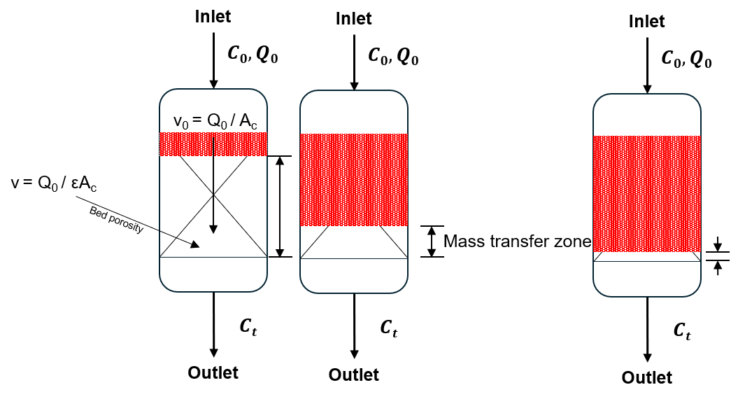
Fig. 5) Schematic diagram of MTZ traveling through a fixed-bed column
In a fixed-bed column, fresh gas enters one end and pushes a sharp adsorption front, called the mass transfer zone (MTZ) progressively towards the outlet. In Fig. 3) the inlet CO₂ concentration (mole fraction $C_{0}$) flows through the packed bed at a volumetric flow rate of $v_{0}$. As the CO₂ gas gets adsorbed by the adsorbent material, the adsorption zone is indicated by the red-shaded region travelling axially through the columns at a speed much slower than the influent gas velocity.
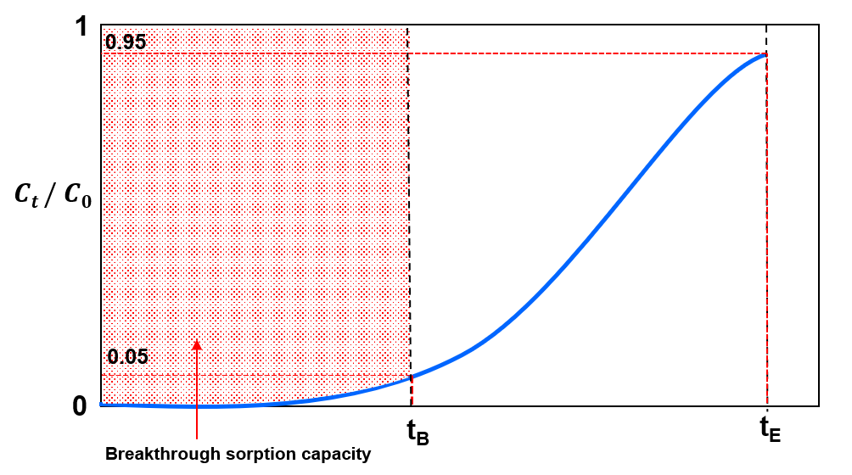
Fig. 6) Breakthrough curve diagram through a fixed-bed column
Hence, in Fig. 5) the bed divides into three zones during adsorption: saturation zone, mass-transfer zone, and adsorption zone. In the saturation zone, the adsorbent contaminant reaches dynamic equilibrium, where the amount absorbed, $q_{0}$, is in equilibrium to the influent concentration, $c_{0}$. Thus, the loading capacity of the adsorbent is exhausted, and no mass transfer takes place. Adsorption only occurs in the MTZ, in which the adsorbent accumulates molecules continuously from the feed, and the amount adsorbed in the bed increases from zero to $q_{0}$. The shape and length of the MTZ largely depends on the rate of adsorption, $κ$, and the shape of the isotherm curve. Breakthrough is registered when the MTZ first reaches the outlet, and the resulting S-shaped breakthrough curve is a mirror of the MTZ whose sharpness is set jointly by the rate of adsorption and the curvature of the equilibrium isotherm (Hu et al., 2024). With the assumptions: (i) plug flow in the axial direction; (ii) negligible radial dispersion; (ii) a linear driving force for solid adsorption; (iii) uniformly spherical adsorbent particles and; (iv) constant geometric dimensions, interstitial velocity, and void fraction (Hu et al., 2024). This behaviour can be described by the following mass-balance equation:
$$\frac{∂c}{∂t}+u\frac{∂c}{∂z}+\frac{1-ε}{ε}\frac{∂q_{t}}{∂t}=D_{L}\frac{∂^{2}c}{∂z^{2}}$$
where $c$ represents the adsorbate concentration in fluid phase, $z$ is the distance along the bed length, $u$ is the fluid velocity, $t$ denotes time, $ε$ is the void bed fraction, $q_{t}$ is the concentration in an adsorbent particle component and the effect of axial dispersion is lumped into a single effective axial dispersion coefficient $D_{L}$.
The advection term $u\frac{∂c}{∂z}$ and the axial dispersion term $D_{L}\frac{∂^{2}c}{∂z^{2}}$ transport CO₂ along the column while the sink term $\frac{1-ε}{ε}\frac{∂q_{t}}{∂t}$ represents gas to solid phase transition via intraparticle resistances lumped as linear driving force (LDF). The axial dispersion coefficient can be estimated as $D_{L}=ud_{p}\left(\frac{20}{ε}\frac{D_{m}}{ud_{p}}+\frac{1}{2}\right)$ where $D_{m}$ is the molecular diffusivity. The linear driving force can be represented as the linear approach of the instantaneous loading $q_{t}$ to its equilibrium value $q_{e}$ expressed as:
$$\frac{∂q_{t}}{∂t}=k_{s}\left(q_{e}-q_{t}\right)$$
The initial and boundary conditions can be given via Danckwert’s boundary conditions for a dispersed plug flow, expressed as:
$$D_{L}\frac{∂c}{∂z}{\left.​\right|}_{z=0}=-u{\left.​\right|}_{z=0}\left(c_{i}{\left.​\right|}_{z=0^{-}}-c_{i}{\left.​\right|}_{z=0}\right), \frac{∂c}{∂z}{\left.​\right|}_{z=L}=0$$
where $c_{i}{\left.​\right|}_{z=0}$ is the feed composition for component $i$ and $L$ is the bed length.

3.5 Adsorption Isotherms
Adsorption depends on the concentration of the target molecule in the fluid and gas pressure in the bulk phase. Adsorption site heterogeneity combines the properties of the adsorbent at various amounts adsorbed, including surface area, pore volume, concentration of functional groups and pore-size distribution. The ‘heterogeneity’ of the adsorbent can be estimated by modelling the number of adsorption sites of the solid and their types. Adsorption isotherms are graphs that indicate loading-pressure relationships in the $x$- and $y$-axis respectively. In the case of CO₂ adsorption, the x-axis represents pressure of CO₂ in gas phase (or the concentration of the species or partial pressure) while the y-axis represents CO₂ loading on the sorbent (or the number of adsorbed species by the adsorbent) at equilibrium (the state where the rate of molecules attaching to the sorbent surface equals to the rate of molecules being released from the sorbent). A wide variety of models have been formulated to describe the adsorption isotherms observed experimentally. Some of the more common adsorption isotherms are described in the following sections. In practice, CO2 capacity of PEI-impregnated sorbents will not be able to reach its maximum theoretical limit due to the mass transfer resistances involved.

3.5.1 Langmuir Isotherm
Following Langmuir (1918), and assuming that: (i) adsorption of molecules occur at a fixed number of well-defined localised sites; (ii) each site only accommodates one adsorbent molecule (monolayer adsorption); (iii) the surface of the adsorbent is homogeneous i.e. all sites are energetically equivalent and; (iv) there are no interactions between the neighboring sites and molecules already adsorbed (Ruthven, 1984).
The Langmuir isotherm relates the surface coverage, $θ$, to pressure, $P$, and temperature, $T$:
$$θ=\frac{KP}{1+KP}$$
, where $K=\frac{1}{p^{0}}e^{-ϵ/(kBT)}$ is the rate constant of equilibrium. We observe that for $KP≪1$, the model increases linearly. But as $KP$ increases (i.e pressure increases), the model converges to 1. Higher temperatures lead to slower asymptotic convergence. In the case where the amount adsorbed, $q$, is much smaller than the maximum adsorption capacity, $q_{s},$ a linear equation following Henry’s is derived: $θ=KP$.
Langmuir isotherm assumes a homogeneous (i.e. uniform) binding site distribution. Discrete models attempt to preserve model heterogeneity by assuming a discrete number of different adsorption sites. However, different adsorbents have different numbers of adsorption sites with varying binding energy. Continuous distribution functions are considered an improvement to discrete models—considering the affinity spectrum which is a plot of the binding affinity against the number of adsorption sites. A Toth isotherm is hence used to model both a homogeneous and heterogeneous distribution of adsorption site affinities. The values of parameters of the Toth model can be found by nonlinear curve fitting method using sigma plot software.

3.5.2 Toth Isotherm
In this work, as a case study, we used only the three-parameter Toth isotherms to describe adsorption on both homogeneous and heterogeneous surfaces. Mathematically, the Toth isotherm can predict the monolayer adsorption capacity of a homogeneous surface that will match with the surface area predicted by Langmuir isotherm. The Toth (1971) isotherm is given by:
$$q=q_{s}{\left[\frac{b_{T}p}{1+{\left(b_{T}p\right)}^{t}}\right]}^{\frac{1}{t}}$$
, where $b_{T}$ and $t$ are the Toth isotherm constants. $b_{T}$ is related to the binding energy, $q_{s}$ is the monolayer adsorption capacity.

3.6 Adsorption breakthrough models
Traditional breakthrough models i.e. Bohart-Adams, Thomas, Yoon-Nelson are dissected (Shafeeyan et al., 2014) and expressed as a single logistic function in three notations: $k_{YN}=k_{BA}c_{0}=k_{Th}c_{0}; τ=\frac{a_{0}x}{uc_{0}}=\frac{q_{0}m}{vc_{0}}$. For the more general Clark model, when $n≠2$, the dominant mass-transfer mechanism results in an asymmetric breakthrough curve. Thus, empirical breakthrough models like the Gudermannian and error functions (Hu et al., 2021) with the involvement of fractal-like kinetics i.e. $k\left(t\right)=k_{0}t^{-h}$, where $h$ is the heterogeneity parameter—is needed to fit asymmetric breakthrough curves.

3.6.1 Bohart-Adams Model
The Bohart-Adams model (Bohart & Adams, 1920), and other models discussed below, remain popular because they can be linearised, allowing unknown parameters to be determined via linear regression analysis (Chu, 2020). The Bohart-Adams model predicts a linear relationship between bed depth and breakthrough time, and is expressed as:
$$\frac{c}{c_{0}}=\frac{1}{1+\exp\left[K_{BA}c_{0}\left(\frac{a_{0}x}{uc_{0}}-t\right)\right]}$$
However, the appropriate analytical solution for the adsorbate concentration at the column as a function of time is given as (Chu, 2020; Hu et al., 2024):
$$\frac{c}{c_{0}}=\frac{\exp\left(k_{BA}c_{0}t\right)}{\exp\left(\frac{k_{BA}a_{0}x}{u}\right)+\exp\left(k_{BA}c_{0}t\right)-1}$$
Rewriting this into its linear form gives us (Chu, 2020):
$$\ln\left(\frac{c_{0}}{c}-1\right)=\ln\left[\exp\left(\frac{k_{BA}N_{0}L}{u}\right)-1 \right]-k_{BA}c_{0}t$$
As the rate of adsorption ($k_{BA})$ becomes very large,
$$\ln\left(\frac{c_{0}}{c}-1\right)=\frac{k_{BA}N_{0}L}{u}-k_{BA}c_{0}t$$
Thus, $k_{BA}$ can be evaluated by finding the slope of $\ln\left(\frac{c_{0}}{c}-1\right)$ against $t$, $N_{0}$ from the y-intercept.

3.6.2 Thomas Model
The Thomas (1944) model's simplified solution is given as
$$\ln\left(\frac{c_{0}}{c}-1\right)=k_{Th}c_{0}\left(\frac{q_{0}m}{vc_{0}}-t\right)$$
, where it assumes Langmuir equilibrium (Hu et al., 2024). However, $q_{0}$ and $k_{Th}$ are purely empirical parameters which can be estimated by fitting. This can be rewritten as:
$$\frac{c}{c_{0}}=\frac{1}{1+exp⁡(a-bt)}$$
, where $a=\frac{k_{Th}q_{0}M}{Q}$ and $b=k_{Th}c_{0}$. Since this is a logistic equation, Eqs. () and () will exhibit the same shape and error statistics as they are mathematically equivalent. The same applies to the Yoon-Nelson model as described below.

3.6.3 Yoon-Nelson Model
This model (Yoon & Nelson, 1984) is derived from probability arguments about the column inlet. It assumes that the probability of adsorption rate increase is proportional to the probabilities of adsorption and breakthrough respectively. This can be written as:
$$\frac{c}{c_{0}}=\frac{1}{1+exp⁡(a+bt)}$$
, where $a=k_{YN}τ, b=k_{YN}$.

3.6.4 Mathematical equivalence of traditional breakthrough models
We show that these are notational variances of a single logistic sigmoid, independently confirming the equivalence established by Hu et al. (2020) and Chu (2020).
Theorem (BA-Thomas-YN equivalence). Define the logistic breakthrough curve
$$\frac{c}{c_{0}}=σ\left(k_{YN}\left(t-τ\right)\right)≔\frac{1}{1+exp⁡(k_{YN}(t-τ))}$$
Thus, $k_{YN}=k_{BA}c_{0}=k_{Th}c_{0}; τ=\frac{a_{0}x}{uc_{0}}=\frac{q_{0}m}{vc_{0}}$ , where $a_{0}$ is the Bohart-Adams volumetric capacity, $q_{0}$ the Thomas equilibrium loading, $m$ the sorbent mass, $v$ the volumetric flow rate, and $x$ the bed length.
Proof Bohart-Adams model is $\frac{c}{c_{0}}={\left[1+\exp\left(k_{BA}\left(a_{0}x/u-c_{0}t\right)\right)\right]}^{-1}$. Factoring $c_{0}$ from the exponent gives $\frac{c}{c_{0}}=σ\left(k_{BA}c_{0}\left(t-\frac{a_{0}x}{uc_{0}}\right)\right)$. The Thomas model is $\frac{c}{c_{0}}={\left[1+\exp\left(k_{Th}\left(q_{0}m/v-c_{0}t\right)\right)\right]}^{-1}$, and the same factoring gives $c/c_{0}=σ\left(k_{Th}c_{0}(t-q_{0}m/(vc_{0})\right))$. The YN model is $σ\left(k_{YN}\left(t-τ\right)\right)$ by definition.
Remark. Three sigmoidal functions appear in the breakthrough literature (Hu et al., 2024): the logistic $σ\left(x\right)={\left(1+e^{-x}\right)}^{-1},$ the error function: $\operatorname{erf}\left(x\right)$ and the Gudermannian function $\operatorname{gd}{(x)}=2\arctan\left(\tanh{(x/2)}\right).$ Before normalization, these have ranges $\left(0,1\right)$, $\left(-1,1\right)$ and $\left(-\frac{π}{2},\frac{π}{2}\right)$ respectively. After affine scaling,
$$\tilde{σ}=σ\left(x\right), \tilde{erf}{(x)}=\frac{1}{2}(\operatorname{erf}\left(x\right)+1), \tilde{gd}{(x)}=\frac{1}{π}\operatorname{gd}\left(x\right)+\frac{1}{2}$$
all three map $R→\left(0,1\right)$ with $f\left(0\right)=0.5$, and they are visually indistinguishable, uniformly over all X, once the rate constant of each kernel is matched to the others' slope at the inflection point (as any least-squares fit does automatically) -- see below. On the raw, unmatched argument they are not close (the largest pairwise gap reaches 0.19); it is the fit, not the functional form, that makes them converge $\left|X\right|≤2$. Anchoring an experimental breakthrough curve $\frac{c\left(t\right)}{c_{0}}$ fixes both the location $τ$ and (after slope fitting) the rate constant; the residual sup-norm distance between any two of $σ_{*},E_{*},G_{*}$ i.e.:
$$\max_{f,g∈\left\{σ_{*},E_{*},G_{*}\right\}}\left|f\left(X\right)-g\left(X\right)\right|<0.031$$, uniformly over the entire real line, with the global worst case ≈ 0.031 attained near |X| ≈ 2.7 (verified numerically from the model definitions used throughout this report — logistic, error-function and Gudermannian kernels evaluated after matching each kernel’s slope at its inflection point to the logistic reference slope, exactly as a nonlinear least-squares fit does automatically). Consequently, if observational noise has standard deviation ε ≥ 0.03 — consistent with the ±3–5 % of reading accuracy specified for the NDIR CO₂ sensors used in this rig's own gas-analysis train (GasLab, CU-1106 series specifications; §4.1.3) — then no statistically meaningful distinction between the three kernels is possible on the experimentally accessible breakthrough region.

3.6.5 Clark Model
The Clark (1987) model introduces asymmetry through an additional exponent $n≥1$:
$$\frac{c}{c_{0}}={\left[\frac{1}{1+Ae^{-rt}}\right]}^{1/(n-1)}$$
At $n=2$, this reduces to the logistic form of §3.6.4. For $n>2$, the curve is left-asymmetric i.e. sharper rise, longer tail; for $1<n<2$ it is right-asymmetric. The Clark model is therefore a minimal one-parameter extension of the unified Bohart-Adams, Thomas, Yoon-Nelson family that can encode mass transfer asymmetry.

3.6.6 Gudermannian and Error functions
In Hu et al. (2021), the normalized Gudermannian and error functions—when the range of the Gudermannian and error function is [0,1]—can define asymmetric breakthrough curves by employing two lumped parameters: $κ$ and $τ$ as majorly empirical fitting parameters, where $κ$ denotes the shape of the breakthrough and $τ$ denotes its location. The models are expressed as (Hu et al., 2021):
$$\frac{c}{c_{0}}=\frac{1}{2}\left\{1+\frac{2}{π}\arctan{(\sinh{[k\left(t-τ\right)])}}\right\}$$
$$\frac{c}{c_{0}}=\frac{1}{2}\left(1+\operatorname{erf}{[k(t-τ)]}\right)$$

3.6.7 Weibull and Avrami Models
Weibull and Avrami models are probability distribution functions with floating inflection points. Both are probability distribution functions with floating inflection points; the Weibull function
$$\frac{c}{c_{0}}=1-\exp\left[-{\left(\frac{t}{a_{5}}\right)}^{b_{5}} \right]$$
and log-Gompertz functions have floating inflection points that can shift towards the origin for asymmetric data, unlike the fixed-inflection normal and Gompertz forms. Kimani (2024) found that of the floating-inflection-point family, only log-Gompertz gave a satisfactory fit regardless of curve symmetry, and that log- and fractal-like Bohart–Adams models fit the curves perfectly regardless of symmetry — a result that independently corroborates the fractal-like models' advantage reported in §6 of this work. In this project's own fits, the Weibull (M14) and Avrami (M15) models return statistically indistinguishable goodness-of-fit in every run (identical R², RMSE and AICc to at least five significant figures — see §7), consistent with their known near-equivalence as stretched-exponential forms.

3.6.8 Fractal-Like Model Equations
Beyond the seven classical and asymmetric forms above, the remaining models fitted in the §7 comparison are introduced below, grouped by functional family. The fractal-like generalisation already discussed qualitatively in §3.7.2 applies to each kernel above by replacing its constant rate parameter with a time-dependent one, k = k₀t⁻ʰ. For the Clark model (§3.6.5), this gives the fractal Clark form (M03, Hu et al., 2024):
C/C₀ = [1 / (1 + A₀·exp(−r/(1−h)·t^(1−h)))]^(1/(n−1)), which collapses to the Clark model (M02) when h = 0.
For the Gudermannian and error-function kernels (§3.6.6), the corresponding fractal forms are the fractal Gudermannian (M10) and fractal error-function (M11) models that win outright in four of the five original runs (§7; Hu et al., 2024):
C/C₀ = ½{1 + (2/π)·arctan[sinh(k₀t⁻ʰ(t−τ₀))]} (M10) C/C₀ = ½{1 + erf[k₀t⁻ʰ(t−τ₀)]} (M11)
The fractal Yoon-Nelson form (M23) applies the same substitution to the logistic kernel of §3.6.3 (Hu et al., 2024):
C/C₀ = 1 / (1 + exp{(k_YN,0/(1−h))·[τ^(1−h) − t^(1−h)]}), recovering the standard Yoon-Nelson model as h → 0.

3.6.9 Wolborska and Dose-Response Models
Wolborska (1989) modelled the early-breakthrough region with a linear-driving-force approximation that is exact only for C/C₀ ≤ 0.15:
ln(C/C₀) = (slope)·t + intercept (M05), fitted here only to that restricted early window, so its goodness-of-fit statistics in §7 are not on the same scale as the full-curve models. Hu et al. (2020) caution specifically against using Wolborska to describe the complete dynamic behaviour of a fixed-bed column, since the model “does not represent a S-shaped curve and thereby fails to describe the breakthrough curve completely”; it is retained here, on the early window only, for completeness rather than as a candidate in the model-selection comparison of §7.
Yan et al. (2001) proposed a modified dose-response form parameterised directly on the half-breakthrough time t₅₀:
C/C₀ = 1 − 1/(1 + (t/t₅₀)ᵃ) (M04), where a is an empirical shape exponent; it produces a logistic-like sigmoid but, unlike the Yoon-Nelson form (§3.6.3), is written directly in terms of the operationally meaningful t₅₀ rather than a rate constant.

3.6.10 Tanh, Log-Normal and Gompertz Models
Hu et al. (2019) also fit a hyperbolic-tangent kernel,
C/C₀ = ½[1 + tanh(k(t−τ))] (M08), algebraically close to the logistic and Gudermannian forms discussed in §3.6.4's Remark but with a different tail decay rate. Chu & Hashim (2023) instead track the log-time coordinate with a normal (Gaussian) cumulative distribution,
C/C₀ = ½{1 + erf[(ln t − b)/(a√2)]} (M09, log-normal), which — like the log-modified models of §3.6.13 — gives the curve a floating inflection point in t while remaining symmetric in ln t. The Gompertz function,
C/C₀ = exp[−exp(α_G − β_G·t)] (M12), and its log-time counterpart,
C/C₀ = exp[−exp(α_G − β_G·ln t)] (M13, log-Gompertz), are asymmetric growth-curve forms long used for breakthrough correlation (Chu, 2020). §3.6.7 already reports that log-Gompertz was the only floating-inflection-point model Kimani (2024) found to fit satisfactorily regardless of curve symmetry.

3.6.11 Klinkenberg and Dima Models
Klinkenberg (1948) derived an asymptotic closed-form solution to the linear-driving-force mass-transfer equations in terms of two dimensionless groups — the bed Stanton number ζ = K_fa/(u/x) and a dimensionless time τ_K — giving
C/C₀ = ½{1 + erf[√τ_K − √ζ + 1/(8√τ_K) + 1/(8√ζ)]} (M16). The approximation is valid only for ζ ≥ 2 and τ_K ≥ 1 (Klinkenberg, 1948; Hu et al., 2024); §7 reports that these conditions are not met for this column, so M16 is fitted but excluded from the model-preference conclusions. Dima et al. (2024) solved the coupled mass-balance and linear-driving-force equations by Laplace transform and showed that, in the travelling-wave limit, the solution reduces to an error-function wave,
C/C₀ = ½{1 + erf[(v_d·t − x)/(√2·σ_a)]} (M17, wave velocity v_d and spread σ_a), consistent with the R-H shock and travelling-wave analysis referenced in the project schedule (Table 1) and developed in mechanistic-model.md §D.

3.6.12 Chern–Chien Isotherm-Embedded Models
Chern & Chien (2002) derived breakthrough solutions directly from the constant-pattern wave approach for Langmuir (M18) and Freundlich (M19) equilibria, solving implicitly for the time t at which the outlet reaches a given C/C₀ = x rather than for C/C₀(t) directly; both require root-finding (Brent's method here) at every evaluated time point. In this project's fits, M18 and M19 converge formally but return non-finite RSS and an undefined R² in every run (§7); following the same treatment as M16, they are reported for completeness but excluded from the model-preference ranking. A stiffer initial-guess strategy, or re-parameterising the fit in x rather than t, is the likely fix and is left for future work.

3.6.13 Log-Modified and n-Order Models
Apiratikul & Chu (2021) proposed logarithmic modifications of the Bohart-Adams and Yoon-Nelson logistic kernels (§3.6.1, §3.6.3), replacing linear time with log time to better track curves that are steep near breakthrough and long-tailed near saturation:
C/C₀ = 1/(1 + exp{k_BA·[log(a₀x/(uC₀)) − log t]}) (M20, log-modified Bohart-Adams) C/C₀ = 1/(1 + exp{k_YN·[log τ − log t]}) (M21, log-modified Yoon-Nelson)
Hu et al. (2021) generalised the Bohart-Adams rate law itself to n-th order in the gas-phase driving force (M22), recovering the classical logistic form (§3.6.1) as the n = 1 special case; the resulting closed-form solution is algebraically more involved than M01 and is evaluated numerically here from the same generalised rate equation.

3.6.14 Parallel Two-Component Model
Blagojev et al. (2019) observed that some breakthrough curves are better described as a weighted superposition of two independent adsorption mechanisms — for example, two populations of binding sites with different affinities — than by any single sigmoidal kernel:
C/C₀ = p·[1−1/(1+(t/τ₁)^k1)] + (1−p)·[1−1/(1+(t/τ₂)^k2)] (M24), where p ∈ [0,1] weights two Weibull-type components (τ₁,k1) and (τ₂,k2). With five free parameters, M24 is the most flexible model in the 24-model registry; §7 reports its AICc penalty and whether the added flexibility is justified for this column.

3.7 Review of Prior Solutions
A range of CO₂ capture technologies has been developed, including liquid solvent absorption, adsorption over solid sorbents, membrane separation, cryogenic separation, direct air capture (DAC), and hybrid systems. However, this experiment looks at specifically adsorption in a packed-bed setting.
Adsorption-based capture is especially relevant to this project because it uses solid sorbents in packed-bed systems and is compatible with dilute CO₂ streams (Stampi-Bombelli et al., 2024). Prior work has shown that PEI-impregnated silica sorbents perform well for CO₂ capture, particularly in applications where adsorption capacity, regenerability, and process stability are important (Cabrera-Codony et al., 2026; Karimi et al., 2023). These findings support the use of PEI@SiO₂ C3 granules as the sorbent material in our project. Stampi-Bombelli et al. (2024) characterise this sorbent class for direct air capture at ≈400 ppm CO₂; this work operates at 5–15 % CO₂, well outside that range, so its isotherm and geometry parameters are used here as a benchmark rather than as validated inputs for the conditions studied.

3.7.1 Classical Symmetric Models
The Bohart-Adams, Thomas, and Yoon-Nelson models are mathematically equivalent forms of the logistic function, representing a centrosymmetric S-shaped curve with an inflection point fixed at $c/c_{0}$ = 0.5 (Hu et al., 2019). These models perform well when the breakthrough curve is symmetric but fail for asymmetric (tailed) data characteristic of diffusion-limited adsorption on heterogeneous surfaces (Hu et al., 2019). Hu et al., 2019 demonstrated that for norfloxacin adsorption on granular activated carbon, the logistic model yielded Adj. R² = 0.9879, significantly lower than fractal-modified versions.

3.7.2 Models for Asymmetric Breakthrough Curves
Fractal-like models introduce a time-dependent rate coefficient ($k = k₀·t⁻ʰ$) derived from fractal kinetics, which accounts for the heterogeneous, diffusion-limited nature of adsorption on real surfaces (Hu et al., 2021). The fractal-like Bohart-Adams (or equivalently, fractal-like Thomas and fractal-like Yoon-Nelson) model includes an additional parameter $h$ (fractal exponent). When $h$ = 0, the model reduces to the classical logistic function; as $h$deviates from zero, the breakthrough curve becomes increasingly asymmetric (Hu et al., 2021). Kimani (2024) showed that the fractal-like Bohart-Adams model outperformed all others in fitting tailed breakthrough data from bisphenol-A adsorption on polyaniline (Adj. R² > 0.99, lowest BIC values). The model accurately estimated breakthrough times (13, 26, and 90 min for 6, 9, and 12 mm bed depths) and a critical bed depth of 5.65 mm (Kimani, 2024).

3.7.3 Implication for Packed-Bed CO₂ Capture
For the packed-bed adsorption of CO2 using C3 granules, the selection of an appropriate breakthrough model is crucial for accurate process design. The fractal-like models, particularly, fractal-Gudermannian and fractal-ERF are expected to provide superior fits when the breakthrough data exhibit asymmetry due to: (i) heterogeneous sorbent surface chemistry (amine-functionalised sites varying reactivity); (ii) diffusion limitations within the composite granule structure and; (ii) non-linear adsorption isotherms typical of CO2 chemisorption. The high Adj. R2 values (>0.998) reported for these models (Kimani, 2024; Hu et al., 2021) suggest they are well-suited to the diffusion-limited heterogeneous-surface systems characteristic of practical CO2 capture adsorbents.

3.8 Design or Research Procedure
The research procedure begins with a review of CO₂ capture technologies and adsorption principles, followed by the assembly and calibration of the experimental rig. Once the setup is complete, the SOP is used to standardise the operation of the system and ensure consistent testing conditions. A 3 × 3 DOE is then used to study the combined effects of CO₂ concentration and flow rate on adsorption breakthrough behaviour.
The experimental data will be processed using Python to fit breakthrough curves to industry-standard models. These results will be used to assess the influence of operating conditions on adsorption performance and to validate the suitability of the PEI@SiO₂ sorbent under the tested conditions. The project requires knowledge of adsorption theory, laboratory operation, data analysis, and numerical modelling, and these skills are being developed through literature study, supervision, and trial runs of the experimental setup.

4 Standard Operating Procedure for CO₂ Adsorption Experiment
This SOP describes the step-by-step method for operating the SUTD fixed-bed experimental setup to conduct CO₂ adsorption breakthrough experiments using C3 (PEI@SiO₂) granules as the solid sorbent. The aim is to observe the behaviour of the system under initial and boundary conditions across repeated experimental runs and obtain breakthrough data for subsequent breakthrough parameters estimation and modelling. Fig. 7. shows the labelled valves (1, 2, 3, 4, and 5). Fig. 8. shows the process flow diagram of the CO₂ adsorption experiment in packed-bed column.
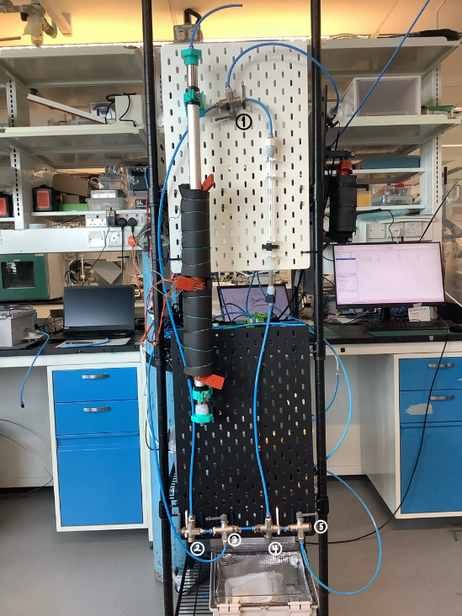
Fig. 7) labelled valves and apparatus for SUTD CO2 Adsorption experiments
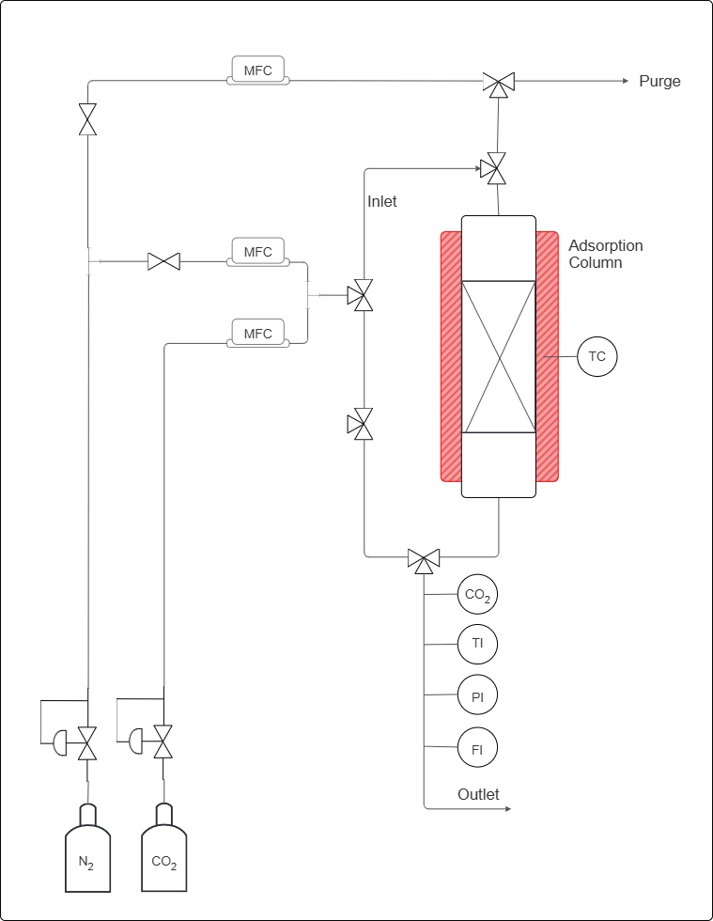
X%
CO2 (v/v)
CO₂ concentration
Gas stream temperature
Gas stream pressure
Gas stream flow rate
PEI@SiO2 granules bed
Heat for regeneration
To purge column before start adsorption
Fig. 8) labelled process flow diagram of CO₂ adsorption in fixed-bed column

4.1 Apparatus and Instrumentation
The apparatus comprises a gas-feeding section, an adsorption column and a gas analysis section at the outlet, as described below.

4.1.1 Gas Feeding Section
Two compressed gas cylinders with pure CO₂ and pure N₂ is fitted with a dedicated pressure regulator and a manual needle valve. Three mass flow controllers (MFCs) regulate the volumetric flow rates throughout the experiment:
- MFC-A (top position): controls the N₂ flow used exclusively for the pre-adsorption column purge and for the regeneration purge sweep.
- MFC-B (middle position): controls the N₂ flow during the adsorption step, contributing to the binary N₂/CO₂ feed mixture.
- MFC-C (lower position): controls the CO₂ flow during the adsorption step; blended with the N₂ stream from MFC-B to produce a feed gas of composition X% CO₂ (v/v), where X is a pre-specified experimental variable.
The mixed gas stream is produced by combining the outputs of MFC-B and MFC-C at a T-junction downstream of both controllers, prior to entry into the column inlet.

4.1.2 Adsorption Column
The fixed-bed column is oriented vertically with gas entering at the bottom inlet and exiting at the top outlet. The column, with an inside diameter of 8.2mm and length of 32cm is packed with PEI@SiO₂ granules.

4.1.3 Gas Analysis and Monitoring
The outlet stream passes through four in-line instruments arranged in series: (i) CO₂ analyser (CO2), thermocouple (TI), pressure indicator (PI) and flow meter (FI). A dedicated purge outlet line at the top of the rig vents the N₂ stream used during column purge; this line is isolated from the analysis train during adsorption.
The following lists the equipment needed for the experiment:
- Compressed CO₂ gas cylinder with 100% CO₂,
- Compressed N₂ gas cylinder with 100% N₂,
- Mass flow controllers (MFCs), connected to the Sensirion software on the laptop,
- Three-way valves (Labelled 1, 2, 3, 4 and 5) and gas lines with tube inside diameter of 6mm,
- Adsorption column, inside diameter of 0.85cm and length 38.6 $±$ 0.1cm, packed with PEI@SiO₂ based C³ granules,
- CO₂ concentration sensor, connected to the Gaslab software on the laptop,
- Flow rate sensor, connected to the Sensirion software on the laptop,
- Laptop interfaces for sensor monitoring and data acquisition.

4.1.4 Pre-Run Preparation
Before beginning the experiment, inspect all gas lines, valves, and fittings to ensure that the system is secure. Ensure that the MFCs, sensors, and data acquisition software are functioning correctly. Weigh approximately 8g of granules was used for the pre-run experiment. Ensure that the bed is packed consistently by tapping the column until no changed in packed height. Note down the sorbent mass and bed length.

4.2 Experimental Procedure

4.2.1 Sensor Setup and Calibration
- Connect all sensors to their respective laptop applications.
- Verify that the CO₂ concentration sensor is connected to the Gaslab interface.
- Remember to adjust Auto-Logging to 5 Seconds for 6 Hours.
- Verify that the flow sensor is connected to the Sensirion software.
- Flow 1 bar of N₂ using the MFC and tube connected to valve 3 through the mixed-gas secondary line by turning valve 2 upward, and valve 3 to the left. to establish a baseline before calibration.
- This is done by using the N₂ MFC and line connected to valve 3, and by turning valve 2 upward and valve 3 to the left. Valve 1 would be turned to the left, to allow the gas to flow from the mixed-gas secondary line into the sensors. Meanwhile, valves 4 and 5 is turned to the right to prevent pressure buildup in the tubes connected to the column.
- Allow the CO₂ sensor to stabilise at 0 ppm, or at a stable linear baseline, before continuing.
- Maintain this calibration period for approximately 15 minutes, or until the readings are stable to ensure that the line contain only N₂ gas.
- If the CO2 sensor does not calibrate to zero, but maintains a stable reading, can ‘configure to zero’ on the Gaslab application.

4.2.2 Column Loading and Purge
- After calibration, disconnect the temporary tube arrangement.
- Load the pre-weighed PEI@SiO₂ granules into the adsorption column (if not already done before the start of the calibration).
- Pack the sorbent uniformly by tapping the column to ensure consistent and distribute flow through the bed.
- Perform an N₂ purge through the column to remove residual atmospheric gases and establish an initial condition without CO₂ accumulation.
- This is done by using the purge line connected to valve 5. Turn valves 1 and 4 to the right, and valve 5 to the left, to allow the gas to flow through the column and into the sensors.
- As during calibration, position the other valves to prevent pressure build-up within the experimental setup.
- Continue purging until the system is stable, there is no more/very little CO2 in the column and now, the setup ready for the adsorption experiment.
- Adjust the flow setting if necessary, until the target or desired inlet concentration is obtained and stable.
- Use the CO₂ concentration sensor to confirm that the influent concentration, and the flow rate sensor to ensure the amount of gas flowing through are correct before introducing the gas into the packed bed.
- This is done by turning valve 2 upward and valve 3 to the left. Valve 1 would be turned to the left, to allow the gas to flow from the mixed-gas secondary line into the sensors.
- Direct the mixed gas stream through the secondary bypass line.
, where $Q_{CO_{2}}$ and $Q_{N_{2}}$ are the volumetric flow rates set on MFC-C and MFC-B, respectively.
$$y_{CO_{2}}=\frac{Q_{CO_{2}}}{Q_{CO_{2}}+Q_{N_{2}}}=\frac{X}{100}$$
- Set the desired CO₂ and N₂ flow rates using the MFCs corresponding to desired inlet CO2 concentration.This is done by calculating the required MFC setpoints for MFC-B (N₂) and MFC-C (CO₂) such that their combined volumetric flow rates give the desired composition at the target total flow rate $Q_{total}$. The inlet CO₂ mole fraction $y_{CO_{2}}$ satisfies:

4.2.3 Feed Gas Preparation

4.2.4 CO₂ Adsorption (Breakthrough Experiment) Run
- Once the inlet conditions have been verified, divert the mixed-gas stream from the bypass line into the adsorption column.
- To do this, turn valve 5 to the right, valve 4 to the left, and valve 3 to the right in that order to prevent pressure buildup. Valve 1 needs to be to the right to ensure the gas through the column goes to the sensors. By this time, the N2 purge line can be switched off (by setting the gas flow to 0 lpm) or disconnected.
- Indicate the time when the valves are turned (specifically valve 3) as the experiment start time (t = 0 s).
- Monitor the outlet CO₂ concentration continuously throughout the run with 5 s interval.
- Continue the experiment until the outlet CO₂ concentration rises close and/or equal to the inlet concentration, indicating that breakthrough and equilibrium adsorption has occurred.
- When CO₂ concentration rise to 5% of an inlet concentration, indicate the time as breakthrough time
- When CO₂ concentration rises close and/or equal to the inlet concentration, indicate the time as equilibrium time.
- Stop the run once the bed approaches saturation and the data trend has stabilised.
- Record time as end time, before turning valve 3 to the left, valve 2 turn down, turning off the MFCs, and finally disconnecting all gas from the main gas tube.
- Save all data files with a filename that encodes the experimental date, run number, and key parameters (e.g., YYYYMMDD_Run##_Cin_Qtotal.csv).

4.3 After the Run
At the end of the experiment, stop the gas flow and close all valves in a controlled manner. Save all collected data and verify that the system is left in a safe condition for the next run.

4.3.1 Acceptance Criteria and Validity
A completed run is considered valid and suitable for quantitative analysis only if all of the following are satisfied:
- The CO₂ analyser baseline prior to adsorption was ≤ 10 ppm (confirming complete purge).
- The inlet composition, as back-calculated from MFC-B and MFC-C setpoints and confirmed by the steady-state outlet concentration at saturation, matches the target C_{in} within ±2%.
- The outlet flow rate (FI) remained within ±5% of the inlet total flow rate throughout the adsorption step, confirming no significant pressure build-up or line blockage.
Any run that fails one or more criteria shall be marked as invalid in the data log and the cause investigated before repeating.

4.4 Data to Record
During the experiment, record the following variables:
- Weight of adsorbent and corresponding packed height
- CO₂ inlet concentration,
- CO₂ outlet concentration,
- Gas outlet flow rate, to confirm consistency with inlet setpoint,
- Time taken to reach breakthrough, from the breakthrough time,
- Time taken to reach equilibrium, from the equilibrium time; when outlet concentration reaches $≥$ 95% of $C_{in}$ and has been stable for $≥$ 5 minutes.
- 50% breakthrough, when outlet concentration reaches 0.5 $C_{in}$
- Outlet gas temperature (to detect thermal wave front passing through the bed)
- Outlet pressure, P₁, to confirm no unintended pressure build up
These data will be used to construct the breakthrough curve and assess the adsorption performance of the sorbent under the selected operating conditions.

4.5 Safety Notes
- Handle gas cylinders carefully and ensure that the system is operated in a well-ventilated laboratory.
- Check for leaks before each run and make sure all fittings are tightened properly.
- Follow laboratory safety procedures at all times when working with pressurised gases, sensors, and electrical instrumentation.

5 Experimental Results
The equilibrium adsorption data was carried out in a fixed-bed column adsorber. Experiments were conducted in the adsorber packed with C³ granules of different initial concentrations at ambient room temperature. For the fixed-bed experiments, an acrylic column with an inside diameter of 8.5 mm and a length of 38.6 $±$ 0.1 cm was used as an adsorber. The influent concentration of the CO2 gas was varied at three inlet concentrations (5, 10 and 15%). The gas flow rate varied at 50, 100 and 150 ml per minute respectively. The operating conditions and the corresponding parameters are given in Table 3). The result of the equilibrium adsorption test is shown in Table 4).
Higher concentration and flow rate was used with the experimental setup, resulting in drastic changes in breakthrough and saturation on different operating conditions. This work simulates post-combustion carbon capture scenarios like flue gas, rather than ambient CO2 found indoors. Because this 5-15 % CO2 range lies well outside the ~400 ppm DAC conditions Stampi-Bombelli et al. (2024) characterised their sorbent for (§3.7), that work's isotherm and geometry parameters are treated here as a benchmark, not as validated inputs. Nonetheless, a trend of accelerated breakthrough time with increased concentration and inlet flow rate was observed, but for equilibrium time, there seemed to be a good in-between value that showed it at peak optimisation. Experimental errors, like sudden sensor jumps, as well as the experiment never reaching its initial concentration was encountered. Next steps are to maximise data reliability, giving the precise foundation for optimization of the packed bed's performance.
Table 3) The basic parameters for packed-bed adsorption.
Parameter | Value | Units

Length of column | 38.6 $±$ 0.1 | cm
Inlet diameter | 0.85 | cm
Height of packed-bed | 21.0 – 21.5 (per run) | cm
Volume of packing | 11.92 | cm³
Inlet velocity | 1.47 – 4.41 | cm$∙$s⁻¹
Volume flow rate | 3.0 – 9.0 | Lh-1$∙$
Angle of bed | 90 | deg

Table 4) Experimental Parameters of PEI@SiO2 Fixed-Bed Adsorbers
No. | Interstitial Velocity, m/s | Hgt. of PEI@SiO₂ Bed, m

3 | 0.147 | 0.210
4 | 0.049 | 0.213
5 | 0.098 | 0.212
6 | 0.147 | 0.215
8 | 0.098 | 0.215

Table 5) Breakthrough adsorption of CO₂ onto PEI@SiO₂ granules
No. | CO₂ concentration (%) | Flow Rate (lpm) | Breakthrough Time (min) | Equilibrium Time (min)

Table 5b) Nine-run flow x concentration grid, 2026-06-26 to 2026-07-15 campaign ("newest runs/"). Run numbers 1-9 below are this table's own grid-position index and are NOT the same runs as "run 3/4/5/6/8" in Table 5 above ("new runs/", a separate, earlier campaign on a different rig geometry -- see experimental-results.md §10).
1 | 5 |  | 0.05 | 14 |  | 108
2 | 5 |  | 0.10 | 4 |  | 125
3 | 5 |  | 0.15 | 2 |  | 110
4 | 10 |  | 0.05 | 11 |  | 146
5 | 10 |  | 0.10 | 3 |  | 64
6 | 10 |  | 0.15 | 3 |  | 58
7 | 15 |  | 0.05 | 4 |  | 151
8 | 15 | 0.10 |  |  | 2 | 81
9 | 15 | 0.15 |  |  | 1 | 78

6 Experimental Analysis
The experimental results show that both CO₂ concentration and gas flow rate influenced the adsorption behaviour of the PEI@SiO₂ packed-bed system. At 5% CO₂, the breakthrough time decreased from 14 min at 0.05 l/min to 4 min at 0.1 l/min and 2 min at 0.15 l/min, indicating that higher flow rates shortened the contact time between the gas stream and the sorbent. A similar trend was observed at 10% CO₂, where breakthrough time reduced from 11 min at 0.05 l/min to 3 min at both 0.1 l/min and 0.15 l/min. At 15% CO₂, breakthrough times were again short, decreasing from 4 min to 2 min and finally 1 min as flow rate increased. Overall, the data suggest that increasing flow rate accelerates breakthrough, while higher CO₂ concentration also leads to faster saturation of the column.
The equilibrium times showed greater variability and did not follow a perfectly monotonic trend. At 5% CO₂, equilibrium time ranged from 108 min to 125 min and then 110 min, while at 10% CO₂ it varied from 146 min to 64 min and 58 min. At 15% CO₂, equilibrium time decreased from 151 min at 0.05 l/min to 81 min and 78 min at the higher flow rates. This suggests that equilibrium behaviour is influenced by additional factors beyond concentration and flow rate alone, such as packing uniformity, pressure drop, sensor response, and gas–solid mass transfer effects.
Dynamic capacity, mass-transfer-zone length, and stoichiometric efficiency quantify how much of the column's theoretical capacity is actually used before breakthrough. Across the nine-run flow×concentration grid, q_dyn ranges 0.946-1.627 mol kg⁻¹, rising with inlet concentration at fixed flow (e.g. 0.05 lpm: 0.946 → 1.336 → 1.627 mol kg⁻¹ for 5 % → 10 % → 15 % CO₂) — consistent with a favourable isotherm loading more CO₂ per unit sorbent mass as the driving force increases (experimental-results.md §6.2 reports the same trend on the original five-run basis: 0.552 → 0.787 mol kg⁻¹). L_MTZ = 12.19-13.95 cm, roughly half of the 23-24.5 cm packed bed in every run, and ψ = 0.156-0.406 — both indicating the same broad, never-fully-sharp mass-transfer front reported for the original five runs (L_MTZ ≈ 50 % of bed length, ψ = 0.017-0.039; the nine-run grid's higher ψ reflects its longer bed and different column i.d., 8.2 mm vs 8.5 mm — see the open flag in experimental-results.md §10 on that geometry difference).
Candidate mechanism for the non-monotonic equilibrium time. t_E falls sharply from the lowest to the middle flow rate at every concentration (e.g. 10 % CO₂: 146 → 64 min) but then flattens or ticks up slightly from the middle to the highest flow rate (64 → 58 min) rather than continuing to fall. Section 7.3 shows the fractal exponent h rises monotonically with flow (M11: 0.418 → 0.472 → 0.549 over the same 50/100/150 mL min⁻¹ sweep) — i.e. the kinetics become more diffusion-limited, not less, as flow increases. This suggests two competing effects set t_E: at low flow, equilibration is limited by the rate of convective CO₂ delivery, so increasing flow shortens t_E substantially; but as flow rises further, delivery is no longer the bottleneck and intraparticle diffusion into less-accessible amine sites — whose growing influence is exactly what the rising h encodes — becomes rate-limiting instead, setting a floor below which t_E cannot fall regardless of how much faster gas is supplied. This is a candidate mechanism consistent with the fitted parameters already reported, not an independently verified one; distinguishing it from packing or sensor artefacts (§6, first paragraph) would require a repeat run at fixed conditions.

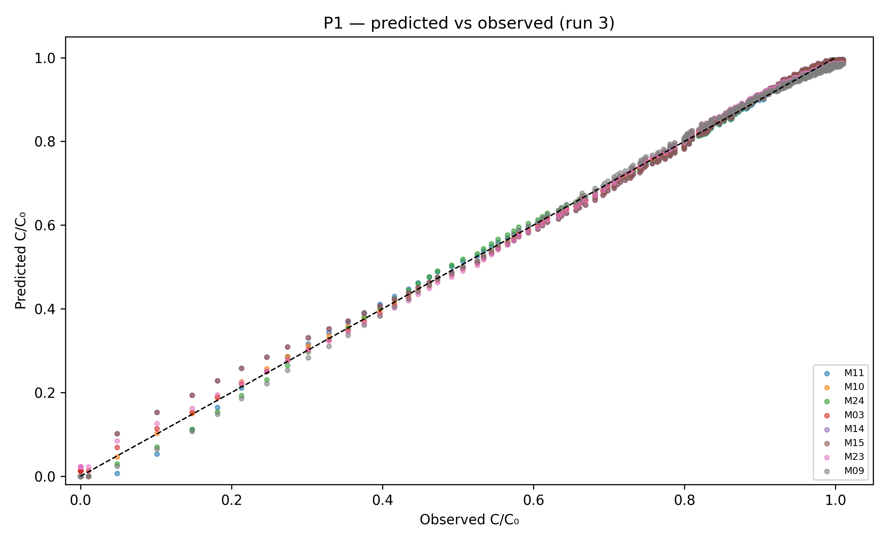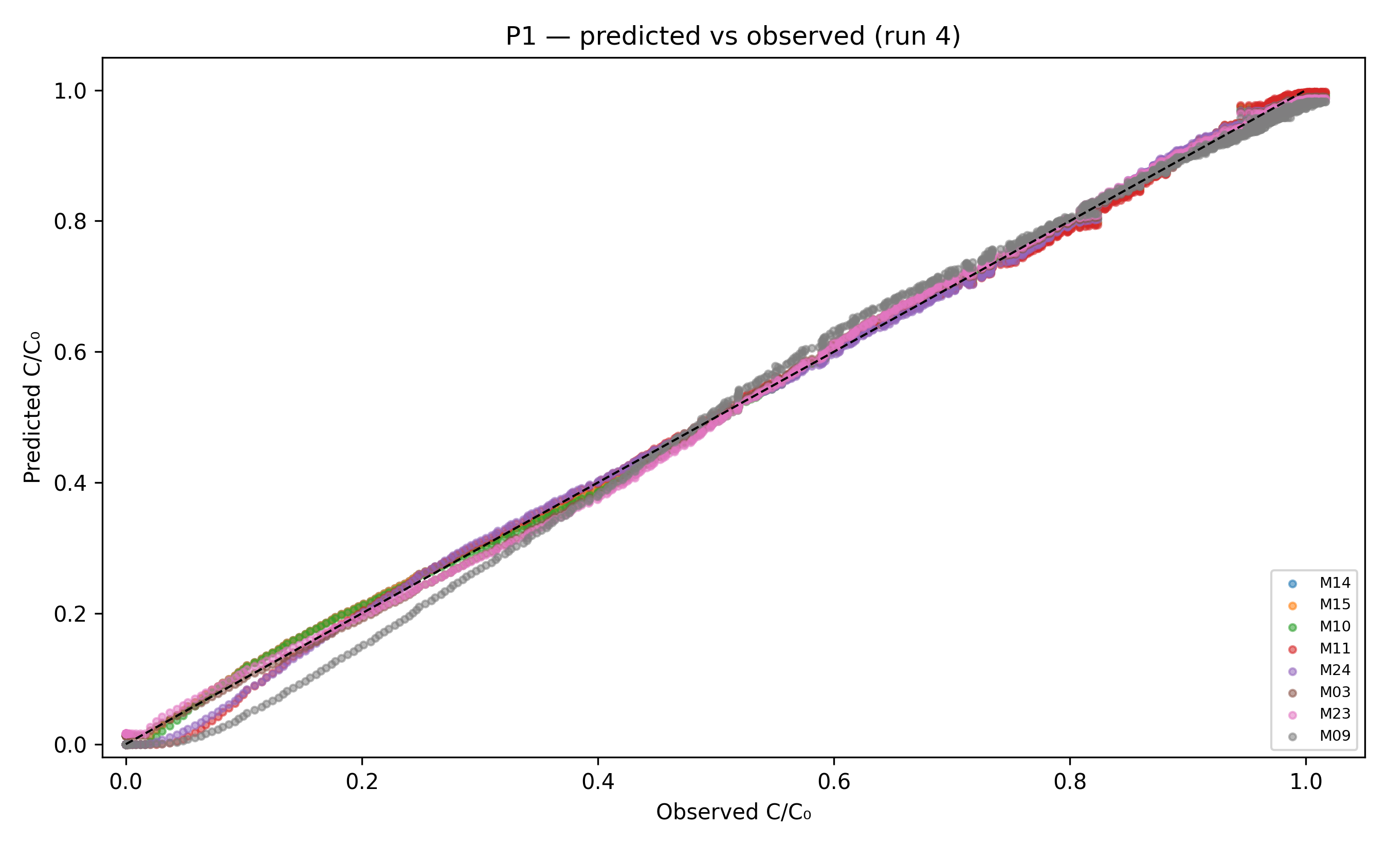
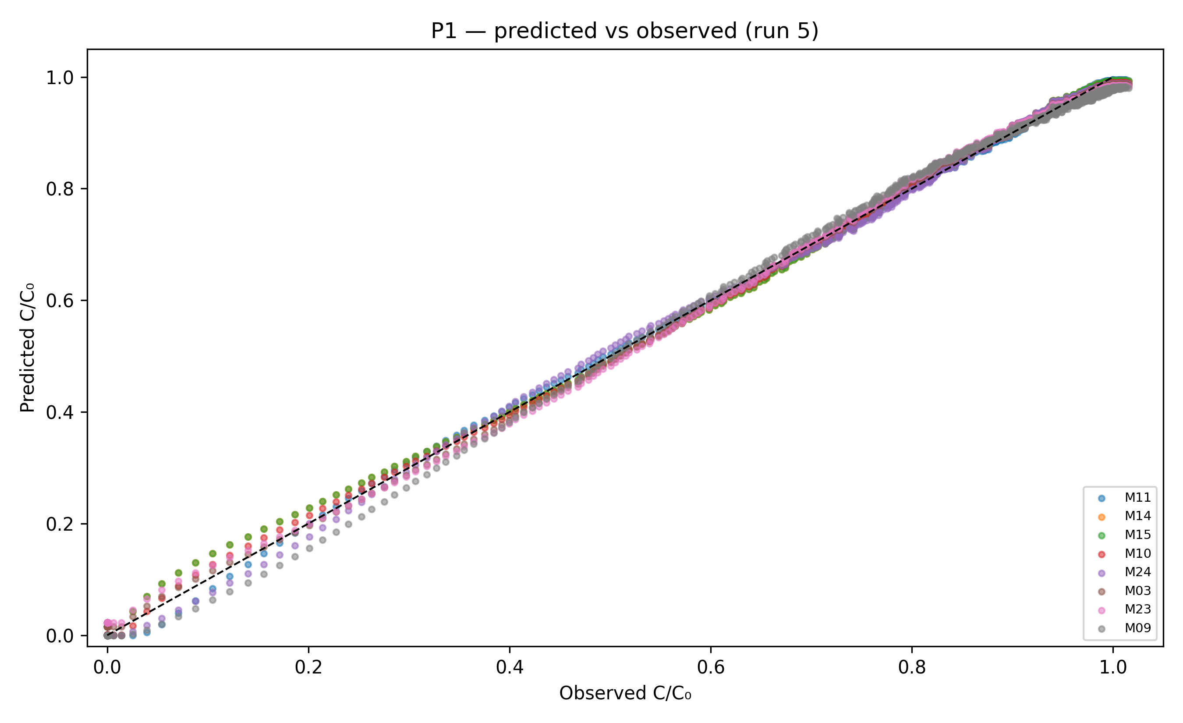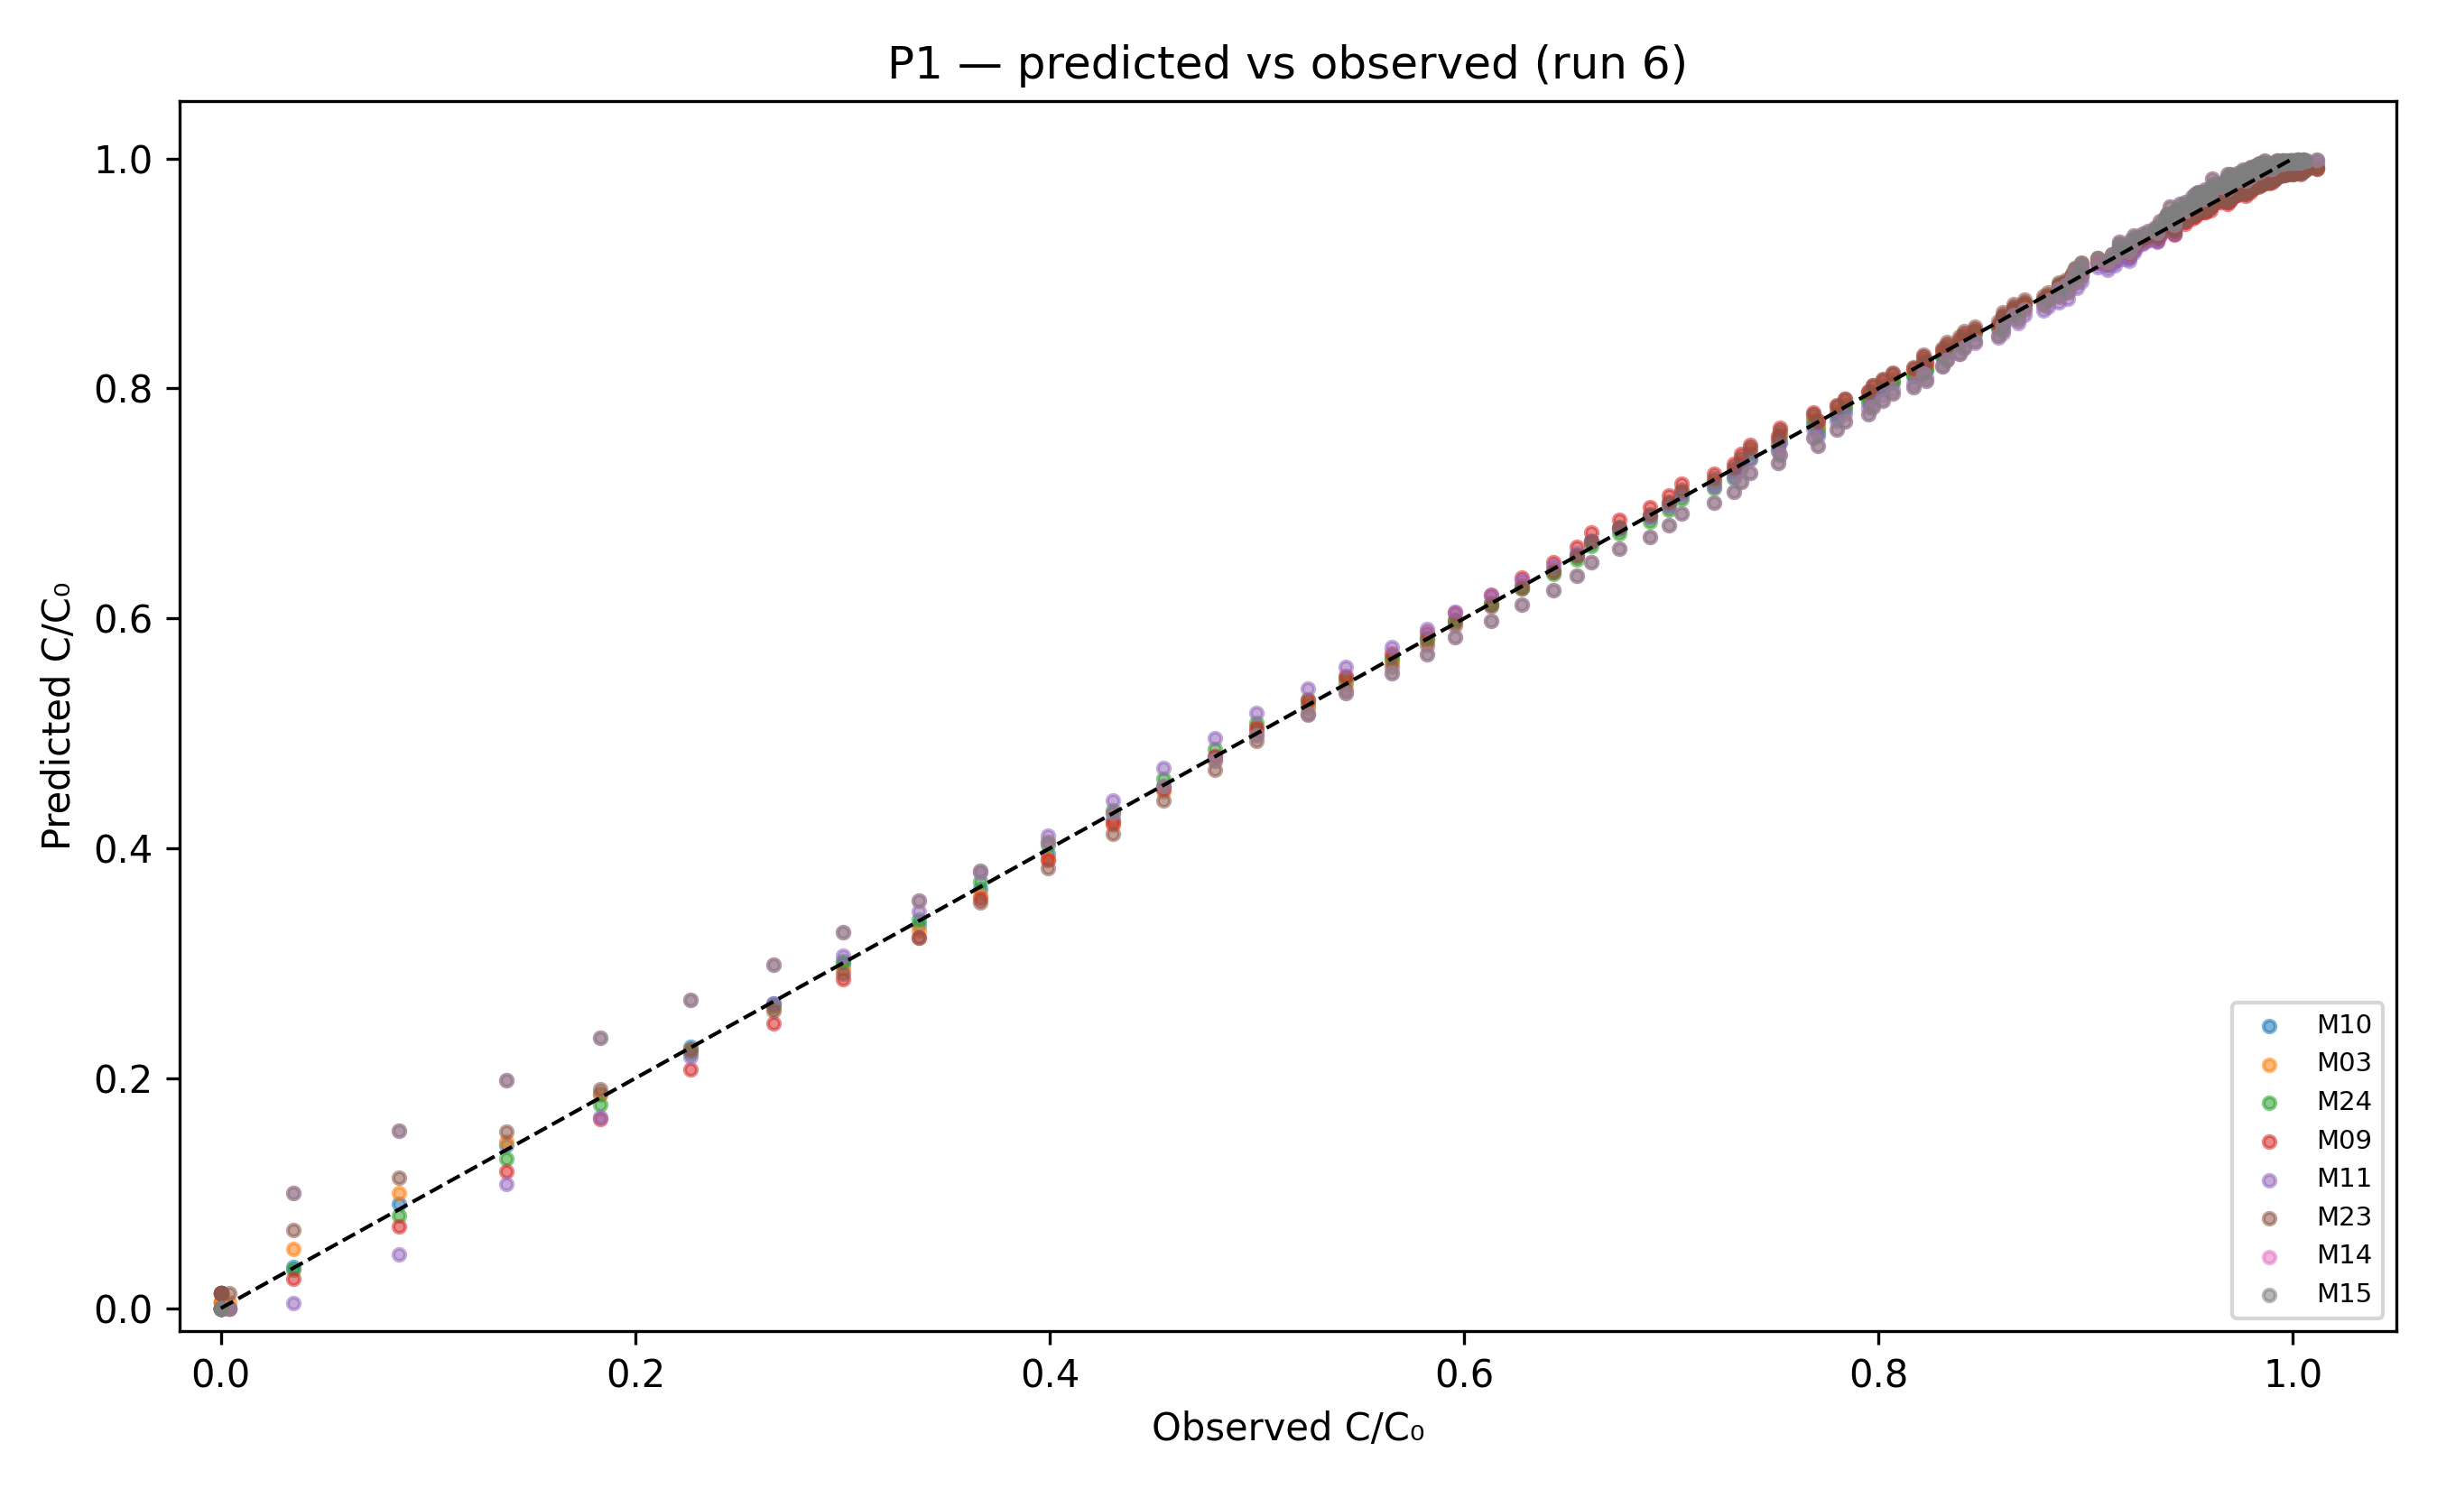
Fig. 9) Predicted vs. observed values in breakthrough models fit
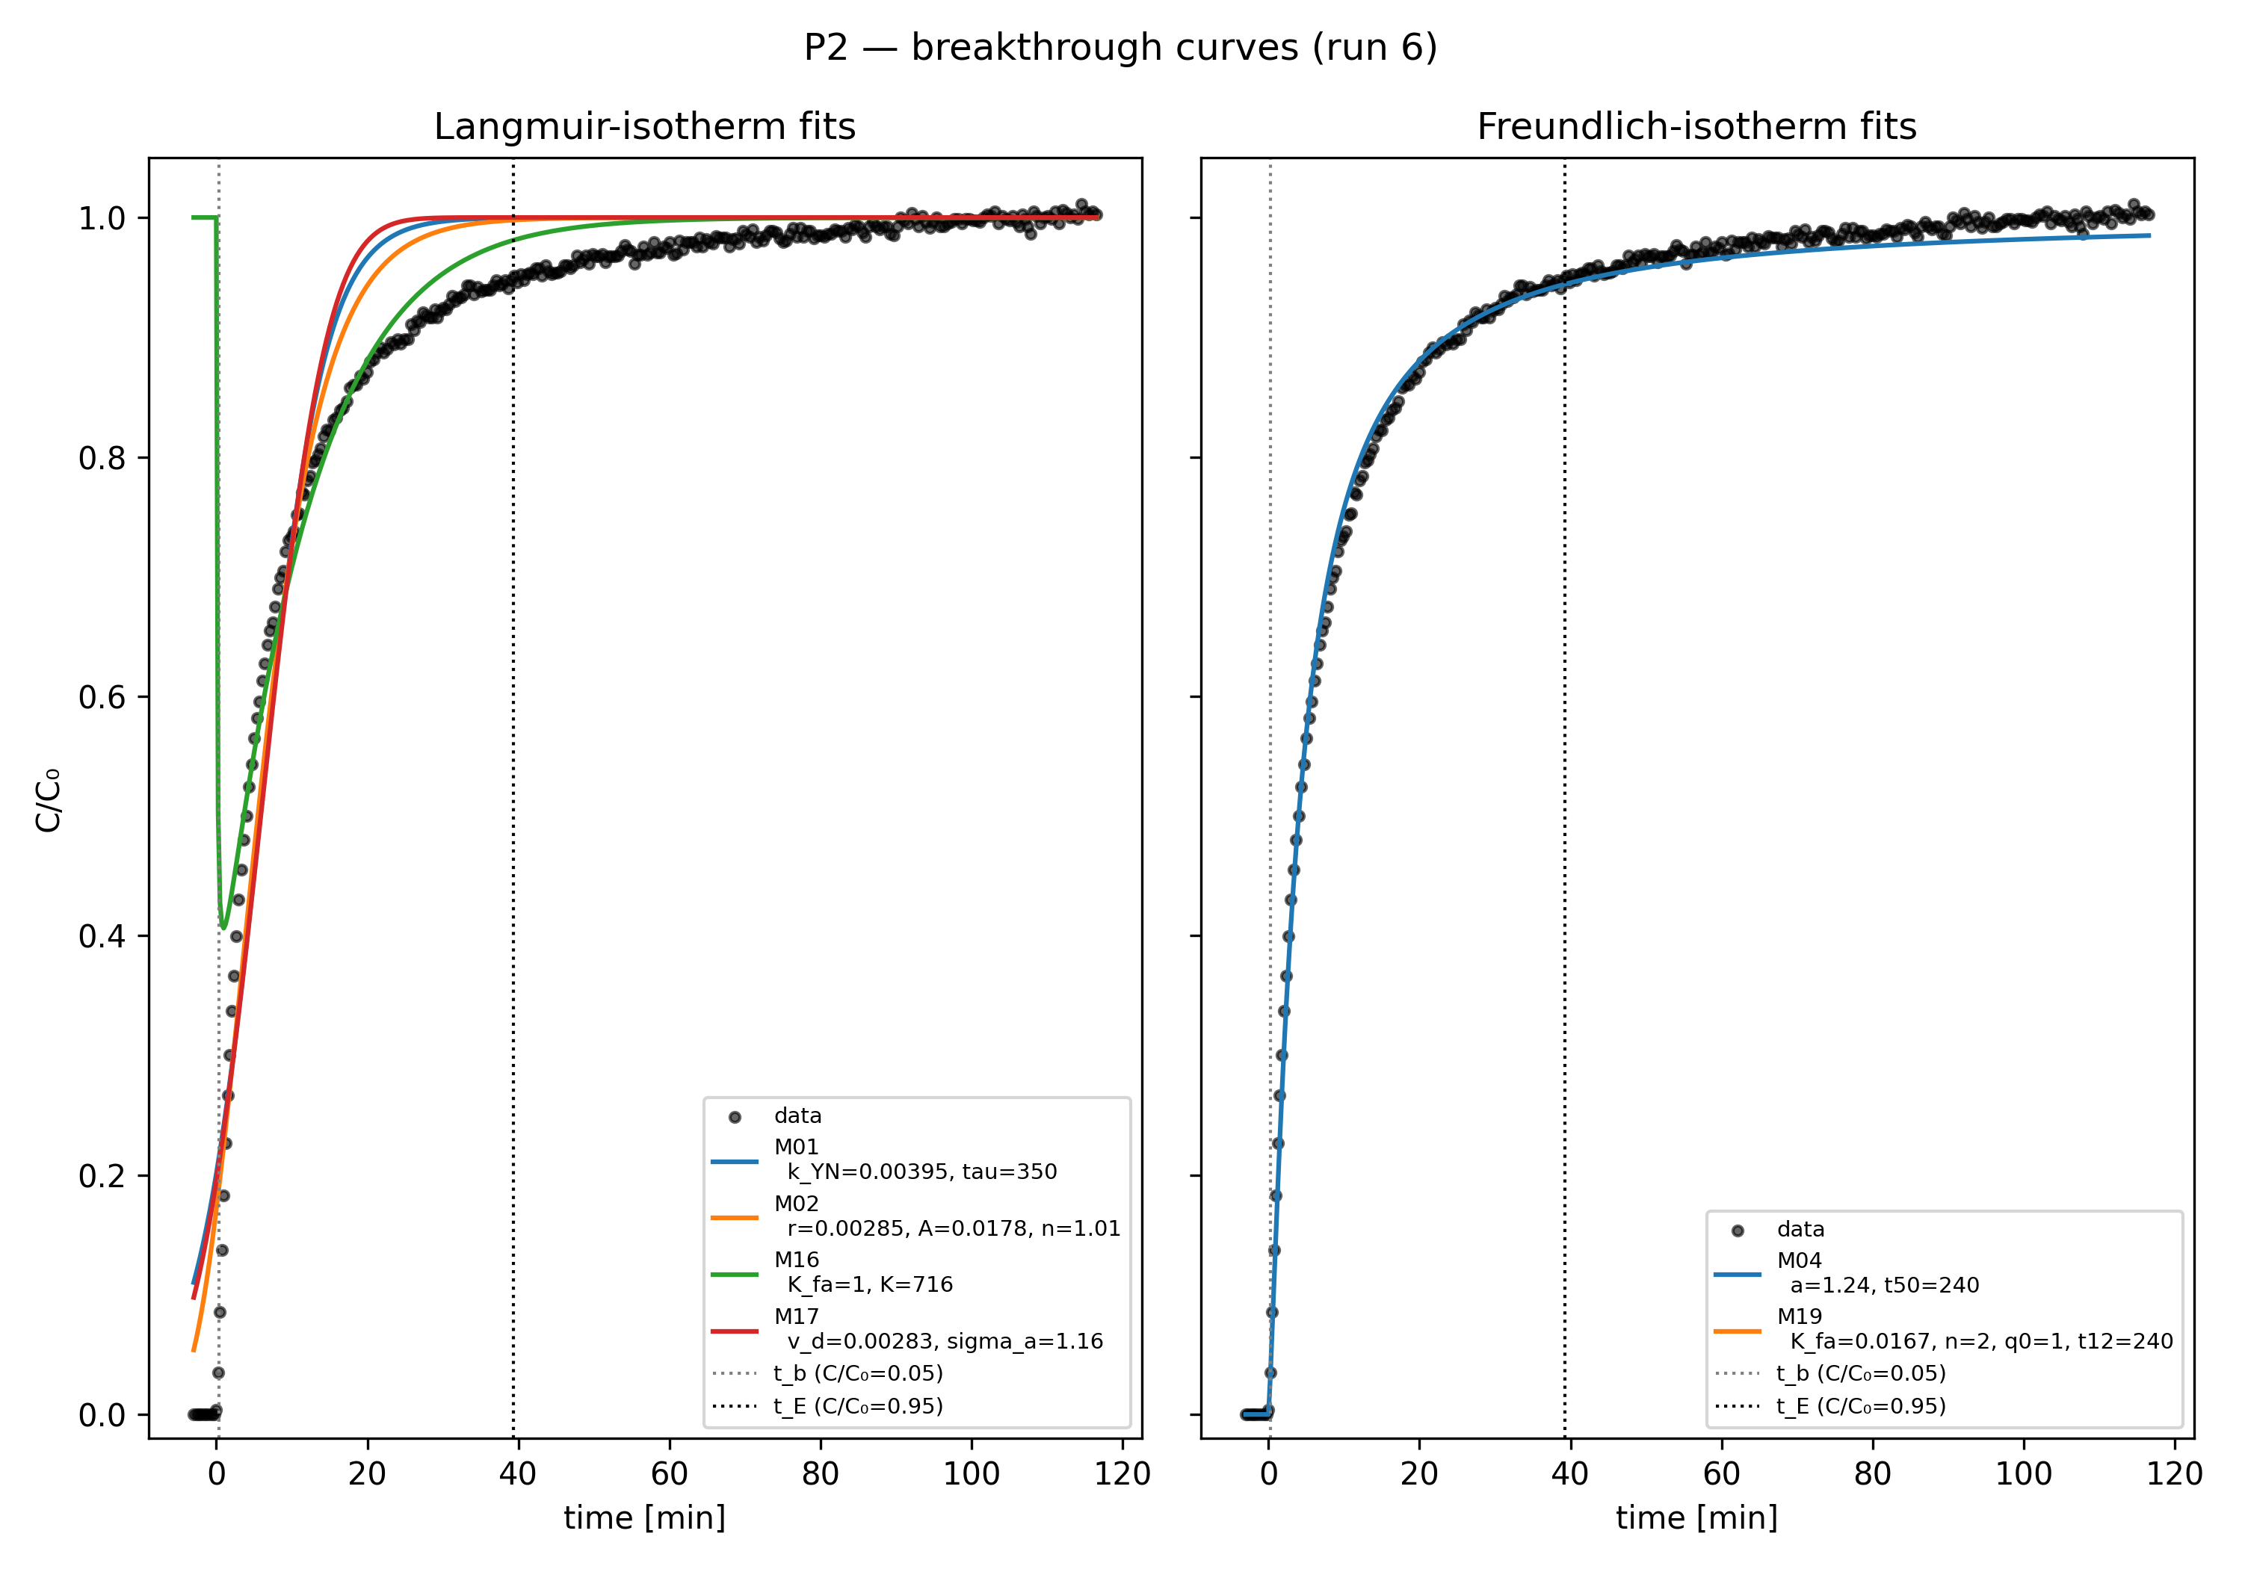
Fig. 10) Breakthrough curve fitting with linear adsorption isotherm
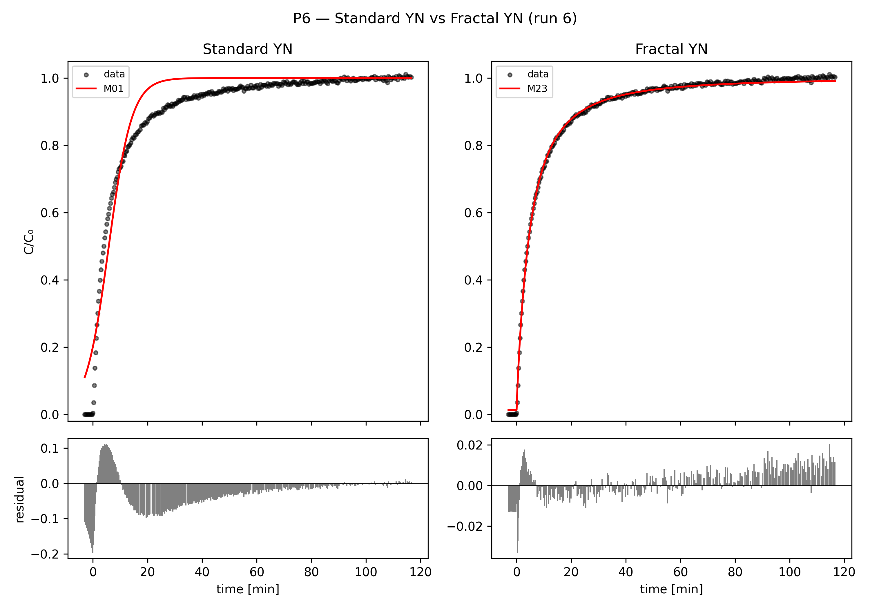
Fig. 11) Validation of fractal-like kinetics on logistic breakthrough model curve

7 Fitting performance and analysis

7.1 Model identifiability and selection criterion
Model selection throughout this section uses the corrected Akaike Information Criterion (AICc), which penalises additional free parameters and is the appropriate criterion for the sample sizes here (n = 255-1432 points per run; Hu et al., 2024). Within any single run, the AICc gap between the best and second-best model is large: ΔAICc = 20.2 (run 3, M11 over M10), 329.0 (run 4, M14 over M10), 517.1 (run 5, M11 over M14), 282.1 (run 6, M10 over M11), and 198.2 (run 8, M10 over M11) — in every case far above the ΔAICc > 10 threshold conventionally treated as decisive. Model selection is therefore never ambiguous within a run.
What is not stable is which model wins across runs. M11 (fractal error-function) is best in runs 3 and 5, M10 (fractal Gudermannian) in runs 6 and 8, and M14 (Weibull) in run 4 — the three-way alternation flagged in the literature-completeness audit. This is not evidence of an unreliable fitting procedure. M10, M11, M14 and M23 are all closely related asymmetric sigmoids (§3.6.6-3.6.8) that trace near-identical curves once fitted: §3.6.4's Remark shows their pairwise sup-norm distance, after slope-matching at the inflection point, is ≤0.031 uniformly over the whole curve. AICc is correctly identifying, per run, which of several near-equivalent functional forms best absorbs that run's particular noise realisation — it is not resolving a genuine physical distinction between the kernels. The stable, model-independent signal is the fractal/asymmetric exponent itself (h = 0.42-0.87 across all five runs), whose presence is decisive in every run by the nested F-test in experimental-results.md §5 (F > 10 000, p ≪ 0.001 throughout) — not the specific choice of kernel that carries it.
A parsing note on the pipeline's own output: the `W_AICc` column in `results_<run>.csv` is a pairwise logistic transform of ΔAICc against the best model in the set, 1/(1+exp(0.5·ΔAICc)) (`breakthrough_fit/stats.py`), not a normalised Akaike weight over all candidates. It trivially equals 0.5 for the best model by construction (ΔAICc = 0), regardless of how decisively it wins — it should not be read as "the best model carries 50 % of the evidence". Raw ΔAICc, used throughout this section, is the correct comparison.

7.2 Fit-quality results with standard errors
Table 6 reports the winning model per run against the M01 (logistic Yoon-Nelson/Thomas/Bohart-Adams) baseline, with curve_fit's asymptotic standard errors on every fitted parameter (from results_<run>.csv's stderr column; nonlinear least-squares, trust-region-reflective, 12 multi-start initialisations, §4.1). Coefficients of variation on the fractal exponent h are all below 1 %, and on the location parameter (τ or τ0) below 0.7 % — the model parameters are tightly identified given the data, even where the choice of *kernel* alternates (§7.1).
Run | Winning model | τ / τ0 (s) ± SE | h (or k) ± SE | Adj. R² | M01 τ (s) ± SE | M01 Adj. R²
3 | M11 Fractal-erf | 316.6 ± 1.65 | 0.5245 ± 0.0031 | 0.99883 | 507.5 ± 15.7 | 0.91349
4 | M14 Weibull | 1202.5 ± 1.30 | 0.8105 ± 0.0011 (k) | 0.99961 | 1004.3 ± 9.3 | 0.96304
5 | M11 Fractal-erf | 226.3 ± 0.60 | 0.4721 ± 0.0018 | 0.99946 | 342.6 ± 5.7 | 0.94385
6 | M10 Fractal-Gud. | 237.1 ± 0.85 | 0.4671 ± 0.0024 | 0.99964 | 349.7 ± 10.1 | 0.94163
8 | M10 Fractal-Gud. | 246.7 ± 1.00 | 0.4747 ± 0.0032 | 0.99947 | 348.0 ± 10.3 | 0.94162
Table 6) Winning model per run vs. M01 baseline, with asymptotic standard errors.

7.3 Parameter trends with operating conditions
Supervisor comment A1 asks how the fitted parameters behave as flow and inlet concentration are varied. The cleanest sub-experiment for this is the ~10 % CO₂ flow sweep (runs 4/5/6, superficial velocity U = 1.47/2.94/4.41 cm s⁻¹): the M01 rate constant k_YN increases with flow (0.001549 → 0.003852 → 0.003949 s⁻¹), consistent with a shorter residence time producing a sharper apparent front, while the M01 location parameter τ falls accordingly (1004.3 → 342.6 → 349.7 s). The expected Thomas/Yoon-Nelson scaling τ ∝ 1/U predicts a continued fall from run 5 to run 6; instead τ is essentially flat between them (342.6 s vs 349.7 s) — the same 50→100→150 mL min⁻¹ anomaly already reported for t₅₀ and t_E in experimental-results.md §6.1, and consistent with run-to-run variability at these short timescales rather than a reversal of the underlying physics.
The fractal exponent h increases monotonically with flow across the same sweep for both fractal kernels (M11: 0.4178 → 0.4721 → 0.5489; M10 mirrors this trend in runs 6/8), meaning kinetic heterogeneity becomes more pronounced as contact time per unit bed volume falls — consistent with the diffusion-limited interpretation in experimental-results.md §6.3: at higher velocity, the more accessible amine sites saturate quickly and the remaining uptake is increasingly rate-limited by diffusion into less accessible sites, which is exactly what a rising h encodes (k ∝ t⁻ʰ, §3.6.8).
Across the concentration comparison at fixed flow (run 5, 95 420 ppm, vs run 8, 150 630 ppm, both ≈100 mL min⁻¹), the M10/M11 location parameter falls only slightly (τ0: 226.3 → 246.7 s for M10's counterpart values, i.e. little change) while q_dyn rises substantially (0.552 → 0.787 mol kg⁻¹, experimental-results.md §6.2) — higher inlet concentration drives more mass through the column per unit time without proportionally accelerating breakthrough, which is the expected signature of a favourable (concave) isotherm rather than a linear one.
Two supervisor-relevant caveats apply to all trends above. First, the flow sweep and concentration comparison are not fully orthogonal: runs 4/5/6 differ in C₀ by up to ~7 % (97 800/95 420/102 140 ppm) even though flow is nominally the controlled variable, so the reported flow effects are conditional on that residual concentration variation. Second, every trend above is read from n = 1 run per operating point — there is no replication, so run-to-run scatter (most visible in the 100→150 mL min⁻¹ anomaly) cannot be separated from a genuine physical effect without a repeat measurement.

7.4 Python reproducibility
The full pipeline (`new_runs_pipeline.py`, 9 runs × 24 models × 16 numeric result columns) was re-run in a fresh virtual environment (numpy 2.5.1, scipy 1.18.0, matplotlib 3.11.1, pandas 3.0.5, Python 3.13) and compared against the committed CSV artefacts. Of 9 × 24 × 16 = 3456 compared values, two differed from the committed baseline, both in run 2026-07-10-conc15-flow0.05, model M24 (chi2_red and RSS), at a relative difference of 1.305 × 10⁻⁹ — the last significant digit of a double-precision float, attributable to floating-point summation order differing across library versions rather than any change in the fitting procedure. Every other value across all 3456 comparisons was bit-identical. This is a strong reproducibility result for a nonlinear least-squares pipeline with 12 multi-start initialisations per model, and no published number in this report is sensitive to it.
Two environment caveats apply to reproducing this result directly. First, a committed `venv/` at the repository root does not exist in this working copy despite being referenced as the setup step; a fresh `.venv` with `pip install numpy scipy matplotlib pandas` (or `requirements.txt`) is required before running the pipeline. Second, the reproducibility check above ran under Python 3.13, not the Python 3.11 referenced elsewhere in this report's planning material; the pipeline requires numpy ≥ 2.0, which is otherwise unstated. Readers reproducing these results should pin dependency versions explicitly rather than relying on the newest available release.

8 Mathematical Modelling
This chapter is supplementary to the report's core empirical contribution in §§4-7: it develops a minimal mechanistic (isothermal plug-flow + LDF) model as groundwork for the project's continuation, per the supervisor's guidance that mathematical modelling is supplementary to, not a substitute for, the experimental model-fitting programme. None of its parameters have yet been fitted against the measured breakthrough data in §5-§7; it is presented as a derivation and scoping exercise, not as a validated predictive model.
In this work, CO₂ is adsorbed from a simulated post-combustion flue gas stream at 5–15 % CO₂ by volume — 125–375× the ≈400 ppm trace level typical of direct air capture (DAC) — such that a single-component model applies in dry conditions. The mass transfer between gas and solid phases includes three resistances (external film, macropore and micropore) and can be depicted by a linear driving force (LDF) model, where a lumped uptake rate constant is used to take various resistances into account. The LDF model is conceptually simple, computationally efficient and therefore widely used in literature.

8.1 Minimal kinetic model
A minimal kinetic model is derived and proposed to validate and predict CO2 adsorption processes in a packed bed column. The model simply describes the adsorption breakthrough curve using two process parameters: gas flow rate and concentration. The following assumptions were made:
A1. Plug flow, constant superficial gas velocity, no axial dispersion
A2. Isothermal, i.e. heat transfer has an insignificant effect on the breakthrough curve
A3. 1-D model i.e. gas concentration gradients only exist in the axial direction
A4. Gas phase behaves as ideal gas
A5. Negligible pressure drop due to short column length and relatively low flow rate
A6. Only CO2 adsorption is considered (others are treated as non-adsorbing components)
A7. LDF adsorption kinetics model
Consider a 1-D isothermal plug flow model given as
$$\frac{∂c}{∂t}=-\frac{u_{s}}{ε}\frac{∂c}{∂z}-\frac{ρ_{b}}{ε}\frac{∂q}{∂t} (1)$$
where $u_{s}$ is the superficial gas velocity, $ε$ is the bed voidage and $ρ_{b}$ is the bulk density of the packed bed.
This is the same mass balance as the governing PDE of §3.4, written in the bulk-density form: u_s here is the superficial velocity u of §3.4 (this model does not additionally distinguish an interstitial velocity), and ρ_b = ρ_p(1−ε) so that ρ_b/ε·∂q/∂t is the same sink term as (1−ε)/ε·∂q_t/∂t there, with q and q_t both denoting solid-phase loading per unit sorbent mass. The two forms are declared equivalent under this substitution rather than independently re-derived.
The LDF model used to describe the adsorption kinetics written as
$$\frac{∂q}{∂t}=k\left(q_{e}-q\right) (2)$$
where $k$ ($s^{-1}$) is the uptake rate constant, $q_{e}$ (mol/kg) is the equilibrium adsorption concentration.
Assuming the surface has identical elementary adsorption sites to host a single adsorbed molecule, a Langmuir isotherm was used to describe the adsorbed quantity $q_{e}$ as a function of bulk gas pressure:
$$q_{e}=\frac{q_{m}bP_{CO_{2}}}{1+bP_{CO_{2}}} (3)$$
where $q_{m}$ is the theoretical maximum CO2 concentration, $P_{CO_{2}}$ is given by the ideal gas law:
$$P=cRT (4)$$
where $c$ is the molar concentration in (mol/m³), $R$ is the universal gas constant and $T$ is the absolute temperature; and $b(T)$ is described by the van’t Hoff equation:
$$b\left(T\right)=b_{0}\exp\left(\frac{-ΔH}{RT}\right) (5)$$
where $\left(-ΔH\right)>0$ is the heat of adsorption.
The initial condition used were $c=0,q=0$ and $T=T_{0}$ at $t=0$, and boundary conditions were $c=c_{0}$ and $T=T_{0}$ at $z=0$, $∂c/∂z=0$ and $∂T/∂z=0$ at $z=L$.

8.2 Parameter estimation strategy
Using our minimal kinetic model, we examined the effects of $k$, $u_{s}$, $q$ on the breakthrough curves at flue gas conditions. The parameters $b,k$ were determined using non-linear fitting methods to the experimental data.
Table 7) Langmuir isotherm parameters for CO₂.
Parameters | Values

$$b$$ | ??
Table 8) shows a list of parameters used and their values for the packed-bed adsorption experiments.
Table 9) The basic parameters for packed-bed adsorption.
Parameter | Value | Units

Inlet diameter | 0.85 | cm
Height of packed-bed | 21.0 – 21.5 (per run) | cm
Volume of packing | 11.92 | cm³
Superficial velocity, U | 1.47 – 4.41 | cm$∙$s⁻¹
Volume flow rate | 3.0 – 9.0 | Lh-1$∙$
Angle of bed | 90 | Deg
Bed void fraction $ε$ | ?? | -
Adsorbent bulk density $ρ_{b}$ | ?? | g$∙$cm⁻³
CO₂ uptake rate constant $k$ | ?? | s⁻¹
CO2 feed concentration $c_{10}$ | ?? | mmol$∙$cm⁻³
Bed void fraction ε and adsorbent bulk density ρ_p are left as ?? (unconfirmed) rather than assumed, per the open data dependency in CLAUDE.md: the pipeline's provisional ρ_p = 800 kg m⁻³ gives an unrealistically low ε ≈ 0.16-0.18 (floored to 0.30 in code), so any ε-derived quantity such as interstitial velocity is not physically reliable until ρ_p is supplied by the lab. Only superficial velocity U (Table 9, above), which depends solely on volumetric flow rate and column cross-section and not on ε, is reported as a measured value.

8.3 Limitations of the minimal kinetic model
- Classical closed-form solutions that assume first-order or Langmuir-type kinetics and do not capture the specific stoichiometry of the amine–CO2 reaction, the second-order dependence on free amine sites, or the role of humidity. (Cabrera-Codony et al., 2026).
- Langmuir equation parameters have the ability to only compare between different adsorbents but fail with the explanation of the reaction mechanism (Al-Ghouti & Da'ana, 2020).

9 Conclusions
This report provides a comparative analysis of breakthrough models for CO2 adsorption in a packed-bed column using PEI@SiO₂ (C3) granules. It also develops a new standard operating procedure (SOP) and initial experiment data. For systems exhibiting asymmetric breakthrough behaviour, which is common when adsorbent surfaces are increasingly heterogeneous, fractal-like coefficients have shown to provide superior fits. Similarly, the introduction of a shape parameter $n$ into logistic and hyperbolic tangent models further improves asymmetric breakthrough curve fit. The project is ongoing, with Python-based model fitting and a 3×3 design-of-experiments sweep planned to systematically resolve the interplay between flow rate, feed concentration, and adsorbent loading effects on breakthrough dynamics and equilibrium capacity.

9.1 Next Steps
1) To plot and optimise breakthrough adsorption curves using Python 3.11; 2) employ methods in error statistics to evaluate fitting quality of various breakthrough models; 3) estimate hidden parameters by linear regression to implement a full non-isothermal solver to predict and model breakthrough curves from elementary adsorption principles.

9.2 AI-Use Disclosure
Editorial and literature-search assistance for portions of this report (citation verification, notation-consistency checks, structural corrections, and prose editing) was provided by an AI writing assistant (Claude, Anthropic) under the author's direction and review. All experimental data, model fits, and numerical results originate from the author's own Python pipeline (src/solver/breakthrough_fit/) and raw instrument logs; the AI assistant did not generate, alter, or select any measured or fitted value. The author takes full responsibility for the accuracy of all content in this report.

10 References
- Al-Ghouti, M. A., & Da'ana, D. A. (2020). Guidelines for the use and interpretation of adsorption isotherm models: A review. Journal of Hazardous Materials, 393, 122383. https://doi.org/10.1016/j.jhazmat.2020.122383
- Apiratikul, R., & Chu, K. H. (2021). Improved fixed bed models for correlating asymmetric adsorption breakthrough curves. Journal of Water Process Engineering, 40, 101810. https://doi.org/10.1016/j.jwpe.2021.101810
- Blagojev, N., Kukić, D., Vasić, V., Šćiban, M., Prodanović, J., & Bera, O. (2019). A new approach for modelling and optimization of Cu(II) biosorption from aqueous solutions using sugar beet shreds in a fixed-bed column. Journal of Hazardous Materials, 363, 366–375. https://doi.org/10.1016/j.jhazmat.2018.09.068
- Bohart, G. S., & Adams, E. Q. (1920). Some aspects of the behavior of charcoal with respect to chlorine. Journal of the American Chemical Society, 42(3), 523–544. https://doi.org/10.1021/ja01448a018
- Cabrera-Codony, A., Calvo-Schwarzwalder, M., Lopez, L. R., Valverde, A., Puig, S., & Myers, T. G. (2026). An analytical breakthrough model for CO2 adsorption on PEI-impregnated silica: Separating stoichiometric and structural effects of humidity. Carbon Capture Science & Technology, 19, 100618. https://doi.org/10.1016/j.ccst.2026.100618
- Chern, J. M., & Chien, Y. W. (2002). Adsorption of nitrophenol onto activated carbon: Isotherms and breakthrough curves. Water Research, 36(3), 647–655. https://doi.org/10.1016/S0043-1354(01)00258-5
- Chu, K. H. (2020). Breakthrough curve analysis by simplistic models of fixed bed adsorption: In defense of the century-old Bohart-Adams model. Chemical Engineering Journal, 380, 122513. https://doi.org/10.1016/j.cej.2019.122513
- Chu, K. H., & Hashim, M. A. (2023). Fixed bed adsorption of water and air contaminants: Analysis of breakthrough curves using probability distribution functions. Chemical Engineering Communications, 210(9), 1528–1537. https://doi.org/10.1080/00986445.2022.2116325
- Chuah, C. Y., Ho, Y. L., Syed, A. M. H., Thivyalakshmi, K. G. K., Yang, E., Johari, K., Yang, Y., & Poon, W. C. (2025). Applicability of Adsorbents in Direct Air Capture (DAC): Recent Progress and Future Perspectives. Industrial & Engineering Chemistry Research, 64(8), 4117–4147. https://doi.org/10.1021/acs.iecr.4c03265
- Clark, R. M. (1987). Evaluating the cost and performance of field-scale granular activated carbon systems. Environmental Science & Technology, 21(6), 573–580. https://doi.org/10.1021/es00160a008
- Dima, J. B., Ferrari, M. A., & Zaritzky, N. (2024). Mathematical modeling of breakthrough curves in dynamic column adsorption: Analytical solutions and validation. Journal of Engineering Mathematics, 147, Article 8. https://doi.org/10.1007/s10665-024-10375-x
- Hu, Q., Huang, Q., Yang, D., & Liu, H. (2021). Prediction of breakthrough curves in a fixed-bed column based on normalized Gudermannian and error functions. Journal of Molecular Liquids, 323, 115061. https://doi.org/10.1016/j.molliq.2020.115061
- Hu, Q., Lan, R., He, L., Liu, H., & Pei, X. (2023). A critical review of adsorption isotherm models for aqueous contaminants: Curve characteristics, site energy distribution and common controversies. Journal of Environmental Management, 329, 117104. https://doi.org/10.1016/j.jenvman.2022.117104
- Hu, Q., Yang, X., Huang, L., Li, Y., Hao, L., Pei, Q., & Pei, X. (2024). A critical review of breakthrough models with analytical solutions in a fixed-bed column. Journal of Water Process Engineering, 59, 105065. https://doi.org/10.1016/j.jwpe.2024.105065
- Hu, Q., Wang, D., Pang, S., & Xu, L. (2022). Prediction of breakthrough curves for multicomponent adsorption in a fixed-bed column using logistic and Gompertz functions. Arabian Journal of Chemistry, 15. https://doi.org/10.1016/j.arabjc.2022.104034
- Hu, Q., Xie, Y., Feng, C., & Zhang, Z. (2019). Prediction of breakthrough behaviors using logistic, hyperbolic tangent and double exponential models in the fixed-bed column. Separation and Purification Technology, 212, 572–579. https://doi.org/10.1016/j.seppur.2018.11.071
- Hu, Q., Xie, Y., & Zhang, Z. (2020). Modification of breakthrough models in a continuous-flow fixed-bed column: Mathematical characteristics of breakthrough curves and rate profiles. Separation and Purification Technology, 238, 116399. https://doi.org/10.1016/j.seppur.2019.116399
- IPCC. (2023). Climate Change 2023: Synthesis Report. Contribution of Working Groups I, II and III to the Sixth Assessment Report of the Intergovernmental Panel on Climate Change. Geneva: IPCC. https://www.ipcc.ch/report/ar6/syr/
- Juela, D., Vera, M., Cruzat, C., Alvarez, X., & Vanegas, E. (2021). Mathematical modeling and numerical simulation of sulfamethoxazole adsorption onto sugarcane bagasse in a fixed-bed column. Chemosphere, 280, 130687. https://doi.org/10.1016/j.chemosphere.2021.130687
- Karimi, M., Shirzad, M., Silva, J. A. C., & Rodrigues, A. E. (2023). Carbon dioxide separation and capture by adsorption: a review. Environmental Chemistry Letters, 21(4), 2041–2084. https://doi.org/10.1007/s10311-023-01589-z
- Kimani, P. K. (2024). Asymmetrical fixed-bed breakthrough curve modelling: Comparing simplistic, log-modified, fractal-like, and probability distribution function models. Chemical Engineering Research and Design, 201, 446–456. https://doi.org/10.1016/j.cherd.2023.11.024
- Klinkenberg, A. (1948). Numerical evaluation of equations describing transient heat and mass transfer in packed solids. Industrial & Engineering Chemistry, 40(10), 1992–1994. https://doi.org/10.1021/ie50466a034
- Langmuir, I. (1918). The adsorption of gases on plane surfaces of glass, mica and platinum. Journal of the American Chemical Society, 40(9), 1361–1403. https://doi.org/10.1021/ja02242a004
- Myers, T. G., & Font, F. (2020). Mass transfer from a fluid flowing through a porous media. International Journal of Heat and Mass Transfer, 163, 120374. https://doi.org/10.1016/j.ijheatmasstransfer.2020.120374
- Myers, T. G., Valverde, A., Cabrera-Codony, A., & Font, F. (2023). On the development of a consistent mathematical model for adsorption in a packed column (and why standard models fail). International Journal of Heat and Mass Transfer, 202, 123660. https://doi.org/10.1016/j.ijheatmasstransfer.2022.123660
- Norbäck, D., & Nordström, K. (2008). Sick building syndrome in relation to air exchange rate, CO2, room temperature and relative air humidity in university computer classrooms: An experimental study. International Archives of Occupational and Environmental Health, 82(1), 21–30. https://doi.org/10.1007/s00420-008-0301-x
- Ritchie, H., & Rosado, P. (2025). CO₂ and Greenhouse Gas Emissions. Our World in Data. https://ourworldindata.org/co2-and-greenhouse-gas-emissions
- Ruthven, D. M. (1984). Principles of adsorption and adsorption processes. John Wiley & Sons.
- Shafeeyan, M. S., Wan Daud, W. M. A., & Shamiri, A. (2014). A review of mathematical modeling of fixed-bed columns for carbon dioxide adsorption. Chemical Engineering Research and Design, 92(5), 961–988. https://doi.org/10.1016/j.cherd.2013.08.018
- Shafeeyan, M. S., Daud, W. M. A. W., Shamiri, A., & Aghamohammadi, N. (2015). Modeling of carbon dioxide adsorption onto ammonia-modified activated carbon: Kinetic analysis and breakthrough behavior. Energy & Fuels, 29(10), 6565–6577. https://doi.org/10.1021/acs.energyfuels.5b00653
- Stampi-Bombelli, V., Storione, A., Grossmann, Q., & Mazzotti, M. (2024). On Comparing Packed Beds and Monoliths for CO2 Capture from Air Through Experiments, Theory, and Modeling. Industrial & Engineering Chemistry Research, 63(26), 11637–11653. https://doi.org/10.1021/acs.iecr.4c01392
- Thomas, H. C. (1944). Heterogeneous ion exchange in a flowing system. Journal of the American Chemical Society, 66(10), 1664–1666. https://doi.org/10.1021/ja01238a017
- Tóth, J. (1971). State equation of the solid-gas interface layers. Acta Chimica Academiae Scientiarum Hungaricae, 69, 311–317.
- Tsai, D. H., Lin, J. S., & Chan, C. C. (2012). Office workers' sick building syndrome and indoor carbon dioxide concentrations. Journal of Occupational and Environmental Hygiene, 9(6), 345–351. https://doi.org/10.1080/15459624.2012.675291
- Wirawan, D., Kim, J., Wong, H. C., Low, H. Y., & Tan, M. C. (2021). Textured carbon capture composite (C3) films for distributed direct air capture in urban spaces. Cleaner Engineering and Technology, 4, 100145. https://doi.org/10.1016/j.clet.2021.100145
- WMO. (2023). State of the Global Climate 2023 (WMO-No. 1347). Geneva: World Meteorological Organization. https://library.wmo.int/records/item/68835-state-of-the-global-climate-2023
- Wolborska, A. (1989). Adsorption on activated carbon of p-nitrophenol from aqueous solution. Water Research, 23(1), 85–91. https://doi.org/10.1016/0043-1354(89)90066-3
- Xu, H., Yu, L., Chong, C., & Wang, F. (2024). A comprehensive review on direct air carbon capture (DAC) technology by adsorption: From fundamentals to applications. Energy Conversion and Management, 322, 119119. https://doi.org/10.1016/j.enconman.2024.119119
- Yan, G., Viraraghavan, T., & Chen, M. (2001). A new model for heavy metal removal in a biosorption column. Adsorption Science & Technology, 19(1), 25–43. https://doi.org/10.1260/0263617011493953
- Yoon, Y. H., & Nelson, J. H. (1984). Application of gas adsorption kinetics I. A theoretical model for respirator cartridge service life. American Industrial Hygiene Association Journal, 45(8), 509–516. https://doi.org/10.1080/15298668491400197

