Automated Financial Data Scraper & Analysis System
Done by : Loh Jun Kai
Github Repository Link: https://github.com/lohjunkai30/financial-analysis-system

Project Description
I utilised SQL databases and Python modules to create an automated financial analysis system that extracts stock market data, perform technical analysis (Relating to the “Golden Cross Strategy”), and generates a summarized investment report of your desired stocks in Word format.

Tech Stack
- Language: Python 3.x
- Database: pgAdmin4 using PostgreSQL (SQLAlchemy)
- Data Analysis: Pandas, NumPy
- Visualization: Matplotlib
- Report Generation: python-docx, python-dotenv

Key Features
These are the key features of my project:
ETL 1. Extracton of Data: Utilisation of yfinance module to extract real-time market data from Yahoo Finance. Currently, it is programmed to extract seven different stocks. (Apple, Amazon, Microsoft, Google, Nvidia, Tesla and AMD)
- Loading of Data: The raw data is loaded into a PostgreSQL (pgadmin4) database ensuring data integrity for further analysis. (Refer to “scraping.py”)
Quantitative Analysis Engine: 1. Data Processing: Leveraged Pandas to digest the data from pgadmin4 and derive key quantitative finance indicators through high-performance manipulation such as SMA50, SMA200, Volatility Percentage, Overnight Gap.
- Algorithmic Logic: Developed a custom analysis engine that generates “Buy/Hold/Sell” recommendations through a decision matrix that references Confluence Trading Strategies and the “Golden Cross Strategy”. (Refer to “analysis.py”)
- Strategic Documentation: For a detailed breakdown of the indicator thresholds used as well a visual of the decision matrix used, please refer to my Github Repository.
  - Decision_Matrix (PDF)
- Data Visualisation: Integrated Matplotlib to generate trend charts from processed DataFrames. The picture below shows an example of the generated charts:
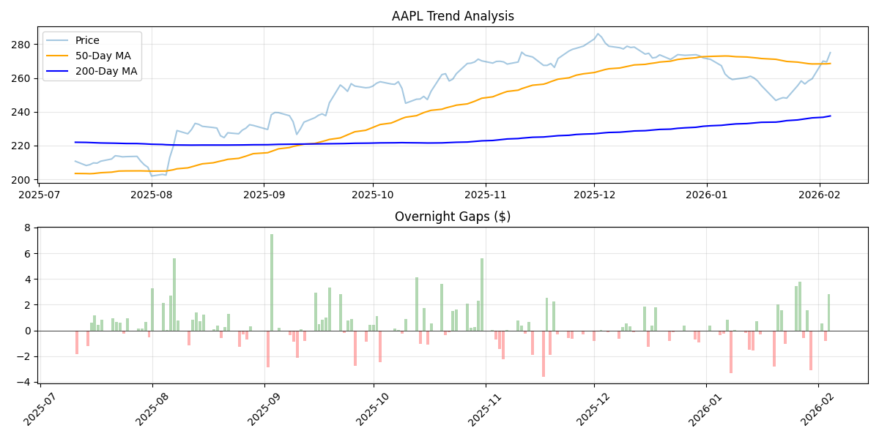 R
Dynamic Reporting: 1. Modularisation: Programme operates through a centralised exeuction script that bridges the ETL and analysis script. (Refer to “masterscript.py”)
- Document Synthesis: Utilises python-docx to programmatically generate reports, embed visuals such as charts and insert analysis from the Quantitative Analysis Engine into a final Word report. A snippet is shown below:
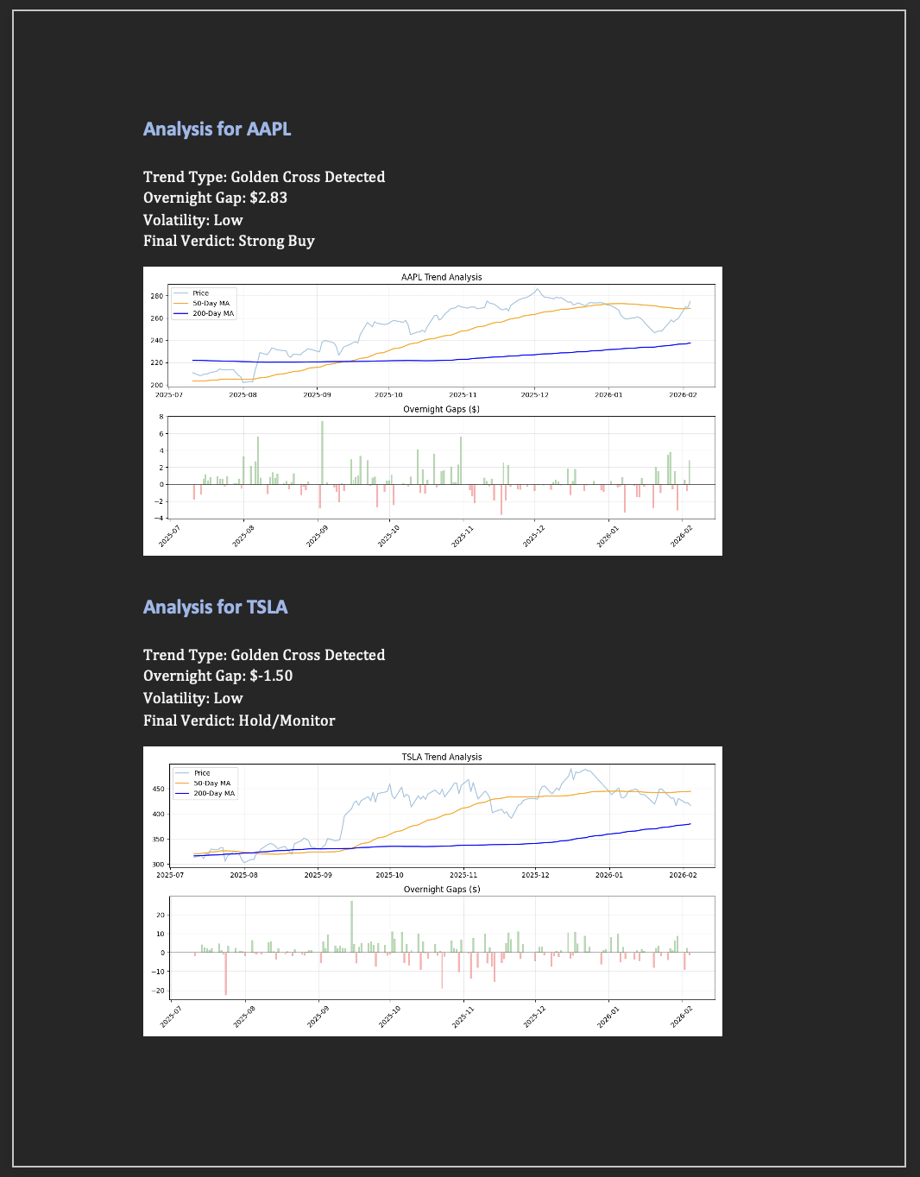
Picture of template report
To view the full template of the report, please refer to my Github Repository

Setup Instructions
- Clone the repository.
- Install dependencies: pip install -r requirements.txt
- Create a .env file based on the .env.example template.
- Run python scripts/masterscript.py to generate reports.

Project Motivation and Background
This project is my first full-stack integration of Python and SQL. As an incoming Business Analytics Student with a focus on finance, I developed this project to bridge the gap between:
1. My theoretical knowledge of both languages. I had attained certifications for both languages separately through practicing and applying my theoretical knowledge to sample/engineered data/problems.
2. Practical application of my knowledge. I realised I should put apply my theoretical knowledge for a purpose. I had always wanted to learn more about metrics/logic for stock analysis which I felt would be a useful application of Python analytical modules and SQL databases.

Key Takeaways
1. Full-Stack Architecture: This project alllowed me to apply my knowledge to something tangible and applicable whilie successfully achieving a level of full-stack development through bridging Python Logic with PostgreSQL database using SQLAlchemy.
2. Dynamic Data Engineering: I scaled my use of Pandas and Matplotlib from small, “clean” datasets to live, high-volume market data. This was also where I applied my finance research on confluence trading to produce a simple analysis logic from the data for actionable insights.
3. Document Automation: I expanded the project scope to include automated reporting using python-docx. Through automating the reports, I have learnt the modality of automation modules as well as their methods of implementation.
4. Version Control and Repository Management: This was my first project that I uploaded to GitHub and was able to learn and understand the Git Workflow (Stage, Commit, Push) which also allowed me to review back prior versions of code. I also learnt to use .gitignore and .env to protect sensitive environment veriables while allowing for public collaboration on Github

Improvements
I have several improvements to this project that I intend to implement down the road as I further upskill myself:
1. Improving the Analysis Formula: The ones used in the current version are basic indicators as I am still experimenting with the formula and script logic. I look to adding other indicators such as “Relative Strength Index” and “Days since Cross”.
2. Improving Report Automation: I want to take it a step further by automating that process, setting a daily timestamp for which the code will automatically run and generate the report.
3. Web Dashboard: While I intend to develop a more robust front-end such as a Dashboard to provide a more comprehensive analysis of the data.

