Daily Financial Strategy Report
Generated On: 2026-02-04

Analysis for AAPL
Trend Type: Golden Cross Detected
Overnight Gap: $2.83
Volatility: Low
Final Verdict: Strong Buy
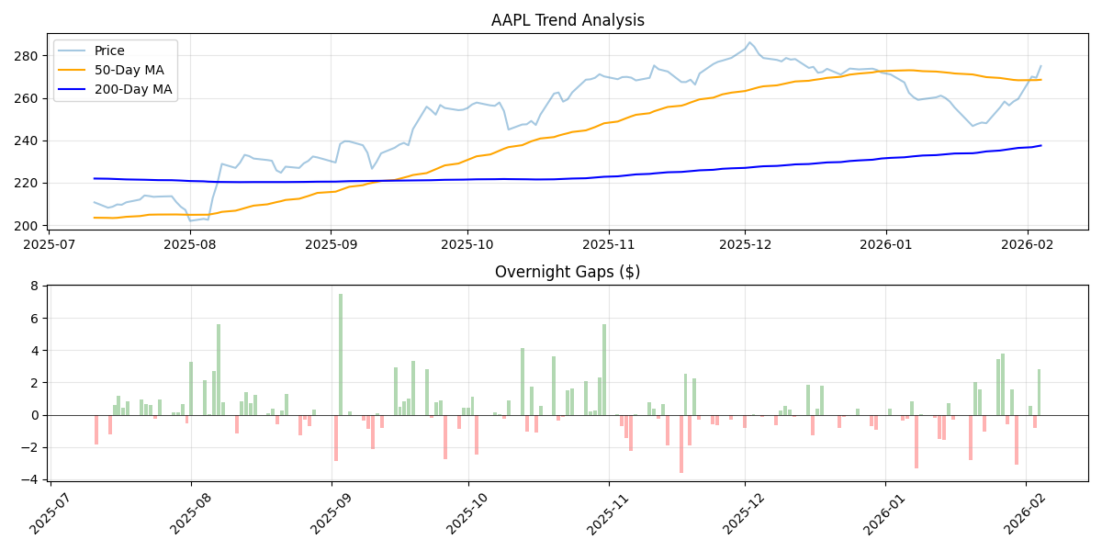

Analysis for TSLA
Trend Type: Golden Cross Detected
Overnight Gap: $-1.50
Volatility: Low
Final Verdict: Hold/Monitor
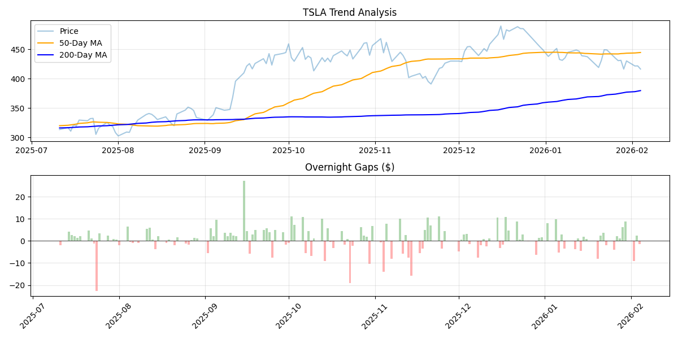

Analysis for NVDA
Trend Type: Persistent Bullish
Overnight Gap: $-0.90
Volatility: Low
Final Verdict: Hold/Monitor
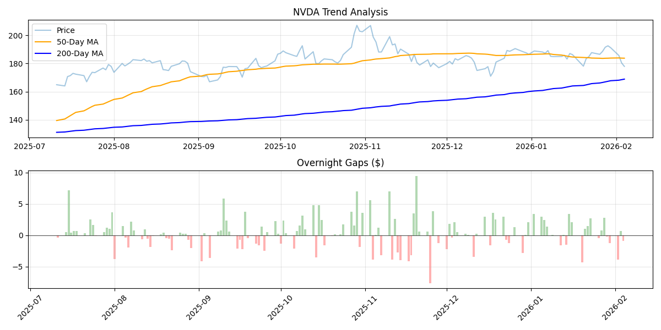

Analysis for AMD
Trend Type: Golden Cross Detected
Overnight Gap: $-26.67
Volatility: High
Final Verdict: Hold/Monitor
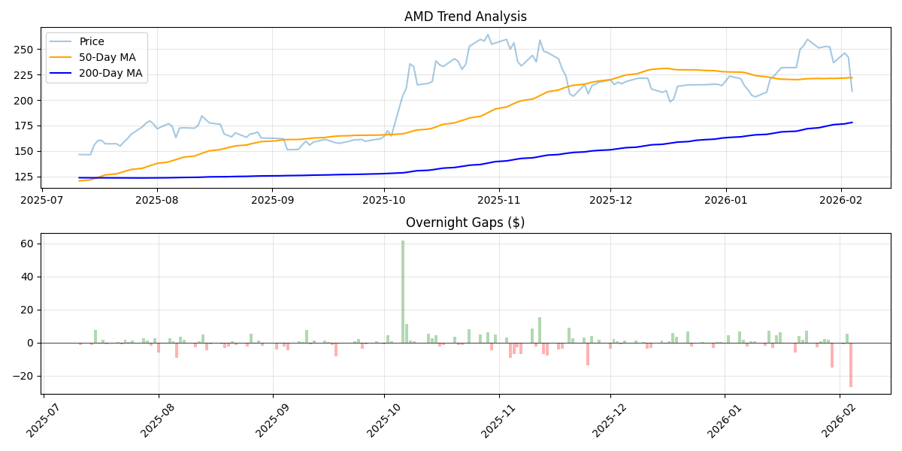

Analysis for AMZN
Trend Type: Persistent Bullish
Overnight Gap: $0.08
Volatility: Low
Final Verdict: Hold/Monitor
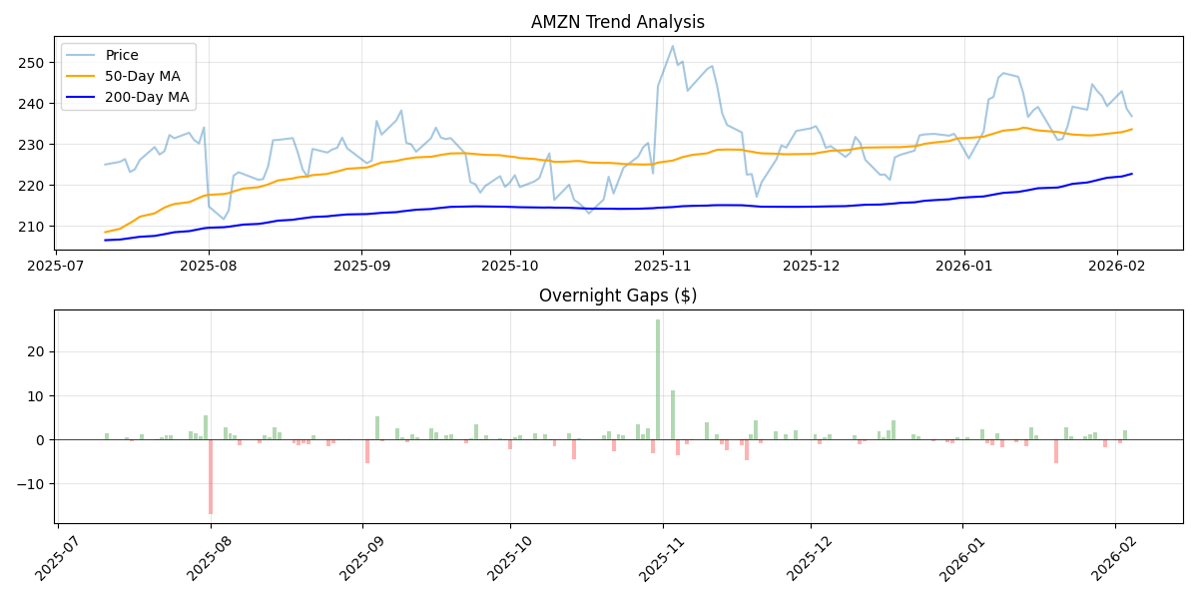

Analysis for MSFT
Trend Type: Death Cross Detected
Overnight Gap: $-0.15
Volatility: Low
Final Verdict: Exit/Neutral
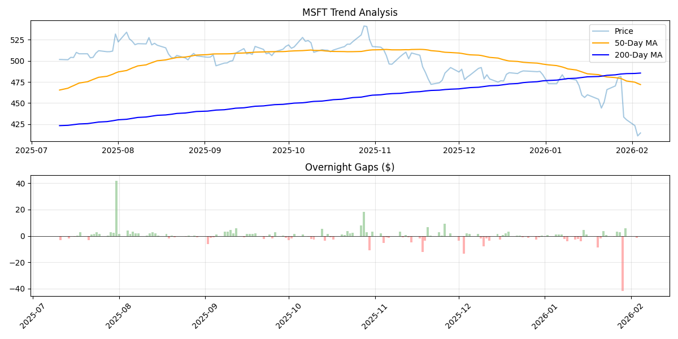

Analysis for GOOGL
Trend Type: Golden Cross Detected
Overnight Gap: $3.25
Volatility: Low
Final Verdict: Strong Buy
