L **LOHN**

**WHITEPAPER**

**VERSION 1.0**

**The manufacturing economy without trust problems.**

**Be our partner, feel the value!**

**Catalin Iordache, Laur Popa**

*Founders of lohncontrol.com*

**ABSTRACT.**

**Mechanism of economic business at lohn**

Lohn is a widely spread contractual form in various industrial fields of international cooperation relations, especially in the industry of clothing, footwear, furniture, machine building industry, electronics and appliance industry, food industry and petrochemical industry.

*According to the specialists’ definition, the processing in lohn system consists of an international economic business carried out on a contractual basis between two companies of different countries where one performs, for a retribution in cash or in kind, a custom-made product according to the designs, drawings, usually with raw materials and materials of the other companies, which keep their right to trade that product under its own trademark.*

**At present, the annual production achieved in lohn at the worldwide level exceeds 10,000 B $.**

Lohn, the custom-made production, is a simple form that can contribute to the advantageous mutual settlement of some international asymmetries related to the available workforce and the cost of workmanship, raw material demand or production capacities.

The custom-made product indicates two aspects:

a)    the finite product is performed with the raw materials and the materials of company that performs the order;

b)    the finite product is manufactured by processing of raw materials and the materials of company that requires the order.

Being about the finite products performed according to the client’s indications and drawings and in the quantity required by him, the dispatch is 100% ensured.

The company that launches the order is called **buyer, importer** or **beneficiary.** The company that performs the product is called **exporter or producer.**

*The buyers at lohn* are companies that hold prestige marks. We may assert that the main goal for the buyer, followed by Lohn operation, is the valuation of capacities of some prestigious marks they benefit of, as well as the managerial and marketing ability.

*The producers at lohn* have the following specific trading aspects:

-  they benefit of production factors, buildings, cars, utilities and especially workforce with a proper qualification;

- they do not have prestigious trademarks and are only focused on the industrial production side, exploiting the competitive benefits of the origin countries, related to the low cost of workforce and the low level of fees.

The international cooperation based on processing at lohn presents for the producer, the advantage that he is granted the possibility to fully involve in the manufacturing capacity and benefit, too, from the maximum exploitation of this capacity.

In his turn, the buyer is granted the possibility to send for processing the raw materials and materials to a country where the workforce is cheaper than in his own country and obtain products manufactured according to his own project and vision. It is noted that, for many times, the beneficiary makes the producer available, as rental or sale in the account of processing, certain machines, installations and devices that ensure a high labor productiveness and a high technical – qualitative level of the end product.

The lohn mechanism is equally simple and efficient for the buyer (Figure 1).

Figure 1.  **Processing mechanism at lohn**

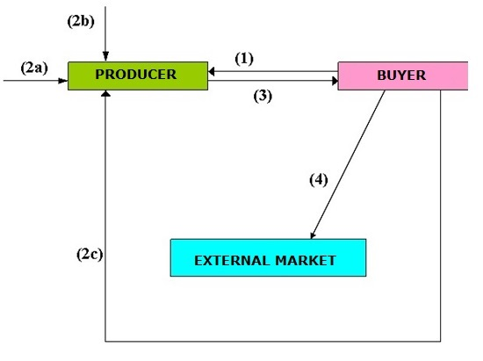

**(1):  Order**

**(2a): National labor**

**(2b): Raw materials, internal materials**

**(2c): Raw materials, imported**

**(3):  Deliveries**

**(4):  Sale**

Thus, the buyer launches the order of product to the producer whom he requires the model, offers him the necessary drawings, usually raw materials, too, entirely or partially, accessories and possibly a special manufacturing know-how. All these items are stipulated by the agreement concluded between the parties, where there are also mentioned a set of clauses such as price at which the producer provides the finite product to the buyer, price that includes mainly the workmanship as asset. The agreement expressly stipulates that the product is performed under the buyer’s trademark, who reserves the trading right on his own market and on the worldwide market.

Transport costs are also taken into account in the efficiency of a cooperative action such as custom-made production. The buyer will preferably turn to countries as close as possible to the outlets for the products ordered.

Depending on the buyer’s involvement, one can talk about **active lohn** and **passive lohn**.

In the case of **active** lohn the producer processes the materials made available by the buyer and exports them to their owner. It also favors the import of technology, broadens the market, increases the qualification of the labor force, opens the perspectives of the cooperative actions. The buyer can also provide tools for finite products, can provide technical assistance in terms of qualification of the labor force or can be involved in organizing and improving the producer's activity.

**Passive** lohn is the opposite of the first, i.e. the buyer sends the materials that belong to it for processing in the producer's country and returns them in the finished form in its own country.

**The major gap between labor costs in developed countries and emerging or poor economies makes lohn a major driver of the world economy for the next 50 years**.

**Performing lohn contracts through blockchain technology will bring important benefits in the future to both buyers and producers. The high transparency of these contracts will eliminate unregistered work as well as the exploitation of vulnerable persons or minors.**

**Blockchain technology in performing lohn contracts**

Blockchain technology through smart contracts can bring indisputable benefits to lohn contracts because it secures on the one hand the buyer's investment that can control and truly manage the producers involved in the development of its products and, on the other hand, provides the psychological comfort required for the producer who, in compliance with the term of the agreement, will definitely receive its payment for the work carried out as soon as possible.

Producers’ reputational risk management is one of the major concerns of buyers within a lohn contract because the latter give to producers, whom they know only from third-party references or under a contract governed by local laws, valuable raw materials having the uncertainty of manufacturing some products according to the required standards and at the deadlines stipulated in the contract. By registering with smart contracts each step of the parties within the lohn contract the blockchain technology will allow the achievement of a reputational profile of both the buyer and the producer. Thus each of the parties can choose the partner they are going to work with in full awareness.

Given that lohn contracts are usually performed in emerging countries with less predictable business law, it is very important to secure the relationship between the parties.

From the producers’ perspective, the development of the production activity based on smart contracts will allow the optimization of production flows, the increase of the accountability of the factors involved due to the rigorous traceability of the product manufactured, the comfort of working with a buyer about whom there are honest and unquestionably accurate information and especially the speed of settlement of the labor provided within the contract. All of these things contribute to a sustainable development of producers from emerging economies, to create a good reputation regarding compliance with the quality standards of the manufactured products and last but not least to transparency of human rights and work ethic observance for the persons employed by them.

The relationship between the main parties of the lohn contract managed in blockchain by smart contracts will create a relaxed business climate and the secondary actors such as carriers, quality control experts or internal suppliers will be able to contribute through other secondary smart contracts to the smooth performance of the main contract. The economic discipline of each party involved will be guaranteed by the Main Smart Contract Rating System. Because as long as all the actors involved will have a general rating archived in the project, they will take care that their business reputation remains high.

Figure 2.

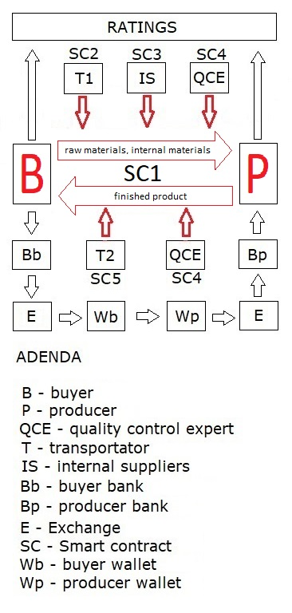

**How does a lohn contract work in blockchain technology?**

The contract between the buyer and the producer also involves third entities that lead to the completion in good conditions thereof. These are the carriers who deliver the raw materials and other goods required to achieve the production in the first phase, and then they pick up the finished products to deliver them to the buyer. Domestic suppliers of raw materials, related services and utilities represent another important category for the success of the production. Above all there are the quality control experts natural or legal persons, who follow on behalf of the buyer the entire production process, from the delivery of the raw materials, the quality thereof, supply or delivery times, the quality of the goods or services provided by the domestic suppliers, the timeliness of the deliveries or of the transportation of the goods and, in particular, the proper execution of the production by observing the buyer's technological indications.

The contribution of each of the involved parties is governed by IF/THEN-type smart contracts subordinated to the main contract between the buyer and the producer. Chaining and the proper execution of these complementary smart contracts lead in the end to a rigorous achievement of the main contract between the parties.

**What are the concrete milestones to perform the smart contract in the blockchain (Figure 2)?**

Example:

*Buyer B concludes with producer P a lohn contract (governed by an IF / THEN-type SC1 smart contract) for the production of goods with a total value of $ 100,000.*

*Stage 1.*

*To do this, it hires the T1 carrier to deliver the raw materials and the technical documentation for the production. The T1 carrier is registered with the SC2 complementary smart contract. The fulfillment of the delivery conditions stipulated by SC2 is a pre-reuisite for the continuation of the contract*

*Stage 2.*

*In this stage, the internal IS suppliers deliver the other goods or services necessary for the production (accessories, complementary raw materials, production areas, utilities, etc.)The quality of the goods or services delivered by them is followed by the SC3 complementary smart contract.*

*Stage 3.*

*At this time, the QCE quality control expert appears, who is hired by the buyer to defend its interests in the relationship with all the parties involved in the production process and to follow the achievement in very good conditions of the manufactured products by observing exactly the technical indications provided. QCE carries out its activity based on the complementary SC4 smart contract and supervises the performance of the T1 carrier, the internal IS suppliers that are paid for by its express indication within SC4 and especially the producer P closely following the stages of the manufacturing process and the rigorous observation of the technological indications.*

*QCE ascertains that all the validity terms of the SC4 complementary smart contract are met and proposes to make payment for the production made to producer P.*

*Stage 4.*

*(VS1) At this time, buyer B initiates payment into an escrow account for the amount of $ 100,000 agreed to make the production at its bank Bb at the order of producer P. On the basis of proof submitted in the English language of $ 100,000 in the escrow account LOHNex E exchange issues 100,000 LOHNusd (parity $ / LOHNusd is 1/1) that it gives to buyer B in its wallet or in person Wb.LOHNusd are transmitted based on the same indications provided by the main smart contract SC1 in the wp producer's wallet when the T2 carrier (which may be the same T1) loads the cargo on the basis of documents specifying the picking up conditions to deliver it to buyer B, thereby executing the SC5 complementary contract and thus fulfilling all the validity conditions of the main SC1 smart contract.*

*When transferring LOHNusd tokens from Wb buyer's wallet to Wp producer’s smart wallet, the main SC1 contract will also pay in ETH the 3% fee on the contract value to LOHNex E for the use of trading platforms of* [*www.lohncontract.com*](http://www.lohncontract.com)*.*

*Also at this moment, QCE and T2 are paid in a form agreed upon in the main SC1 smart contract.*

*Stage 5.*

*The Bp producer's bank will, upon request, remit $ 100,000 to its account in exchange for receiving the LOHNusd tokens received by buyer B in the escrow account together with a 1% fee of the amount paid in the ETH by the LOHNex E exchange.*

*The LOHNex Exchange may issue, upon the parties’ request, tokens in LOHNusd, LOHNeuro, LOHNgbp or any other currency agreed by the parties and which represent the payment currency of the main contract.*

*The guarantee of money transfer by means of an escrow account is based on the "WE NOT TOUCH THE MONEY" philosophy and is intended to provide maximum confidence to all parties involved in performing the lohn contract.*

*The promptness, diligence and proper execution of the conditions for the development of the Main SC1 Smart Contract and the Complementary SC2, SC3, SC4, and SC5 Smart Contracts by the parties involved will be forwarded to an IPFS archive that will establish through a specific algorithm the Business Rating of each part.*

*Business Rating will help businesses manage the reputational risk of trading partners.*

**Interaction between the lohncontrol.com project and the trading platforms of lohncontract.com**

The lohncontrol.com project developed in the ethereum blockchain is designed to efficiently manage trading processes on the regional platforms of lohncontract.com.

[www.lohncontract.com](http://www.lohncontract.com) develops several regional trading platforms meant to provide predictability to the consumer goods manufacuring economy. We refer here to the goods of the textile, leather and footwear industry, the electronics and household aplliances industry, the petrochemical industry and last, but not least, the food industry. For instance, all foods developed by hypermarkets under their own brand are the result of active lohn contracts.

Regional platforms support local producers and the development of their commercial relationships with global brands. The first operational platform is [www.bursadelohn.ro](http://www.bursadelohn.ro) which operates in Romania, one of the largest producers of textiles, leather and footwear in Europe that manufactures products of the most important fashion brands in the world.

Profit from trading platforms of [www.lohncontract.com](http://www.lohncontract.com) will be distributed to all token generated by [www.lohncontrol.com](http://www.lohncontrol.com) , our partners benefiting from the development of the project as shareholders.

The mechanisms managed by the blockchain technology of the lohncontrol.com project have a major role to give mutual trust to all the parties involved in a lohn contract. For emerging markets that host such industrial and commercial processes, trust is a decisive variable in the sustainable development of local economies.