**Ex 1:**

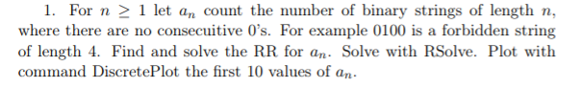

Solution:

**Ex 2:**

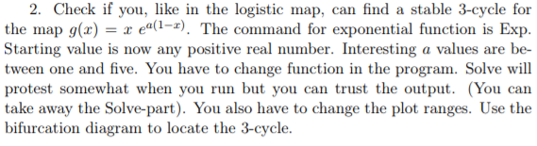

Solution:

For this exercise, we were asked to find a stable 3-cycle for the map : g(x) = x e^(a(1-x)). To find the 3-cycle we first looked at the bifurcation Diagram for this map. We used the range of 1 < a < 4.

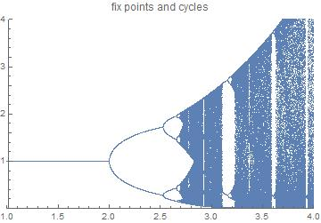

After getting this diagram, we looked at where the 3-cycle could possibly exist. For finding the almost exact values we checked the coordinates inside the window between a= 3.1 and a= 3.2. We found that the coordinates at the bifurcation of this window were a = 3.14 and start = 2.69. We were then able to get the orbit for these coordinates. This orbit graph is showing us how the population almost went to extinction but managed to stay stable. The orbit graph below is showing us the 500 iteration of the orbit for a=3.14 and at a start =2.69.

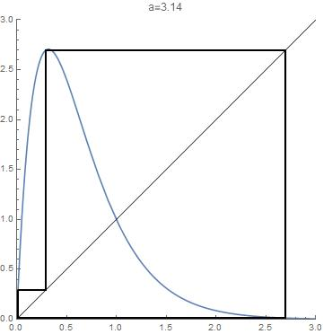

Even after 500 iterations the orbit is stable.

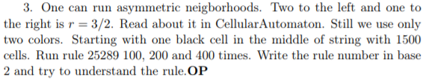

Solution:

**Ex 4:**

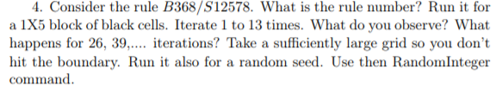

Solution:

We started to look for the rule number from the B368/S12578 notation. We used the table that the teacher showed us in the lectures to able to find the rule number.

|  |  |  |  |
| --- | --- | --- | --- |
| N -> # neighbours | M | 2N+M | 2^(2N+M) |
| 0 | 0 | 0 | 1 |
| 0 | 1 | 1 | 2 |
| 1 | 0 | 2 | 4 |
| 1 | 1 | 3 | 8 |
| 2 | 0 | 4 | 16 |
| 2 | 1 | 5 | 32 |
| 3 | 0 | 6 | 64 |
| 3 | 1 | 7 | 128 |
| 4 | 0 | 8 | 256 |
| 4 | 1 | 9 | 512 |
| 5 | 0 | 10 | 1024 |
| 5 | 1 | 11 | 2048 |
| 6 | 0 | 12 | 4096 |
| 6 | 1 | 13 | 8192 |
| 7 | 0 | 14 | 16384 |
| 7 | 1 | 15 | 32768 |
| 8 | 0 | 16 | 65536 |
| 8 | 1 | 17 | 131072 |

From this table we have found the rule number for Mathematica. Therefore, we have added all the numbers from B368/S12578 : (64+4096+65536)+(8+32+2048+32768+131072), which gave us the rule 235624. From this rule we have created the 2D Cellular Automata program and run it with 1X5 block of black cells. From generation 1 to 13 we can observe a line of blocks that then turn into different patterns within the next iterations until reaching iteration 13, then reaches a final duplicate state of generation 1. For 26 iterations it can be observed a similar final state from iteration 13 but with a lot more space between the two line of blocks. As for 39 iterations it can now be observed 4 line of blocks evenly separated showing a duplicate of iteration 13.

And this is the rule with a random seed :

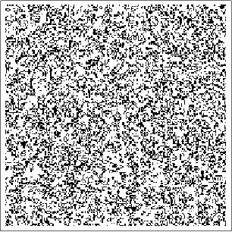

|  |  |  |  |
| --- | --- | --- | --- |
| **n=1** | **n=2** | **n=3** | **n=4** |
| 0 | 00 | 000 | 0000 |
| 1 | 01 | 001 | 0001 |
|  | 10 | 010 | 0010 |
|  | 11 | 011 | 0011 |
|  |  | 100 | 0100 |
|  |  | 101 | 0101 |
|  |  | 110 | 0110 |
|  |  | 111 | 0111 |
|  |  |  | 1000 |
|  |  |  | 1001 |
|  |  |  | 1010 |
|  |  |  | 1011 |
|  |  |  | 1100 |
|  |  |  | 1101 |
|  |  |  | 1110 |
|  |  |  | 1111 |