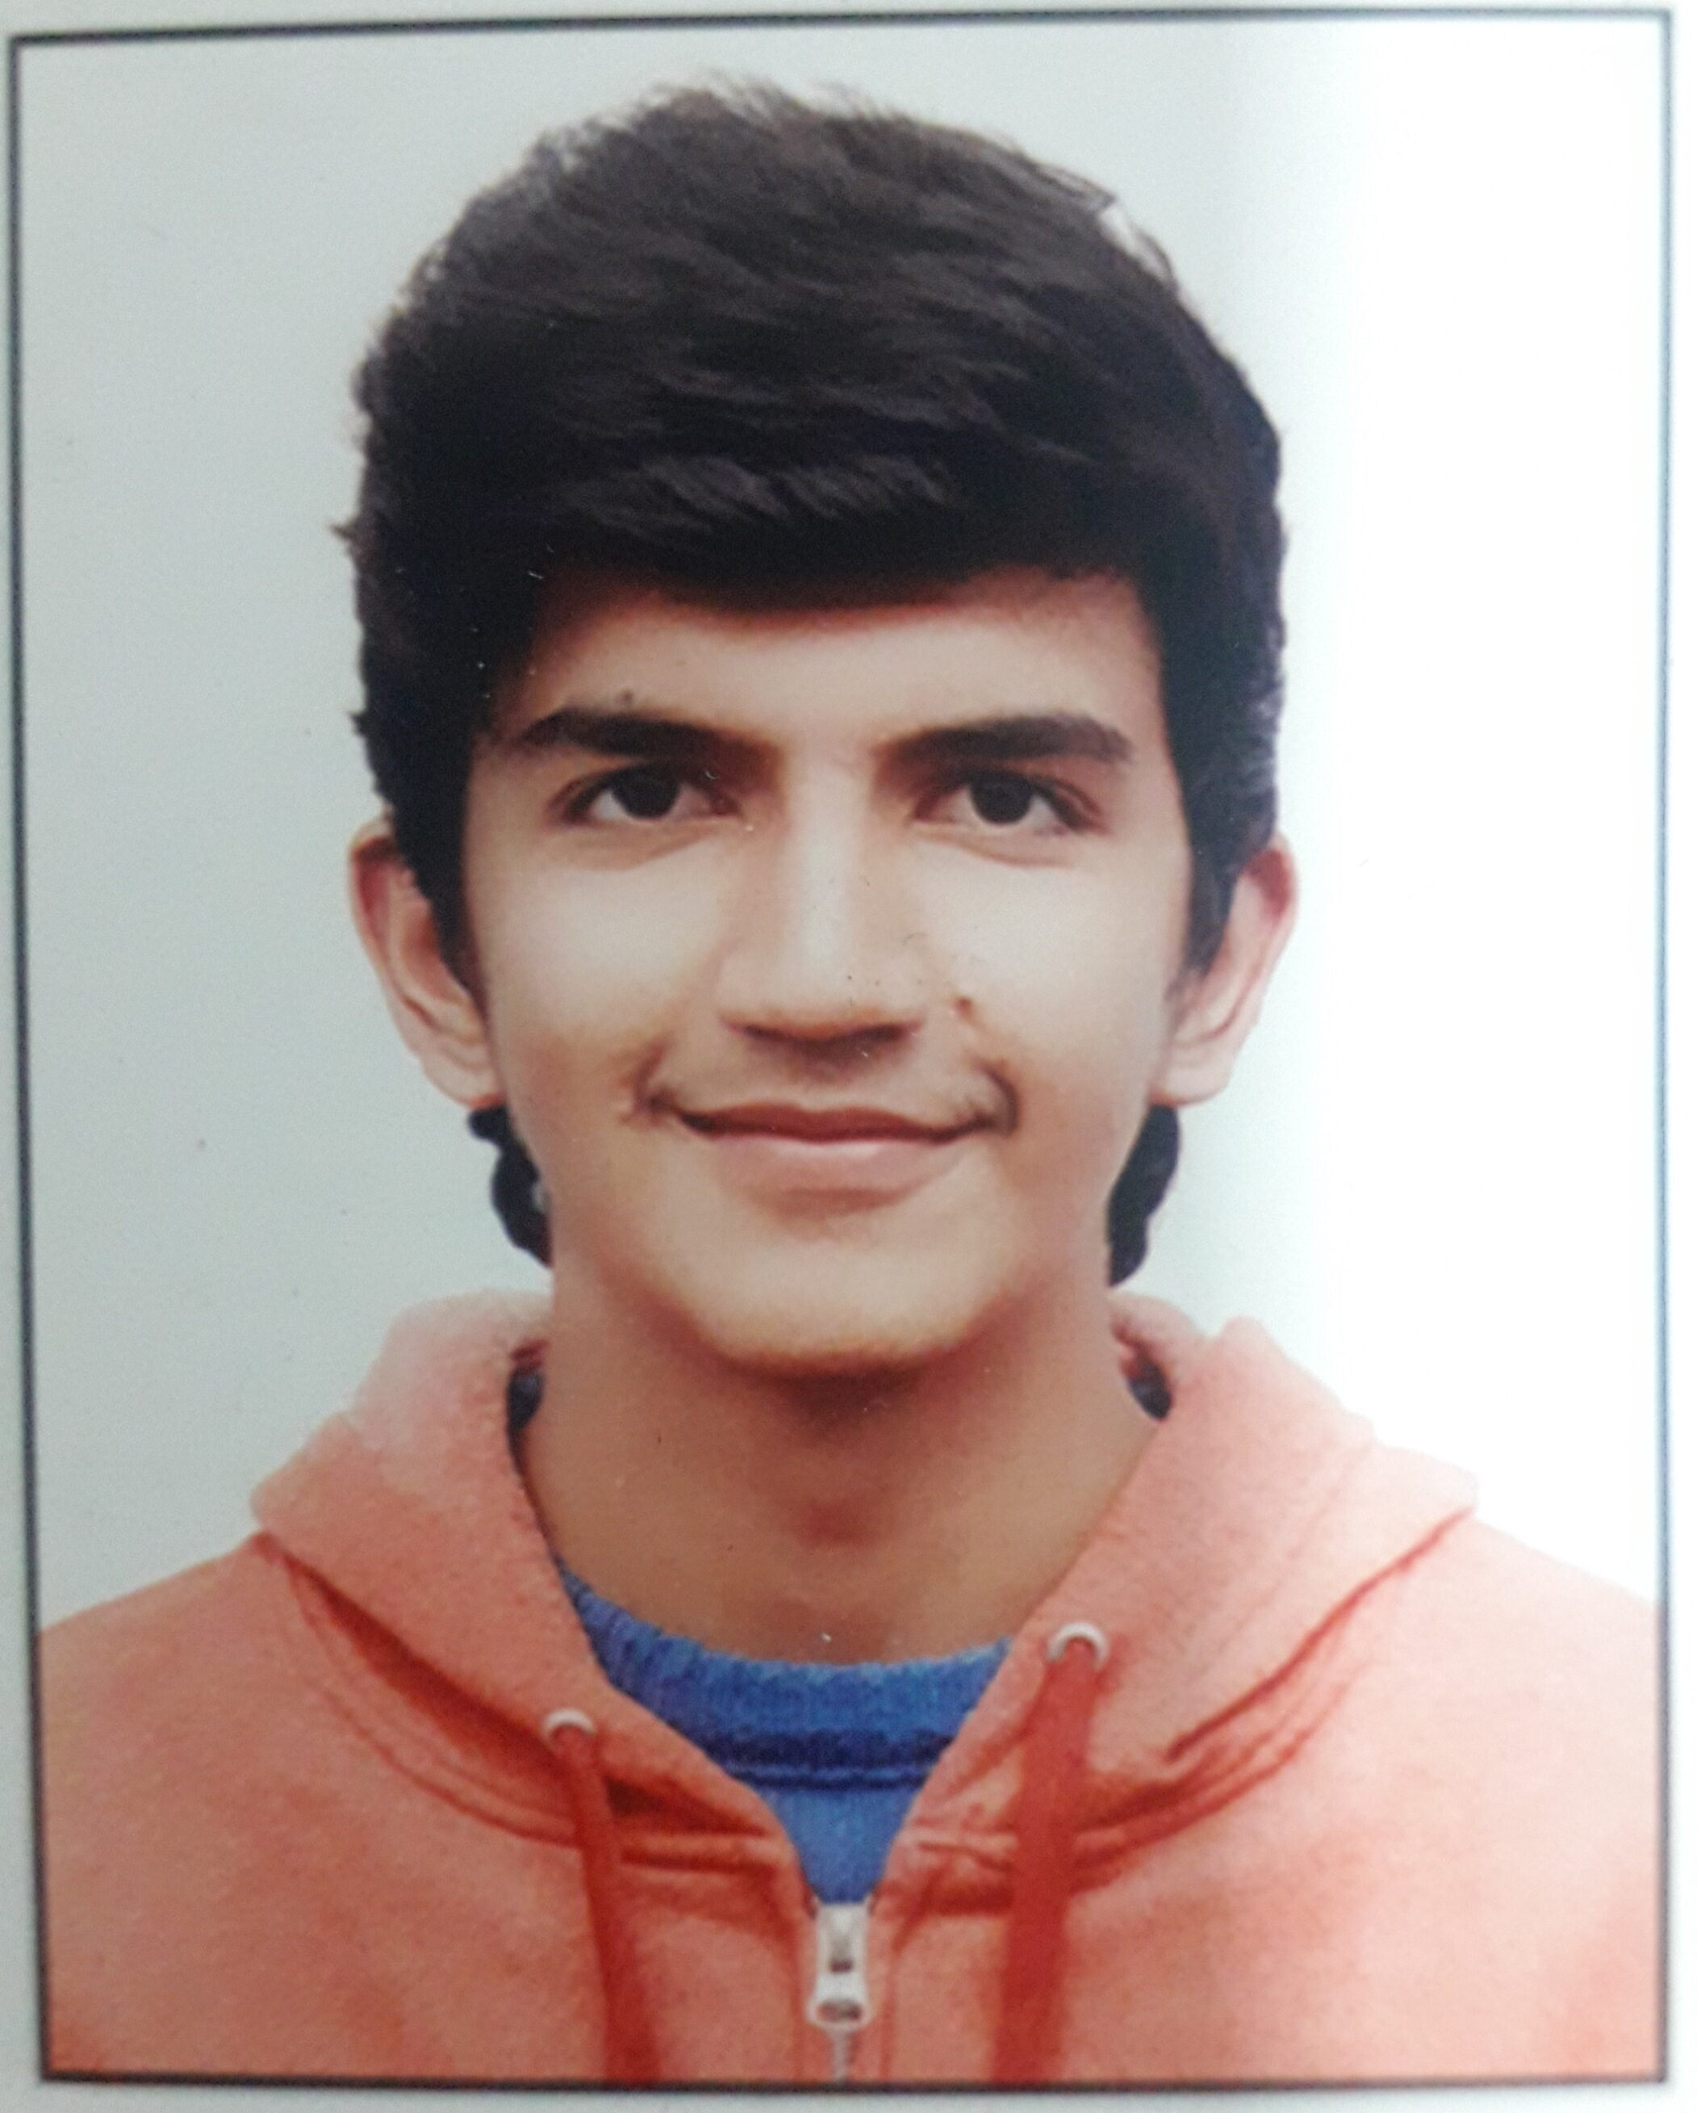

Students Profile-2022

✓
Photo

(Passport Size)

Photo

(Passport Size)

Photo

(Passport Size)

Photo

(Passport Size)
Select 1 option only: Placements Higher Studies Entrepreneurship Others (Specify)

Photo

(Passport Size)
Software Development Engineer
Photo

(Passport Size)
Priority in Placements 1. Salary 2. 2. Choiced Profile (Specify)

Please specify the reason of your choice _Because the field is so broad and encompasses a variety of roles related to both computer applications and systems, and it offers a career path with endless progression and opportunities__________________________

Name: First Kashish__________ Middle_____________ Last _Chhabra___________________
S/o, D/o __Virender Chhabra_____________________________________________________
Father’s / Mother’s / Sibling Occupation ___Teacher________________________________
(Name of Company / Organization/ Family Business, For which they are working): _FIITJEE___

Address: _First floor, DU-68, Pitampura, New Delhi______________

City _Delhi______________ Pin Code _110034____________________

Date of Birth (DD/MM/YY) __18/07/2000_____________Branch/Shift: CSE, Morning shift_

U/Roll No: 05015002718________

Tel No.: (R)_________________________ (M) : _8587010669_______________________
Email ID: __kashishch18@gmail.com______________________________________

Gap in Academics (In years): _ 0_____

Academic Distinction & Result (Semester wise % ; without credits) :

10th | 95 | Diploma(if any) :
12th | 92.8
Sem. I | 78.69 | Sem. IV | 81.33
Sem. II | 75 | Sem. V | 90.67
Sem. III | 74 | Sem. VI

Overall: _80.11_____%

Training/Projects @: __Attended “International Conference on Artificial Intelligence and Applications” held in MSIT in February, 2020___
Project 1: Front end Web Development of a website for a restaurant _____
__ Project 2: News Application in Android ____________________________
Project 3: Instagram Clone

Personality Profile *: __Aptitude: Software Development, Problem Solving
Strengths: Hardworking, Sincere, sense of commitment & dedication, Honest, Adaptability to different setups
Weakness: Hesitate in taking initiative, in order to achieve perfection may exceed deadline

Extra Curricular Activities # : __1)_Member of Event Management Team, MSIT Unfiltered_
2)_Member of Octave Music Society of MSIT ___________________________________
3) Runner up in 64 Squares(Chess tournament) held in MSIT

Desired Career Goals: (a) Short – Term: __Software Engineer in an esteemed organization__

(b) Long – Term: __Software Engineer in a Product based Company Android Developer in a Product based Company _

Preparing for GATE/GRE/CAT etc. (pls Specify): ____NO__________________________

Any Other Important Information:
______________________________________________________________________________________________________________________________________________

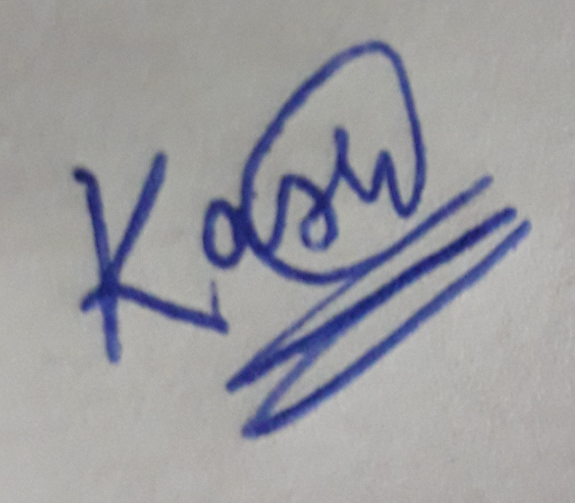

Signature of Guardian Signature of Student

GUIDELINES

NOTES : -

@ Also may mention about any SEMINARS, WORKSHOPS, CONFERENCES ATTENDED/INDUSTRIAL VISITS UNDERTAKEN

* May describe in terms of :-
(i) Aptitude :- Indicate preference for a particular type of a functional activity e.g.…… planning / Manufacturing / Operations / Computer Software Development / Hardware Mgt. / Materials Mgt. etc.

(ii) Strengths :- Hardwork & Sincerity / sense of commitment & dedication / Honesty & Integrity / Adaptability to different setups / Innovative / Ability to work under pressure & deadlines / willingness to excel etc.

(iii) Weakness :- Over ambition / over enthusiasm / stickler for cleanliness / over eager to get result quickly / seeking perfection in every activity etc.

# Sports & Quiz / Tech Fest / Declamation etc.

