
How to enable more flight modes

This is an example how to set up more flight modes for the Thunderbird. I recommend to create a new model and do all steps with it. Call the model "HaveFun" or something like that.

I this example I use the Pan Mode Switch (S2, Channel 10) to select one of the two sets of flight modes:

- Set One (S2 up or down) has "Altitude" in upper position of the flight mode switch S4, "Position hold" in the middle position and "Return to home" in the lower position.
- Set Two (S2 middle posiotion) has "Rattitude" in upper position of the flight mode switch S4, "Stabilized" in the middle position and again "Return to home" in the lower position.

Set One is the same as GPS off/on. Set two contains more advanced flight modes. "Acro" was left off because I'm too old for this stuff.

Step 1: Channel settings at ST16

Open channel settings and select A01.
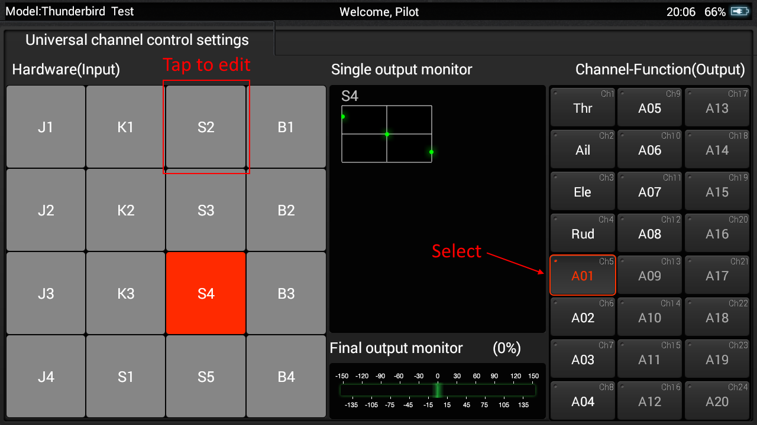

Tap on S2 and hold it to get menu. Select "Edit" from the menu.

Set "Accumulation", Pos.0 to "Act" and -50%. Tap on Save.
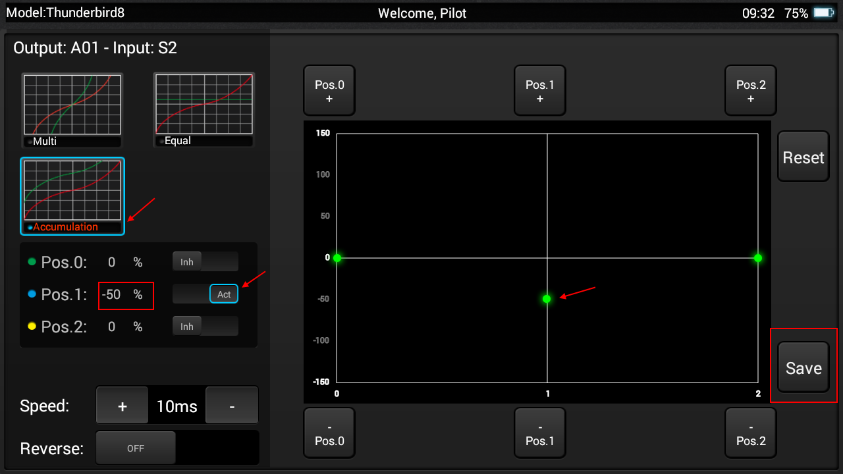
Now you should get a mixed channel for flight modes:
- S2 up/down: 100% > 0 > -100%
- B2 middle: 50% > -50% > -150%
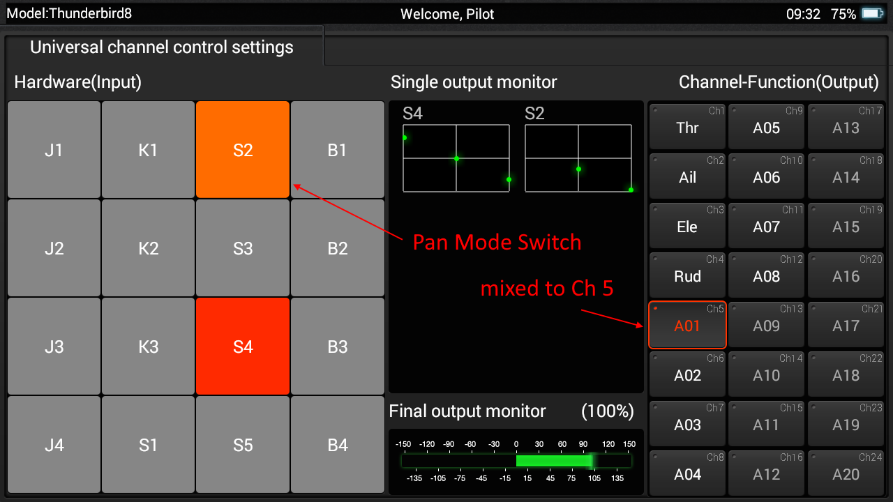
Remark: Channel A02 (RTH channel) must still have values 0 > 0 > 150% in both positions of S2 switch. Check this!

Step 2: Assign flight modes in QGroundControl

Bind the new model to Thunderbird and connect it to QGroundControl by USB cable.
Now we have more possibilities to add flight modes:
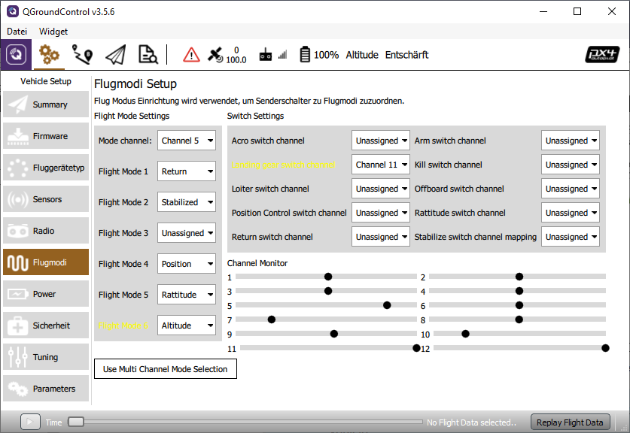
Go to "Settings" > "Flight modes" and assign flight modes to the mode items.

- Mode channel remains Channel 5.
- Flight mode 1 is lower position of the Flight mode switch S4, remains "Return" for both Sets.
- Flight mode 2 belongs to Set Two, middle position, will be assigned to "Stabilized".
- Flight mode 3 remains "Unassigned".
- Flight mode 4 belongs to Set One, middle position, remains "Position".
- Flight mode 5 belongs to Set Two, upper position, will be assigned to "Rattitude" *.
- Flight mode 6 belongs to Set One, upper position, will be assigned to "Altitude".

Test all switch positions carefully in flight mode settings of QGroundControl. The active switch combination is highlighted.

Mode-switch | AUX-switch | FlightMode | Status LED | Pos % | Log value
up | up | Altitude | Blue blinking | +100% | 3412.0
up | down | Rattitude | White blinking | +50% | 2730.0
middle | up | Position hold | Purple solid | 0% | 2048.0
middle | down | Stability | Blue solid | -50% | 1365.0
down | up | RTH | Red blinking | -100% | 683.0
down | down | RTH | Red blinking | -150% | 0.0

* In newer versions of QGroundControl the flight mode "Rattitude" is no more available. But we can still assign this mode as longas it is available in our firmware. The flight mode names are represented as numbers in the parameters (enum). Rattitude is still number 9.
Go to Vehicle Setup > Parameter and select parameter set "Commander". There are parameter COM_FLTMODEx for six slots [x = 1 ... 6] . You see what was already assigned. Select the slot you want to change (for above explained set this is COM_FLTMODE5) and check "Advanced Settings" and "Manual Entry". Enter "9" for Rattitude, save and done.
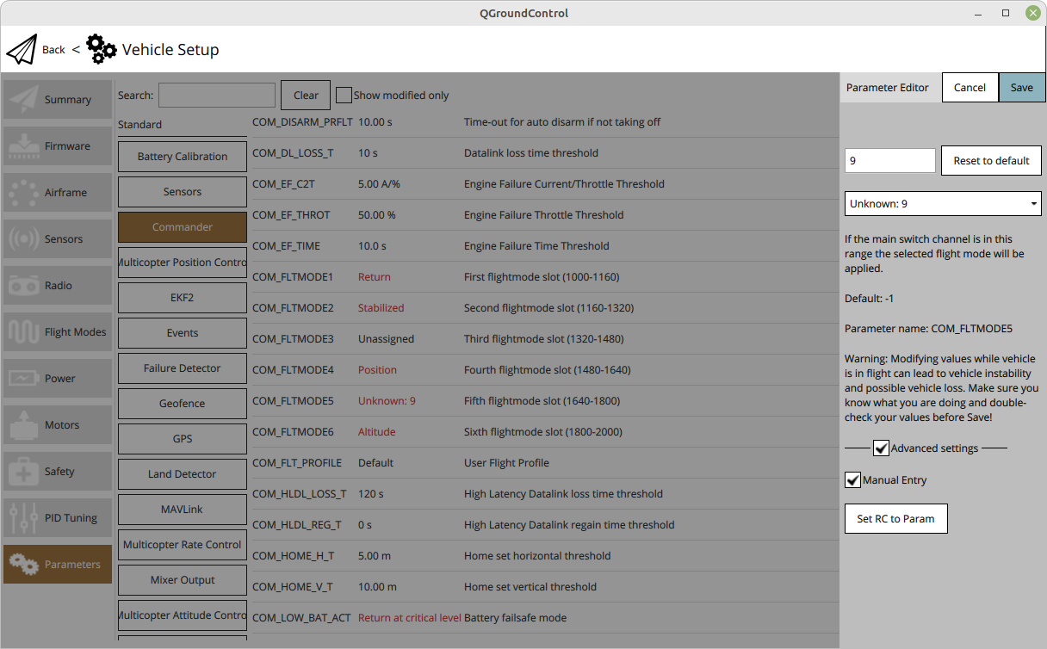

Note: Test changed flight modes without propellers before you use this settings in real flight sessions. First test flights do better without camera. Do all this on your own risk!

