Table of Contents

Set up docker 1

Create databases 1

Create influx database (Influx 1x version only): 1

Create prostgres database 1

Posgres only: Create table in database 1

Add column to table 1

Remove column: 1

show databases: 2

Influxdb 2

Postgres 2

*delete database (if needed) 2

Deal with firewall 2

check if can access ip:port 2

Check docker logs: 2

GRAFANA 2

Open Grafana: 2

Create DataSource 2

**DEEP2, WS**

*** note that we had to modify docker-compose.yalm (pasted below) to make it work on deep2 bc influxdb host port (8088) was already been used by different process, so mapped port 8089 (local machine) to port 8086 (container) (instead of the default which is 8088 to 8086)

On deep2 computer:

# Set up docker

In VHF folder (/home/ws/Desktop/VHF), where you have docker-compose.ylm

docker volume create --name=grafana-volume

docker volume create --name=influxdb-volume

docker volume create --name=postgres-volume

docker-compose up -d

# Create databases

## Create influx database (Influx 1x version only):

docker exec -it influxdb influx -execute ‘CREATE DATABASE vhf_influxdb;’

## Create prostgres database

docker exec -it postgres psql -U admin -c "CREATE DATABASE vhf_postgres;"

### Posgres only: Create table in database

docker exec -it postgres psql -U admin -d vhf_postgres -c "CREATE TABLE presence_analysis (id SERIAL PRIMARY KEY, time TIMESTAMP NOT NULL, receiver VARCHAR(255) NOT NULL, transmitter VARCHAR(255) NOT NULL, decision BOOLEAN NOT NULL, base64_data TEXT);

### Add column to table

docker exec -it postgres psql -U admin -d vhf_postgres -c "ALTER TABLE presence_analysis ADD COLUMN filepath VARCHAR(255);"

### Remove column:

docker exec -it postgres psql -U admin -d vhf_postgres -c "ALTER TABLE presence_analysis DROP COLUMN id;"

* Change type of column:

docker exec -it postgres psql -U admin -d vhf_postgres -c "ALTER TABLE presence_analysis ALTER COLUMN decision TYPE INTEGER USING decision::integer;"

## Show databases:

### Influxdb

docker exec -it influxdb influx -execute 'SHOW DATABASES'

### Postgres

docker exec -it postgres psql -U admin -c '\l'

## Delete database (if needed)

docker exec influxdb influx -execute 'drop database vhf_influxdb'

# Deal with firewall

sudo iptables -A INPUT -p tcp --dport 8086 -j ACCEPT

sudo iptables -A INPUT -p tcp --dport 8089 -j ACCEPT

# check if can access ip:port

telnet 10.1.3.211 8089

# Check docker logs:

docker logs CONTAINER_NAME

# GRAFANA

## Open Grafana:

Open browser: <https://localhost:3000>

## Create DataSource (link docker database to Grafana)

Left Panel>Connections>Data sources>Create new one

**Adds on

* added Base64 Plug in
* added Static database https://www.youtube.com/watch?v=QOV8ECOUjWs

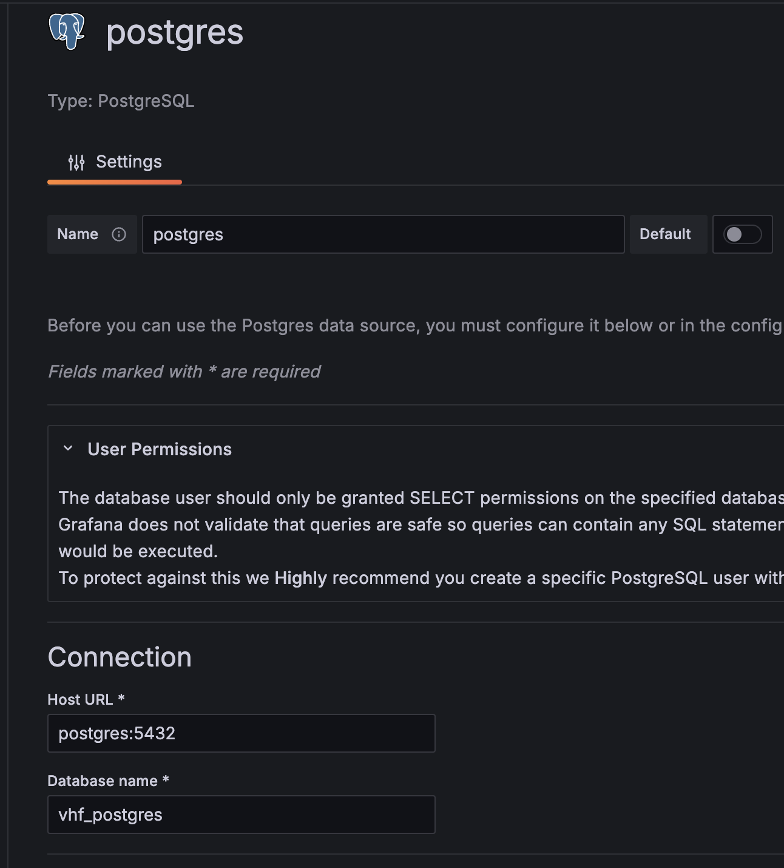

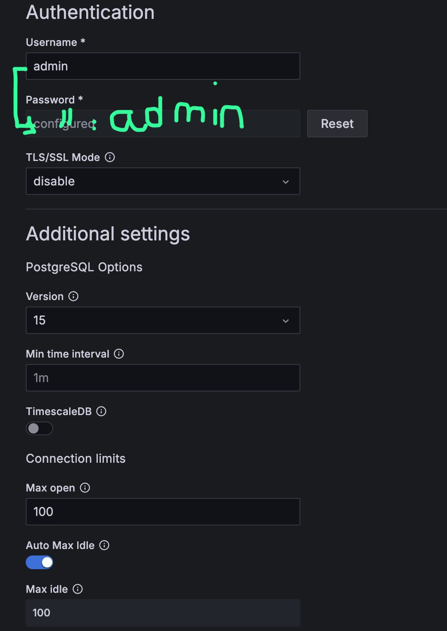

**MODIFIED Docker-compose.yml:**

~~~~~~~~~~~~~~~~~~~~~~~~~~~~~~~~~~~~~~~~~~~~~~~~~~~~~~~~~~~~~~~~~~~

version: "3.8"

services:

grafana:

image: grafana/grafana

container_name: grafana

restart: always

environment:

- GF_PANELS_DISABLE_SANITIZE_HTML=true

ports:

- "3000:3000"

volumes:

- grafana-volume:/var/lib/grafana

influxdb:

image: influxdb:1.8.10

container_name: influxdb

restart: always

ports:

- "8089:8086"

volumes:

- influxdb-volume:/var/lib/influxdb

postgres:

image: postgres:15.0

container_name: postgres

restart: always

environment:

POSTGRES_USER: admin

POSTGRES_PASSWORD: admin

ports:

- "5432:5432"

volumes:

- postgres-volume:/var/lib/postgresql/data

volumes:

grafana-volume:

external: true

influxdb-volume:

external: true

postgres-volume:

external: true

**Notes**

* Grafana: default host port =3000
* Influxdb: default host port: 8086
* ** Influxdb would call port 8088 on the computer but this port was already used by another process on deep2 so mapped it to 8089