*Put these at the top of your document:*

name

assignment

This is 11 pt. font, 1.5 line spacing, and 6 pt. spacing after each paragraph (or after each line that ends with the enter key being pressed). It is clear, informative, and easy to read. Remember, complete sentences have a subject, verb, and direct object. They, perhaps, take longer to write, but they are easier to read and can be read more quickly. Writing with complete sentences also helps with learning, and it demonstrates—to yourself and to your reader—that you understand the material.

***Here is a sample answer. (What is not in italics is the answer.)***

1. The consumer price index (cpi) for November 1992 is 142.100. The consumer price index for November 2020 is 260.721.

*This is using the equation editor for the inflation rate:*

The inflation rate is calculated this way:

This is inflation rate for the period, November 1992 to November 1991:

*You can also do it without the equation editor.*

This is inflation rate for the period, November 1992 to November 1991:

(260.721 – 142.100)/142.100 = 83.48%

*Or you can insert the math as an image (Take a photo and crop it. Then insert it. Resize it as needed.)*

This is inflation rate for the period, November 1992 to November 1991:

*You will also need to insert graphs using the same method. For example, like this:*

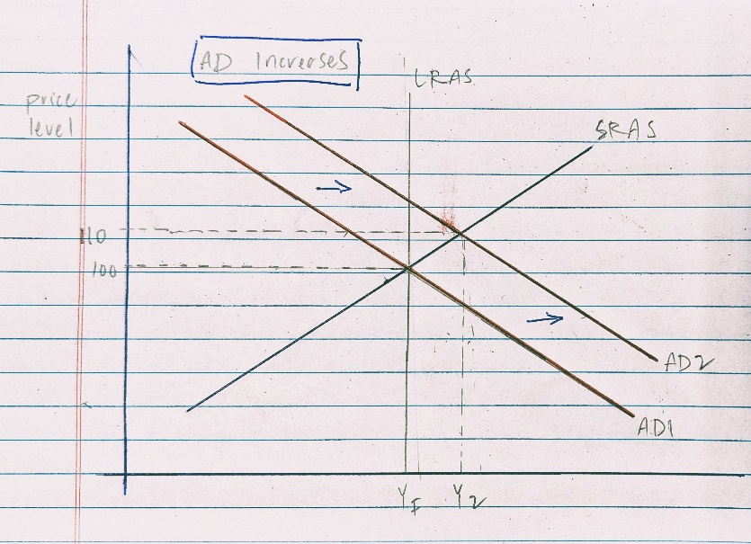

*Make the image large enough to be easy to view. To change its size, first, click on the image, and then select “Picture Format” from the far right end of the ribbon (above).*