Put these at the top of your document:
name
assignment

This is 11 pt. font, 1.5 line spacing, and 6 pt. spacing after each paragraph. It is clear and easy to read.
When appropriate, your answers should be in complete sentences—that is, they should have a subject, verb, and direct object. Complete sentences, perhaps, take longer to write, but they are easier to understand and can be read more quickly. Writing with complete sentences also helps with learning, and it demonstrates—to yourself and to your reader—that you understand the ideas that you are trying to express.
You can make tables in Word that look like this:
 | state 1 | state 2 | state 3
option 1 | a | b | c
option 2 | d | e | f

But Word doesn’t make it particularly easy to create a plain table like that one, and so you might find it easier to write your tables on paper (neatly), take a photo, and then insert them into the document like this:
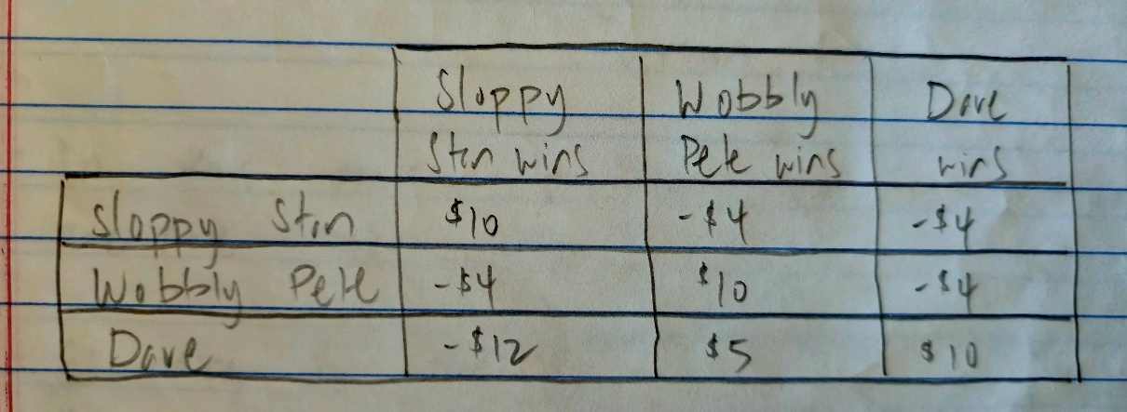
Insert the image in the right spot and make it large enough to be easy to view. To change its size, first, click on the image, and then select “Picture Format” from the set of options above (on the far-right).

