Les variances:

|  |  |  |  |  |  |  |  |  |
| --- | --- | --- | --- | --- | --- | --- | --- | --- |
| con | fv | pd | ma | a65 | gdp | cda | hb | le |
| 1.878636 | 537.4474 | 9.13878 | 65.51512 | 43.21139 | 290.2968 | 1.498045 | 6.272088 | 29.48935 |

Summary:

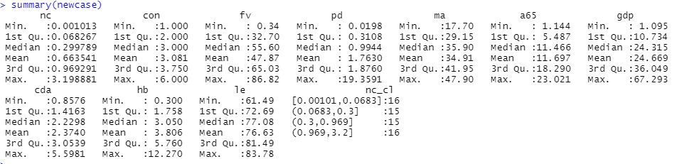

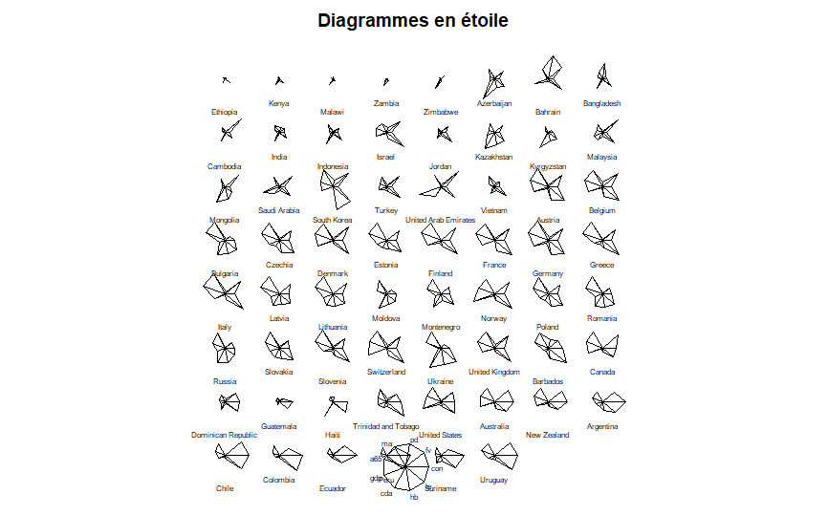

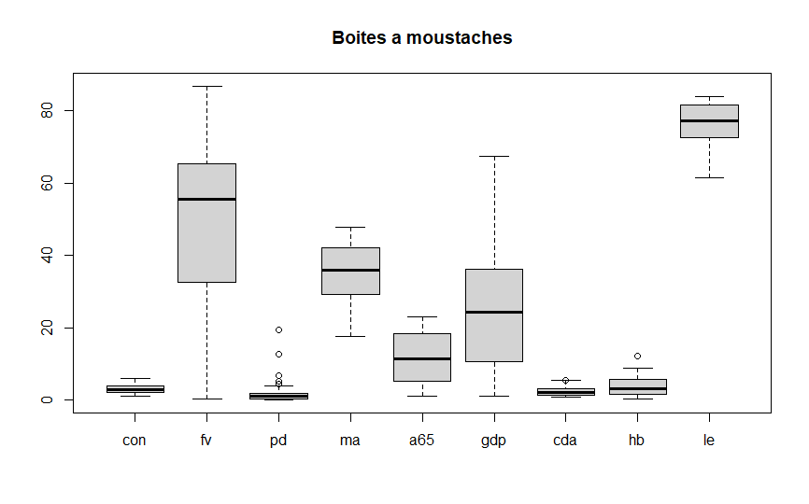

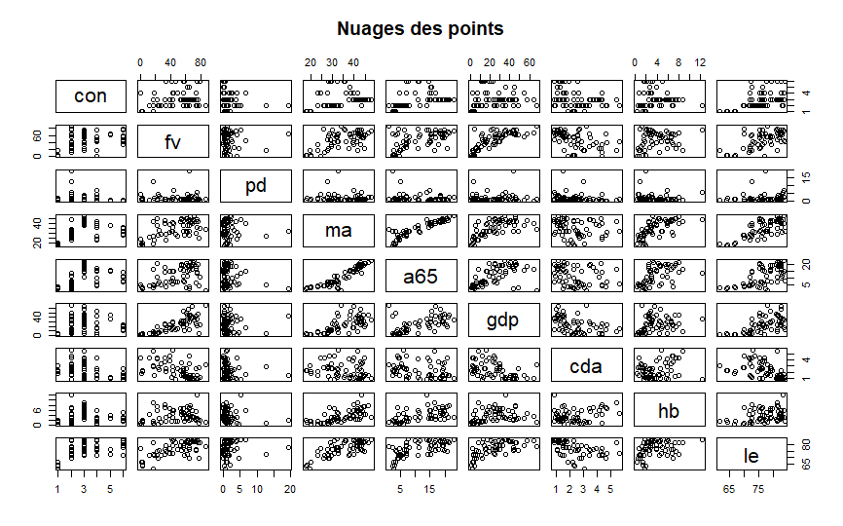

Matrice de corrélations :

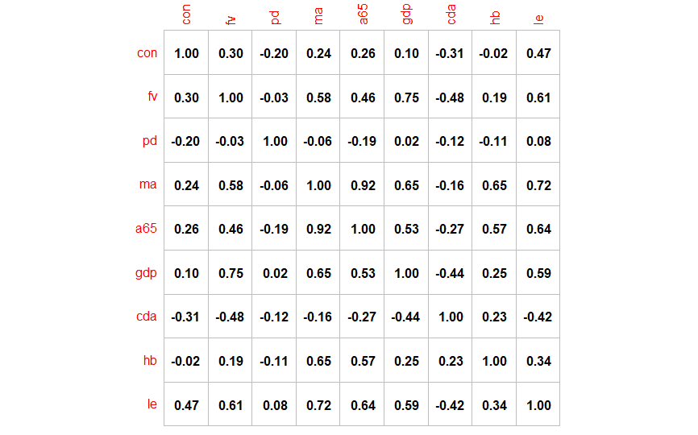

Summary ACP :

