TD04 : Branches + Merge

Partie 2
$ git branch
loispatane
* main
$ git status
On branch main
Your branch is ahead of 'origin/main' by 1 commit.
(use "git push" to publish your local commits)

nothing to commit, working tree clean

Partie 3
$ git switch -c feature/display-observation-dates
Switched to a new branch 'feature/display-observation-dates'
$ git branch
* feature/display-observation-dates
loispatane
main

Partie 4
$ python src/main.py
=== MarketPulse ===

Market configuration
Period : 1 month
Interval : Daily

Instrument
AAPL - Apple Inc.
Observations : 21
First date : 2026-09-01
Last date : 2026-09-30
First close : 250.00 USD
Last close : 266.20 USD

Benchmark
SP500 - S&P 500
Observations : 21
First date : 2026-09-01
Last date : 2026-09-30
First close : 6600.00
Last close : 6742.00

Partie 5
$ git status
On branch feature/display-observation-dates
Changes not staged for commit:
(use "git add <file>..." to update what will be committed)
(use "git restore <file>..." to discard changes in working directory)
modified: src/main.py

no changes added to commit (use "git add" and/or "git commit -a")
$ git diff
diff --git a/src/main.py b/src/main.py
index b56eab9..ddecd5c 100644
--- a/src/main.py
+++ b/src/main.py
@@ -36,6 +36,14 @@ def get_last_close(prices):
return float(last_row["close"])

+def get_first_date(prices):
+ return prices[0]["date"]
+
+
+def get_last_date(prices):
+ return prices[-1]["date"]
+
+
def display_configuration():
print("Market configuration")
print(f"Period : {LOOKBACK_LABEL}")
@@ -49,6 +57,8 @@ def display_market_summary(asset, prices, show_currency=True):

print(f"{asset['ticker']} - {asset['name']}")
print(f"Observations : {len(prices)}")
+ print(f"First date : {get_first_date(prices)}")
+ print(f"Last date : {get_last_date(prices)}")
print(f"First close : {get_first_close(prices):.2f}{currency}")
print(f"Last close : {get_last_close(prices):.2f}{currency}")
$ git add src/main.py
(aucune sortie)
$ git diff --staged
diff --git a/src/main.py b/src/main.py
index b56eab9..ddecd5c 100644
--- a/src/main.py
+++ b/src/main.py
@@ -36,6 +36,14 @@ def get_last_close(prices):
return float(last_row["close"])

+def get_first_date(prices):
+ return prices[0]["date"]
+
+
+def get_last_date(prices):
+ return prices[-1]["date"]
+
+
def display_configuration():
print("Market configuration")
print(f"Period : {LOOKBACK_LABEL}")
@@ -49,6 +57,8 @@ def display_market_summary(asset, prices, show_currency=True):

print(f"{asset['ticker']} - {asset['name']}")
print(f"Observations : {len(prices)}")
+ print(f"First date : {get_first_date(prices)}")
+ print(f"Last date : {get_last_date(prices)}")
print(f"First close : {get_first_close(prices):.2f}{currency}")
print(f"Last close : {get_last_close(prices):.2f}{currency}")
$ git commit -m "feat: display first and last observation dates"
[feature/display-observation-dates 21f6094] feat: display first and last observation dates
1 file changed, 10 insertions(+)
$ git status
On branch feature/display-observation-dates
nothing to commit, working tree clean
$ git log --oneline -5
21f6094 (HEAD -> feature/display-observation-dates) feat: display first and last observation dates
b8e8d2c (main) feat: add reusable market summary with first and last close
5207db8 (origin/main, origin/loispatane, origin/HEAD, loispatane) first td session
ba5c9f4 Update Readme
9fd6c8a Update Readme

Partie 6
$ git log --oneline --graph --decorate --all
* 21f6094 (HEAD -> feature/display-observation-dates) feat: display first and last observation dates
* b8e8d2c (main) feat: add reusable market summary with first and last close
* 5207db8 (origin/main, origin/loispatane, origin/HEAD, loispatane) first td session
* ba5c9f4 Update Readme
* 9fd6c8a Update Readme
* bfb94a6 init projecttemplate
$ git diff main..feature/display-observation-dates
diff --git a/src/main.py b/src/main.py
index b56eab9..ddecd5c 100644
--- a/src/main.py
+++ b/src/main.py
@@ -36,6 +36,14 @@ def get_last_close(prices):
return float(last_row["close"])

+def get_first_date(prices):
+ return prices[0]["date"]
+
+
+def get_last_date(prices):
+ return prices[-1]["date"]
+
+
def display_configuration():
print("Market configuration")
print(f"Period : {LOOKBACK_LABEL}")
@@ -49,6 +57,8 @@ def display_market_summary(asset, prices, show_currency=True):

print(f"{asset['ticker']} - {asset['name']}")
print(f"Observations : {len(prices)}")
+ print(f"First date : {get_first_date(prices)}")
+ print(f"Last date : {get_last_date(prices)}")
print(f"First close : {get_first_close(prices):.2f}{currency}")
print(f"Last close : {get_last_close(prices):.2f}{currency}")
- Sur la branche, il y a les fonctions get_first_date et get_last_date et l'affichage de First date et Last date pour l'instrument et le benchmark.
- Ce changement n'est pas dans main car il a été commité seulement sur la branche. Tant qu'il n'y a pas de merge, main reste sur l'ancien commit.
- Si la branche était abandonnée, main ne changerait pas et le commit ne serait jamais intégré.

Partie 7
$ git switch main
Switched to branch 'main'
Your branch is ahead of 'origin/main' by 1 commit.
(use "git push" to publish your local commits)
$ git branch
feature/display-observation-dates
loispatane
* main
$ git merge feature/display-observation-dates
Updating b8e8d2c..21f6094
Fast-forward
src/main.py | 10 ++++++++++
1 file changed, 10 insertions(+)
$ git log --oneline --graph --decorate --all
* 21f6094 (HEAD -> main, feature/display-observation-dates) feat: display first and last observation dates
* b8e8d2c feat: add reusable market summary with first and last close
* 5207db8 (origin/main, origin/loispatane, origin/HEAD, loispatane) first td session
* ba5c9f4 Update Readme
* 9fd6c8a Update Readme
* bfb94a6 init projecttemplate
$ python src/main.py
=== MarketPulse ===

Market configuration
Period : 1 month
Interval : Daily

Instrument
AAPL - Apple Inc.
Observations : 21
First date : 2026-09-01
Last date : 2026-09-30
First close : 250.00 USD
Last close : 266.20 USD

Benchmark
SP500 - S&P 500
Observations : 21
First date : 2026-09-01
Last date : 2026-09-30
First close : 6600.00
Last close : 6742.00
- Oui, la fonctionnalité est visible depuis main : les dates s'affichent.
- Oui, le commit 21f6094 est toujours visible dans l'historique.
- Git a fait un fast-forward : main n'avait pas changé, donc Git a juste avancé main jusqu'au commit de la branche, sans commit de merge.
- Le graphe est linéaire, main et la branche pointent sur le même commit 21f6094.

Partie 8
$ git branch
feature/display-observation-dates
loispatane
* main
$ git branch --merged
feature/display-observation-dates
loispatane
* main
$ git log --oneline --graph --decorate --all
* 21f6094 (HEAD -> main, feature/display-observation-dates) feat: display first and last observation dates
* b8e8d2c feat: add reusable market summary with first and last close
* 5207db8 (origin/main, origin/loispatane, origin/HEAD, loispatane) first td session
* ba5c9f4 Update Readme
* 9fd6c8a Update Readme
* bfb94a6 init projecttemplate
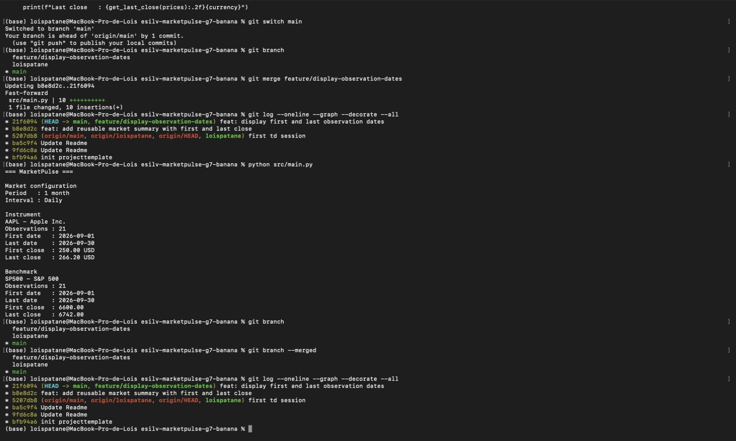
$ git branch -d feature/display-observation-dates
Deleted branch feature/display-observation-dates (was 21f6094).
$ git branch
loispatane
* main
$ git log --oneline --graph --decorate --all
* 21f6094 (HEAD -> main) feat: display first and last observation dates
* b8e8d2c feat: add reusable market summary with first and last close
* 5207db8 (origin/main, origin/loispatane, origin/HEAD, loispatane) first td session
* ba5c9f4 Update Readme
* 9fd6c8a Update Readme
* bfb94a6 init projecttemplate

Partie 10
$ git status
On branch main
Your branch is ahead of 'origin/main' by 2 commits.
(use "git push" to publish your local commits)

nothing to commit, working tree clean
$ git log --oneline --graph --decorate --all
* 21f6094 (HEAD -> main) feat: display first and last observation dates
* b8e8d2c feat: add reusable market summary with first and last close
* 5207db8 (origin/main, origin/loispatane, origin/HEAD, loispatane) first td session
* ba5c9f4 Update Readme
* 9fd6c8a Update Readme
* bfb94a6 init projecttemplate
$ python src/main.py
=== MarketPulse ===

Market configuration
Period : 1 month
Interval : Daily

Instrument
AAPL - Apple Inc.
Observations : 21
First date : 2026-09-01
Last date : 2026-09-30
First close : 250.00 USD
Last close : 266.20 USD

Benchmark
SP500 - S&P 500
Observations : 21
First date : 2026-09-01
Last date : 2026-09-30
First close : 6600.00
Last close : 6742.00

