BIT 4107 – Mobile Application Development

Student Name: LoiseRose Njeri Wainaina
Admission Number: BIT/2025/69955
School/Faculty: School of computing and Informatics
Programme: Bachelor of Information Technology
Academic Year: 3
Semester: 2
Lecturer: MR NYORO
Phone Number 0748693194

Table of Contents
(For all source code full working system will be uploaded in git hub) 3
Week 1: Introduction to Mobile Application Development 3
Practical Activities Undertaken 3
Tools/Software Used 3
TASK 2. FIRST APP CREATION 6
TASK 3: CHALLENGES AND SOLUTIONS 9
Personal Reflection 11
Week 2: Mobile Development Environment 12
STUDENT MINI MANAGEMENT 12
CHALLENGES AND SOLUTION OF WEEK2: 16
Week 3: User Interface Design 17
FIGMA TASK 17
PERSONAL REFLECTION 22

(For all source code full working system will be uploaded in git hub)

Week 1: Introduction to Mobile Application Development

Practical Activities Undertaken

Tools/Software Used

TASK 1: DEVELOPMENT TOOLS ASSEMENT
I had the following tools in my device so the was no need for me to install them again …
I identified them by running these commands in the cmd.
- Java Development kit
Version: java -version
Status: installed and working 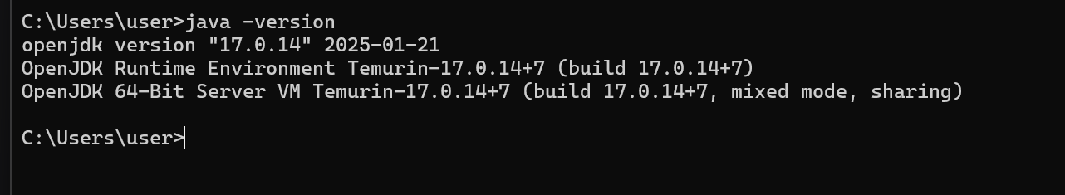

- Node .js
Version: node –version
Status: installed
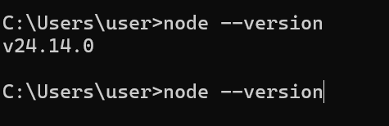

- Git
Version: git – version
Status: installed
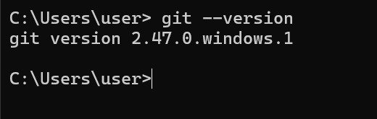
- Vs code
Version: code - -version
Status: installed
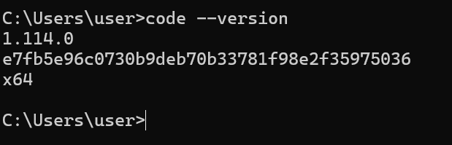

The other tools that I needed included
- Flutter sdk
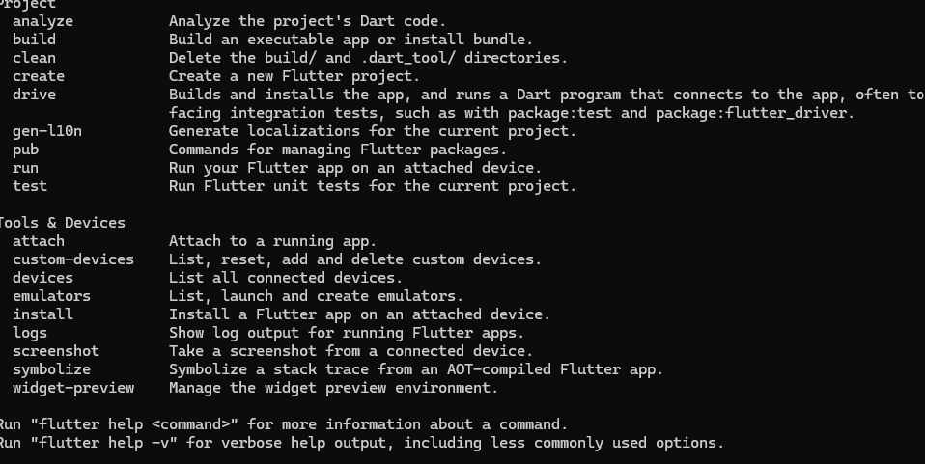
- Android studio
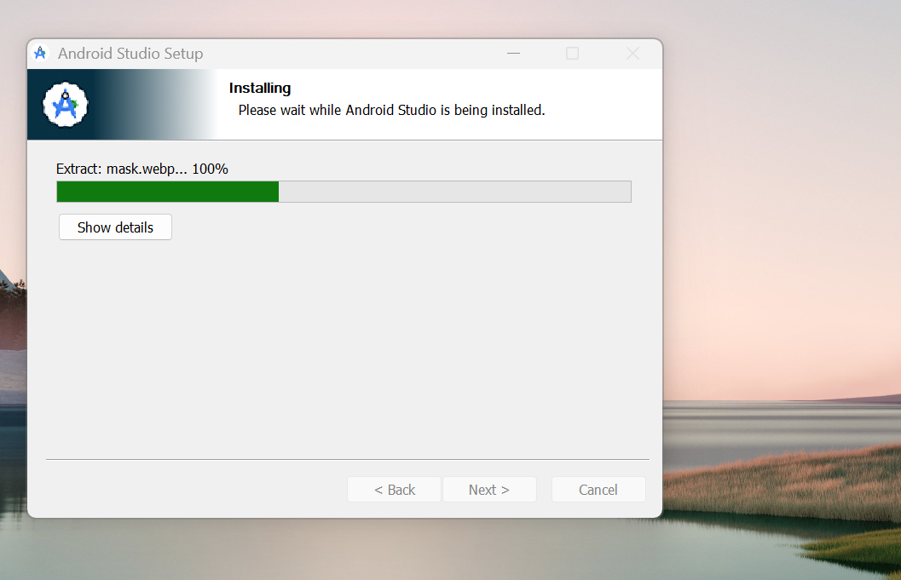

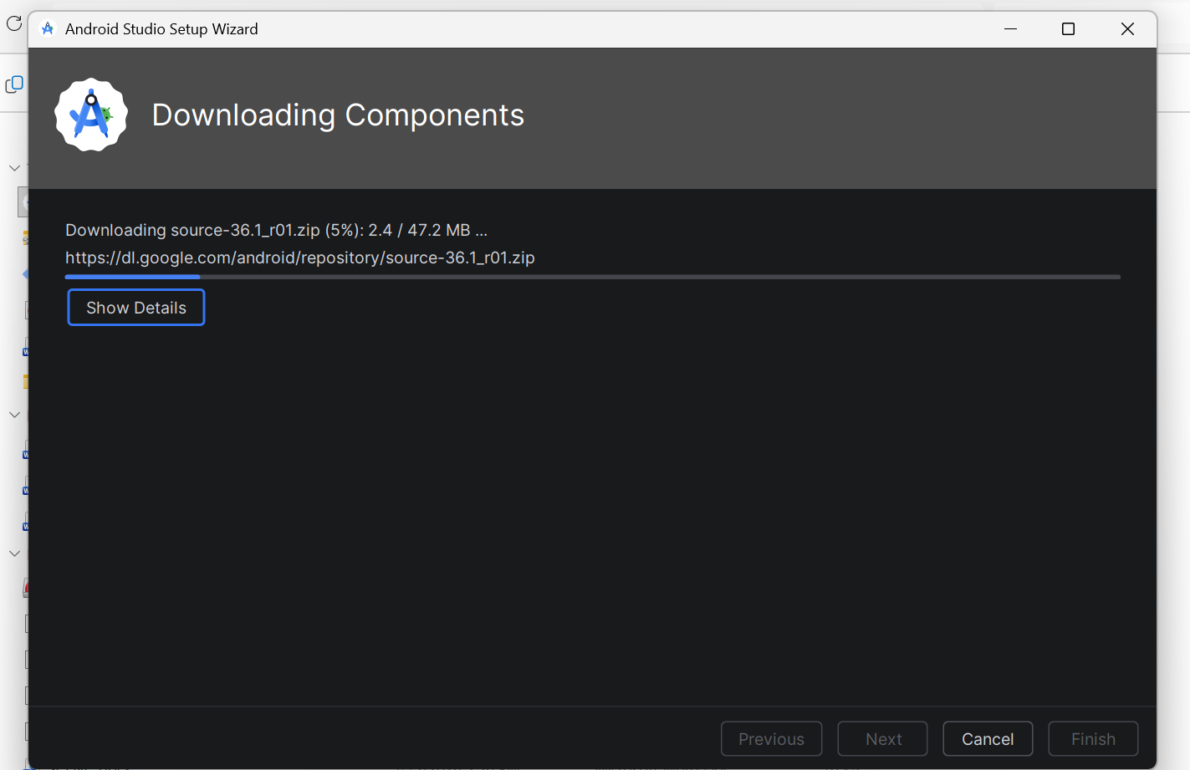

- Emulator working properly
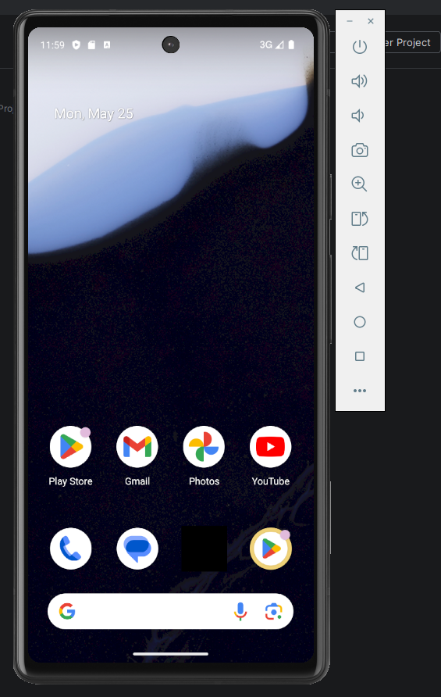

TASK 2. FIRST APP CREATION
App title: My first mobile app
Background color: deep purple
Fontsize:28

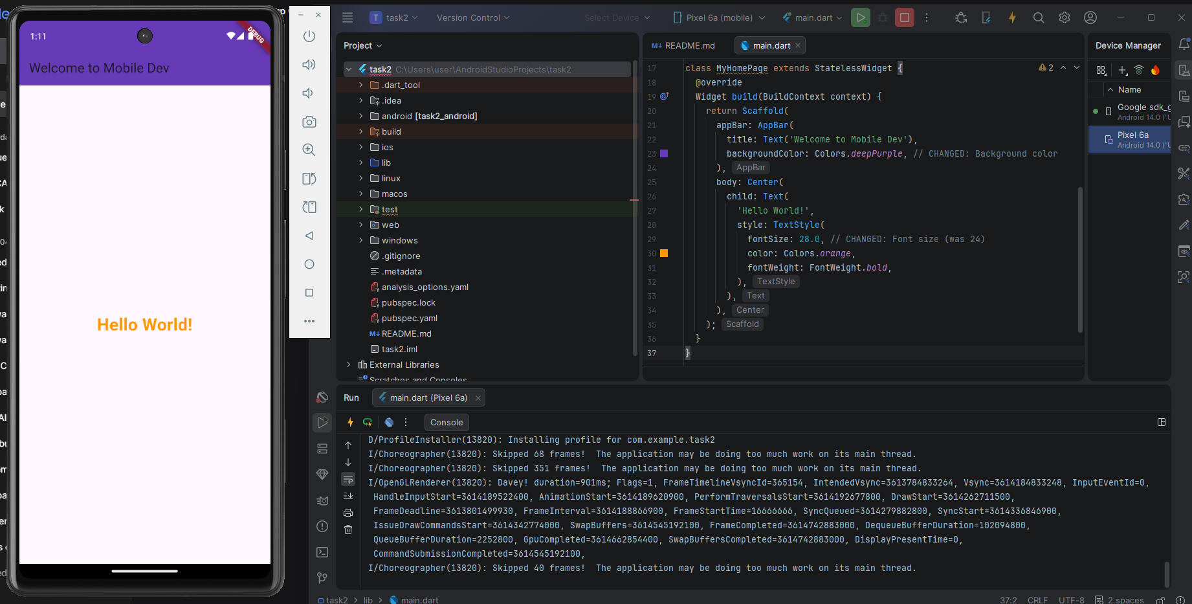

App title: TASKMASTERPRO
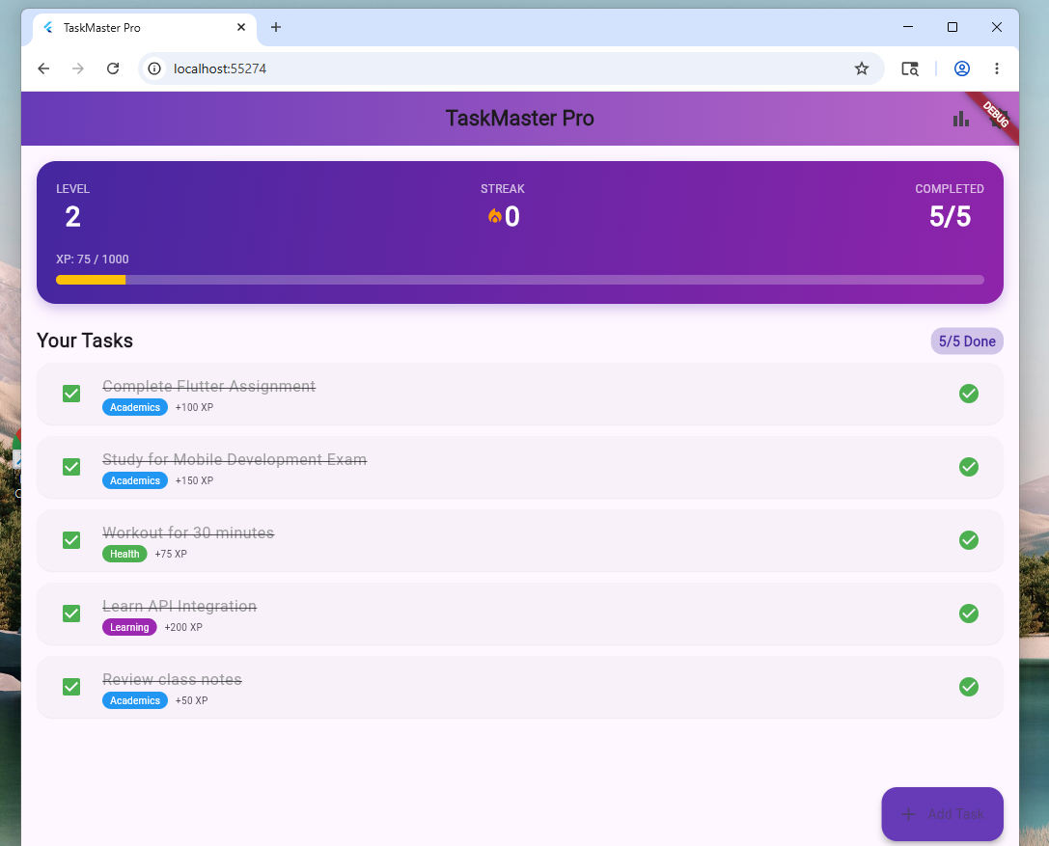
You can also add tasks
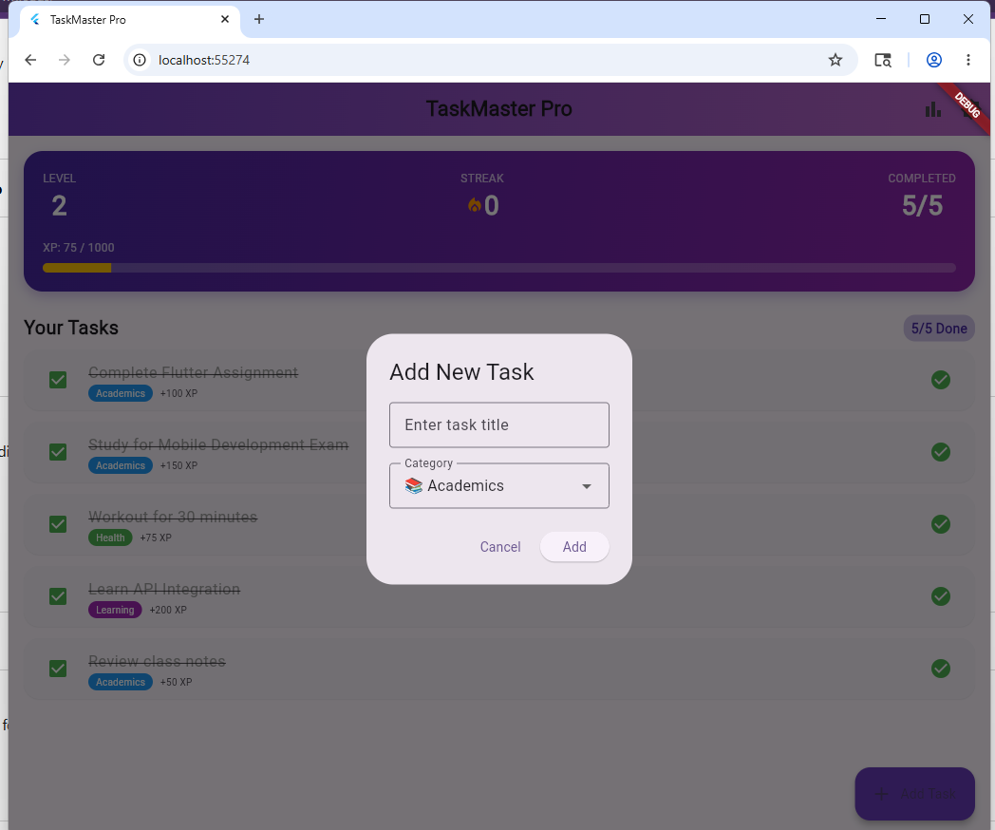

TASK 3: CHALLENGES AND SOLUTIONS
Challenge 1: kept being unable to download sdk for flutter
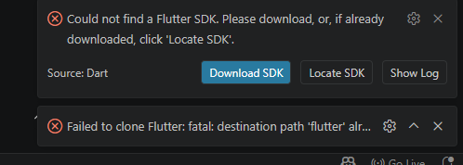
Trials: had to uninstall git and install it again because I thought it was the one causing issue. but unfortunately, it wasn’t the cause.
Solution: I had to install the flutter manually instead of using the visual studio.
Challenge 2. The app could only run on chrome but refused to run on windows
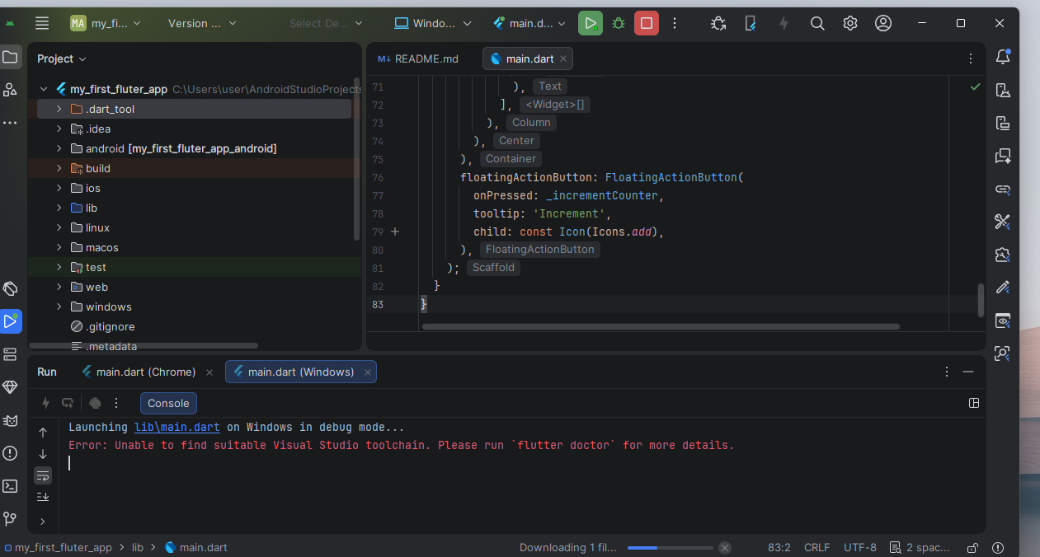
Solution: first started by the checking the type of visual studio I have by running this command
- Where msbuild
this totally failed coz it presented another challenge
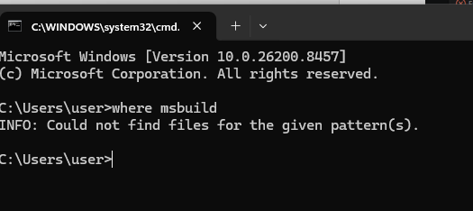
Which made me confirm what the flutter doctor had been telling me: that the necessary visual studio build tools were not installed yet in my system.
The solution for this was
- Either I install the full visual studio which required a lot of space
- Or I just download the building tools I need from the visual studio website
I decided to go with the second option
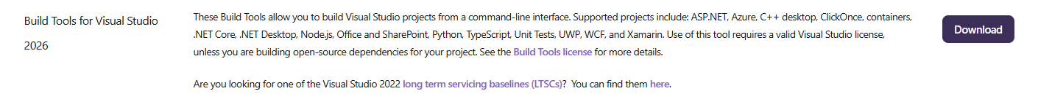

Personal Reflection
It was both frustrating and insightful to set up Flutter and to fix the errors in the build tool. The manual installation of the SDK and Visual Studio build tools helped me to learn how to troubleshoot systematically. It was rewarding to get that first app up and running with Chrome.

Week 2: Mobile Development Environment

STUDENT MINI MANAGEMENT

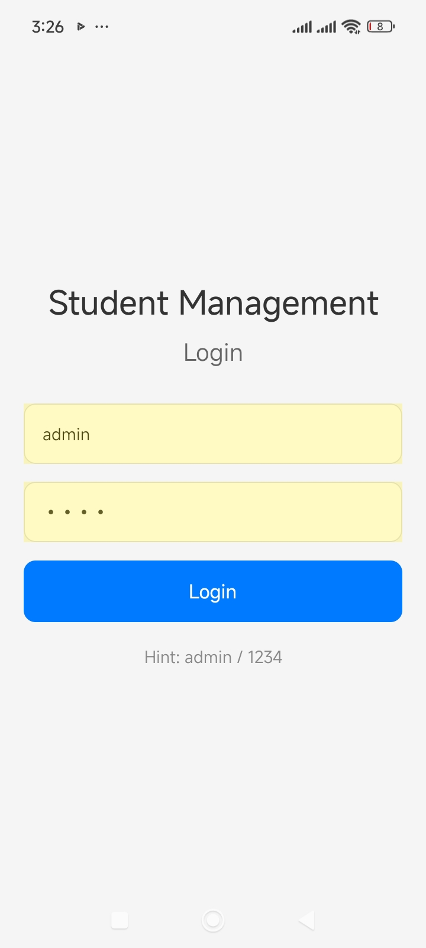

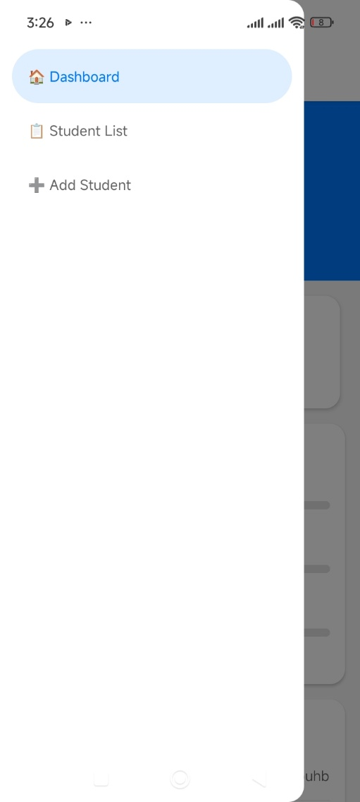

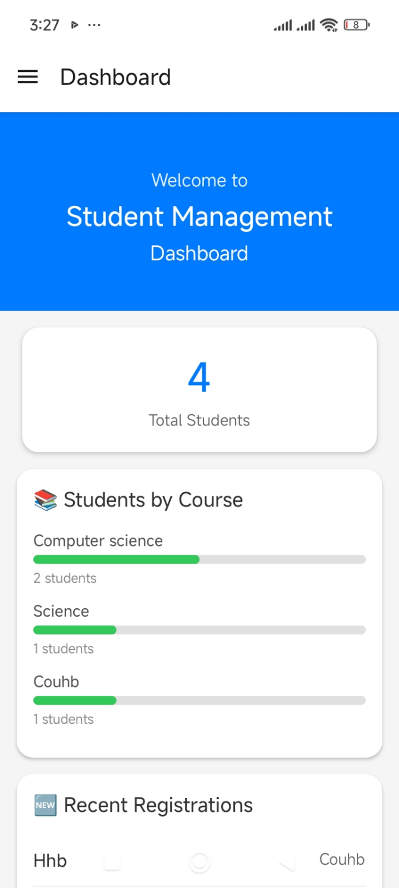

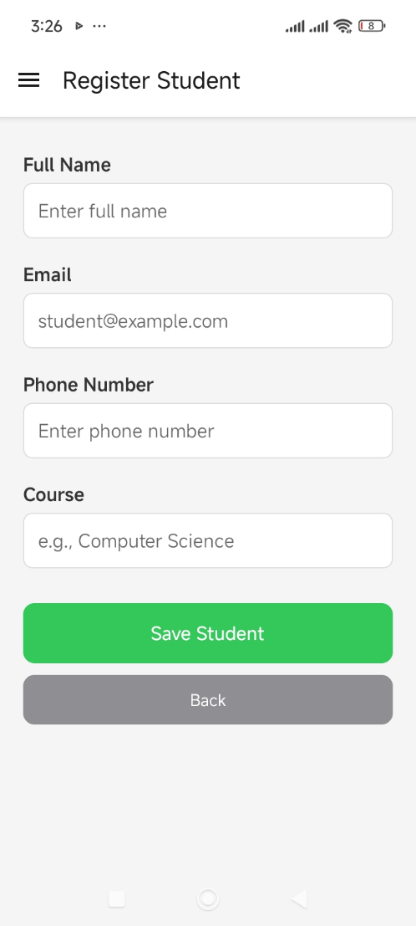

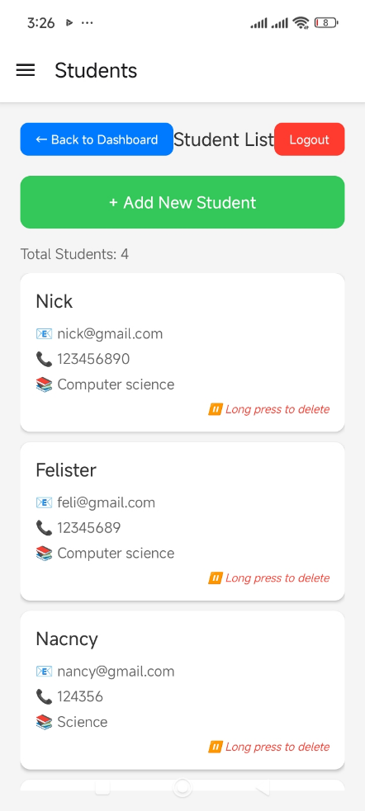

CHALLENGES AND SOLUTION OF WEEK2:
Challenges:
The process of running the program with the Android Studio simulation was not so easy, because my laptop often had to be restarted when I was in the process of writing this application, so it became slow, frustrating and less motivated to write this program. There were also problems with using USB debugging to run the app on my phone, as I had difficulties finding the settings on my phone that are needed for it.
solutions:
To overcome these challenges, I looked at the other ways to test the application and found Expo Go. Expo Go was used in conjunction with an application running in Visual Studio Code, making it possible to test and run the application directly on the phone. This worked well, it doesn't put too much strain on my laptop and helped me make the development process smoother

Week 3: User Interface Design

FIGMA TASK

  - LOGIN IN PAGE

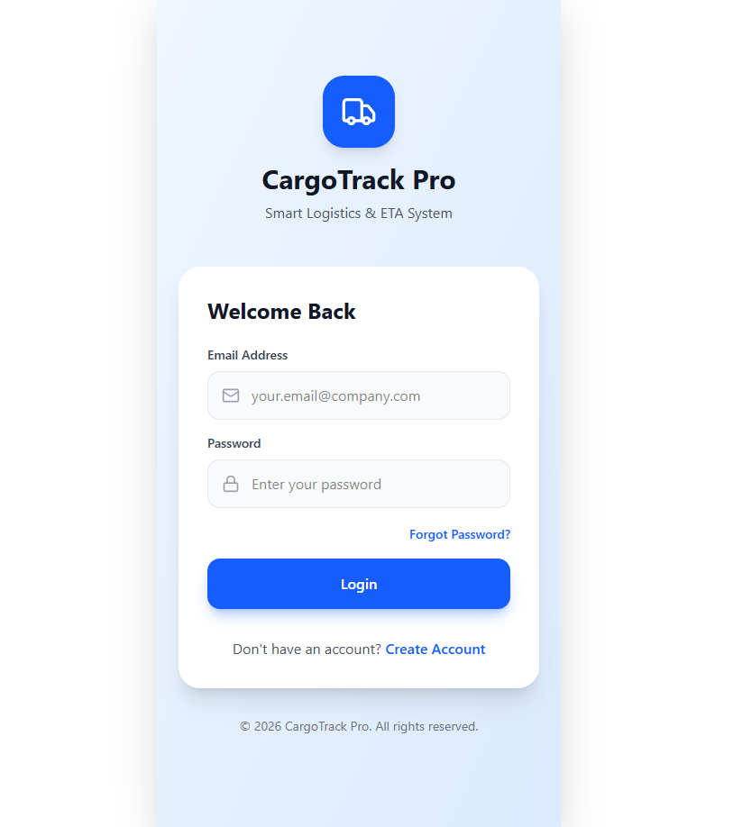
After login it takes you to this page
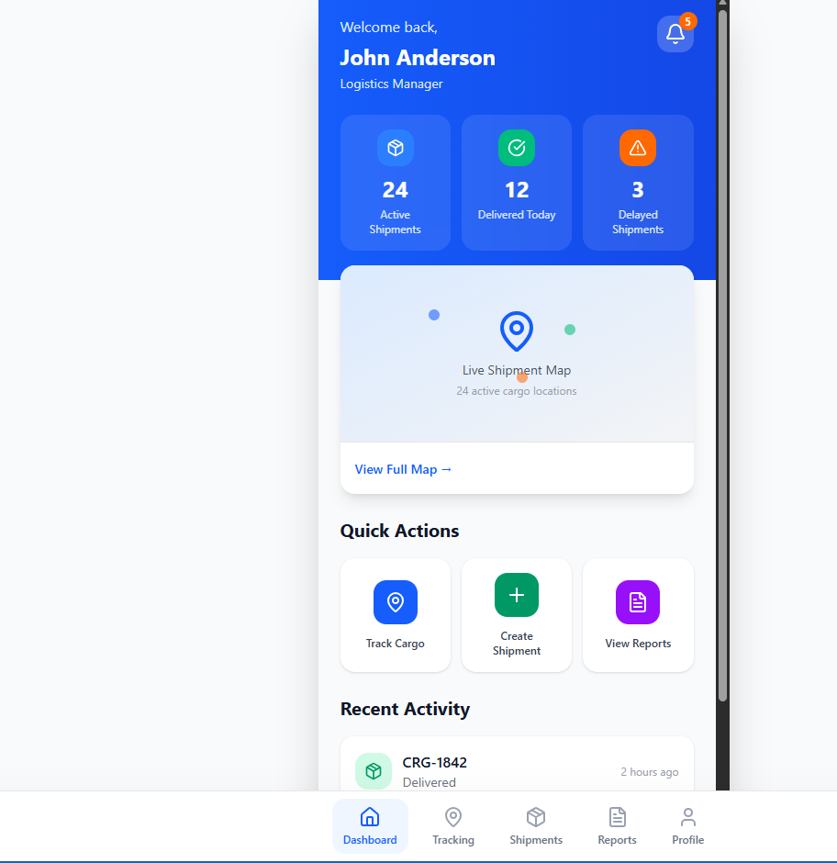
Tracking page
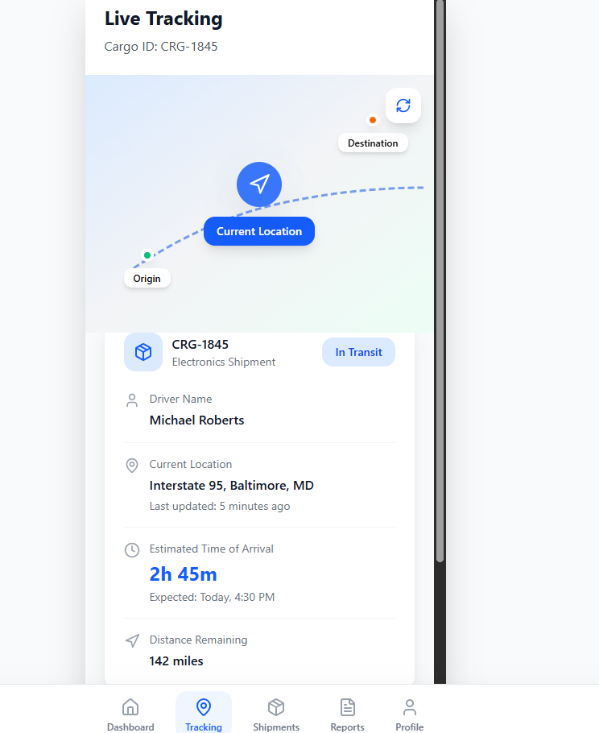
Shipments page
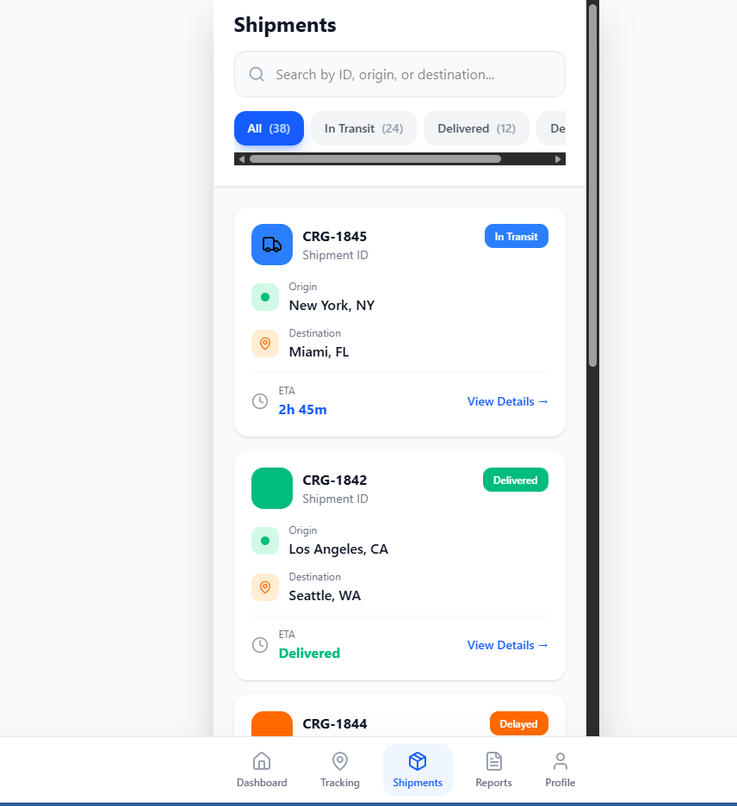
Reports page
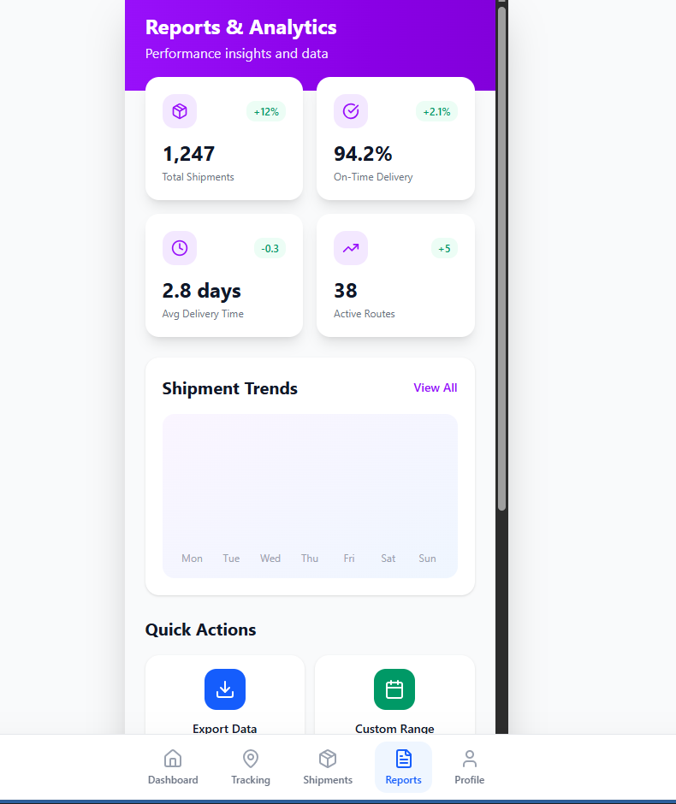
And the final page. profile page
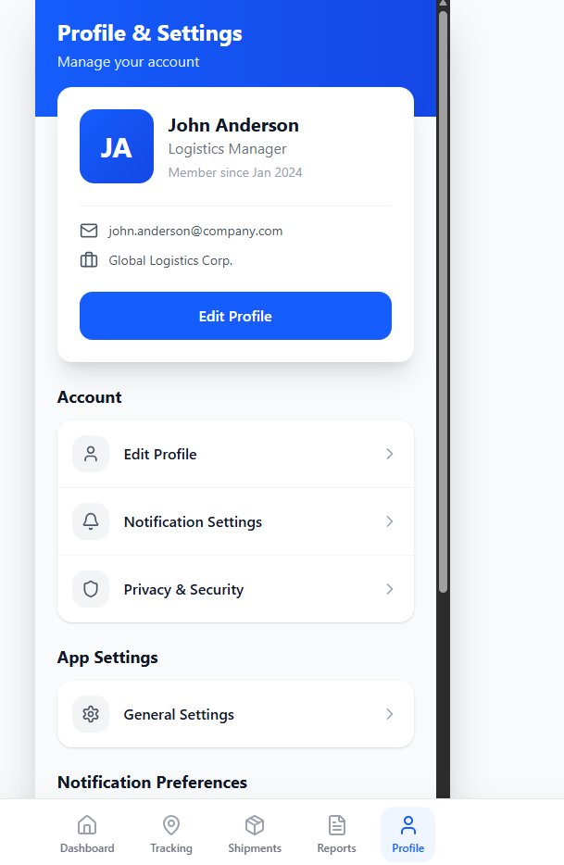

PERSONAL REFLECTION
In Week 3, I learned how to use Figma and I was able to design my first project successfully. I was really happy to see my design implemented by incorporating it into Visual Studio and creating the actual application. This experience helped me improve my skills in designing and developing.

