Estimating the Labor Market Value of Community College Bachelor’s Degrees: Evidence from a Pilot Study in Early Childhood Education

Riley Acton ⓡ*  Miami University |  | Camila Morales ⓡ  University of Texas at Dallas |  | Julia A. Turner ⓡ  Northwestern University
 | Lois Miller ⓡ  University of South Carolina |  | Kalena E. Cortes ⓡ  Texas A&M University

PRELIMINARY – PLEASE DO NOT CITE OR DISTRIBUTE
Click here for the latest version of this draft
This version: February 23, 2026

Abstract: Despite large returns to postsecondary education, disparities in degree attainment across income and racial-ethnic groups persist, leading policymakers to explore alternative strategies for increasing postsecondary access and success. Community College Baccalaureate (CCB) programs have emerged as one alternative, offering more affordable and accessible pathways to bachelor’s degrees. However, little is known about their value in the labor market. To understand how completing a CCB degree may impact graduates’ labor market prospects, we conduct a resume audit study in which we submit fictitious applications to real job postings, experimentally assigning the institution attended, degree awarded, and applicant race and ethnicity. In this pilot study, we focus on early childhood education (ECE) programs, which may be particularly impactful for women of color, who are overrepresented in the ECE workforce, often in low-wage positions. We find that CCB degrees are viewed comparably to both traditional bachelor’s degrees and associate degrees by employers in this setting, with similar rates of callbacks across degree types. These findings will inform larger audit study in other fast-growing CCB programs (i.e., business, information technology, and healthcare) across the U.S.
JEL Codes: I21, I23, I24
Keywords: community college baccalaureate; college accessibility; college choices; college attainment; associate degree; bachelor’s degree; community colleges; two-year colleges; four-year colleges; public postsecondary institutions
- Introduction
The labor market returns to postsecondary education have risen substantially in recent decades, reflecting structural changes in the US economy and growing demand for skilled workers (Autor, 2014; Ashworth & Ransom, 2019). The percentage of jobs requiring at least a bachelor’s degree has more than doubled since the 1970s, rising from 16% to nearly 36%, and projections indicate continued growth in the kinds of occupations requiring some form of postsecondary credential (Carnevale, Smith, & Strohl, 2013; Carnevale, Smith, Van Der Werf, & Quinn, 2023). Although bachelor’s degree attainment has also increased meaningfully over time, progress has been markedly uneven. Over the past three decades, gaps in college attendance and bachelor’s degree completion have widened between underrepresented minority (URM) and non-URM students, and between low- and high-income students (Cahalan et al., 2021; Reber & Smith, 2023). Consequently, broadening pathways to a bachelor’s degree is key to meeting a growing demand for skilled labor and expanding access to the economic mobility higher education affords.
Policy interventions aimed at increasing postsecondary enrollment and success largely focus on increasing access to four-year institutions. These efforts often address demand-side barriers that are well documented in the literature, such as college preparation in the K-12 sector, financial aid and credit constraints, and informational barriers (see Dynarski, Page, & Scott-Clayton, 2022 and Dynarski et al., 2022 for comprehensive literature reviews). Many of these interventions have proven successful and have led to large-scale reforms, such as required standardized testing regimes (Goodman, 2016; Hyman, 2017), mandated FAFSA completion (Deneault, 2023), and direct admissions programs (Odle & Delaney, 2025). However, these policy changes largely presume that the path to a bachelor’s degree runs through traditional four-year colleges and universities, underemphasizing the role of community colleges as a central access point to higher education. When they do consider community colleges, it is usually through their transfer function, but while the majority of students who begin at a community college intend to transfer to a four-year to earn a bachelor’s degree, only about one-third transfer and only half of those who transfer earn a bachelor’s degree within six years (Velasco et al, 2024). Even those students who do successfully transfer and earn a bachelor’s degree might not reap labor market rewards (Miller, 2025).
In this paper, we evaluate the labor market outcomes of a growing, yet understudied, pathway to a bachelor’s degree – the community college baccalaureate (CCB). Offered across 24 states (Community College Baccalaureate Association & Bragg & Associates, Inc., 2024), CCB programs allow community college students to complete their bachelor’s degree without having to transfer to a traditional four-year institution. In addition to being more accessible financially and academically, community colleges are more geographically accessible, which may be particularly important for URM and low-income students who are more sensitive to the distance they must travel to reach college (Acton, Cortes, & Morales, 2024; Acton, Cortes, Miller, & Morales, 2024). Thus, CCB programs may offer a path to increasing overall bachelor’s degree attainment, while also reducing completion disparities by race-ethnicity and income. However, their potential as an effective mechanism to broaden economic opportunity ultimately depends on whether this new degree is perceived favorably in the labor market.
In order for community colleges to offer bachelor’s degrees, states must pass legislation allowing them to do so. Although the first CCBs were authorized by West Virginia in 1989, most of the growth of CCB programs has been in more recent years. Between 2004 and 2022, the share of community colleges offering bachelor’s degrees increased from 2.1% to 16.5% and the number of degrees awarded more than quadrupled, from 3,327 to 16,059 (see Figure 1). CCB programs are often offered only in specific high-demand fields, aligned with community colleges’ workforce development mission (Van Noy et al., 2023).
The relatively recent introduction of CCB programs and the small number of total degrees awarded has limited the scope for causal research on the returns to these degrees. Indeed, most of the existing evidence on the returns to CCB programs relies exclusively on descriptive analyses comparing the earnings of students with CCB degrees with those of individuals holding either associate or bachelor’s degrees from traditional four-year institutions. Studies drawing on data from single states indicate strong average earnings for CCB completers (Cominole, 2017; Kaikkonen & Quarles, 2018; Love, 2020; Meza & Bragg, 2022). In a separate paper, we conduct a national-level descriptive analysis, and our findings suggest that CCB programs offer an intermediate credential, with median earnings typically falling in between those of associate degree holders and graduates with a bachelor’s degree from a traditional four-year institution (Acton, Morales, Cortes, Turner, & Miller, 2026). Nonetheless, the causal impacts of attaining a CCB degree remain largely unexplored.
To circumvent identification and data challenges, we explore employer’s value of CCB programs by conducting a resume audit study in which we apply to real job vacancies using fictitious resumes that randomly vary the applicant’s degree (i.e., associate versus bachelor’s), the institution that conferred it (i.e., community college versus traditional four-year university), and their race and ethnicity (White, Black, or Hispanic) signaled through their first and last names. We are ultimately interested in understanding both the labor market value and potential racial-ethnic equity impacts of CCB degrees across many fields of study. However, for this pilot study, we have focused on the labor market value of CCB programs in early childhood education (ECE) —a popular and growing field among CCB offerings with 23 currently active programs across the nation, including 7 approved since 2020 (CCBA, 2024). The ECE field offers multiple advantages for our pilot. First, it enables us to focus on women, as they make up upwards of 97 percent of the workforce in this industry, which simplifies the construction of fictitious applicant names. Second, this degree prepares students for a well-defined set of occupations, facilitating both the identification and application of job postings. Finally, ECE CCB programs have the potential to close racial-ethnic gaps in earnings and promote economic mobility, with an overrepresentation of women of color particularly among the lowest-paid positions in this industry (Austin et al., 2019).
We conducted our pilot study over the course of 17 weeks and across two major cities: Dallas, TX, and Seattle, WA. Both Texas and Washington rank among the top five states with the highest number of authorized CCB programs, though the institutional saturation of CCB offerings varies meaningfully across the two. Nearly 90 percent of community colleges in Washington offer at least one bachelor’s degree compared to just over 30 percent in Texas (Love, Bragg, and Harmon, 2021). As a result, students and employers in Washington may have greater exposure to and knowledge of CCB degrees compared to students and employers in Dallas—a layer of heterogeneity we plan to explore in our analyses. Overall, across these two cities, we collected information on 3,171 job vacancies and applied to 1,570, for an overall submission success rate of roughly 50%. Following the resume submission stage, we then tracked employers’ responses to capture differences in callback rates across degrees, institutions, and applicant’s implied race to test how employer discrimination by race and ethnicity interacts with perceptions of degree type.
Our preliminary results suggest that applicants with CCB degrees perform similarly to applicants with traditional bachelor’s or associate degrees in the ECE labor market. Over 20 percent of all applicants received an interview request, and over 30 percent received either an interview request or a request for more information. We do not find any statistically or economically significant differences in callback rates across the three degree types (AA, CCB, or traditional BA). For CCBs relative to traditional bachelor’s degrees, we can rule of negative effects on interview requests larger than 0.8 percentage points (3.7 percent of the baseline mean), implying that CCB holders may not be disadvantaged in this labor market. At the same time, do not find evidence that CCB degree holders are being called back more often than associate degree holders and can rule out positive effects greater than 1.9 percentage points (6.3 percent of the baseline mean).
We note that results may be specific to the ECE labor market, a tight labor market that is characterized by low wages, high turnover, and persistent vacancies. Most of the job postings for which we applied did not require a bachelor’s degree, so employers in our sample may have thought that they would have a better chance of hiring or retaining someone with an associate or CCB degree relative to a traditional bachelor’s. This is consistent with responses to our employer survey, which we sent to email addresses collected through callbacks and job postings to better understand potential mechanisms underlying the results of the experimental audit study. In the survey, employers emphasize experience, personality, and reliability as the primary drivers of hiring decisions. A common theme of responses is worry about not being able to offer high enough pay to secure applicants, especially those with higher levels of education.
Results from this pilot study inform our scaled-up version of the audit study, set to launch in summer 2026. In the larger study, we will expand to more industries and labor markets to paint a more comprehensive picture of how CCB degrees are viewed in the labor market. We are targeting business, information technology (IT), and nursing as fields of study, which are the most commonly offered CCB degrees nationally. We will be submitting applications across to six distinct labor markets: two cities in each of Texas, Washington, and Florida, which are some of the top states for CCB programs. We plan to submit approximately 50,000 resumes (10 times the scale of our pilot) which will allow for richer heterogeneity by race-ethnicity, gender, field of study, and location.
This study contributes to a robust literature assessing the returns to college (see Lovenheim & Smith, 2022 and Oreopoulos and Petronijevic, 2013, for comprehensive reviews), specifically joining a long tradition of resume audit studies and experimental approaches to estimate the labor market returns to community colleges and of emerging post-secondary options – such as for-profit and online credentials (Darolia et al., 2014; Deming et al., 2016; Zhu 2023) – and to explore employer perceptions of applicant characteristics (Riach & Rich, 2002; Bertrand & Mullainathan, 2004; Lahey, 2008). To our knowledge, this is the first resume audit study designed to evaluate the returns to CCB degrees specifically, and to investigate how the labor market reception of these degrees may interact with documented patterns of racial and ethnic discrimination in the labor market.

- Policy And Labor Market Background
Although the community college baccalaureate was first authorized in West Virginia in 1989, momentum towards offering these degrees across the country has only recently gained traction and widespread attention. The CCB policy landscape is active and currently evolving, with 24 states currently offering these degrees and several (Illinois and Iowa) in the process of introducing legislation at the state level. Even across the 24 states that have authorized CCBs, authorization strategy varies significantly. Florida and Washington state have granted near-universal authorization, while several large states—including California and Texas—cap degree awarding and number of programs with the goal of limiting competition between community colleges and traditional four-year institutions. The variation across states in familiarity with CCB programs in general and within the ECE industry is a key dimension of the heterogeneity that we explore in this pilot study and one that we hope to pursue in the full study.
In our case, Texas and Washington provide two unique policy landscapes in which to study the labor market value of the CCB degree. Although the CCB legislation was introduced in Texas and Washington around the same time (2003 and 2005, respectively), CCBs have grown at a much more rapid pace in Washington than in Texas. In 2024, roughly 3% of Washington students enrolled in community colleges were in CCB programs, whereas CCB enrollment accounted for less than 1% in Texas (THECB, 2025; SBCTC, 2025; Carpenter, 2025). As of 2023, 100% of the community colleges in Washington state were enrolling students in CCB programs, whereas the reach of programs in Texas is still limited to fewer than half of all community colleges in the state. We hypothesize that the popularity of CCB programs across the state and especially in the major metropolitan areas in which we concentrate our resume submissions (Dallas and Seattle) may affect employers understanding of and attitudes towards the degrees, which may in-turn influence their probability of hiring CCB graduates.
A common feature of CCB legislation across states is the requirement that CCB programs be tailored to local workforce needs. Written into many state-level CCB legislative documents is the requirement that programs be limited to industries in which labor demand is currently outstripping supply (Meza and Love, 2023). Figure 3 shows that the most common CCB industries across the country are Business, Health Professions, Computer and Information Sciences, and Education. Although business degrees dominate the CCB landscape with nearly 40% of CCBs awarded in 2022-2023 coming from business CIP codes, education represents one of the fastest-growing CCB fields of study across the country, largely spurred by notable labor shortages across all levels of education in the wake of the COVID-19 pandemic (Kersenbrok, 2025; Meza and Love, 2023).
ECE Labor Market Details
The early childhood education workforce in the U.S. is characterized by persistent challenges related to low wages, high turnover, and growing labor shortages—conditions rooted in what many have identified as market failure in the ECE sector (CEA, 2023a, 2023b; Treasury, 2024). ECE workers are disproportionately female, with women representing upwards of 97% of the workforce, and women of color are overrepresented in the field, often in the lowest paid positions (Coffey, 2022; Evangelist et al, 2025). Despite limited data on this workforce, studies such as Austin et al. (2019) document substantial racial wage gaps in the ECE sector: Black early educators earn approximately 78 cents for every dollar earned by their white counterparts, while Hispanic educators earn roughly 90 cents on the dollar, even after controlling for education, experience, and work setting. Given the demand for credentials and certification among early childhood educators, the workforce has a relatively high rate of post-secondary attendance. The Center for American Progress reports that nearly 80% of the ECE workforce reports having some college, and at least half have obtained an associate degree (Coffey, 2022).
Wages in the ECE sector are relatively low compared to other occupations requiring similar levels of education and certification. As of 2025, the Bureau of Labor Statistics reports median wages for child care workers were approximately $15.41 per hour, while preschool teachers earned around $17.85 per hour—both substantially lower than the median wage for kindergarten teachers with comparable credentials, who earned approximately 40% more annually (BLS, 2025a, 2025b). The combination of low wages and limited benefits contributes to annual turnover rates of 14.9 percent in the child care market—about 65 percent higher than turnover in the median occupation and 75 percent higher than turnover among kindergarten teachers—creating instability for both workers and the children they serve (Fee, 2024).
The COVID-19 pandemic exacerbated longstanding workforce challenges in the ECE sector. Between February 2020 and April 2020, ECE employment fell more than 30 percent, and the industry is still recovering (CEA, 2023b). This workforce collapse, combined with increasing demand for ECE services as parents returned to work and states expanded public pre-K programs, has created acute labor shortages. In a 2024 survey conducted by the National Association for the Education of Young Children (NAEYC), 68% of directors of child care facilities reported having significant vacancies within their program (NAEYC, 2024). This problem is further exacerbated by employers reporting difficulty filling positions and longer time-to-hire periods (Khattar & Coffey, 2023), conditions that lend themselves especially well to innovative policy solutions such as CCB program introductions.
The introduction of CCB programs in the ECE field are particularly well-timed given the shifting credential requirements for early childhood educators over the past two decades. The professionalization movement—which has seen federal and state policies increasingly mandate bachelor’s degree attainment—gained significant momentum with the 2007 reauthorization of the Head Start Act, which required that at least 50% of Head Start teachers hold a bachelor’s degree in ECE or a related field by the end of 2013 (U.S. Congress, 2007). What started as national legislation, however, proved tractable across states, with a 2020 National Institute for Early Education Research report finding that as of 2018, 78% of state-funded public preschool programs required teachers to hold at least a bachelor’s degree alongside their teaching certification (Friedman-Krauss et al, 2020). The demand for bachelor’s degrees in the field has contributed to the tightness of the labor market and could potentially create an important pay gradient by educational attainment. This policy landscape makes bachelor's degree accessibility in ECE particularly consequential for workforce equity and economic mobility.

- Experimental Design Details
We examine the labor market value of CCB degrees by tracking employer responses to fictitious resumes. In this section, we briefly describe the study setting, resume construction, and provide an overview of our experimental procedures. Sample resumes are shown in Appendix A.
Pilot Study Setting and Job Posting Collection
Our pilot focused on two ECE CCB programs and the returns to these degrees in their associated local labor markets. The Dallas College Bachelor of Applied Science (BAS) in Early Childhood Education and Teaching and the North Seattle College BAS in Early Childhood Education present two similar programs situated in geographically unique labor markets. Although both Texas and Washington introduced CCB legislation nearly 20 years ago, Washington offers more than triple the number of CCB programs. The concentration of CCB degrees in local labor markets in Washington may result in higher levels of familiarity with these degrees across employers. In both states, however, the ECE CCB is relatively new. These conditions allow us to understand the value of a truly “new” credential in the eyes of employers across settings that vary in general familiarity with CCBs. Our post-experiment employer survey, described below, further explores employers’ recognition and understanding of these degrees.
We submitted resumes to jobs located in the largest metropolitan area in each state near the selected CCB institutions: in Texas, applications were submitted to jobs in Dallas; in Washington, to jobs in Seattle. We initially focused on jobs in a 25-mile radius around the city in question; in Week 5, we expanded our search radius to 35 miles around the city to maximize the number of postings available. Our postings collection occurred once per week at the beginning of the week (Sunday night through Monday afternoon). To collect postings, research assistants (RAs) searched two large, commonly used job posting websites using the keyword phrase “early childhood education.” RAs then recorded every available job posting, collecting all available information (focusing on job title, employer name, location, salary, and benefits information) for each posting.
Once collected, postings were fed into our resume randomizer script (described in more detail below). This resume randomizer script searched for (1) duplicate postings across weeks (using employer name and job title) and (2) duplicate employers across weeks. Duplicate postings across weeks were discarded (the first instance of each posting was kept), and duplicate employers across weeks were flagged such that employers did not receive multiple resumes with the same applicant profile information (name, email, phone number), but different work histories. The construction of these resume features is discussed in more detail below.
Resume Construction – Profiles
The names on resumes were chosen so that job applicants would vary in terms of signaled race and ethnicity. As ECE is a female-dominated field, we chose names that uniformly signaled female-identifying applicants (Evangelist et al, 2025). We used Census Bureau data to identify common first names for each racial/ethnic group represented in our study: Black, Hispanic, and white. We selected 10 first- and last-name combinations within the 25 most relatively common female names for each race-ethnicity group. In light of research from Fryer and Levitt (2004), we avoided using names, especially for Black applicants, that are more commonly given to children from lower socioeconomic (SES) households, including names used as examples in Fryer and Levitt (2004), which could confound the effect of race with perceived SES background.
We created separate email addresses and phone numbers for each of these 30 names in Dallas and in Seattle (i.e., we created 60 total email addresses and phone numbers). Where possible, email addresses were some combination of the applicant’s first and last names and a randomly assigned birthdate. If necessary, we also assigned a (random) middle initial for email generation (i.e., catalina.b.ortiz@gmail.com). Phone numbers for each labor market were selected to have the same geographically relevant area code. Profiles on job-posting websites were also created for each applicant (60 in total across Seattle and Dallas); no information apart from email and first and last name was saved in the profile.
Resume Construction – Work Histories
We populated resumes with randomly selected combinations of actual work histories, relying on resumes posted online by real job seekers who had attended the group of institutions we study. To collect these job histories, we had RAs search the online resume bank for each institution and record the individual work experiences of any individual who had graduated from an ECE program at one of these institutions. We split these work experiences into two types: relevant experience and other service experience. Relevant experience was any work history that included work at an early childhood education center or work with young children. Other service experience were traditional entry-level jobs in retail or food service (i.e., Starbucks barista, retail worker at Best Buy, etc.). We include one of each type of experience, of similar length, on each resume. From the resume bank we also collected short descriptions to accompany each job. We used these descriptions, along with similar descriptions generated by ChatGPT, to create comparable versions of these bullet-pointed job descriptions to accompany each job experience. The resume randomizer program randomizes the collection of bullet points included with each service job and relevant job experience on the resumes.
Ensuring the comparability of these work histories across applicants is incredibly important for the strength of the education signal, so for each resume, we drew from the same city-specific pool of work histories. Additionally, we structured work history such that each individual had similar years of work experience (within 1 year of difference) and all work histories only included post-high school employment. We set up resumes such that—with the exception of a program-mandated work experience—there were no new jobs listed after or during the college experience.
All six programs (two AA, two BA, two CCB) we study require students to complete a mandatory “residency” program in which they participate in ECE-related work experience during their time in college. In order to maximize comparability of this experience while minimizing chance of detection, we listed that each of our applicants completed these experiences in an unspecified school in the nearest large, public school district (i.e., Seattle Public Schools or Dallas Independent School District). We also varied the title of the work experience across applicants (for example “Student Teaching Intern - Seattle School District” versus “Classroom Intern - Seattle Public School District”). Finally, we ensured that all applicants completed the student teaching experience in the Spring semester of their degree program (i.e., January-May 2025).
Other Resume Characteristics
Our resumes also included information on high school attended and additional skills. Additional skills were of two types: required and non-required. Required skills were those that appeared on 90% of resumes viewed in the resume bank and that we deemed “common” for individuals applying to ECE jobs in each state. These included: driver’s license, first aid certification, and CPR certification. All applicants had these skills listed in the skills portion of their resume. In order to minimize detection, we then included a randomly selected group of non-required skills to round out this skills section. These skills were also collected from the resume banks and included things like customer service, Microsoft Office, and computer skills.
High schools listed on resumes were carefully selected as to not provide an unintended signal about socioeconomic status or academic performance. We used National Center for Education Statistics data on local high school characteristics to specifically select high schools that were near-median performers in terms of aggregate state test scores and that were in near-median household income areas. In Dallas, we further used administrative data from the University of Texas at Dallas Education Research Center to identify high schools that were commonly attended by Dallas College students. The three high schools chosen in each locality were then double checked with authors that are familiar with each of the cities (Seattle and Texas) to ensure that they did not “stand out” in any way.
We were also concerned about the formatting of resumes providing a basis for employer detection. In order to avoid this, our resume randomizer program randomized three key features of the resumes: font, spacing, and organization. Six common, similar fonts were chosen (i.e., Calibri, Times New Roman, etc.) and randomized across resumes. Ensuring that all resumes fit on only one page, the program also varied spacing and justification (centering the applicant’s name, adding space between applicant email and the first section, etc.) in order to slightly alter the overall look of the resume. Finally, the organization of the resumes (e.g., whether education or work history was listed first) was randomized. These features were randomized and the program standardized several key features (e.g., applicant name and information at the top).
Resume Sending
We saw a large volume of postings in the beginning of the summer, when many new graduates are entering the labor market and employers are seeking new talent. Figure 2 shows the growth in cumulative postings over the course of the pilot submission period (beginning June 2025 and ending October 2025), which began to level-off around Week 13 (after Labor Day). Note also that resume submissions did not keep pace with postings over the course of the submission period. This is due to several factors, some of which were resolved over the course of submission and some of which were not. A major issue in the ECE submission space is the requirement of a Social Security Number (SSN) to apply to a position. Many jobs with public school districts required an SSN to apply. We did not submit any resumes to these positions. Additionally, over the course of the first two weeks, we encountered a large number of job postings that required an applicant address and/or a cover letter. We ultimately generated a bank of both addresses and cover letters to be randomly used when required by the posting. The creation of both addresses and cover letters is discussed further in Appendix B. Note that these features were only included in the application when explicitly required by the job posting.
Applications were sent to two types of jobs: those that require at most an associate degree (i.e., did not require a bachelor’s degree), and those that require a bachelor’s degree. When applying to jobs that did not require a bachelor’s degree, RAs submitted three resumes that varied by degree type: an associate degree, a CCB, and a BA from a nearby open-access public four-year institution. When applying to jobs that required a bachelor’s, we submitted only two resumes: a CCB, and BA from an open-access four-year (see Table 1). In this pilot study, the vast majority of job postings to which we successfully applied did not require a bachelor’s degree. This was largely we were not able to apply to public school positions, which typically required bachelor’s, due to the requirement of a social security number on the application.
RAs were assigned a group of postings each week with associated, randomized resumes to submit. Resumes were generated using our randomizer script. A specific set of resumes was generated for each recorded job posting. This set of resumes included 2-3 resumes (based on the educational requirement listed on the posting) of the same race/ethnicity. The randomizer script ensured no profile overlap within employers week-to-week. RAs were instructed to send all resumes to a single employer within one 5-hour window, but to leave at least 30 minutes between resume submissions to the same employer in order to minimize detection. We collect data on submitting RA identity in order to test and control for any inadvertent submission strategy effects, but inclusion of submitting RA fixed effects does not impact results. Importantly, even if RAs were submitting slightly differently, one RA submitted all resumes to a single job posting, so that any cross-RA differences in submissions would not undermine the randomization.

Employer Survey
After the conclusion of the audit study, we fielded an original survey of employers and hiring managers to better understand how they perceive and evaluate different postsecondary credentials, including CCBs. This survey was sent to email addresses that we collected from callbacks and job postings, such that it was received the same individuals that likely encountered our resumes in the field (but they were not informed of the deception). Emails were sent roughly three months after conclusion of resume submissions, informing recipients that we are a group of researchers conducting a study about hiring practices and education and asking them to complete a 10-minute survey in exchange for $25 in compensation.
The survey collects detailed information about respondents’ educational backgrounds, professional roles, and responsibilities in the hiring process (e.g., resume review, interviewing, salary setting). We also ask if the employer uses AI tools in the resume screening process. It then elicits employer evaluations of key resume characteristics such as degree type, institution attended, and field of study. A central module presents a vignette in which respondents choose who to hire and assign starting salaries to three hypothetical, equally qualified candidates who differ only by credential: an associate degree from a local community college, a bachelor’s degree from a community college, and a bachelor’s degree from a four-year university. The survey concludes with a series of questions assessing respondents’ awareness of community colleges offering bachelor’s degree.
The data collected from this survey, described in section VI, provide an important interpretive complement to the resume audit experiment. While the audit design captures employers’ revealed preferences in actual hiring behavior, the survey reveals their stated preferences, beliefs, and rationales. Together, the two data sources allow us to estimate not only the empirical labor market returns to CCB degrees, but also to illuminate the mechanisms underlying those outcomes.

- Empirical Approach
The outcome variable of interest for this study is “callback” rates from employers. There are several types of callback feedback an employer could provide, so we separately record each instance of feedback from employers. For example, we construct two separate “callback” indicators: explicit interview request or a request for more information. Whereas an interview request explicitly indicates the employer is moving ahead with the hiring process, many employers followed up with a request for more information (e.g., Would you be willing to commute x minutes? Do you have any experience running a classroom? etc.). Here, to avoid wasting employer time, we simply record the response as a request for information (which we consider a positive signal, but not as positive as an explicit interview request) and inform the employer that the applicant has accepted another position.
We use these callbacks (each indicator separately) as a signal of perceived value of the post-secondary degree in the local labor market. Given the experimental nature of the study, the assessment of results is largely straightforward: we compare callback rates across the different types of degrees to understand how CCBs are valued relative to associate degrees and traditional bachelor's degrees from open-access public 4-year institutions. Formally, the estimating equation takes the following form:
$Y_{v}=α+β∙D^{'}+γ∙X^{'}+ε_{v}$
where $Y_{v}$ is the outcome variable: an indicator for personalized callback or email communication from the potential employer. $D'$ represents the appropriate set of indicator variables for the various degree types included in the resumes sent to a specific job vacancy. See Table 1 for a breakdown of each of the degree types for various job types. In our baseline results, we do not include covariates, but results are not sensitive to the inclusion of a vector of covariates $X'$ (e.g., fixed effects for job posting characteristics, submitting RA, and resume characteristics). This equation estimates the adjusted difference in callback rates between degrees from different types of institutions. We can also use the same specification to study how differences in callback rates across degree type interact with racial-ethnic identity of the applicant. We also conduct heterogeneity analyses along a number of job characteristics (e.g., location, education requirement, posted wage/salary).

- Preliminary Results
Figure 4 shows the raw callback rates across the three degree types. Callback rates were high across the board: 22-23 percent of applicants received an interview request, and an additional 10-13 percent received a request for more information (often alongside an indication that the employer would like to schedule an interview pending the response). Callback rates are similar across all thee degree types, although CCB holders are slightly more likely to receive a “positive callback” than the other degree types.
Figure 5 shows preliminary results from our main estimating equation for callbacks to applicants with CCB degrees, relative to applicants with either as associate degree or a bachelor’s from a traditional 4-year institution. In each panel (interview request on the left; positive callback on the right), the top (red) dot is the estimated coefficient for CCB relative to AA holders, and the bottom (blue) dot is the estimated coefficient for CCB relative to traditional BAs. The lines plot 95 percent confidence intervals for each estimated coefficient. Overall, we do not find any statistically or economically significant differences in callbacks between the three degree types.
For CCB applicants relative to traditional bachelor’s degree holders, we can rule out negative effects larger than 0.8 percentage points (3.7 percent of the baseline mean) for interview requests, implying that CCB holders may not be disadvantaged in this labor market. However, we also do not find evidence that CCB degree holders are being called back more often than associate degree holders and can rule out positive effects greater than 1.9 percentage points (6.3 percent of the baseline mean).
There are several reasons why we might not see reduced callback rates for associate and CCB holders relative to traditional bachelor’s degree holders. Given the limitation that we were not able to apply to job postings in the public school district (since they asked for SSNs), most of the job postings that we applied to did not require a bachelor’s degree. Only 131 (8 percent) of job postings indicated that a bachelor’s degree was required, with the remaining job postings either requiring a high school diploma (39 percent), postsecondary experience less than a bachelor’s degree (14 percent), or not listing an education requirement (38 percent). Thus, employers in our sample may have thought that they would have a better chance of hiring someone with an associate or CCB (i.e., higher expected yield) or might not be willing to pay the market rate for bachelor’s degree holders. This could be amplified by the fact that the early childhood education market is a very tight labor market (Khattar & Coffey, 2023). This sentiment was expressed in our employer survey, described in section VI. To explore the impact of required degree type on our results, we separately estimate callback differences between CCB and traditional bachelor’s degree holder among the subset of job postings that required a BA. Figure 6 shows the results. While the point estimates are negative for CCBs, the confidence intervals are wide (reflecting the relatively small sample), including negative impacts up to 7.3 percentage points and positive impacts up to 5.6 percentage points for interview requests. We anticipate being able to estimate these effects much more precisely in the scaled-up study where we should be able to apply to many more positions requiring a bachelor’s degree.
Given results of prior audit studies which find discrimination against underrepresented minority applicants and the over-representation of Black and Hispanic women in the ECE workforce, we are interested in whether the impacts of degree type on callbacks may vary across race-ethnicity. Figure 6 plots our estimated coefficients separately for White, Black, and Hispanic applicants. Across the board, we do not find statistically significant differences between degree types. We also explore heterogeneity by location (i.e., Dallas versus Seattle) in Appendix Figure C.1, posted hourly pay in Appendix Figure C.2, and whether job posting advertised benefits in Appendix Figure C.3, and largely do not find meaningful differences. However, we caution that our power for detecting heterogenous effects in our pilot study is limited and we anticipate being able to explore these dimensions more in the full study.
Our main results are robust to the inclusion of a large host of covariates. In Tables 2 and 3 we iteratively add sets of fixed effects to examine how it impacts the estimated effects of CCBs relative to traditional bachelor’s and associate degrees, respectively. The first column of each table represents our baseline model without covariates. The second column additionally includes controls for the name of the applicant (and its implied race-ethnicity), the third column adds controls for the applicant’s high school of attendance and high school graduation year, the fourth column adds fixed effects for work experience and skills included on the resume, the fifth column controls for the education requirement posted in the job add, the sixth column includes the week of submission and platform (i.e., Indeed or ZipRecruiter) of the job posting, the seventh column controls for whether the posting advertises health insurance, dental insurance, and retirement benefits, the eight column controls for location (i.e., Texas or Washington), the ninth column includes fixed effects for the RA responsible for the submissions, and the final column controls for the hourly pay (of jobs that included wage/salary information). Coefficients are stable across all specifications.

- Preliminary Employer Survey Results
To complement the revealed preference evidence from the audit study, we supplement our analysis with preliminary results from an ongoing survey of ECE employers. During the resume submission process, we collected the email addresses (when available) of employers whose job postings we applied to with fictitious resumes. Several months after we concluded resume submission, we emailed these employers with the opportunity to complete a survey on ECE hiring practices (a 5–10-minute Qualtrics survey). Individuals who completed the survey were compensated $25 for their time. As of this writing, we have collected responses from 63 employers and hiring managers (a roughly 11% response rate). While the survey remains in the field and these results should be interpreted as suggestive given the relatively small sample size, several patterns emerge that underscore potential mechanisms at play in the ECE market.
First, respondents are a relatively educated group: roughly 86 percent hold a degree above a high school diploma, with 27 percent holding a BA, 22 percent holding an associate degree, and 36 percent holding a graduate degree of some sort. This breakdown suggests that many hiring managers are themselves credentialed to a level comparable to or above the applicants they are evaluating. The vast majority of respondents (78 percent) report that their employer does not use AI tools in the hiring process, with only 13 percent confirming AI use and the remaining 9 percent noting specific cases or uncertainty (“only if Indeed uses them [AI tools]”). Although this is relevant context for interpreting the audit results, as it suggests that screening decisions in this sector are largely driven by human reviewers, we argue that even if AI screening tools were to influence our results, this would be an important result—rather than a methodological limitation—as these tools reflect “real-world” hiring practices that CCB graduates encounter.
When asked to rate the importance of various resume characteristics for an entry-level hire on a scale of 1 to 10, respondents ranked work experience highest by a substantial margin (mean of 7.8), followed by degree type (5.2) and major or field of study (4.7). The specific college or university attended was rated nearly irrelevant, with a mean score of just 2.0. This pattern is consistent with the ECE labor market’s traditionally low postsecondary education requirements, favoring an emphasis on practical experience and skills. Open ended responses from employers repeatedly emphasize experience, personality, and reliability as the primary drivers of hiring decisions. Illustrative of this sentiment, one respondent wrote: “The place of education doesn't matter. We hire people that have experience and their personality.”
As an important comparison to our audit study results, the survey also included a vignette in which respondents were asked to choose among three hypothetical applicants—Taylor (who has an AA), Alex (CCB), and Jordan (BA)—who were otherwise equally qualified for an entry-level ECE position and assign them each a starting salary. Among respondents who made a hiring choice, Taylor (the AA holder) was selected most often, by 48 percent of respondents, followed by Jordan (the traditional BA holder) at 37 percent, with Alex (the CCB holder) selected by only 16 percent. At face value, this stated preference ordering appears to diverge from the revealed preference evidence in the audit, where CCB applicants appeared as likely to receive employer attention than either AA or traditional BA applicants. Importantly, however, unlike the audit experiment, employers were forced to choose just one applicant to hire in the survey vignette. This divergence between the survey and audit study may underscore the tightness of the ECE labor market, which causes real-world employers to callback applicants who may be less than their first choice.
The open-ended survey responses provide some evidence of these patterns. A recurring theme across responses is that salary budgets in the ECE sector are severely constrained, and that degree level carries real cost implications for employers—even when they express indifference to credentials on principle. As one respondent put it: "We typically do not hire many employees with BA degrees due to salary restrictions." Another noted: "How much we pay for a position is based mostly on what we are able to pay for that position." This suggests a plausible mechanism underlying the audit results: employers in this market may be willing—or even prefer—to hire CCB and AA holders precisely because they offer a lower-cost alternative to traditional BA graduates. This possibility is consistent with tight labor market conditions in the ECE market and with the yield-based explanations discussed in the context of the audit results.
Responses to the vignette salary question further support this interpretation. Respondents were asked to estimate the starting salary they would offer to each of the three hypothetical candidates, regardless of who they hired. While we are still processing these data, preliminary patterns suggest that respondents offer meaningfully lower salaries to Taylor (the AA holder) than to Jordan (the BA holder), with Alex (the CCB holder) receiving offers that fall between the two. This gradient is consistent with our descriptive national earnings analysis (Acton et al., 2025) and suggests that employers tend to perceive CCBs as an intermediate credential occupying a space between the associate and traditional bachelor's degrees. Taken together, these stated salary differentials may help explain the revealed behavior in the audit: if employers believe CCB and AA applicants will accept lower starting pay, they may extend more callbacks to these applicants precisely because they expect to be able to hire them.
Finally, one potential concern when CCB degrees enter the market is that employer may not be aware of exactly what the degrees are. This uncertainty could cause bias against applicants in favor of more established degrees. Although we don’t see these patterns in the ECE market, the uncertainty or level of knowledge about these degrees is worth trying to better understand. In this spirit, the survey asked respondents what types of degrees are offered by community colleges in their area. Approximately 59 percent of respondents reported knowing that community colleges in their area offer bachelor's degrees—a level of awareness that is notably higher than we might have anticipated given the relatively recent introduction of CCB programs, especially in Texas, but still leaves four in ten respondents unaware of this credential type. This variation in employer awareness represents a potentially important mechanism for heterogeneity in the audit results, and one that we intend to explore more fully as the survey sample grows. The remaining 41 percent of respondents who were unaware that community colleges offer bachelor's degrees at the time of our study may have interpreted CCB credentials differently when they appeared on resumes, either discounting them or conflating them with more familiar credentials—a possibility that future analysis of the survey data, as well as a scaled-up version of the audit study in new settings, will allow us to explore.

- Discussion
As the labor market returns to a bachelor's degree have grown and labor demand for credentialled workers continues to rise, the issue of ensuring access to bachelor’s degrees for all students has gained the focus of policymakers across the country. Community college baccalaureate degrees represent one solution to this policy problem: leveraging the geographic, financial, and academic accessibility of community colleges to deliver a bachelor's degree without requiring students to navigate the transfer process. Yet the promise of CCBs as a mechanism for closing attainment and earnings gaps hinges critically on whether employers recognize and value them. This paper offers the first causal evidence on that question in a pilot setting.
Using a resume audit study in the early childhood education labor markets across Dallas, TX and Seattle, WA, we find no evidence that CCB graduates experience any statistically or economically significant penalties compared to traditional bachelor’s degree or associate degree graduates. We can rule out negative effects relative to traditional bachelor's degree holders larger than 0.8 percentage points—roughly 3.7 percent of the baseline mean—for positive callbacks and interview requests. These estimates are stable to the iterative inclusion of controls for applicant characteristics, resume features, job posting characteristics, and submitting RA identity.
Our preliminary employer survey results provide important interpretive context for these findings. ECE employers in our sample rate work experience as by far the most important resume characteristic for entry-level hiring, with degree type and field of study ranked considerably lower, and the specific institution attended rated nearly irrelevant. Open-ended responses repeatedly emphasize experience, personality, and reliability as primary drivers of hiring decisions. Taken together, these patterns are consistent with a labor market that is both extremely tight and highly constrained by salary budgets—conditions under which employers may be willing, or even prefer, to hire CCB and AA holders who offer comparable credentials at a lower expected cost. This interpretation is further supported by the salary gradient observed in the survey vignette, where respondents offered CCB holders starting salaries between those of AA and traditional BA holders—a pattern consistent with our descriptive national earnings analysis (Acton et al., 2025).
Several important caveats apply. Our pilot study is necessarily limited in scope, focusing on a single field of study in two labor markets over a 17-week submission window. ECE is characterized by specific features, including persistent labor shortages, constrained salary budgets, and relatively low postsecondary education requirements, that may not generalize to other industries or settings in which CCBs are offered, such as business or health professions. Additionally, our study speaks to employer callback behavior rather than to the wages that CCB graduates ultimately earn, and these may reflect distinct margins of employer response. The interaction of degree type with applicant race and ethnicity also remains an important open question: while we do not detect statistically significant heterogeneity across racial-ethnic groups in this pilot, our power for detecting such effects is limited, and the overrepresentation of women of color in the ECE workforce—often in the lowest-paid positions—makes this a particularly consequential dimension to examine as the study scales up.
We are currently designing a full study that will address many of these limitations directly. By extending the audit to additional fields and labor markets that vary in CCB program saturation and employer familiarity, we hope to assess the generalizability of the patterns documented here and explore heterogeneity with greater statistical precision. Nonetheless, the findings from this pilot offer an early signal that CCB graduates are not experiencing a significant penalty in the ECE labor market, a meaningful result given prior concerns that this new credential might be discounted by employers. As the CCB policy landscape continues to evolve, ongoing attention to the returns to these degrees relative to existing alternatives will be essential for assessing whether this pathway can deliver on its promise of broadening access to the bachelor's degree.

References
Acton, Riley K., Kalena Cortes, and Camila Morales. (2024). Distance to Opportunity: Higher Education Deserts and College Enrollment Choices. National Bureau of Economic Research, No. 33085.
Acton, Riley, Kalena E. Cortes, Lois Miller, and Camila Morales. (2024). Distance to Degrees: How College Proximity Shapes Students’ Enrollment Choices and Attainment Across Race and ethnicity and Socioeconomic Status. National Bureau of Economic Research, No. 33337, January 2025.
Riley K. Acton, Camila Morales, Kalena Cortes, Julia A. Turner, and Lois Miller, "Community College Bachelor’s Degrees: How CCB Graduates’ Earnings Compare to AAs and BAs," NBER Working Paper 34684 (2026), https://doi.org/10.3386/w34684.Ashworth, Jared, and Tyler Ransom. (2019). “Has the College Wage Premium Continued to Rise? Evidence from Multiple US Surveys.” Economics of Education Review 69: 149-154.
Austin, Lea J.E., Bethany Edwards, and Marcy Whitebook. (2019). “Racial Wage Gaps in Early Education Employment.” URL: https://cscce.berkeley.edu/publications/brief/racial-wage-gaps-in-early-education-employment/
Autor David H. (2014). Skills, education, and the rise of earnings inequality among the “other 99 percent.” Science, 344(6186), 843–851.
Bertrand, M., & Mullainathan, S. (2004). Are Emily and Greg More Employable Than Lakisha and Jamal? A Field Experiment on Labor Market Discrimination. American Economic Review, 94(4), 991–1013.
Bureau of Labor Statistics (BLS), U.S. Department of Labor. (2025a). Kindergarten and elementary school teachers. Occupational Outlook Handbook.
Bureau of Labor Statistics (BLS), U.S. Department of Labor. (2025b). Preschool teachers. Occupational Outlook Handbook.
Cahalan, Margaret W., Marisha Addison, Nicole Brunt, Pooja R. Patel, and Laura W. Perna. (2021). “Indicators of Higher Education Equity in the United States: 2021 Historical Trend Report.” Pell Institute for the Study of Opportunity in Higher Education.
Carnevale, Anthony P., Nicole Smith, and Jeff Strohl. Recovery: Job Growth and Education Requirements through 2020. Washington, DC: Georgetown University Center on Education and the Workforce, 2013.
Carnevale, Anthony P., Nicole Smith, Martin Van Der Werf, and Michael C. Quinn. After Everything: Projections of Jobs, Education, and Training Requirements through 2031. Washington, DC: Georgetown University Center on Education and the Workforce, 2023.
Cellini, S. R., & Chaudhary, L. (2014). The labor market returns to a for-profit college education. Economics of Education Review, 43, 125–140.
Chetty, Raj, John N. Friedman, Emmanuel Saez, Nicholas Turner, and Danny Yagan. (2020). “Income Segregation and Intergenerational Mobility Across Colleges in the United States.” The Quarterly Journal of Economics 135, no. 3: 1567-1633.
Cominole, Melissa Biber. (2017). “Employment Outcomes for Graduates of Washington State's Applied Baccalaureate Degree Programs.”
Community College Baccalaureate Association (CCBA). (2024). URL: https://www.accbd.org/category/ccb-data/.
Council of Economic Advisers. (2023a). Chapter 4: Investing in young children’s care and education (In Economic Report of the President, pp. 125–150). Executive Office of the President. U.S. Government.
Council of Economic Advisers. (2023b). Did Stabilization Funds Help Mothers Get Back to Work After the COVID-19 Recession? Executive Office of the President. U.S. Government.
Dale, S. B., & Krueger, A. B. (2002). Estimating the Payoff to Attending a More Selective College: An Application of Selection on Observables and Unobservables. Quarterly Journal of Economics, 117(4), 1491–1527.
Dale, Stacy B, and Alan B Krueger. “Estimating the Effects of College Characteristics over the Career Using Administrative Earnings Data.” The Journal of Human Resources 49, no. 2 (2014): 323–58.
Darolia, Rajeev, Cory Koedel, Paco Martorell, Katie Wilson, and Francisco Perez‐Arce. "Do employers prefer workers who attend for‐profit colleges? Evidence from a field experiment." Journal of Policy Analysis and Management 34, no. 4 (2015): 881-903.
Deming, D. J., Goldin, C., & Katz, L. F. (2012). The for-profit postsecondary school sector: Nimble critters or agile predators? Journal of Economic Perspectives, 26(1), 139–164.
Deming, D. J., Yuchtman, N., Abulafi, A., Goldin, C., & Katz, L. F. (2016). The value of postsecondary credentials in the labor market: An experimental study. American Economic Review, 106(3), 778–806.
Deneault, C. (2023). College enrollment and mandatory FAFSA applications: Evidence from Louisiana. American Economic Journal: Economic Policy, 15(3), 465-494.
Draisey, B. (2025). Iowa community college association report plots path to bachelor’s degrees. Iowa Capital Dispatch.
Dynarski, Susan, Aizat Nurshatayeva, Lindsay C. Page, and Judith Scott-Clayton. (2022). Addressing Non-Financial Barriers to College Access and Success: Evidence and Policy Implications. Working Paper No. w30054. National Bureau of Economic Research.
Dynarski, Susan, Lindsay C. Page, and Judith Scott-Clayton. College Costs, Financial Aid, and Student Decisions. (2022). Working Paper No. w30275. National Bureau of Economic Research.
Evangelist, M., Tonsberg, C., Mattingly, M. J., Savage, S., & Chaganti, S. (2025). Early educators and public school teachers: A comparison of labor market outcomes. Monthly Labor Review. U.S. Bureau of Labor Statistics.
Fee, K. D. (2024). Using worker flows to assess the stability of the early childcare and education workforce, 2010-2022. Federal Reserve Bank of Cleveland. https://doi.org/10.26509/frbc-cd-20240119.
Friedman-Krauss, A. H., Barnett, W. S., Garver, K. A., Hodges, K. S., Weisenfeld, G. G., & Gardiner, B. A. (2020). The state of preschool 2019: State preschool yearbook. National Institute for Early Education Research.
Fryer, R. G., Jr., & Levitt, S. D. (2004). The causes and consequences of distinctively Black names. Quarterly Journal of Economics, 119(3), 767–805.
Goodman, S. (2016). Learning from the test: Raising selective college enrollment by providing information. Review of Economics and Statistics, 98(4), 671-684.
Goodman, J. S., Hurwitz, M., & Smith, J. (2017). Access to 4-year public colleges and degree completion. Journal of Labor Economics, 35(3), 829–867.
Hillman, Nicholas. (2016). “Geography of College Opportunity: The Case of Education Deserts.” American Education Research Journal 53, no. 4.
Hillman, Nicholas, and Taylor Weichman. (2016). Education Deserts: The Continued Significance of 'Place' in the Twenty-First Century. American Council on Education Center for Policy Research and Strategy.
Hyman, J. (2017). ACT for all: The effect of mandatory college entrance exams on postsecondary attainment and choice. Education Finance and Policy, 12(3), 281-311.
Kaikkonen, Darby A., and Christopher L. Quarles. (2021). “The effect on earnings of the applied baccalaureate degree.” Community College Review 46, no. 4 (2018): 347-367.
Kersenbrock, Angela. (2025). “The Growth of Community College Baccalaureates.” Community College Daily.
Khattar, R., & Coffey, M. (2023). The child care sector is still struggling to hire workers. Center for American Progress.
Kozakowski, W. (2023). Are Four-Year Public Colleges Engines for Economic Mobility? Evidence from Statewide Admissions Thresholds. (EdWorkingPaper: 23 -727).
Kramer, Dennis A., Justin C. Ortagus, and Jacqueline Donovan. (2021). “Competing for bachelor’s degrees: Are community colleges cutting into the market share of 4-year institutions?.” American Educational Research Journal 58, no. 2: 343-385.
Lahey, J. N. (2008). Age, Women, and Hiring. Journal of Human Resources, 43(1), 30–56.
Lang, K., & Weinstein, R. (2013). The wage effects of not-for-profit and for-profit certifications: Better data, somewhat different results. Labour Economics, 24, 230–243.
Love, Ivy. (2020). "The Baccalaureate and Beyond: An Analysis of Demographics and Labor Market Outcomes of Florida Community College Baccalaureate Graduates." New America.
Meza, Elizabeth and Ivy Love. (2023). “Community College Baccalaureate Programs as an Equity Strategy: Student Access and Outcomes Data.” New America.
Love, Ivy, Debra Bragg, and Tim Harmon. (2023). "Mapping the Community College Baccalaureate." New America.
Lovenheim, M. F., & Smith, J. (2022). Returns to Different Postsecondary Investments: Institution Type, Academic Programs, and Credentials. NBER Working Paper Series (no. 29933).
Meza, Elizabeth Apple, and Debra D. Bragg. (2022). “Scaling up Community College Baccalaureates in Washington State: Labor Market Outcomes and Equity Implications for Higher Education.” Education Policy Analysis Archives 30, no. 140: n140.
Miller, Lois. (2025). Switching Schools: Effects of College Transfers. (EdWorkingPaper: 25-1159). Retrieved from Annenberg Institute at Brown University: https://doi.org/10.26300/4khw-c054.
National Association for the Education of Young Children. (2024). “We are NOT OK”: Early childhood educators and families face rising challenges as relief funds expire.
Odle, Taylor, and Jennifer Delaney. (2025). Experimental Evidence on "Direct Admissions" from Four States: Impacts on College Application and Enrollment. (EdWorkingPaper: 23 -834). Retrieved from Annenberg Institute at Brown University: https://doi.org/10.26300/6xtn-2j84
Oreopoulos, Philip and Uros Petronijevic. (2023). "Making College Worth It: A Review of Research on the Returns to Higher Education," NBER Working Paper 19053, https://doi.org/10.3386/w19053.
Reber, Sarah, and Ember Smith. (2023). “College Enrollment Disparities: Understanding the Role of Academic Preparation.” The Brookings Institution.
Riach, P. A., & Rich, J. (2002). Field Experiments of Discrimination in the Market Place. The Economic Journal, 112(483), F480–F518.
Smith, Goodman, and Hurwitz (2024). The Economic Impact of Access to Four-Year Colleges. NBER Working Paper Series (no. 27177).
State Board for Community and Technical Colleges (SBCTC). (2025). Enrollment data dashboard. https://www.sbctc.edu/colleges-staff/research/data-public/enrollment-data-dashboard.
Texas Higher Education Coordinating Board (THECB). (2025). Expanding enrollment across communities and institutions. THECB Data. https://databridge.highered.texas.gov/ expanding-enrollment-across-communities-and-institutions.
U.S. Congress. (2007). Improving Head Start for School Readiness Act of 2007, H.R. 1429, 110th Cong. § (Public Law 110-134).
U.S. Department of the Treasury. (2021). The economics of childcare supply in the United States. https://home.treasury.gov/system/files/136/The-Economics-of-Childcare-Supply-09-14-final.pdf.
Van Noy, Michelle, Andrew Weaver, Allison Forbes, and Debra Bragg. (2023). “The Community College Role in Economic Development: A Conceptual Model.” Education and Employment Research Center Working Paper Series.
Velasco, Tatiana, John Fink, Mariel Bedoya, Davis Jenkins, and Tania LaViolet (2024). Tracking Transfer: Community College and Four-Year Institutional Effectiveness in Broadening Bachelor’s Degree Attainment. Report from the Community College Research Center.
Wilburn, Caroline. (2025). “Texas community college bachelor's degree programs are booming. Why aren't more students enrolling?” Kinder Institute for Urban Research.
Zimmerman, S. D. (2014). The Returns to College Admission for Academically Marginal Students. Journal of Labor Economics, 32(4), 711–754.
Zhu, Z. (2023). Discrimination against community college transfer students—Evidence from a labor market audit study. Economics of Education Review, 97, 102482.

Figures and tables
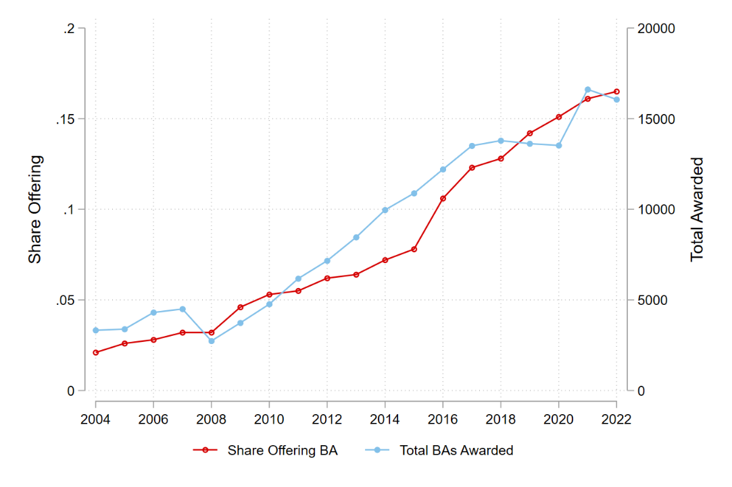
Figure 1. Share of Community Colleges Awarding CCBs and Number Awarded

Notes: This figure uses IPEDS data to plot the share of community colleges (defined as public postsecondary institutions that predominantly award degrees and certificates below the bachelor’s degree level) offering bachelor’s degrees and the total number of CCBs awarded between the 2004 and 2022 academic years.

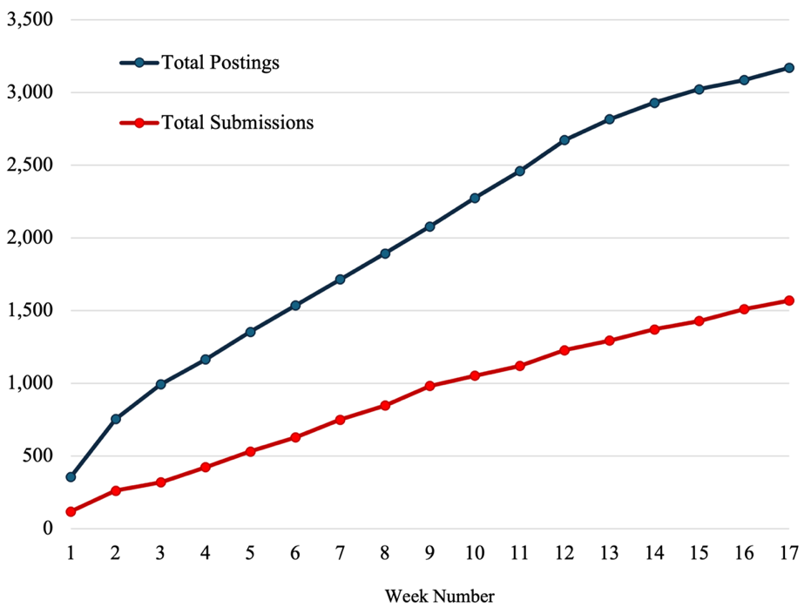
Figure 2. Total Postings vs. Total Submissions

Notes: Total job postings collected versus total postings with completed submissions are plotted. Note that each submission consists of 2-3 resumes, so submission in this case simply refers to a completed submission set for each posting.

Figure 3. Share of CCBs Awarded by Field of Study
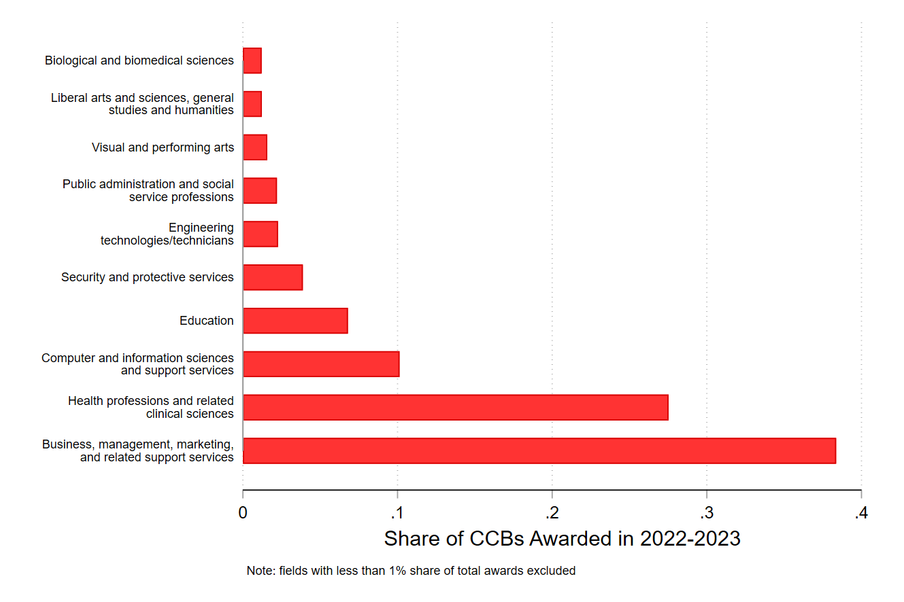
Notes: Share of CCBs awarded in academic year 2022-2023 by field of study (CIP2). Data come from IPEDS, degrees are considered CCBs if they are bachelor’s degrees awarded by an institution that predominantly awards associate degrees.

Figure 4. Callback Rates Across Degree Types
Notes: This figure plots the share of resume submissions that received an interview request, or a positive callback (i.e., request for more information), across degree types.

Figure 5. Callbacks for CCB Degrees Relative to Associate and Traditional Bachelor’s
Notes: This figure plots the estimated effects of resumes including CCB degrees on callback rates from equation (1) without covariates, where the red dots are relative to resumes with associate degree and the blue dots are relative to resumes with traditional bachelor’s degrees. The horizontal lines represent 95% confidence intervals. We cluster standard errors at the job ad level.

Figure 6. Callback Results for Job Postings Requiring a Bachelor’s Degree
Notes: This figure plots the estimated effects of resumes including CCB degrees on callback rates from equation (1), relative to resumes with traditional bachelor’s degrees. The horizontal lines represent 95% confidence intervals. We cluster standard errors at the job ad level.

Figure 7. Heterogenous Callback Results by Race-Ethnicity
Notes: This figure plots the estimated effects of resumes including CCB degrees on callback rates from equation (1), where the red symbols are relative to resumes with associate degrees and the blue symbols are relative to resumes with traditional bachelor’s degrees. The top estimate among each set are for White applications, second are for Black applicants, and third are for Hispanic applicants. The horizontal lines represent 95% confidence intervals. We cluster standard errors at the job ad level.

Table 1: Degree Required by Employer and Type of Resume Submission
Degree Required by Employer: | Resume Submission Types:
AA or less | Resume Type 1: AA
 | Resume Type 2: CCBA
 | Resume Type 3: BA - Public, Open Access
Bachelor’s | Resume Type 1: CCBA
 | Resume Type 2: BA - Public, Open Access

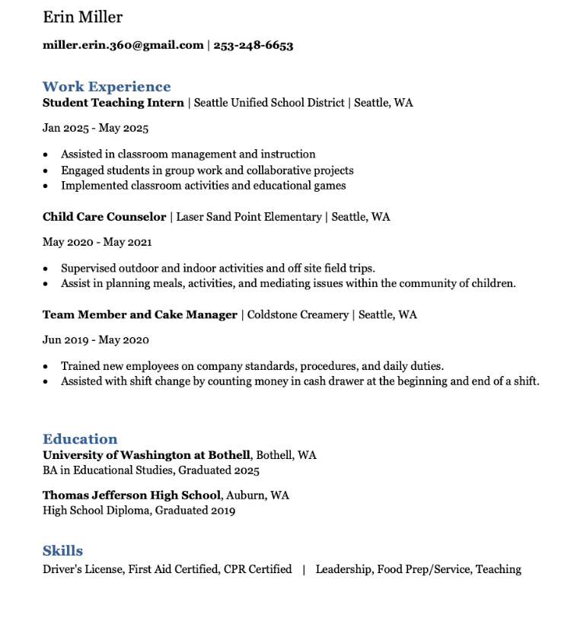
Appendix A: Sample Resumes
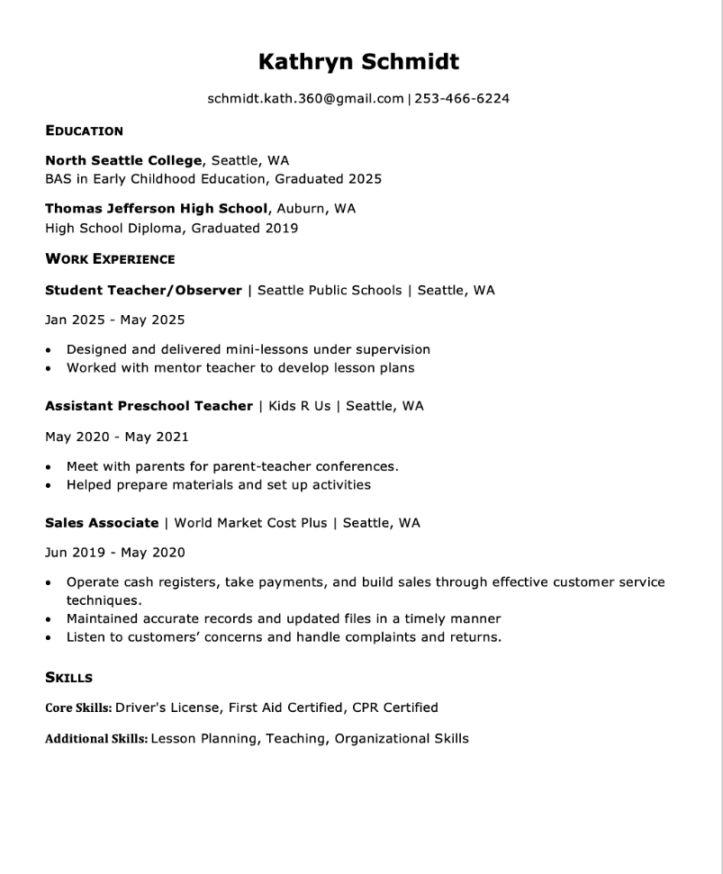
Appendix B: Address and Cover Letter Generation
After two weeks of submission, we realized that occasionally, employers were requiring applicants to include an address and/or cover letter with their application submission. In order to maximize our number of submissions, we followed the following steps to generate addresses and cover letters.
We generated a random set of 20 addresses for each city that RAs were instructed to randomize and record across applications when an address was required by the employer. Addresses were chosen to minimize signal of socioeconomic status to the employer: they were chosen in median household income census tracts. In addition, in order to avoid overlap with any real potential applicants, we used addresses in large apartment complexes and failed to provide an apartment number.
We also generated a small bank of cover letters that were generated by ChatGPT (and revised by the authors) to sound very similar but not identical. Cover letters were written to highlight similar skills and applicant features and were purposefully broad in scope. When cover letters were required, RAs submitted different versions to accompany each randomized resume.

Appendix C: Supplementary Figures and Tables
Figure C.1 Heterogenous Callback Results by State
Notes: This figure plots the estimated effects of resumes including CCB degrees on callback rates from equation (1), where the red symbols are relative to resumes with associate degrees and the blue symbols are relative to resumes with traditional bachelor’s degrees. The top estimates among each set are for job postings in Texas and the bottom are for Washington. The horizontal lines represent 95% confidence intervals. We cluster standard errors at the job ad level.

Figure C.2 Heterogenous Callback Results by Pay
Notes: This figure plots the estimated effects of resumes including CCB degrees on callback rates from equation (1), where the red symbols are relative to resumes with associate degrees and the blue symbols are relative to resumes with traditional bachelor’s degrees. The top estimates among each set are for job postings with a midpoint of hourly pay less than $20/hour and the bottom are for more than $20/hour. The horizontal lines represent 95% confidence intervals. We cluster standard errors at the job ad level.

Figure C.3 Heterogenous Callback Results by Benefits
Notes: This figure plots the estimated effects of resumes including CCB degrees on callback rates from equation (1), where the red symbols are relative to resumes with associate degrees and the blue symbols are relative to resumes with traditional bachelor’s degrees. The top estimates among each set are for job postings that list at least one of retirement, health, and dental benefits; the bottom is for job postings that do not list benefits. The horizontal lines represent 95% confidence intervals. We cluster standard errors at the job ad level.

*ⓡ Author order was determined using the American Economic Association’s (AEA) randomized author order tool. Acton: Department of Economics, Miami University, 800 E. High St., Oxford, OH 45056 (e-mail: actonr@miamioh.edu). Morales: Economics Program, University of Texas at Dallas, 800 W Campbell Rd, Richardson, TX, 75080 (email: camila.morales@utdallas.edu). Turner: School of Education & Social Policy, Walter Annenberg Hall, 2120 Campus Drive, Evanston, IL 60208 (e-mail: juliaturner2027@u.northwestern.edu). Miller: Department of Economics, Darla Moore School of Business, 1014 Greene St, Columbia, SC 29208 (email: lois.miller@moore.sc.edu). Cortes: The Bush School of Government and Public Service, Texas A&M University, 4220 TAMU, 2088 Allen Building, College Station, TX 77843 (e-mail: kcortes@tamu.edu). We are grateful for financial support from J-PAL North America, the Texas A&M Bush School Seed Grant, and the Strada Foundation. We are also thankful for research management support from Denielle Amparado, Noreen Giga, Daneila Gómez Treviño and Amanda Lee of J-PAL. This work would not have been possible without the excellent research assistance of Annalee Debenport, Sam Ederington, Naveen Hari, Kara Jones, Luke Koulouris, Miranda Lambert, Aadya Mishra, Nina Riccardi, and Addie Taylor. We are grateful for our partnership with Dallas College, in particular, the guidance of Heather Bryant, Navi Dhaliwal, and David Mahan. We also thank Elizabeth Bell, Jessica Brown, Rajeev Darolia, Kirabo Jackson, Andrew Simon, and conference and seminar participants at the MidSouth Education Policy Workshop, the Opportunity for Inclusive Growth Early Career Researcher Day, the Association for Public Policy Analysis and Management, Northwestern University, and Clemson University. for their helpful comments and suggestions. Institutional support was provided by Miami University, University of Texas at Dallas, Northwestern University, University of South Carolina, and Texas A&M University.
Several more states are actively considering legislation that would authorize the introduction or expansion of CCB programs (Draisey, 2025).
The most common reason for not being able to successfully submit resumes to a job posting was the requirement of social security numbers in the application.
Note also that we fail to reject that all three degree types are equal, as well as the pairwise difference of associate and traditional bachelor’s holders.
In addition to these standardized fields across postings, the RAs also collected any text that was included with the posting. These messages often included information about the job responsibilities and requirements not included in standardized fields. There is potential for future analysis using these text data.
Birthdates were randomly assigned to make the applicants between 23 and 24 years old. Birthdates were not included on resumes but were used if requested in the job application.
When applying to jobs and creating applicant profiles, incognito windows were used so that the submitting RA’s IP location could not be collected. This, we believed, help minimize risk of detection.
This choice of experience site was chosen after conversations with partners at Dallas College, who expressed that the nearby public school districts were the most common place for students to complete their student teaching requirements.
Note that resume submissions in this instance collapses 2-3 resumes submitted to a single job posting down to a single submission.
Specifically, 131 (8 percent) of job postings indicated that a bachelor’s degree was required. The remaining job postings either did not list an education requirement (38 percent) or listed a lower level of required education.
Note that we randomize race/ethnicity across posting in order to minimize the number of resumes sent to each employer (i.e., to avoid sending 9 resumes to each employer (one for each race-education pair)).
We use “callbacks” as shorthand for contact from the hiring employer. Nearly 70% of the time, this contact is in the form of email communication to the applicant. Under 10% of callbacks come in the form of phone calls to the applicant. The other 20% are communicated via the job posting platform.
Note also that we fail to reject that all three degree types are equal, as well as the pairwise difference of associate and traditional bachelor’s holders.

