Assignment #1 | LP Problems Solver

- Team members:
- نور خالد محمد – 22011319
- لجين سامح عبدالمنعم – 22011054
- عبدالرحمن محمد احمد – 22010887
- Simplex Method:
Code Explanation:
simplex:
- Adds slack variables.
- Calls handleUrVariables() to handle unrestricted variables.
- Forms Tableau.
handleUrVariables:
- Replaces x_{i} with x_{i}⁺-x_{i}⁻
solveTableau:
- Implements the Simplex algorithm

Sample Run:
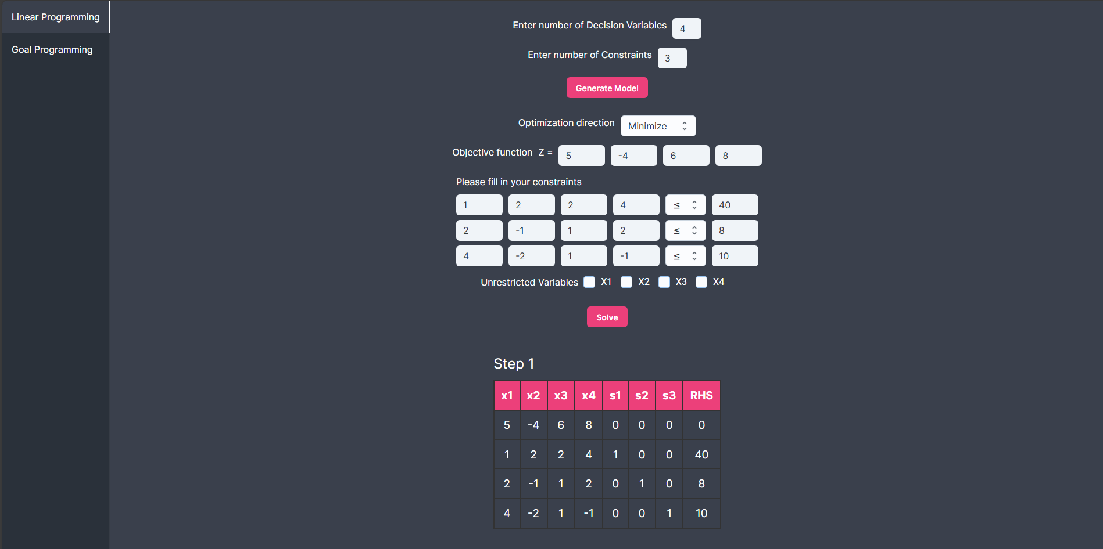
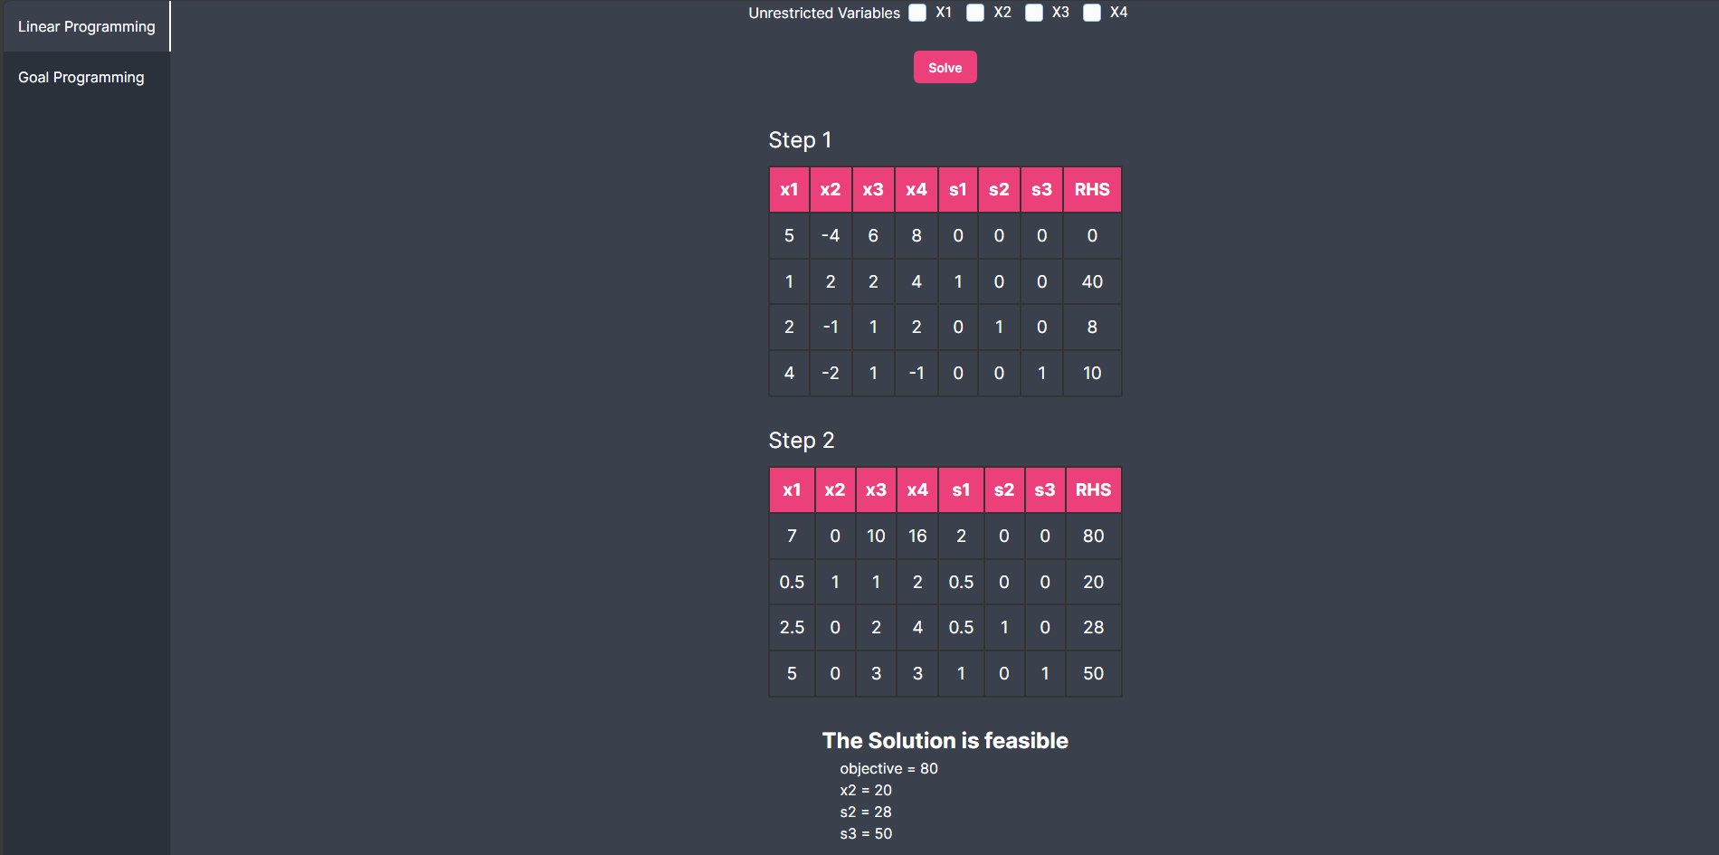

- Big M Method:
Code Explanation:
formulateConstraints:
- Handles unrestricted variables.
- Adds slack, surplus and artificial variables.
simplex:
- Forms Tableau.
- Implements the Simplex algorithm.

Sample Run:
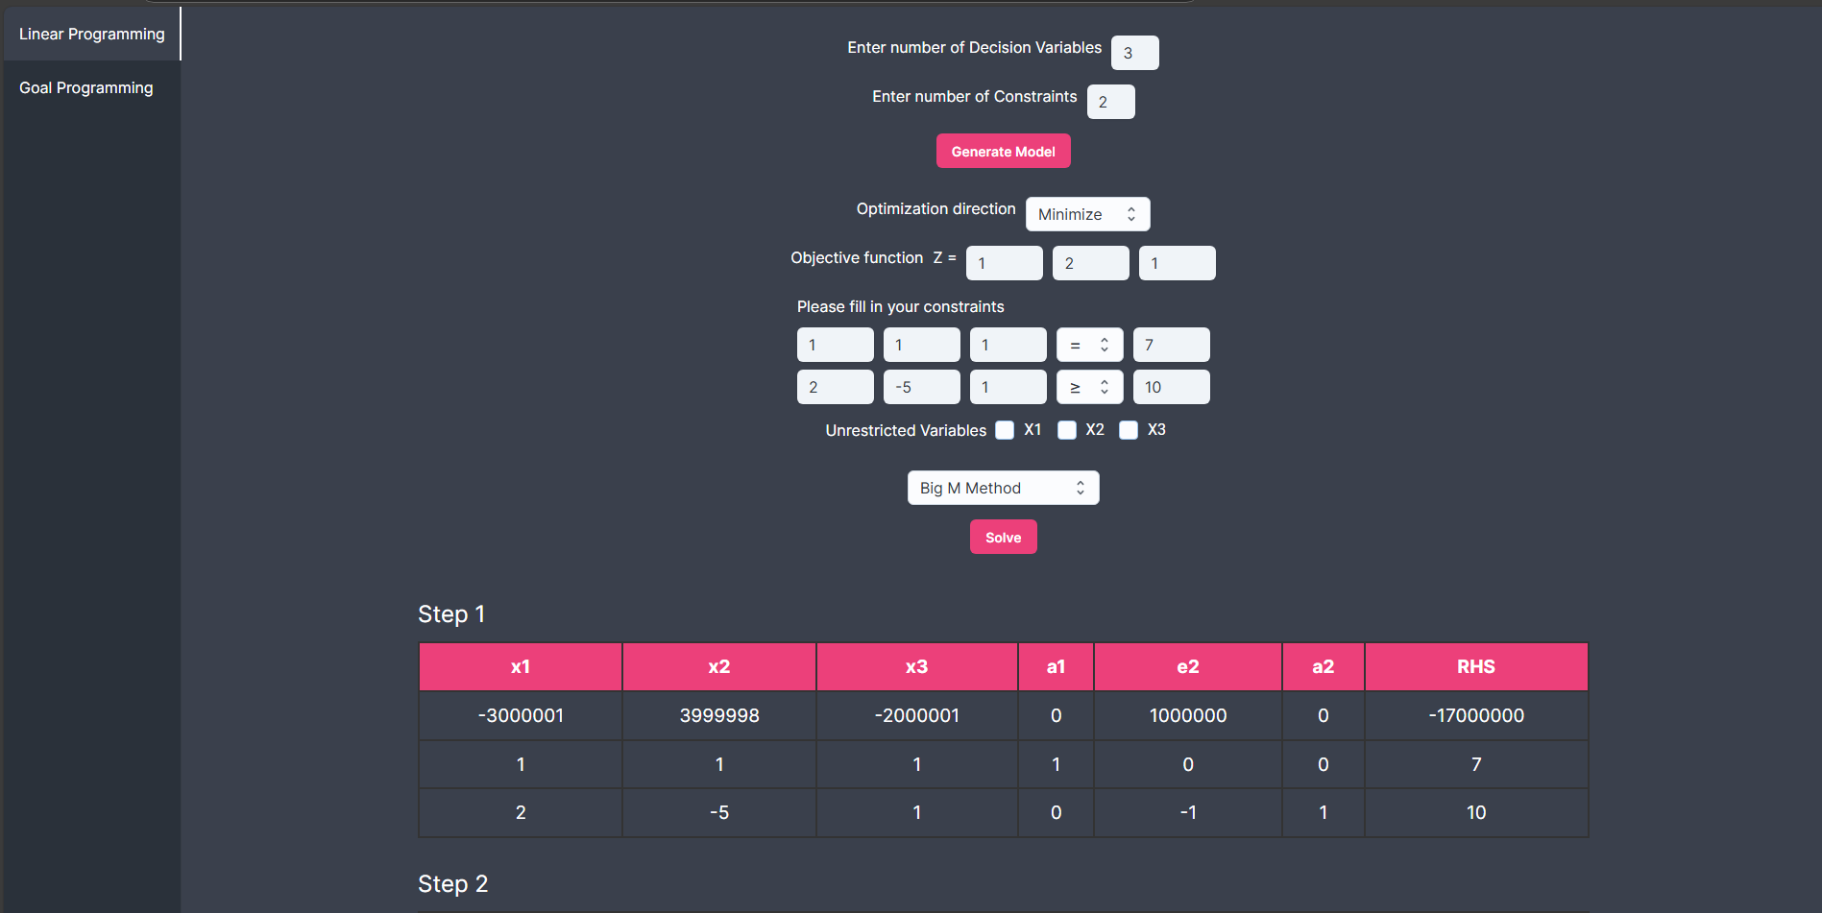
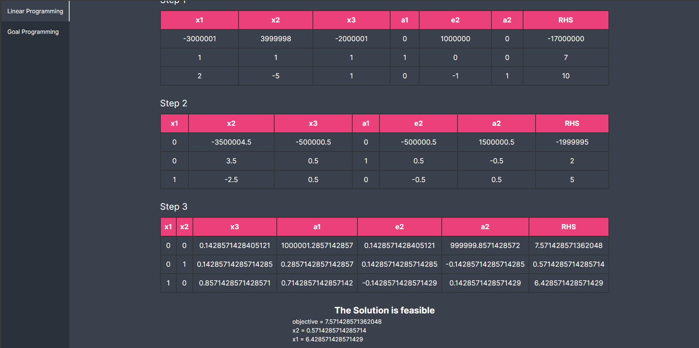

- Two Phase Method:
Code Explanation:
formulateTwoPhase:
- Adds slack, surplus and artificial variables.
- Handles unrestricted variables.
TwoPhasesimplex:
- Implements Phase 1.
Secondarysimplex:
- Implements Phase 2.
- Converts problem into standard simplex tableau.
Sample Run:
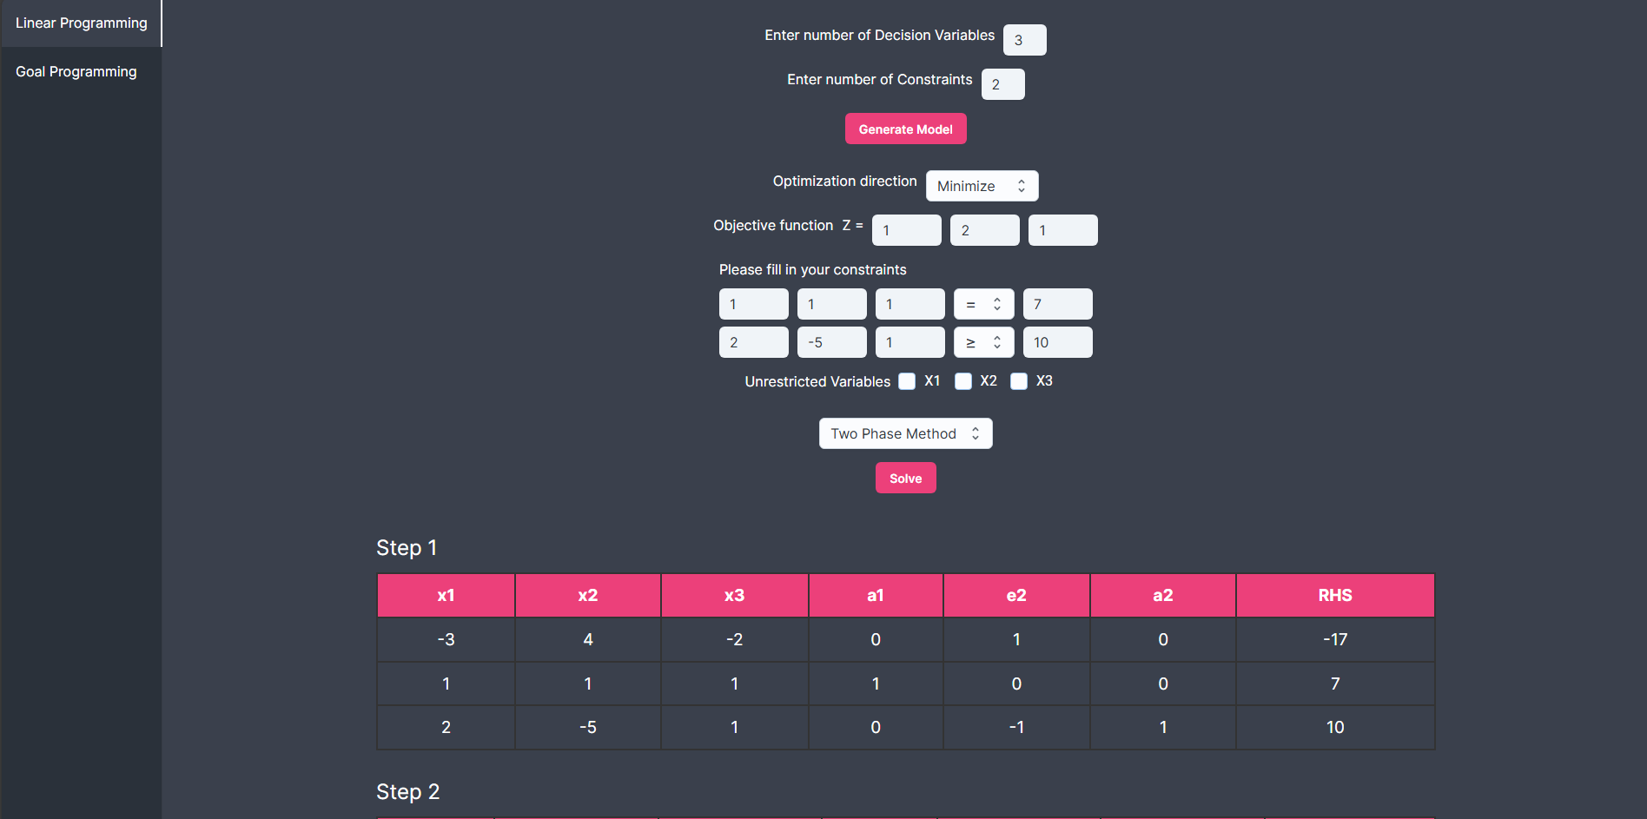
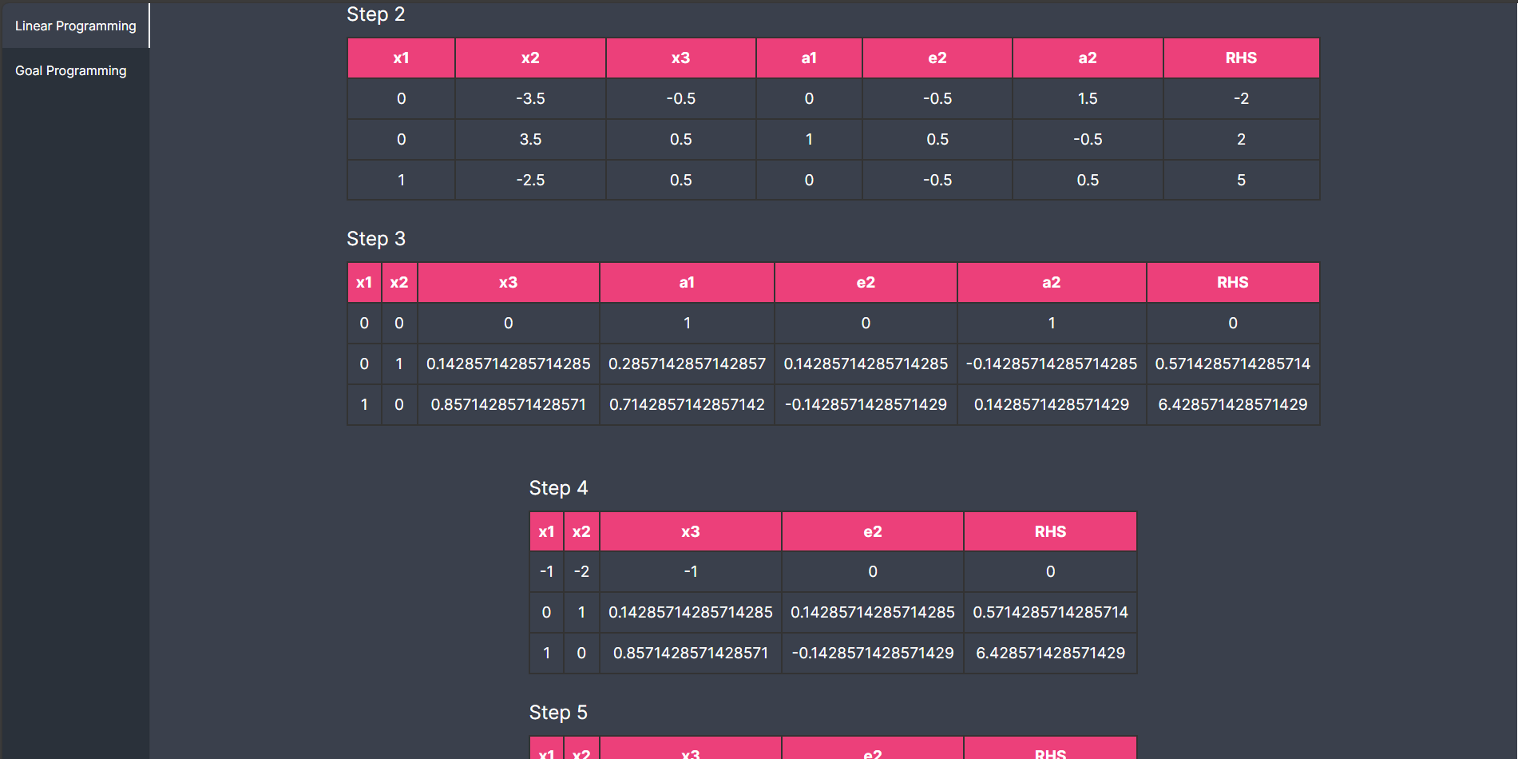

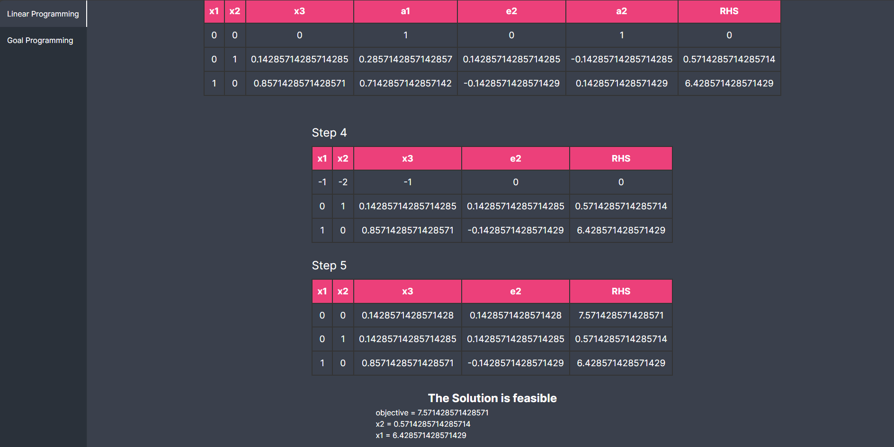

- Goal Programming:
Code Explanation:
solve_goal_programming:
- Create constraint matrix.
- Set objective function.
- Call simplex method to solve tableau.
Sample Run:
