**Дніпровський науковий ліцей інформаційних технологій**

**Дніпровської міської ради**

**Курсова робота з англійської мови**

**Тема: Перші 13 американських штатів.**

**The first thirteen American states**

**Виконавець**

**Макшанов Артем Михайлович**

**Ліцеїст 10А класу**

**Керівник**

**Віролайнен Ніна Валентинівна**

**Дніпро**

**2024**

**Contents**

Introduction 3

Main part:

1. Delaware 6

1. Pennsylvania 9
2. New Jersey 12
3. Georgia 14
4. Connecticut 16
5. Massachusetts 18
6. Maryland 21
7. South Carolina 23
8. New Hampshire 25
9. Virginia 28
10. New York 32
11. North Carolina 34
12. Rhode Island 36

History 38

Conclusion 40

Answer keys 41

Literature 45

**Introduction:**

The history of the United States' formation is a complex narrative that intertwines the journeys of 13 British colonies towards independence, self-governance, and the establishment of a nation built on principles of freedom and democracy.

In 1620, a ship named “Mayflower” (from the English word “mayflower”) left the port of Plymouth with 102 Puritans who had fled England due to religious persecution, known as the Pilgrim Fathers. During the voyage, they signed the Mayflower Compact, a self-governance agreement. In December 1620, the Pilgrim Fathers landed near Cape Cod (Massachusetts) and decided to stay there. This day (December 22) is celebrated annually in the United States as Pilgrim Fathers Day.

They founded Virginia, and later 12 more colonies. Eight colonies were royal (Virginia, North and South Carolina, Georgia, Massachusetts, New Hampshire, New York, and New Jersey). Three colonies (Maryland, Pennsylvania, and Delaware) belonged to private individuals, and two (Connecticut and Rhode Island) were self-governing. Many settlers were Protestants who were driven out of their homeland due to religious beliefs. In the northern colonies, the land belonged to small farmers. They cultivated the land themselves and hired workers when necessary. In the southern colonies (Virginia, Carolina, Georgia), the land was obtained by English aristocrats. They created plantations on them to grow cotton and tobacco. The workforce consisted of black people who were imported from Africa. The number of slaves reached 60% of the population.

Until 1774, the colonies were independent and separate from each other. But thanks to the efforts of the prominent public figure B. Franklin, a union was formed, which included the future first 13 states of the United States. The list consisted of 9 provinces:

* New Hampshire
* Massachusetts Bay
* New Jersey
* New York
* Pennsylvania
* Maryland
* South Carolina
* North Carolina
* Georgia

In addition to the provinces, 4 colonies entered the Union:

* Rhode Island and Providence Plantations
* Connecticut
* Delaware
* Virginia

When George III ascended to the throne of England, he wanted to strengthen his power by plundering the colonies. A stamp duty law was introduced - a tax that had to be paid by everyone who printed agreements, documents, newspapers, even playing cards. In 1763, the king issued a decree banning settlement in western lands. The interests of fur traders were protected, but this decree outraged farmers who needed land. The English government banned the opening of factories, and industrial goods were imported into the colonies at inflated prices. For example, in 1750, it was allowed to smelt iron and iron in the colonies, but there was still a ban on their processing. Shipowners were prohibited from using non-English sailcloth. It was ridiculous: in 1732, the export of felt hats from the colonies was banned.

Although the stamp duty was repealed the following year, the conflict remained. A boycott of English goods began. In 1773, a group of Americans in Boston, dressed as Indians, threw boxes of tea into the sea. This “Boston Tea Party” marked the beginning of the struggle. During the War of Independence, all colonists divided into two camps: patriots (supporters of independence) and loyalists (supporters of the legitimate authority of the English king).

The English authorities closed the port of Boston for trade. In response, uprisings began in all 13 colonies. In September 1774, the First Continental Congress met in Philadelphia, attended by 56 representatives from 12 colonies. The “Declaration of Rights” was adopted, condemning England’s policy and defending the colonies’ right to life, liberty, and property. The colonies began to create armed units.

In April 1775, the first armed clashes between the English army and the colonists took place under Lexington and Concord. The War of Independence (1775-1783) began in North America.

The colonies declared themselves independent countries - states. Virginia was the first to do so. During the war, in 1776, the “Declaration of Independence of the United States” was signed by 13 states, which raised the fighting spirit of Americans. Volunteers from Europe began to arrive in America - the most famous of them were General Lafayette from France and Kosciuszko from Poland.

The story of the first 13 American states is a multifaceted tapestry woven with threads of exploration, revolution, and unwavering pursuit of self-governance. These states, once British colonies, birthed the United States of America, shaping its character and defining its destiny.

**States:**

**1. Delaware:** 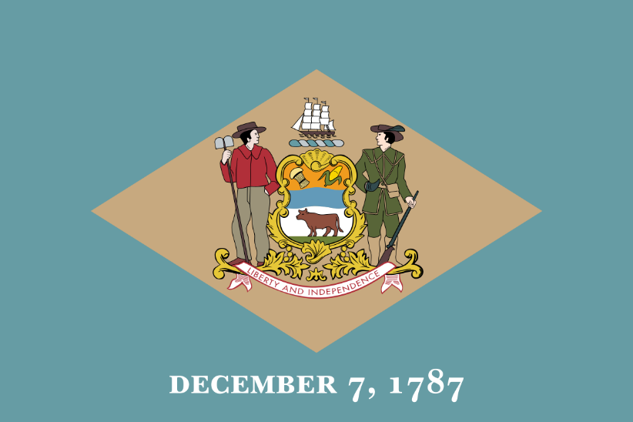

Delaware is a small state in the eastern United States, located on the Atlantic coast. It is the second smallest state by area and the sixth most densely populated state. It has three counties: New Castle, Kent, and Sussex. Its capital is Dover and its largest city is Wilmington. It is known as the “First State” because it was the first to ratify the U.S. Constitution in 1787. It is also called the “Diamond State” because of its strategic location and the “Blue Hen State” because of its official state bird.

Delaware has a rich and diverse history, dating back to the early colonization of North America by European settlers. It was originally inhabited by Native American tribes such as the Lenni Lenape, the Susquehanna, the Nanticoke, and others. It was explored by the Dutch, the Swedish, and the English, who established trading posts and settlements along the Delaware River and Bay. It was part of the Dutch colony of New Netherland, the Swedish colony of New Sweden, and the English colony of Pennsylvania, until it declared its independence in 1776. It was one of the Thirteen Colonies that rebelled against British rule and formed the United States of America. It was the site of several important events and battles during the American Revolution, such as the Battle of Cooch’s Bridge and the Battle of Brandywine. It was also a slave state that remained loyal to the Union during the Civil War.

Delaware has a diverse and dynamic economy, based on agriculture, manufacturing, banking, and tourism. It is one of the leading producers of poultry, especially broiler chickens, in the country. It also grows corn, soybeans, wheat, and other crops. It has a strong industrial sector, with major companies such as DuPont, Chemours, and Gore-Tex operating in the state. It is also a major financial center, with many banks and corporations incorporated in the state, due to its favorable tax laws and business-friendly regulations. It attracts millions of visitors every year, who enjoy its beaches, parks, museums, and historical sites.

Delaware has a vibrant and diverse culture, influenced by its Native American, European, African, and Asian heritage. It has a variety of festivals, events, and traditions, such as the Delaware State Fair, the Dover Days Festival, the Apple Scrapple Festival, and the Return Day Parade. It has a rich musical and artistic scene, with genres such as jazz, blues, rock, and hip hop, and artists such as Cab Calloway, George Thorogood, and Joe Biden. It has a distinctive cuisine, featuring dishes such as scrapple, chicken and dumplings, crab cakes, and peach pie. It has a proud sports legacy, with teams such as the Delaware Blue Hens, the Wilmington Blue Rocks, and the Delaware 87ers, and athletes such as Elena Delle Donne, Dwayne Henry, and Delino DeShields.

**Exercise 1 (Delaware):**

1. **Why is Delaware known as the "First State"?**

a) It was the first state discovered by European settlers.

b) It was the first state to ratify the U.S. Constitution in 1787.

c) It was the first state to declare independence from British rule.

1. **What is the capital of Delaware?**

a) Wilmington

b) Dover

c) New Castle

1. **Delaware is also referred to as the "Diamond State" because of its:**

a) Wealth in diamond mines.

b) Abundance of diamond-shaped landmarks.

c) Strategic location.

1. **Which of the following tribes originally inhabited Delaware?**

a) Lenni Lenape, Susquehanna, and Nanticoke

b) Navajo, Apache, and Sioux

c) Aztec, Maya, and Inca

1. **During the Civil War, Delaware was:**

a) A Confederate state that seceded from the Union.

b) Neutral and did not participate in the war.

c) A Union state that allowed slavery.

1. **Delaware's economy is heavily based on:**

a) Oil refining and export.

b) Agriculture, manufacturing, banking, and tourism.

c) Fishing and marine trade.

1. **Which festival is NOT mentioned as being celebrated in Delaware?**

a) Delaware State Fair

b) Burning Man Festival

c) Apple Scrapple Festival

1. **The official state bird of Delaware is the:**

a) Blue Hen

b) Bald Eagle

c) Cardinal

1. **Which of the following companies is mentioned as operating in Delaware?**

a) Apple Inc.

b) DuPont

c) Tesla Motors

1. **Who among the following is NOT listed as an artist or athlete from Delaware?**

a) Cab Calloway

b) Joe Biden

c) LeBron James

**2. Pennsylvania**

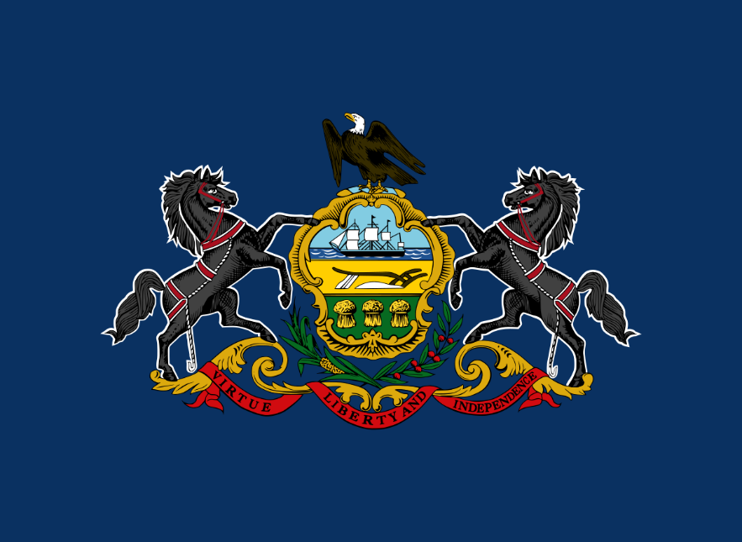Pennsylvania is a state in the northeastern United States, bordered by New York, New Jersey, Delaware, Maryland, West Virginia, Ohio, and Lake Erie. It is the 33rd largest state by area and the 5th most populous state. It has 67 counties and its capital is Harrisburg. Its largest city is Philadelphia, which was also the first capital of the United States. It is known as the “Keystone State” because of its central role in the formation of the country, as well as the “Quaker State” because of its founder, William Penn, who was a Quaker.

Pennsylvania has a long and rich history, dating back to the Native American tribes that inhabited the region, such as the Lenape, the Susquehannock, the Iroquois, and others. It was explored and colonized by the Dutch, the Swedish, and the English, who established trading posts and settlements along the Delaware River and Bay. It was part of the Dutch colony of New Netherland, the Swedish colony of New Sweden, and the English colony of Pennsylvania, until it declared its independence in 1776. It was the site of many important events and battles during the American Revolution, such as the First and Second Continental Congresses, the Declaration of Independence, the Liberty Bell, the Battle of Brandywine, the Battle of Germantown, the Valley Forge, and the Battle of Monmouth. It was the second state to ratify the U.S. Constitution in 1787. It was also the site of the Constitutional Convention in 1787, where the Founding Fathers drafted and signed the Constitution. It was the first state to abolish slavery in 1780.

Pennsylvania has a diverse and dynamic economy, based on agriculture, manufacturing, mining, energy, tourism, and services. It is one of the leading producers of dairy, poultry, eggs, mushrooms, apples, grapes, and other crops in the country. It also has a strong industrial sector, with major industries such as steel, iron, coal, oil, natural gas, chemicals, plastics, textiles, and electronics. It is home to some of the largest and most influential corporations in the world, such as Comcast, Heinz, Hershey, PPG, U.S. Steel, and Vanguard. It attracts millions of visitors every year, who enjoy its natural beauty, historical landmarks, cultural attractions, and recreational activities.

Pennsylvania has a vibrant and diverse culture, influenced by its Native American, European, African, and Asian heritage. It has a variety of festivals, events, and traditions, such as the Groundhog Day, the Mummers Parade, the Pennsylvania Farm Show, the Philadelphia Flower Show, and the Oktoberfest. It has a rich musical and artistic scene, with genres such as classical, jazz, blues, rock, and hip hop, and artists such as Stephen Foster, Marian Anderson, Billie Holiday, John Coltrane, Andy Warhol, and Taylor Swift. It has a distinctive cuisine, featuring dishes such as cheesesteak, hoagie, pretzel, pierogi, scrapple, and shoofly pie. It has a proud sports legacy, with teams such as the Philadelphia Eagles, the Pittsburgh Steelers, the Philadelphia 76ers, the Pittsburgh Penguins, the Philadelphia Phillies, and the Pittsburgh Pirates, and athletes such as Joe Montana, Joe Namath, Wilt Chamberlain, Mario Lemieux, and Arnold Palmer.

**Exercise 2 (Pennsylvania):**

1. What is Pennsylvania known as due to its central role in the formation of the United States?

a) The Liberty State

b) The Quaker State

c) The Keystone State

1. Which Native American tribe is NOT mentioned as having inhabited Pennsylvania?

a) Iroquois

b) Navajo

c) Lenape

1. In what year did Pennsylvania abolish slavery?

a) 1780

b) 1787

c) 1776

1. Which of the following cities was the first capital of the United States?

a) Harrisburg

b) Philadelphia

c) New York

1. Pennsylvania was the ___ state to ratify the U.S. Constitution.

a) first

b) second

c) third

1. Which industry is NOT listed as a part of Pennsylvania's economy?

a) Mining

b) Software development

c) Agriculture

1. Which of the following festivals is specific to Pennsylvania?

a) Groundhog Day

b) Coachella

c) Lollapalooza

1. Who among the following artists is NOT mentioned as being associated with Pennsylvania?

a) Taylor Swift

b) Bob Dylan

c) Andy Warhol

1. The Battle of ___ is NOT listed as an event that took place in Pennsylvania.

a) Brandywine

b) Monmouth

c) Gettysburg

10. Which Pennsylvania city is home to the Liberty Bell?

a) Pittsburgh

b) Philadelphia

c) Harrisburg

**3. New Jersey**

New Jersey is a state in the northeastern United States, bordered by New York, New Jersey, Delaware, Maryland, West Virginia, Ohio, and Lake Erie. It is known as the “Garden State” for its agricultural production and the “Crossroads of the Revolution” for its strategic role in the American Revolutionary War. It is also famous for its beaches, casinos, and musical legends.

Some of the facts and information about New Jersey are:

* It is the 11th state to ratify the U.S. Constitution on December 18, 1787.
* It is the fourth smallest state by area and the most densely populated state.
* It has 21 counties and its capital is Trenton. Its largest city is Newark.
* It has the highest percentage of millionaire households in the nation.
* It is the only state where all of its counties are classified as metropolitan areas.
* It is the birthplace of many famous people, such as Thomas Edison, Albert Einstein, Frank Sinatra, Bruce Springsteen, Jon Bon Jovi, Whitney Houston, and Meryl Streep.
* It is the leading producer of cranberries, blueberries, and tomatoes in the country.
* It has more than 50 resort cities and towns, such as Atlantic City, Cape May, and Asbury Park.
* It has more than 1,800 miles of shoreline, including 130 miles of Atlantic coast.

**Exercise 3 (New Jersey):**

1. New Jersey is known as the "Garden State" because of its:

а) Large number of public gardens and parks.

b) Significant agricultural production.

c) Reputation for environmental conservation.

1. Which of the following is NOT a reason New Jersey is famous?

a) Its beaches and casinos.

b) Hosting the first official baseball game.

c) Being the largest state by area.

1. New Jersey has the highest percentage of millionaire households in the nation. This statement is:

a) True

b) False

c) Not mentioned

1. Which famous person is NOT listed as being from New Jersey?

a) Albert Einstein

b) Elvis Presley

c) Frank Sinatra

1. The capital of New Jersey is:

a) Newark

b) Trenton

c) Atlantic City

**4. Georgia**

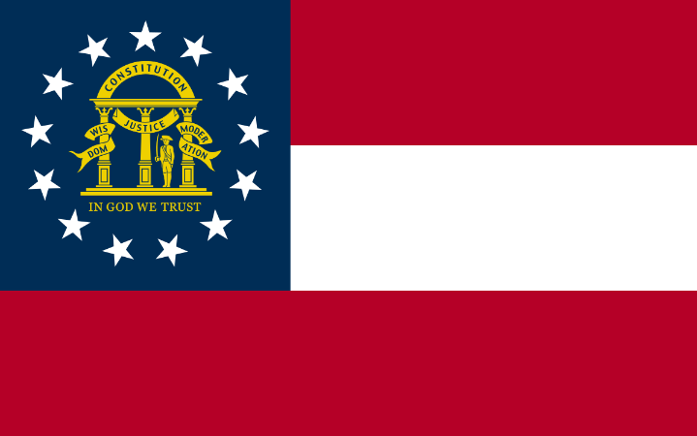Georgia is a state in the southeastern United States, bordered by Florida, Alabama, Tennessee, North Carolina, and South Carolina. It is the 24th largest state by area and the 8th most populous state. It has 159 counties and its capital is Atlanta. It is known as the “Peach State” for its peach production and the “Empire State of the South” for its economic and cultural influence. It is also famous for its history, music, and natural beauty.

Georgia has a long and rich history, dating back to the Native American tribes that inhabited the region, such as the Creek, the Cherokee, the Seminole, and others. It was explored and colonized by the Spanish, the French, and the English, who established trading posts and settlements along the coast and the rivers. It was the fourth state to ratify the U.S. Constitution on January 2, 1788. It was the site of many important events and battles during the American Revolution, such as the Siege of Savannah, the Battle of Kettle Creek, and the Battle of Augusta. It was also the site of the Yazoo land fraud, one of the largest land scandals in U.S. history, in which four companies bribed the state legislature to sell them 35 million acres of land at a fraction of its value.

Georgia was a slave state that supported the Confederate States of America (Confederacy) during the American Civil War. It seceded from the Union on January 19, 1861 and joined the Confederacy on February 4, 1861. It contributed more than 100,000 soldiers to the Confederate cause, as well as many resources and supplies. It was the site of many major battles and campaigns, such as the Atlanta Campaign, the Battle of Chickamauga, the Battle of Peachtree Creek, the Battle of Atlanta, the Battle of Jonesboro, and the March to the Sea. It was the last state to be restored to the Union on July 15, 1870, after a period of Reconstruction.

Georgia has a diverse and dynamic economy, based on agriculture, manufacturing, service, and technology. It is one of the leading producers of cotton, peanuts, pecans, peaches, poultry, and eggs in the country. It also has a strong industrial sector, with major industries such as aerospace, automotive, textiles, paper, and chemicals. It is home to some of the largest and most successful corporations in the world, such as Coca-Cola, Delta Air Lines, Home Depot, UPS, and CNN. It is also a major hub for education, research, and innovation, with many prestigious universities and institutions, such as the Georgia Institute of Technology, Emory University, the University of Georgia, and the Centers for Disease Control and Prevention.

Georgia has a vibrant and diverse culture, influenced by its Native American, European, African, and Asian heritage. It has a variety of festivals, events, and traditions, such as the Georgia State Fair, the Georgia Peach Festival, the Georgia National Rodeo, and the Georgia Renaissance Festival.

**Exercise 4 (Georgia):**

1. What is Georgia known as due to its peach production?

a) The Cotton State

b) The Empire State of the South

c) The Peach State

2. In what year did Georgia ratify the U.S. Constitution?

a) 1776

b) 1788

c) 1870

3. Which Native American tribes inhabited Georgia?

a) Sioux, Apache, and Navajo

b) Creek, Cherokee, and Seminole

c) Iroquois, Algonquin, and Huron

4. Georgia was the last state to be restored to the Union after the Civil War. In what year did this occur?

a) 1861

b) 1865

c) 1870

5. Which of the following is NOT listed as a major industry in Georgia?

a) Aerospace

b) Shipbuilding

c) Textiles

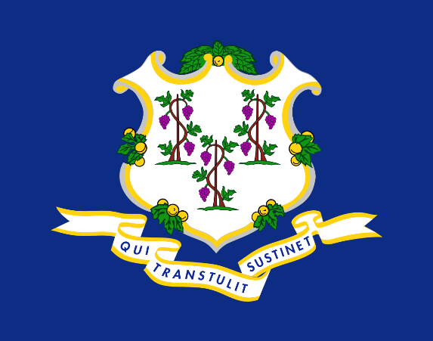**5.Connecticut**

Connecticut is a state in the northeastern United States, bordered by New York, Massachusetts, and Rhode Island. It is known as the “Constitution State” for its role in the creation of the U.S. Constitution and the “Nutmeg State” for its reputation of producing or importing nutmeg. It is also famous for its history, education, and innovation.

Some of the facts and information about Connecticut are:

* It is the fifth state to ratify the U.S. Constitution on January 9, 1788.
* It is the third smallest state by area and the fourth most densely populated state.
* It has eight counties and its capital is Hartford. Its largest city is Bridgeport.
* It has the highest per capita income and the second highest human development index in the nation.
* It is the first state to have a state constitution, the Fundamental Orders of Connecticut, adopted in 1639.
* It is the birthplace of many famous people, such as Eli Whitney, Samuel Colt, Noah Webster, Harriet Beecher Stowe, Mark Twain, and George W. Bush.
* It is home to the first public library, the first hamburger, the first helicopter, and the first nuclear submarine.
* It is the leading producer of silverware, clocks, helicopters, and submarines in the country.
* It has more than 250 miles of coastline, including the Long Island Sound and the Connecticut River.
* It has more than 130 state parks and forests, such as Gillette Castle State Park, Sleeping Giant State Park, and Mashamoquet Brook State Park.

**Exercise 5 (Connecticut):**

1. What nickname is Connecticut known by due to its role in the creation of the U.S. Constitution?

a) The Constitution State

b) The Nutmeg State

c) The Liberty State

2. Connecticut is the ___ state by area.

a) Largest

b) Third smallest

c) Sixth largest

3. Which city is the capital of Connecticut?

a) Hartford

b) Bridgeport

c) New Haven

4. In what year did Connecticut ratify the U.S. Constitution?

a) 1639

b) 1776

c) 1788

5. Connecticut is home to the first public ___.

a) School

b) Library

c) Hospital

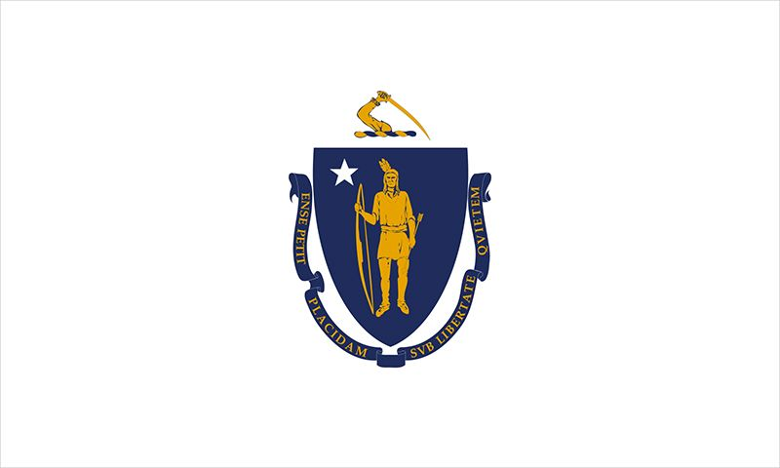**6.Massachusetts**

Massachusetts is a state in the northeastern United States, bordered by New York, Vermont, New Hampshire, Rhode Island, and Connecticut. It is known as the “Bay State” for its numerous bays and harbors, the “Old Colony State” for its early colonial history, and the “Cradle of Liberty” for its role in the American Revolution.

Massachusetts has a long and rich history, dating back to the Native American tribes that inhabited the region, such as the Wampanoag, the Nipmuc, the Massachusett, and others. It was explored and colonized by the French, the Dutch, and the English, who established trading posts and settlements along the coast and the rivers. It was part of the British colony of Massachusetts Bay, until it declared its independence in 1776. It was the sixth state to ratify the U.S. Constitution on February 6, 1788. It was the site of many important events and battles during the American Revolution, such as the Boston Massacre, the Boston Tea Party, the Battles of Lexington and Concord, the Battle of Bunker Hill, the Siege of Boston, and the Battle of Springfield. It was also the site of the Salem witch trials, one of the most notorious cases of mass hysteria and persecution in colonial America, in which 19 people were executed for witchcraft in 1692.

It is one of the leading states in higher education, with more than 100 colleges and universities, including Harvard University, Massachusetts Institute of Technology, Boston University, and Tufts University. It is also one of the leading states in health care, with world-renowned hospitals and research centers, such as Massachusetts General Hospital, Brigham and Women’s Hospital, and Dana-Farber Cancer Institute. It is also one of the leading states in technology, with major industries such as biotechnology, information technology, robotics, and renewable energy. It is home to some of the largest and most innovative companies in the world, such as IBM, Microsoft, Google, Amazon, Facebook, and Tesla.

Massachusetts has a vibrant and diverse culture, influenced by its Native American, European, African, and Asian heritage. It has a variety of festivals, events, and traditions, such as the Boston Marathon, the St. Patrick’s Day Parade, the Head of the Charles Regatta, and the First Night. It has a rich musical and artistic scene, with genres such as classical, jazz, folk, rock, and pop, and artists such as Leonard Bernstein, Yo-Yo Ma, James Taylor, Aerosmith, and New Kids on the Block. It has a distinctive cuisine, featuring dishes such as clam chowder, baked beans, lobster roll, and Boston cream pie. It has a proud sports legacy, with teams such as the Boston Red Sox, the Boston Celtics, the New England Patriots, the Boston Bruins, and the Boston College Eagles, and athletes such as Ted Williams, Larry Bird, Tom Brady, Bobby Orr, and Doug Flutie.

**Exercise 6 (Massachusetts):**

1. Massachusetts is known as the "Bay State" due to its:

a) Large number of educational institutions

b) Numerous bays and harbors

c) Historical significance in the American Revolution

2. Which Native American tribe was NOT mentioned as inhabiting Massachusetts?

a) Wampanoag

b) Sioux

c) Massachusett

3. The Salem witch trials, resulting in the execution of 19 people for witchcraft, occurred in what year?

a) 1692

b) 1776

c) 1788

4. Massachusetts was the ___ state to ratify the U.S. Constitution.

a) Fourth

b) Sixth

c) Eighth

5. Which of the following universities is NOT located in Massachusetts?

a) Harvard University

b) Yale University

c) Massachusetts Institute of Technology

6. Which event is not associated with Massachusetts?

a) The Boston Massacre

b) The Siege of Boston

c) The Battle of Gettysburg

7. Massachusetts is a leading state in:

a) Agriculture

b) Technology

c) Oil production

8. What dish is Massachusetts famous for?

a) Pizza

b) Clam chowder

c) Sushi

9. Which of these companies is NOT mentioned as having a major presence in Massachusetts?

a) Tesla

b) Coca-Cola

c) Amazon

10. Which of the following sports teams is from Massachusetts?

a) Miami Dolphins

b) New England Patriots

c) Los Angeles Lakers

**7.Maryland**

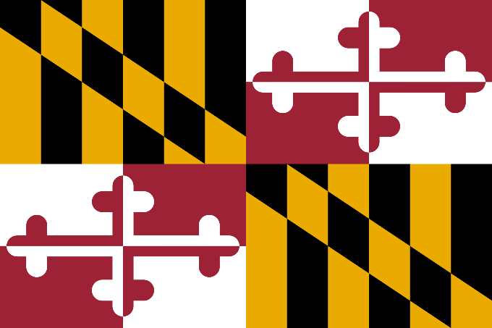Maryland is a state in the eastern United States, bordered by Pennsylvania, Delaware, Virginia, West Virginia, and the District of Columbia. It is known as the “Old Line State” for its role in the American Revolution, the “Free State” for its early abolition of slavery, and the “Chesapeake Bay State” for its location on the largest estuary in the country. It is also famous for its seafood, especially crabs and oysters.

Some of the facts and information about Maryland are:

* It is the seventh state to ratify the U.S. Constitution on April 28, 1788.
* It is the 42nd largest state by area and the 19th most populous state.
* It has 23 counties and its capital is Annapolis. Its largest city is Baltimore.
* It has the highest median household income and the lowest poverty rate in the nation.
* It is the only state where all of its counties are classified as metropolitan areas.
* It is the birthplace of many famous people, such as Francis Scott Key, Harriet Tubman, Frederick Douglass, Babe Ruth, and Thurgood Marshall.
* It is home to the United States Naval Academy, the National Aquarium, and the Fort McHenry National Monument.
* It is the leading producer of blue crabs and is renowned for its crab cakes.
* It has more than 50 state parks and forests, such as Assateague Island State Park, Patapsco Valley State Park, and Catoctin Mountain Park.

**Exercise 7 (Maryland):**

1. Maryland is known as the "Free State" because of its:

a) Large number of freed slaves during the Civil War

b) Early abolition of slavery

c) Role in the American Revolution

d) None of the above

2. Which of the following borders Maryland?

a) New York

b) Ohio

c) Virginia

d) Kentucky

3. Maryland ratified the U.S. Constitution as the ___ state.

a) First

b) Seventh

c) Tenth

d) Twelfth

4. What is Maryland's largest city?

a) Annapolis

b) Frederick

c) Columbia

d) Baltimore

5. Maryland is the leading producer of:

a) Cotton

b) Soybeans

c) Blue crabs

d) Wheat

**8.South Carolina**

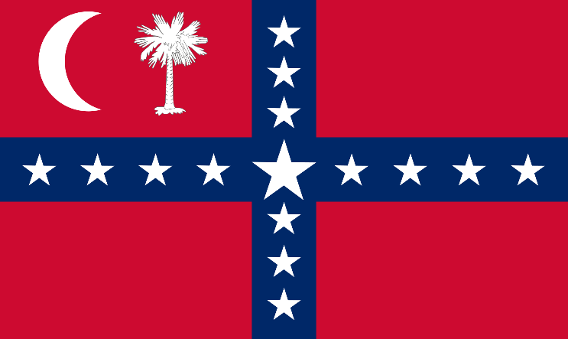South Carolina is a state in the southeastern United States, bordered by North Carolina, Georgia, and the Atlantic Ocean. It is known as the “Palmetto State” for its official state tree, the sabal palmetto, which symbolizes its resistance to the British during the American Revolution. It is also famous for its history, culture, and natural beauty.

Some of the facts and information about South Carolina are:

* It is the eighth state to ratify the U.S. Constitution on May 23, 1788.
* It is the 40th largest state by area and the 23rd most populous state.
* It has 46 counties and its capital is Columbia. Its largest city is Charleston.
* It has the lowest percentage of residents who have obtained a bachelor’s degree or higher in the nation.
* It is the only state where tea is grown commercially.
* It is the birthplace of many famous people, such as John C. Calhoun, Andrew Jackson, Strom Thurmond, James Brown, Darius Rucker, and Stephen Colbert.
* It is home to the first golf course in America, the first public museum in America, and the first opera house in America.
* It is the leading producer of peaches, tobacco, and turkeys in the country.
* It has more than 200 miles of coastline, including the Grand Strand, a 60-mile stretch of beaches and resorts.
* It has more than 80 state parks and forests, such as Congaree National Park, Hunting Island State Park, and Table Rock State Park.

**Exercise 8 (South Carolina):**

1. South Carolina is known as the "Palmetto State" because of its:

a) Famous Palmetto Bug

b) Abundance of palm trees on its beaches

c) Official state tree, the sabal palmetto

d) None of the above

2. What is the capital of South Carolina?

a) Charleston

b) Greenville

c) Columbia

d) Spartanburg

3. South Carolina ratified the U.S. Constitution as the ___ state.

a) Fourth

b) Eighth

c) Twelfth

d) Twenty-third

4. Which of the following is NOT grown or produced commercially in South Carolina?

a) Tea

b) Peaches

c) Coffee

d) Tobacco

5. What is unique about South Carolina in terms of education?

a) It has the highest number of colleges per capita

b) It has the highest graduation rate in the country

c) It has the lowest percentage of residents with a bachelor’s degree or higher

d) All of its public schools are ranked top in the nation

**9.New Hampshire**

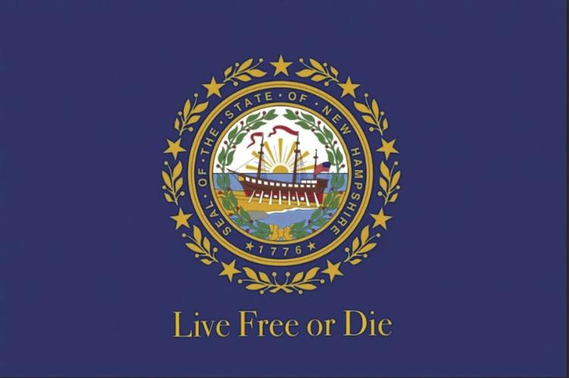New Hampshire is a state in the northeastern United States, bordered by Maine, Vermont, Massachusetts, and Quebec, Canada. It is known as the “Granite State” for its abundant granite formations and quarries, the “Mother of Rivers” for its rivers that flow to the Atlantic Ocean, and the “White Mountain State” for its mountain range that covers most of the state. It is also famous for its natural beauty, political influence, and cultural diversity.

Some of the facts and information about New Hampshire are:

* It is the ninth state to ratify the U.S. Constitution on June 21, 1788.
* It is the fifth smallest state by area and the tenth least populous state.
* It has 10 counties and its capital is Concord. Its largest city is Manchester.
* It has the first-in-the-nation presidential primary, which gives it a significant role in choosing the candidates for the U.S. presidential election.
* It is the only state that does not require its residents to pay income tax and sales tax.
* It is the birthplace of many famous people, such as Daniel Webster, Franklin Pierce, Robert Frost, Alan Shepard, and Adam Sandler.
* It is home to the highest peak in the northeastern U.S., Mount Washington, which has the world’s worst weather and the fastest wind speed ever recorded on Earth.
* It is the leading producer of maple syrup in the U.S., producing about 90,000 gallons per year.
* It has more than 1,300 lakes and ponds, including Lake Winnipesaukee, the largest lake in the state and the third largest in New England.
* It has more than 250 state parks and forests, such as Franconia Notch State Park, Crawford Notch State Park, and White Mountain National Forest.

**Exercise 9 (New Hampshire):**

1. New Hampshire is known as the “Granite State” due to its:

a) Abundant granite formations

b) Rugged mountain landscapes

c) Granite-based economy

2. What is the capital of New Hampshire?

a) Concord

b) Manchester

c) Portsmouth

3. New Hampshire ratified the U.S. Constitution as the ___ state.

a) First

b) Fifth

c) Ninth

4. Which of these taxes does New Hampshire NOT require its residents to pay?

a) Income tax

b) Sales tax

c) Both a and b

5. Who among the following is NOT a famous person born in New Hampshire?

a) Daniel Webster

b) Mark Twain

c) Adam Sandler

6. Mount Washington is known for having:

a) The highest peak in the U.S.

b) The world’s worst weather

c) The largest ski resort

7. New Hampshire leads the U.S. in the production of:

a) Cheese

b) Apples

c) Maple syrup

8. The largest lake in New Hampshire is:

a) Lake Winnipesaukee

b) Lake Champlain

c) Lake Tahoe

9. New Hampshire’s first-in-the-nation presidential primary gives it significant influence in:

a) The U.S. presidential election

b) State elections

c) Local governance

10. How many counties does New Hampshire have?

a) 5

b) 10

c) 15

**10.Virginia**

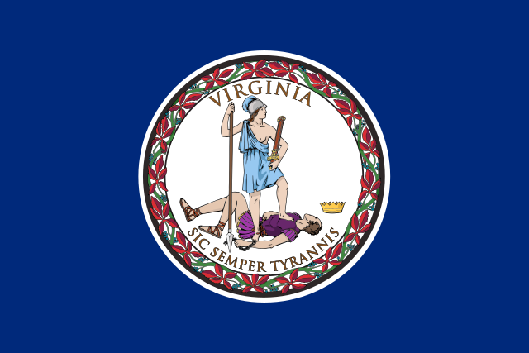Virginia is a state in the eastern United States, with a rich and varied history, from its colonial beginnings to its modern achievements. It is the birthplace of many presidents, patriots, and pioneers, as well as the site of many battles, revolutions, and innovations. It is also a state with a diverse and beautiful landscape, from its mountains and valleys to its rivers and coastlines.

Here are some of the facts and information about Virginia:

* It is the tenth state to ratify the U.S. Constitution on June 25, 1788.
* It is the 35th largest state by area and the 12th most populous state.
* It has 95 counties and 38 independent cities and its capital is Richmond. Its largest city is Virginia Beach.
* It has the highest concentration of technology workers in the nation.
* It is the only state that has produced eight U.S. presidents: George Washington, Thomas Jefferson, James Madison, James Monroe, William Henry Harrison, John Tyler, Zachary Taylor, and Woodrow Wilson.
* It is home to the first permanent English settlement in North America, Jamestown, founded in 1607.
* It is the site of the first representative assembly in the Americas, the House of Burgesses, established in 1619.
* It is the place where the first African slaves arrived in 1619, marking the beginning of slavery in the colonies.
* It is the location of the first Thanksgiving in 1619, celebrated by English settlers and Native Americans.
* It is the scene of the first major clash of the American Revolution, the Battle of Great Bridge, in 1775.
* It is the host of the Virginia Convention of 1776, where the Virginia Declaration of Rights and the Virginia Statute for Religious Freedom were adopted.
* It is the witness of the surrender of the British army at Yorktown in 1781, ending the American Revolution.
* It is the venue of the Virginia Convention of 1788, where the U.S. Constitution was ratified by a narrow margin.
* It is the origin of the Virginia Plan, which proposed a bicameral legislature and a strong national government, influencing the structure of the U.S. Constitution.
* It is the source of the Virginia and Kentucky Resolutions, which asserted the rights of the states to nullify unconstitutional federal laws, sparking the debate over states’ rights and federalism.
* It is the leader of the secession from the Union in 1861, becoming the capital of the Confederate States of America.
* It is the battleground of more than half of the Civil War battles, such as the First and Second Battles of Bull Run, the Seven Days Battles, the Battle of Fredericksburg, the Battle of Chancellorsville, the Battle of Gettysburg, the Battle of the Wilderness, the Siege of Petersburg, and the Battle of Appomattox Court House.
* It is the site of the first successful powered flight by the Wright brothers at Kitty Hawk in 1903.
* It is the location of the Pentagon, the headquarters of the U.S. Department of Defense, and the CIA, the Central Intelligence Agency.
* It is the home of the Arlington National Cemetery, the final resting place of more than 400,000 veterans and their families.
* It is the host of the Jamestown 2007 celebration, commemorating the 400th anniversary of the founding of Jamestown.
* It is the scene of the Virginia Tech shooting in 2007, the deadliest mass shooting in U.S. history at the time.

**Ex. 10 (Virginia):**

1. Virginia is known for having the highest concentration of what type of workers?

a) Healthcare

b) Technology

c) Education

d) Agriculture

2. Which is the largest city in Virginia?

a) Richmond

b) Norfolk

c) Virginia Beach

d) Alexandria

3. How many U.S. presidents were born in Virginia?

a) 4

b) 6

c) 8

d) 10

4. What significant event happened in Virginia in 1619?

a) The first permanent English settlement

b) The arrival of the first African slaves

c) Both a and b

d) The founding of the House of Burgesses

5. The Battle of Great Bridge was a major event in which conflict?

a) The American Revolution

b) The Civil War

c) World War I

d) The War of 1812

6. Where did the British army surrender, ending the American Revolution?

a) Jamestown

b) Richmond

c) Yorktown

d) Virginia Beach

7. The Virginia Plan influenced what aspect of the U.S. government?

a) The bicameral legislature

b) The judicial system

c) The executive branch

d) The electoral college system

8. Virginia was the ___ state to ratify the U.S. Constitution.

a) First

b) Tenth

c) Thirteenth

d) Fifteenth

9. Which is NOT a Civil War battle that took place in Virginia?

a) Battle of Gettysburg

b) Siege of Petersburg

c) Battle of Appomattox Court House

d) Battle of Bull Run

10. The first successful powered flight by the Wright brothers took place in:

a) Virginia

b) North Carolina

c) Ohio

d) New York

**11.New York**

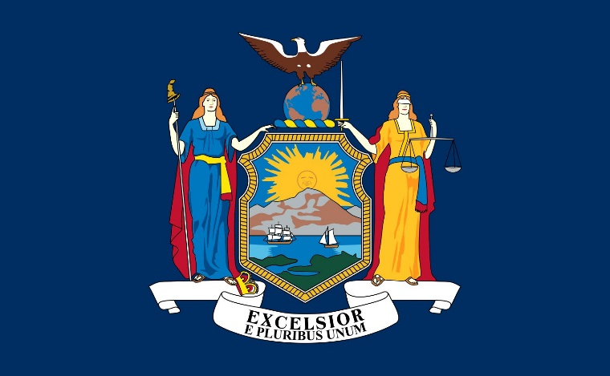New York is a state in the northeastern United States, with a long and diverse history, from its Native American origins to its role as a global city and a cultural and economic hub. It is the birthplace of many movements, innovations, and icons, as well as the site of many challenges, tragedies, and triumphs. It is also a state with a varied and beautiful landscape, from its mountains and lakes to its rivers and islands. Some facts about New York:

* It is the eleventh state to ratify the U.S. Constitution on July 26, 1788.
* It is the fourth largest state by area and the third most populous state.
* It has 62 counties and its capital is Albany. Its largest and most famous city is New York City, which is also the most populous city in the U.S. and one of the most influential cities in the world.
* It has the third largest economy in the nation and the eighth largest in the world, with major sectors such as finance, media, entertainment, technology, and tourism.
* It is the home of the New York Stock Exchange, Wall Street, Broadway, Times Square, the Statue of Liberty, the Empire State Building, and many other landmarks and attractions.
* It is the origin of many cultural and social movements, such as the Harlem Renaissance, the Stonewall riots, the hip hop culture, and the feminist movement.
* It is the site of many historical events and conflicts, such as the American Revolution, the War of 1812, the Erie Canal, the Civil War Draft Riots, the Great Depression, the World’s Fairs, the 9/11 attacks, and the COVID-19 pandemic.
* It is the birthplace or residence of many famous people, such as Alexander Hamilton, Theodore Roosevelt, Franklin D. Roosevelt, Eleanor Roosevelt, Martin Luther King Jr., Malcolm X, Walt Whitman, Mark Twain, Edith Wharton, F. Scott Fitzgerald, Andy Warhol, Robert De Niro, Madonna, Jay-Z, and Donald Trump.
* It is the leading producer of dairy, apples, grapes, and wine in the country.

**Exercise 11 (New York):**

1. New York ratified the U.S. Constitution as the ___ state.
   * 1. Fourth
     2. Eleventh
     3. Thirteenth
     4. Fifteenth
2. The capital of New York is:
   1. New York City
   2. Buffalo
   3. Albany
   4. Rochester
3. Which of the following landmarks is NOT in New York?
   1. The Statue of Liberty
   2. The Golden Gate Bridge
   3. Times Square
   4. The Empire State Building
4. New York is the birthplace of which cultural movement?
   1. The Renaissance
   2. The Harlem Renaissance
   3. The Industrial Revolution
   4. The Beat Generation
5. Which sector is NOT a major part of New York's economy?
   1. Technology
   2. Agriculture
   3. Oil refining
   4. Finance
6. The New York Stock Exchange is located in:
   1. Central Park
   2. Wall Street
   3. Broadway
   4. Silicon Alley
7. New York is a leading producer of:
   1. Rice
   2. Dairy
   3. Beef
   4. Cotton
8. The largest city in New York is:
   1. Albany
   2. Buffalo
   3. New York City
   4. Syracuse
9. Which historical event did NOT occur in New York?
   1. The American Revolution
   2. The War of 1812
   3. The Civil War Draft Riots
   4. The Boston Tea Party
10. New York's economy is ranked ___ in the world.
    1. First
    2. Third
    3. Eighth
    4. Twelfth

**12.North Carolina**

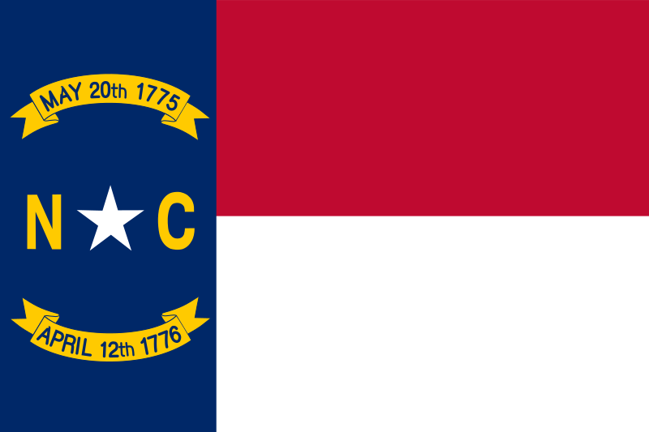North Carolina is a state in the southeastern United States, with a long and diverse history, from its Native American origins to its modern achievements. It is the birthplace of many presidents, patriots, and pioneers, as well as the site of many battles, revolutions, and innovations. It is also a state with a diverse and beautiful landscape, from its mountains and valleys to its rivers and coastlines.

Some of the highlights of North Carolina history are:

* It was the 12th state to ratify the U.S. Constitution on November 21, 1789.
* It was the home of the Research Triangle Park, one of the largest research and development centers in the world, and the Charlotte Douglas International Airport, the 11th busiest airport in the world.
* It was the origin of many cultural and social movements, such as the Moravian Church, the Mecklenburg Declaration of Independence, the Wilmington Insurrection of 1898, and the Greensboro sit-ins.
* It was the site of many historical events and conflicts, such as the Lost Colony of Roanoke, the Tuscarora War, the Regulator Movement, the American Revolution, the War of 1812, the Civil War, the Wright brothers’ first flight, and the Lumbee Rebellion.
* It was the birthplace or residence of many famous people, such as Andrew Jackson, James K. Polk, Andrew Johnson, Edward R. Murrow, Billy Graham, Michael Jordan, and Maya Angelou.
* It was the leading producer of tobacco, sweet potatoes, and turkeys in the country.
* It had more than 300 miles of coastline, including the Outer Banks, a chain of barrier islands that are home to the Cape Hatteras National Seashore and the Cape Lookout National Seashore.

**Exercise 12 (North Carolina):**

1. North Carolina ratified the U.S. Constitution as the ___ state.
   * 1. 10th
     2. 12th
     3. 15th
     4. 20th
2. Which of the following is NOT a cultural or social movement originating in North Carolina?
   1. The Moravian Church
   2. The Mecklenburg Declaration of Independence
   3. The Boston Tea Party
   4. The Greensboro sit-ins
3. The first flight by the Wright brothers took place in:
   1. Kitty Hawk, North Carolina
   2. Charlotte, North Carolina
   3. Raleigh, North Carolina
   4. Asheville, North Carolina
4. Which of the following is North Carolina known to be the leading producer of?
   1. Rice
   2. Cotton
   3. Tobacco
   4. Wheat
5. The Outer Banks in North Carolina are famous for:
   1. Being the largest city
   2. Their historical significance in the Civil War
   3. A chain of barrier islands
   4. The birthplace of several U.S. presidents

**13.Rhode Island**

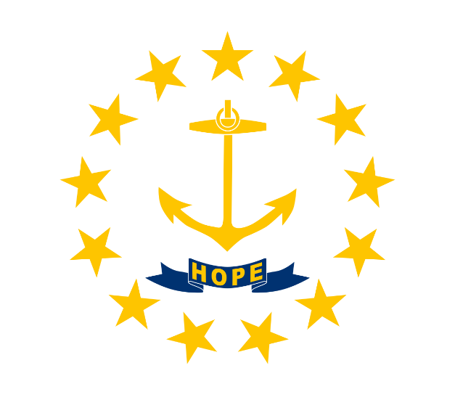Rhode Island, the smallest state in the United States, is steeped in a history as rich and profound as that of its larger counterparts. Officially known as the State of Rhode Island and Providence Plantations. Founded by Roger Williams in 1636 as a haven for those seeking religious freedom, Rhode Island became a beacon of tolerance, distinguishing itself from other colonies that adhered to strict religious conformity.

Rhode Island's economy in the colonial era was diverse; while it engaged in farming and fishing, it also became a hub for shipbuilding and trade, including the infamous triangular trade. This trade involved the exchange of slaves from Africa, rum from Rhode Island, and goods from the Caribbean, marking a dark chapter in its otherwise progressive history. Despite this, Rhode Island was the first of the colonies to renounce allegiance to the British Crown in May 1776, a bold step towards independence.

The state's landscape, characterized by its extensive shoreline along Narragansett Bay, has earned it the nickname "The Ocean State." This geographical feature played a vital role in Rhode Island's development, contributing to its maritime activities and the growth of cities like Newport and Providence. Newport, in particular, became known for its thriving colonial trade and later as a summer retreat for America's wealthiest families during the Gilded Age, leading to the construction of opulent mansions that remain tourist attractions today.

In the 19th century, Rhode Island was at the forefront of the Industrial Revolution in America. The establishment of Samuel Slater's cotton mill in Pawtucket marked the beginning of the industrialization of the United States, transforming Rhode Island into a manufacturing powerhouse. This period saw a significant increase in the state's population, fueled by waves of immigrants seeking work in its mills and factories.

Despite its small size, Rhode Island has been a leader in advocating for various social and political reforms. It was the first to take action against British authority, the first to pass laws abolishing slavery in 1652 (though these laws were not strictly enforced until the post-Revolutionary period), and it consistently fought for religious and personal freedom.

Today, Rhode Island is celebrated for its vibrant culture, which reflects the diverse heritage of its population. It is also home to several prestigious institutions of higher education, including Brown University and the Rhode Island School of Design, which contribute to its reputation as a center of art, innovation, and research.

Rhode Island's rich history is preserved in its historic sites, from the colonial streets of Providence to the Gilded Age mansions of Newport. Its cultural festivals, beautiful beaches, and maritime heritage continue to attract visitors, making it a unique destination that offers much more than its size might suggest. Despite being the smallest state, Rhode Island's contribution to American history, culture, and innovation is immense, making it an integral part of the national fabric.

**Exercise 13 (Rhode Island):**

1. Who founded Rhode Island as a haven for those seeking religious freedom?
   * 1. John Winthrop
     2. Roger Williams
     3. Benjamin Franklin
     4. Samuel Slater
2. What nickname is Rhode Island known by due to its extensive shoreline?
   1. The Granite State
   2. The Ocean State
   3. The Garden State
   4. The Bay State
3. Which city in Rhode Island became known for its thriving colonial trade and as a summer retreat for America's wealthiest families?
   1. Providence
   2. Pawtucket
   3. Newport
   4. Warwick
4. What marked the beginning of the industrialization in the United States?
   1. The founding of Brown University
   2. The establishment of Samuel Slater's cotton mill in Pawtucket
   3. The signing of the Declaration of Independence
   4. The end of the American Revolution
5. Rhode Island was the first of the colonies to do which of the following?
   1. Renounce allegiance to the British Crown
   2. Establish a university
   3. Create a public park
   4. Implement a tax system
6. Which institution in Rhode Island contributes to its reputation as a center of art, innovation, and research?
   1. Rhode Island School of Design
   2. University of Rhode Island
   3. Providence College
   4. New England Institute of Technology

**History of these 13 American states:**  
  
The abbreviation "U.S." appears in the papers of George Washington in 1791, and the abbreviation "U.S.A." first appeared in 1795. But for two more years after the declaration of independence the name "United States of North America" was officially used; the word "North" was excluded from the name by the decision of the Continental Congress in 1778.

**Northern Colonies:**

New Hampshire and Massachusetts: Founded by Puritans seeking religious freedom in the 1600s, these colonies embraced strict moral codes and self-sufficiency. Plymouth Colony (1620) and Massachusetts Bay Colony (1630) laid the groundwork for participatory democracy and education.

**Rhode Island and Connecticut**: Dissenters from Massachusetts' rigid rule founded these colonies. Roger Williams championed religious tolerance in Rhode Island, while Connecticut emphasized representative government.

**Middle Colonies**:

**New York and New Jersey**: Originally Dutch settlements, these colonies became diverse hubs of trade and commerce. New York City emerged as a bustling port, while New Jersey offered fertile farmland and religious tolerance.

**Pennsylvania and Delaware**: Founded by William Penn as a Quaker haven, Pennsylvania promoted peace, religious freedom, and tolerance. Delaware, once part of Pennsylvania, later became a separate colony known for its shipbuilding and agriculture.

**Southern Colonies**:

**Maryland:** Lord Baltimore established Maryland as a haven for Catholics facing persecution in England. It became a center for tobacco cultivation and religious pluralism.

**Virginia**: Founded in 1607 as Jamestown, Virginia became the first successful English colony. It relied heavily on indentured servants and later enslaved Africans for labor, primarily cultivating tobacco.

**North Carolina and South Carolina**: Initially part of Carolina, these colonies eventually split due to economic and cultural differences. North Carolina retained a more agrarian society, while South Carolina became a wealthy rice-producing colony with a large slave population.

**Georgia**: Founded in 1733 as a debtor's colony and a buffer against Spanish Florida, Georgia initially prohibited slavery. However, it later adopted a plantation economy fueled by enslaved labor.

**Shared Struggles and Independence:**

Despite their diverse origins and economies, the colonies faced common challenges under British rule. Taxation without representation, restrictions on trade, and growing resentment towards imperial policies fueled a shared desire for independence. This culminated in the American Revolution (1775-1783), where the united colonies severed ties with Britain and established themselves as the first independent nation in the Americas.

The legacy of these 13 states is profound. They laid the foundation for American democracy, enshrined in the Constitution of the United States. Their stories of struggle, ingenuity, and a yearning for freedom continue to resonate with us today, reminding us of the power of a united people and the enduring values that shaped a nation.

**Conclusion:**

In wrapping up my exploration of the first 13 American states—Delaware, Pennsylvania, New Jersey, Georgia, Connecticut, Massachusetts, Maryland, South Carolina, New Hampshire, Virginia, New York, North Carolina, and Rhode Island—we see how special each one was in shaping what America is today. These states were the first building blocks of the country, and each one brought something unique to the table. From Delaware being the very first to agree to the new country's rules, to Rhode Island being the last of the bunch, their stories show us how different people with different ideas can come together to make something truly amazing.

Back when America was just starting, these states were where the big fight for freedom happened and where the first rules of how to run the country were made. They had to deal with really tough problems, like disagreeing on who should make the rules and how to make sure everyone got a fair say. These early challenges are like lessons for us today, showing the importance of working together and finding solutions that work for everyone.

But it's not just about their struggles. These states also kicked off some of the best things we still see in America today. They started some of the first schools, made rules about being able to practice whatever religion you want, and came up with new ways to run a government that others around the world would look up to. Even as America grew, the ideas that started in these states about freedom, democracy, and always trying to improve things have stayed at the heart of what it means to be American.

Looking at these first 13 states gives us a clearer picture of how America got its start and what makes it unique. They teach us that bringing people together, celebrating our differences, and always striving to be better are key parts of the American spirit. By learning about these states, we get a guide on how to keep making America a place where everyone can dream big and work together to make those dreams come true.

In short, the story of these first states isn't just history—it's a living lesson on teamwork, innovation, and the enduring power of the American dream. As we move forward, remembering their journey can help us navigate the challenges of today and tomorrow, ensuring that the spirit of unity, progress, and freedom continues to define the American experience.

**Keys**

Ex.1:

1. b;
2. b;
3. c;
4. a;
5. c;
6. b;
7. b;
8. a;
9. b;

10. c.

Ex.2:

1. c) The Keystone State

2. b) Navajo

3. a) 1780

4. b) Philadelphia

5. b) second

6. b) Software development

7. a) Groundhog Day

8. b) Bob Dylan

9. c) Gettysburg (This is a trick question; while Gettysburg is in Pennsylvania, it wasn't mentioned in the text, unlike the Battle of Brandywine and the Battle of Monmouth, which were mentioned in the context of other states or events.)

10. b) Philadelphia

Ex.3:

1. b) Significant agricultural production.

2. c) Being the largest state by area.

3. a) True

4. b) Elvis Presley

5. b) Trenton

Ex. 4:

1. c) The Peach State

2. b) 1788

3. b) Creek, Cherokee, and Seminole

4. c) 1870

5. b) Shipbuilding

Ex. 5:

1. a) The Constitution State

2. b) Third smallest

3. a) Hartford

4. c) 1788

5. b) Library

Ex. 6:

1. b) Numerous bays and harbors

2. b) Sioux

3. a) 1692

4. b) Sixth

5. b) Yale University

6. c) The Battle of Gettysburg

7. b) Technology

8. b) Clam chowder

9. b) Coca-Cola

10. b) New England Patriots

Ex. 7:

1. b) Early abolition of slavery

2. c) Virginia

3. b) Seventh

4. d) Baltimore

5. c) Blue crabs

Ex. 8:

1. c) Official state tree, the sabal palmetto

2. c) Columbia

3. b) Eighth

4. c) Coffee

5. c) It has the lowest percentage of residents with a bachelor’s degree or higher

Ex. 9:

1. a) Abundant granite formations

2. a) Concord

3. c) Ninth

4. c) Both a and b

5. b) Mark Twain

6. b) The world’s worst weather

7. c) Maple syrup

8. a) Lake Winnipesaukee

9. a) The U.S. presidential election

10. b) 10

Ex. 10:

1. b) Technology
2. c) Virginia Beach
3. c) 8
4. c) Both a and b
5. The American Revolution
6. Yorktown
7. The bicameral legislature
8. Tenth
9. Battle of Gettysburg
10. North Carolina

Ex. 11:

1. b) Eleventh
2. c) Albany
3. b) The Golden Gate Bridge
4. b) The Harlem Renaissance
5. c) Oil refining
6. b) Wall Street
7. b) Dairy
8. c) New York City
9. a) The Boston Tea Party
10. c) Eighth

Ex.12:

1. b) 12th
2. c) The Boston Tea Party
3. a) Kitty Hawk, North Carolina
4. c) Tobacco
5. c) A chain of barrier islands

Ex. 13:

1. b) Roger Williams
2. b) The Ocean State
3. c) Newport
4. b) The establishment of Samuel Slater's cotton mill in Pawtucket
5. a) Renounce allegiance to the British Crown
6. a) Rhode Island School of Design

**Literature**

[The Original 13 States of the United States (thoughtco.com)](https://www.thoughtco.com/the-original-13-us-states-3322392)

[List of U.S. states by date of admission to the Union - Wikipedia](https://en.wikipedia.org/wiki/List_of_U.S._states_by_date_of_admission_to_the_Union)

[Original thirteen states - Ballotpedia](https://ballotpedia.org/Original_thirteen_states)

[Learn & Explore - Preparing for the Oath (si.edu)](https://americanhistory.si.edu/citizenship/learn/a-growing-nation/64/learn)

[What Are the First 13 States In Order? - CLJ (communityliteracy.org)](https://communityliteracy.org/what-are-the-first-13-states-in-order/)

[The 13 Colonies: Map, Original States & Facts | HISTORY](https://www.history.com/topics/colonial-america/thirteen-colonies)

[What Are the First 13 States In Order? - Caniry](https://www.caniry.com/what-are-the-first-13-states-in-order/)

[History of Delaware - Wikipedia](https://en.wikipedia.org/wiki/History_of_Delaware)

[Delaware (history.com)](https://www.history.com/topics/us-states/delaware)

[Delaware Pictures and Facts (nationalgeographic.com)](https://kids.nationalgeographic.com/geography/states/article/delaware)

[Delaware State Facts - What state has more chickens than humans? (dehistory.org)](https://dehistory.org/learn/delaware-facts/)

[Pennsylvania (history.com)](https://www.history.com/topics/us-states/pennsylvania)

[History of Pennsylvania - Wikipedia](https://en.wikipedia.org/wiki/History_of_Pennsylvania)

[Pennsylvania - Colonial, Revolution, Industry | Britannica](https://www.britannica.com/place/Pennsylvania-state/History)

[History of New Jersey - Wikipedia](https://en.wikipedia.org/wiki/History_of_New_Jersey)

[New Jersey - Colonel History, Industrialization & Organized Crime](https://www.history.com/topics/us-states/new-jersey)

[New Jersey State Facts - New Jersey History Firsts (ereferencedesk.com)](https://www.ereferencedesk.com/resources/state-facts/new-jersey.html)

[New Jersey Pictures and Facts (nationalgeographic.com)](https://kids.nationalgeographic.com/geography/states/article/new-jersey)

[History of New Jersey - Wikipedia](https://en.wikipedia.org/wiki/History_of_New_Jersey)

[History of Georgia (U.S. state) - Wikipedia](https://en.wikipedia.org/wiki/History_of_Georgia_%28U.S._state%29)

[Georgia | History, Flag, Facts, Maps, & Points of Interest | Britannica](https://www.britannica.com/place/Georgia-state)

[Georgia History - New Georgia Encyclopedia](https://www.georgiaencyclopedia.org/articles/history-archaeology/georgia-history-overview/)

[Connecticut (history.com)](https://www.history.com/topics/us-states/connecticut)

[History of Connecticut - Wikipedia](https://en.wikipedia.org/wiki/History_of_Connecticut)

[Timeline: Settlement of the Colony of Connecticut - Connecticut History | a CTHumanities Project](https://connecticuthistory.org/timeline-settlement-of-the-colony-of-connecticut/)

[Connecticut Pictures and Facts (nationalgeographic.com)](https://kids.nationalgeographic.com/geography/states/article/connecticut)

[Connecticut (history.com)](https://www.history.com/topics/us-states/connecticut)

[History of Massachusetts - Wikipedia](https://en.wikipedia.org/wiki/History_of_Massachusetts)

[Massachusetts - First Thanksgiving, the Wampanoag & Harvard (history.com)](https://www.history.com/topics/us-states/massachusetts)

[History of Massachusetts - Wikipedia](https://en.wikipedia.org/wiki/History_of_Massachusetts)

[Massachusetts - Wikipedia](https://en.wikipedia.org/wiki/Massachusetts)

[Maryland (history.com)](https://www.history.com/topics/us-states/maryland)

[History of Maryland - Wikipedia](https://en.wikipedia.org/wiki/History_of_Maryland)

[Maryland Pictures and Facts (nationalgeographic.com)](https://kids.nationalgeographic.com/geography/states/article/maryland)

[Maryland summary | Britannica](https://www.britannica.com/summary/Maryland-state)

[South Carolina - Colonel History, Civil War & Myrtle Beach](https://www.history.com/topics/us-states/south-carolina)

[History of South Carolina - Wikipedia](https://en.wikipedia.org/wiki/History_of_South_Carolina)

[South Carolina Pictures and Facts (nationalgeographic.com)](https://kids.nationalgeographic.com/geography/states/article/south-carolina)

[South Carolina State History for Kids (ducksters.com)](https://www.ducksters.com/geography/us_states/south_carolina_history.php)

[New Hampshire - Colonial, Revolution, Lakes | Britannica](https://www.britannica.com/place/New-Hampshire-state/History)

[History of New Hampshire - Wikipedia](https://en.wikipedia.org/wiki/History_of_New_Hampshire)

[New Hampshire - Portsmouth, White Mountains & Shakers (history.com)](https://www.history.com/topics/us-states/new-hampshire)

[History of Virginia - Wikipedia](https://en.wikipedia.org/wiki/History_of_Virginia)

[Virginia - Capital, Facts & Statehood (history.com)](https://www.history.com/topics/us-states/virginia)

[History of Virginia in Timeline - Popular Timelines](https://populartimelines.com/timeline/Virginia)

[Virginia State History for Kids (ducksters.com)](https://www.ducksters.com/geography/us_states/virginia_history.php)

[History of New York (state) - Wikipedia](https://en.wikipedia.org/wiki/History_of_New_York_%28state%29)

[New York - Native American tribes, Immigration & the Harlem Renaissance (history.com)](https://www.history.com/topics/us-states/new-york)

[New York | Capital, Map, Population, History, & Facts | Britannica](https://www.britannica.com/place/New-York-state)

[New York | Capital, Map, Population, History, & Facts | Britannica](https://www.britannica.com/place/New-York-state)

[History of North Carolina - Wikipedia](https://en.wikipedia.org/wiki/History_of_North_Carolina)

[North Carolina | Capital, Map, History, & Facts | Britannica](https://www.britannica.com/place/North-Carolina-state)

[North Carolina Pictures and Facts (nationalgeographic.com)](https://kids.nationalgeographic.com/geography/states/article/north-carolina)

[North Carolina History Timeline: North Carolina Important Dates (ereferencedesk.com)](https://www.ereferencedesk.com/resources/state-history-timeline/north-carolina.html)

[North Carolina - Wikipedia](https://en.wikipedia.org/wiki/North_Carolina)

[Rhode Island - Size, Founder & Facts (history.com)](https://www.history.com/topics/us-states/rhode-island)

[History of Rhode Island - Wikipedia](https://en.wikipedia.org/wiki/History_of_Rhode_Island)

[Rhode Island State Facts - Rhode Island History Firsts (ereferencedesk.com)](https://www.ereferencedesk.com/resources/state-facts/rhode-island.html)