# ABSTRACT

Being a naturally blessed mystical land of himalayas, Nepal attracts tourist from all around the globe. The year 2020 is even being recognized as Tourism Year by the Nepali government, but the country never focuses on making travel easier, so to overcome this problem we made a digital approach via our app “**TRAVEL PERFECT**”. This app is basically developed to assist tourists exploring Nepal by providing trekking information along with the platform to choose their perfect travel companion and participate in a cause close to their heart.

User can pre-decide every aspects of the trip through this app. They can even book their accommodations and transportation for the entire trip. This app will be also helpful for the people who are interested to accompany the guest. Furthermore, this app also provides the information about the voluntary projects and causes that may be appealing to travellers.

**Keywords*:*** *travel, tourist, trekking, information, voluntary projects, companion*

**TABLE OF CONTENT**

ABSTRACT ii

LIST OF FIGURE iv

LIST OF ABBREVIATION v

CHAPTER 1. INTRODUCTION 1

1.1.BACKGROUND THEORY 1

1.2 PROBLEM STATEMENT 2

1.3 OBJECTIVES 2

1.4 SCOPE OF THE PROJECT 2

1.5 APPLICATIONS 3

CHAPTER 2. LITERATURE REVIEW 4

2.1 EXISTING TRAVEL/TOURISM APPS IN NEPAL 5

2.1.1 NEPAL TRAVEL GUIDE OFFLINE 5

2.1.2 NEPAL TRAVEL GUIDE BY TRIPOSO 5

2.2 LIMITATIONS OF PREVIOUS SYSTEMS 5

2.3 SOLUTION PROPOSED BY OUR SYSTEM 5

CHAPTER 3. METHODOLGY 7

3.1 PROCESS MODEL 7

3.2 SYSTEM BLOCK DIAGRAM 8

CHAPTER 4. EPILOGUE 10

4.1 EXPECTED OUTPUT 10

4.2 GANTT CHART 11

REFRENCES 12

# 

# LIST OF FIGURE

Figure 3.1.1: Process Model

Figure 3.2.1: Block Diagram

Figure 4.2.1: Gantt chart

# LIST OF ABBREVIATION

**ABC :** Annapurna Base Camp

**AI :** Artificial Intelligenc

**EBC :** Everest Base Camp

**GDP :** Gross Domestic Product

**ID :** Identification

**KNP :** Khaptad National Park

**WTTC:** World Travel and Tourism Council

**CHAPTER 1. INTRODUCTION**

## BACKGROUND THEORY

Hitting new places to explore its natural beauty, culture, people, food, and vibe can be an enriching experience for anyone but finding a perfect travel companion that makes the task of managing all those necessary travel arrangement is troublesome. NEPAL, a mystical land of Himalayas lures travelers from all around the globe to witness its majestic mountain peaks, rich culture that has stood the test of time and its ever welcoming beautiful people who have made "Atithi Devo Bhava" a mantra to live their life by. Trekking across this beautiful terrain which makes its way to majestic mountains is always a primary goal for travelers coming to Nepal but being a underdeveloped nation, our country also attracts people of tender heart who finds their true meaning in life by making some underprivileged peoples life in mystical land a little easier. We aim to provide these beautiful travelers a platform to find a voluntary project which is close to their heart and get involved in it and make their life meaningful. So our project ‘**TRAVEL PERFECT’** focuses on these aspects so the travelers exploring Nepal would have an enriching experience free of any unnecessary hassles.

Three most visited travel destinations ABC, EBC and Khaptad National Park are taken as our test centers. In addition to the information about these places to visit, users will be provided with the video clips and photographs of these places which will make them pack their bags and hit the road asap. Furthermore, Routes were provided by the help of Map from the user’s current location to the destination chosen by them. This app provides a platform for traveler to choose their perfect travel companion (guide) using our apps AI. They can interact directly with the interested guides as their personal information and contacts will be provided here. At the end of the tour user can show their gratitude to the guide or file a complaint as per their manner through the points which will affect their popularity and future selections.

In addition to the volunteering, app provide users with a list of ongoing activities or the activity going to be held inside which there will be the description of the nature of work with work place and helping time. In addition to the financial volunteering, app provide user with the direct access to the community leader of that project.

## 

## 1.2 PROBLEM STATEMENT

In the 21st century, people tend to have a very busy life. People need to visit different places for the sake of refreshment from their daily hectic life and Nepal, having abundant natural beauty, always tries to welcome a huge number of tourist but does not provide the required proper information about the trip. Firstly, being in a completely different place, tourists always try to get the proper information about the routes, places of accommodation. They also feel uncomfortable interacting with local peoples in a different geographical area away from home because of cultural differences. In spite of the presence of numerous travel agencies and tourist guides in our country, travelers always prefer to visit without a guide because they cannot be frank with the guide. They also feel that the cost of hiring a guide is too expensive for some travelers.

Being a developing country, there are numerous ongoing projects in our country which seeks financial help as well as volunteering needs. There are different reports where people who want to be involved in such projects fall victim to fraud. This happens because these people register for volunteer work from unverified and unreliable sources. The security threat has been increased due the unreliable/unregistered projects to the tourist. The cases of crimes like robbery, harassment, rape, murder, extortion has also been reported by tourist. This then lowers the reputation of our country in the eyes of potential future visitors.

## 1.3 OBJECTIVES

The objectives of our project are:

* To help travelers find great travel destinations with accurate routes and geographical information.
* To help travelers find guides of similar age group to make their visit and travels as comfortable as possible.
* To help travelers find and get involved in volunteering activities that they are interested in

.

## 1.4 SCOPE OF THE PROJECT

Currently very few apps provide the information about the trekking routes but with those apps user cannot get any information about the guides and accurate geographical information so that they cannot prepare themselves for the visit. So our app provides the users with proper routes and geographical information along with the guide of similar age group with whom they can have private talk. Furthermore, we encourage local people to collaborate with us in their leisure time. Beside that our app helps users being involved in the volunteering activities for which they show interest. Along with this users were reminded for their trip with notification. User was provided with the search bar to search their destination for visit. In a nutshell, our app focuses on all round upliftment of the tourism sector.

## 1.5 APPLICATIONS

* The application will guide the travelers about the best route to reach the destination.
* The application provides the opportunity for the interested one to interact with the tourist and guide them to the destination.
* The application acts as the medium for the tourist who is not here for visit but also for some volunteering work.
* It works as a remainder of trip to the traveler.
* It allows travelers to have direct contact with the guides for the information about prerequisite for the destination.

# CHAPTER 2. LITERATURE REVIEW

As one of the world’s largest economic sectors, travel and tourism creates jobs, drives exports, and generates prosperity across the world. So, it continues to make a real difference to the lives of millions of people by driving growth, reducing poverty and fostering development. According to the World Travel & Tourism Council’s (WTTC) annual research in 2018, travel and tourism is one of the world’s booming industries, generating approximately US$ 8.8 trillion annually and contributing 319 million jobs to the world economy.

Nepal has great potential to become a top destination for tourists as the nation is famous for its snowcapped mountains, abundant flora and fauna, exciting trekking routes and rich cultural and religious diversity. According to Lonely Planet, Kathmandu is the 5th top travel destination while tripadvisor.com has ranked Kathmandu at 19th out of 25 best tourism destinations in the world for the year 2019. These facts reveal that there are many places like Kathmandu that could fascinate tourists from around the world.

According to the WTTC, the share of tourism sector in Nepal's GDP is only 5 percent which must be more than 50 percent to reach this target government is promoting Nepal through the concept of visit Nepal concept. For this there are many app that were created to promote the Nepal's tourism sector but due to several issue such as lack of information on app, weak user compatibility etc. In 2018 around 1 million visitors have visited Nepal but by 2020 government aim to double the population. To meet this target technology must be blended with the nature in a proper way.

In recent years there has been exponential growth in the number of travel agencies, tour guides, tour operators, rafting agencies and this is the place which fails to meet the users expectation because the traveler looking for hassle free one stop solution for all their plans aren't able to find one which results in the loss of tourist for the country. So, the use of the mobile app in the field of our concern can redefine the way of tourism in Nepal which will automatically bring more tourists resulting in upliftment of socio-economic status of people.

So far, there is no aggregate data that shows a significant contribution of tourism related apps in Nepal’s GDP. So, through this app we are making an ambitious goal of bringing significant change in this sector and for this Government should facilitate with grass root levels research and investigations.

## 2.1 EXISTING TRAVEL/TOURISM APPS IN NEPAL

Nepal specific travel and trekking apps currently available in play store are mentioned below:

## 2.1.1 NEPAL TRAVEL GUIDE OFFLINE

Nepal Travel Guide Offline is an offline travel guide, which recommends detailed articles around the country in relation to your current location. Most of the information that the user will look for are hidden behind a pay wall.

## 2.1.2 NEPAL TRAVEL GUIDE BY TRIPOSO

Nepal Travel Guide by Triposo is another offline travel guide that has information about different hotels, activities and events in different cities and regions of Nepal.

## 2.2 LIMITATIONS OF PREVIOUS SYSTEMS

These currently available apps are trying to facilitate tourists in their travels and we sincerely are grateful to them for being the pioneer in this field but they haven't been able to entertain all the interests of travelers coming to Nepal. Also most of them are way behind in user friendliness and instead of making travel easy, unknowingly they are making it more difficult due to the lack of proper information, user preferences and so on. Also these apps fail to accommodate one of the main interests of tourist coming to Nepal i.e. participating in voluntary work and being involved in a cause which gives their life a meaning. We being the vivid travelers have encountered tourists facing such problems and want to make this task easier and hassle free.

## 2.3 SOLUTION PROPOSED BY OUR SYSTEM

After researching a lot about the pros and cons of prevalent apps in Nepal, we are committed to bring a remarkable change in online tourism experience of Nepal. Our app primarily focuses on providing user friendly information about trekking routes and available accommodations in that area. Also we are focused on providing a platform where the tourists can interact directly with the guides if needed and contact them personally for their convenience. In this platform any Nepali with good command over language and having strong knowledge of the routes can provide their information and on the basis of this information, tourists coming to Nepal can choose their travel partner which fits to their interests.

In addition to this, we are planning to provide the platform for tourists to choose the voluntary projects which they feel is close to their heart and helps them in fulfilling their purpose and makes their travel truly meaningful in every aspect.

# CHAPTER 3. METHODOLGY

## 3.1 PROCESS MODEL

## 3.1.1 INCREMENTAL MODEL

Incremental Model is a process of software development where requirements are broken down into multiple standalone modules of software development cycle. Incremental development is done in steps from analysis design, implementation, testing/verification, maintenance. Each iteration passes through the requirements, design, coding and testing phases. And each subsequent release of the system adds function to the previous release until all designed functionality has been implemented.

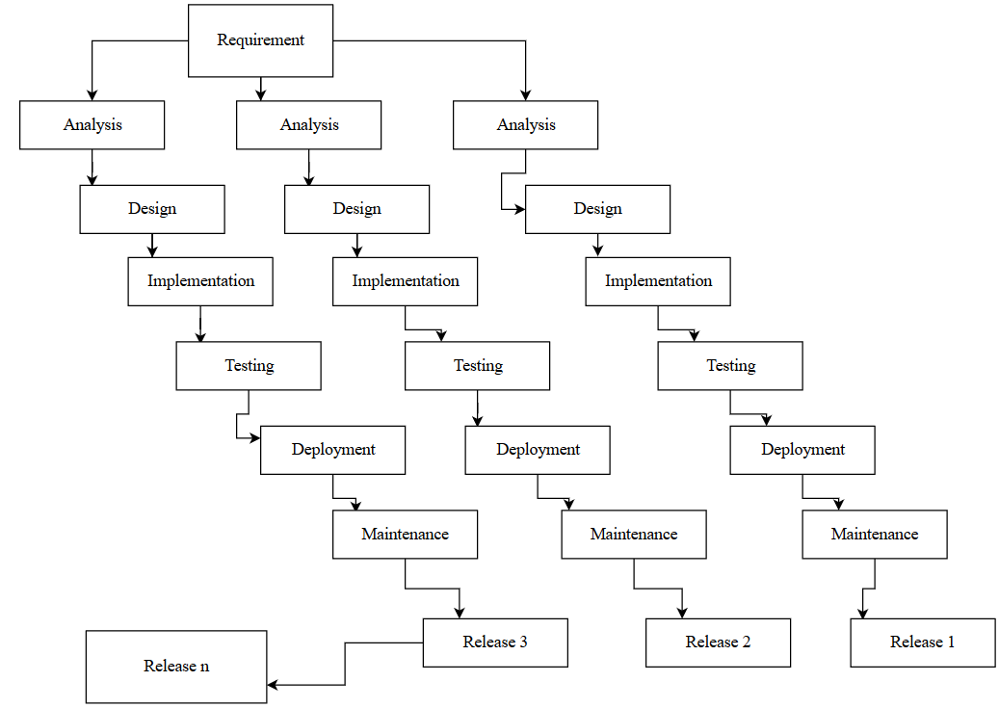

Figure 3.1.1: INCRMENTAL MODEL

We will be using the incremental model for the development of our product. The main focus at the beginning will be developing the core product. The core product will display the places to visit by the use of GPS and map API. Accordingly, the process will be started by analyzing the problems faced by the internal and external tourist during their visit. And as per their problems we will be designing the suitable program and implement it. After the implementation we will be testing it whether there is any error or not? If it is error free then we will repeat the same process again and again until we do not obtain the targeted application. The final product will be ready for the client review. The required modification, maintenance and support will be given accordingly as per the review of the client.

## 3.2 SYSTEM BLOCK DIAGRAM

When user opens an app they will be welcomed by signup/login screen. The beautifully designed Home page consists of a “Search Menu” in topmost row along with the “Suggested places” to visit and “List of ongoing project”. The user can access the more features by navigating through the sidebar at the leftmost corner which encompasses of “System setting”, “List of Guides”, “Videos”.

When the user clicks the Search menu they can search the destination they want to visit. This section consists of the most comfortable route and the best available places for accommodation required for their trip. Even they can book the places for accommodation through the contact information provided in our app.

In the “Suggested places” section based on the user preferences the app shows the most preferred places to visit according to the recommendation by other user.

Clicking on the “On Going” project the user can navigate through the ongoing project and the detail info about the project is given to the user. If they want to contribute to the project the contact information will be provided in this section.

Navigating through the “Sidebar”, settings can be accessed by the user to toggle notifications according to the user’s needs. Dark mode can also be turned on from the settings. The “Guide Profile” consists of a list of the guides that are suggested according to the user’s age. The contact information of the guide is also provided along with an option to provide feedback in the guide profile page.

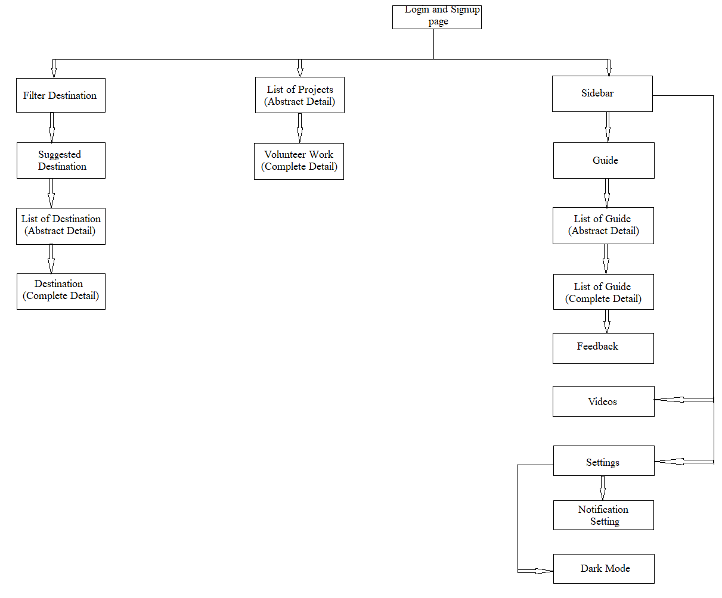

Figure 3.2.1: SYSTEM BLOCK DIAGRAM

# CHAPTER 4. EPILOGUE

## 4.1 EXPECTED OUTPUT

**“TRAVEL PERFECT”** is a mobile app designed and developed to help the tourist to get the most out of their next travel destination. This app provides the information of the routes the travelers are planning to travel with the help of maps, video footage and images of the place in a way which has never been presented before. Moreover, this app also provides the necessary details for the accommodations during the entire trip. Also we expect tourist to find their perfect travel partner to make the most out of this trip which will directly or indirectly help Nepali youths in making some extra income and also help in their personal growth. Tourist can choose the guide according to their preferences and the reviews and rating made by previous visitors. This app will also have the feature to know about the necessary transportations to be used by the tourists during their entire stay. In addition to all these features we hope our app will also provide a platform for the tourist to involve in causes close to their heart which will make their travel meaningful and in return bring a socio-economic change in our country.

**4.2 GANTT CHART**

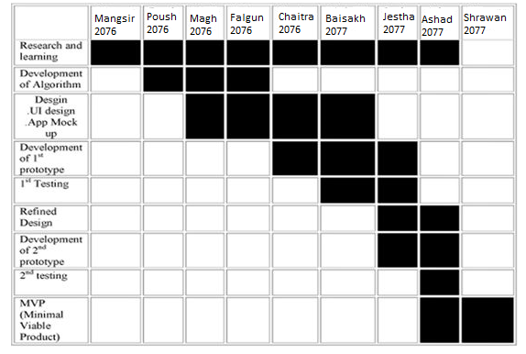

Figure 4.2.1: Gantt chart

# 

# REFRENCES

[1] The Himalayan Times, "Tourism industry in Nepal” September 2019 [online]. Available:

<https://thehimalayantimes.com/opinion/tourism-industry-in-nepal-make-it-backbone-of-economy/>

[Accessed 28 Nov, 2019]

[2] “Incremental build model", Wikipedia [online].Available:

<https://en.wikipedia.org/wiki/Incremental_build_model>

[Accessed 28 Nov, 2019]