Design Patterns
Name: NALLANI LOKAKALYAN
Registered Mail: 2300030853cseh1@gmail.com

Exercise 1: Singleton Pattern

package Design_patterns;
public class Exercise_1 {
static class Logger {
private static Logger instance;
private Logger() {
System.out.println("Logger Instance Created");
}
public static Logger getInstance() {
if (instance == null) {
instance = new Logger();
}
return instance;
}
public void log(String message) {
System.out.println("LOG: " + message);
}
}
public static void main(String[] args) {
Logger logger1 = Logger.getInstance();
Logger logger2 = Logger.getInstance();
logger1.log("First Message");
logger2.log("Second Message");
if (logger1 == logger2) {
System.out.println("Only one Logger instance exists.");
} else {
System.out.println("Multiple Logger instances exist.");
}
}
}

Output Screenshot
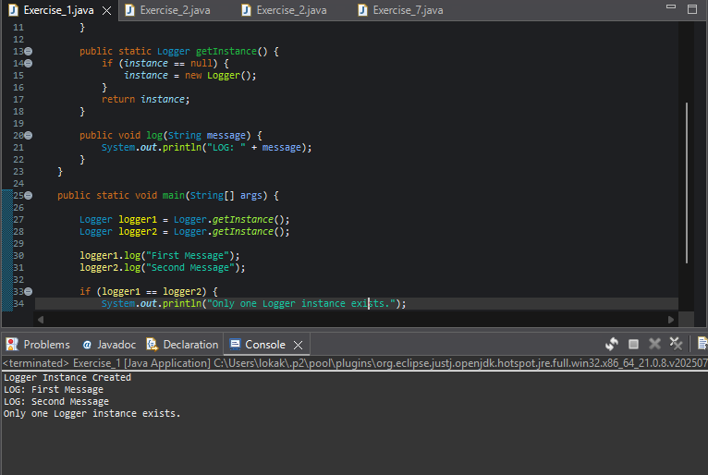

Exercise 2: Factory Method Pattern

package Design_patterns;
public class Exercise_2 {
interface Document { void open(); }
static class WordDocument implements Document {
public void open() { System.out.println("Word Document Opened"); }
}
static class PdfDocument implements Document {
public void open() { System.out.println("PDF Document Opened"); }
}
static class ExcelDocument implements Document {
public void open() { System.out.println("Excel Document Opened"); }
}
static abstract class DocumentFactory {
public abstract Document createDocument();
}
static class WordFactory extends DocumentFactory {
public Document createDocument() { return new WordDocument(); }
}
static class PdfFactory extends DocumentFactory {
public Document createDocument() { return new PdfDocument(); }
}
static class ExcelFactory extends DocumentFactory {
public Document createDocument() { return new ExcelDocument(); }
}
public static void main(String[] args) {
DocumentFactory wordFactory = new WordFactory();
Document wordDoc = wordFactory.createDocument();
wordDoc.open();
DocumentFactory pdfFactory = new PdfFactory();
Document pdfDoc = pdfFactory.createDocument();
pdfDoc.open();
DocumentFactory excelFactory = new ExcelFactory();
Document excelDoc = excelFactory.createDocument();
excelDoc.open();
}
}

Output Screenshot:
