Contents

1. DM SCCS 1

Application Details 1

Application Flow: 2

Index Page 2

Sign Up Page: 3

Login Page: 3

Shopping Cart & Checkout Page 4

Application DB Details 6

User Table: 7

Product Table 7

Line Item Table 8

Order Table 8

Transaction Table 9

Application Workflows: 9

Index Page Workflow 9

Sign Up Page Workflows 10

Login Page Workflows: 11

Shopping Cart & Checkout Page Workflows 12

Stripe Configurations: 21

# DM SCCS

## Application Details

|  |  |
| --- | --- |
| Application Title | Decision Minds Shopping Cart & Checkout Service |
| Application Link | <https://dm-sccs.bubbleapps.io/version-test> |
| Application Synopsis | Shopping Cart & Checkout Service application will be used by all the Users of a Shop as they can select their Products & add to a Cart, at the end they can pay the money by using the Stripe Payment Service. |
| Technical Stack | Bubble.io |
| Bubble.io Components Used | Pages, Groups, Repeating Groups, Texts, Inputs, Buttons, Icons, Workflows, Data/DB Stuff |
| Reasons to Choose Shopping Cart & Checkout Service | Shopping Cart & Checkout Service is a daily used application by every Shop but this is a more sophisticated application as there are more Data Types /DB Tables with Parent & Child relationships which I need to represent by using Bubble.io This application integrate with Stripe Payment services provider that lets merchants accept credit and debit cards or other payments. |
| Stripe Test Card Details for the Card Payment | Card No : 4000003560000008  MM /YY : Any Test Value in MM / YY format  CVC: Any 3 digit Number |

## Application Flow:

This Application deals with the below given Pages:

1. Index Page
2. Sign Up Page
3. Login Page
4. Shopping Cart & Checkout Page
5. Stripe Payment Page

### Index Page

As soon as the user clicks on <https://dm-sccs.bubbleapps.io/version-test>, the User will be redirected to the Index page:

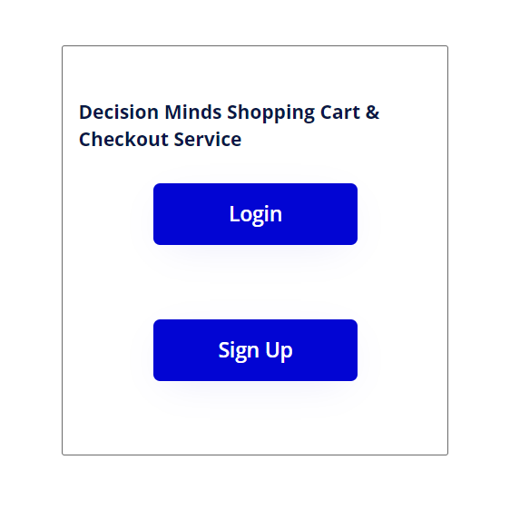

Every new User has to click on “Sign Up” Button to traverse to the “sign Up” Page. A user has to click on Login Button to traverse to the **Shopping Cart & Checkout** Page.

### Sign Up Page:

Please find the below given Layout with the sample values:

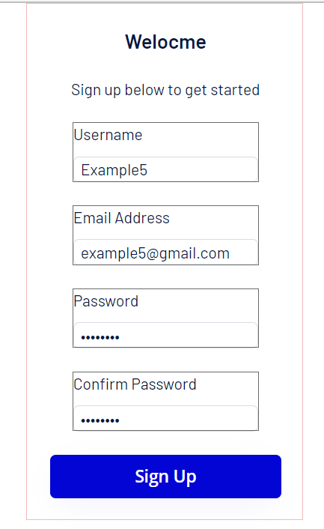

As soon as the User clicks on the **“Sign Up”** Button, he/she will be redirected to the **Login** Page

### Login Page:

Please find the below given Layout with the sample values:

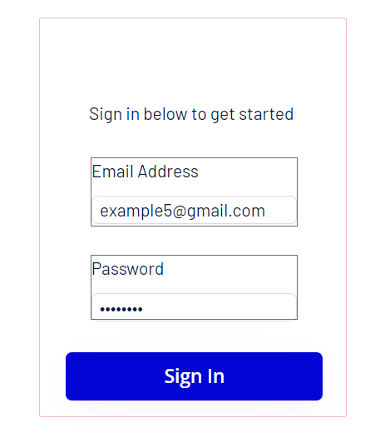

As soon as the User clicks on the **“Sign In”** Button, he/she will be redirected to the **Shopping Cart & Checkout** Page

### Shopping Cart & Checkout Page

Please find the below given Layout with the sample values:

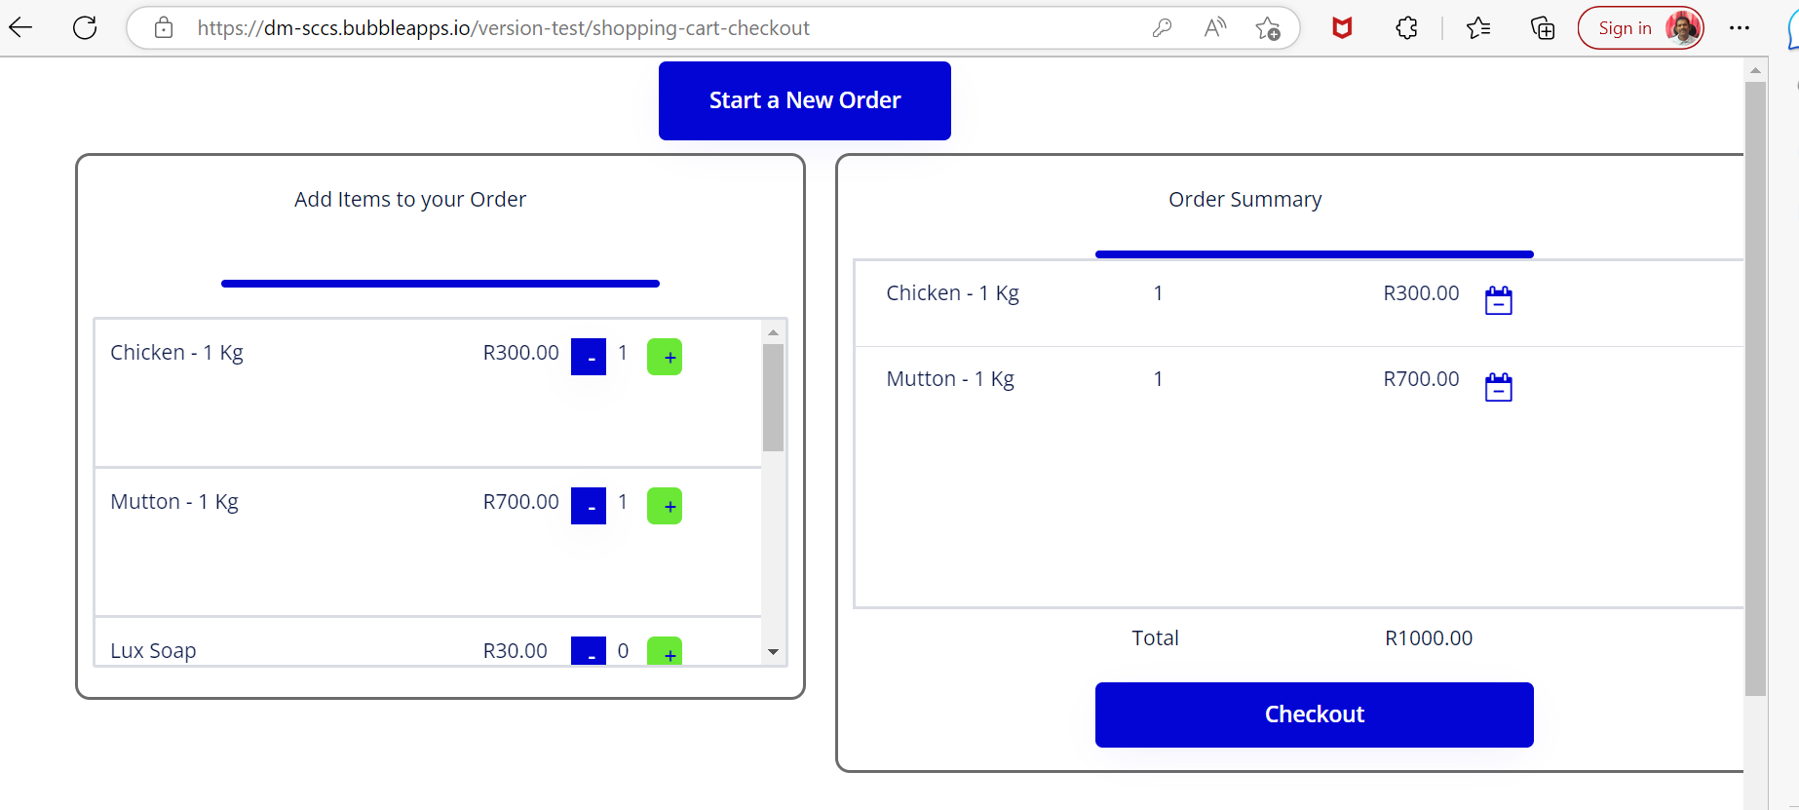

The List of Products will be displayed on the Left side Items Group.

1. The User has to click on **“+”** Button to increase the quantity of the Product because of which a Line Item of the Order will be updated on the Right side - “Order Summary” Group.
2. Similarly, the User has to click on **“-“Button** to decrease the quantity of the Product because of which a Line Item of the Order will be updated on the Right side - “Order Summary” Group.
3. The total of the Order will be displayed at the bottom of the Right side - “Order Summary” Group.
4. As soon as the User clicks on the Checkout Button, the Stripe Payment page will be displayed.

The below given Card details has to be entered to complete the payment.

|  |  |
| --- | --- |
| Card No | 4000003560000008 |
| MM /YY | Any value in MM / YY format where YY should be the future value |
| CVC | Any 3 digit Positive Number |

Stripe Card Page:

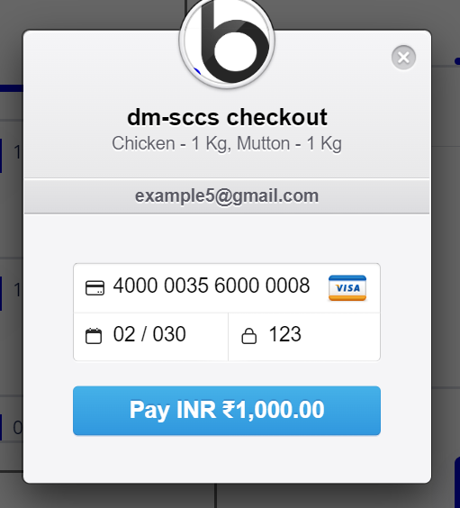

As soon as the User clicks on the above “Pay INR XXXX” Button, the payment will be processed but as of now the application is failing at the last step, I am working on the same:

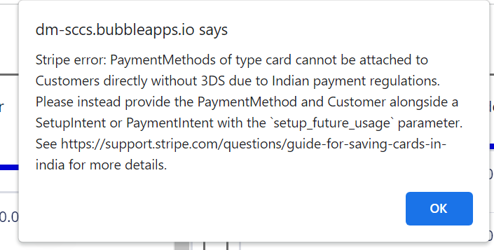

## Application DB Details

The Below given DB Tables were used in this Application:

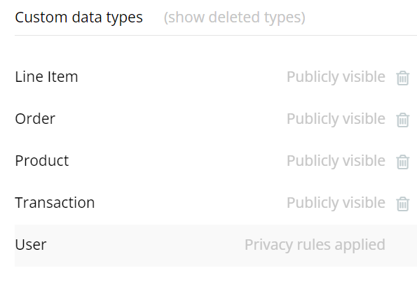

### User Table:

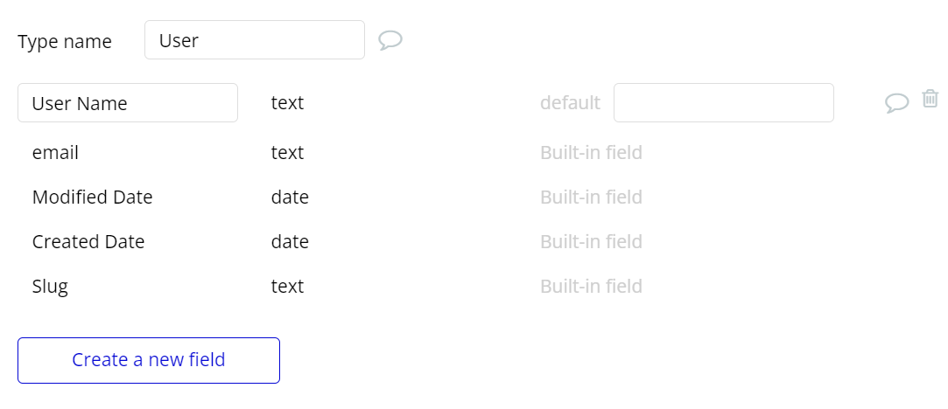

### Product Table

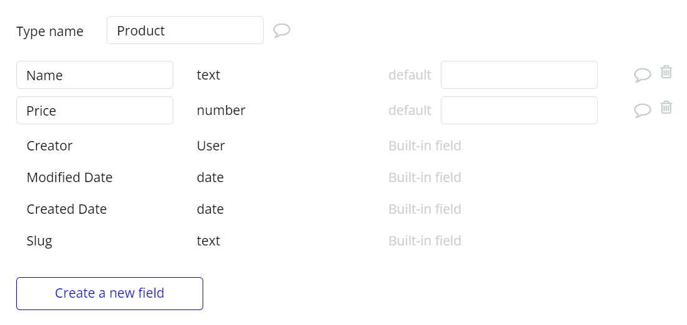

### Line Item Table

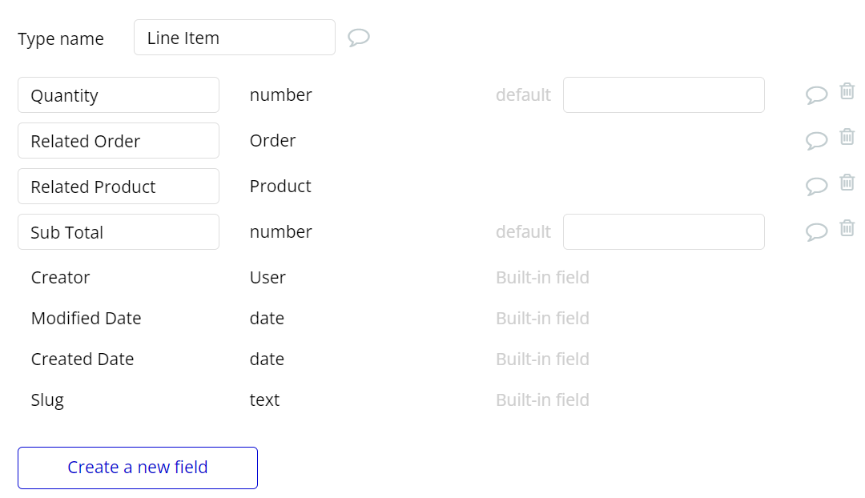

### Order Table

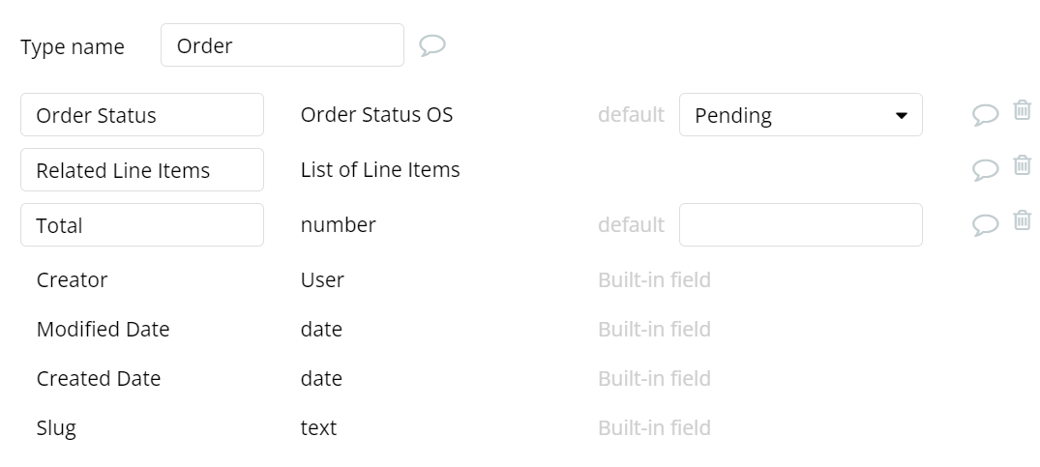

### Transaction Table

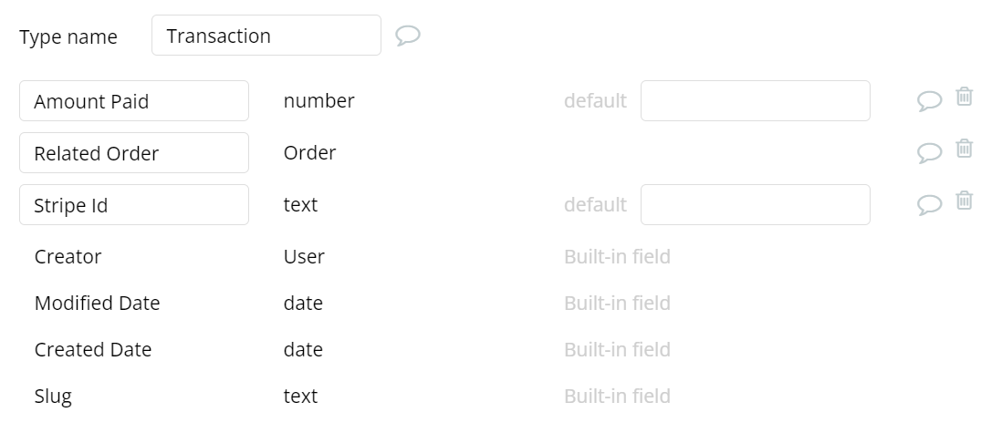

## Application Workflows:

### Index Page Workflow

1. When Button Login is clicked 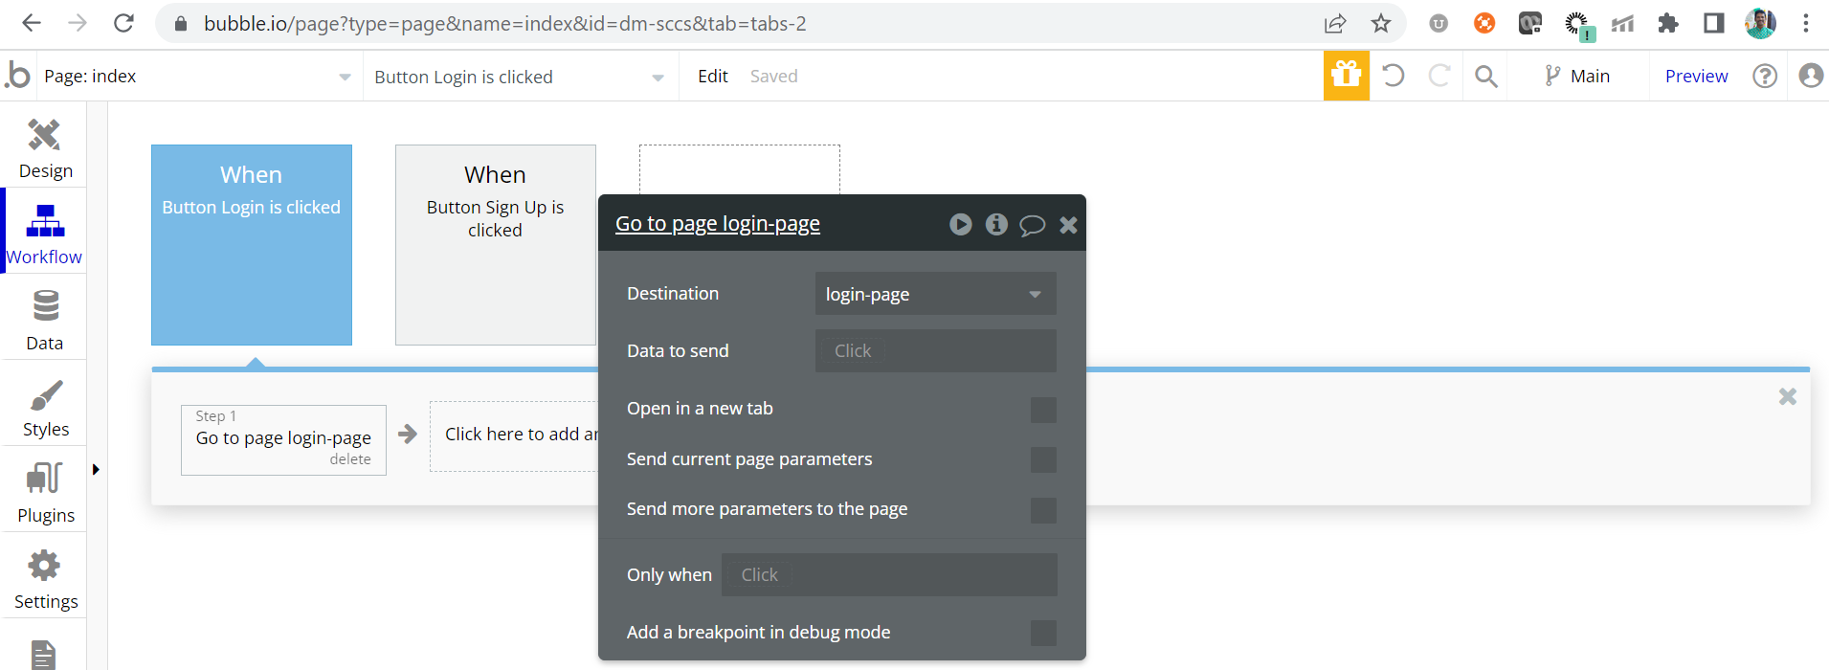
2. When Button Sign Up is clicked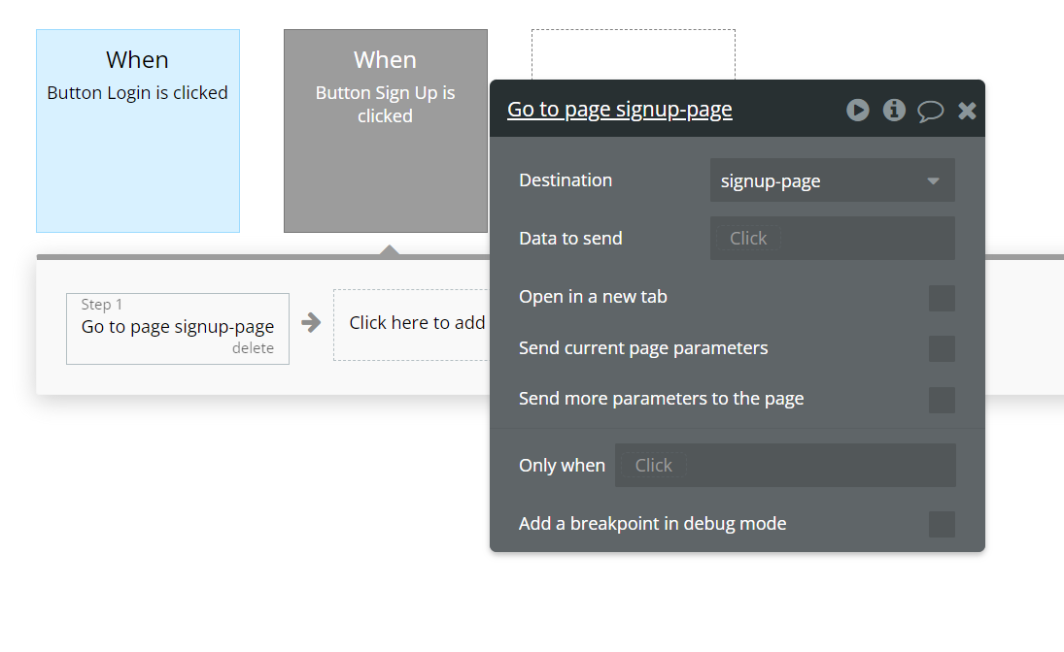

### Sign Up Page Workflows

1. When Button Sign Up is clicked:

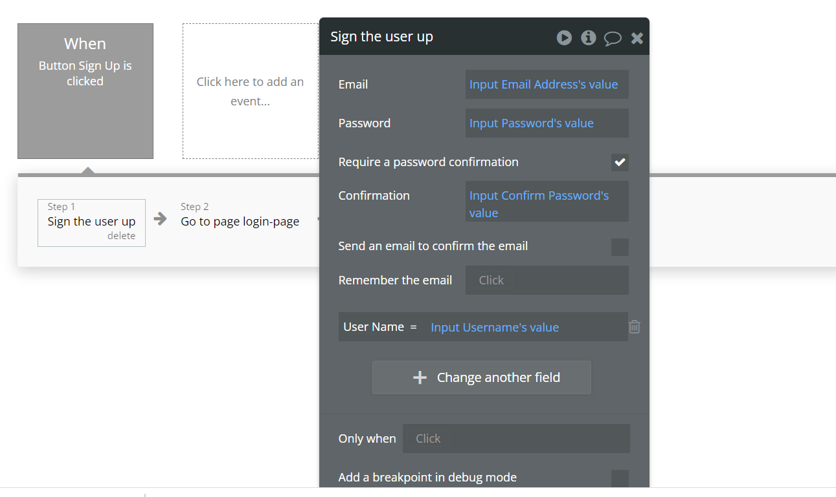

1. Go to Login Page:

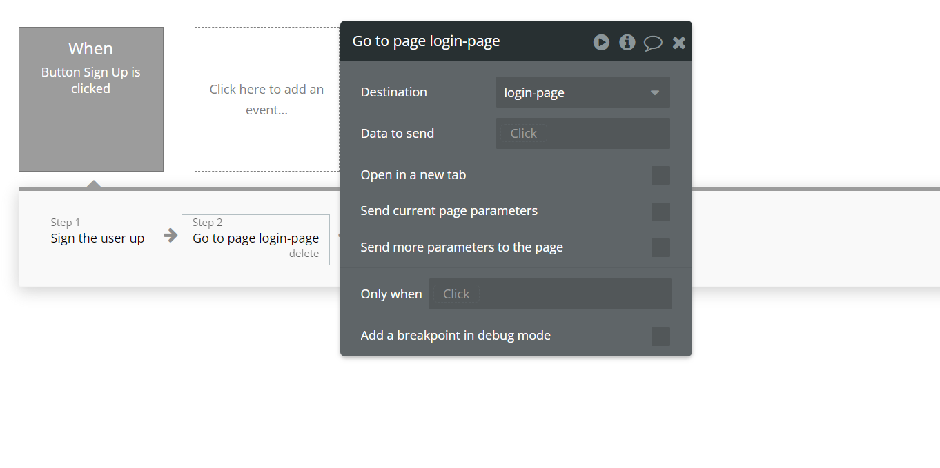

### Login Page Workflows:

#### When Button Sign In is clicked

1. Log the User in

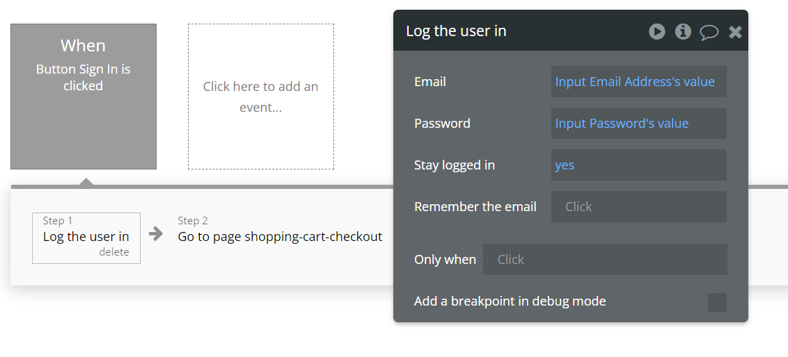

1. Go to Shopping Cart & Checkout Page

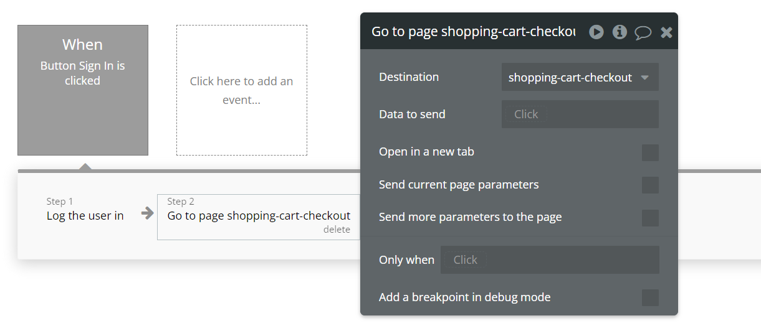

### Shopping Cart & Checkout Page Workflows

#### When Page is loaded

1. Creating the new Order

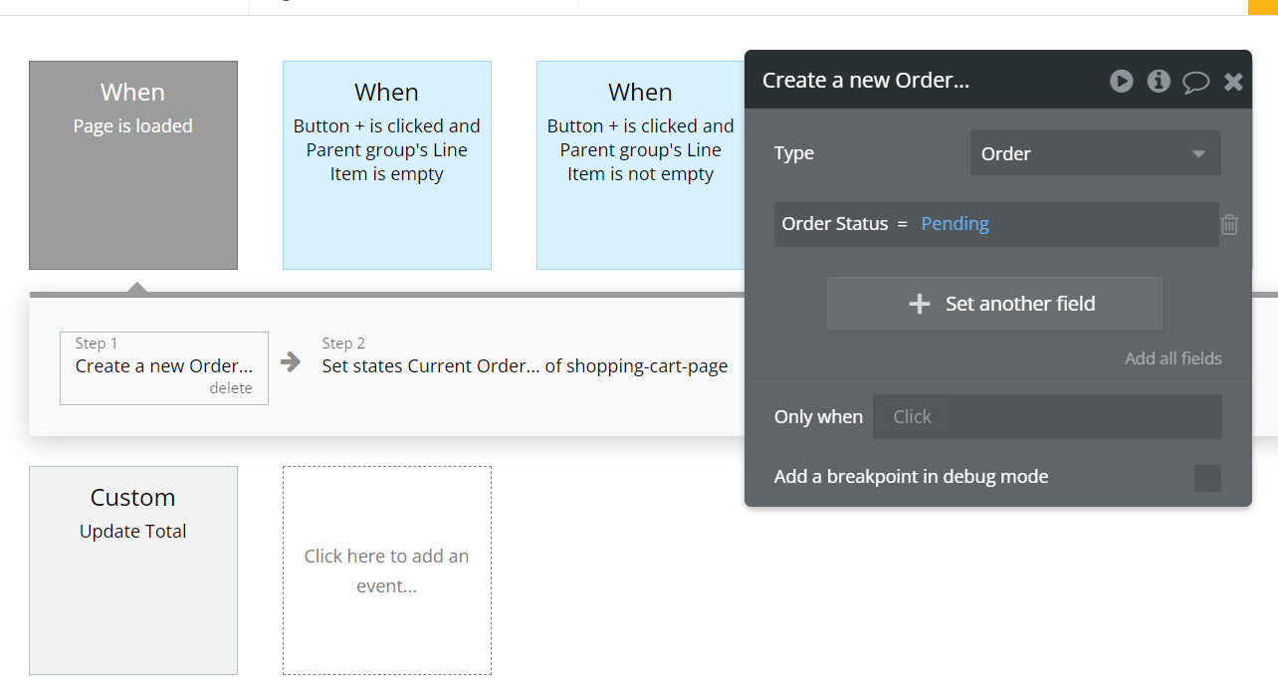

1. Setting State of Current Order

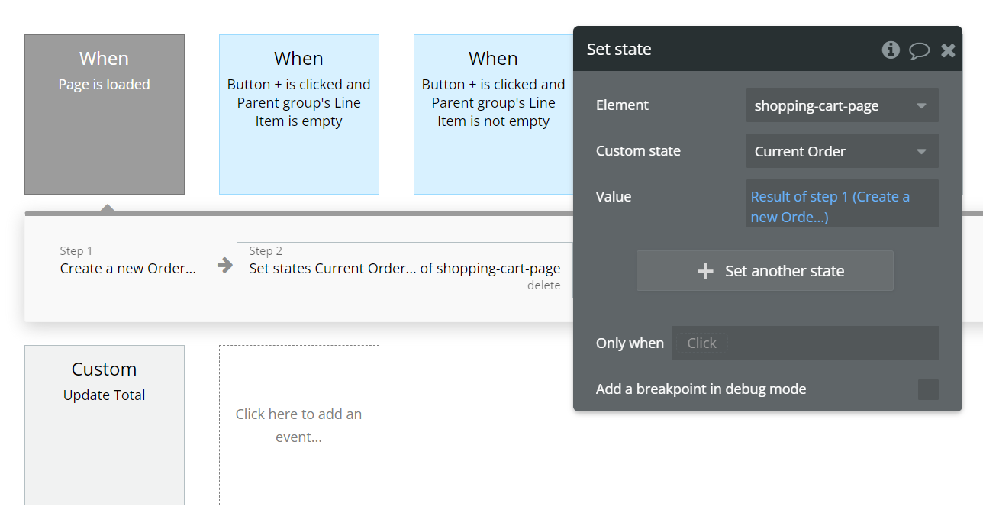

#### When Button + is clicked & Parent Group’s Line Item is Empty

1. Create a new Line Item

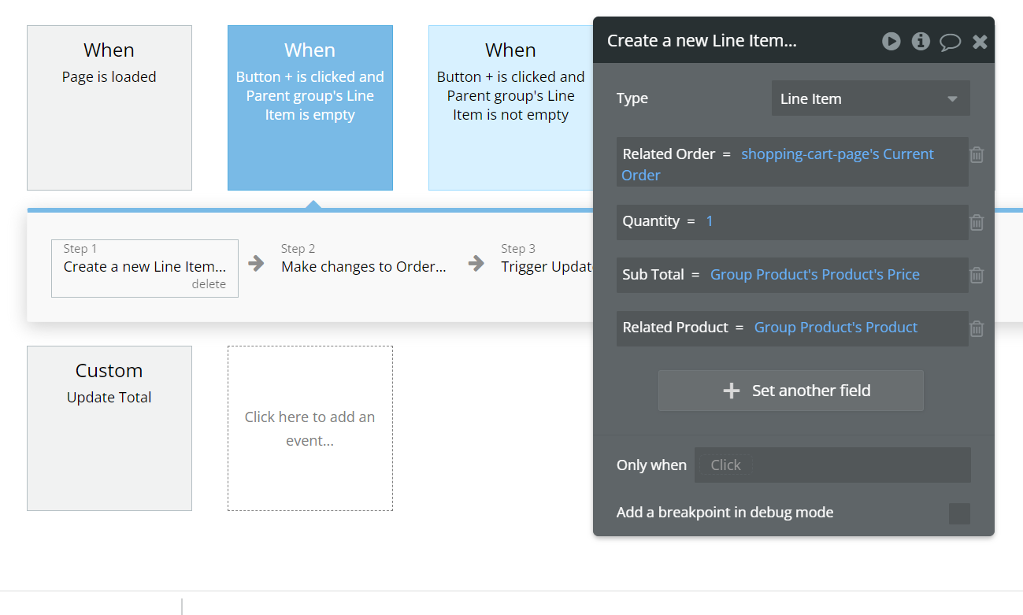

1. Making changes to Order

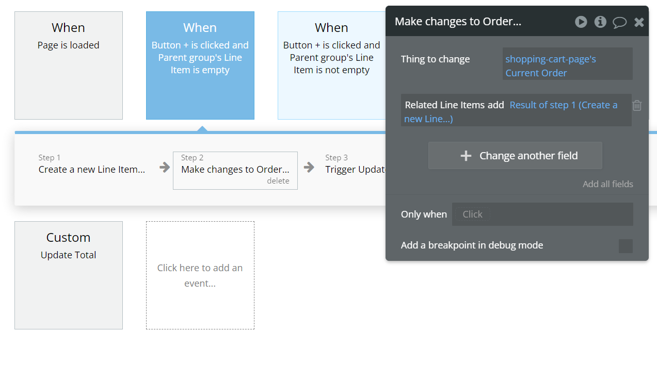

1. Trigger Update Total

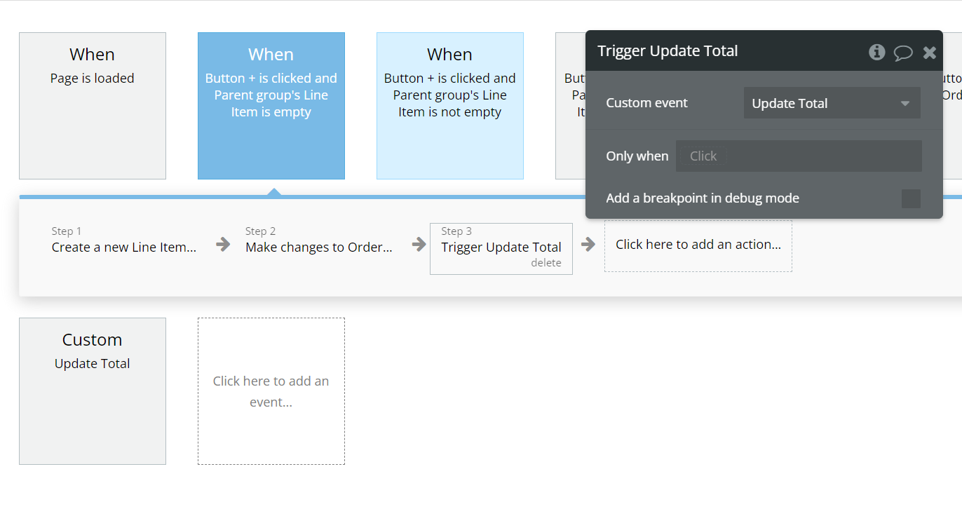

#### When Button + is clicked & Parent Group’s Line Item is Not Empty

1. Make changes to Line Item

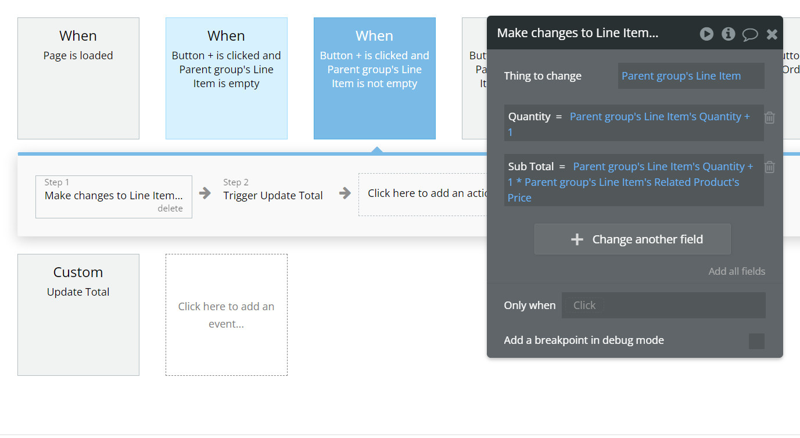

1. Trigger Update Total

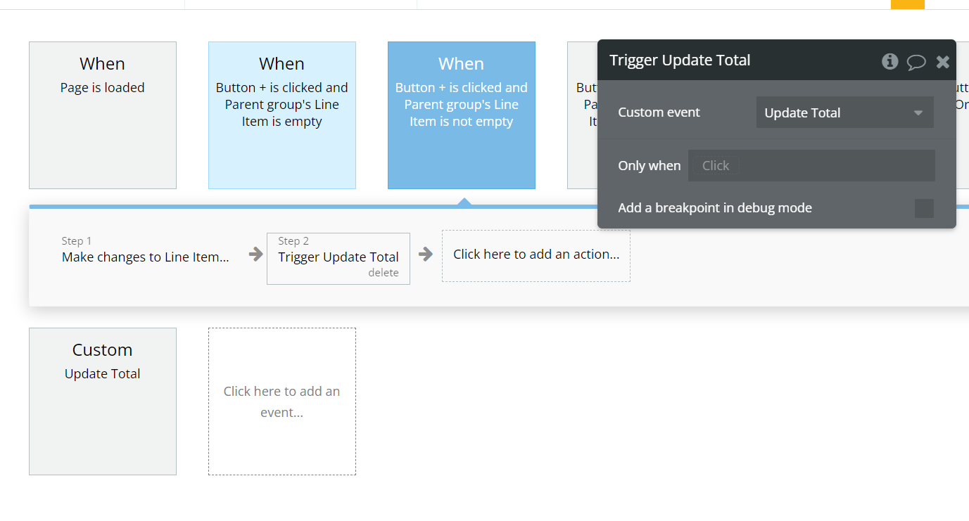

#### When Button - is clicked & Parent Group’s Line Item is Not Empty

1. Delete Line Item

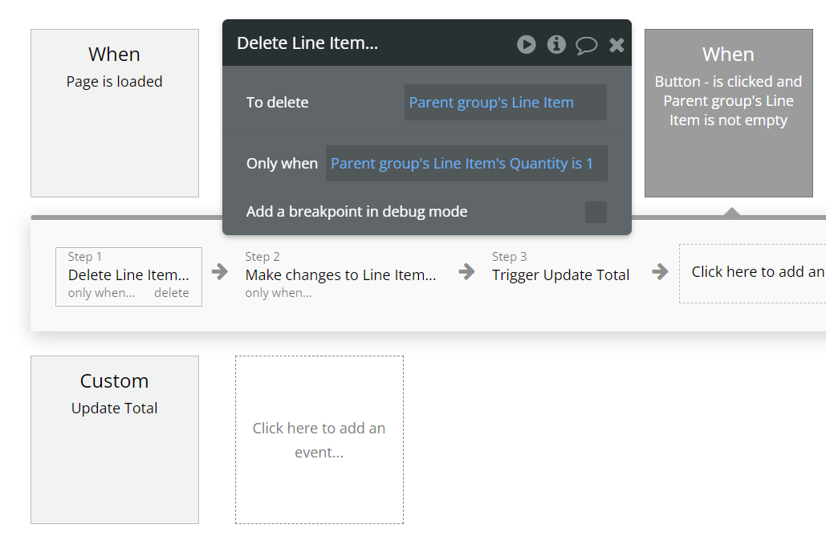

1. Make changes to Line Item

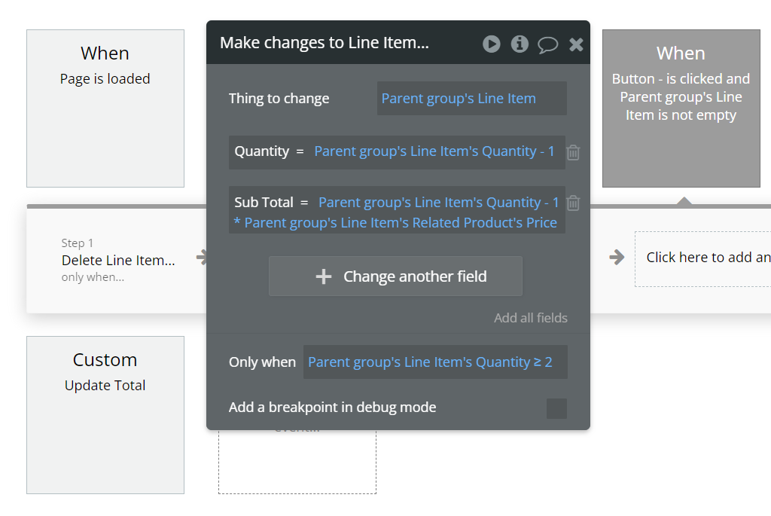

1. Trigger Update Total:

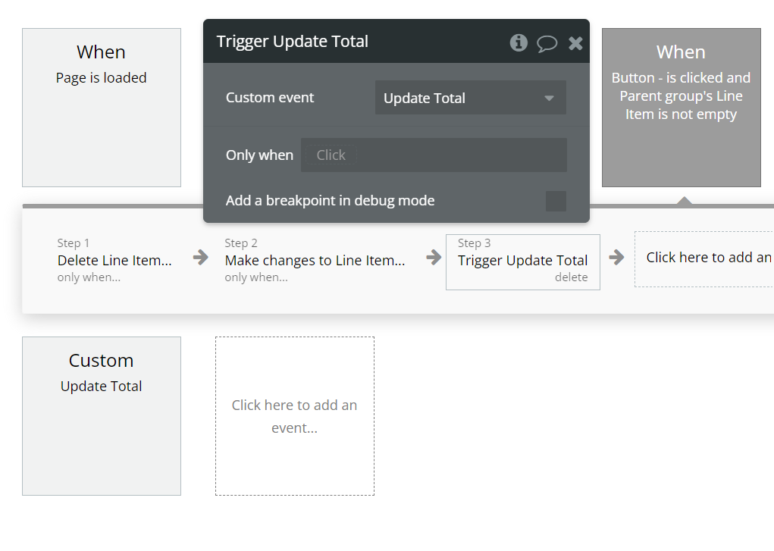

1. Update Total

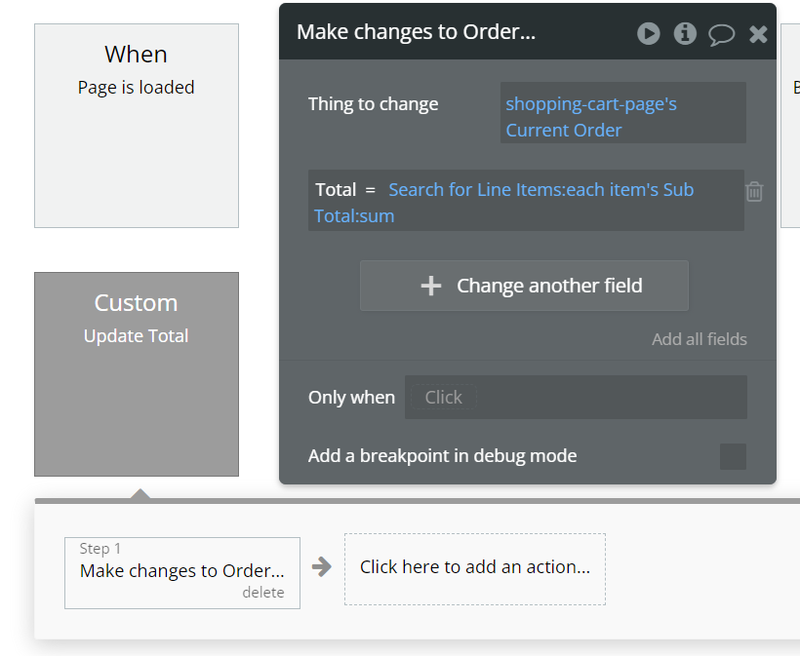

#### When Button “Start a New Order” is clicked

1. Create a New Order

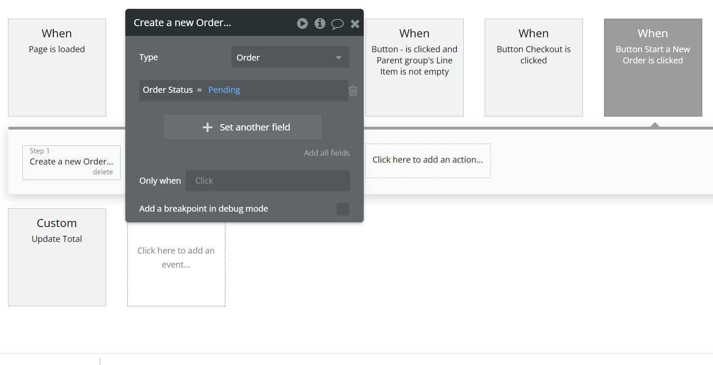

1. Set State of current Order

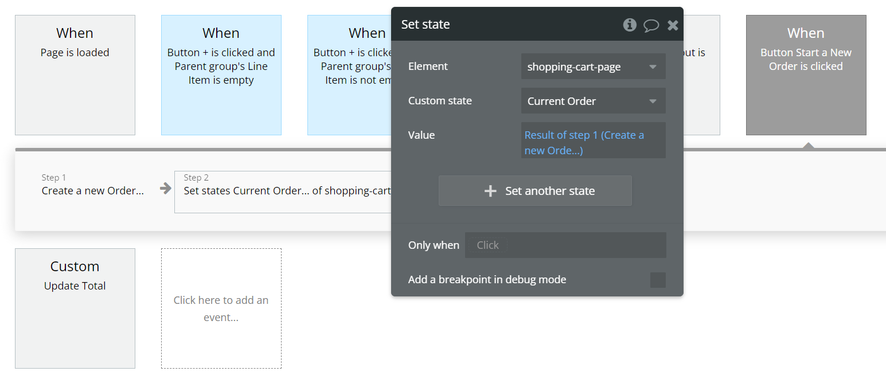

#### When Button Checkout is clicked

1. Charge the Current User



1. Create a New Transaction

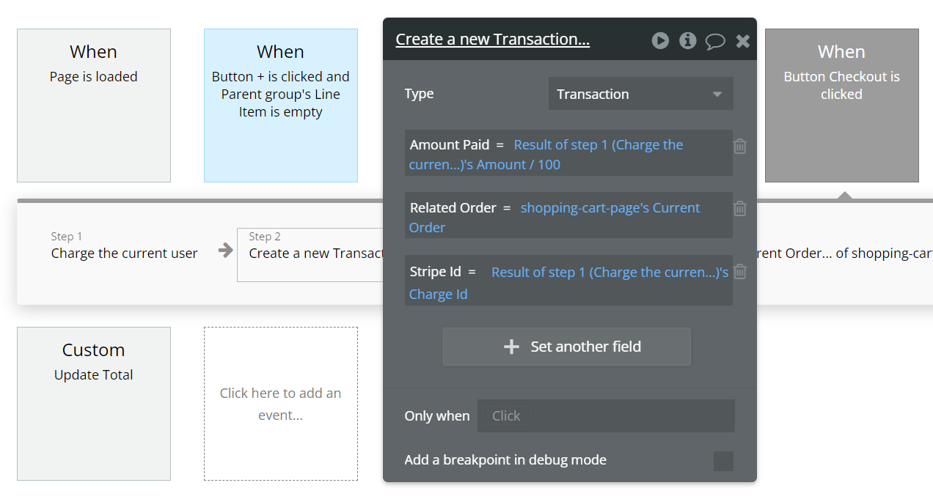

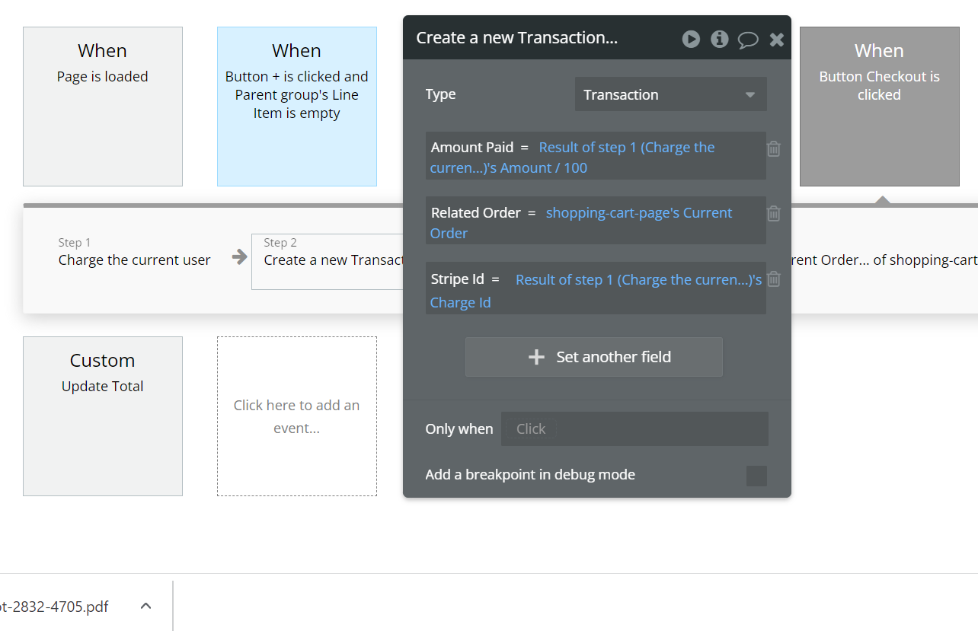

1. Make changes to Order

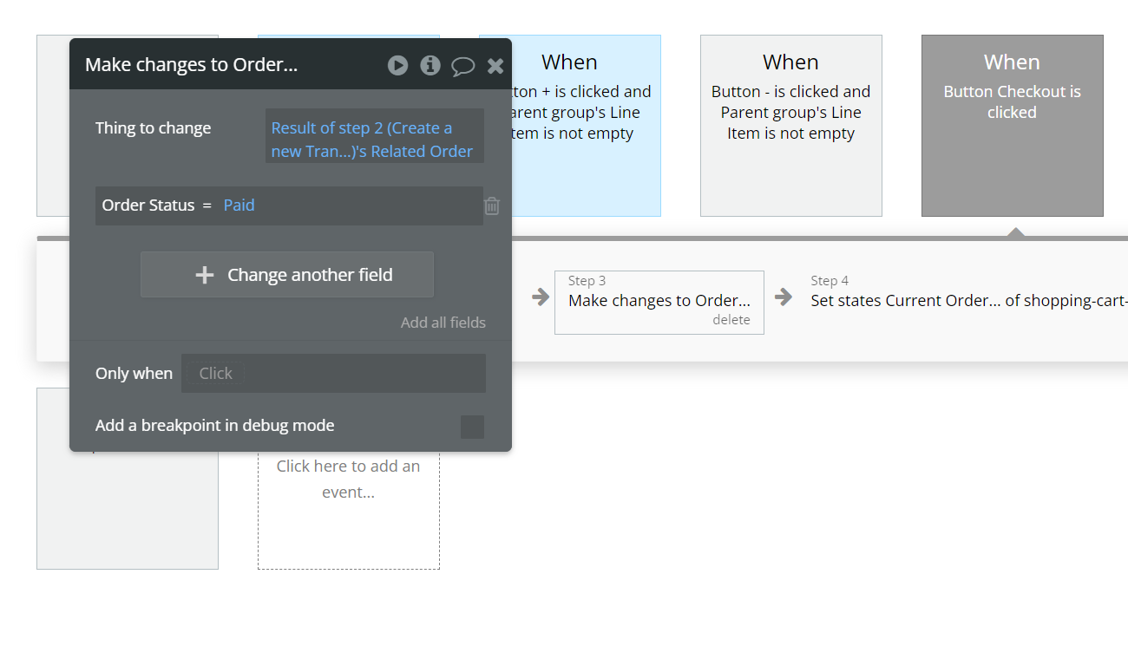

1. Set Status of Current Order

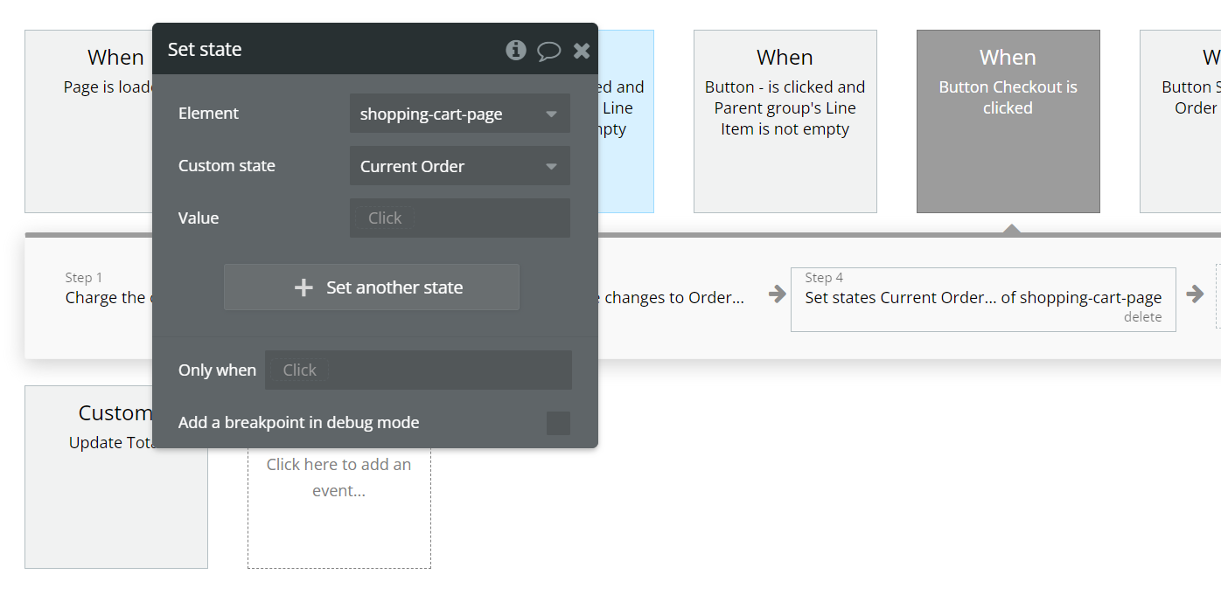

## Stripe Configurations:

We need to go the Stripe plugin section & need to set the below given Values:

1. Secret Key
2. Publishable Key
3. Name for Stripe Checkout

