**Assignment 5**

Lokanath S

1JT18IS032

**Program-5**

**5**.Design an XML document to store information about a student in an engineering college affiliated to VTU. The information must include USN, Name, and Name of the College, Program, Year of Joining, and email id. Make up sample data for 3 students. Create a CSS style sheet and use it to display the document.

**CODE:**

Program5.xml

<?xml-stylesheet type="text/css" href="prog5.css"?>

<!DOCTYPE HTML>

<html>

<head>

<h1> STUDENTS DESCRIPTION </h1>

</head>

<students>

<student>

<USN>USN : 1JT18IS032</USN>

<name>Name : LOKANATH S</name>

<college>COLLEGE : JIT</college>

<branch>BRANCH : Information Science and Engineering</branch>

<year>YEAR : 2018-2022</year>

<e-mail>E-Mail :loka1999@gmail.com</e-mail>

</student>

<student>

<USN>USN : 1JT18IS031 </USN>

<name>NAME : LATHA.D </name>

<college>COLLEGE : JIT</college>

<branch>BRANCH : Information Science and Engineering</branch>

<year>YEAR : 2018-2022</year>

<e-mail>E-Mail : latha2020@gmail.com</e-mail>

</student>

<student>

<USN>USN : 1JT18IS017</USN>

<name>NAME : CHANDAN.J </name>

<college>COLLEGE : JIT</college>

<branch>BRANCH : Information Science and Engineering</branch>

<year>YEAR : 2018</year>

<e-mail>E-Mail : chandan@gmail.com</e-mail>

</student>

</students>

</html>

Program5.css

student {

display: block;

margin-top: 10px;

color: Navy;

}

USN {

display: block;

margin-left: 10px;

font-size: 14pt;

color: Red;

}

name {

display: block;

margin-left: 20px;

font-size: 14pt;

color: Blue;

}

college {

display: block;

margin-left: 20px;

font-size: 12pt;

color: Maroon;

}

branch {

display: block;

margin-left: 20px;

font-size: 12pt;

color: Purple;

}

year {

display: block;

margin-left: 20px;

font-size: 14pt;

color: Green;

}

e-mail {

display: block;

margin-left: 20px;

font-size: 12pt;

color: Blue;

}

**OUTPUT:**

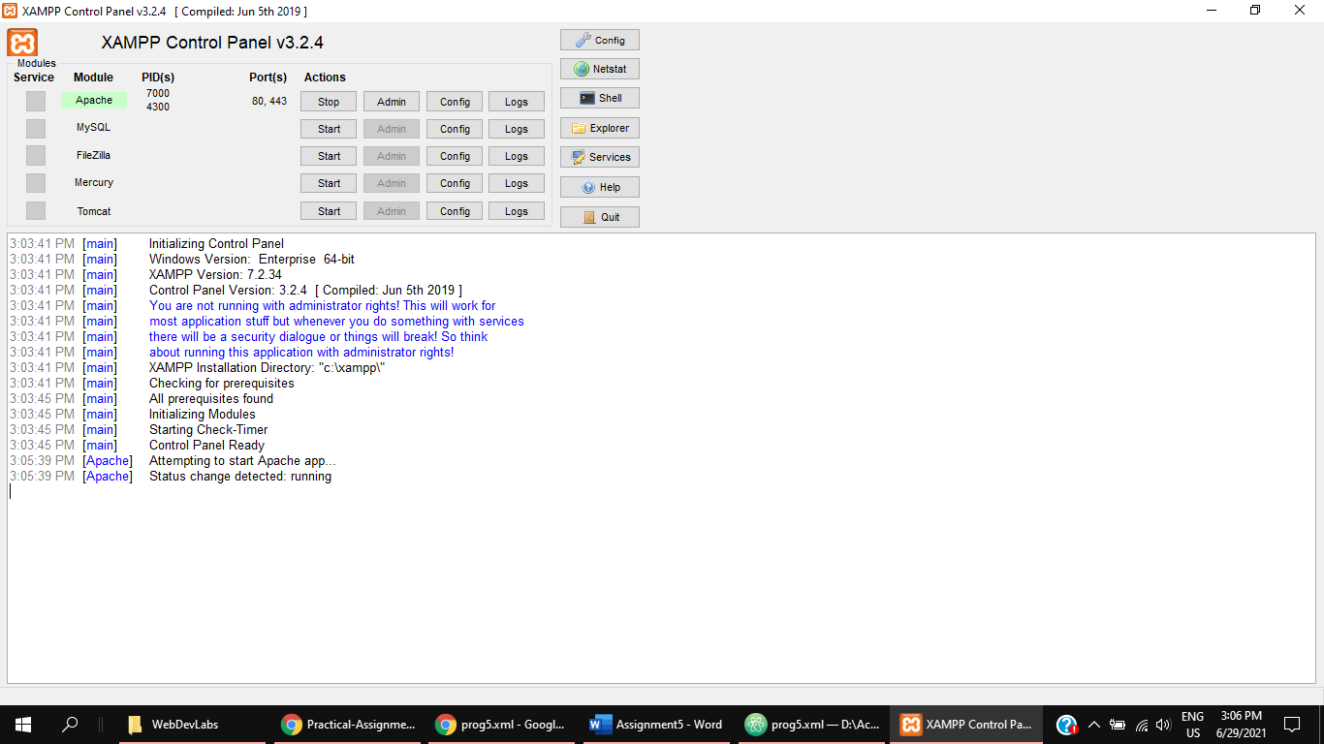

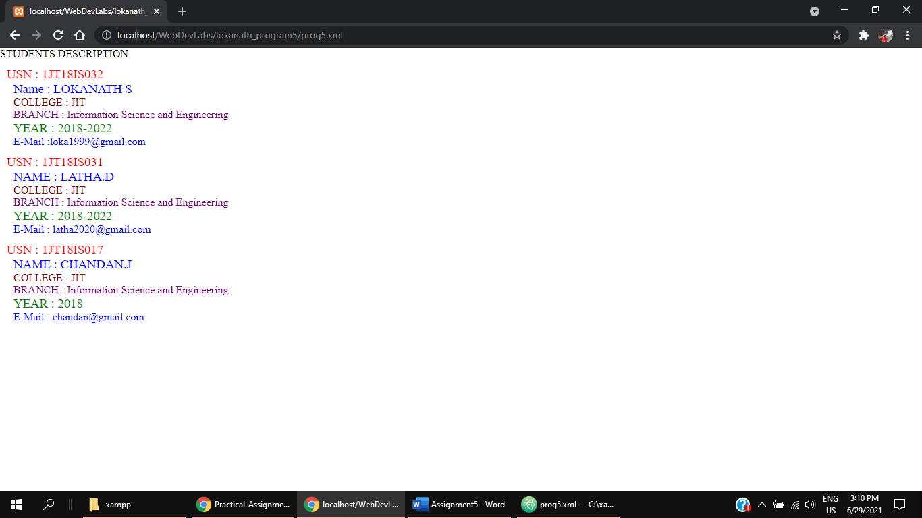

**PROGRAM-6**

**6.**Write a PHP program to keep track of the number of visitors visiting the web page and to display this count of visitors, with proper headings.

**CODE:**

<?php

$user = "Lokanath S";

$fname = 'counter.txt';

$fs = fopen($fname,"r");

$count = fscanf($fs,"%d");

$count[0]++;

fclose($fs);

$fs = fopen($fname,"w");

fprintf($fs,"%d",$count[0]);

fclose($fs);

//control part

?>

<!DOCTYPE html>

<!-- this is a view part -->

<html>

<head>

<title>Program 6</title>

</head>

<body style="background-color:#BADFE7;">

<h1><?php echo $user; ?> WELCOME TO SAMPLE PHP SCRIPT!!</h1>

<h2>This program displays the number of page visits!!</h2>

<h2>REFRESH THE PAGE</h2>

<p>Total number of views are: <?php echo $count[0]?></P>

</body>

</html>

**OUTPUT:**

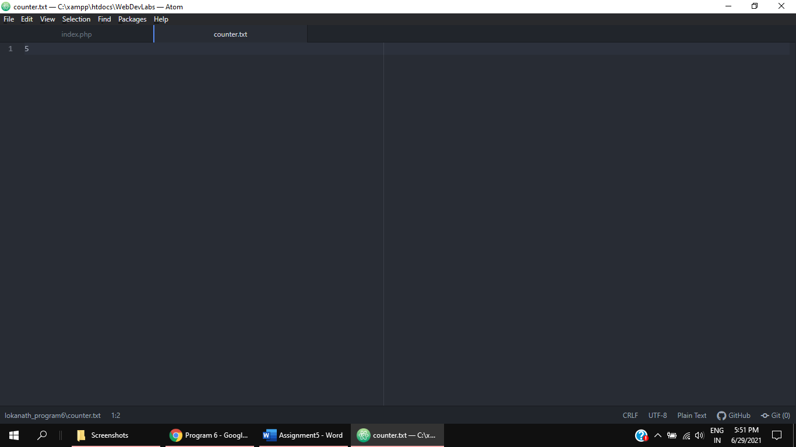

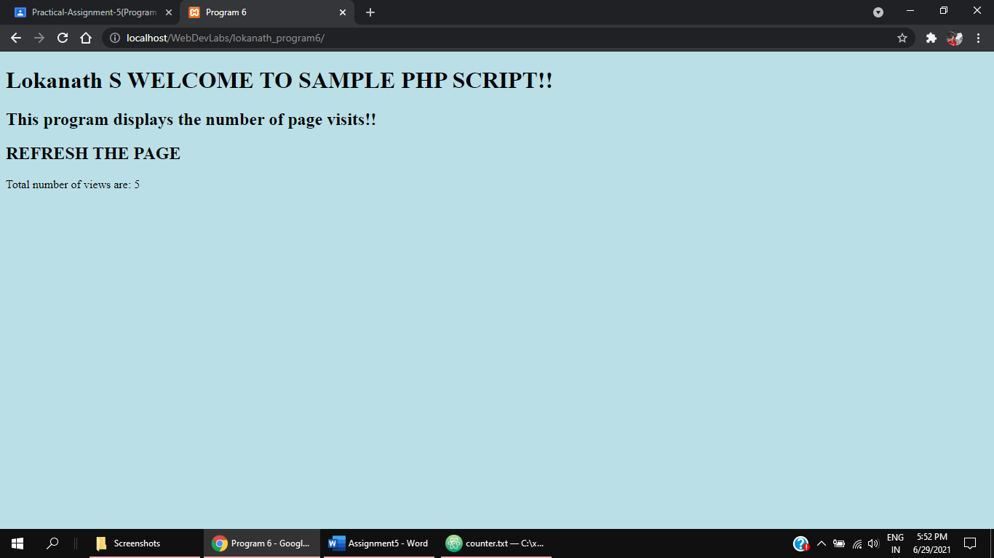

**PROGRAM-7**

**7.**Write a PHP program to display a digital clock which displays the current time of the server.

**CODE:**

<!DOCTYPE HTML>

<html>

<head>

<meta http-equiv="refresh" content="1" />

<style>

p {

color: white;

font-size: 30px;

position: absolute;

top: 50%;

left: 50%;

transform: translate(-50%, -50%);

}

body {

background-color:# F9D326;

}

</style>

<p> <?php

echo "Server Time is ".date(" h: i : s A")."<br>";

echo "Today is " . date("Y/m/d") . "<br>";

echo "Today is " . date("Y.m.d") . "<br>";

echo "Today is " . date("Y-m-d") . "<br>";

echo "Today is " . date("l");

?> </p>

</head>

</html>

**OUTPUT:**

