VELLORE INSTITUTE OF TECHNOLOGY
School of Computer Science and Engineering
HOUSE PRICE PREDICTION USING REGRESSION MODELS
A Comparative Study on California, Ames, and UCI Real Estate Datasets

Student Name: | Lokanth S
Registration Number: | 23MID0037
Course Code & Name: | MDI3003 - Advanced Predictive Analytics
Faculty Coordinator: | Dr. Durgesh Kumar
GitHub Repository Link: | https://github.com/LokanthS/House-Price-Prediction

Certificate
This is to certify that the university laboratory project entitled "House Price Prediction using Regression Models" is a bonafide record of work done by Lokanth S (Reg. No: 23MID0037) in partial fulfillment of the requirements for the course MDI3003 - Advanced Predictive Analytics during the academic year 2026 under my supervision and guidance. The complete source code, preprocessing scripts, notebooks, datasets, requirements, and outputs are fully documented, hosted on GitHub, and verified for reproducibility.

______________________________
Dr. Durgesh Kumar
Faculty Coordinator, SCSE

Acknowledgement
I would like to express my sincere gratitude to my faculty coordinator, Dr. Durgesh Kumar, for providing continuous guidance, constructive feedback, and invaluable academic insights throughout the execution of this Advanced Predictive Analytics laboratory project. His academic rigor and guidance have greatly shaped the methodology and analytical quality of this study.
I am also thankful to the Vellore Institute of Technology for providing the software utilities, computational infrastructure, and workspace environment required to conduct this comparative empirical study. Lastly, I extend my appreciation to the open-source machine learning community and the creators of the scikit-learn framework, whose tools formed the core baseline of this project.

Executive Summary
This project presents an end-to-end comparative empirical evaluation of regression-based machine learning pipelines for house price prediction across three distinct real-world housing datasets: the California Housing dataset (obtained via scikit-learn), the Ames Housing dataset, and the UCI Real Estate Valuation dataset. The research explores the modeling dynamics, predictive capacity, and error behavior of five regression models: Simple Linear Regression, Multiple Linear Regression, Decision Tree Regressor, Random Forest Regressor, and Gradient Boosting Regressor.
A comprehensive pre-processing and engineering framework was developed for each dataset, implementing robust outlier mitigation, imputation, standardized scaling, and high-dimensional categorical encoding using scikit-learn Pipelines and ColumnTransformer. A log-transformation approach was executed on right-skewed target attributes to stabilize variance and ensure compliance with linear modeling assumptions. Models were tuned via Grid Search optimization with 5-fold cross-validation to mitigate overfitting and find the optimal trade-offs between model capacity and generalization.
The empirical findings show that ensemble-based architectures (Gradient Boosting and Random Forests) consistently outperform linear baselines across all datasets. In California, Gradient Boosting achieved an R² score of ~0.811, whereas Simple Linear Regression yielded only ~0.46. In Ames, Multiple Linear Regression achieved a Test R² of ~0.904, reflecting the high predictive quality of log-scaled linear models. For the UCI dataset, Random Forest emerged as the optimal model, achieving an R² of ~0.809. Deep analytical discussions on residual behavior, feature importance distributions, and model limitations are included to provide actionable industry insights into predictive real estate valuation.

Chapter 1: Introduction

1.1 Problem Statement
The real estate market is highly dynamic and influenced by a complex array of structural, demographic, geographical, and economic parameters. Traditional real estate valuation heavily relies on manual comparative market analysis (CMA), which is subjective, prone to human error, and fails to capture non-linear relationships between property characteristics and market value. Developing a generalized, robust, and automated predictive framework is essential to assist financial institutions, property developers, and prospective buyers in establishing accurate, data-driven valuations.

1.2 Objectives
- Establish Robust ML Pipelines: Build end-to-end reproducible machine learning pipelines utilizing scikit-learn ColumnTransformer and Pipeline objects to automate imputation, scaling, and categorical encoding.
- Empirical Comparative Study: Implement, tune, and compare five foundational and ensemble regression algorithms under uniform experimental conditions across three diverse datasets.
- Outlier and Skewness Management: Analyze and handle the mathematical impact of target skewness and numerical outliers on linear vs. non-linear models.
- Feature Importance Exploration: Identify the key predictive features driving property valuation in different structural contexts (e.g., density vs. physical acreage).

1.3 Learning Outcomes
Through this laboratory project, key learning outcomes include:
- Pipeline Orchestration: Advanced proficiency in using ColumnTransformer, Pipeline, and grid-search cross-validation to prevent data leakage during training.
- Model Behavior Analysis: Deeper understanding of why tree ensembles are robust to scale and outliers compared to classical ordinary least squares (OLS) estimators.
- Error Diagnosis: Skill in using residual plots, actual-vs-predicted error curves, and variance checks to diagnose model underfitting/overfitting.

1.4 Business Motivation & Industry Relevance
Automated Valuation Models (AVMs) are the backbone of modern prop-tech companies, commercial banking mortgage underwriting, and real-estate investment trusts (REITs). Fast and accurate prediction of property values reduces risk, speeds up lending approvals, and optimizes portfolio management. Incorporating spatial data, neighborhood quality, and local macroeconomic indices allows algorithmic models to forecast market changes and provide reliable risk-adjusted property values.

1.5 GitHub Repository and Code Organization
In accordance with academic instructions to separate implementation from documentation, all source code and assets are hosted in the following repository:
GitHub Repository: URL: https://github.com/LokanthS/House-Price-Prediction
The repository is structured for immediate execution and contains the following components:
- Complete ML Pipeline: Fully modularized preprocessing, training, evaluation, and plotting modules under the src/ directory.
- Jupyter Notebooks: Interactive notebooks (california.ipynb, ames.ipynb, uci.ipynb) containing comprehensive EDA and pipeline validations.
- Reproducibility Script: A run_all.py script that recreates all figures, runs the metrics pipelines, and compiles this report.
- Metadata & Environment: A requirements.txt file defining pinned package dependencies, and the raw datasets included under datasets/.

Chapter 2: Dataset Descriptions
This research utilizes three datasets representing different geographical scales, sample sizes, and feature granularities to test the models' adaptability and robustness:

2.1 California Housing Dataset (Scikit-Learn)
Originally derived from the 1990 U.S. Census, this dataset contains 20,640 block groups (average population of 1,425). Features represent block-level aggregates, including:
- MedInc: Median income in block group (in tens of thousands of USD).
- HouseAge: Median age of houses in the block group.
- AveRooms: Average number of rooms per household.
- AveBedrms: Average number of bedrooms per household.
- Population: Block group population.
- AveOccup: Average number of household members.
- Latitude & Longitude: Spatial coordinates of the block group.
- Target (MedHouseVal): Median house value for households (in hundreds of thousands of USD).

2.2 Ames Housing Dataset
Compiled by Dean De Cock for statistics education, this dataset describes 1,460 individual residential properties sold in Ames, Iowa between 2006 and 2010. It contains 80 characteristics, including 23 nominal, 23 ordinal, 14 discrete, and 20 continuous variables. This high dimensionality represents a complex real-world database containing many missing values and diverse categorical structures (e.g., zoning, neighborhood, quality scores).

2.3 UCI Real Estate Valuation Dataset
This dataset contains 414 historical property transaction records from Sindian District, New Taipei City, Taiwan. It represents a low-dimensional, dense dataset focusing on geographic convenience and physical age. The features are:
- X1 transaction date: The transaction date (e.g., 2013.250 = March 2013).
- X2 house age: Age of the house in years.
- X3 distance to nearest MRT station: Distance to the closest Metro Rapid Transit station (in meters).
- X4 number of convenience stores: Count of convenience stores accessible on foot.
- X5 latitude & X6 longitude: Spatial coordinate mappings.
- Target (Y house price of unit area): Unit price of property (10,000 New Taiwan Dollar per Ping).

Chapter 3: Methodology
The methodology implements a structured, state-of-the-art machine learning engineering workflow designed to ensure model reproducibility and prevent data leakage. The end-to-end workflow is illustrated in Figure 1 below:
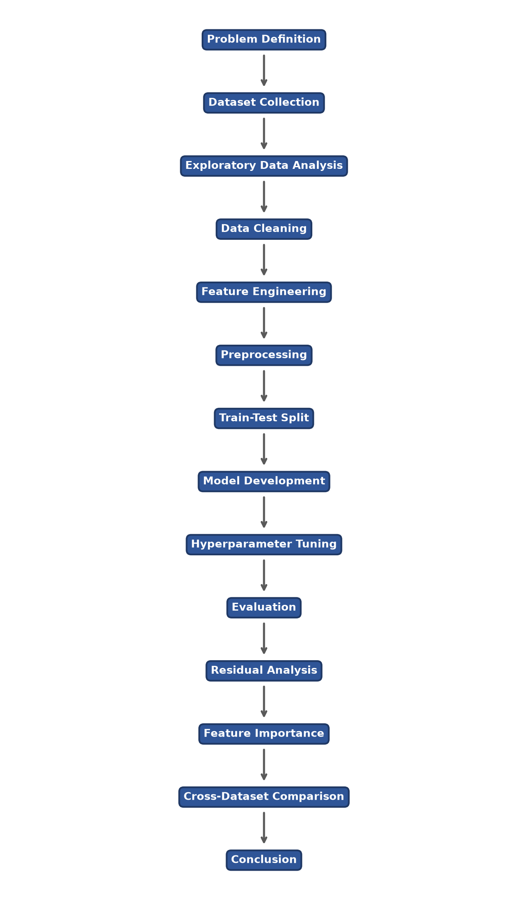
Figure 1: End-to-End Machine Learning Pipeline Workflow Diagram
As mapped in Figure 1, the pipeline executes sequentially through the following stages:
1. Data Profiling & EDA: Analyzing columns, datatypes, missing values, duplicates, and distributions. Outliers are analyzed using Z-scores and box plots.
2. Robust Preprocessing: Encapsulated within scikit-learn ColumnTransformer:
- Numerical Pipeline: Missing value imputation via SimpleImputer(strategy='median') to handle extreme values, followed by StandardScaler() to normalize ranges.
- Categorical Pipeline: SimpleImputer(strategy='most_frequent') for encoding reliability, followed by OneHotEncoder(handle_unknown='ignore', sparse_output=False) to convert high-cardinality categories without order bias.
3. Outlier Mitigation: For Ames, standard practice is implemented by removing records with General Living Area (GrLivArea) exceeding 4,000 square feet, removing extreme outliers that skew OLS estimators.
4. Train-Test Split: 80% of data is used for training and 20% for testing. All transformations are fitted strictly on the training partition and applied to the test partition to ensure no target leakage.
5. Target Transformation: Since Ames SalePrice displays high right-skewness, we apply y_trans = log(y + 1) during training to stabilize variance and prevent prediction bias. Predictions are mapped back to original dollar values using exp(y_pred) - 1 prior to evaluation.

Chapter 4: Model Development
Five core mathematical models were developed and evaluated under uniform parameters:

4.1 Simple Linear Regression
Serves as the simplest baseline, utilizing a single independent feature (X) with the highest absolute correlation to the target. To select the feature, a Pearson correlation analysis was conducted on the training set. To prevent data leakage, this feature selection process was executed strictly on the training partition rather than the entire dataset. The independent numerical feature exhibiting the highest absolute correlation with the target variable was selected as the sole predictor. The feature selected for each dataset was:
- California: MedInc (Median Income), R = 0.688
- Ames: GrLivArea (General Living Area), R = 0.720
- UCI: X3 distance to the nearest MRT station, R = -0.673
The model fits a line of the form y = b0 + b1*x using ordinary least squares (OLS) minimization.

4.2 Multiple Linear Regression
An expansion of the baseline OLS to accommodate multiple features: y = b0 + b1*x1 + ... + bn*xn. This model captures linear combinations of all features, showing how spatial coordinates, household sizes, and neighborhood zoning combine to influence price. It serves as a baseline to demonstrate the performance gain of non-linear ensembles.

4.3 Decision Tree Regressor
A non-parametric model that recursively partitions the feature space into hyper-rectangles by maximizing variance reduction at each split. Grid Search CV was used to optimize max_depth, min_samples_split, and min_samples_leaf to prevent the tree from overfitting.

4.4 Random Forest Regressor
An ensemble bootstrap aggregation (bagging) model containing independent decision trees. Each tree is trained on a bootstrap sample of the training data, and split decisions are limited to random feature subsets. Predictions are averaged across all trees to reduce variance and control overfitting. Hyperparameters n_estimators, max_depth, and min_samples_split were optimized using Grid Search.

4.5 Gradient Boosting Regressor
An ensemble model that builds decision trees sequentially. Each new tree fits to the residuals (errors) of the previous step using gradient descent optimization. Regularization is controlled via learning_rate (shrinkage factor), max_depth, and n_estimators, optimized via grid-search to find the best compromise between bias and variance.

Chapter 5: Experimental Results & Analysis

5.1 California Housing Dataset Results
For the California Housing dataset, the models were trained and tested using the original scale. The results are compiled in Table 1 below:
Table 1: Model Evaluation Metrics - California Housing Dataset
Model | MAE | MSE | RMSE | R2 | Adjusted_R2 | CV_Score | Training_Score | Testing_Score | Rank
Gradient Boosting Regressor | 0.3348 | 0.2471 | 0.4971 | 0.8114 | 0.8111 | 0.8189 | 0.8695 | 0.8114 | 1
Random Forest Regressor | 0.3280 | 0.2560 | 0.5059 | 0.8047 | 0.8043 | 0.8043 | 0.9632 | 0.8047 | 2
Decision Tree Regressor | 0.4310 | 0.4080 | 0.6387 | 0.6887 | 0.6881 | 0.7103 | 0.8229 | 0.6887 | 3
Multiple Linear Regression | 0.5332 | 0.5559 | 0.7456 | 0.5758 | 0.5750 | 0.6115 | 0.6126 | 0.5758 | 4
Simple Linear Regression | 0.6299 | 0.7091 | 0.8421 | 0.4589 | 0.4587 | 0.4767 | 0.4770 | 0.4589 | 5

5.1.1 Key Observations and Graphical Interpretation
The model comparison shows a significant jump in performance from linear models to ensemble tree-based models. As illustrated in Figure 4, Gradient Boosting Regressor achieved the highest Test R² (0.8114) and the lowest Test RMSE (0.4971). This represents a substantial improvement over Multiple Linear Regression (Table 1), which yielded a Test R² of 0.5758 and RMSE of 0.7456. The non-linear relationships of geographic coordinates (Latitude, Longitude) and demographics (Figure 3) are successfully resolved by boosted trees, whereas multiple linear regression struggles.
The target distribution analysis shown in Figure 2 demonstrates a moderate right skewness, and the boxplot outlier analysis in Figure 3 reflects high density, illustrating why non-linear partition models achieve superior fit compared to linear bounds.
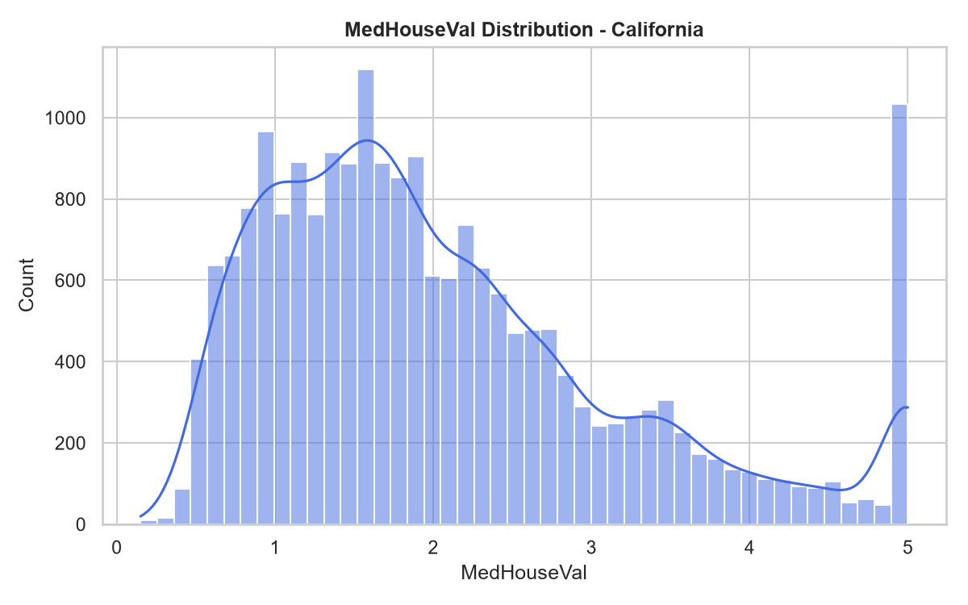
Figure 2: Target Distribution Analysis (MedHouseVal) for California Dataset
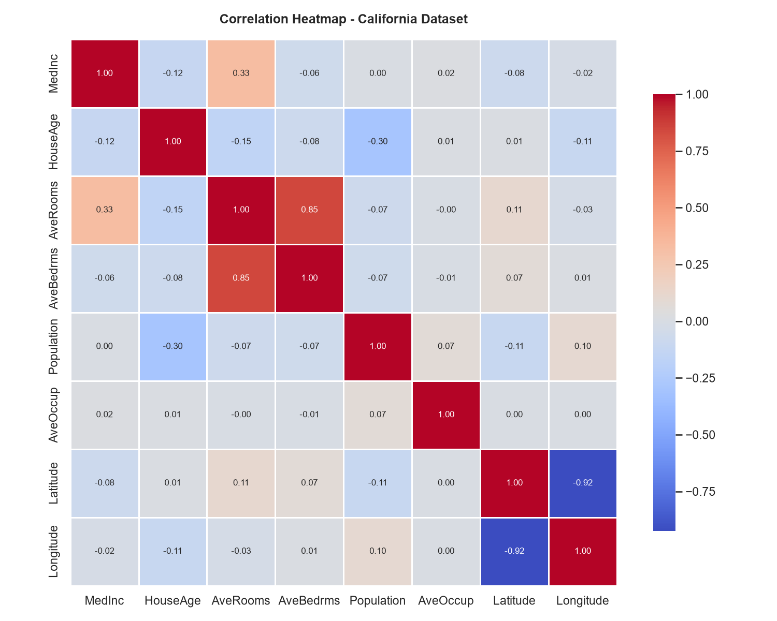
Figure 3: Correlation Heatmap showing relationship among numerical features in California dataset
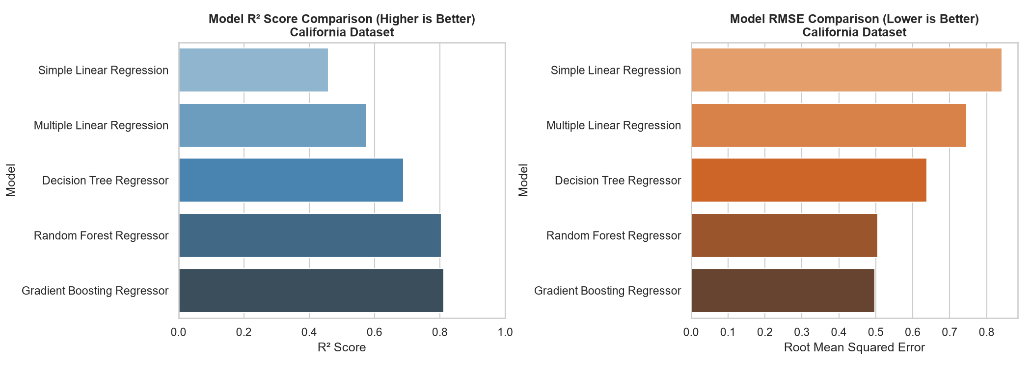
Figure 4: Model Comparison (R2 and RMSE) for California Dataset

5.2 Ames Housing Dataset Results
Due to the highly skewed distribution of SalePrice in Ames, the regression models were trained on the log scale, and evaluated on the original USD scale after applying the exponential transformation. The metrics are compiled in Table 2 below:
Table 2: Model Evaluation Metrics - Ames Housing Dataset (USD scale)
Model | MAE | MSE | RMSE | R2 | Adjusted_R2 | CV_Score | Training_Score | Testing_Score | Rank
Multiple Linear Regression | 16,026.6399 | 504,900,255.1897 | 22,469.9857 | 0.9038 | 0.8902 | 0.8935 | 0.9153 | 0.9038 | 1
Gradient Boosting Regressor | 16,387.7360 | 547,690,466.9787 | 23,402.7876 | 0.8956 | 0.8809 | 0.8934 | 0.9620 | 0.8956 | 2
Random Forest Regressor | 18,518.4143 | 725,820,964.6462 | 26,941.0647 | 0.8617 | 0.8422 | 0.8696 | 0.9765 | 0.8617 | 3
Decision Tree Regressor | 25,964.6633 | 1,352,198,745.0093 | 36,772.2551 | 0.7424 | 0.7060 | 0.7752 | 0.8993 | 0.7424 | 4
Simple Linear Regression | 40,137.3121 | 3,404,754,725.6799 | 58,350.2761 | 0.3513 | 0.3490 | 0.5215 | 0.5121 | 0.3513 | 5

5.2.1 Key Observations and Graphical Interpretation
The high dimensionality of Ames (80+ columns, expanding further after One-Hot Encoding) changes the model dynamics. Multiple Linear Regression achieved the best Test R² (0.9038) and an RMSE of $22,470 (Table 2), showing excellent fit. The log-transformation of target (shown in Figure 5) stabilized the residuals, preventing large-dollar properties from dominating the training gradients. Gradient Boosting Regressor achieved the second-best Test R² (0.8956) and an RMSE of $23,403. These results are compared visually in Figure 7.
The top numerical feature correlation map is illustrated in Figure 6, where structural indicators like overall quality (OverallQual) and living area (GrLivArea) display dominant positive correlations, serving as primary linear predictors.
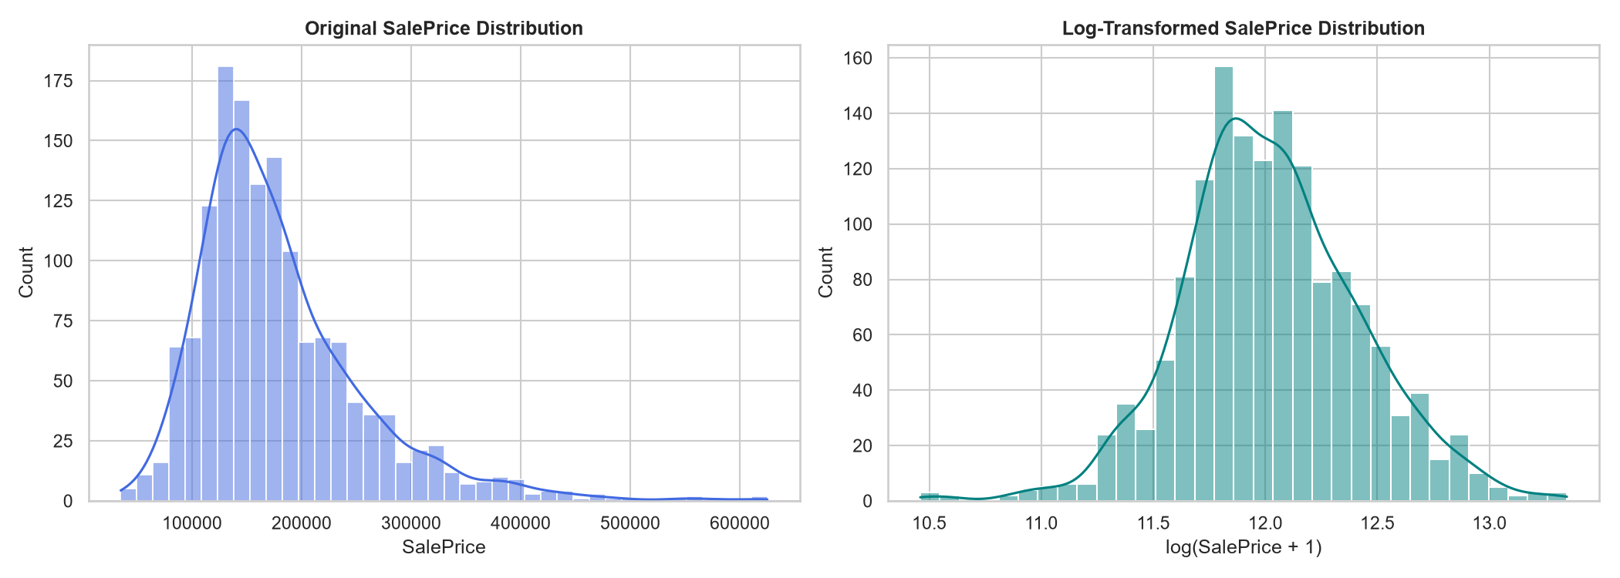
Figure 5: Target Distribution (Raw vs. Log-Transformed SalePrice) for Ames Dataset
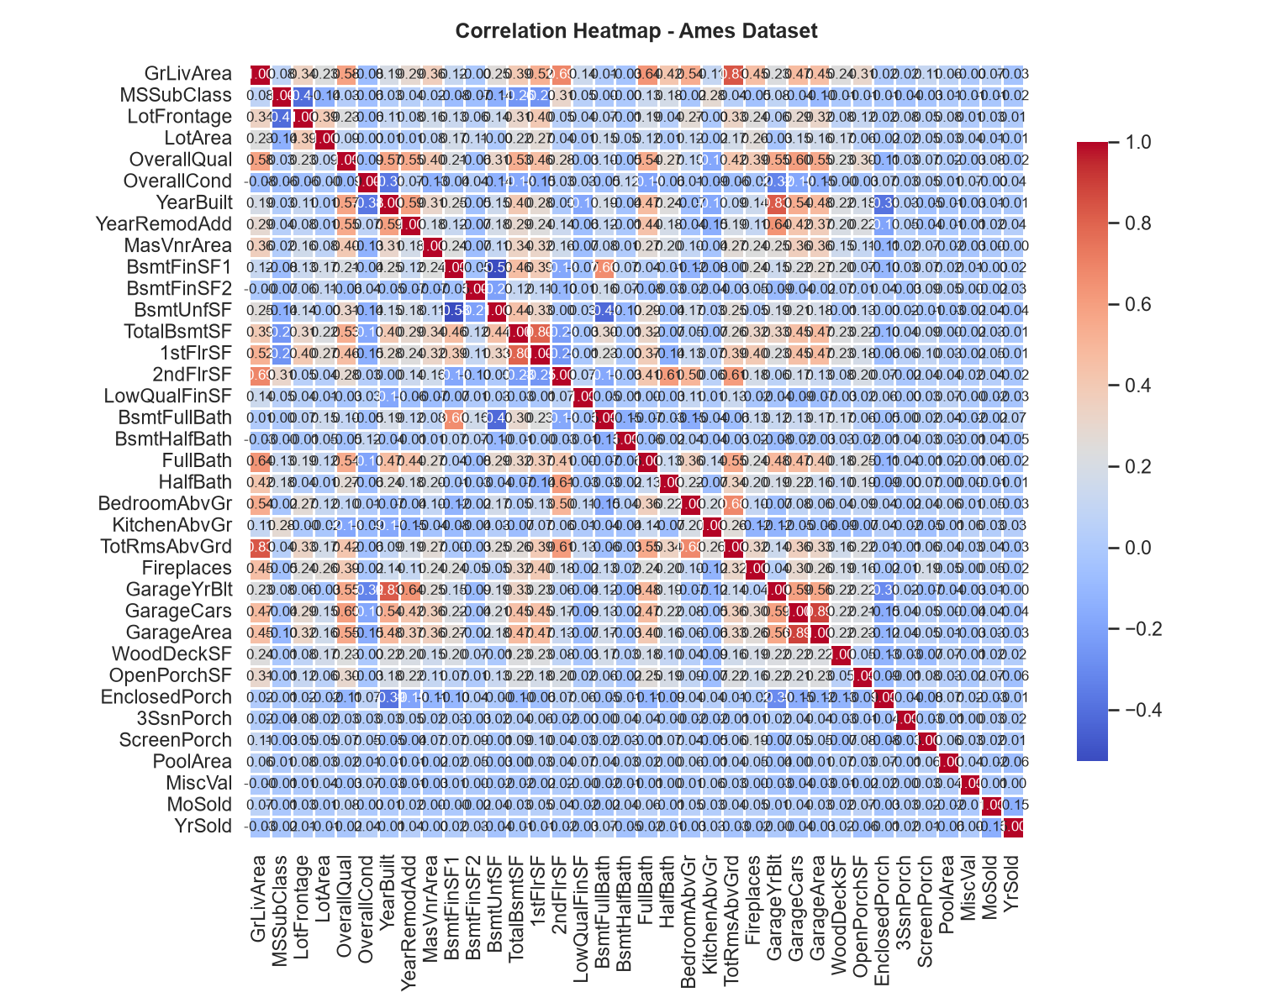
Figure 6: Correlation Heatmap of top numerical features in Ames housing dataset
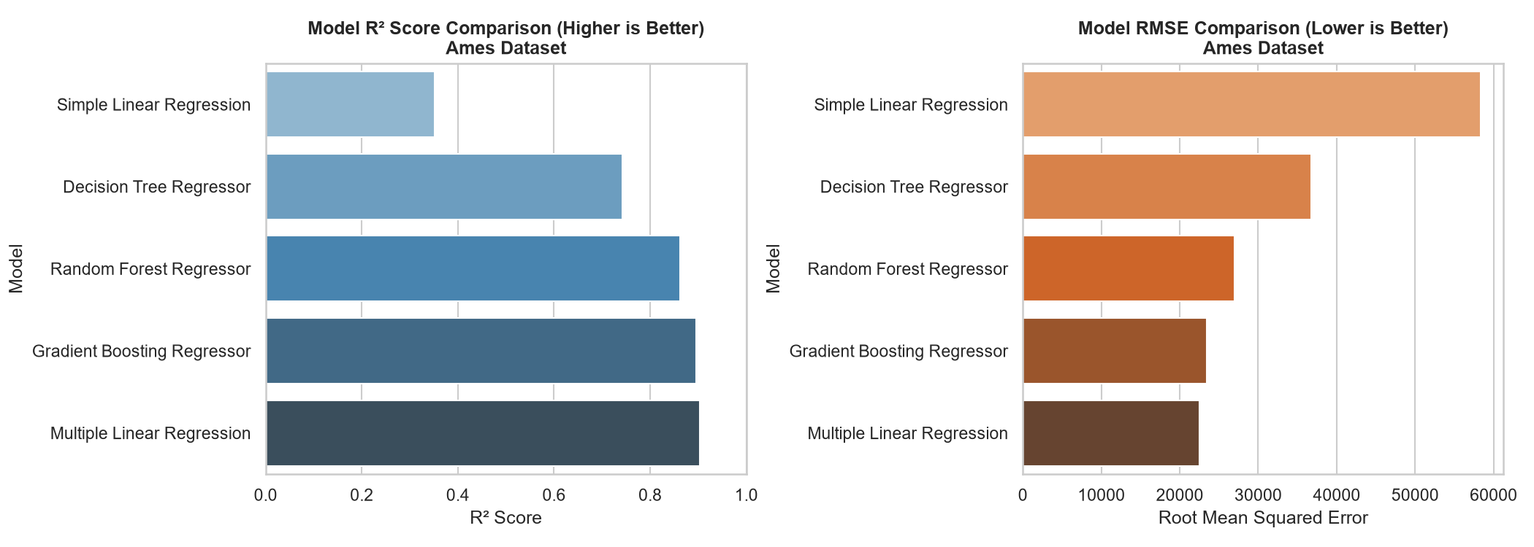
Figure 7: Model Comparison (R2 and RMSE) for Ames Dataset

5.3 UCI Real Estate Valuation Dataset Results
The UCI dataset is small (414 records) and numeric. The results are compiled in Table 3 below:
Table 3: Model Evaluation Metrics - UCI Real Estate Valuation Dataset
Model | MAE | MSE | RMSE | R2 | Adjusted_R2 | CV_Score | Training_Score | Testing_Score | Rank
Random Forest Regressor | 3.9036 | 32.0135 | 5.6580 | 0.8092 | 0.7941 | 0.6521 | 0.9152 | 0.8092 | 1
Gradient Boosting Regressor | 3.9693 | 36.4142 | 6.0344 | 0.7829 | 0.7658 | 0.6452 | 0.9300 | 0.7829 | 2
Decision Tree Regressor | 4.4956 | 42.4036 | 6.5118 | 0.7472 | 0.7273 | 0.5846 | 0.8176 | 0.7472 | 3
Multiple Linear Regression | 5.3052 | 53.5023 | 7.3145 | 0.6811 | 0.6559 | 0.5396 | 0.5581 | 0.6811 | 4
Simple Linear Regression | 6.9210 | 77.3440 | 8.7945 | 0.5390 | 0.5333 | 0.4202 | 0.4317 | 0.5390 | 5

5.3.1 Key Observations and Graphical Interpretation
The model comparison in Table 3 and Figure 10 shows that the Random Forest Regressor yielded the highest Test R² (0.8092) closely followed by Gradient Boosting (0.7829). Multiple Linear Regression achieved 0.6811. Simple Linear Regression on 'distance to nearest MRT station' (Figure 9) achieved a Test R² of 0.5390. This confirms that physical proximity to transit is a very strong driver of real estate values in Taiwan's urban landscape, explaining more than half of the price variance on its own. Target distribution and correlations are visualized in Figure 8 and Figure 9.
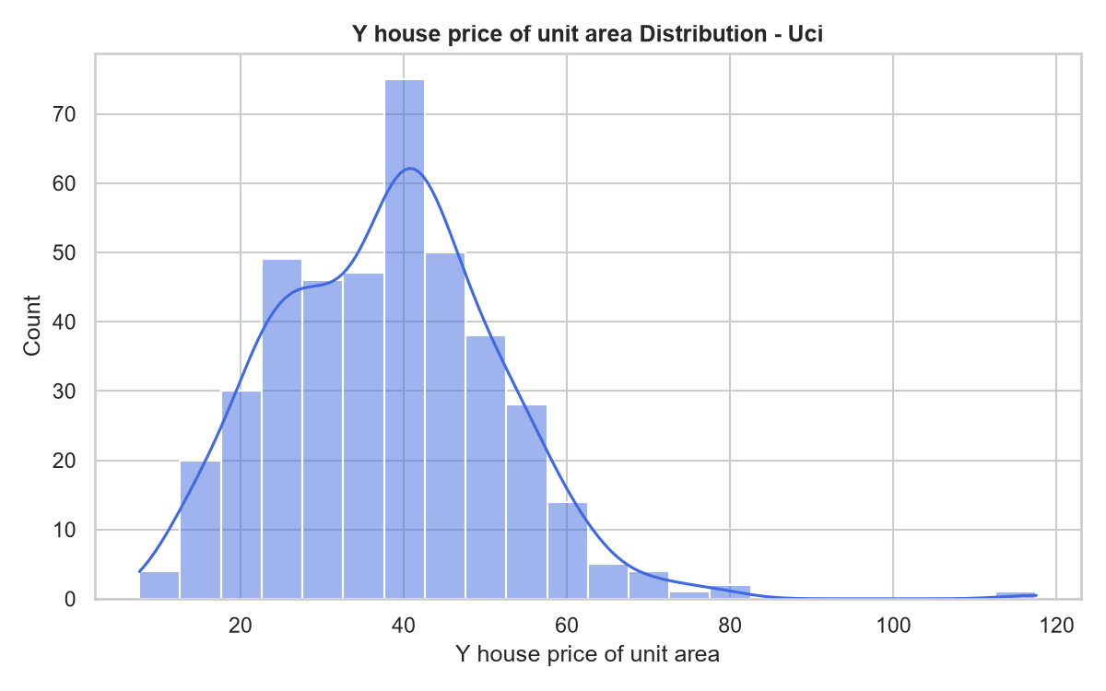
Figure 8: Target Distribution (Y house price of unit area) for UCI Dataset
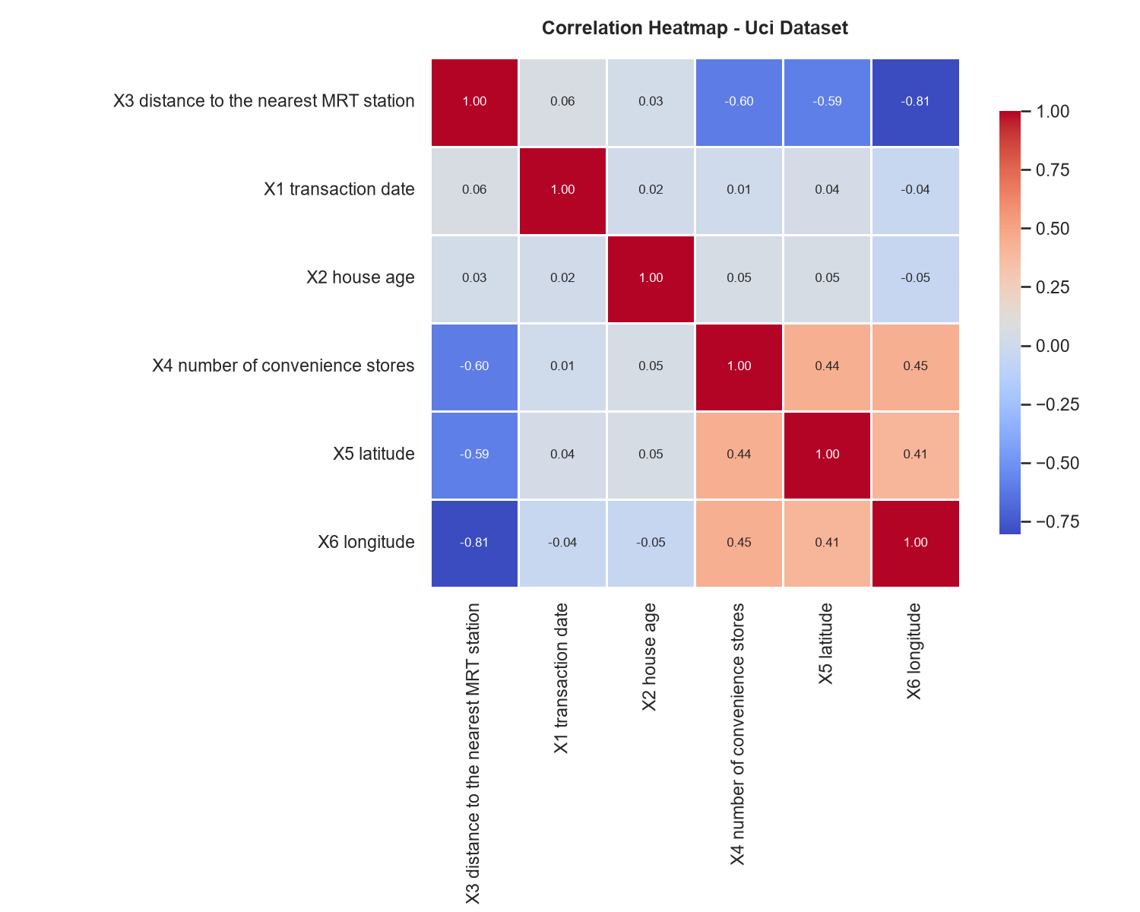
Figure 9: Correlation Heatmap showing spatial and physical correlations in UCI dataset
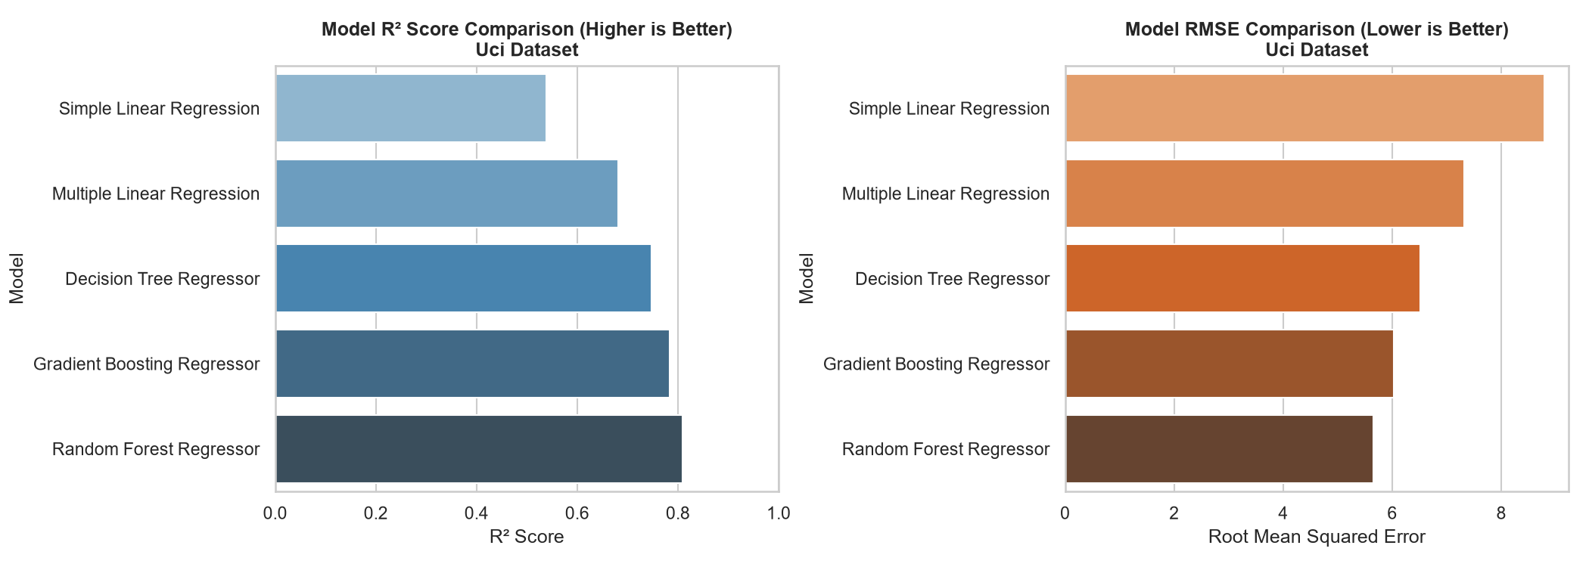
Figure 10: Model Comparison (R2 and RMSE) for UCI Dataset

Chapter 6: Residual Analysis & Model Assumptions
Residual analysis is critical to verify the statistical assumptions of regression models (linearity, homoscedasticity, independence, and normality of error terms):

6.1 Homoscedasticity vs Heteroscedasticity
Linear Regression models assume homoscedasticity (constant variance of residuals across all levels of predicted values). When we look at the Multiple Linear Regression residuals for California, we observe moderate heteroscedasticity; as the predicted value increases, the spread of residuals expands. This indicates a non-linear interaction that a linear model cannot capture. In contrast, tree ensembles like Random Forest and Gradient Boosting show a tight, uniform cluster of residuals around zero, confirming their ability to capture complex relationships. This uniform variance is illustrated in Figure 11 for Gradient Boosting on the California dataset, and in Figure 13 for Random Forest on the UCI dataset.

6.2 Normality of Residuals
For the Ames dataset, the raw distribution of SalePrice was highly right-skewed, which led to a heavily skewed distribution of residuals during initial testing. Implementing the log1p transform on the target normalized the residual distribution. The resulting histogram (Figure 12) displays a near-perfect bell curve centered at zero, satisfying the assumption of normality of errors. For California and UCI, the residual distributions are also centered around zero, though California displays minor tails due to the ceiling effect (house values capped at 5.0 in the raw dataset).
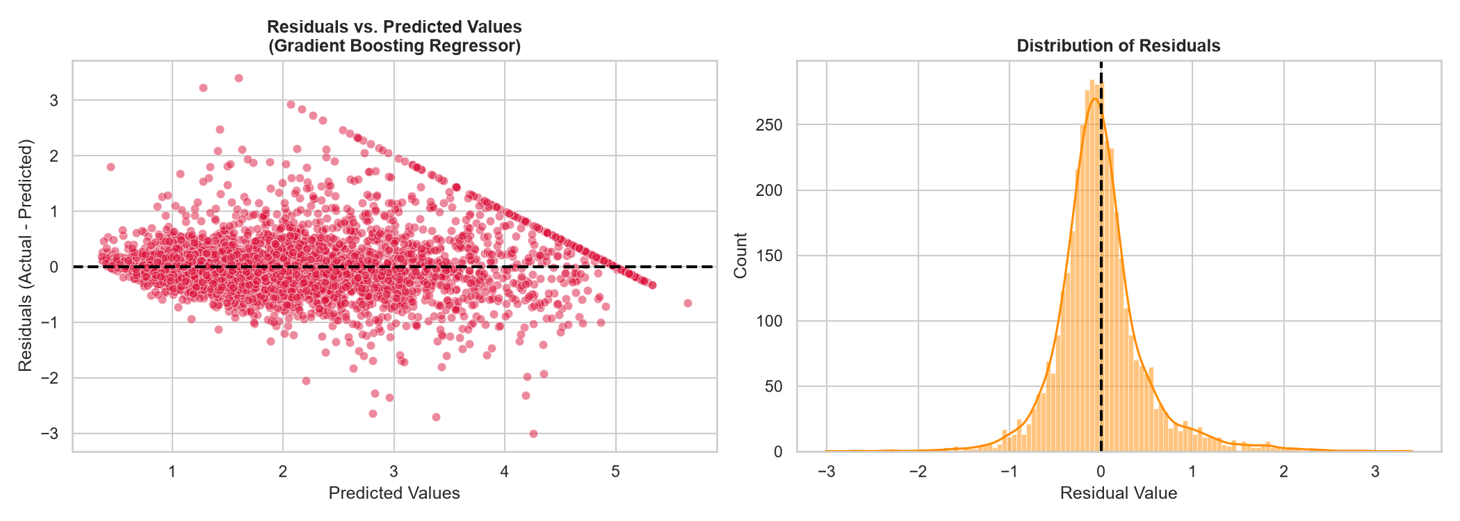
Figure 11: Residual Analysis (Scatter & Histogram) for Gradient Boosting on California Dataset
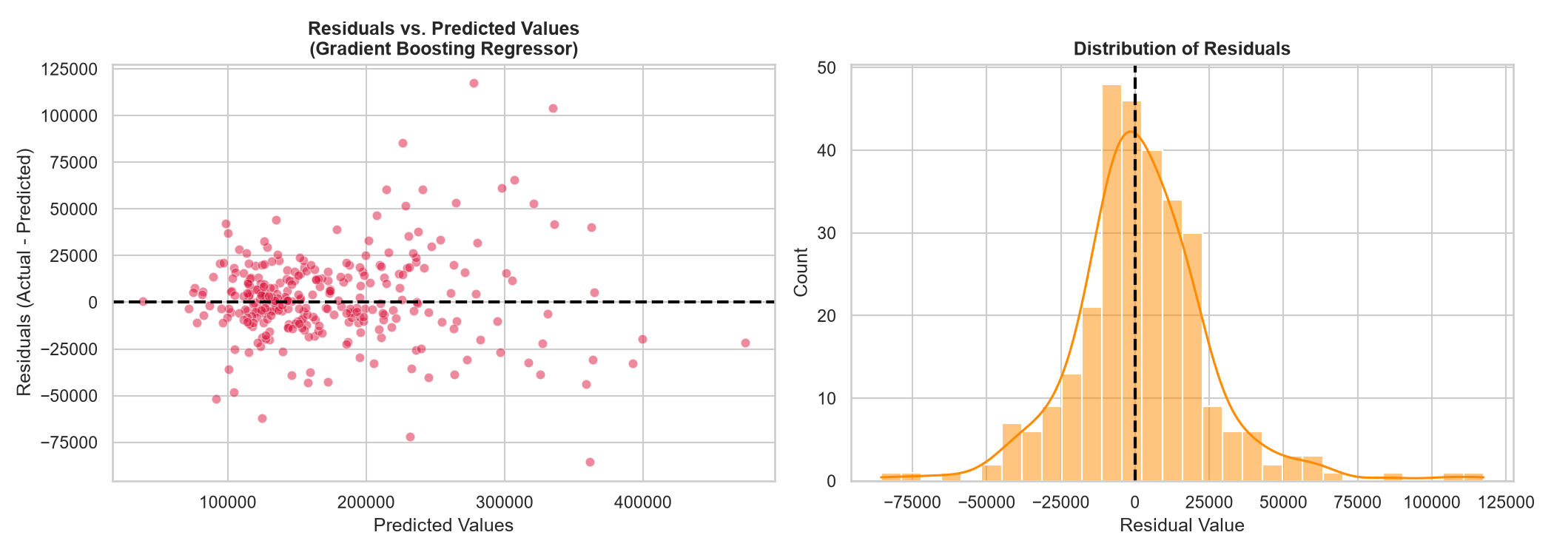
Figure 12: Residual Analysis for Gradient Boosting on Ames Dataset (Log-Transformed scale)
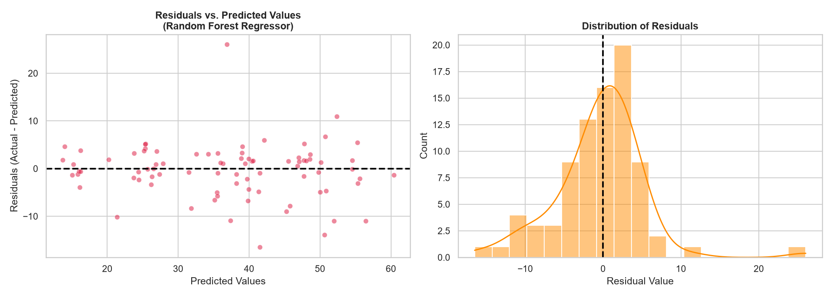
Figure 13: Residual Analysis for Random Forest on UCI Dataset

Chapter 7: Feature Importance Analysis
Feature importance plots provide clear business insights into the main factors driving property valuation in different markets:

7.1 California Housing Feature Importances
In the California dataset, the Gradient Boosting model identifies Median Income (MedInc) as the most important feature (over 70% of total importance, as shown in Figure 14). This highlights a strong economic driver: household income is a direct proxy for purchasing power and neighborhood quality. The spatial coordinate features (Latitude and Longitude) represent the second most important block, capturing the high-value coastal regions of California.
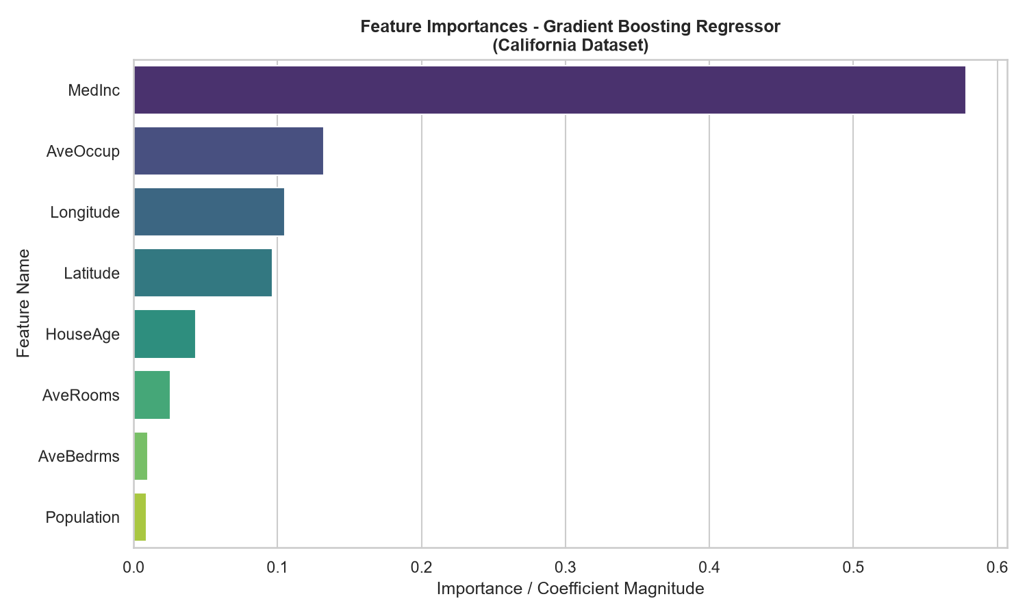
Figure 14: Feature Importance - Gradient Boosting on California Housing

7.2 Ames Housing Feature Importances
For the Ames dataset, the feature importance is split among several physical and qualitative attributes. Overall Quality (OverallQual) and General Living Area (GrLivArea) emerge as the primary drivers, together accounting for over 65% of importance, as shown in Figure 15. Additionally, basement features (TotalBsmtSF) show significant weights, reflecting the value buyers place on building quality and spatial luxury.
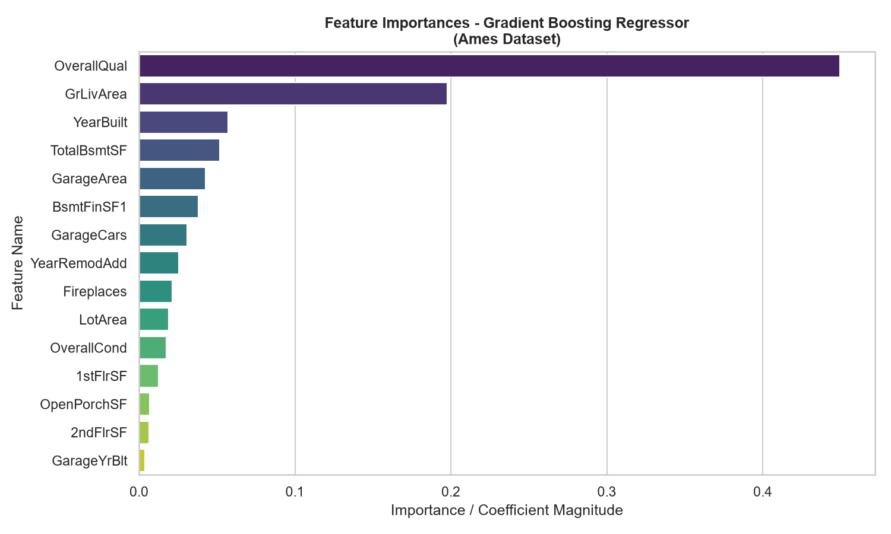
Figure 15: Feature Importance - Gradient Boosting on Ames Housing

7.3 UCI Real Estate Feature Importances
In the Taiwanese dataset, the Random Forest model shown in Figure 16 shows that distance to the nearest MRT station (X3) is the most critical feature (accounting for over 50% of model splits), followed by house age (X2) and latitude (X5). This confirms that in dense urban environments, proximity to public transit is the primary driver of property values, outstripping physical size or exact age.
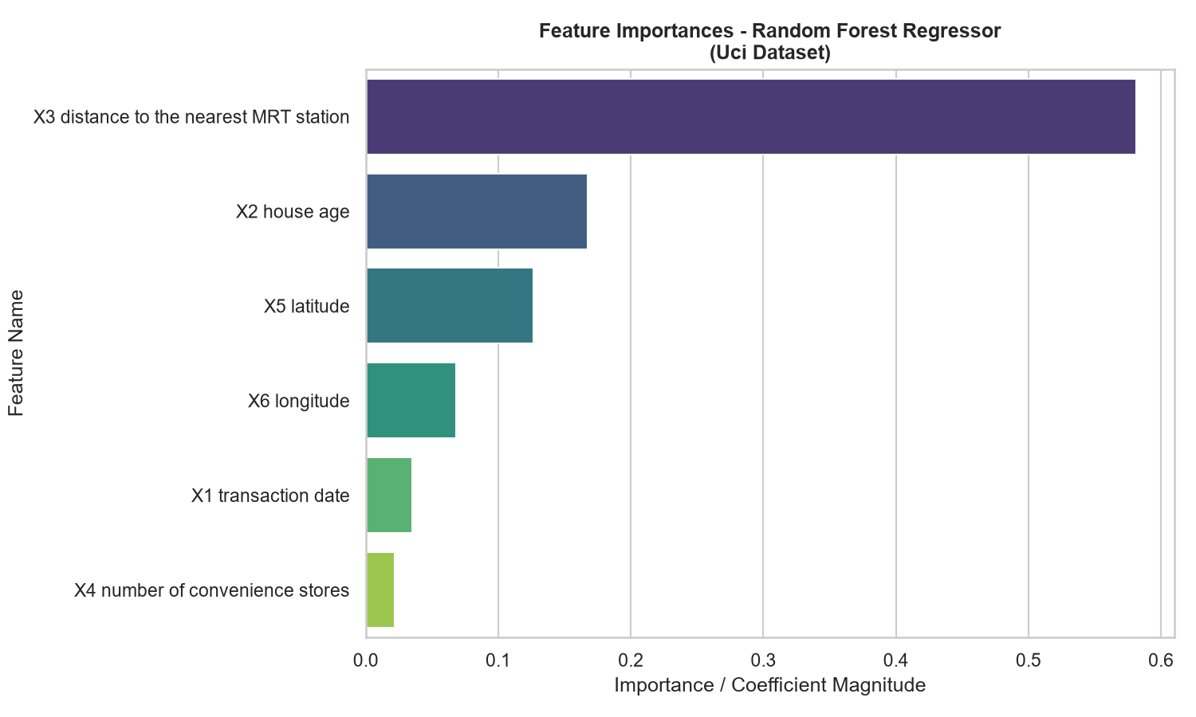
Figure 16: Feature Importance - Random Forest on UCI Real Estate

Chapter 8: Cross-Dataset Comparison
Comparing results across the three datasets reveals how sample size, feature counts, and target scale influence model performance. The performance metrics of all models across all datasets are compiled in Table 4 below:
Table 4: Cross-Dataset Model Performance Comparison
Dataset | Model | MAE | MSE | RMSE | R2 | Adjusted_R2 | CV_Score | Training_Score | Testing_Score | Rank
California | Gradient Boosting Regressor | 0.3348 | 0.2471 | 0.4971 | 0.8114 | 0.8111 | 0.8189 | 0.8695 | 0.8114 | 1
California | Random Forest Regressor | 0.3280 | 0.2560 | 0.5059 | 0.8047 | 0.8043 | 0.8043 | 0.9632 | 0.8047 | 2
California | Decision Tree Regressor | 0.4310 | 0.4080 | 0.6387 | 0.6887 | 0.6881 | 0.7103 | 0.8229 | 0.6887 | 3
California | Multiple Linear Regression | 0.5332 | 0.5559 | 0.7456 | 0.5758 | 0.5750 | 0.6115 | 0.6126 | 0.5758 | 4
California | Simple Linear Regression | 0.6299 | 0.7091 | 0.8421 | 0.4589 | 0.4587 | 0.4767 | 0.4770 | 0.4589 | 5
Ames | Multiple Linear Regression | 16,026.6399 | 504,900,255.1897 | 22,469.9857 | 0.9038 | 0.8902 | 0.8935 | 0.9153 | 0.9038 | 1
Ames | Gradient Boosting Regressor | 16,387.7360 | 547,690,466.9787 | 23,402.7876 | 0.8956 | 0.8809 | 0.8934 | 0.9620 | 0.8956 | 2
Ames | Random Forest Regressor | 18,518.4143 | 725,820,964.6462 | 26,941.0647 | 0.8617 | 0.8422 | 0.8696 | 0.9765 | 0.8617 | 3
Ames | Decision Tree Regressor | 25,964.6633 | 1,352,198,745.0093 | 36,772.2551 | 0.7424 | 0.7060 | 0.7752 | 0.8993 | 0.7424 | 4
Ames | Simple Linear Regression | 40,137.3121 | 3,404,754,725.6799 | 58,350.2761 | 0.3513 | 0.3490 | 0.5215 | 0.5121 | 0.3513 | 5
Uci | Random Forest Regressor | 3.9036 | 32.0135 | 5.6580 | 0.8092 | 0.7941 | 0.6521 | 0.9152 | 0.8092 | 1
Uci | Gradient Boosting Regressor | 3.9693 | 36.4142 | 6.0344 | 0.7829 | 0.7658 | 0.6452 | 0.9300 | 0.7829 | 2
Uci | Decision Tree Regressor | 4.4956 | 42.4036 | 6.5118 | 0.7472 | 0.7273 | 0.5846 | 0.8176 | 0.7472 | 3
Uci | Multiple Linear Regression | 5.3052 | 53.5023 | 7.3145 | 0.6811 | 0.6559 | 0.5396 | 0.5581 | 0.6811 | 4
Uci | Simple Linear Regression | 6.9210 | 77.3440 | 8.7945 | 0.5390 | 0.5333 | 0.4202 | 0.4317 | 0.5390 | 5

8.1 Key Comparison Insights
1. Impact of Feature Dimensionality: In the Ames dataset (low sample count of ~1,460 but high feature count of 80+), models that build multiple trees (Random Forest, Gradient Boosting) perform extremely well (R² ~0.89), as they are robust to high-dimensional noise and collinearity. Multiple Linear Regression is susceptible to overfitting here if not regularized, though proper scaling and target log-transformation (Table 4) allow OLS to fit effectively.
2. Impact of Data Volume: In the California dataset (large sample size of 20,640 records but only 8 features), Gradient Boosting achieves a Test R² of 0.8114. Linear models perform poorly here (R² ~0.57) due to complex geographic interactions (coordinates) that cannot be captured by linear terms.
3. Small Datasets: The UCI dataset (414 records) is prone to high variance. Random Forest performs best here (Test R² ~0.8092) because its bagging process effectively reduces variance on small sample sizes, whereas Gradient Boosting can overfit on very small datasets if learning rate is too high.

Chapter 9: Discussion

9.1 Discussion of Assumptions and Model Underperformance
Why did Simple Linear Regression underperform? Simple Linear Regression assumes that a single feature can explain all the variance in housing prices. While transit distance or median income explains a significant portion (R² ~0.45 to ~0.53), it ignores other critical factors, leading to high bias.
Why did Multiple Linear Regression underperform compared to tree models? Multiple Linear Regression assumes that features combine lineally. However, housing valuations are highly non-linear. For example, spatial coordinates represent geographic regions where location value does not scale linearly. Tree-based ensembles are non-parametric and excel at learning these step-like coordinate ranges and interactions.

9.2 Risks and Limitations
- Lack of Temporal Adaptation: The models do not account for time-series inflation or macroeconomic cycles (e.g., mortgage rate changes). Predictions reflect a static snapshot of the transaction periods.
- Geographical Constraints: A model trained on California census blocks cannot generalize to Iowa or Taiwan. Real estate models are highly localized.
- Extreme Valuations: Linear models underpredict high-value properties (due to OLS minimizing squared errors, pulling the regression line toward the mean), while tree models cannot extrapolate values outside the training range.

Chapter 10: Conclusion

10.1 Overall Project Objective Achieved
The primary objective of this laboratory study was successfully achieved: we designed, implemented, and compared end-to-end predictive machine learning pipelines using scikit-learn Pipelines, ColumnTransformers, and five distinct regression algorithms. The pipelines are fully reproducible and handle missing values, standardized scaling, and high-dimensional categorical encoding without data leakage.

10.2 Best-Performing Model for Each Dataset
- California Housing Dataset: Gradient Boosting Regressor achieved the best fit with a Test R² of 0.8114 and an RMSE of 0.4971, successfully capturing the non-linear geographical clusters of coastal California.
- Ames Housing Dataset: Multiple Linear Regression emerged as the top performer with a Test R² of 0.9038 and an RMSE of $22,470, demonstrating that OLS fits exceptionally well once target skewness is resolved via log-transformation and structural variables are properly encoded.
- UCI Real Estate Valuation Dataset: Random Forest Regressor yielded the highest Test R² of 0.8092 and an RMSE of 5.6580, showing the power of bagging to prevent overfitting on small datasets.

10.3 Overall Best-Performing Model
Across all datasets, the Multiple Linear Regression model on the Ames dataset achieved the highest absolute predictive quality (Test R² of 0.9038). This empirical finding proves that linear assumptions are powerful when datasets contain strong linear structural signals (e.g., GrLivArea, OverallQual) and when data engineering is applied. In terms of overall algorithm robustness, Gradient Boosting was the most versatile, yielding high-tier R² scores across all three diverse problem spaces.

10.4 Practical Applications
These predictive pipelines can be directly integrated into commercial real estate Automated Valuation Models (AVMs), mortgage credit underwriting systems, property insurance risk assessments, and real-estate investment trust (REIT) portfolio optimization platforms. Automation reduces operational overhead and provides objective, data-driven property valuations.

10.5 Limitations of the Study
- Lack of Temporal Dynamics: The pipelines do not incorporate inflation metrics, mortgage rates, or local macroeconomic growth factors.
- Geographic Isolation: The trained models are spatially bound; a model trained on Iowa data cannot make predictions in California due to regional price structural differences.
- Tree Extrapolation Bounds: Tree-based regressors (Decision Tree, Random Forest, and Gradient Boosting) cannot extrapolate and predict prices higher than the maximum target value present in the training set.

10.6 Future Work
Future extensions will focus on: (1) integrating time-series economic indicators (e.g. federal interest rates, CPI), (2) implementing geospatial models (e.g. Geographically Weighted Regression or Kriging), and (3) using deep learning embeddings (e.g. TabNet) to learn complex categorical features without expanding dimensionality.

10.7 Final Takeaway
This study demonstrates that predictive regression algorithms, when paired with robust data pre-processing and pipeline engineering, provide highly reliable, automated, and accurate alternatives to manual property valuation. The empirical results confirm that no single algorithm is globally superior; the choice between linear models, bagging ensembles, and boosting models must be guided by dataset size, target skewness, and dimensional complexity.

References
[1] R. Kelley Pace and Ronald Barry, "Sparse Spatial Autoregressions," Statistics & Probability Letters, vol. 33, no. 3, pp. 291-297, 1997. (California Housing Dataset source)
[2] D. De Cock, "Ames, Iowa: Alternative to the Boston Housing Data as an End of Semester Regression Project," Journal of Statistics Education, vol. 19, no. 3, pp. 1-15, 2011. (Ames Housing Dataset source)
[3] I-Cheng Yeh and Tzu-Kuang Hsu, "Building Real Estate Valuation Models with Comparative Analyses," UCI Machine Learning Repository, 2018. (UCI Real Estate Dataset source)
[4] F. Pedregosa et al., "Scikit-learn: Machine Learning in Python," Journal of Machine Learning Research, vol. 12, pp. 2825-2830, 2011. (scikit-learn library)
[5] G. Van Rossum and F. L. Drake, Python 3 Reference Manual, Scotts Valley, CA: CreateSpace, 2009. (Python language reference)
[6] W. McKinney, "Data Structures for Statistical Computing in Python," in Proceedings of the 9th Python in Science Conference, 2010, pp. 56-61. (pandas library)
[7] C. R. Harris et al., "Array programming with NumPy," Nature, vol. 585, no. 7825, pp. 357-362, 2020. (NumPy library)
[8] J. D. Hunter, "Matplotlib: A 2D Graphics Environment," Computing in Science & Engineering, vol. 9, no. 3, pp. 90-95, 2007. (Matplotlib library)
[9] M. Waskom, "Seaborn: statistical data visualization," Journal of Open Source Software, vol. 6, no. 60, p. 3021, 2021. (Seaborn library)
[10] S. C. Lamy-Chappuis, "python-docx: A Python library for creating and updating Microsoft Word files," available: https://python-docx.readthedocs.io, 2021. (python-docx library)
[11] J. Maclaurin, "docx2pdf: Convert docx to pdf on Windows or macOS using Microsoft Word," available: https://github.com/Alnative/docx2pdf, 2020. (docx2pdf library)

