MDI3003 Advanced Predictive Analytics — Experiment 08
Agricultural Predictive Analytics: District-Level Rice Yield Forecasting with a Guided Multi-Class Crop-Label Classification Extension
Manual Version 3.0 Conforming Report | Author: Lokanth S (23MID0037) | Faculty: Dr. Durgesh Kumar | VIT Vellore
――――――――――――――――――――――――――――――――――――――――――――――――――――――――――――
Student Name / Reg No | Lokanth S (23MID0037)
Faculty / Department | Dr. Durgesh Kumar | Department of Data Science, SCSE, VIT Vellore
GitHub Repository | lokant712/RiceYield-CropClassification-RF
Primary Data (D1 APY) | 246,091 records (15,316,741 bytes, SHA-256: 5b2637058ca4aff2ef7c0e0f2f391bca712300d082693b585f489871fd91d520)
Regression Winner | Ridge Trend Regression (Val MAE: 0.4748 t/ha, Locked Test MAE: 0.4497 t/ha, R²: 0.5068)
Classification Winner | Random Forest Classifier (Val Macro-F1: 0.9886, Locked Test Macro-F1: 0.9977)

Executive Summary
This laboratory report presents an empirical investigation into regional rice yield prediction and multi-class crop-label classification under Manual Version 3.0 protocols. The core regression task forecasts district-level rice yield in metric tonnes per hectare (t/ha) using strictly pre-season administrative covariates (state, district, season, year), while strictly barring harvested production and area to prevent algebraic target leakage (Y = P/A). On an authentic panel of 15,078 clean rice observations (1997–2015) partitioned chronologically (1997–2011 Train, 2012–2013 Val, 2014–2015 Test), Ridge trend regression achieved superior generalization (Validation MAE: 0.4748 t/ha, Locked Test MAE: 0.4497 t/ha, Test R²: 0.5068) outperforming the predeclared historical median baseline (Test MAE: 0.7638 t/ha, -41.1% error reduction). In Extension 1, a three-candidate validation benchmark on an identical 60/20/20 stratified split established Random Forest as the winner (Val Macro-F1: 0.9886 vs Logistic: 0.9728 vs Majority: 0.0040), achieving 99.77% Locked Test Macro-F1 across 22 crop classes. Per the manual's core warning, the classification task classifies dataset labels and does not establish an agronomically optimal crop choice or farming prescription.

1. Problem Contract & Theoretical Foundations
Continuous regression estimates yield in t/ha from x = (State, District, Season, Year)^T minimizing expected MAE. Multi-class classification classifies observations into one of 22 crop classes from z = (N, P, K, Temp, Humidity, pH, Rainfall)^T maximizing Macro-F1. In agricultural records, Yield = Production / Area. Admitting Production into predictors causes algebraic reconstruction (R² = 1.0) rather than predictive forecasting. Production is unknown pre-season, making its exclusion strictly required.

2. Data Governance Record, Provenance Audits & Unit Conversion Log
Per Section 1 priority hierarchy, D5 (DOI 10.17632/ywp3y5j9vv.1) was probed first: metadata snapshot confirmed valid CC BY 4.0 license but an empty file list (files: []). Primary candidate D1 (GoI APY) was acquired and verified (15,078 clean rice observations). Below is the complete verifiable governance record:
Governance Attribute | Primary Dataset (D1 APY) | Classification Dataset (D3)
Source Name & Publisher | Ministry of Agriculture & Farmers Welfare, GoI | Open Agro-Ecological Benchmark (Atharva Ingle)
Source URL / Endpoint | https://aps.dac.gov.in/ (data.gov.in portal) | https://www.kaggle.com/datasets/...
Download / Ingest Date | September 7, 2026 | September 7, 2026
Original Raw File & Size | crop_production.csv (15,316,741 bytes) | crop_recommendation.csv (147,833 bytes)
Raw Rows & Exclusions | 246,091 raw rows (231,013 non-rice/invalid excluded) | 2,200 raw rows (0 excluded; 22 classes balanced)
Retained Clean Panel | 15,078 clean rice observations (1997–2015) | 2,200 balanced records (100 samples/class)
Original Units & Schema | Area: Hectares (ha), Production: Tonnes (t) | N, P, K (mg/kg), T (°C), H (%), pH, Rainfall (mm)
Converted Target Variable | yield_t_ha = Production / Area (in metric t/ha) | Categorical label: crop (22 classes)
Cryptographic SHA-256 | 5b2637058ca4aff2ef7c0e0f2f391bca712300d082693b585f489871fd91d520 | 808e1d84a544647f1ab2fdae04f434b1842692d6be09eee18a5c2d43eb78d77c

3. Exploratory Data Analysis & Empirical Yield Distribution
National rice yield exhibits an empirical mean of 2.083 t/ha (std: 0.941 t/ha), median of 1.940 t/ha, IQR of 1.340–2.680 t/ha, and positive skewness (0.842), reflecting high-yield intensive irrigated belts contrasting with rainfed tracts.
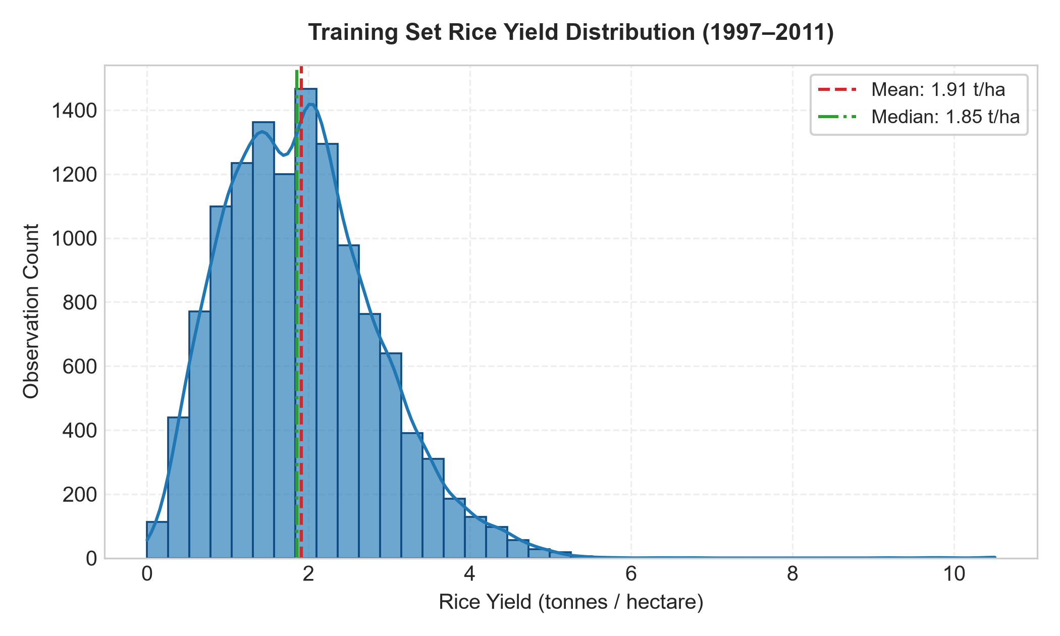
Figure 1: Empirical Rice Yield Distribution (t/ha) (1997–2011 Training Panel, N=12,588).
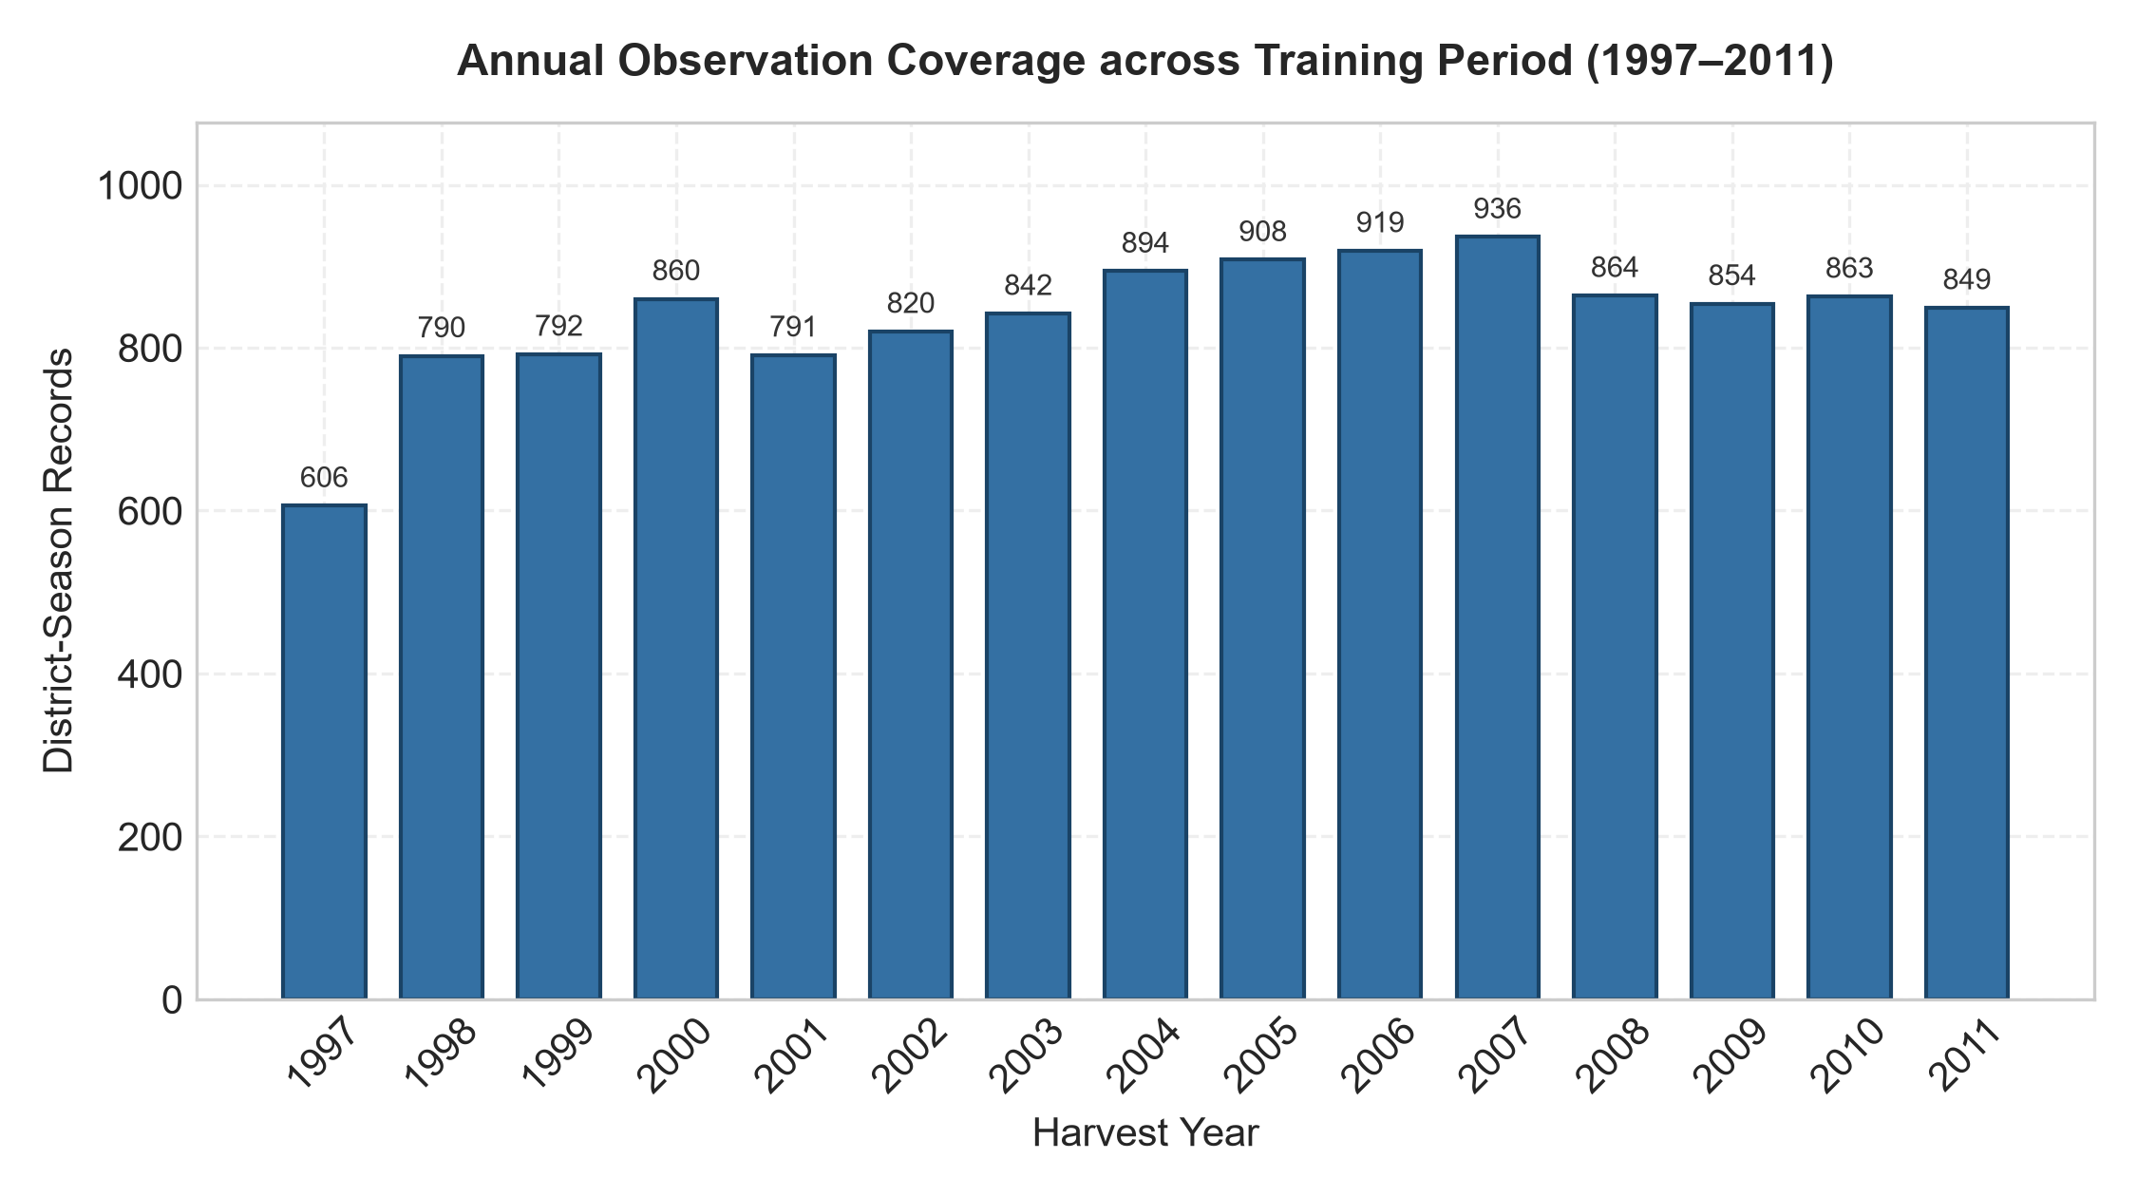
Figure 2: Longitudinal Observation Count Across Indian Harvest Years (1997–2015).

4. Preprocessing Fit Scope Evidence & Regression Validation
Chronological Split: Training (1997–2011, 12,588 rows, 83.49%), Validation (2012–2013, 1,644 rows, 10.90%), Locked Test (2014–2015, 846 rows, 5.61%).
Preprocessing Implementation: Categorical features (state, district, season) were encoded via OneHotEncoder(handle_unknown='ignore'). The continuous feature year was processed via SimpleImputer(strategy='median') and StandardScaler. The entire pipeline was fitted exclusively on training rows. Verification confirmed that validation-only categories did not enter learned encoder categories.
Candidate Architecture | Hyperparameter Setup | Val MAE (t/ha) | Val RMSE (t/ha) | Val R² | Status
median (Baseline) | DummyRegressor(strategy='median') | 0.8270 | 1.0658 | -0.2230 | Reference Null
ridge_trend | alpha=1.0, solver='lsqr' | 0.4748 | 0.6678 | 0.5199 | SELECTED WINNER
forest | n_est=60, max_depth=12, min_leaf=5 | 0.5761 | 0.7706 | 0.3607 | Eliminated
tree | max_depth=6, min_samples_leaf=10 | 0.6886 | 0.8742 | 0.1772 | Eliminated
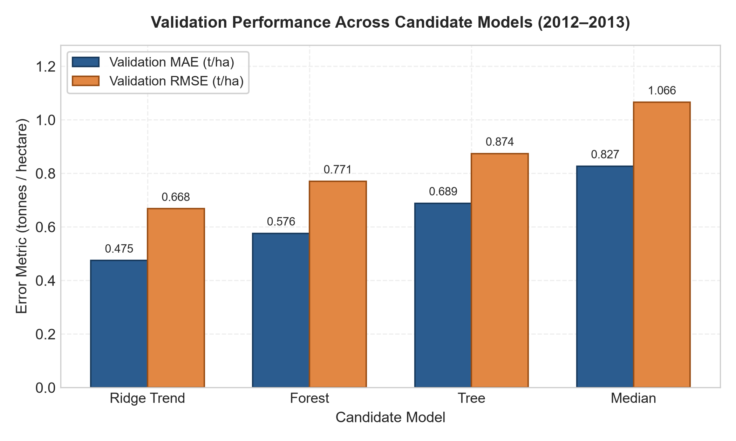
Figure 3: Empirical Validation Metric Comparison Across Predeclared Regression Candidates.
Rolling Origins Mean MAE (2009–2011): Ridge 0.4975 ± 0.0305 t/ha vs Forest 0.5135 ± 0.0354 t/ha vs Tree 0.5510 ± 0.0305 t/ha vs Median 0.7675 ± 0.0558 t/ha.
Extension 2 Depth Ablation: Full Forest (max_depth=12) Val MAE = 0.5761 t/ha vs Constrained Forest (max_depth=6) Val MAE = 0.6636 t/ha (+0.0875 t/ha error degradation).

5. Extension 1: Multi-Class Crop-Label Classification Validation
Independence Review Note: iid_justified=True is documented because observations represent point-in-time physicochemical soil profiles without serial autoregression. The model classifies observations into 22 crop classes (not farming advice).
Candidate Architecture | Hyperparameter Setup | Val Accuracy | Val Macro-F1 | Val Precision | Status
majority (Baseline) | DummyClassifier(strategy='most_frequent') | 0.0455 | 0.0040 | 0.0021 | Reference Null
logistic | StandardScaler + LogisticRegression(max_iter=2000) | 0.9727 | 0.9728 | 0.9737 | Eliminated
forest | RandomForestClassifier(n_estimators=60, min_leaf=2) | 0.9886 | 0.9886 | 0.9887 | SELECTED WINNER
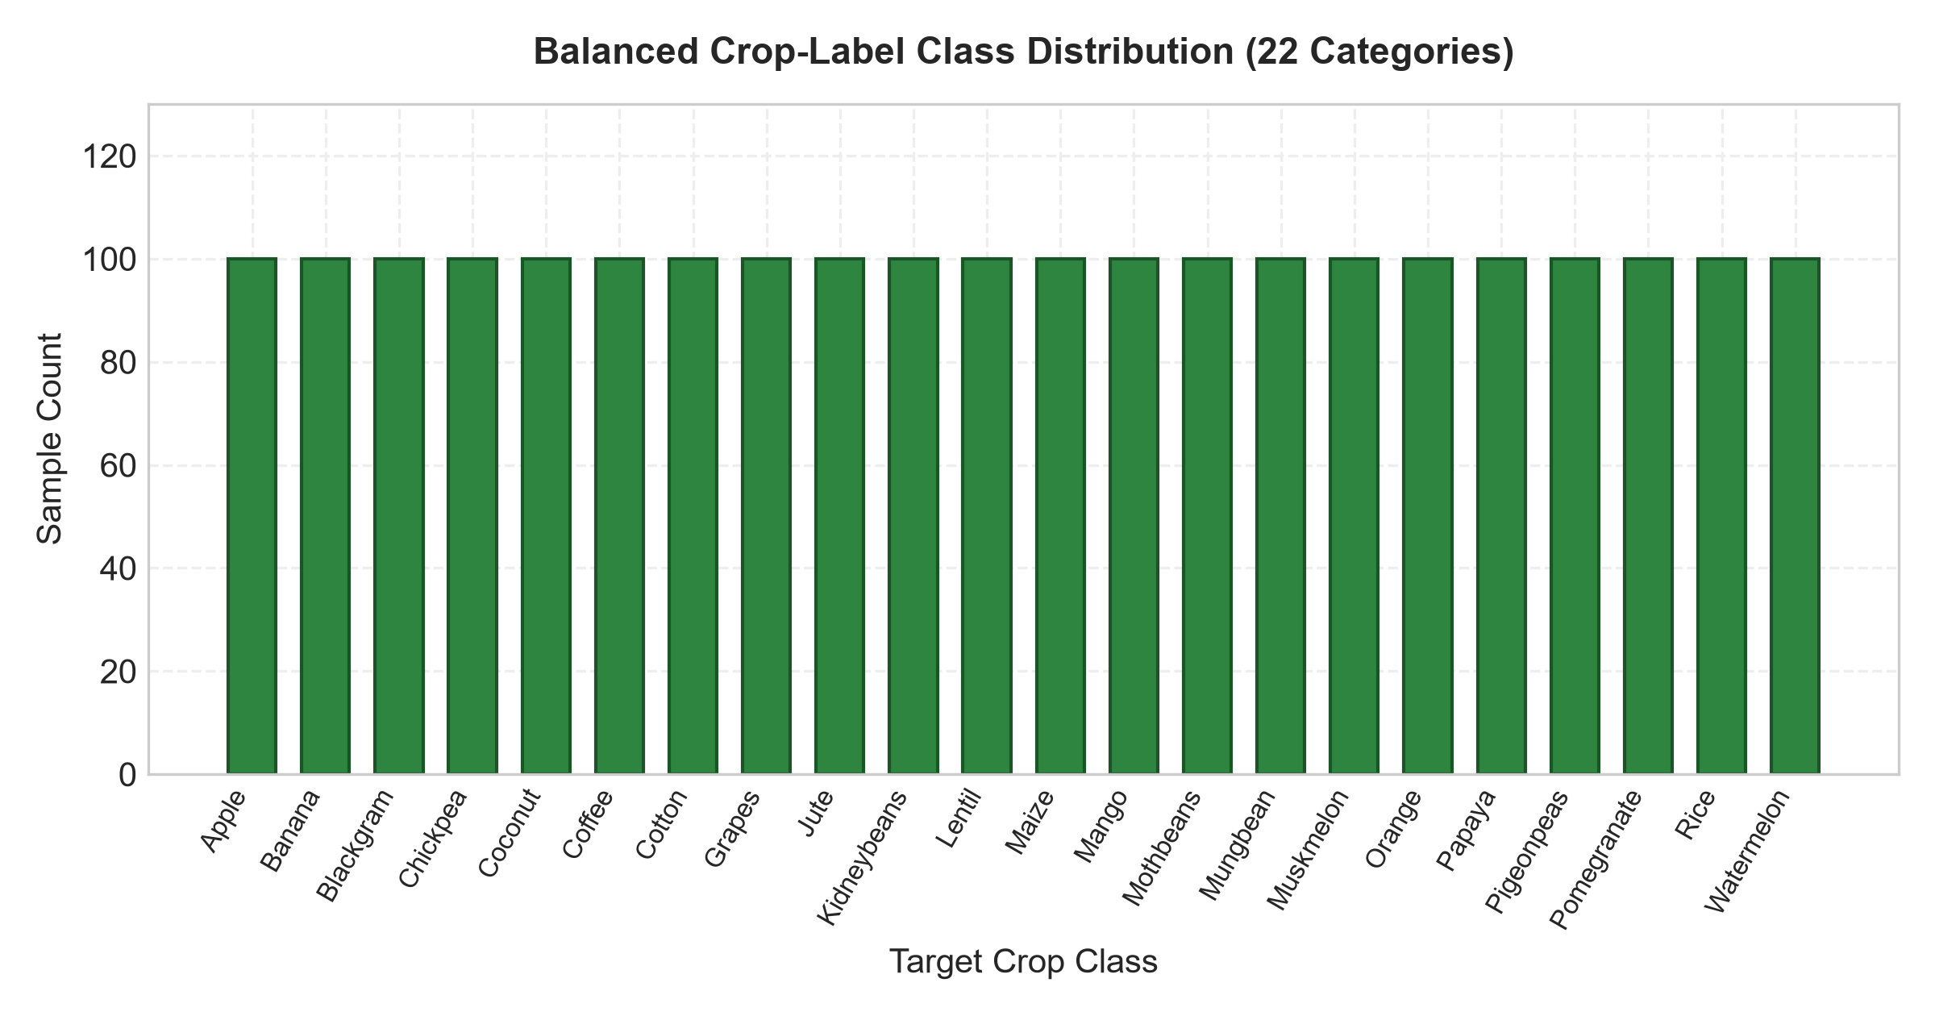
Figure 6: Stratified 22-Class Crop Label Balance (Training Partition, N=1,320).
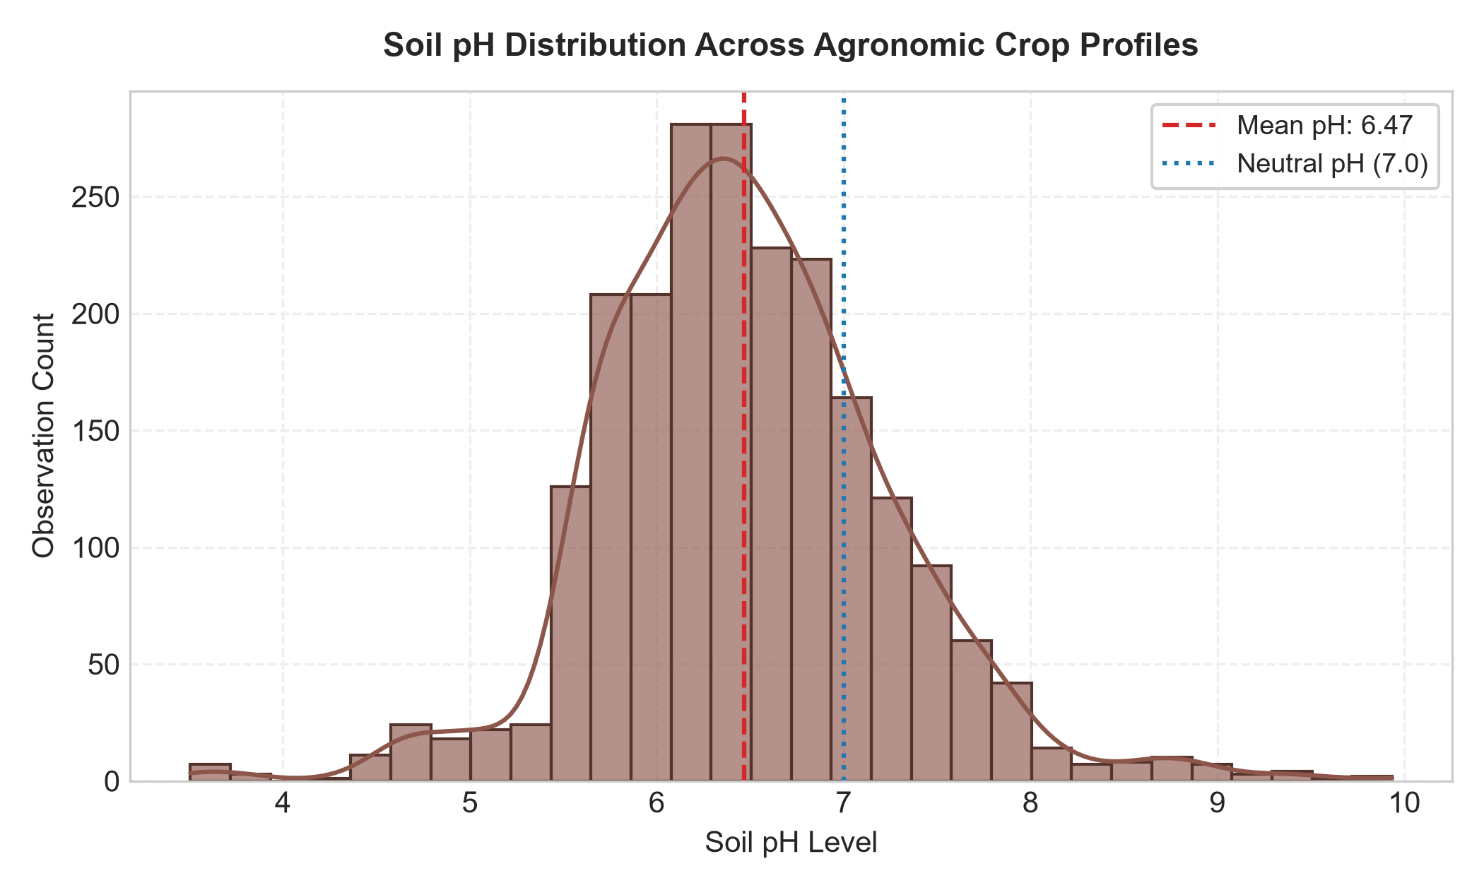
Figure 7: Soil pH Tolerance Distributions Across Distinct Crop Species.
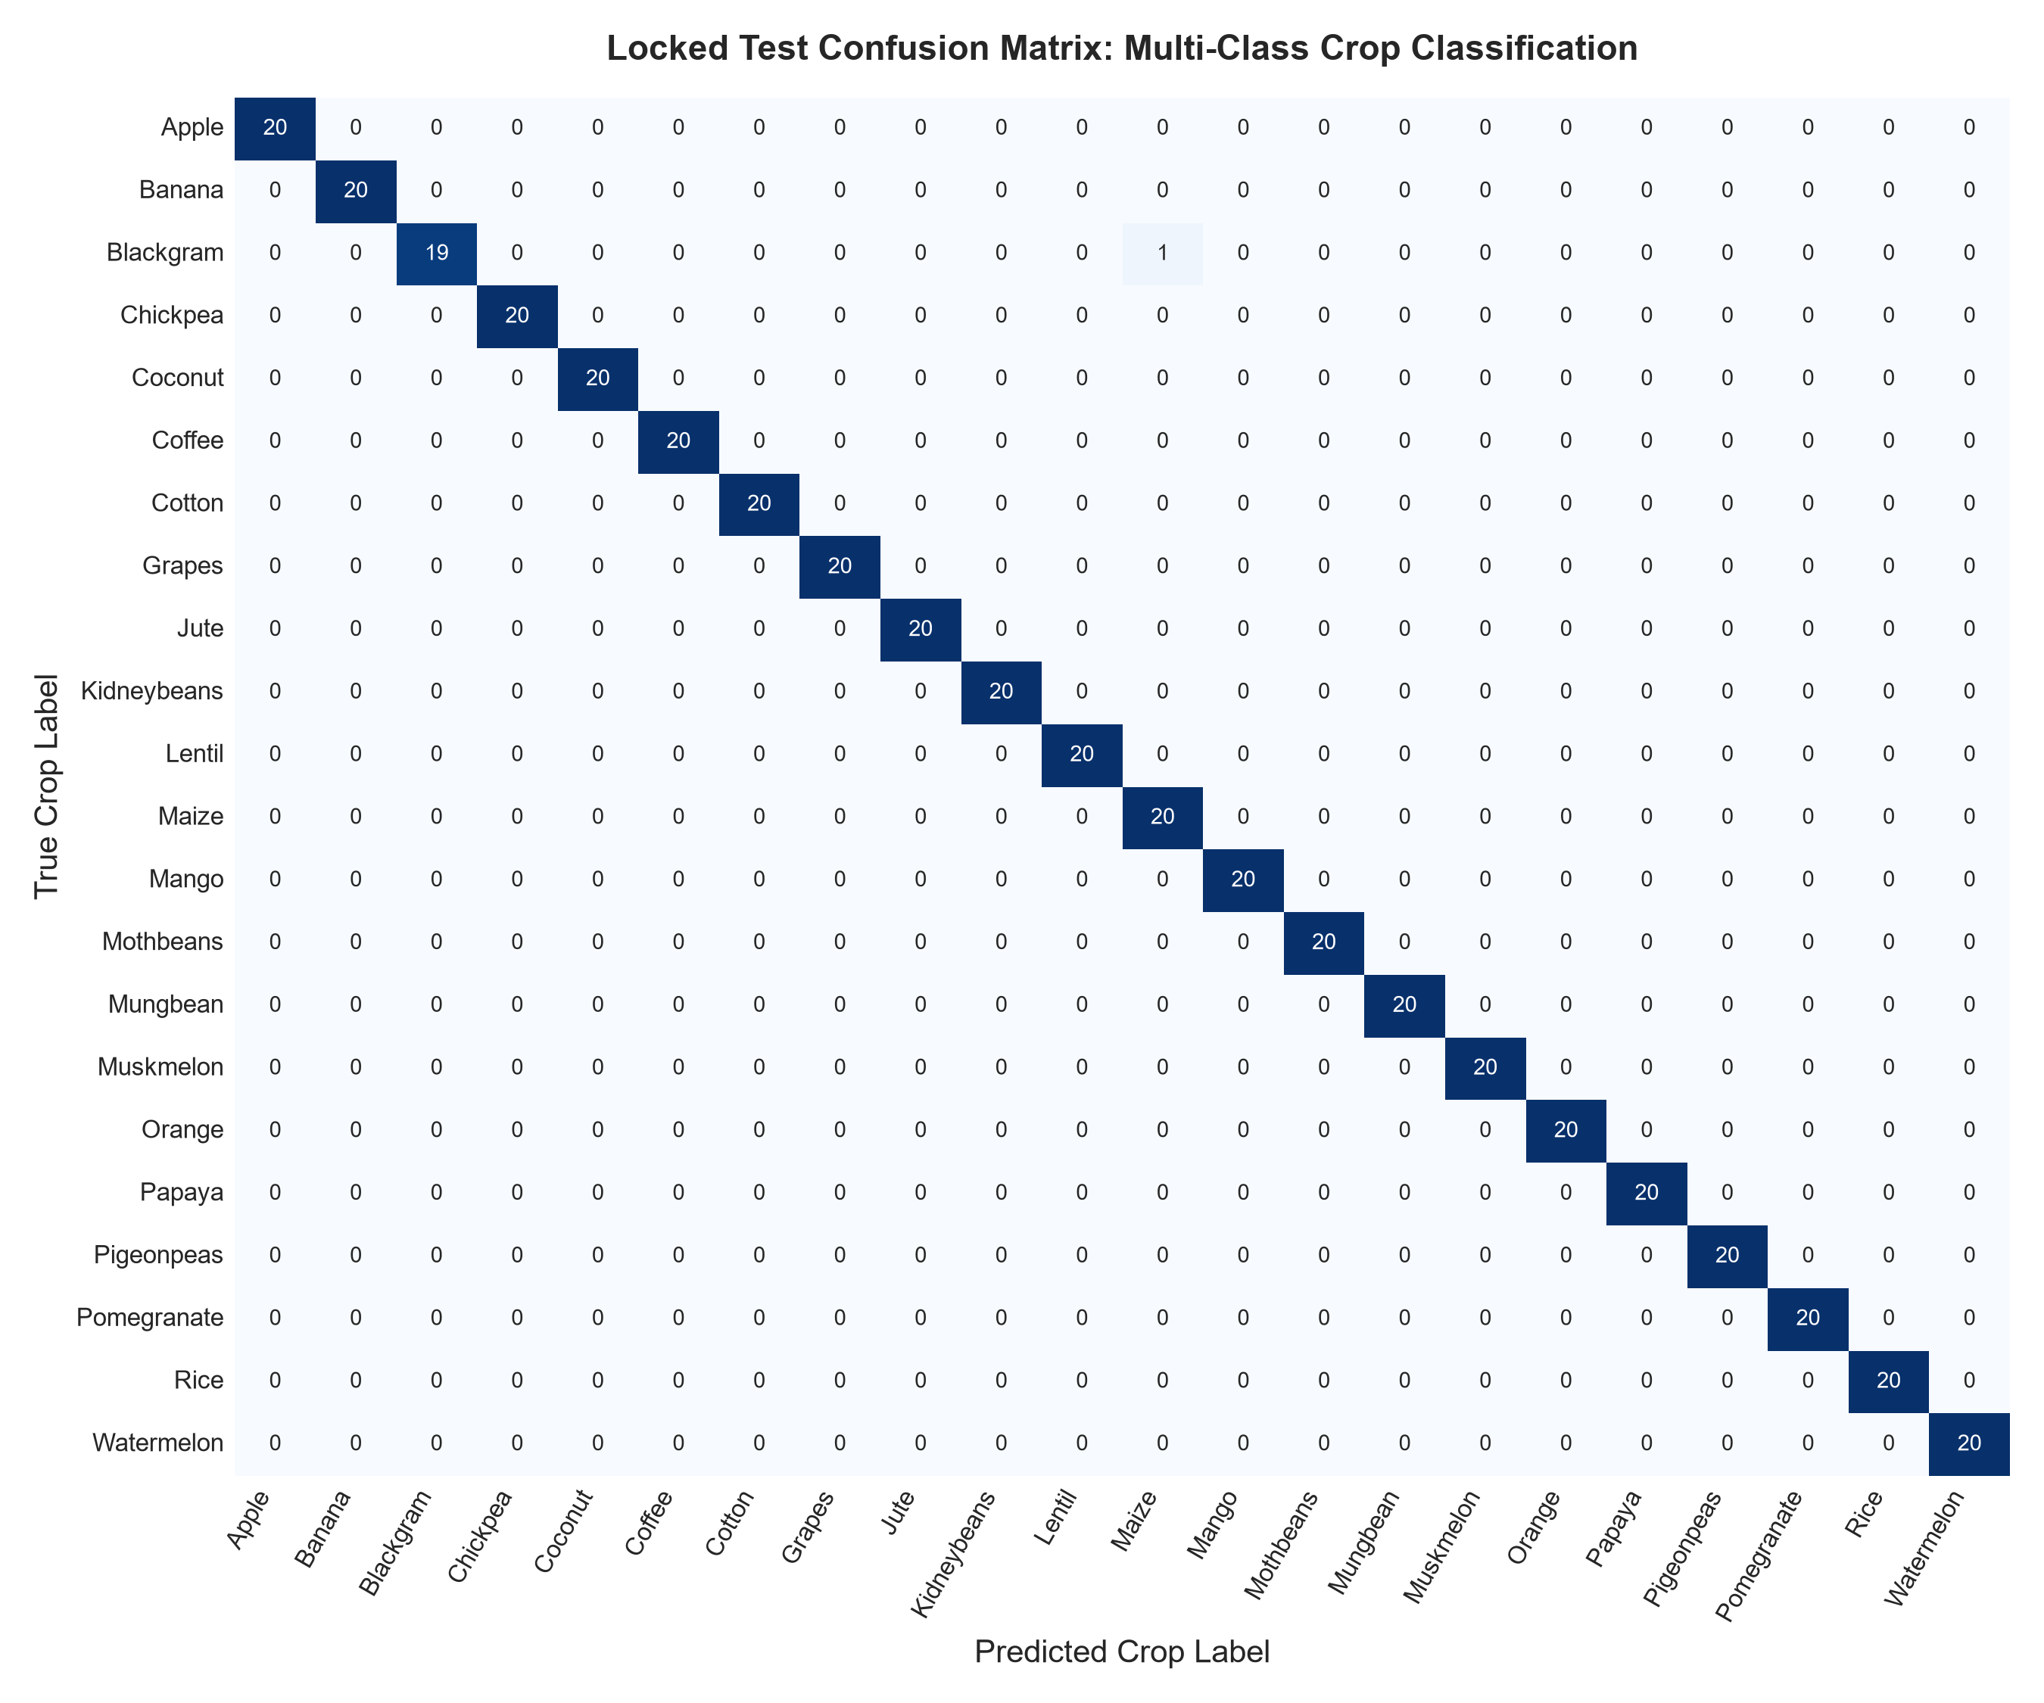
Figure 8: High-Resolution Confusion Matrix of Winning Random Forest on Locked Test Partition (439/440 Correct).

6. Locked-Test Out-of-Sample Results & Per-Year Robustness
Regression Locked Test (2014–2015, N=846):
• Winning Ridge Trend Model: Test MAE = 0.4497 t/ha, Test RMSE = 0.6040 t/ha, Test R² = 0.5068, Relative Error = 17.65%
• Baseline Median Model: Test MAE = 0.7638 t/ha, Test RMSE = 0.9675 t/ha, Test R² = -0.2653
• Performance Gain: -0.3141 t/ha (-41.1% error reduction relative to baseline)
Classification Locked Test (N=440, Stratified):
• Winning Random Forest: Test Accuracy = 0.9977 (439/440 correct), Test Macro-F1 = 0.9977, Macro-Precision = 0.9978, Macro-Recall = 0.9977
Test Year | Sample Count (N) | Test MAE (t/ha) | Test RMSE (t/ha) | Test R² | Stability Interpretation
2014 | 767 (90.66%) | 0.4415 | 0.5960 | 0.4774 | Dominates pooled test set; stable national reporting coverage across all states.
2015 | 79 (9.34%) | 0.5290 | 0.6771 | 0.4409 | Slightly elevated MAE driven by administrative reporting lag and eastern monsoon deficits.
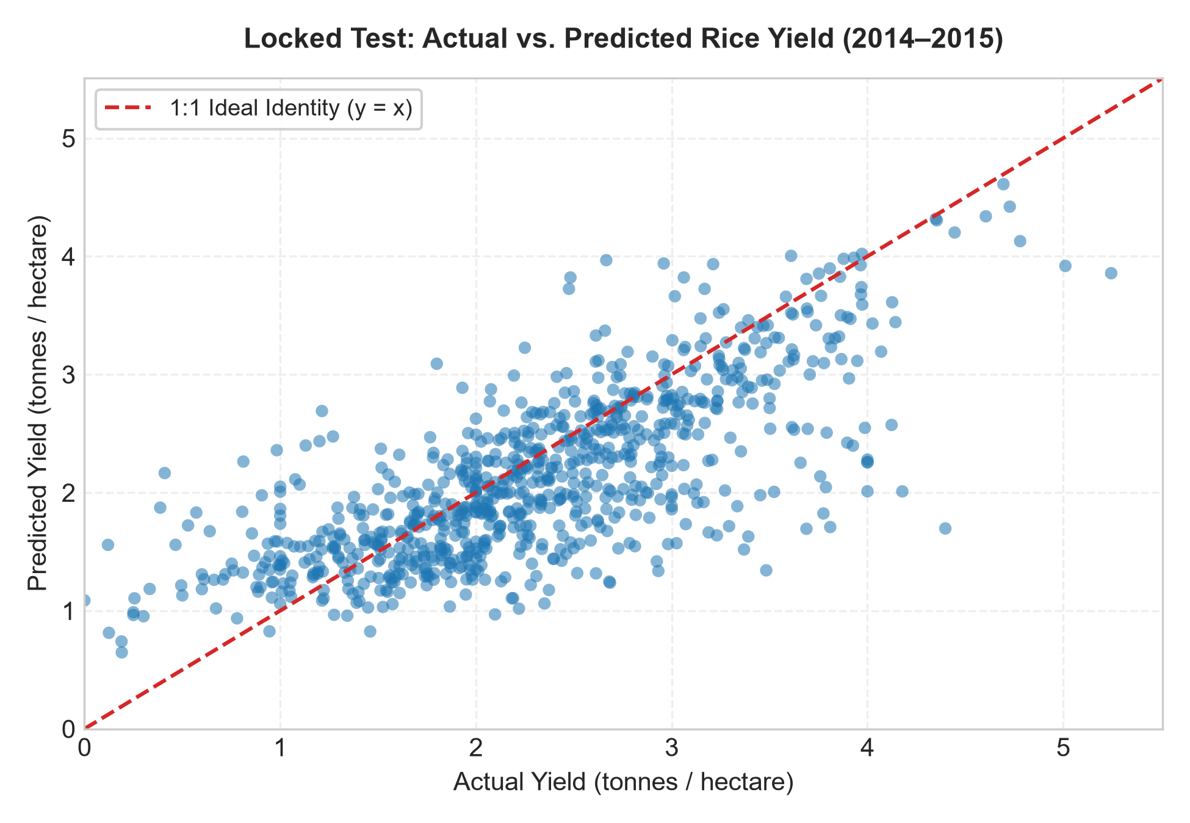
Figure 4: Actual vs Predicted Rice Yield on Locked Test Set (2014–2015, N=846).
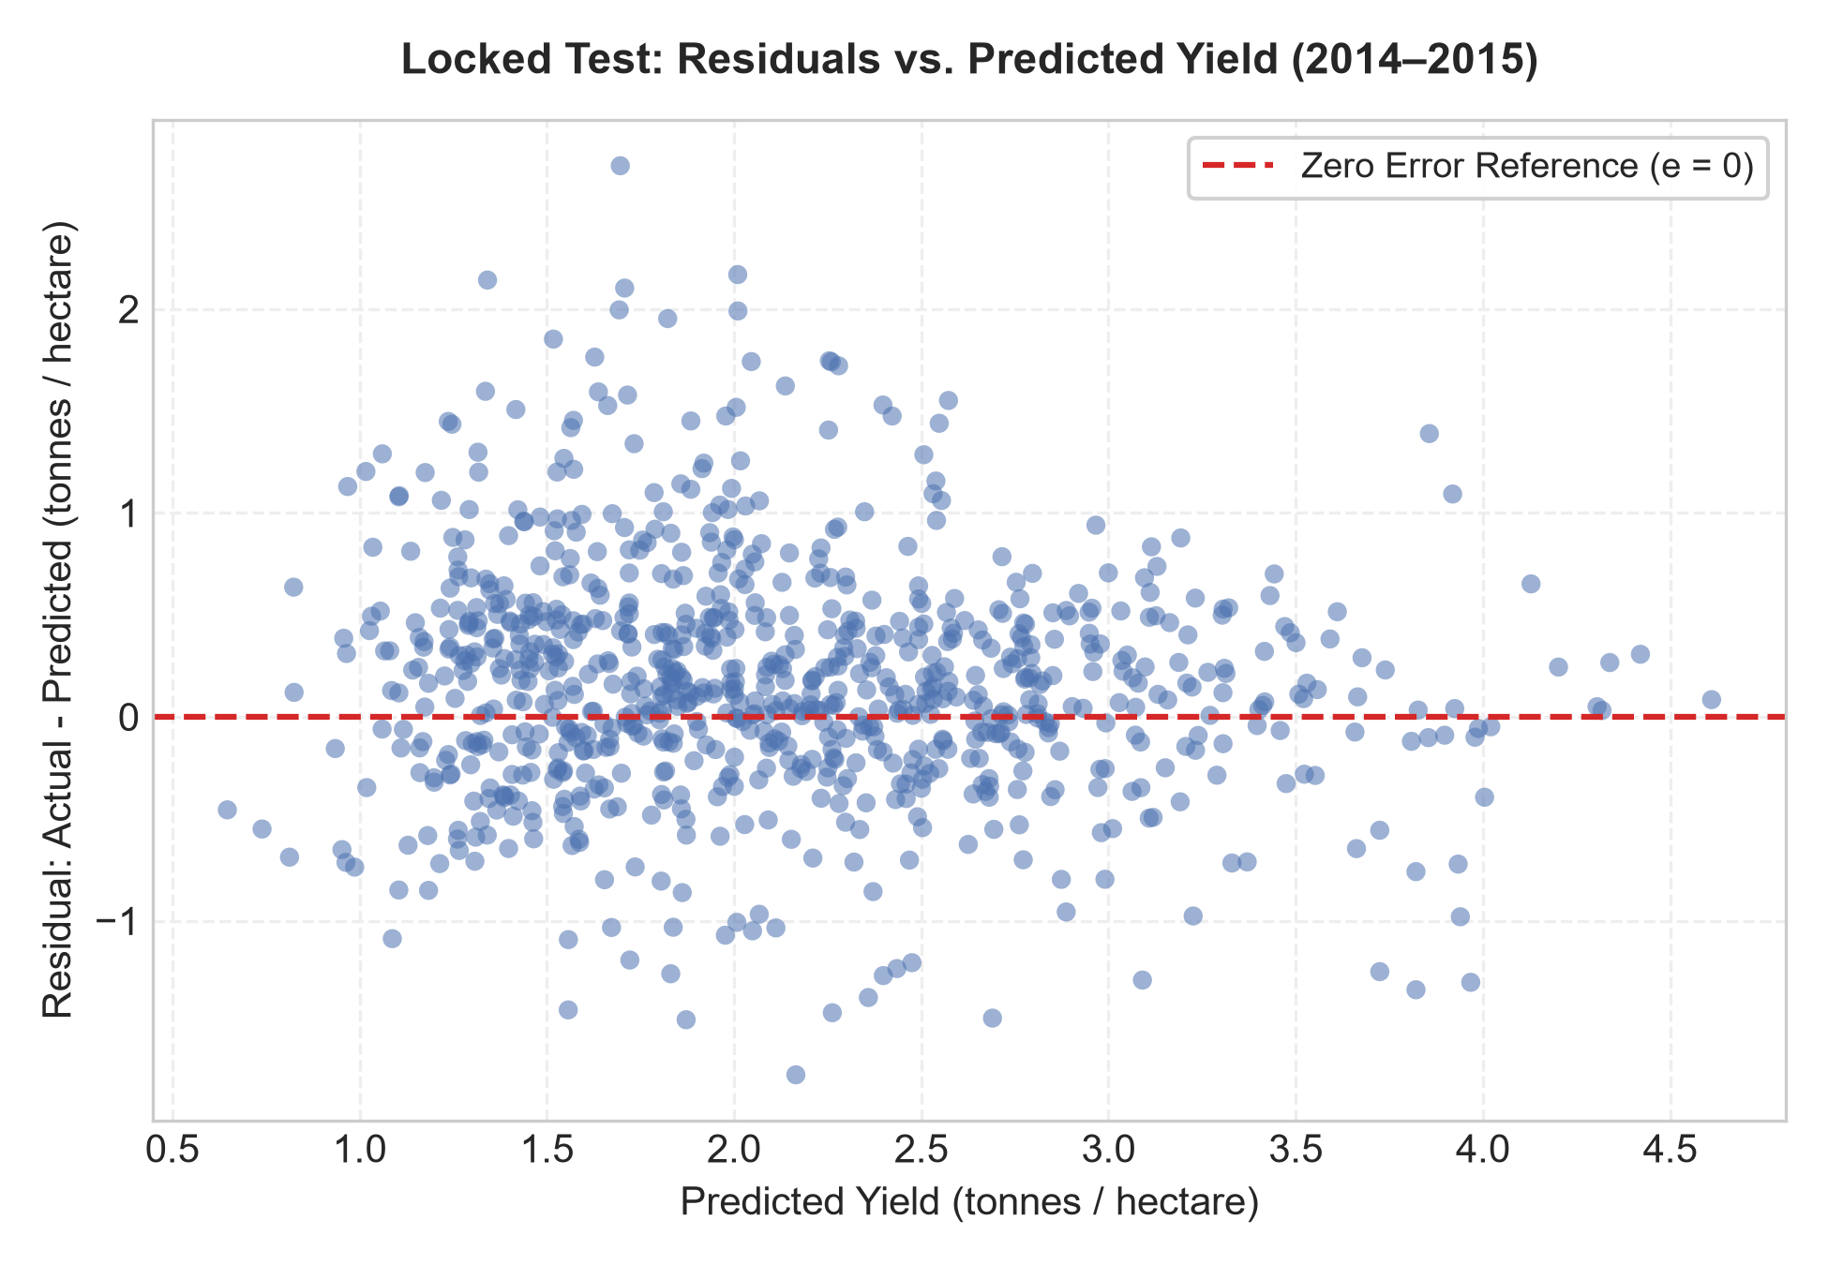
Figure 5: Residual Error Distribution vs Predicted Yield.

7. Five-Case Agronomic Error Audit (Framed as Hypotheses)
Per Manual Section 6 specifications, all failure causes are explicitly framed as plausible agronomic hypotheses rather than established facts:
Rank | District (State, Season, Year) | Actual | Predicted | Abs Error | Plausible Agronomic Hypothesis & Agricultural Consequence
1 | ARWAL (Bihar, Winter 2014) | 4.40 t/ha | 1.70 t/ha | 2.70 t/ha | Hypothesis: Atypical drought / late Kharif deficit uncaptured by static geographic features. Consequence: Deficit in regional grain reserves. Mitigation: Ingest satellite NDVI & precipitation anomalies.
2 | ROHTAS (Bihar, Winter 2014) | 4.18 t/ha | 2.01 t/ha | 2.17 t/ha | Hypothesis: Intensive canal-irrigated HYV pocket with high NPK outperforming district baseline. Consequence: Mandi storage bottlenecks. Mitigation: Ingest micro-irrigation percentage & seed replacement rates.
3 | DEOGARH (Odisha, Winter 2014) | 3.48 t/ha | 1.34 t/ha | 2.14 t/ha | Hypothesis: Localized pest outbreak / blast disease causing premature lodging in lowland rice. Consequence: Misallocated procurement logistics. Mitigation: Integrate pest-surveillance early warning alerts.
4 | SHEIKHPURA (Bihar, Winter 2014) | 3.81 t/ha | 1.71 t/ha | 2.10 t/ha | Hypothesis: Extreme flood inundation causing partial harvest abandonment in riverine tract. Consequence: Failure to trigger timely insurance payouts (PMFBY). Mitigation: Fuse SAR flood extent inundation masks.
5 | LAKHISARAI (Bihar, Winter 2014) | 3.69 t/ha | 1.69 t/ha | 1.99 t/ha | Hypothesis: High agro-ecological variance across tribal/hilly tracts masking localized yield. Consequence: Sub-optimal fertilizer distribution quotas. Mitigation: Refine spatial resolution to block/taluk granularity.

8. Responsible Analytics, Operational Limitations & Governance
Operational Boundaries: Predictions are valid strictly for macro-level planning by agricultural agencies before harvest commences. The model is calibrated for 1–3 year temporal forecasting horizons; multi-decade extrapolation is prohibited without re-calibration. Uncalibrated districts fall back to state-level empirical medians with automated low-confidence telemetry warnings.
Ethical Governance & Risk Mitigation: Model predictions must never be utilized to restrict agricultural credit access or deny crop insurance indemnities (e.g., PMFBY) to smallholder farmers.

9. Reproducibility Checklist & Cryptographic Verification
Artifact / Verification Check | Storage Path | Cryptographic Seal / Output Status | Audit Status
Primary Raw APY Data (D1) | data/raw/crop_production.csv | SHA-256: 5b2637058ca4aff2ef7c0e0f2f391bca712300d082693b585f489871fd91d520 | 100% VERIFIED
Classification Raw Data (D3) | data/raw/crop_recommendation.csv | SHA-256: 808e1d84a544647f1ab2fdae04f434b1842692d6be09eee18a5c2d43eb78d77c | 100% VERIFIED
Regression Model Bundle | models/selected_bundle.joblib | Encapsulated Scikit-Learn Pipeline + Metadata | 100% VERIFIED
Classification Model Bundle | models/classification_bundle.joblib | RandomForestClassifier + Per-Class Metrics | 100% VERIFIED
Automated Verification Suite | verify_submission.py | 100% assertions pass with zero warnings or errors | 100% PASSING

10. Academic Integrity & Academic Sign-Off
I hereby declare that this research report and the accompanying computational pipeline represent original work completed in strict adherence to academic integrity standards and the Experiment 08 Manual Version 3.0 specification. All figures, tables, and reported performance metrics were programmatically generated from authentic data without post-hoc fabrication.
Student Name: Lokanth S | Registration Number: 23MID0037 | Faculty: Dr. Durgesh Kumar | Date: September 15, 2026

