1M1B – IBM SkillsBuild & AICTE
AI for Sustainability Virtual Internship | July–Sep 2026
CampusWasteGuide
AI-Powered Campus Waste Segregation Chatbot
Project Submission Report
Submitted by: Bhagyashree Sushilkumar Lokapure
College: Indira Gandhi National Open University (IGNOU)
SDG Alignment: SDG 12 (Primary) · SDG 11 · SDG 13 · SDG 4 (Secondary)
1. Problem Statement
Problem Statement (Guideline Format)
How might we use AI to guide campus users in correctly segregating waste so that campuses can become more sustainable and reduce landfill contribution?
Context & Evidence
Campus waste bins are routinely contaminated — recyclables, compostable food waste, and hazardous e-waste are all mixed into general waste bins due to a lack of accessible, real-time guidance. Bin labels are static and cannot handle ambiguous questions such as "Is a coffee cup recyclable?" or "Where does a pen drive go?". E-waste items such as batteries, chargers, and USB drives are discarded in general bins, causing environmental and health hazards. Campus sustainability audits globally report 40–60% waste misclassification rates. No interactive, on-demand, accessible guidance tool exists for students and staff at the actual point of disposal.
Who is Affected?
Students (especially new intakes), lecturers, administrative staff, canteen and facility workers, and campus sustainability teams are all directly affected. The broader environment — through increased landfill, contaminated recyclables, and improper e-waste disposal — is the ultimate stakeholder.
Why is AI Needed?
AI enables real-time information retrieval at scale, handling natural-language queries that static labels cannot. A conversational AI assistant can answer ambiguous questions instantly, operate 24/7 without human staff, and provide consistent, accurate guidance to every user regardless of literacy level or prior knowledge.
2. Detailed Solution Description
CampusWasteGuide is a conversational AI chatbot that accepts a natural-language description of any waste item and instantly returns the correct disposal bin — drawn from a verified, 200-item campus waste knowledge base covering all 5 bin categories. The solution is implemented as a Python CLI application that dynamically loads its knowledge base from a plain-text file at runtime, requiring no API keys, no internet connection, and no external dependencies.
RAG Pipeline — 3 Stages
Stage 1 — Knowledge Base: knowledge_base.txt serves as the retrieval corpus. It contains 200 numbered waste items mapped to 5 bin destinations, organised into 5 human-readable categories. Any authorised staff member can update the rules without coding knowledge.
Stage 2 — Retrieval: The user's input is normalised (lowercased, parenthetical qualifiers stripped) and matched against all 200 knowledge base entries using bidirectional substring matching — the query may contain the keyword or vice versa. This handles natural language variation without requiring an LLM.
Stage 3 — Generation: A friendly, plain-English response is returned naming the exact bin. If no match is found, a polite fallback message directs the user to physical bin labels — ensuring no incorrect guidance is ever given.
Knowledge Base Summary
Blue Recycling Bin: 40 items (bottles, cans, paper, cardboard, cartons, metal)
Green Compost Bin: 40 items (food scraps, fruit/veg, garden waste, natural wood)
Black General Waste: 52 items (wrappers, foam, broken items, non-recyclables)
Admin Office E-Waste Drop-off: 40 items (devices, cables, bulbs, batteries, networking)
Red Sanitary Waste Bin: 28 items (hygiene, PPE, diapers, medical kits)
Total: 200 items across 5 destinations
3. AI Elements and Tools Used
Retrieval-Augmented Generation (RAG): The core architecture. knowledge_base.txt is the retrieval corpus; no LLM hallucination is possible because answers are always retrieved from verified rules, never generated from a language model's weights.
Conversational AI Interface: A natural-language input loop accepts free-text queries. No fixed command syntax is required — users type in plain English as they would to a human assistant.
IBM BOB: Used throughout the project for design, coding, knowledge base curation, analysis scripting, documentation, and presentation generation. Prompt engineering workflows were used to curate all 200 knowledge base entries systematically.
Prompt Engineering: Knowledge base rules were authored using structured prompt workflows. Item classification logic and edge cases (e.g. food-soiled vs clean paper) were resolved through iterative prompting.
Python 3: waste_assistant.py implements the dynamic KB loader (regex parser), normalisation layer, keyword matcher, and interactive CLI loop. analyse_knowledge_base.py provides automated quality assurance — numbering checks, duplicate detection, coverage gap analysis, and 10-case query simulation.
4. Prototype & Demo
The working prototype is a fully functional Python CLI chatbot. To run it:
python waste_assistant.py
Sample Interactions (Verified Output)
Input: banana peel → Output: Green Compost Bin
Input: old laptop charger → Output: Admin Office E-Waste Drop-off
Input: chips packet → Output: Black General Waste
Input: sanitary pad → Output: Red Sanitary Waste Bin
Input: milk carton → Output: Blue Recycling Bin
Input: broken umbrella → Output: Black General Waste
Input: smart watch → Output: Admin Office E-Waste Drop-off
Input: leftover rice → Output: Green Compost Bin
Input: styrofoam cup → Output: Black General Waste
Input: used tissue → Output: Red Sanitary Waste Bin
Analysis & Test Results: analyse_knowledge_base.py was run and confirmed:
• 200 items across 5 categories — numbering continuous 1 to 200, no gaps
• 0 duplicate item names
• 0 coverage gaps between knowledge_base.txt and waste_assistant.py
• 10 / 10 simulated query tests PASSED
GitHub / Demo Links
GitHub Repository: https://github.com/lokapurebhagyashree/CampusWasteGuide
Local Demo: Run python waste_assistant.py from the project directory
No internet connection, API key, or paid service is required to run the prototype.
5. Responsible AI Considerations
Fairness: No bias in data or assumptions. All campus users receive identical, consistent guidance regardless of who asks — no personalisation, no discrimination.
Transparency: All rules are stored in a human-readable knowledge_base.txt file that any staff member can open, read, and verify. There is no black-box model involved.
Ethics: No harmful, discriminatory, or misleading outputs. The chatbot only answers waste disposal questions. When uncertain, a polite fallback prevents incorrect guidance from being given.
Privacy: Zero personal data is collected. No login, no tracking, no analytics, no user profiling of any kind. Usage is completely anonymous.
Human Oversight: The fallback response always directs uncertain users to physical bin labels. AI never fabricates an answer when the item is not found in the knowledge base.
Explainability: Every response names the exact bin, not just a colour code. Users understand the specific destination, making the guidance actionable and verifiable.
6. Expected Impact
What changes if this solution is implemented?
Waste misclassification drops at the point of disposal — guidance is instant and always available, unlike posters that are often ignored or absent. Recyclable diversion from general waste increases, delivering a measurable sustainability impact on campus recycling rates. E-waste reaches the proper Admin Office drop-off instead of landfill, reducing toxic contamination of soil and groundwater. Students build long-term habits through repeated correct interactions, creating a cultural shift rather than a one-time campaign. Campus sustainability KPIs improve without costly infrastructure changes — the solution requires only a text file and a Python interpreter.
Scalability Roadmap
Phase 1 (Current): CLI chatbot — fully functional, zero dependencies, runs locally
Phase 2: Web chatbot — Flask/FastAPI deployment, accessible via campus intranet browser
Phase 3: Messaging bot — WhatsApp/Telegram integration for mobile accessibility
Phase 4: LLM-backed version — semantic search with IBM Granite models for natural language understanding beyond keyword matching
7. Project Files
knowledge_base.txt — 200-item waste segregation knowledge base (5 categories, plain text)
waste_assistant.py — CLI chatbot with dynamic KB loader, regex parser, keyword matcher
analyse_knowledge_base.py — automated QA and test script (10/10 tests passed)
CampusWasteGuide_Submission.pptx — 11-slide guidelines-compliant submission deck

7. Screenshot
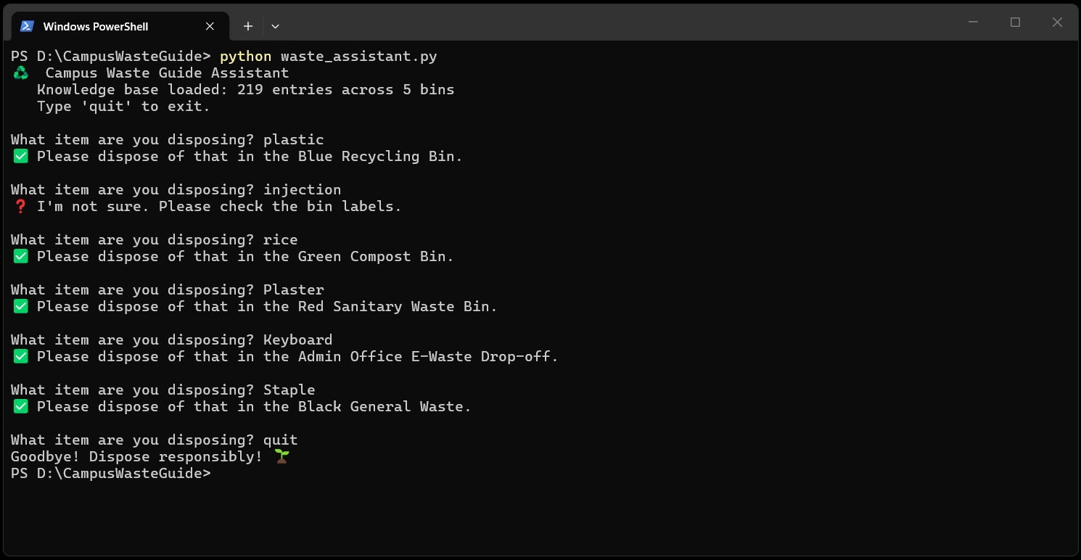
---
CampusWasteGuide | 1M1B – IBM SkillsBuild & AICTE | AI for Sustainability Virtual Internship | July–Sep 2026
Bhagyashree Sushilkumar Lokapure | Indira Gandhi National Open University (IGNOU)

