**# S190 Competency Check - SDET I**

This assignment explain the process to execute the Test Automation Suite.

The test cases were executed on a webpage http://automationpractice.com/index.php. This assignment was implemented using the automated testing framework like

Selenium Webdriver + TestNG (using Java Language). The requirements to execute the assignment include the installations of Java, Eclipse, Selenium Webdriver and TestNG.

The objective of this assignment is to verify the functionalities of the given webpage.

**## Documentation**

<https://github.com/lokare06/Mystore.git>

**## Environment Variables**

To run this assignment, you will need to add the following environment variables in Java. The basic steps include

Download or save the appropriate JDK version for Windows. ...

Right-click the Computer icon on your desktop and select Properties.

Click advanced system settings.

Click Environment variables.

Under User variables, click New.

Enter JAVA_HOME as the variable name.

Enter the path to the JDK as the variable value

**## Initial Configuration and installation**

To execute this assignment, the essential configuration need to be done.

In JAVA IDE (eclipse), the first step is to create Maven project. This project helps to update/include .jar files automatically.

The jar files like TestNG jar, Selenium-Java jar, etc. The pagefactory was used in this assignment to support page object design pattern.

Next step is to create a "Shop", is a Maven project, based on the given assignment. In this project folder, four packages were created namely com.shop.pageobject, com.shop.testcases, com.shop.listener, com.shop.utilities

Using these packages, we have created locators and methods, creating test cases, and checking of test cases (success/failure), etc.

**## Running Tests**

To verify the webpage/website, the following test methods are created.

TC_LoginTest_001- 1 method

TC_HeaderTest_001-9 methods

TC_FooterTest_001-9 methods

TC_DressesTest_001-1 method

TC_CheckOut_001-1 method

Test cases are run using TestNG Test

<?xml version="1.0" encoding="UTF-8"?>

<!DOCTYPE suite SYSTEM "https://testng.org/testng-1.0.dtd">

<suite name="MyStore">

<listeners>

<listener class-name="com.shop.Listener.Listener"/>

</listeners>

<test name="Shop">

<parameter name="browser" value="chrome"/>

<classes>

<class name="com.shop.TestCases.TC_HeaderTest_001"/>

<class name="com.shop.TestCases.TC_FooterTest_001"/>

<class name="com.shop.TestCases.TC_DressesTest_001"/>

<class name="com.shop.TestCases.TC_CheckOutTest_001"/>

</classes>

</test>

</suite>

**## Page Factory in Page Object Model**

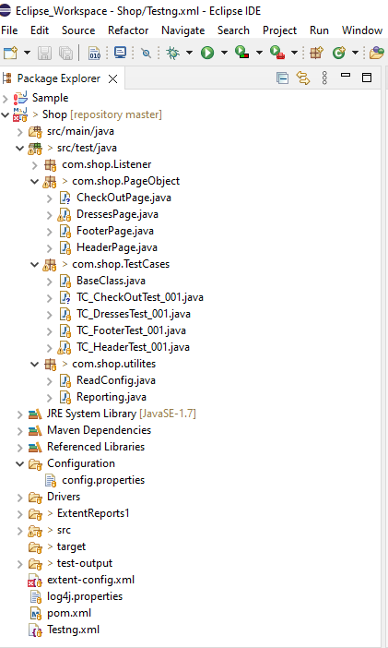

**## Test Reports**

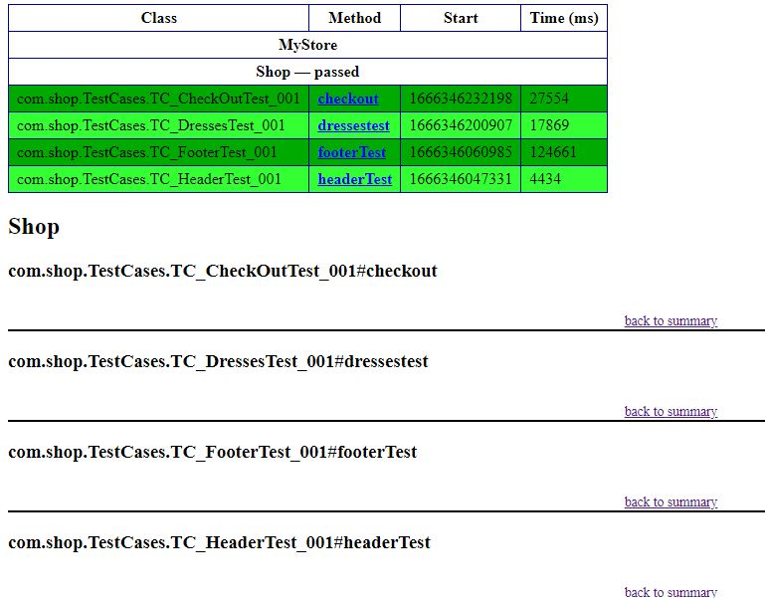

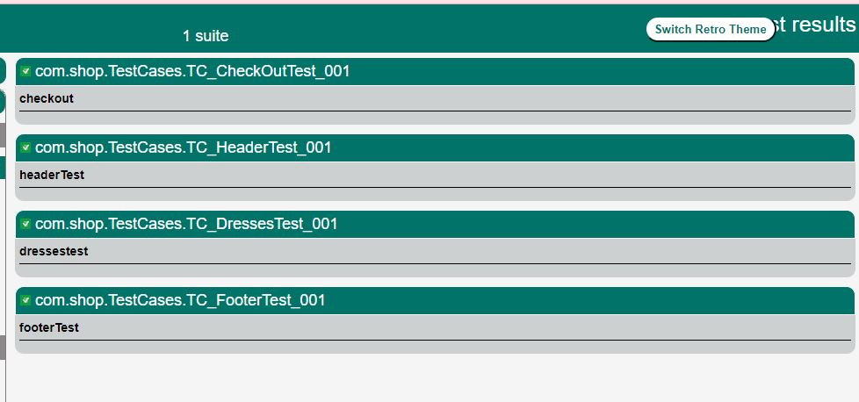

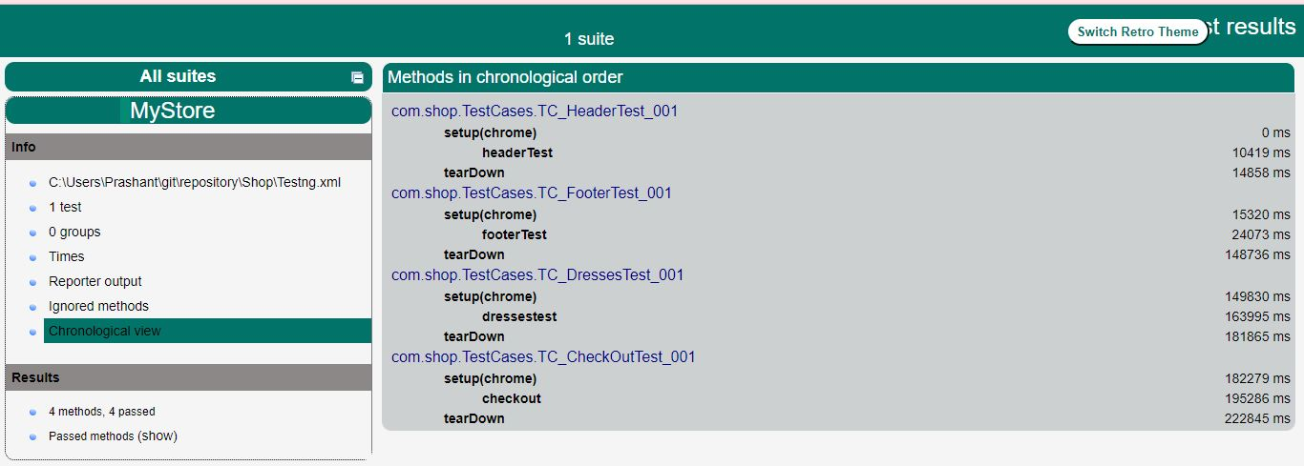

**## About Me**

I'm a software test Engineer.

**## Skills**

java, Selenium Webdriver,Testng,Jenkins

**📫 How to reach me**

Lokare.deepali06@gmail.com