Company/Client Name | Madras Cricket Club
Project Name | Message Broadcasting
Release Date
Release Notes | Broadcasting message with image/file to selected group through whatsapp/email
IP | http://3.109.198.190:3000/

Screen :

When click on Menu Broadcast->Manage Broadcast, It shows the list

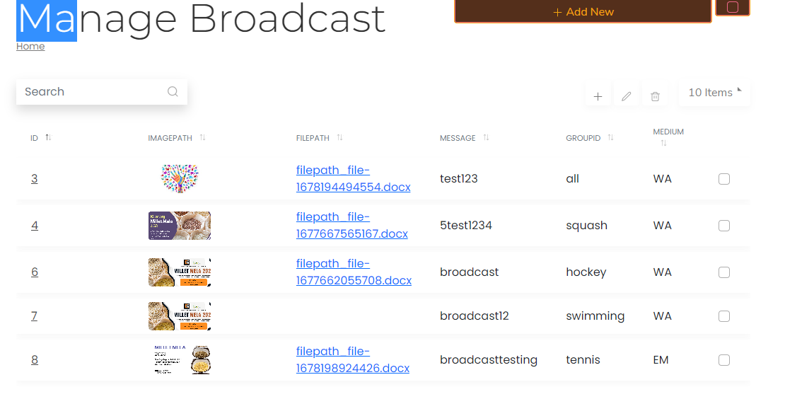
When click add/edit button, it shows the Message broadcasting screen.

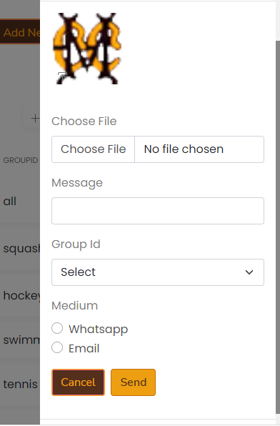
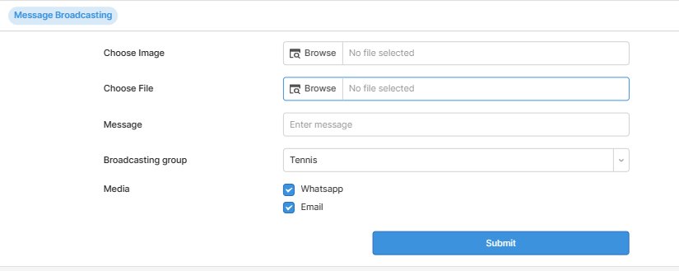

- Choose Image and File
- Enter broadcasting message
- Choose Broadcasting group from list(All,Tennis…etc)
- You can also select the media whatsapp and email
- When click on send button details are saved in database and the message broadcasting is started for selected group and media.

Table Details:
member_sports:
CREATE TABLE `member_sports` (
`member_code` varchar(10) CHARACTER SET utf8 NOT NULL,
`billiards` varchar(10) COLLATE utf8_unicode_ci NOT NULL DEFAULT '',
`badminton` varchar(10) COLLATE utf8_unicode_ci NOT NULL DEFAULT '',
`cricket` varchar(10) COLLATE utf8_unicode_ci NOT NULL DEFAULT '',
`hockey` varchar(10) COLLATE utf8_unicode_ci NOT NULL DEFAULT '',
`squash` varchar(10) COLLATE utf8_unicode_ci NOT NULL DEFAULT '',
`tennis` varchar(10) COLLATE utf8_unicode_ci NOT NULL DEFAULT '',
`swimming` varchar(10) COLLATE utf8_unicode_ci NOT NULL DEFAULT '',
`status` varchar(5) COLLATE utf8_unicode_ci NOT NULL DEFAULT '',
PRIMARY KEY (`member_code`)
) ENGINE=InnoDB DEFAULT CHARSET=utf8 COLLATE=utf8_unicode_ci

broadcast_detail :
CREATE TABLE `broadcast_detail` (
`id` int(11) NOT NULL AUTO_INCREMENT,
`adminCode` varchar(30) DEFAULT NULL,
`imagepath` varchar(500) NOT NULL,
`filepath` varchar(500) NOT NULL,
`message` varchar(1000) NOT NULL,
`groupid` varchar(60) NOT NULL,
`medium` varchar(60) NOT NULL,
`status` varchar(60) CHARACTER SET latin1 NOT NULL,
`flag` varchar(50) NOT NULL,
PRIMARY KEY (`id`)
) ENGINE=MyISAM AUTO_INCREMENT=9 DEFAULT CHARSET=utf8

