Company/Client Name | Madras Cricket Club
Project Name | Creating reports for admin login
Release Date | 03-May-2022
Release Notes | Creating menu for report and based on month filter show reports and download it as csv file.
IP | http://3.109.198.190:3000/

Tasks Status
S.No | Task Description | Category | Status
1 | Creating Menu | Task
2 | Generate report based on month | Task
3 | Download the report as csv file | Task
4 |  | Task

Known Issues
S.No | Issue Description | Notes
1
2
3

Creating Menu for payment report under main menu Report:

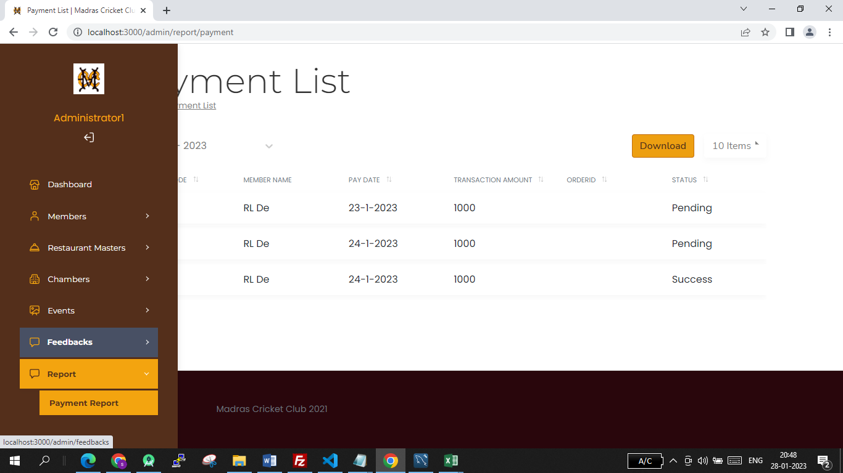

Click Report->Payment Report menu, it shows like that

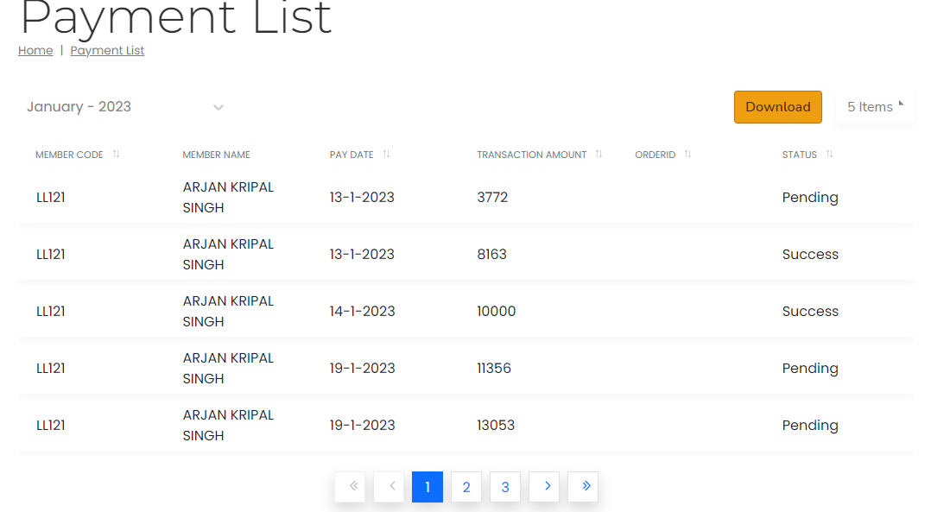

- Based on Month and pagination size selection the report will be generated.
- When click on Download button the full report(selected month report) is saved as csv file.

- When open the csv file, it should show all the records

