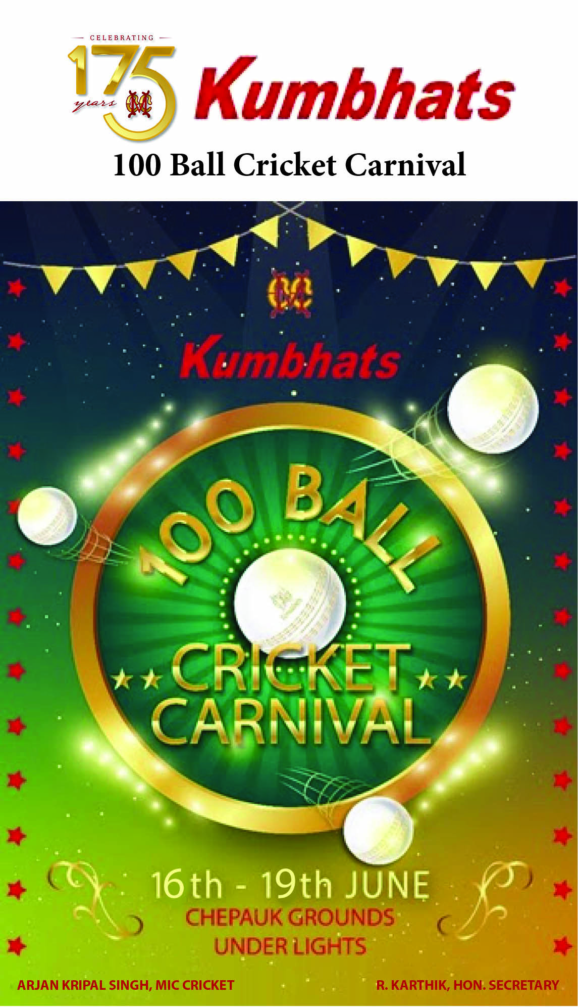

The MCC Kumbhats’ 100 Ball Cricket Carnival will be held between 16th & 19th June, 2022 at the Chepauk grounds, under floodlights.
Balraj Vasudev's ‘Dev’s Tigers', K.Ravishankar's 'TSM Superstars', Abhimanyu Jhaver's 'Jhaver Smashers', TT Ashok's 'Towering Titans' and S Balakrishnan’s ‘Thalaivars’ will be the 5 teams competing for the coveted title.
The auction to select players for these teams will be held on Thursday, 5th May at 6:00 pm in the Sports Complex.
Looking forward to members’ participation to encourage & support family and friends who will be taking part in the auction.

ARJAN KRIPAL SINGH R.KARTHIK
MIC - Cricket Honorary Secretary

