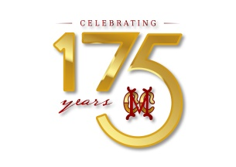
Squash
Lightning Doubles Tournament

Dear Member,
A Squash lightning Doubles Tournament is to be held on Friday, 4th March, evening at the Club courts.
Details of the tournament are outlined below:
- The event will be in the format of a ' squash lightning Doubles' open only to members and their dependents.
- Matches will commence at 5.00 pm.
- A register will be available at the Squash court for signing up by members, from 25th February, or shall contact squash marker Prasath @ 9600020993 to register.
Looking forward to active participation of members.

NIKHIL SWAMINADHAN R.KARTHIK
Member-in-charge – Squash Honorary Secretary

