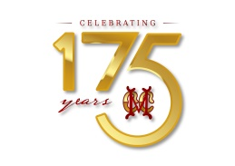
BADMINTON LEAGUE – 2022
10th to 13th March 2022

Dear Member,
The MCC Badminton League 2022 will be held from 10th to 13th March 2022. There will be 4 Teams. The tournament will be played over 4 days – League format for 3 days and the Finals on the last day - and will be open only to MCC Members and their dependents.
Schedule
League Matches - 10th to 12th March 2022, 5.00 pm
Sunday, 13th March 2022
5.00 pm - Finals
8.00 pm - Prize Distribution
Members interested in participating are requested to enter their names in the register provided in the Shuttle Court on or before 1st March 2022. Members participating must ensure their availability for the entire duration of the tournament.
Looking forward to your cooperation and support.

H.E.SRINIVAS SHASTRY R. KARTHIK
MIC Badminton Honorary Secretary

