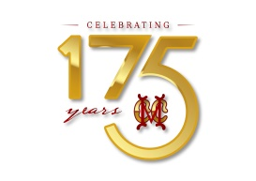
TENNIS

Dear Member,
We wish to inform you that the finals of the UCAL - TNTA TENNIS LEAGUE CHAMPIONSHIP – MIXED DOUBLES between MCC and Madras Club will be held at MCC Court No.1 on Tuesday, 26th April 2022, 3.45 PM onwards.
In view of the above, Tennis Court No.1 will not be available for members' use until completion of the match.
Inconvenience caused to members is regretted.
We request members to come & cheer our players.

RVRK.RANGA RAO R.KARTHIK
MIC - TENNIS HONORARY SECRETARY

